Field-Level Reliability of Satellite Crop Monitoring: A Reproducibility and Sensitivity Audit of the SICKLE Benchmark, Cauvery Delta, Tamil Nadu

Department of Data Science and Business Systems
SRM Institute of Science and Technology, Kattankulathur

Abstract—India has begun deciding crop-insurance payouts from satellite models. Under the YES-TECH framework of the Pradhan Mantri Fasal Bima Yojana, technology-based yield estimates carry a minimum 30% weightage across 344 districts in 12 states, with no upper cap; Madhya Pradesh uses 100%. The official manual specifies validation at the Gram Panchayat, explicitly “the smallest administrative unit”, and across all 116 pages we found no requirement to validate below it. Decisions, however, concern individual fields. This paper audits the research benchmark on which such models are built. Using SICKLE (WACV 2024), 64 released models across four tasks were reproduced and then re-evaluated per field. We report four defects that make the published numbers irreproducible, including a 6.5 IoU-point dependence on evaluation batch size with frozen weights, and a mislabelled error metric in the phenology tasks. A controlled ten-rung ablation at three seeds shows five of nine modelling choices cannot be distinguished from seed-to-seed variation at three seeds. The two steps that do exceed it both add information (temporal +0.1198, radar +0.1860); the remainder, which add model complexity, are inconclusive rather than demonstrably ineffective. Per field, a reported pixel-pooled IoU of 0.8665 corresponds to a median field of 0.672, with 33% of fields below 0.5; for the regression tasks the typical field is better than the aggregate but roughly one field-season in ten is two to four times worse. Crucially, these failures are systematic rather than random (seed-to-seed correlation r = +0.52), which makes selective automation feasible: reliable fields can be processed automatically and the rest referred for verification.
Keywords—crop insurance, PMFBY, YES-TECH, satellite crop monitoring, reproducibility, per-field evaluation, smallholder agriculture, Cauvery Delta, semantic segmentation, yield estimation

Introduction
Satellite crop monitoring has moved from research into administration. Under the Pradhan Mantri Fasal Bima Yojana (PMFBY), the Yield Estimation System based on Technology (YES-TECH), introduced by the Ministry of Agriculture and Farmers Welfare in 2023, blends satellite-derived yield estimates with manual Crop Cutting Experiments to determine insurance payouts. In 2025–26 it operated across 344 districts in 12 states. The national floor is a 30% weightage to modelled yield, states may raise it at discretion, and the manual places no upper cap; Madhya Pradesh has adopted 100%.
The unit of assessment is administrative. The YES-TECH manual states its objective as yield estimation “at the smallest administrative unit, i.e., Gram Panchayat”. Across the full 116-page manual we found fifteen references to the Insurance Unit and seven to the Gram Panchayat, and no occurrence of plot-level, field-level, per-farmer or sub-Insurance-Unit validation. The single numeric accuracy criterion we located applies to crop mapping, not yield, and is evaluated at Insurance Unit average. Section 5.1.5 further provides that past estimates “shall not be entertained in any court of law or appellate authority”, are exempt from the Right to Information Act as intellectual property, and are not made public.
A village-level estimate is nevertheless assembled from predictions over the individual fields it contains. If a model errs systematically on a subset of those fields, the errors do not cancel in the aggregate; they bias it. Validation against a handful of crop cuttings at village level cannot detect this. The quantity that is never measured is the one on which three farmer-facing decisions depend: a field’s yield for an insurance payout, a field’s harvest date for procurement scheduling, and a field’s transplanting date for irrigation timing.
Scope. This paper reports a reproducibility and per-field reliability audit of a published benchmark. It is deliberately distinct from a second study, in progress, which asks how the benefit of temporal and multi-sensor modelling scales with the number of independent training plots; that question requires a data-regime sweep over nested plot subsets and is not addressed here. The ablation of Section III-C is used in this paper to characterise the benchmark’s sensitivity to modelling choices at full data, not to answer the scaling question, and the two sets of results are not combined.
We do not have access to YES-TECH’s operational models, which are not public. We therefore audit the research benchmark on which models of this kind are developed and compared: SICKLE, published at WACV 2024, covering smallholder paddy in the Cauvery Delta of Tamil Nadu. Our contributions are:
- Four defects in the released benchmark that make its published numbers irreproducible, each measured rather than asserted.
- A controlled ten-rung ablation at three seeds, showing that five of nine modelling choices cannot be distinguished from seed-to-seed variation at three seeds, and that the two that do exceed it are both additions of information rather than of model complexity.
- A per-field audit of 64 released models across four tasks, quantifying the gap between reported and per-field accuracy and showing that its direction is task-dependent.
- Evidence that per-field failures are systematic across independent training runs, which makes selective automation implementable.

Literature Review
SICKLE [1] provides multi-sensor, multi-temporal imagery from Landsat-8, Sentinel-1 and Sentinel-2 over the Cauvery Delta, annotated at 3 m, 10 m and 30 m with crop type, yield and three phenology dates. It comprises 2,370 season-level samples drawn from smallholder plots averaging 0.38 acres across four delta districts, and is accompanied by released baselines for U-Net3D, UTAE and ConvLSTM across five tasks.
The dependence of segmentation metrics on object size is established. Wang et al. [2] show that per-dataset mean intersection over union is biased toward large objects, propose fine-grained and worst-case variants, and benchmark fifteen networks across twelve natural and aerial datasets, framing the result as model and dataset auditing. Object-based versus pixel-based accuracy assessment is likewise long-standing in agricultural remote sensing. We therefore treat per-field evaluation as established methodology that we apply, not as a contribution of this work.
What is less examined is whether per-field failure is reproducible across independent training runs. Metric bias concerns the estimator; repeatability concerns whether the same objects fail each time, which determines whether failures can be anticipated and routed for human verification. We address that question directly, and extend the per-field view from segmentation to regression tasks where the field is not an analytical choice but is imposed by the quantity itself.

Method

Dataset and evaluation protocol
All experiments use the released SICKLE splits. The tabular index contains 351 unique plots and 2,370 season-level samples: 1,937 samples from 315 plots for training and 227 samples from 36 plots for validation. The test split of 206 samples is unlabelled — every row is blank in PLOT_ID, CROP and PADDY_BIN and no masks exist — so every number reported here is a validation number and is not comparable to the published test table. For yield and the phenology tasks only rows with a recorded yield qualify, reducing validation to 41 field-seasons from 14 plots. To state the batching precisely, since it matters for Section IV-A: EVALUATION uses a batch size of 32 in full precision throughout, and all reported metrics are computed under that setting. TRAINING uses an effective batch size of 32 formed as a micro-batch size of 8 with 4 gradient-accumulation steps, under bfloat16 autocast, to fit an 8.5 GB device. Because the temporal axis is padded to the per-batch maximum, the padded tensor seen during training can differ from that of true batch-32 training; this setting is held constant across all rungs so that rung-to-rung differences remain controlled, but absolute values are not directly comparable to runs trained at a true batch of 32, and we do not assume the effect is identical across architectures.

Reproduction gate
No analysis was permitted to proceed until the harness could recover a published number. For each released checkpoint we load the authors’ own configuration, data pipeline and model, evaluate on the validation split, and compare against the best epoch in that run’s training log. The tolerance was declared before any run and was not widened afterwards: 0.01 absolute for crop type, 10% relative for the regression tasks.

Controlled ablation
Ten configurations were defined, each inheriting from its predecessor and altering exactly one factor: v1 single acquisition; v2 adds the full temporal sequence; v3 augmentation; v4 class-weighted loss; v5 Sentinel-1 radar; v6 Landsat-8; v7 UTAE in place of U-Net3D; v8 a wider encoder; v9 a cosine schedule with warmup; v10 plot-balanced sampling. Each was run at three seeds, giving 30 runs and approximately 109 GPU-hours. A difference between adjacent rungs is attributable to that single change within this experimental system; we term this controlled component attribution and make no causal claim. A difference smaller than the seed-to-seed standard deviation is reported as inconclusive, not as zero.

Per-field evaluation
Mask band 0 carries the plot identifier, which makes per-field evaluation possible. For crop type we pool each field’s pixels into one confusion matrix and weight fields equally. For yield, mask band 5 stores yield divided by pixel count, so a field’s yield is the sum over its pixels; a per-pixel error would describe a quantity scaling inversely with field area. For the phenology tasks a date is a single value per field. Aggregation is to the field-season rather than the field, since a plot recurs across seasons and a crop is insured for a season. Confidence intervals are obtained by resampling fields, never pixels, as pixels within a field are one measurement repeated rather than independent observations.

Results and Discussion

Four defects in the released benchmark
First, evaluation depends on batch size. With frozen weights, identical data and unmodified code, the released [L8] U-Net3D scores 0.7071, 0.6561 and 0.6409 at batch sizes 32, 16 and 8 respectively — a swing of 6.5 IoU points produced by batch composition alone. The temporal axis is padded to the per-batch maximum and the pad mask is realigned to the pooled length by truncation rather than pooling, so whether masking engages depends on which samples share a batch. Any IoU reported on this benchmark without its evaluation batch size is therefore not reproducible.
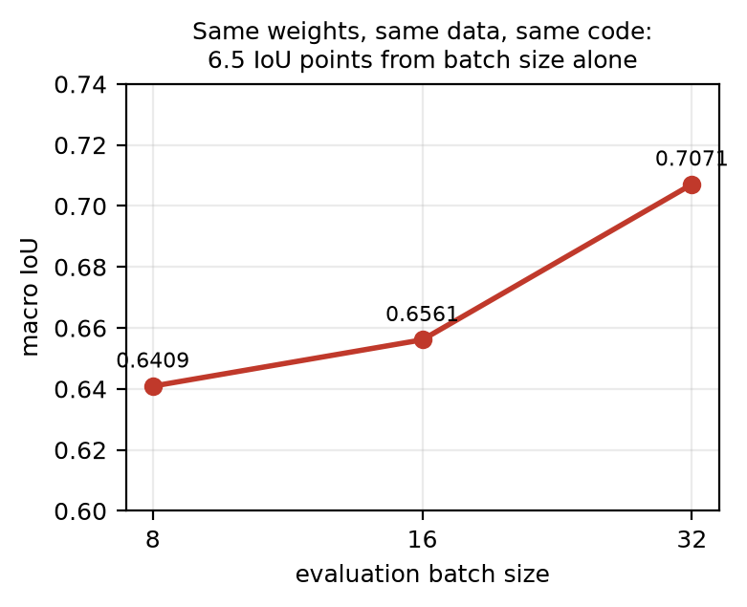
Fig. 1. Evaluation of a frozen checkpoint depends on batch size.
Second, the same realignment divides by zero. A sample whose early acquisitions are empty — common where acquisitions begin late in a season or cloud-affected frames are zero-filled — yields an all-padding truncated mask and a NaN output. We measured 13 of 1,937 training samples affected and 0 of 227 validation samples, which explains why reproduction succeeds while training fails. No guard exists anywhere in the reference implementation. Third, three of the four released UTAE baselines never trained: all are best at epoch 1, and two score an identical 0.3812 with paddy IoU exactly 0.000, predicting a single class everywhere. Fourth, the phenology tasks report a column labelled MAPE which is in fact mean absolute error divided by the constant 183, computed per pixel; we verified that the reported value equals MAE/183 exactly in nine of nine released runs. We additionally note that 16 of the 21 crop labels have no validation plots, so only binary paddy classification is evaluable on this benchmark.

Information helps; model complexity does not
Two of nine ablation steps produce effects larger than the seed-to-seed spread: adding the full temporal sequence (+0.1198 pixel-pooled IoU) and adding Sentinel-1 radar (+0.1860). Both add measurement. Every step that adds model complexity — a wider encoder, a cosine schedule, the UTAE architecture, augmentation and plot-balanced sampling — is inconclusive or negative, and those rungs consumed roughly three quarters of the compute. Two of them appeared to be results at a single seed and did not survive three: augmentation read −0.0496 and the capacity rung −0.0098 at seed 0 alone. With 351 plots, additional parameters do not create additional evidence, whereas an additional sensor does; radar matters here in particular because a substantial share of mid-season optical frames in the monsoon are cloud-affected.
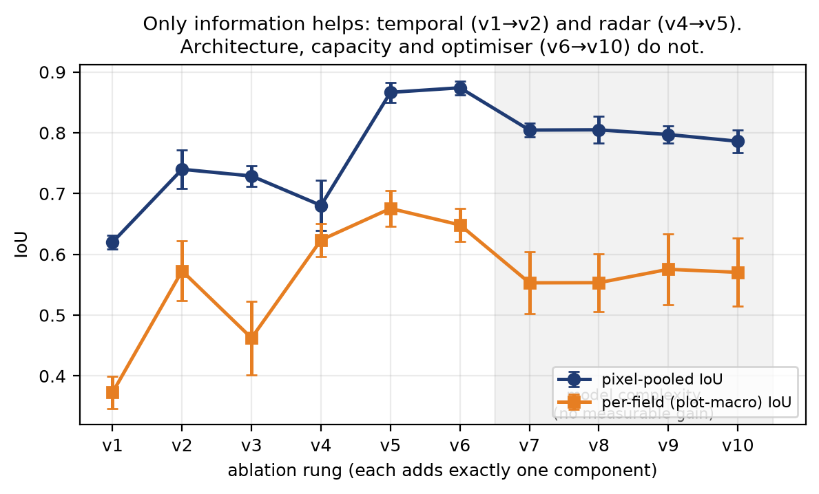
Fig. 2. Ten-rung controlled ablation, three seeds. Error bars are seed-to-seed standard deviation.

Reported pixel-pooled IoU does not describe a field
For the best configuration, pixel-pooled IoU is 0.8665 while the median individual field scores 0.672, and 12 of 36 validation fields — 33% — fall below 0.5. The reported figure is an average over pixels and describes no particular field.
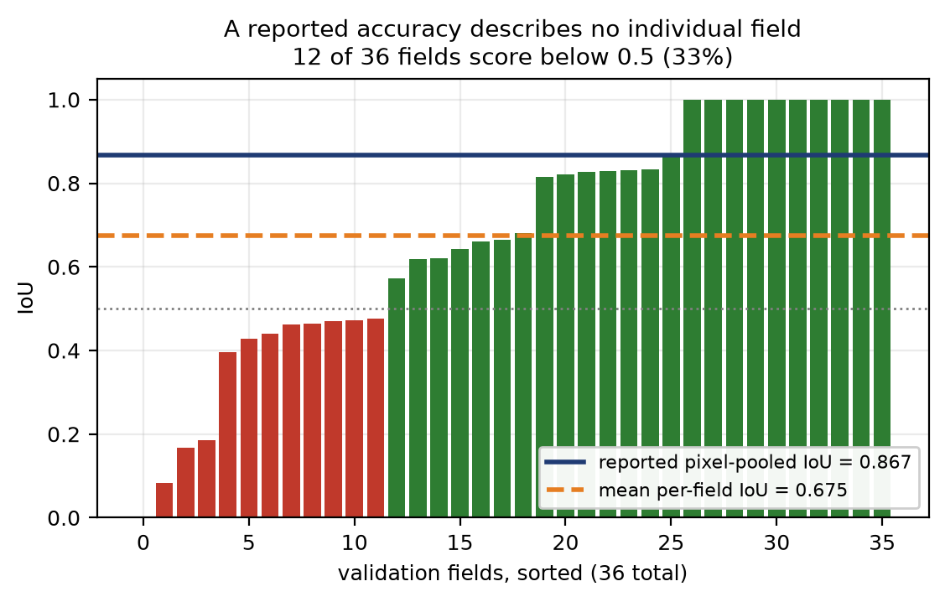
Fig. 3. Per-field IoU for the best configuration, with the reported pixel-pooled value overlaid.

Across four tasks the direction is task-dependent
All 52 released models for the three regression tasks reproduced within tolerance (52 of 52 gates passed), and together with the twelve crop-type cells this gives 64 verified models. For crop type the median field is worse than the aggregate. For yield and the phenology dates the median field is better than the aggregate, but the tail is markedly heavier: one field-season in ten is two to four times worse than typical. What is consistent across tasks is not the direction of the gap but that the aggregate conceals the tail.
Task | Reported MAE | Typical field | p90 | p90 / median
Crop yield (kg) | 574.81 | 398.74 | 1247.12 | 3.13×
Harvesting date (days) | 13.97 | 12.11 | 28.43 | 2.35×
Transplanting date (days) | 5.48 | 3.31 | 12.03 | 3.64×
TABLE I. Reported versus per-field-season error, medians across all released models per task.
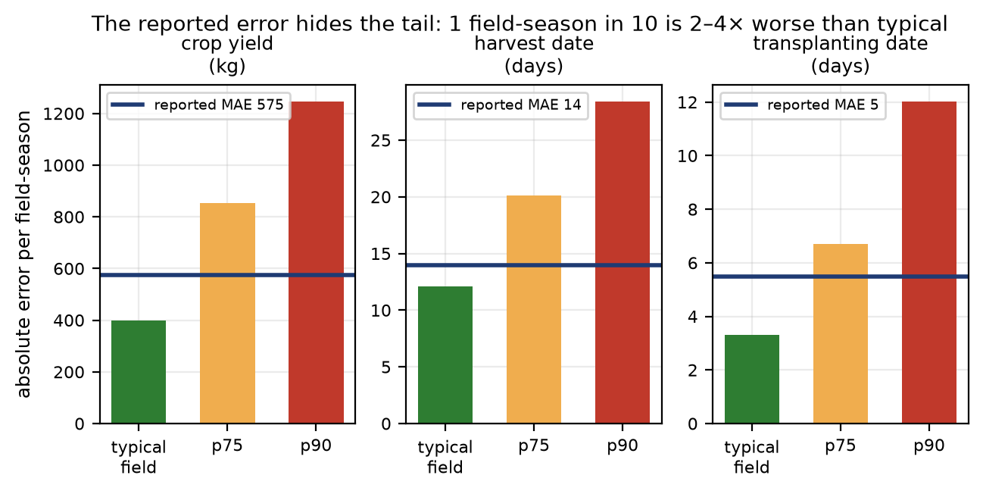
Fig. 4. For every regression task the typical field is better than the reported error, while the tail is far worse.

Failures are systematic, which admits a remedy
Per-field IoU correlates between independent seeds at r = +0.52 to +0.58, and 11 of the 12 fields scoring below 0.5 do so in every run. Poor performance is thus a property of the field rather than of the training run. This is the practical consequence of the audit: because the difficult fields recur, they can be identified and handled differently. A deployment can process reliably-mapped fields automatically and refer the remainder for manual verification, which would be impossible if failure were random. We therefore recommend that per-field error distributions, not only aggregate accuracy, be reported before any such model informs decisions taken at field level.
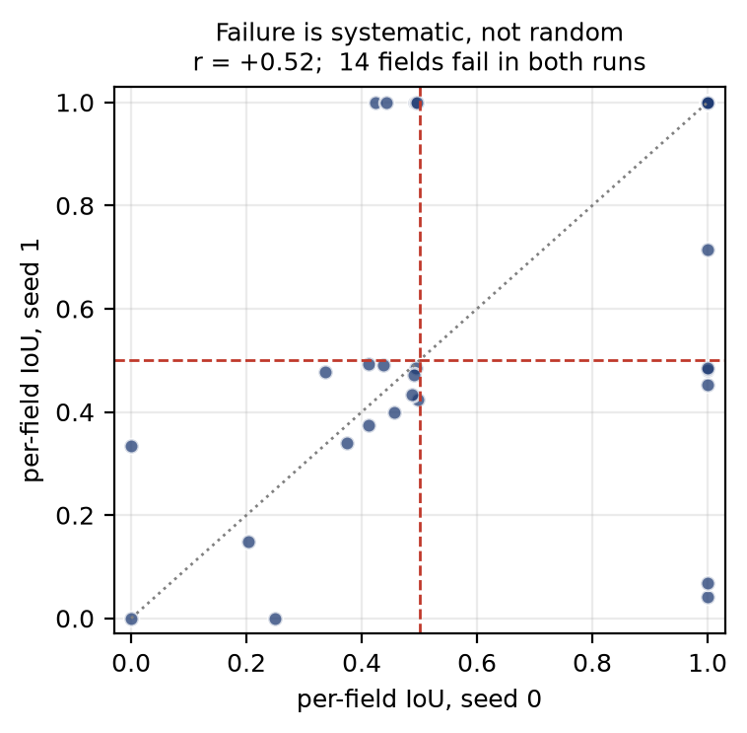
Fig. 5. Per-field IoU between two independent seeds. The same fields fail in both runs.

Unreliable fields can be identified without labels
Systematic failure is only actionable if the difficult fields can be recognised at inference time, when no labels exist. We tested two signals that require none. The first is seed disagreement: the fraction of a field’s pixels on which independently seeded models do not all agree, available to any deployment that trains more than one model. The second is mean predictive confidence from a single model. Both are evaluated as screening tests, since that is how they would be used: what share of fields must be referred for verification (workload), and what share of genuinely unreliable fields that referral catches (recall).
Both signals correlate with per-field IoU in the useful direction — seed disagreement at r = -0.513 and confidence at r = -0.626. Referring the 50% of fields with the highest seed disagreement captures 92% of the unreliable fields (11 of 12), against 61% precision. Confidence alone, which needs only one trained model, captures 67% at a workload of 33%. Random referral would capture a share equal to the workload, so both signals carry real information. This converts the recommendation of Section IV-E from a proposal into a measured procedure: a deployment can process the majority of fields automatically while referring a minority that contains most of the failures.
This result rests on 36 validation fields, of which 12 are unreliable. A single field is 2.8 percentage points of any rate quoted above. These numbers establish that the signals are informative; they do not establish an operating threshold, which would require a substantially larger evaluation set.
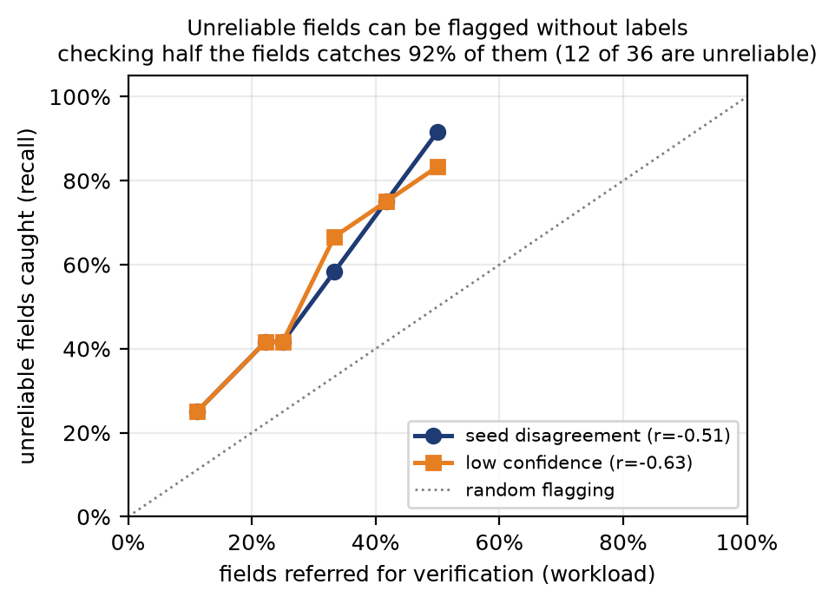
Fig. 6. Screening performance of two label-free signals. The diagonal is random referral.

Reproducibility
Every run records a manifest containing the resolved configuration, a content hash of it, the git commit and a dirty-tree flag, the device, the effective and micro batch sizes, the seed and the trainable parameter count. Reproduction tolerances were declared in the source before any run and were not widened. All scripts that produce the tables and figures in this paper are released with the code, and the document itself is generated from the result files so that no value in the text is transcribed by hand.

Limitations
Every result is a validation-set number computed on 36 fields, and on 41 field-seasons from 14 plots for yield and the phenology tasks, because the benchmark’s test split is unlabelled. The study covers one delta, one cropping system and the period 2018–2020. We audit SICKLE, a research benchmark; we do not audit YES-TECH’s operational models, which are not publicly available, and no claim is made about their accuracy. Training used gradient accumulation with micro-batches of 8, which changes temporal padding relative to a true batch of 32; this was held constant across all rungs so that rung-to-rung differences remain controlled, and all evaluation was performed in full precision at the pinned batch size. Per-field evaluation follows established methodology [2] and is applied here rather than proposed.

Conclusion
India has begun automating crop-insurance payouts from satellite data. Under YES-TECH, modelled yield carries at least 30% weightage across 344 districts and up to 100% in Madhya Pradesh, while validation is specified only at the Gram Panchayat and the resulting estimates are neither appealable in court nor obtainable under the Right to Information Act. Decisions, however, are ultimately about individual fields, and when a model errs systematically on particular fields those errors bias the village figure rather than cancelling within it. The farmers exposed to that risk are precisely those whose holdings this benchmark represents, averaging 0.38 acres.
Because the operational models are not public, we audited the research benchmark on which such models are built. Reproducing 64 released models across four tasks, we found four defects that make the published numbers irreproducible; that five of nine modelling choices cannot be distinguished from seed variation at three seeds, the two exceeding it both being additions of information rather than model complexity; and that a reported pixel-pooled IoU of 0.8665 corresponds to a median field of 0.672 with 33% of fields below 0.5, while the regression tasks conceal a tail in which one field-season in ten is two to four times worse than typical.
The remedy follows from the final result. Because per-field failures recur across independent training runs rather than occurring at random, the difficult fields are identifiable in advance. We therefore propose that benchmarks and operational systems report per-field error distributions alongside aggregate accuracy, and that deployments adopt selective automation: process the fields a model handles reliably, and refer the remainder for human verification. This does not pay a farmer or raise a yield. It is a safeguard — a measurement that is currently absent, and that would expose failures before they reach the people least able to contest them.

References
[1] D. Sani, S. Mahato, S. Saini, H. K. Agarwal, C. S. Devshali, S. Anand, G. Arora, and T. Jayaraman, “SICKLE: A Multi-Sensor Satellite Imagery Dataset Annotated with Multiple Key Cropping Parameters,” in Proc. IEEE/CVF Winter Conf. on Applications of Computer Vision (WACV), 2024.
[2] Z. Wang, M. Berman, A. Rannen-Triki, P. H. S. Torr, D. Tuia, T. Tuytelaars, L. Van Gool, J. Yu, and M. B. Blaschko, “Revisiting Evaluation Metrics for Semantic Segmentation: Optimization and Evaluation of Fine-grained Intersection over Union,” in Advances in Neural Information Processing Systems (NeurIPS), 2023.
[3] Mahalanobis National Crop Forecast Centre, Department of Agriculture and Farmers Welfare, Government of India, “Yield Estimation System based on Technology (YES-TECH) under PMFBY — Manual,” 2023.
[4] Department of Agriculture and Farmers Welfare, Government of India, “Pradhan Mantri Fasal Bima Yojana — Revised Operational Guidelines,” 2020.
[5] V. Sainte Fare Garnot and L. Landrieu, “Panoptic Segmentation of Satellite Image Time Series with Convolutional Temporal Attention Networks,” in Proc. IEEE/CVF Int. Conf. on Computer Vision (ICCV), 2021.
[6] X. Shi, Z. Chen, H. Wang, D.-Y. Yeung, W.-K. Wong, and W.-C. Woo, “Convolutional LSTM Network: A Machine Learning Approach for Precipitation Nowcasting,” in Advances in Neural Information Processing Systems (NeurIPS), 2015.
[7] O. Çiçek, A. Abdulkadir, S. S. Lienkamp, T. Brox, and O. Ronneberger, “3D U-Net: Learning Dense Volumetric Segmentation from Sparse Annotation,” in Proc. MICCAI, 2016.
[8] Centre for Science and Environment, “Assessment of technology-based yield estimation under PMFBY in Madhya Pradesh,” 2025.

