ANALYSTLAB AFRICA
Machine Learning Internship Programme · Week 2
Data Preprocessing Report
ShopSmart Retail Group — Preparing the Data for Machine Learning
Prepared by Umar Muhammad · ShopSmart Retail Group dataset

1. Business objective
Two supervised-learning problems are planned: predicting the value of an order (regression, target Order_Value) and predicting whether an order is returned (classification, target Is_Returned). This report documents every step that turns nine raw ShopSmart tables into one machine-learning-ready dataset, and why each decision was taken. It accompanies the Jupyter notebook ShopSmart_Week2_Preprocessing.ipynb.

2. Data inspection
All nine tables were loaded and inspected for shape, data types, missing values, duplicates and descriptive statistics. The modelling table has 50,000 orders (one row per order) and an overall return rate of 4.88%.
Check | Result
Missing cells (all 9 tables) | 0
Exact duplicate rows (all 9 tables) | 0
Foreign keys that fail to resolve | 0 (customers, products, stores, returns all match)
Order period | 1 Jan 2025 – 31 Dec 2025
Date columns stored as text | Order, registration, store opening, return and restock dates

3. Data-quality issues
Because the tables are complete, the audit tested business logic rather than only counting blanks. Thirteen issues were found:
Issue | Table | Affected | Treatment
Line_Total subtracts Discount as a flat number (not as a %) | order_items | 50,000 (100%) | Target is a deterministic formula of its inputs (leakage); discount effect is negligible
Order Unit_Price differs from catalogue Selling_Price (>1 unit) | orders vs products | 50,000 (100%) | Two conflicting price sources; order price used
Returns recorded on Cancelled/Pending orders | returns | 1,685 (67.4%) | Impossible business flow; Order_Status kept but treated with caution
Return_Date earlier than Order_Date | returns | 1,252 (50.1%) | Return timing is unreliable; not used as a feature
Orders with more than one return record | returns | 58 (2.3%) | Collapsed to one order-level flag
Refund_Amount larger than the order's Line_Total | returns | 270 (10.8%) | Refund amount not used (post-event, inconsistent)
Order placed before the customer's registration date | orders vs customers | 5,159 (10.3%) | Tenure would be negative; clipped to 0 and flagged
Duplicate customer e-mail addresses | customers | 49 (1%) | E-mail is personal data; dropped
Duplicate customer phone numbers | customers | 4 (0.1%) | Phone is personal data; dropped (formats are also inconsistent)
States that appear under more than one Region | stores | 6 (60%) | Store_Region is unreliable; kept as a weak feature
Store names that are duplicated | stores | 15 (60%) | Store_ID used as the key, name dropped
Sub_Category holds a single constant value ('General') | products | 500 (100%) | Zero information; dropped
Suppliers with malformed phone numbers (<7 digits) | suppliers | 80 (16.4%) | Table not used in the model
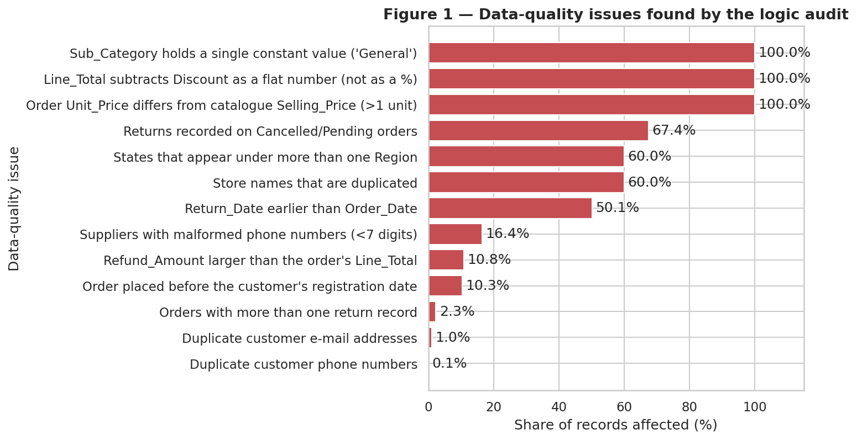
Figure 1 — Data-quality issues found by the logic audit
Most important finding: Line_Total equals Quantity × Unit_Price − Discount, where Discount is a 0–20 whole number. The target is therefore a near-exact function of its inputs, which explains the R² of 1.0 in Week 1. Treating Discount as a percentage would lower the average order value by about 15,000.

4. Data cleaning decisions
Step | Decision | Reason
Missing values | No imputation needed | None exist; plan (median / mode / flag) documented for future refreshes
Duplicates | None removed; 58 orders with two return records collapsed to one flag | No exact duplicates; the order is the unit of prediction
Text values | Stripped and standardised case | Levels were already consistent; protects future loads
Data types | Dates parsed with explicit month/day/year format; categories typed | Prevents silent day/month swaps; enables time features
Validation | Assertions on quantity 1–5, discount 0–20, prices > 0, age 18–100 | Fails loudly if bad values appear
Joins | Orders joined to items, customers, products, stores, returns with 1:1 or many-to-1 validation | A bad key raises an error instead of duplicating rows
Target | Is_Returned = order has at least one return record | Matches Week 1 (4.88%)
Leakage | Return count, return date and refund amount not carried forward | Only known after the outcome

5. Feature engineering
Fourteen features were created, three columns were renamed for clarity, and columns without modelling value were removed.
Feature | Built from | Why it was created
Order_Month, Order_Quarter, Order_DayOfWeek, Is_Weekend | Order date | Expose seasonality and weekday behaviour; models cannot use raw dates
Gross_Value | Quantity × Unit_Price | Basket size before discount (also the source of the leakage)
Shipping_Share | Shipping ÷ Gross_Value | Shipping burden relative to basket size
Unit_Margin_Pct | Catalogue selling and cost price | Product profitability
Price_vs_Catalog_Gap | Order price − catalogue price | Captures the conflicting price sources
Customer_Tenure_Days, Ordered_Before_Registration | Order and registration dates | Customer age on the platform; flag keeps impossible rows visible (negative tenure set to 0)
Age_Band | Customer age | Ordered age groups: 18-29, 30-44, 45-59, 60+
Prior_Orders | Running count per customer | Purchase history using only earlier orders (no future leakage)
Store_Age_Years, Is_Local_Store | Store opening date; customer vs store state | Store maturity; whether customer bought in home state

Renamed: Line_Total → Order_Value, Discount → Discount_Pct, Age → Customer_Age. Removed: first name, last name, e-mail, phone (personal data); Customer_City (duplicates state); Sub_Category (constant); Brand and Product_Name (about 500 unique values, effectively IDs); all ID columns except the row key Order_ID.
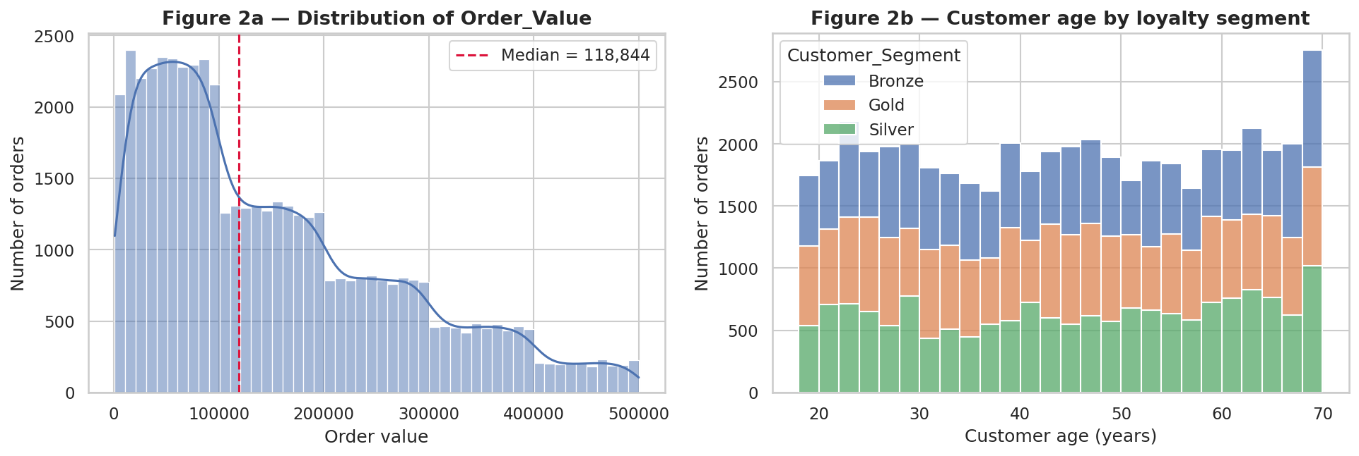
Figure 2 — Order_Value distribution and customer age by segment
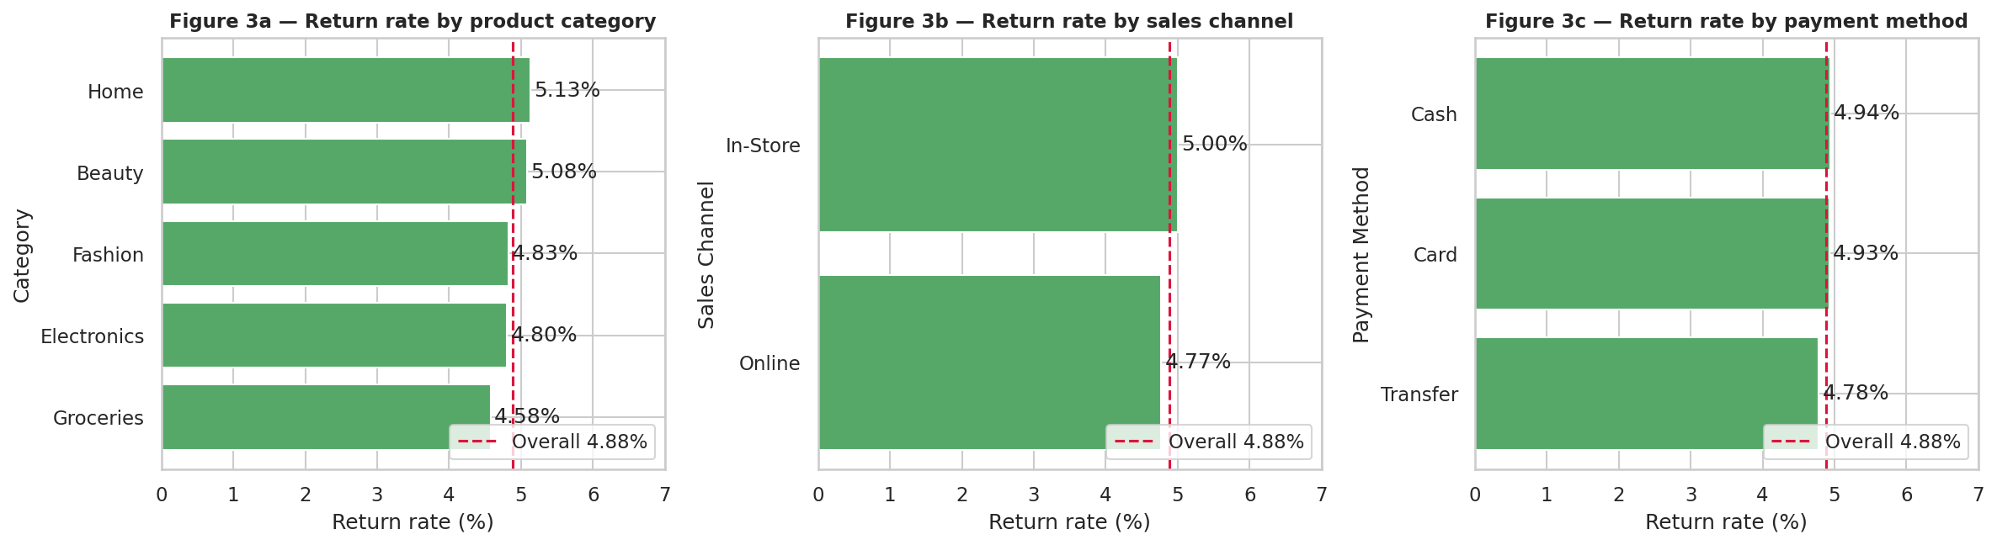
Figure 3 — Return rate by category, channel and payment method

6. Encoding and scaling

6.1 Train/test split
The data was split before any statistics were learned: 40,000 training rows and 10,000 test rows (80/20, stratified on Is_Returned, random_state 42). The return rate is 4.88% in both parts. All scalers were fitted on the training rows only, so the test set stays unseen.

6.2 Encoding
Technique | Applied to | Reason
Ordinal | Customer_Segment (Bronze < Silver < Gold); Age_Band | Categories have a natural order that the numbers preserve
Label (0/1) | Sales_Channel, Gender | Two levels only; one column suffices, no false ordering
One-hot (first level dropped) | Payment_Method, Order_Status, Category, Customer_State, Store_Region | Nominal categories; avoids implying order; drop-first avoids collinearity

6.3 Scaling
Scaler choice follows a rule applied to each column in the training data, rather than one scaler for everything:
Scaler | Rule | Columns
RobustScaler | |skew| > 0.5 | Gross_Value, Prior_Orders, Shipping_Share
MinMaxScaler | ≤ 12 distinct values (bounded) | Age_Band_Ord, Customer_Segment_Ord, Discount_Pct, Order_DayOfWeek, Order_Month, Order_Quarter, Quantity
StandardScaler | Symmetric continuous | Cost_Price, Customer_Age, Customer_Tenure_Days, Price_vs_Catalog_Gap, Selling_Price, Shipping_Cost, Store_Age_Years, Unit_Margin_Pct, Unit_Price

Binary and one-hot columns stay as 0/1. Targets are never scaled. Scaling changes units, not shape (Figure 4), so large-number columns such as Gross_Value (up to about 500,000) no longer dominate small ones such as Quantity (1–5).
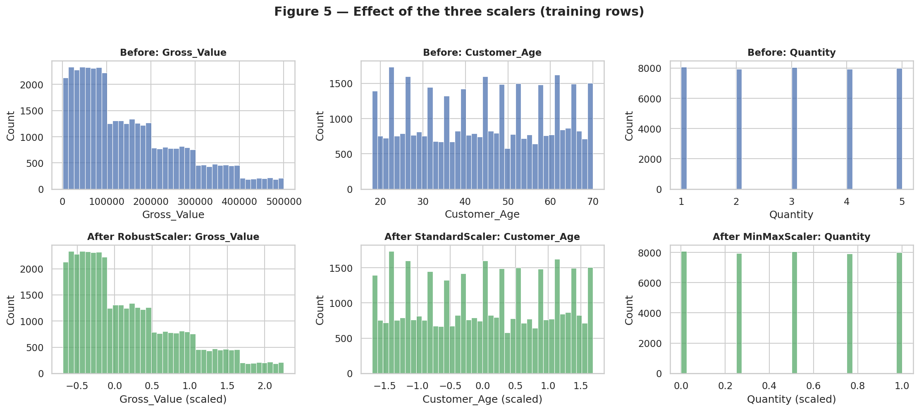
Figure 4 — Effect of the three scalers (training rows)

7. Outlier detection
Outliers were measured on original values using the IQR rule (1.5 × IQR fences), Z-scores (|z| > 3) and box plots.
Feature | Max | Skew | IQR outliers | Z > 3
Gross_Value | 499975 | 0.89 | 410 (0.82%) | 0
Order_Value | 499960 | 0.89 | 410 (0.82%) | 0
Shipping_Cost | 5000 | 0 | 0 (0%) | 0
Unit_Price | 99998 | -0.01 | 0 (0%) | 0
Customer_Age | 70 | -0.01 | 0 (0%) | 0
Customer_Tenure_Days | 1089 | 0.19 | 0 (0%) | 0
Prior_Orders | 23 | 0.64 | 557 (1.11%) | 170
Store_Age_Years | 5.92 | 0 | 0 (0%) | 0
Shipping_Share | 4.54 | 9.79 | 5428 (10.86%) | 800

- Gross_Value / Order_Value: 410 baskets (0.82%) flagged by IQR but none beyond 3 standard deviations; they are the top of a legitimate right-skewed range (maximum about 500,000 = price 100,000 × quantity 5).
- Prior_Orders: 557 values (1.1%) are loyal repeat customers (up to 23 earlier orders).
- Shipping_Share: extreme ratios arise from very small baskets; removed later by the variance threshold.
Decision: all rows were kept. Deleting or capping high baskets would remove the most valuable customers and bias value predictions downward. Robust scaling limits their influence instead.
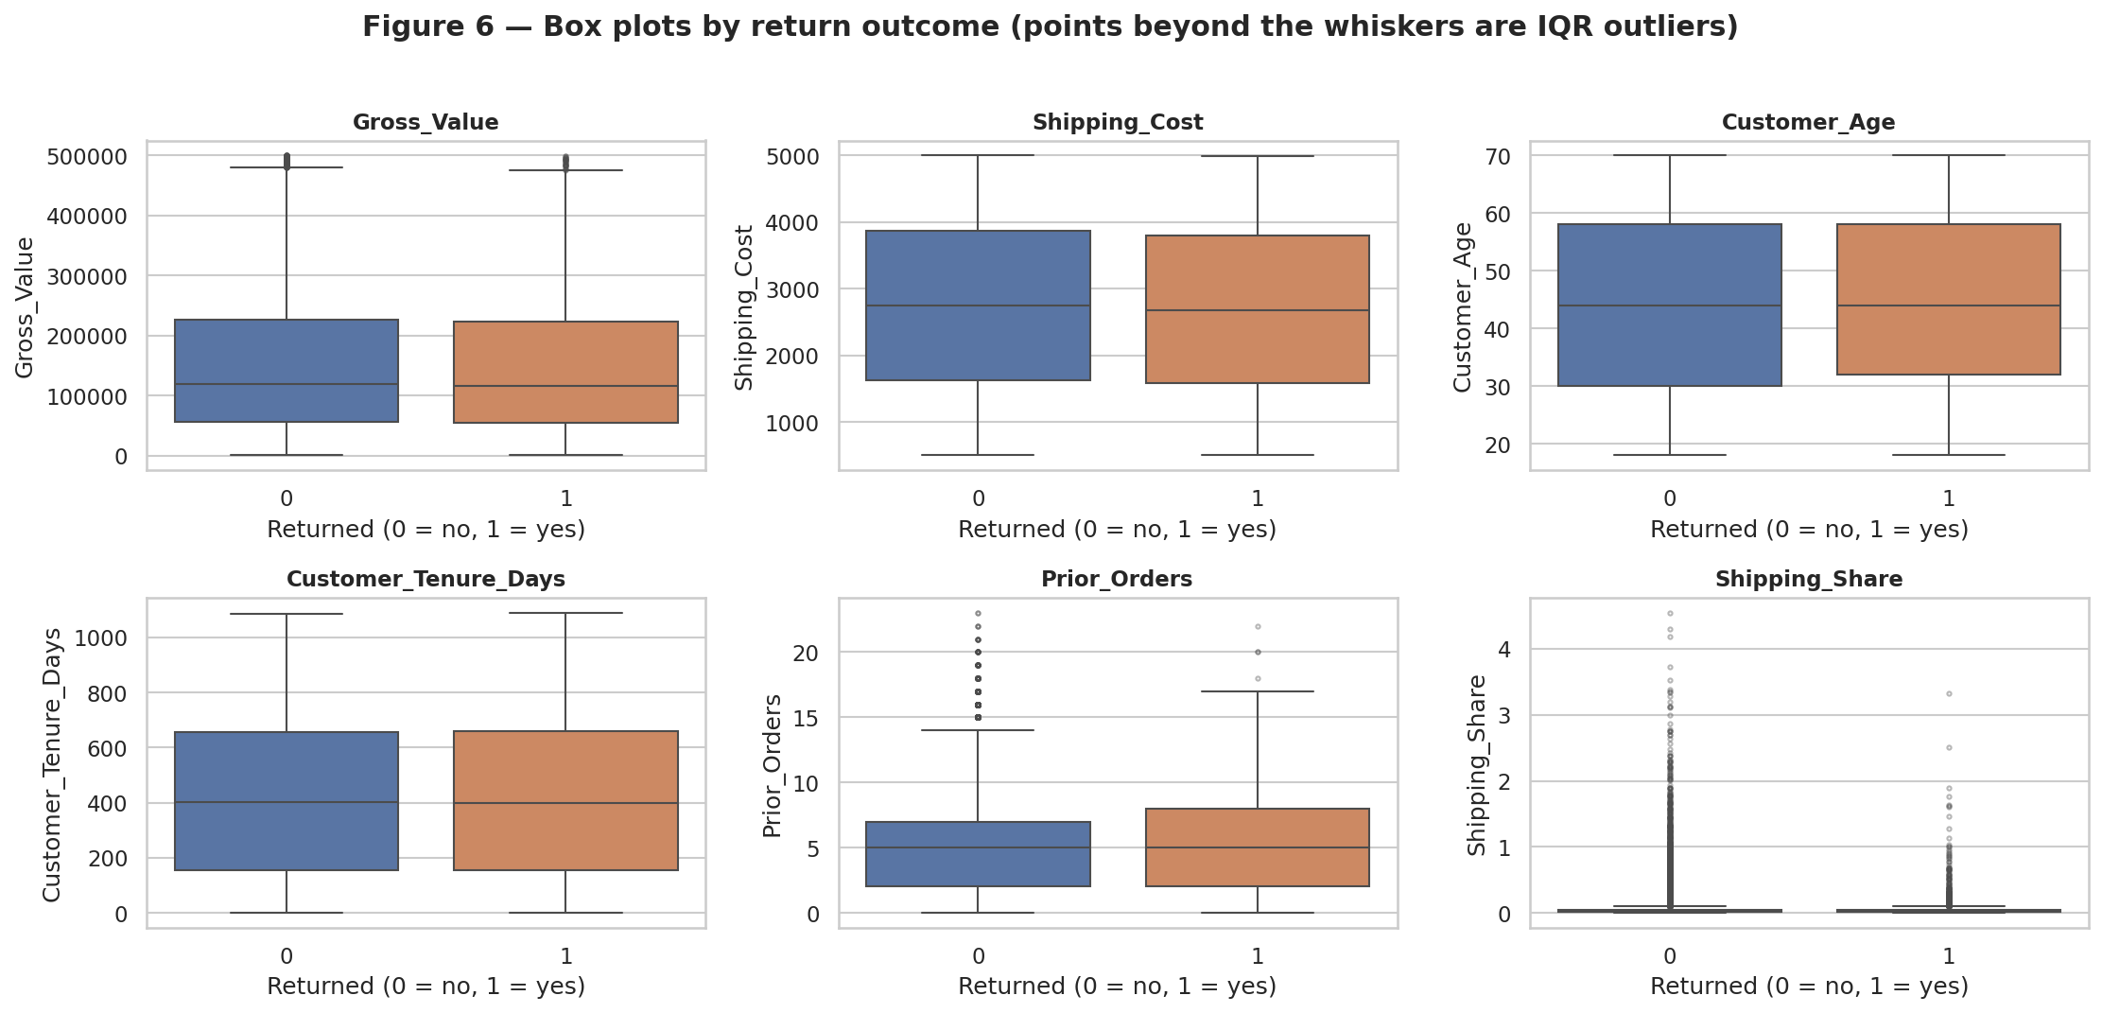
Figure 5 — Box plots by return outcome

8. Feature selection
Starting from 44 encoded and scaled candidates, four methods were applied to the training rows only:
- Variance threshold (0.01): removed Shipping_Share (almost constant after rescaling because of its extreme tail).
- Correlation analysis (|r| > 0.85): removed Order_Month, Customer_Age, Selling_Price, each a near-duplicate of a retained feature (e.g. Order_Month vs Order_Quarter, Customer_Age vs Age_Band).
- Leakage check: Gross_Value correlates with Order_Value at 1.0000, so it is excluded from the regression feature set.
- Importance versus a random-noise probe: only 5 of 39 features exceeded a column of pure noise, and only slightly; cross-validated ROC-AUC is 0.4955 ± 0.0116.
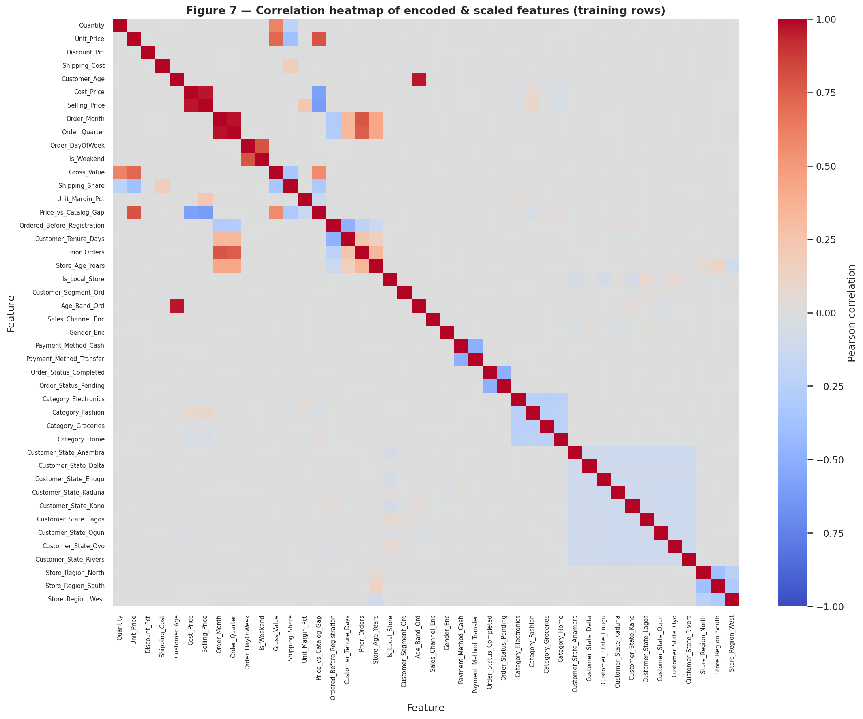
Figure 6 — Correlation heatmap of encoded and scaled features
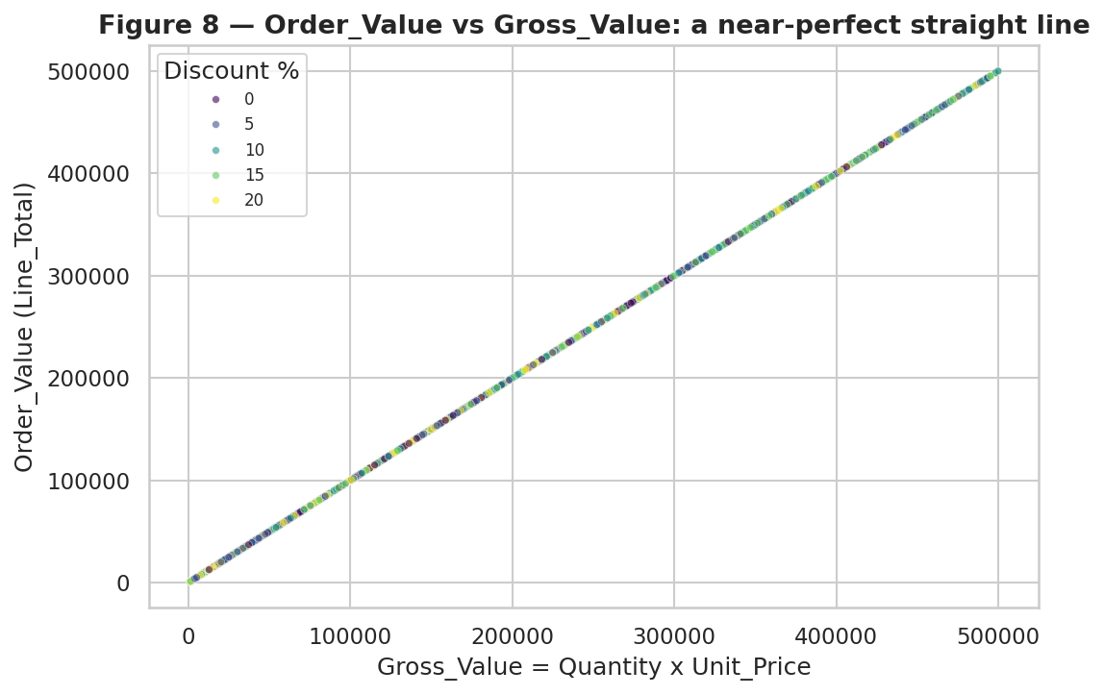
Figure 7 — Order_Value against Gross_Value: a near-perfect straight line
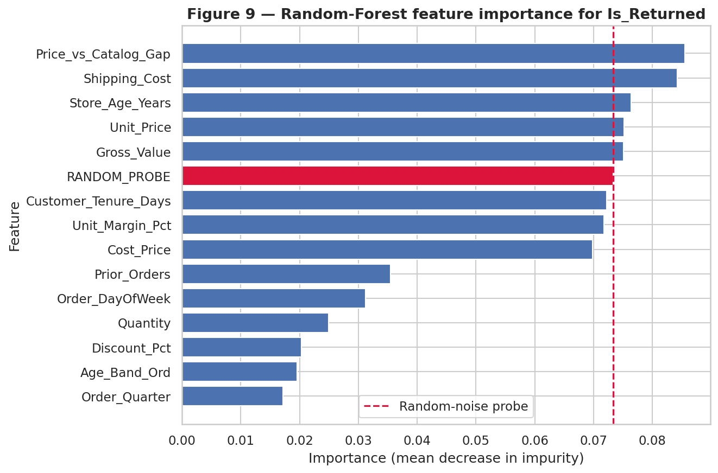
Figure 8 — Random-Forest importance for Is_Returned, with random-noise probe
Result: 40 features were retained. Three feature sets are saved in feature_sets.json: classification (all 40), regression without Gross_Value, and regression without any arithmetic inputs.
Regression feature set | Test R²
With Gross_Value (leaky) | 1.000
Without Gross_Value (quantity and price kept) | 1.000
Without arithmetic inputs (quantity, price, discount, price gap, shipping share) | -0.002

9. Final dataset
File | Shape | Contents
ShopSmart_ML_Ready.csv | 50,000 × 44 | Order_ID, Split, two targets, 40 encoded and scaled features
ShopSmart_Cleaned.csv | 50,000 × 33 | Readable cleaned table (no personal data), before encoding and scaling
feature_sets.json, preprocessing_artifacts.joblib | — | Feature lists, fitted encoders and scalers for reuse on new data

Readiness checks passed: no missing values, no infinite values, all feature columns numeric, unique order keys, both train and test partitions present.

10. Key observations
- The raw data is complete but logically flawed; counting blanks alone would have missed every important problem.
- Order_Value is determined by quantity and price, so high regression accuracy reflects arithmetic. This is the cause of the Week 1 result of R² = 1.0.
- Returns appear unrelated to the recorded product, customer, store, price and timing fields (ROC-AUC 0.4955).
- Only 4.88% of orders are returned, so accuracy is a misleading metric; recall, precision and ROC-AUC should be used.
- Only 33% of orders are Completed; revenue analysis must filter by order status.

11. Limitations and next steps
- Confirm with the data owner whether Discount is a percentage; if so Order_Value should be recomputed.
- Returns information (timing, status, refund) is inconsistent and was used only as a yes/no flag.
- Week 3: train baseline models on the stored split, use class weights or resampling for returns, compare against a majority-class baseline, and report the regression with and without arithmetic inputs.

