ANALYSTLAB AFRICA
Machine Learning Track · Week 4
Consumer Complaint Volume Forecasting Prototype
Modelling report: data validation, forecasting, evaluation and limitations
Prepared by Umar Muhammad · CFPB complaints about Bank of America, May 2017 – Aug 2023

1. Executive summary
This project builds and tests a model that forecasts how many consumer complaints the CFPB receives about Bank of America each month. It uses 62,516 records, 75 complete months (May 2017 – Jul 2023), and a chronological, rolling-origin evaluation that never lets the model see the future.
- Trend: volume grew about 2.4 times between 2018 and 2022 (7,872 to 12,953 complaints a year). Seasonality is weak; the trend dominates.
- Accuracy: a typical 1 – 3 month forecast misses by about 8 – 13% of monthly volume (WAPE). Test months Jan – Jul 2023: 11.8% for the best model, 13.1% for "repeat last month". Without the July 2023 burst: 4.4% and 5.6%.
- Main finding: no method is reliably better than the simple baseline. The model that won validation (Ridge) lost to the baseline on the test months, and no improvement is statistically significant. The one robust result is that seasonal-naive forecasting is clearly worse.
- Burst risk: July 2023 saw 1,749 complaints (about 60% above the previous six months' typical level), concentrated on 11 – 15 July. No model anticipated it, and models that carried it forward over-forecast August by more than 120%.
- Use: treat forecasts as a planning range (about 1,100 – 1,500 complaints a month for Sep – Oct 2023), refreshed monthly, with burst monitoring. A forecast of complaint volume says nothing about misconduct or company performance.

2. Business context and responsible use
Stakeholders need to monitor complaint volumes and anticipate workload. A complaint is a consumer-reported issue; it does not establish misconduct or a regulatory violation. Recorded company responses are not proof that a complaint was resolved satisfactorily. This prototype forecasts the number of complaints received and makes no claim about the company's behaviour or future performance.

3. Data validation and preparation
The supplied workbook (62,516 rows, 12 columns) was preserved unchanged; all cleaning is done in memory and is reproducible from the notebook.
Check | Result | Decision
Complaint ID unique; duplicate rows | Unique; 0 duplicate rows (1,494 rows match another except the ID) | Kept: different IDs are different complaints
Blank Timely response? | 1,494, exactly the In-progress complaints | Never counted as No; excluded from the timely-response denominator
Missing sub-issue / public response / sub-product | 10,858 / 2,175 / 7 | Labelled by meaning (not specified, no public response recorded)
Date validity | None forwarded before receipt; ranges match the brief | Valid
Forwarding interval | Mean 1.22 d, median 0 d, 79.4% same day, 435 over 30 d, max 275 d | Kept; it is CFPB intake to forwarding, not company response time
Reporting months | 76 consecutive months, none missing | No gap repair needed
Partial months | Aug 2023 covers 28 days (20 of 23 weekdays); May 2017 starts on day 1 | Aug 2023 excluded from modelling, used as a separate check; May 2017 kept (no effect)
Zero-complaint product months | Student loan 46, payday/title loan 3 | Genuine zeros, not missing data

Shared KPIs (consistent with the other tracks): total 62,516 complaints; timely-response 96.06% of valid records (58,619 Yes, 2,403 No), with 1,494 In-progress records excluded and reported separately; mean forwarding interval 1.22 days (median 0).
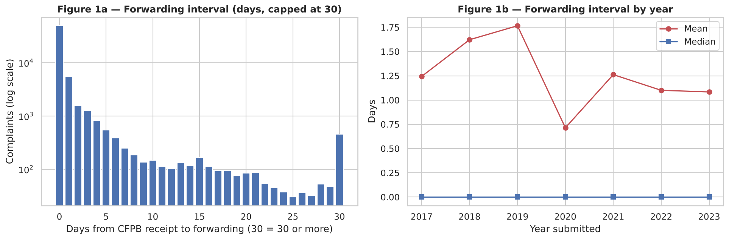
Figure 1 — CFPB forwarding interval: 79% same day, long tail

4. Historical trends
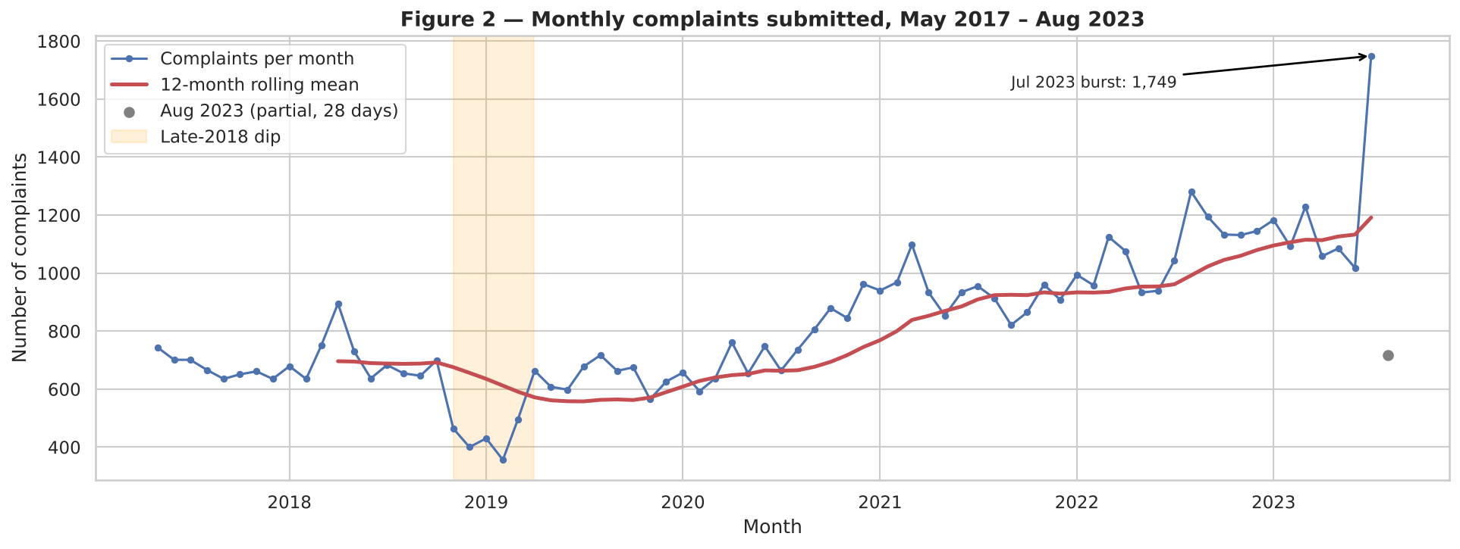
Figure 2 — Monthly complaints submitted, May 2017 – Aug 2023
- Trend strength 0.78 versus seasonal strength 0.16 (0 = none, 1 = dominant): volume is driven by a long-run trend, not a calendar pattern.
- A dip from November 2018 to March 2019 (as low as 356 a month) and a burst in July 2023 are visible. The data do not explain either, and no cause is assumed.
- The product mix shifts over time: mortgage complaints fall as a share, credit-card and credit-reporting complaints grow.
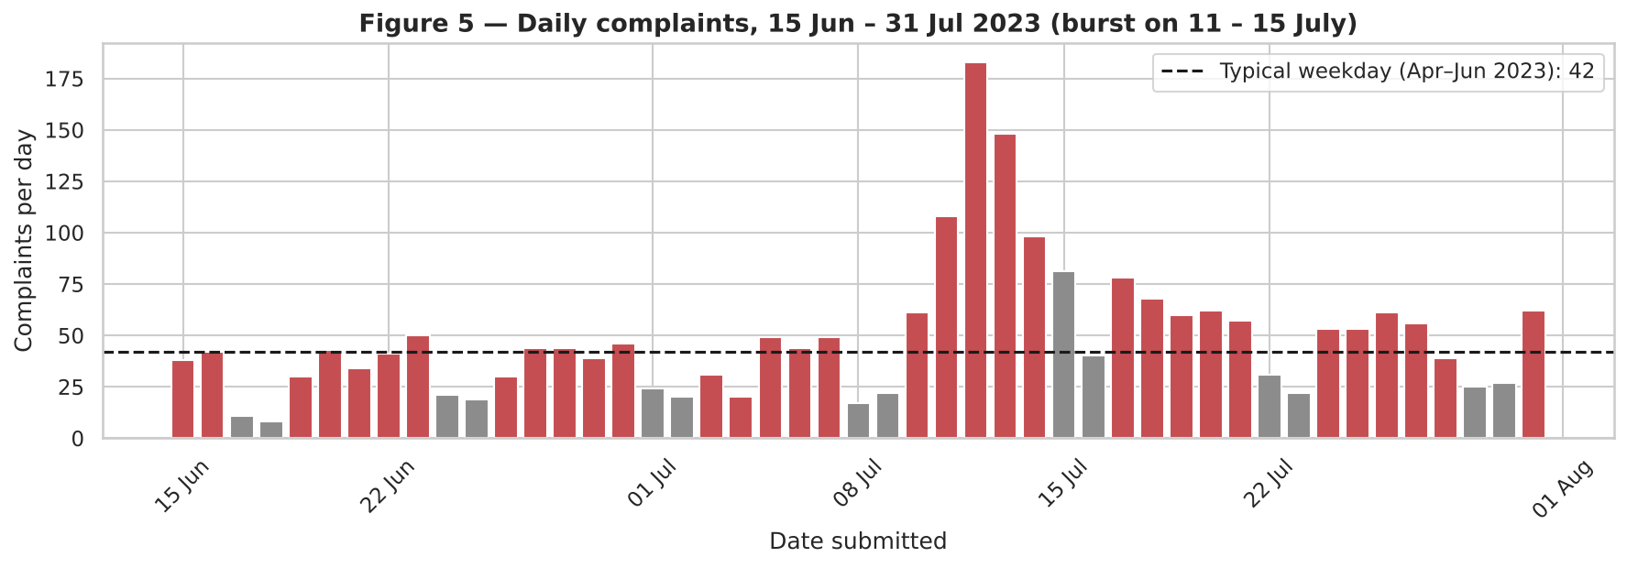
Figure 3 — The July 2023 burst: 11 – 15 July, peak 183 complaints in one day

5. Forecasting problem and validation design
Item | Definition
Target | Complaints submitted in a calendar month (by Date submitted), modelled as complaints per weekday and converted back using the target month's weekday count
Horizons | 1 – 6 months ahead; planning focus 1 – 3 months
Features (history only) | Last month's rate, last 3 months, 6- and 12-month averages, recent change, month of year (sine/cosine), trend index
Validation | Rolling origin with an expanding window: every forecast is made from data up to its origin and nothing later. Validation = Jan – Dec 2022; Test = Jan – Jul 2023 (used once). Tuning only on validation.
Partial months | Aug 2023 excluded from training and evaluation; used as an extra out-of-sample check scaled to the weekdays actually covered
Metrics | MAE (average miss), RMSE (penalises large misses), WAPE (total absolute error ÷ total actual)

6. Models and results
Nine methods were compared: four baselines (naive, seasonal naive, 3-month average, 6-month median), exponential smoothing with damped trend, ARIMA (order chosen by AIC at every origin), ridge regression, gradient boosting, and an ensemble of the last three. Ridge penalty and boosting depth were chosen on validation months only.

6.1 Validation (2022), average over 1 – 3 month horizons
Method | MAE | RMSE | WAPE %
Ridge regression | 82 | 112 | 7.6
Ensemble (ETS+Ridge+GBM) | 91 | 110 | 8.4
6-month median | 102 | 117 | 9.5
Gradient boosting | 105 | 134 | 9.7
Naive | 106 | 130 | 9.8
ARIMA | 106 | 130 | 9.8
Exp. smoothing (damped) | 107 | 126 | 9.9
3-month average | 114 | 129 | 10.6
Seasonal naive | 156 | 200 | 14.4

6.2 Test (Jan – Jul 2023), average over 1 – 3 month horizons
Method | MAE | RMSE | WAPE % | WAPE % excl. July
Gradient boosting | 141 | 270 | 11.8 | 4.4
6-month median | 145 | 253 | 12.1 | 5.8
3-month average | 151 | 268 | 12.6 | 5.8
Ensemble (ETS+Ridge+GBM) | 157 | 266 | 13.0 | 6.6
ARIMA | 157 | 285 | 13.1 | 5.6
Exp. smoothing (damped) | 158 | 280 | 13.1 | 6.0
Naive | 157 | 285 | 13.1 | 5.6
Ridge regression | 175 | 260 | 14.6 | 9.7
Seasonal naive | 187 | 284 | 15.5 | 9.0

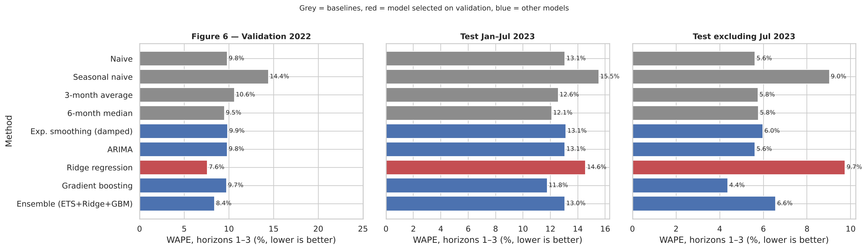
Figure 4 — Model comparison: validation, test, and test excluding July 2023
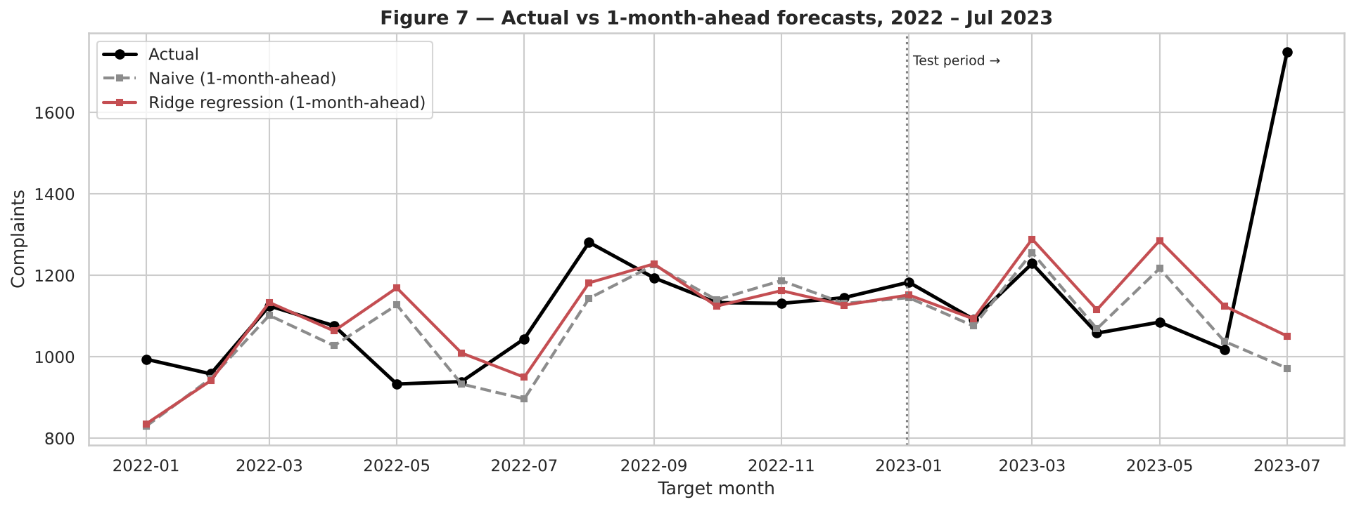
Figure 5 — Actual vs 1-month-ahead forecasts, 2022 – Jul 2023
Reading the results. Ridge was best on validation (7.6%) but worst of the non-seasonal methods on test (14.6%; 9.7% without July). ARIMA chose a plain random walk, ARIMA(0,1,0), at all 19 origins, so it equals the naive baseline. The ranking changes from one six-month window to the next:
Method | 2022 Jan–Jun | 2022 Jul–Dec | 2023 Jan–Jul
Naive | 10.5 | 9.2 | 13.1
6-month median | 12.3 | 7.1 | 12.1
Ridge regression | 10.6 | 5.0 | 14.6
Gradient boosting | 7.3 | 11.8 | 11.8
Ensemble (ETS+Ridge+GBM) | 9.4 | 7.5 | 13.0

Paired Wilcoxon tests against the naive baseline give p-values from 0.15 upwards for every method except seasonal naive, which is significantly worse (p = 0.02). With only 75 months, the extra complexity cannot be shown to beat "repeat last month". Because forecasts for neighbouring months are correlated, even these p-values are generous.
Error also grows with horizon (Figure 6), and sensitivity checks show that dropping May 2017 changes nothing, that using raw instead of weekday-adjusted counts raises the naive error from 11.1% to 11.8%, and that the July 2023 burst alone accounts for about 3 of the 11 percentage points of error.
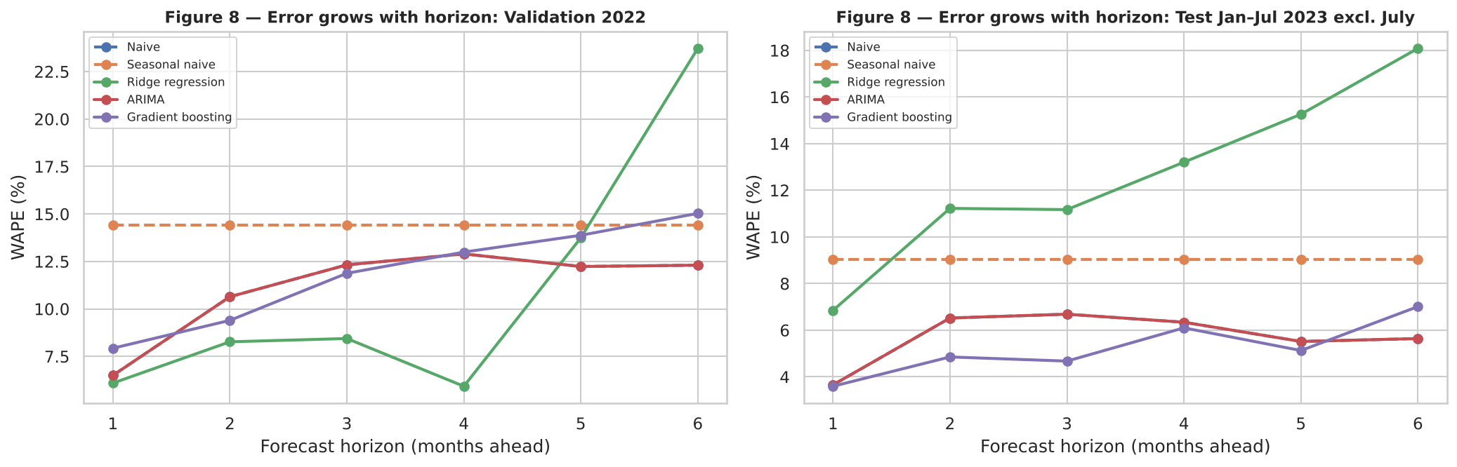
Figure 6 — Forecast error rises with the horizon

7. Error analysis
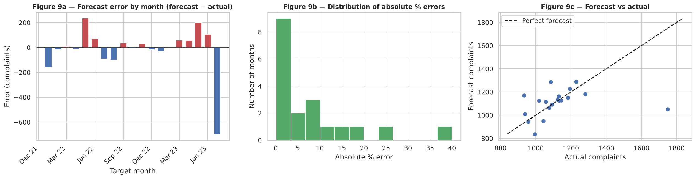
Figure 7 — Forecast errors by month, their distribution, and forecast vs actual
- The largest misses are turning points: July 2023 (actual 1,749, forecast 1,051), May 2022 (25% too high) and May 2023 (18% too high). Forecasts that lean on last month's level overshoot when volume falls back.
- Average error is -17.5 complaints (slightly low), driven by July 2023. Error autocorrelation is -0.06: no obvious unused pattern remains.

Partial-month check: August 2023
Method | Full-month forecast | Scaled to 20 weekdays | Actual (28 days) | Error %
Ridge regression | 1843 | 1603 | 717 | +123.5
Naive | 1916 | 1666 | 717 | +132.3
6-month median | 1223 | 1063 | 717 | +48.3
Gradient boosting | 1917 | 1667 | 717 | +132.5

August fell back to about 36 complaints per weekday (46 in June, 83 in July). Methods that lean on last month over-forecast by more than 120%; the 6-month median, which ignores a single burst, was much closer (+48%). A one-off burst must be flagged and not carried forward automatically.

8. Product-level forecasts
Six products average at least 30 complaints a month. One-month-ahead WAPE over the same validation and test months:
Product | Avg / month | Naive % | Exp. smoothing % | Ridge % | Gradient boosting % | Best
Checking or savings | 327 | 13.2 | 13.3 | 14.1 | 13.9 | Naive
Credit / prepaid card | 213 | 12.2 | 11.3 | 12.0 | 11.5 | Exp. smoothing (damped)
Credit reporting | 101 | 10.3 | 10.4 | 11.7 | 12.6 | Naive
Debt collection | 36 | 20.4 | 20.0 | 21.9 | 22.8 | Exp. smoothing (damped)
Money transfer / virtual currency | 46 | 10.3 | 12.8 | 19.3 | 13.3 | Naive
Mortgage | 88 | 21.9 | 21.1 | 23.8 | 22.3 | Exp. smoothing (damped)

Naive or exponential smoothing wins for every product; the machine-learning models do not help. Small products have the highest relative error because small counts are inherently noisy. Low-volume products (student loans: 46 zero months) are too sparse to forecast.
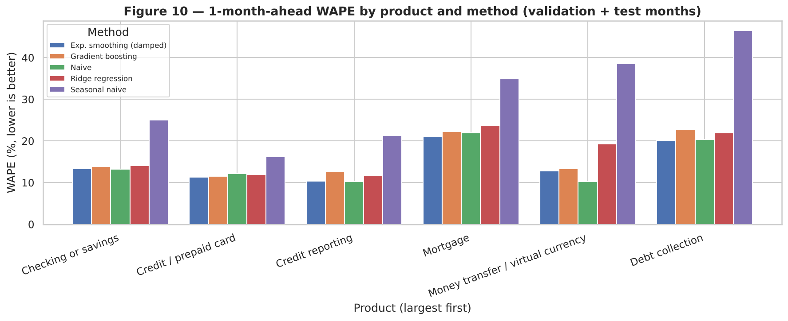
Figure 8 — One-month-ahead WAPE by product and method

9. Forecast for the coming months
Month | Forecast (selected model) | Rough 80% range | Robust-level scenario
2023-08 (full-month equivalent) | 1843 | 1646 – 2060 | 1223
2023-09 | 1493 | 1198 – 1717 | 1117
2023-10 | 1478 | 1178 – 1595 | 1170

The as-is forecast is pulled upward by July's burst; the robust-level scenario treats July as a one-off. A sensible planning range for September – October is roughly 1,100 to 1,500 complaints. Ranges come from the model's own backtest errors (about 19 months per horizon), so they are rough. Horizons beyond 3 months were not shown to be reliable.
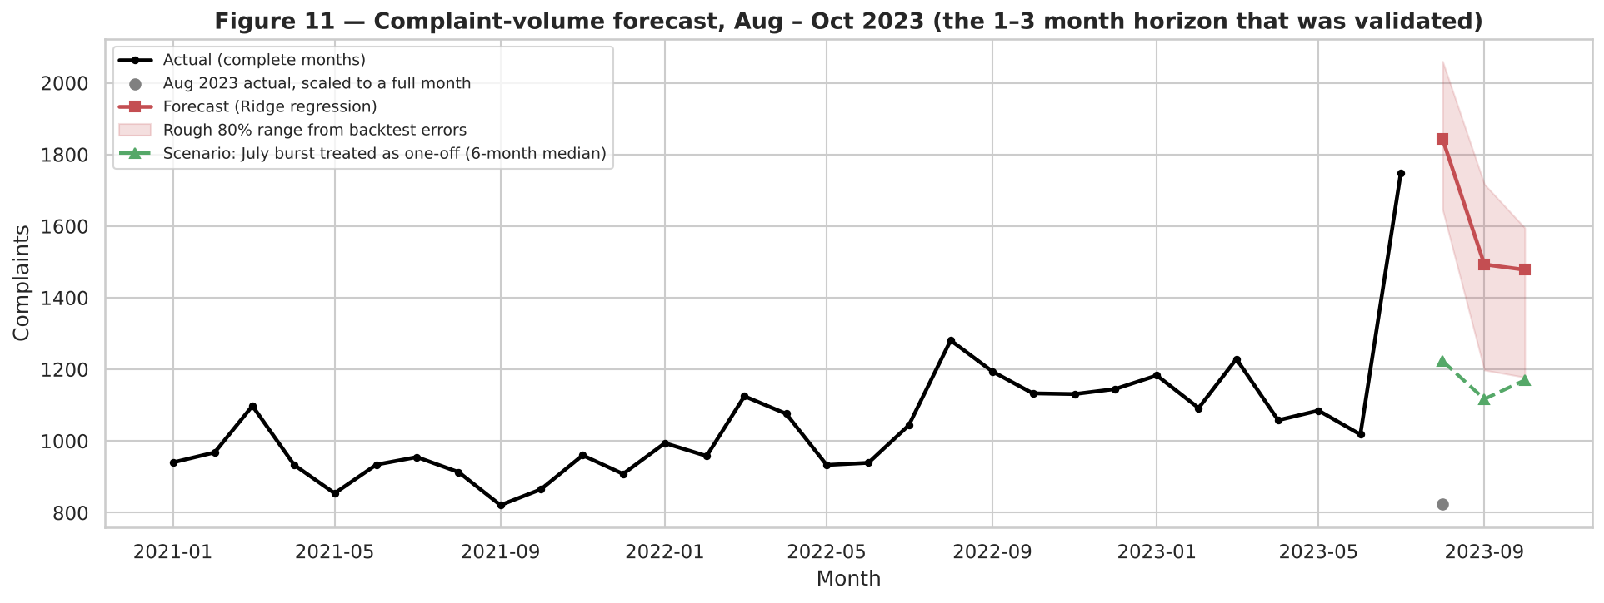
Figure 9 — Forecast for Aug – Oct 2023 with scenario and rough range

10. Limitations and recommendations

Limitations
- Short history (75 months) with a trend, a dip and a burst whose causes are not in the data.
- The validation winner did not generalise to the test months; differences between methods are small and not statistically significant.
- Only complaint counts are used; no external drivers are available or assumed.
- Interval estimates are rough, and forecasts beyond 3 months are unvalidated.
- A complaint is not misconduct, and the forecast does not describe company performance.

Recommendations
- Use forecasts as a planning range and refresh them monthly with the newest complete month.
- Keep the naive baseline in the loop and promote a more complex model only if it keeps beating it.
- Monitor daily counts for bursts (for example, more than twice the usual weekday level) so a one-off is not carried forward automatically.
- Forecast only the larger products (checking/savings, credit/prepaid card, credit reporting).
- Add external event indicators if stakeholders can supply them, and revisit the model as history grows.

Appendix — Reproducibility
File | Purpose
notebook/Complaint_Volume_Forecasting.ipynb | Full analysis with explanations, 11 figures
src/train_and_forecast.py | Re-trains the selected model from the raw workbook and writes forecasts (verified to match the notebook exactly)
models/model_recipe.json, complaint_forecaster.joblib | Model recipe, settings and series; the model is re-fitted at each origin
data/processed/*.csv | Monthly series, product series, backtest forecasts and metrics, future forecast
docs/DATA_QUALITY.md, docs/KPI_definitions.md | Data-quality log and shared KPI definitions

