ADS INTEGRATION DOCUMENTATION :

Everything is done for you :

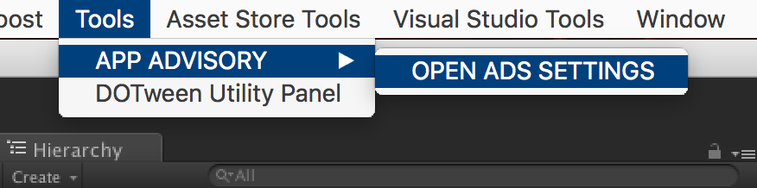

And Select the networks you want (don’t forget to get the SDKs if needed) :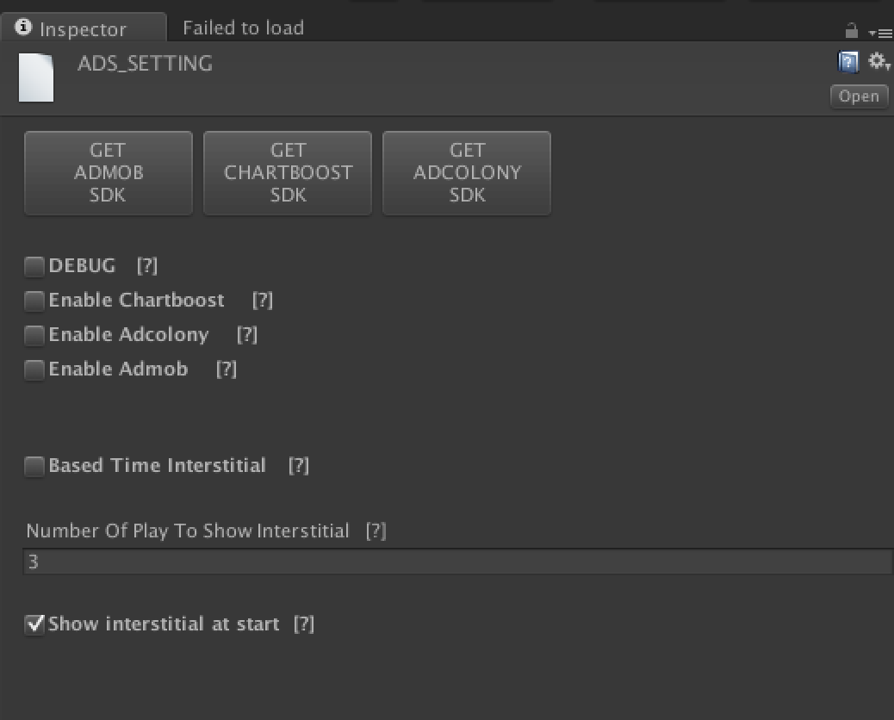

For Unity Ads, please visit my website :

<https://appadvisory.zendesk.com/hc/en-us>

You should have a GameObject named « AdsInit » in the hierarchy view :

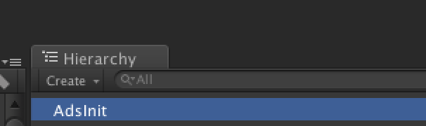

If not, please do a right click on the hierarchy view and :

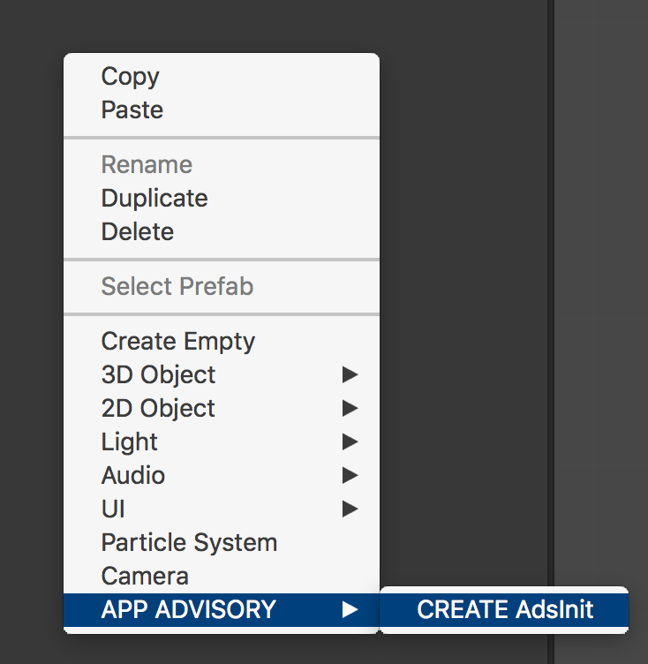

By default we display interstitial every 5 game over. To change it :

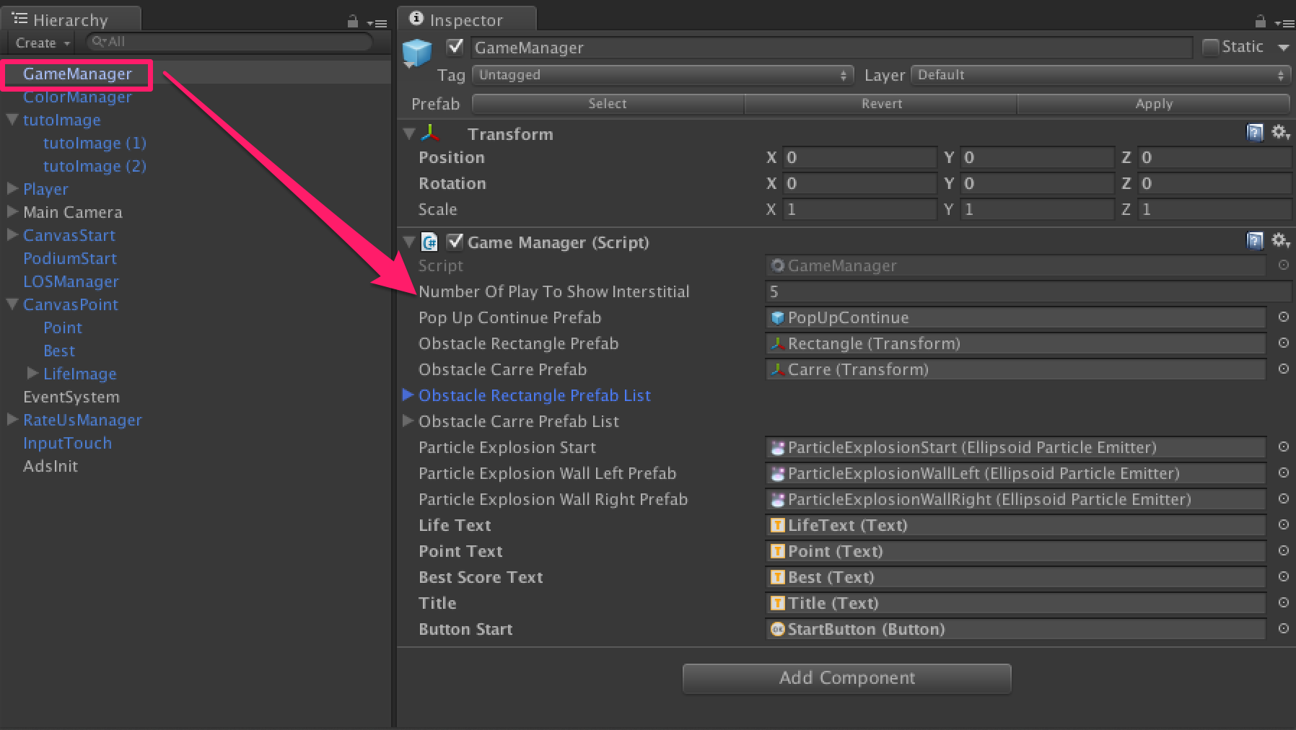

Thanks !

Our other assets : <http://u3d.as/9cs>

Contact : [contact@app-advisory.com](mailto:contact@app-advisory.com)