**Kick Starter Analysis**

**Summary:**

* Theatrical productions appear to utilize Kickstarter funding significantly more than other venture categories.
* Pie charts could be used to better represent percentage visualizations (see the bonus question: “**Outcomes Based on Goals Analysis**”).
* An obvious limitation of the data set is that Goal and Pledged amounts are not being measured against currency exchange rates across the different countries where the Kickstarter campaigns are launched.

**Launch Date Analysis**

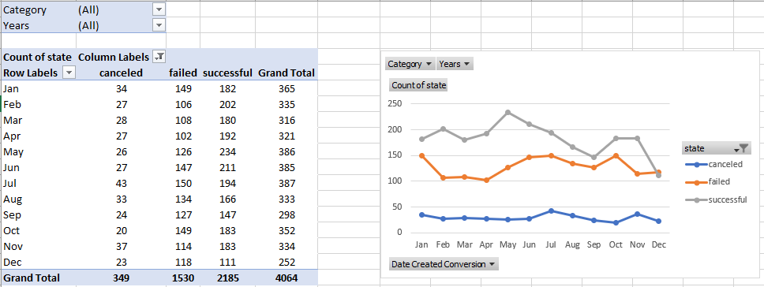

**Category Analysis**

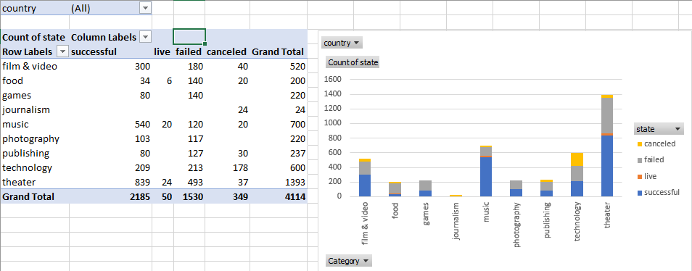

**Sub-Category Analysis**

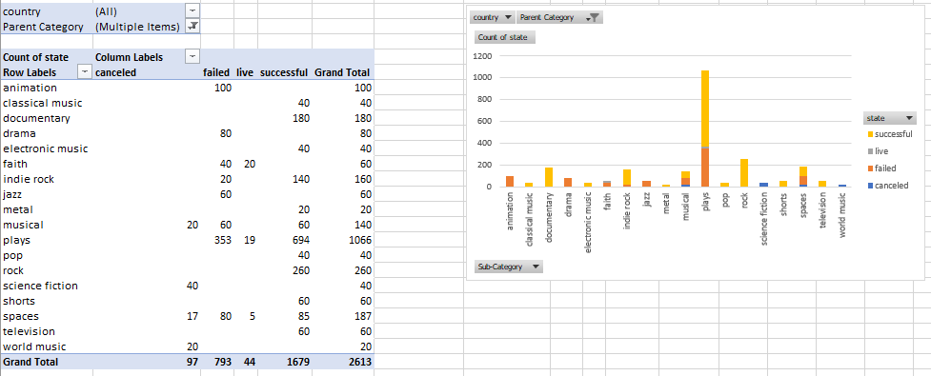

**Outcomes Based on Goals**

