**Project Motivation**

Our team spent quite some time browsing various data set related websites until we came across the following link:



Since it met the quality requierments for the ETL mini-project we did furhter research seeing this website link that looks at the world hunger issues affecting young children. We wanted to learn more about this pressisng subject so we chose this data set for analysis expecting to use the website below for background information.

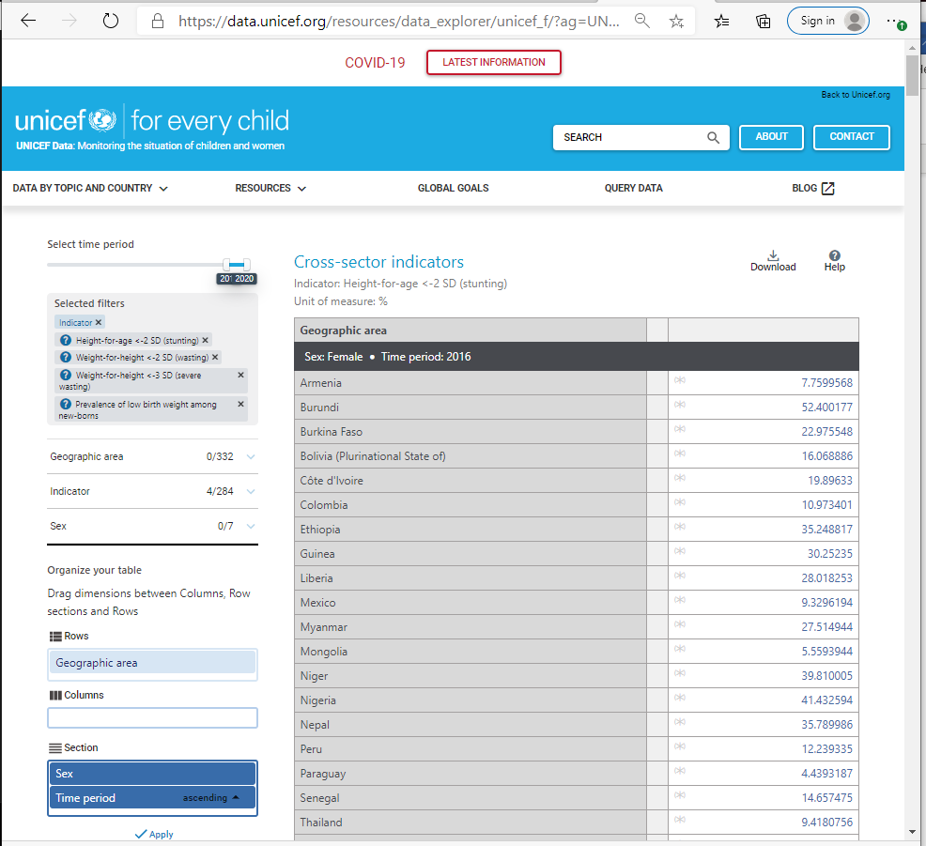

and

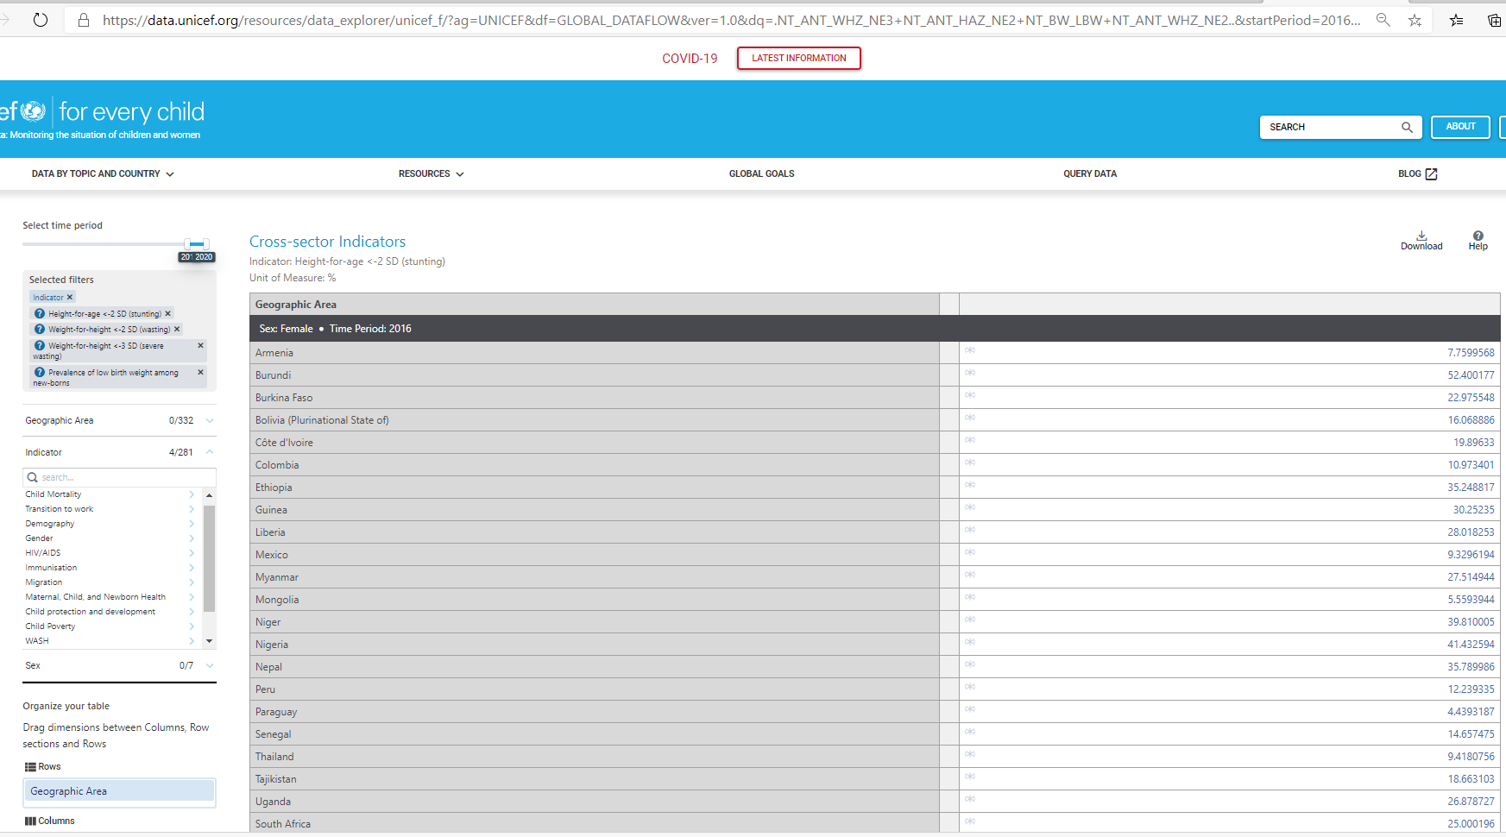

**Data Set Specific Information**

# Malnutrition across the globe. Data of countries from 1983-2019 Nutrition 0 competitions 159 datasets 5 kernels

Nutrition is the science that interprets the interaction of nutrients and other substances in food in relation to maintenance, growth, reproduction, health and disease of an organism. In this tag you'll find the most nutritious datasets and kernels.**983-2019**

[[](https://www.kaggle.com/ruchi798)Ruchi Bhatia](https://www.kaggle.com/ruchi798)

[Data](https://www.kaggle.com/ruchi798/malnutrition-across-the-globe) [Tasks](https://www.kaggle.com/ruchi798/malnutrition-across-the-globe/tasks) [Kernels(2)](https://www.kaggle.com/ruchi798/malnutrition-across-the-globe/kernels) [Discussion(2)](https://www.kaggle.com/ruchi798/malnutrition-across-the-globe/discussion) [Activity](https://www.kaggle.com/ruchi798/malnutrition-across-the-globe/activity) [Metadata](https://www.kaggle.com/ruchi798/malnutrition-across-the-globe/metadata)

New Notebook

Usability

10.0

**License**

[CC0: Public Domain](https://creativecommons.org/publicdomain/zero/1.0/)

**Tags** [reference](https://www.kaggle.com/tags/reference)[health](https://www.kaggle.com/tags/health)[health conditions](https://www.kaggle.com/tags/health-conditions)[public health](https://www.kaggle.com/tags/public-health)[nutrition](https://www.kaggle.com/tags/nutrition)

**Description**

Malnutrition continues to be the reason for making children much more vulnerable to diseases and death. There are 4 broad types of malnutrition: wasting, stunting, underweight and overweight.

1. **Wasting** – Moderate and severe: % of children aged 0–59 months who are below minus two standard deviations from median weight-for-height. **Severe Wasting** - % of children aged 0–59 months who are below minus three standard deviations from median weight-for-height
2. **Stunting** – Moderate and severe: % of children aged 0–59 months who are below minus two standard deviations from median height-for-age
3. **Underweight** – Moderate and severe: % of children aged 0–59 months who are below minus two standard deviations from median weight-for-age
4. **Overweight** – Moderate and severe: % aged 0-59 months who are above two standard deviations from median weight-for-height

**Inspiration**

* Was there a decline or rise in the number of malnutrition cases country-wise?
* Which countries bear the greatest share of all forms of malnutrition?
* % of stunted, overweight and wasted children under 5, by country income classification

Data Visualization on Tableau: <https://public.tableau.com/profile/ruchi.bhatia#!/vizhome/MalnutritionAnalysis/MalnutritionAnalysis>

###### **Data Explorer Summary**

[Download (302 KB)](https://www.kaggle.com/ruchi798/malnutrition-across-the-globe/download)

country-wise-average.csv

malnutrition-estimates.csv

2 files

28 columns

**Further Insight into Malnutrition**

**There are broad sub-forms of undernutrition:**

Undernutrition makes children much more vulnerable to disease and death.

**Low weight-for-height is known as wasting**. It usually indicates recent and severe weight loss, because a person has not had enough food to eat and/or they have had an infectious disease, such as diarrhea, which has caused them to lose weight. A young child who is moderately or severely wasted has an increased risk of death, but treatment is possible.

**Low height-for-age is known as stunting**. It is the result of chronic or recurrent undernutrition, usually associated with poor socioeconomic conditions, poor maternal health and nutrition, frequent illness, and/or inappropriate infant and young child feeding and care in early life. Stunting holds children back from reaching their physical and cognitive potential.

**Children with low weight-for-age are known as underweight.** A child who is underweight may be stunted, wasted, or both.

**Children with high weight-for-age are known as overweight.**