

**International School**

**CAPSTONE PROJECT II**

CMU-SE 451

**ARCHITECTURE DESIGN**

Version 1.1  
Date: March 20th, 2022

JOB MANAGEMENT SYSTEM

**Submitted by**

Nguyen Ho Anh Khoa

Nguyen Van Phu Thien

Phan Van Phat

Mai Tuan

**Approved by**

Tran Kim Sanh

Proposal Review Panel Representative:

Name Signature Date

Capstone Project 1- Mentor:

Name Signature Date

**Da Nang, May 2022**

**PROJECT INFORMATION**

|  |  |  |  |  |
| --- | --- | --- | --- | --- |
| **Project acronym** | JMS | | | |
| **Project title** | Job managementt system | | | |
| **Start date** | March 01th, 2022 | **End Date** | May 5th, 2022 | |
| **Lead institution** | International School, Duy Tan University | | | |
| **Project mentor** | Tran Kim Sanh  Email: sanhtk@gmail.com  Phone: 0987 409 464 | | | |
| **Product owner & Contact Detail** | Nguyen Ho Anh Khoa  [Svencoop50490@gmail.com](mailto:Svencoop50490@gmail.com)  Phone: 0583 861 808 | | | |
| **Partner organization** | Duy Tan University | | | |
| **Scrum Master** | Nguyen V Phu Thien | phuthienst@gmail.com | | 0365 462 172 |
| **24211215214** | Nguyen V Phu Thien | phuthienst@gmail.com | | 0365 462 172 |
| **24211205981** | Phan Van Phat | vanphat899@gmail.com | | 0899 933 440 |
| **24211210664** | Nguyen Ho Anh Khoa | Svencoop50490@gmail.com | | 0583 861 808 |
| **24211214345** | Mai Tuan | Mtuan232605@gmail.com | | 0337 239 887 |

**DOCUMENT APPROVAL**

|  |  |  |  |
| --- | --- | --- | --- |
| **Mentor** | Tran Kim Sanh | **Signature:** |  |
| **Date:** |  |
| **Product Owner** |  | **Signature:** |  |
| **Date:** |  |
| **Scrum Master** | Nguyen Van Phu Thien | **Signature:** |  |
| **Date:** |  |
| **Team Member(s)** | Phan Van Phat | **Signature:** |  |
| **Date:** |  |
| Nguyen Ho Anh Khoa | **Signature:** |  |
| **Date:** |  |
| Mai Tuan | **Signature:** |  |
| **Date:** |  |

**REVISION HISTORY**

|  |  |  |  |
| --- | --- | --- | --- |
| **Version** | **Date** | **Comments** | **Author** |
| 1.0 | 26/03/2022 | Create Architecture Design document | Phan Van Phat |
| 1.1 | 23/04/2021 | Update document | Phan Van Phat |

**CONTENTS**

1. Introduction 6

1.1 Project overview 6

1.2 Purpose 6

1.3 Business driver 6

2. Architecture driver 6

2.1 Business constraints 6

2.2 Technical constraints 7

2.3 Functional requirement 7

3. Quality attributes 7

3.1 Utility table 7

3.2 Quality Attributes 8

4. Architecture overview 10

4.1 System context 11

4.2 Component and connector 11

4.3 Module view 13

4.4 Allocation view 14

5. ATAM 15

5.1 Present the ATAM 15

5.2 Present the business Drivers 15

5.3 Present the Archicture 16

5.4 Identify the Archicture approaches 16

5.5 Analyze the Archictural approaches 17

5.6 Brainstorm and prioritize scenarios 17

6. References 17

1. Introduction
   1. Project overview

The "JOB MANAGEMENT SYSTEM" hopes to help people find jobs quickly. and help administrators manage tasks effectively. Where users can find jobs related to the IT industry. And there is a team of consultants for users. the system can direct to the place where the person needs to find a job.

* 1. Purpose

This specification covers following:

● Brief specification of the project, high level requirement.

● Detail quality attribution.

● System context, sequence diagrams.

● Architecture presented by various view types: Component and Connect, Module view and Allocation view.

* 1. Business driver

Business problems:

+ Need to schedule and map directions.

+ Manage accounts, blogs, and jobs.

Business needs:

+ Create software that can manage accounts, blogs, and job information.

1. Architecture driver
   1. Business constraints

● Sources: 4 people.

● Project was started on: 01/03/2022.

● Project will be ended on: 05/05/2022.

● Project will be finished in 63 days.

● Cost: $ 1320,4

* 1. Technical constraints

*Web constraint:

- Programming Language: JavaScript, PHP

- Framework: Bootstrap5

- Operating System: Windows

- Web Browser: Chrome

- Database: MySQL

*System/ Network / Server:

- Laptop to develop (Window 11 pro).

- Internet connection

- Web Browser: Chrome

- Network Accessing: World Wide Web (WWW), HTTP methods (POST, GET).

- Server: PHPmyadmin, XAMPP

* 1. Functional requirement

References to Product Backlog specification of ProductBacklog document.

1. Quality attributes
   1. Utility table

There are following quality attributes that drive the design of architecture. Each quality attribute scenario is ranked with importance (I) defined by the Product Owner, and the estimated level difficulty (D). Both values are based on a scale of High (H) - Medium (M) - Low (L).

* 1. Quality Attributes

**Sercurity**

|  |  |
| --- | --- |
| Scenario: When admin creates a new account for use. The password will be hashed out and saved in the database | |
| Type | Security password |
| Stimulus | Provide a hash password code |
| Source of stimulus | Admin |
| Environment | In runtime |
| Artifact stimulated | The system |
| Response | Password will be hash before saving |
| Response measure | Response time under 15 second |

*Tabel 1: Hash Password*

**Modifiability**

|  |  |
| --- | --- |
| Scenario: The system can continuously expand more functions without affecting other basic functions when upgrading. | |
| Type | Modifiability |
| Stimulus | expand more functions |
| Source of stimulus | The system |
| Environment | expand more functions without affecting |
| Artifact stimulated | The system expand more functions |
| Response | Using system when upgrading |
| Response measure | Upgrading response |

*Tabel 2: Upgrade system*

**Performance**

|  |  |
| --- | --- |
| Scenario: When a candidate searches for a job, applies to upload a cv, loads a blog, the system will respond in less than 5 seconds. | |
| Type | Performance |
| Stimulus | On the electronic board |
| Source of stimulus | The candidate |
| Environment | Runtime |
| Artifact stimulated | The system |
| Response | The processing speed to put the menu in the cart |
| Response measure | Less than 5s |

*Tabel 3: Response for homepage space*

**Usability**

|  |  |
| --- | --- |
| Scenario: Users will log in to the system before starting work, the system will check which roles the user belongs to and return the corresponding working interface. | |
| Type | Usability |
| Stimulus | On the login form |
| Source of stimulus | Users |
| Environment | The system before starting work |
| Artifact stimulated | The system |
| Response | Return the corresponding working interface |
| Response measure | Return the corresponding |

*Tabel 4: Usability for users*

1. Architecture overview

This section shows the diagrams which bounds our target system and describes the architecture and interaction between components.

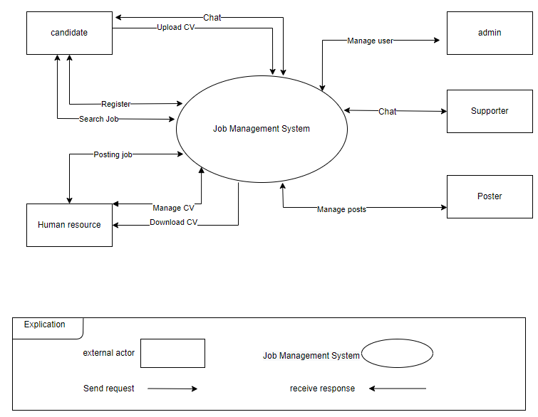

* 1. System context

- Candidate has responsibility to:

* Sign up account if they want.
* Search jobs.
* Upload CV file from their computer to the system.
* Read blogs.
* Change their information.
* Chat with supporter.

- Supporter has responsibility to:

* Chat with candidate.

- HR has responsibility to:

* Can add, delete, edit the jobs.
* Can download cv file when candidate uploaded cv file for the job.

- Poster has responsibility to:

* Can add, delete, edit the post.

- Admin has responsibility to:

* Can add, delete, edit accounts for candidate, HR, supporter, poster.
  1. Component and connector

We main used a C&C view to argue and reason about architectural properties, quality attribute requirements, and functional requirements that the system must add here.

This view type partitions the system into components that have some runtime presence such as processes, objects, data stores, and connectors or that represent pathways of communication such as data flows and access to shared storage.

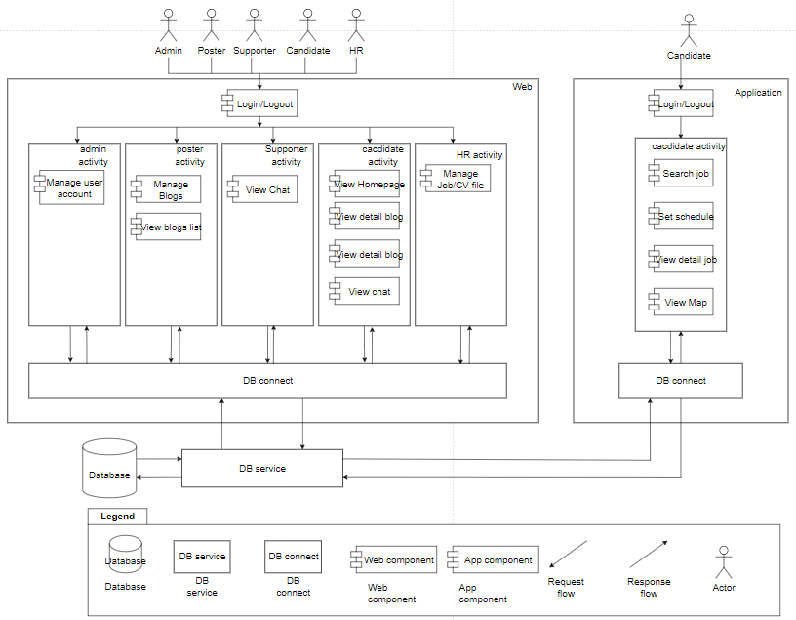

*Figure 1: C&C for web app*

**Prose**

|  |  |
| --- | --- |
| **Element** | **Responsibilities** |
| Application | Web app is a component that manages and implements interactive functions for users that are handled on the UI. Web app interact directly with users and take action on web app |
| DB connect | connect to database to query data. |

* 1. Module view

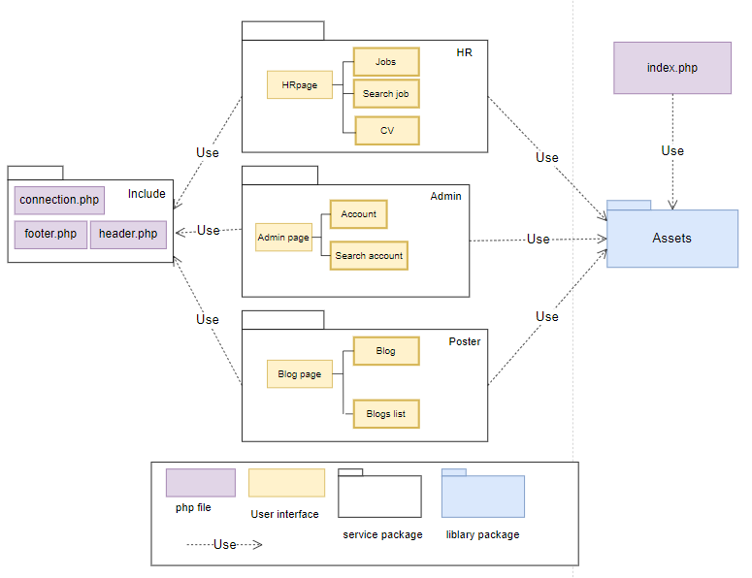

**Prose**

|  |  |
| --- | --- |
| **Element** | **Responsibilities** |
| Index.php | when starting the system will run the first file index.php |
| HR, Admin, Poster. | this is where the user interface, and the corresponding features for each actor. |
| include | Connect to the database, including header and footer. |
| Assets | including img, jquery, css files, bootstrap libraries. |

* 1. Allocation view

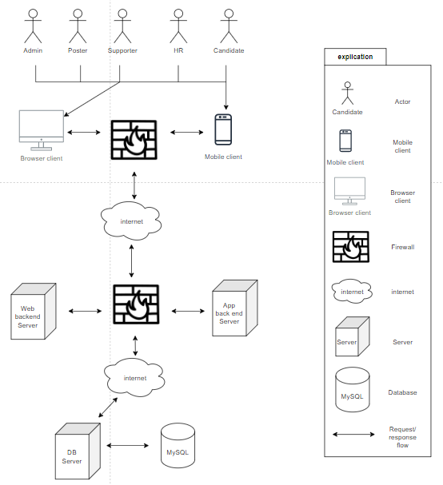

*Allowcation view*

**Prose**

|  |  |
| --- | --- |
| **Element** | **Responsibilities** |
| Browser client/ mobile client | PC/smart phone of user. |
| Firewall | A firewall is a network security device that monitors incoming and outgoing network traffic and permits or blocks data packets based on a set of security |
| Server | A server is a piece of computer hardware or software (computer program) that provides functionality for other programs or devices |

1. ATAM
   1. Present the ATAM

* Overall evaluation of system architecture documents, system designs on 3 views: static view, dynamic view, and physical view based on ATAM 9 Steps method.
* Expect to achieve an accurate and objective evaluation of the architectural document. From there, the project team assesses the ability to complete the project and achieve the Architecture Drivers.
  1. Present the business Drivers

- The content on the document presented about the following:

-Who are the business drivers

-Business problems and goals for the system are presented by the project decision makers

- System’s features

- System’s requirements

- Project constraints

- Project scope

* 1. Present the Archicture
* Current Architecture state: The design is systematically overviewed on all 3 views: allocation view, module view and component and connector view.
* Expected architecture state: The architecture is easy to understand, easy to read, full of content, clear and responsive to the constraints and Quality Attributes of the system.
* Impact of following project constraints in the architecture:

Time / Deadline: Project will finished in 99 days (1584 hours)

Members / Cost: 4 members with cost $5152

Quality Attributes: Sercurity, Performace, Usability, Modifiability

* 1. Identify the Archicture approaches
* Architecture pattern: Service-oriented achitecture (SOA)
* In SOA, services use protocols that describe how they pass and parse messages using description metadata. This metadata describes both the functional characteristics of the service and quality-of-service characteristics. Service-oriented architecture aims to allow users to combine large chunks of functionality to form applications which are built purely from existing services and combining them in an ad hoc manner. A service presents a simple interface to the requester that abstracts away the underlying complexity acting as a black box. Further users can also access these independent services without any knowledge of their internal implementation
* The architectural blueprints are broken down into sections and interact with the services.
  1. Analyze the Archictural approaches

|  |  |
| --- | --- |
|  | Evaluate |
| Tradeoffs | + With a service bus system, the performance level is enhanced and the trade-off in system security decreases  + Ease of use pays off with system performance. Meeting good performance reduces ease of use and vice versa |
| Sensitivity points | + Dependence on the services of external systems  + Depends quite a lot on the network system and the data transmission speed of the services.  + No data backup solution yet |
| Risk and non-risk scenarios | + When security is threatened, hackers attack services, security can be affected.  + Network problem occurred.  + A service is dead. |

* 1. Brainstorm and prioritize scenarios

Rank priority based on the constraint and attributes:

-Sercirity

-Performance

-Usability

-Modifiability

1. References

|  |  |  |
| --- | --- | --- |
| **No.** | **References** | **Document Information** |
| 1 | Design standards,  Document standards | https://www.softwarearchitecturebook.com/svn/main/slides/ppt/26_Standards.ppt |
| https://standards.ieee.org/standard/1471-2000.html |
| https://ieeexplore.ieee.org/document/917550 |
| 2 | Patterns | https://en.wikipedia.org/wiki/Architectural_pattern |
| 3. | Evaluation standards | https://www.iso.org/obp/ui/#iso:std:iso-iec-ieee:42030:ed-1:v1:en |
| https://gabrielfs7.github.io/software-architecture/2019/10/18/atam-analyze-evaluate-architecture/ |