
FPT UNIVERSITY
HO CHI MINH CITY CAMPUS

SMART PARKING MANAGEMENT SYSTEM
Software Requirements Specification

Group Members | Trần Nguyễn Bảo Việt (Leader)  Huỳnh Hữu Thắng  Nguyễn Thanh Nguyên Khôi  Đặng Thành Phát
Supervisor | Tôn Thất Hoàng Minh

July 2026

Link Github
BE: https://github.com/Ziecne205/BE.git
FE: https://github.com/Ziecne205/FE.git
Parking-driver: https://github.com/Ziecne205/parking-driver.git

TABLE OF CONTENTS

I. Software Requirement Specification 1
1. Product Overview 1
2. User Requirements 1
2.1 Actors 1
2.2 Use Cases 1
2.2.1 Diagram(s) 1
2.2.2 Descriptions 1
3. Functional Requirements 1
3.1 System Functional Overview 1
3.1.1 Screen Flows 1
3.1.2 Main Business Process Flows 1
3.1.3 Screen Descriptions 1
3.1.4 Screen Authorization 1
3.1.5 Non-Screen Functions (Background Jobs) 1
3.1.6 Entity Relationship Diagram 1
3.2 Functional Requirements — Detail by Module 1
3.2.1 Authentication 1
3.2.2 Driver — View Parking Information 1
- API Endpoint: GET /api/driver/parking-info | Auth: PUBLIC
3.2.3 Driver — Advance Booking 1
- API Endpoint: POST /api/driver/reservations/{id}/extend | Auth: DRIVER | Input: { newExpectedExitTime: ISO-8601 } | Output: ReservationDTO with updated expectedExitTime
- Business Logic: Validate quota for extended time window. If OK, update expectedExitTime. Additional fee is charged automatically at checkout — no immediate payment required upon extension.
- Precondition: Reservation.status = CheckedIn AND an open ParkingSession exists (Admitted or Parked)
- Actors: Driver
3.2.3.5 Extend Reservation (UC-37)
3.2.4 Staff — Parking Session Management 1
3.2.5 Manager — Parking Lot Management 1
3.2.6 Admin — System Administration 1
3.3 Incident Management 1
3.3.1 Create Incident (Staff) 1
- API Endpoint: POST /api/staff/incidents | Auth: STAFF/MANAGER/ADMIN | Input: { sessionId?, issueType, description, proofImageUrl? }
3.3.2 Acknowledge Incident (Manager) 1
- API Endpoint (already listed): PATCH /api/manager/incidents/{id}/take-over | Auth: MANAGER/ADMIN
3.3.3 Resolve Incident 1
- API Endpoint: PATCH /api/staff/incidents/{id}/resolve OR PATCH /api/manager/incidents/{id}/resolve | Auth: STAFF/MANAGER/ADMIN | Input: ?resolutionNotes=
3.4 Feedback 1
3.4.1 Submit Feedback 1
- API Endpoint: POST /api/driver/feedbacks | Auth: DRIVER | Input: { sessionId, rating (1-5), comment? }
4. Non-Functional Requirements 1
4.1 External Interfaces 1
4.2 Quality Attributes 1
5. Requirement Appendix 1
5.1 Business Rules 1
5.2 Common Requirements 1
5.3 API Message List (Error Codes) 1

I. Software Requirement Specification

1. Product Overview
Smart Parking Management System is an intelligent parking management platform built for a building / mixed-use complex. The system enables real-time tracking of parking sessions, advance booking management with deposits, automatic fee calculation based on flexible pricing policies, automatic incident detection via gate cameras, and revenue reporting — all through a web interface.
The system consists of two front-end web apps (Admin/Manager/Staff and Driver) and one REST API backend:
- Web Admin (Next.js 16): Two separate front-ends — one for Manager/Staff/Admin and one for Driver — to use and manage the parking lot
- REST API (Spring Boot 3 / Java 21, MongoDB Atlas): Backend handling all business logic, integrated with PayOS for online payments and SendGrid for OTP email

Context Diagram
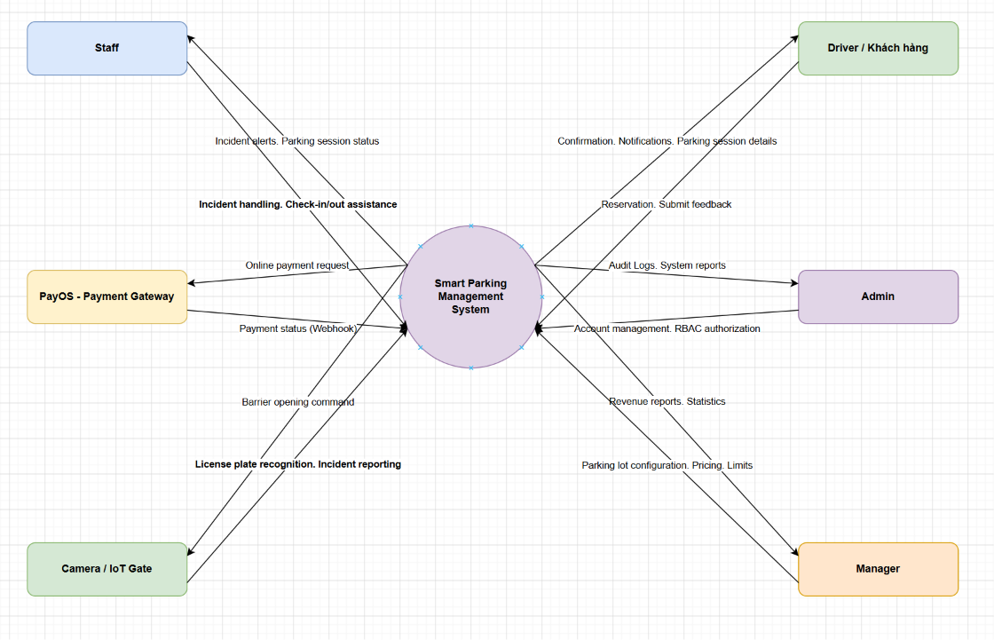

2. User Requirements

2.1 Actors
# | Actor | Description
1 | Administrator (Admin) | System administration: manage user accounts, permissions, view audit logs, system configuration
2 | Manager | Parking operation management: manage floors, slots, vehicle types, pricing policies, booking quotas, view revenue reports, handle incidents
3 | Staff (Staff) | Gate operation: perform check-in/check-out, handle incidents, simulate camera
4 | Driver (Customer) | Parking lot users: view parking lot info, advance booking, pay deposit, view parking history, send feedback

2.2 Use Cases

2.2.1 Diagram(s)
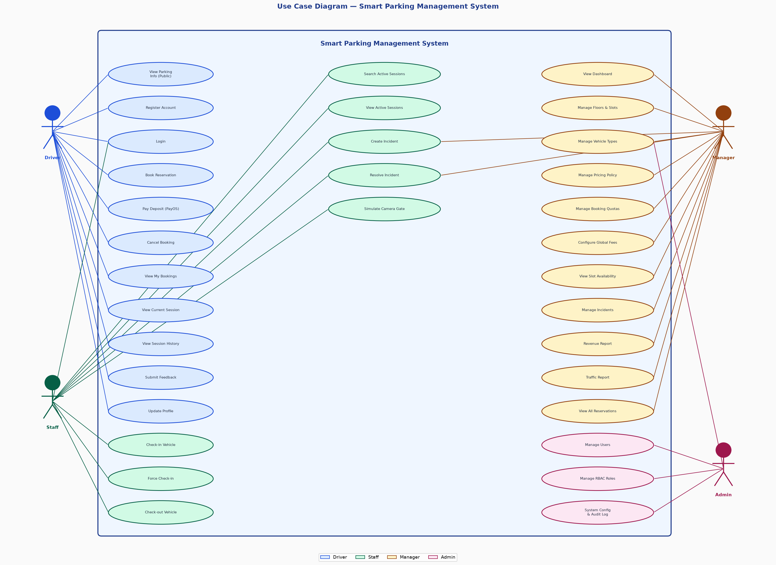
Use Case Diagram — Overview

2.2.2 Descriptions
ID | Use Case | Actors | Description
1 | Login | Admin, Manager, Staff, Driver | Allows users to access the system using username and password. System issues JWT token upon successful authentication.
2 | Register account | Driver | Allows customers to create a new account with Driver role. Information includes username, password, full name, phone number, email.
3 | View parking lot information | Driver (Public) | View public information: operating hours, pricing by vehicle type, current available slots. No login required.
4 | Profile management | Driver | View and update personal information (full name, phone number, email).
5 | Advance booking | Driver | Create advance booking with license plate, vehicle type, expected entry/exit time. System calculates the deposit (a configurable % of the estimated fee, default 50%) and returns Pending status.
6 | Pay booking deposit | Driver | Pay deposit via PayOS to confirm booking (Pending → Confirmed).
7 | Cancel booking | Driver | Cancel booking in Pending or Confirmed status. Can only be canceled when more than 3 hours before expected entry time.
8 | View my bookings | Driver | View list of all bookings of the logged-in account along with current status.
9 | View current parking session | Driver | View active parking sessions (Admitted/Parked/Moved) along with real-time estimated fees.
10 | View parking history | Driver | View completed or incident parking sessions.
11 | Parking session payment | Driver | Pay parking fee when exiting the parking lot via mock payment gate or PayOS.
12 | Send feedback | Driver | Rate parking experience after completing the session (rating 1-5, with comments).
13 | Check-in xe | Staff | Receive vehicle into lot: scan license plate, select vehicle type, select entry gate. System auto-matches with booking if available.
14 | Force Check-in | Staff | Manual confirm when license plate does not match booking. System records audit log.
15 | Check-out xe | Staff | Receive vehicle out of lot: scan license plate, select exit gate, select payment method. System calculates final fee.
16 | Search parking session | Staff | Find open parking session by license plate.
17 | Incident management | Staff | Create, view and resolve incident reports at the parking lot.
18 | Gate Camera Simulator | Staff | Simulate camera automatically reading license plates at entry/exit gates to test the system.
19 | View dashboard | Manager | View real-time overview: number of empty/occupied/maintenance slots, open sessions, unresolved incidents, occupancy rate.
20 | View status by floor | Manager | View details of empty/occupied/maintenance slots for each floor.
21 | Floor management | Manager | Create, edit, delete floor information in the parking lot.
22 | Parking slot management | Manager | Create, edit, delete parking slots. Switch slot to maintenance status (trigger Capacity-Crash Cascade if needed).
23 | Vehicle type management | Manager | Add/edit/delete vehicle types (car, motorbike, truck,...).
24 | Pricing policy management | Manager | Create/update pricing policy for each vehicle type: base price, overtime hourly rate, night surcharge, lost card fee.
25 | Booking quota management | Manager | Set advance booking quota by time slot for each vehicle type (% of total capacity).
26 | Global fee configuration | Manager | Adjust business parameters: % deposit, overstay fee/hour, no-show grace time.
27 | View available capacity | Manager | View headroom (slots remaining for walk-in customers) by vehicle type and by area.
28 | Incident management (Manager) | Manager | View, filter, receive and resolve incidents.
29 | View revenue report | Manager | View revenue report by time range, by vehicle type.
30 | View traffic report | Manager | View number of vehicle entries/exits by day/week/month.
31 | Manage all bookings | Manager | View list of all bookings in the system.
32 | User management | Admin | View list, lock/unlock accounts, reset passwords.
33 | RBAC permission management | Admin | View role list, assign/revoke permission for each role.
34 | System configuration management | Admin | Create and view key-value configurations in SystemConfigs.
35 | View Audit Log | Admin | View user action history with filters by action, entity, user, time range.
36 | View Admin Dashboard | Admin | View overall system overview: total users, total sessions, total revenue, incidents.
37 | Extend Reservation | Driver | Extend the expected exit time of an active booking while the vehicle is inside the lot. Requires CheckedIn status and an open session (Admitted/Parked). System validates quota for the extended time window. No immediate payment — fee calculated at checkout.

3. Functional Requirements

3.1 System Functional Overview

3.1.1 Screen Flows

3.1.1.1 Driver Flow (Web App)
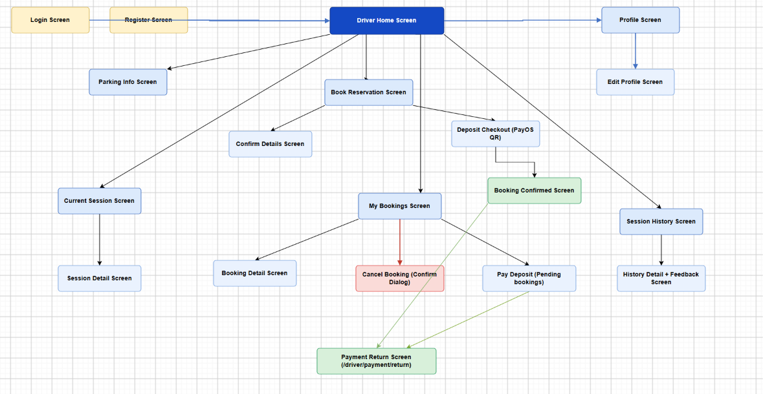

[Home / Parking Info]
→ [Login / Register]
→ [Driver Dashboard]
→ [Advance Booking (BookFlow)]
→ [Select vehicle type, date & time]
→ [Confirm information]
→ [Pay deposit via PayOS]
→ [Booking confirmed successfully]
→ [My Bookings]
→ [Booking details]
→ [Cancel booking]
→ [Pay pending deposit]
→ [Current parking session]
→ [Parking history]
→ [Personal profile]
3.1.1.2 Staff Flow (Web App)
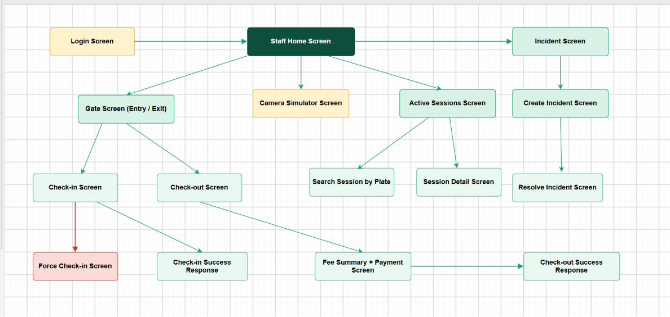

[Staff Login]
→ [Gate Screen]
→ [Vehicle Check-in]
→ [Scan License Plate + Vehicle Type]
→ [Auto-match Booking / Walk-in]
→ [Force Check-in (if plate mismatch)]
→ [Vehicle Check-out]
→ [Search session by plate]
→ [Calculate fee & confirm payment]
→ [Open Sessions]
→ [Incident Report]
→ [Camera Simulator]
3.1.1.3 Manager Flow (Web App)
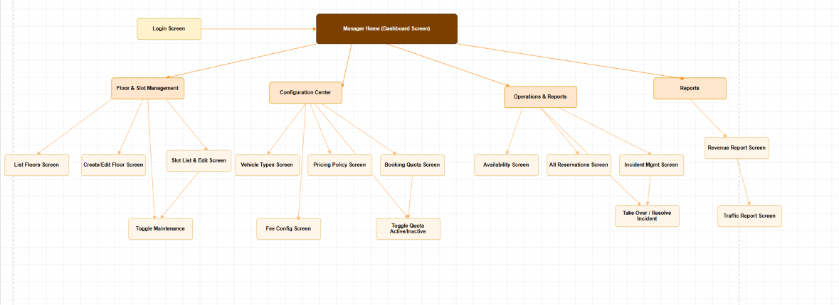

[Manager Login]
→ [Overview Dashboard]
→ [Floor & Slot Management]
→ [Floor List]
→ [Slots by Floor]
→ [Update maintenance status]
→ [Configuration]
→ [Vehicle Types]
→ [Pricing Policy]
→ [Booking Quota]
→ [Global Fees (FeeConfig)]
→ [Available Capacity]
→ [Bookings (system-wide)]
→ [Incidents]
→ [Revenue / Traffic Reports]
3.1.1.4 Admin Flow (Web App)
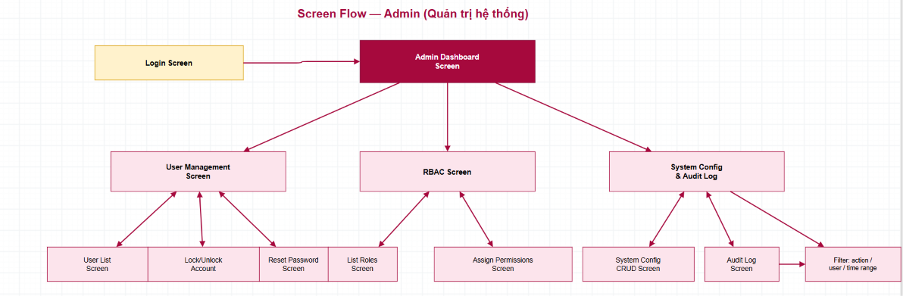

[Admin Login]
→ [Admin Dashboard]
→ [User Management]
→ [User List]
→ [Lock/Unlock]
→ [Reset Password]
→ [RBAC Permissions]
→ [Role List]
→ [Assign/revoke permissions]
→ [System Configuration (SystemConfigs)]
→ [Audit Logs]

3.1.2 Main Business Process Flows
Hình 1
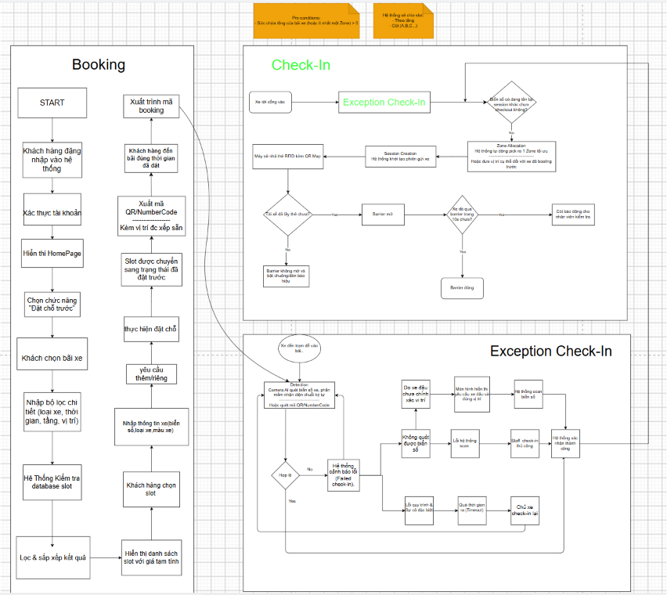
Hình 2
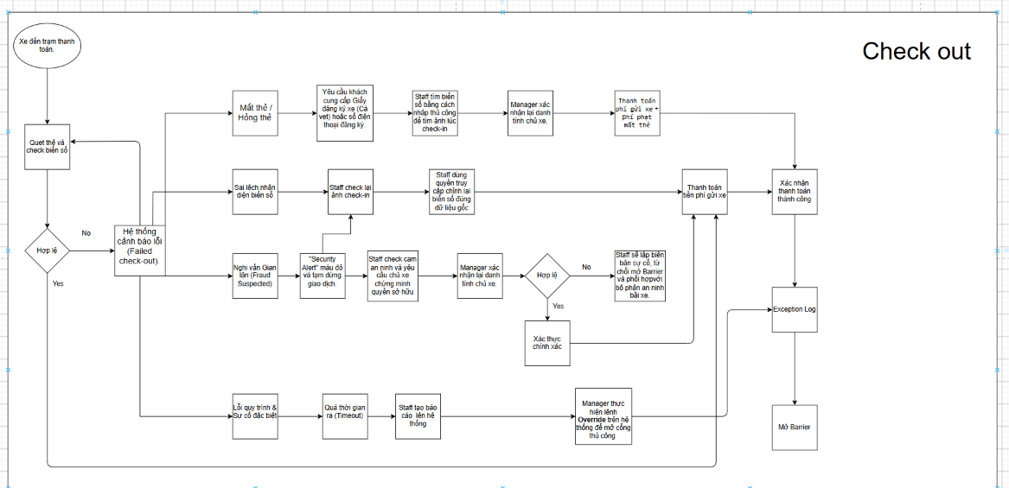
Hình 3 Flow 1:
Users / Driver booking

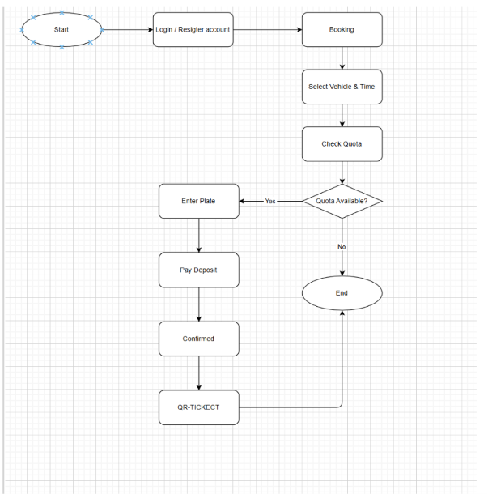
Hình 4 Flow 2:
Vehicle Check-in

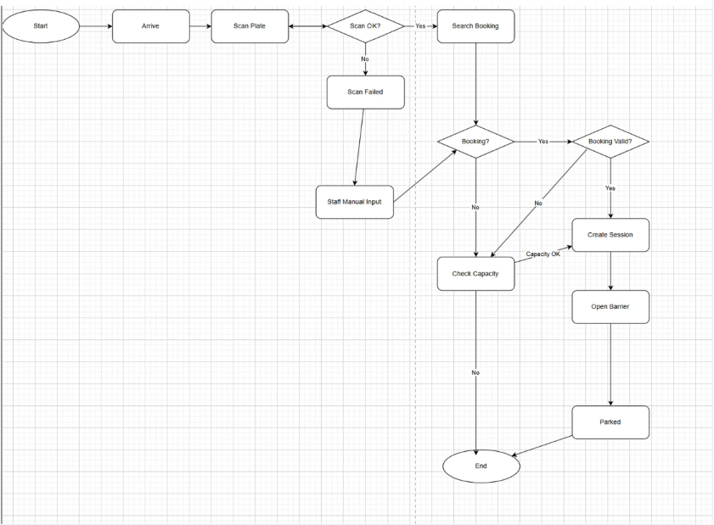
Hình 5 Flow 3: Vehicle Check-out & Payment
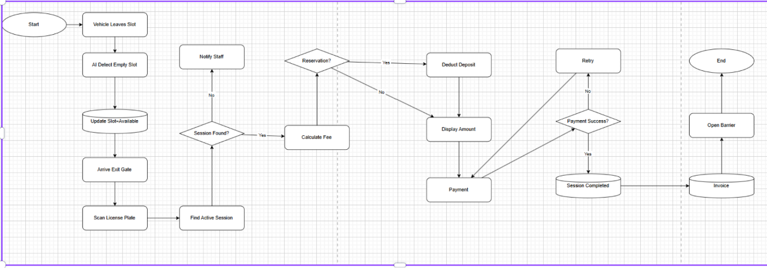
Hình 6 Flow 4: Parking Operations Management.
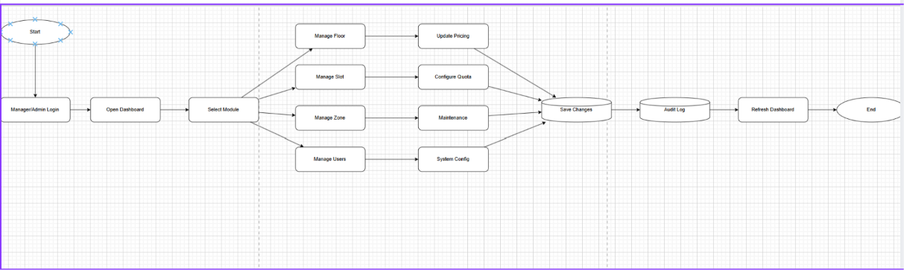
Hình 7 Flow 5: Incident Management
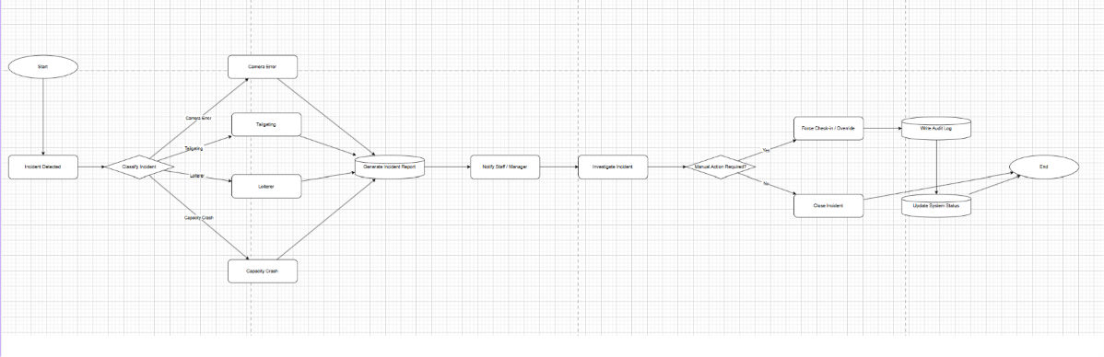

3.1.3 Screen Descriptions
3.1.3.1 Web App — Driver
# | Feature | Screen | Description
1 | View parking lot information | Home (Public) | Display operating hours, pricing by vehicle type, current available slots. No login required.
2 | Login | Login Screen | Driver enters username/password. System returns JWT token.
3 | Register | Register Screen | Driver fills in full account information (username, password, full name).
4 | Dashboard Driver | Home Screen | Display summary: open session, upcoming bookings.
5 | Advance booking | Book Screen | Form to select vehicle type, license plate, entry/exit date time. Displays estimated deposit fee.
6 | Deposit payment | Deposit Checkout Screen | Display PayOS QR or payment link. Poll status every 1.5 seconds.
7 | Booking list | My Bookings Screen | View all bookings, filter by status. Actions: cancel, pay deposit.
8 | Current parking session | Current Sessions Screen | Display parked vehicles, time, real-time estimated fee.
9 | Parking history | Session History Screen | List of completed sessions with actual fees.
10 | Profile | Profile Screen | View and update personal information.

3.1.3.2 Web App — Staff
# | Feature | Screen | Description
1 | Check-in xe | Check-in Screen | Staff enters license plate, vehicle type, selects entry gate. System automatically matches booking if found. Returns new session information.
2 | Force Check-in | Force Check-in Screen | For cases where the camera's license plate reading does not match the booking. Staff confirms the actual license plate and reason.
3 | Check-out xe | Check-out Screen | Staff enters license plate or finds session, selects exit gate and payment method. Displays final fee (including overstay surcharge if any).
4 | Open session list | Active Sessions Screen | View all vehicles currently in the lot with entry time and estimated fee.
5 | Search session by plate | Search Session Screen | Staff quickly finds open session by license plate.
6 | Incident management | Incident Screen | Create, view and resolve incidents. Filter by incident type and status.
7 | Camera Simulator | Simulator Screen | Simulate entry/exit gate camera automatically checking in/out using mock license plates.

3.1.3.3 Web App — Manager
# | Feature | Screen | Description
1 | Overview Dashboard | Dashboard Screen | Statistic cards: total slots, empty slots, occupied slots, maintenance slots, open sessions, unresolved incidents, occupancy rate.
2 | Status by floor | Floor Status Screen | Floor List with slot statistics for each floor.
3 | Floor management | Floor Management Screen | CRUD floor information: floor name, dedicated vehicle type, total capacity.
4 | Parking slot management | Slot Management Screen | CRUD parking slot. Update maintenance status (trigger cascade if capacity decreases).
5 | Vehicle type management | Vehicle Type Screen | CRUD vehicle types and dimension parameters.
6 | Pricing policy management | Pricing Policy Screen | CRUD pricing policy: base price, base hours, extra hour price, night surcharge, lost card fee, effective date.
7 | Booking Quota | Booking Quota Screen | CRUD quota time slots. Toggle enable/disable each quota.
8 | Global fee configuration | Fee Config Screen | Adjust: % deposit, overstay fee/hour, no-show grace period (minutes).
9 | Available Capacity | Availability Screen | Headroom by vehicle type and area.
10 | All bookings | All Reservations Screen | List of all bookings in the system, along with deposit status.
11 | Incident management | Incident Management Screen | View/filter incidents, receive, resolve with notes.
12 | Report doanh thu | Revenue Report Screen | Chart and table of revenue by date range, filtered by vehicle type.
13 | Traffic report | Traffic Report Screen | Number of vehicle entries/exits, average parking time by day.

3.1.3.4 Web App — Admin
# | Feature | Screen | Description
1 | Admin Dashboard | Admin Dashboard Screen | Overall statistics: total users, total sessions, total revenue, incidents.
2 | User list | User Management Screen | View all accounts, filter by role, status.
3 | Change user status | User Detail Screen | Lock (Inactive/Banned) or unlock (Active) accounts.
4 | Reset password | User Detail Screen | Admin resets password for user.
5 | Management RBAC | RBAC Screen | View role list, view and assign/revoke permission for each role.
6 | System configuration | System Config Screen | CRUD key-value configuration (DAY_START_HOUR, DAY_END_HOUR,...).
7 | Audit Log | Audit Log Screen | View action history with filters: action, entity, userId, time range.

3.1.4 Screen Authorization
Screen / Function | Admin | Manager | Staff | Driver
View parking lot information (Public) | ✓ | ✓ | ✓ | ✓
Auth
Login | ✓ | ✓ | ✓ | ✓
Register |  |  |  | ✓
Driver
Advance booking |  |  |  | ✓
View my bookings |  |  |  | ✓
Cancel booking |  |  |  | ✓
Deposit payment (PayOS) |  |  |  | ✓
View current parking session |  |  |  | ✓
View parking history |  |  |  | ✓
Send feedback |  |  |  | ✓
Staff
Check-in xe | ✓ | ✓ | ✓
Force Check-in | ✓ | ✓ | ✓
Check-out xe | ✓ | ✓ | ✓
Search session by plate | ✓ | ✓ | ✓
Open session list | ✓ | ✓ | ✓
Create incident | ✓ | ✓ | ✓
Resolve incident (Staff) | ✓ | ✓ | ✓
Camera Simulator | ✓ | ✓ | ✓
Manager
Overview Dashboard | ✓ | ✓
Floor management (CRUD) | ✓ | ✓
Parking slot management (CRUD) | ✓ | ✓
Toggle parking slot maintenance | ✓ | ✓
Vehicle type management | ✓ | ✓
Pricing policy management | ✓ | ✓
Booking quota management | ✓ | ✓
Global fee configuration | ✓ | ✓
View available capacity | ✓ | ✓
View all bookings | ✓ | ✓
Incident management (Manager) | ✓ | ✓
Report doanh thu | ✓ | ✓
Traffic report | ✓ | ✓
Admin
User management | ✓
Lock/Unlock account | ✓
Reset password | ✓
Management RBAC | ✓
System configuration | ✓
Audit Log | ✓
Admin Dashboard | ✓

3.1.5 Non-Screen Functions (Background Jobs)
# | Feature | System function | Description
1 | Detect vehicle standing at the gate for a long time | Loiterer Detection | Job runs every 5 mins: session in `Admitted` status over 15 mins without entering a slot → auto create `IncidentReport` type `Loiterer`. Avoid duplicates by checking existing incidents before creating.
2 | Automatically close session of vehicle left slot for too long | Stale Moved Session | Job runs every 5 mins: session `Moved` (left slot) over 30 mins without checking out → auto close session (`status = Completed`), create `IncidentReport` type `Overstay` for manual reconciliation.
3 | Cancel no-show booking | No-Show Cancellation | Job runs every 15 mins: booking `Pending`/`Confirmed` past `expectedEntryTime` + grace period (configurable) without checking in → cancel (`status = Expired`) and lose deposit (`depositStatus = Forfeited`).

3.1.6 Entity Relationship Diagram
3.1.6.1 Entities Description
# | Entity | Description
1 | Users | Save information of all system users. PK: UserId. FK: RoleId
2 | Roles | Save roles: Admin, Manager, Staff, Driver. PK: RoleId
3 | Permissions | Save list of permissions in the system. PK: PermissionId
4 | RolePermissions | In MongoDB there is no join collection: a Role document embeds its permissions as a list of DBRef to Permission.
5 | VehicleTypes | Save vehicle types: car, motorbike, truck,... PK: VehicleTypeId
6 | Floors | Save floor information in the parking lot. PK: FloorId. FK: VehicleTypeId (dedicated vehicle type)
7 | Gates | Save entry/exit gate information. PK: GateId. Has type: Entry, Exit
8 | ParkingSlots | Save each parking slot. PK: SlotId. FK: FloorId, VehicleTypeId. Status: Available, Occupied, Maintenance
9 | ParkingCards | Save physical parking card (if using card system). PK: CardId
10 | Reservations | Save Driver's advance booking. PK: ReservationId. FK: UserId, VehicleTypeId. Status: Pending, Confirmed, CheckedIn, Fulfilled, Cancelled, Expired. DepositStatus: Pending, Paid, Forfeited, Refunded
11 | ParkingSessions | Save actual parking session from entry to exit. PK: SessionId. FK: ReservationId, CardId, DriverUserId, VehicleTypeId, EntryGateId, ExitGateId, SuggestedSlotId, ActualSlotId. Status: Admitted, Parked, Moved, Completed, Exception. Flags: IsForceCheckIn, IsOverstay
12 | PricingPolicies | Save pricing policy for each vehicle type. PK: PolicyId. FK: VehicleTypeId. Fields: BasePrice, BaseHours, ExtraHourPrice, NightSurcharge, LostTicketFee, EffectiveDate. Status: Active, Expired
13 | Payments | Save payment transaction of the session/booking. PK: PaymentId. FK: SessionId, ReservationId. Status: Pending, Success, Failed
14 | BookingQuotas | Save booking quota by time slot. PK: QuotaId. FK: VehicleTypeId. Fields: StartTime, EndTime, QuotaPercent, IsActive
15 | IncidentReports | Save incident at the parking lot. PK: IncidentId. FK: SessionId, ReportedByUserId, HandledByStaffId. IssueType: Loiterer, Overstay, DamagedVehicle, MissingPlate, Other. Status: Open, InProgress, Resolved
16 | Feedbacks | Save Driver's feedback after parking. PK: FeedbackId. FK: SessionId, UserId. Fields: Rating (1-5), Comment
17 | AuditLogs | Save important action history. PK: LogId. FK: UserId. Action: STAFF_CHECK_IN, STAFF_CHECK_OUT, STAFF_FORCE_CHECK_IN, etc.
18 | SystemConfigs | Save system-wide key-value configuration. PK: ConfigKey. Example: DAY_START_HOUR, DAY_END_HOUR
19 | PasswordResetTokens | Save password reset token. PK: TokenId. FK: UserId
3.1.6.2 Logical Entity Relational Diagram
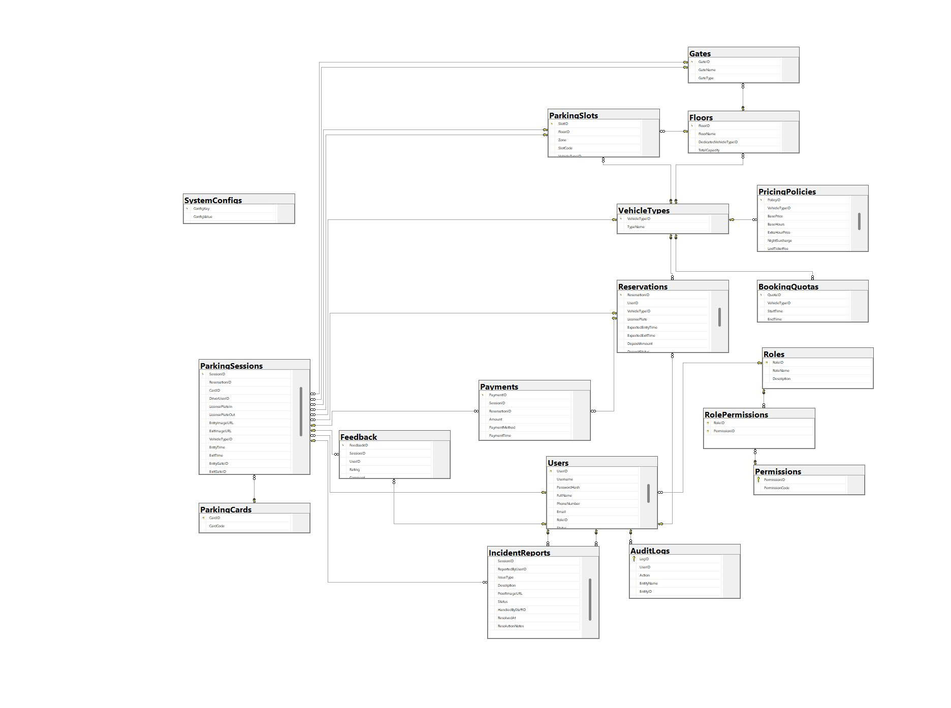

# | Entity | Description
1 | Roles | Save roles in the system (Admin, Manager, Staff, Driver).  - Primary Key: RoleID  - Foreign Key: (none)
2 | VehicleTypes | Save supported vehicle types (Motorbike, 4-seat Car, 7-seat Car).  - Primary Key: VehicleTypeID  - Foreign Key: (none)
3 | Floors | Save information of floors/areas in the parking lot.  - Primary Key: FloorID  - Foreign Key: DedicatedVehicleTypeID → VehicleTypes(VehicleTypeID)
4 | Users | Save system user account information.  - Primary Key: UserID  - Foreign Key: RoleID → Roles(RoleID)
5 | ParkingSlots | Save information of each physical parking slot in the lot.  - Primary Key: SlotID  - Foreign Key: FloorID → Floors(FloorID)  - Foreign Key: VehicleTypeID → VehicleTypes(VehicleTypeID)
6 | Gates | Save information of entry/exit gates of the parking lot.  - Primary Key: GateID  - Foreign Key: FloorID → Floors(FloorID)
7 | ParkingCards | Save information of RFID cards issued to parking customers.  - Primary Key: CardID  - Foreign Key: (none)
8 | PricingPolicies | Save pricing policy for each vehicle type (base price, hourly rate, night surcharge, lost ticket fee).  - Primary Key: PolicyID  - Foreign Key: VehicleTypeID → VehicleTypes(VehicleTypeID)
9 | BookingQuotas | Save maximum booking quota by time slot and vehicle type (calculated by % of capacity).  - Primary Key: QuotaID  - Foreign Key: VehicleTypeID → VehicleTypes(VehicleTypeID)
10 | Reservations | Save customer's advance booking information (including deposit and status).  - Primary Key: ReservationID  - Foreign Key: UserID → Users(UserID)  - Foreign Key: VehicleTypeID → VehicleTypes(VehicleTypeID)
11 | ParkingSessions | Save parking session information from entry to exit, linked to the actual slot confirmed by the camera.  - Primary Key: SessionID  - Foreign Key: ReservationID → Reservations(ReservationID)  - Foreign Key: CardID → ParkingCards(CardID)  - Foreign Key: DriverUserID → Users(UserID)  - Foreign Key: VehicleTypeID → VehicleTypes(VehicleTypeID)  - Foreign Key: EntryGateID → Gates(GateID)  - Foreign Key: ExitGateID → Gates(GateID)  - Foreign Key: SuggestedSlotID → ParkingSlots(SlotID)  - Foreign Key: ActualSlotID → ParkingSlots(SlotID)
12 | Payments | Save payment information (parking fee, booking deposit).  - Primary Key: PaymentID  - Foreign Key: SessionID → ParkingSessions(SessionID)  - Foreign Key: ReservationID → Reservations(ReservationID)
13 | IncidentReports | Save incidents arising during parking lot operation (lost ticket, license plate mismatch, overstay...).  - Primary Key: IncidentID  - Foreign Key: SessionID → ParkingSessions(SessionID)  - Foreign Key: ReportedByUserID → Users(UserID)  - Foreign Key: HandledByStaffID → Users(UserID)
14 | Feedback | Save star rating and customer feedback after each parking session.  - Primary Key: FeedbackID  - Foreign Key: SessionID → ParkingSessions(SessionID)  - Foreign Key: UserID → Users(UserID)
15 | Permissions | Save detailed list of permissions in the system (RBAC).  - Primary Key: PermissionID  - Foreign Key: (none)
16 | RolePermissions | Represents the many-to-many relationship between Role and Permission. In MongoDB it is stored as an embedded list of DBRef inside each Role document (no separate join collection or composite key).  - Storage: embedded DBRef list inside the Role document (MongoDB has no separate join collection / composite key)  - Foreign Key: RoleID → Roles(RoleID)  - Foreign Key: PermissionID → Permissions(PermissionID)
17 | AuditLogs | Save log of all important actions in the system (audit trail).  - Primary Key: LogID  - Foreign Key: UserID → Users(UserID)
18 | SystemConfigs | Save global configuration parameters of the system (timezone, currency, grace period, etc.).  - Primary Key: ConfigKey  - Foreign Key: (none)

3.2 Functional Requirements — Detail by Module

3.2.1 Authentication
3.2.1.1 Login
- API Endpoint: POST /api/auth/login | Auth: PUBLIC | Response: { token, username, roleName }
- Trigger: User clicks the "Login" button
- Actors: Admin, Manager, Staff, Driver
- Description: The system receives username + password, authenticates via BCrypt, and issues a JWT token containing the user's role. The token is used for all subsequent API requests.
- Input: { username, password }
- Output: { token, username, roleName }
- Error: Invalid credentials → HTTP 401 Unauthorized
3.2.1.2 Account Registration
- API Endpoint: POST /api/auth/register | Auth: PUBLIC | Response: { token, username, roleName }
- Trigger: Guest clicks "Register"
- Actors: Guest (unauthenticated)
- Description: Creates a new account with the default role of Driver. The password is hashed using BCrypt before being stored.
- Input: { username, password, fullName, phoneNumber?, email?, roleName? }
- Output: { token, username, roleName }
- Validation: Username must be unique; password must meet minimum length requirements

3.2.2 Driver — View Parking Information
- Trigger: When accessing the home page (no authentication required)
- Actors: All users (Public API)
- Description: Displays 3 information groups:
- Operating hours (retrieved from SystemConfigs: DAY_START_HOUR, DAY_END_HOUR)
- Active pricing policy for each vehicle type
- Current available slots by vehicle type (aggregated in a single pass instead of an N+1 loop)
- Output: { parkingName, operatingHours, totalAvailableSlots, availabilityByVehicleType[], pricingPolicies[] }

3.2.3 Driver — Advance Booking
3.2.3.1 Create Booking
- API Endpoints: GET /api/driver/reservations/quote?vehicleTypeId=&entryTime=&exitTime= (preview fee) | POST /api/driver/reservations (create, Auth: DRIVER)
- Trigger: Driver clicks "Confirm Booking" in the form
- Actors: Driver
- Description:
- Validate that expectedExitTime > expectedEntryTime
- Validate quota for the vehicle type's time slot (multi-document transaction to keep the quota check and insert atomic)
- Retrieve the latest Active pricing policy for the vehicle type
- Calculate deposit = estimatedFee × depositPercent (estimatedFee = total estimated fee for the whole booking window; depositPercent from FeeConfig, default 50%)
- Create a Reservation with status = Pending, depositStatus = Pending
- Input: { vehicleTypeId, licensePlate, expectedEntryTime, expectedExitTime }
- Output: ReservationDTO
- Errors: Quota full → QUOTA_FULL; No active pricing → PRICING_NOT_CONFIGURED
3.2.3.2 Quota Validation
- Internal logic — no direct API. Triggered automatically on POST /api/driver/reservations.
- The system retrieves quota rules for the selected vehicle type
- Filter quotas where isActive = true and the time window covers the expectedEntryTime
- Calculate quotaLimit = floor(capacity × quotaPercent / 100)
- Count Pending/Confirmed bookings with overlapping time ranges
- If currentBooked >= quotaLimit → reject the request
3.2.3.3 Deposit Payment (PayOS)
- API Endpoints: POST /api/driver/payments/payos/create-link (Auth: DRIVER) | POST /api/driver/reservations/{id}/confirm-deposit (Auth: DRIVER) | POST /api/payments/payos/webhook (HMAC-signed, called by PayOS)
- Trigger: Driver clicks "Pay Deposit"
- Description: Creates a PayOS checkout link with amount = the booking's depositAmount. PayOS calls back the server webhook upon payment completion → Server updates depositStatus = Paid, status = Confirmed.
- Input: { type: "DEPOSIT", id: reservationId }
- Output: { checkoutUrl, orderCode }
3.2.3.4 Cancel Booking
- API Endpoint: PATCH /api/driver/reservations/{id}/cancel | Auth: DRIVER
- Trigger: Driver clicks "Cancel"
- Condition: Status must be Pending or Confirmed AND more than 3 hours before expectedEntryTime
- Result: status = Cancelled, depositStatus = Refunded (if previously Paid)
- Error: Within 3 hours of entry → CANCEL_TOO_LATE

3.2.4 Staff — Parking Session Management
3.2.4.1 Vehicle Check-in
- API Endpoint: POST /api/staff/sessions/check-in | Auth: STAFF/MANAGER/ADMIN | Input: { licensePlate, vehicleTypeId, entryGateId, entryImageUrl?, reservationId? } | Output: CheckInResponse { sessionId, isForceCheckIn, suggestedSlot }
- Trigger: Staff confirms a vehicle entering the gate
- Actors: Staff, Manager, Admin
- Description (multi-document transaction):
- Find a Confirmed reservation by reservationId or by license plate + vehicle type
- Calculate walk-in headroom = C (non-Maintenance slots) − Inside(t) − Outstanding(t)
- If walk-in (no booking) and headroom ≤ 0 → deny entry
- Create ParkingSession: status = Admitted, record entryGate, entryTime, entryImageUrl
- If a booking exists → update reservation.status = CheckedIn
- Input: { licensePlate, vehicleTypeId, entryGateId, entryImageUrl?, reservationId? }
- Output: CheckInResponse including the isForceCheckIn flag
3.2.4.2 Force Check-in
- API Endpoint: PATCH /api/staff/sessions/{id}/force-check-in | Auth: STAFF/MANAGER/ADMIN | Input: { actualPlate, reason? }
- Trigger: Staff manually confirms entry when the license plate does not match
- Description:
- Update session.licensePlateIn = actualPlate
- Update reservation.licensePlate if the session is linked to a booking
- Set flag isForceCheckIn = true
- Write AuditLog with action = STAFF_FORCE_CHECK_IN
- Input: { actualPlate, reason? }
3.2.4.3 Vehicle Check-out
- API Endpoint: POST /api/staff/sessions/check-out | Auth: STAFF/MANAGER/ADMIN | Input: { licensePlate, exitGateId, paymentMethod, lostTicket?, exitImageUrl? } | Output: CheckOutResponse { totalFee, isOverstay, policyUsed }
- Trigger: Staff confirms a vehicle exiting the gate
- Description:
- Find the open session by license plate
- Calculate fee using the formula (see section 3.2.4.4)
- Check for overstay (exceeding 24-hour grace period)
- Create a Payment record
- Update session.status = Completed, record exitTime and exitGate
- Release the parking slot (slot.status = Available)
- If a booking exists → reservation.status = Fulfilled
- Input: { licensePlate, exitGateId, exitImageUrl?, paymentMethod?, lostTicket }
- Output: CheckOutResponse including totalFee, isOverstay, policyUsed
3.2.4.4 Fee Calculation Formula
numHours = Math.ceil(durationMinutes / 60) // round up to nearest hour
If numHours <= baseHours:
fee = basePrice
If numHours > baseHours:
fee = basePrice + extraHourPrice × (numHours - baseHours)
If night hours exist outside [DAY_START_HOUR, DAY_END_HOUR]:
fee += nightSurcharge
If card lost (lostTicket = true):
fee += lostTicketFee
If overstay (> 24h):
overstayHours = Math.ceil(totalHours - OVERSTAY_GRACE_HOURS)
fee += overstayRatePerHour × overstayHours
session.isOverstay = true

3.2.5 Manager — Parking Lot Management
3.2.5.1 Floor Management (CRUD)
- API Endpoints: GET /api/manager/floors | POST /api/manager/floors | PUT /api/manager/floors/{id} | DELETE /api/manager/floors/{id} | Auth: MANAGER/ADMIN
- Trigger: Manager clicks create/edit/delete floor action
- Create input: { floorName, dedicatedVehicleTypeId, totalCapacity }
- Delete error: Cannot delete a floor that still contains parking slots
3.2.5.2 Parking Slot Management (CRUD + Maintenance)
- API Endpoints: GET /api/manager/slots?floorId= | POST /api/manager/slots | PATCH /api/manager/slots/{id}/maintenance?maintenance=true/false | Auth: MANAGER/ADMIN | Response includes: cancelledBookings[] when capacity crash occurs
- Trigger: Manager clicks create/edit/delete/toggle-maintenance action
- Create input: { floorId, zone, slotCode, vehicleTypeId }
- Toggle maintenance (PATCH /maintenance?maintenance=true):
- Set slot.status = Maintenance
- Trigger Capacity-Crash Cascade: calculate deficit = (Inside + Outstanding) − newCapacity
- If deficit > 0: cancel the most-recently-created bookings equal to the deficit, refund the deposit for each
3.2.5.3 Pricing Policy Management
- API Endpoints: GET /api/manager/pricing-policies?vehicleTypeId= | POST /api/manager/pricing-policies | PATCH /api/manager/pricing-policies/{id}/deactivate | Auth: MANAGER/ADMIN
- Trigger: Manager clicks create/update pricing policy
- Description: Each vehicle type can have multiple pricing policies, only Active policy is used to calculate fees. Deactivate pricing policy → status = Expired.
- Input: { vehicleTypeId, basePrice, baseHours, extraHourPrice, nightSurcharge?, lostTicketFee?, effectiveDate }
3.2.5.4 Management Booking Quota
- API Endpoints: GET /api/manager/quotas?vehicleTypeId= | POST /api/manager/quotas | PATCH /api/manager/quotas/{id}/toggle | Auth: MANAGER/ADMIN
- Trigger: Manager clicks create/edit/delete/toggle quota
- Description: Limit the number of advance bookings by % capacity in a specific time slot. Toggle isActive to turn on/off quota without deleting.
- Input: { vehicleTypeId, startTime, endTime, quotaPercent }
3.2.5.5 Global Fee Configuration
- API Endpoints: GET /api/manager/fee-config | PUT /api/manager/fee-config { depositPercent(0.20=20%), overstayRatePerHour, noShowGraceMinutes } | Auth: MANAGER/ADMIN | NOTE: 0.20 = 20% — same value as BR-02, different notation only
- Trigger: Manager clicks Save Configuration
- Description: Parameters are saved to SystemConfigs, taking effect immediately without restarting the server.
- Parameters:
- depositPercent: Deposit percentage (default 0.20)
- overstayRatePerHour: Overstay surcharge per hour
- noShowGraceMinutes: Grace period duration before a booking is treated as a no-show
- hourlyRate: Reference hourly rate
- blacklistThreshold: Account ban threshold
3.2.5.6 View Available Capacity
- API Endpoint: GET /api/manager/capacity | Auth: MANAGER/ADMIN | Returns CapacityDTO[] grouped by vehicleType
- Trigger: Manager opens the Availability screen
- Formula:
Walk-in Headroom = C − Inside(t) − Outstanding(t)
C = total slots NOT in Maintenance status
Inside(t) = number of vehicles currently in the lot (status: Admitted/Parked)
Outstanding(t) = number of Confirmed bookings not yet checked in
3.2.5.7 Revenue Report
- API Endpoint: GET /api/manager/reports/revenue?fromDate=&toDate=&vehicleTypeId= | Auth: MANAGER/ADMIN
- Trigger: Manager selects a date range and clicks View
- Input: ?fromDate=&toDate=
- Output: Total revenue, breakdown by day and vehicle type
3.2.5.8 Traffic Report
- API Endpoint: GET /api/manager/reports/traffic?fromDate=&toDate= | Auth: MANAGER/ADMIN
- Trigger: Manager selects a date range and clicks View
- Output: Number of entries/exits per day, average parking duration

3.2.6 Admin — System Administration
3.2.6.1 User Management
- API Endpoints (already listed): PATCH /api/admin/users/{id}/status | PATCH /api/admin/users/{id}/reset-password | GET /api/admin/users?role=&status=&page=&size= | Auth: ADMIN
- Trigger: Admin navigates to the user management page
- Features:
- View all user accounts
- Change account status: Active, Inactive, Banned
- Reset password (raw string, re-hashed via BCrypt)
- Endpoints: PATCH /api/admin/users/{id}/status, PATCH /api/admin/users/{id}/reset-password
3.2.6.2 RBAC Permission Management
- API Endpoints (already listed): GET /api/admin/rbac/roles | PUT /api/admin/rbac/roles/{roleId}/permissions { permissionIds:[] } | Auth: ADMIN
- Trigger: Admin navigates to the RBAC page
- Features: View list of current roles and permissions. Override entire permissions of a role (PUT replace, not append).
- Endpoint: PUT /api/admin/rbac/roles/{roleId}/permissions
3.2.6.3 Audit Log
- API Endpoint: GET /api/admin/audit-logs?action=&entityName=&userId=&from=&to= | Auth: ADMIN
- Trigger: Admin needs to review the action history
- Filters: action, entityName, userId, from, to
- Example actions: STAFF_CHECK_IN, STAFF_CHECK_OUT, STAFF_FORCE_CHECK_IN

3.3 Incident Management

3.3.1 Create Incident (Staff)
- Trigger: Staff detects an incident
- Input: { sessionId?, issueType, description, proofImageUrl? }
- IssueType enum: Loiterer, Overstay, DamagedVehicle, MissingPlate, Other
- Initial status: Open

3.3.2 Acknowledge Incident (Manager)
- Trigger: Manager takes over the incident
- Endpoint: PATCH /api/manager/incidents/{id}/take-over
- Status: Open → InProgress

3.3.3 Resolve Incident
- Trigger: Manager/Staff resolves the incident
- Input: ?resolutionNotes=
- Status: InProgress → Resolved

3.4 Feedback

3.4.1 Submit Feedback
- Trigger: Driver submits a review after parking
- Actors: Driver
- Input: { sessionId, rating (1–5), comment? }
- Validation: sessionId must belong to a Completed session of that Driver; rating must be between 1 and 5

4. Non-Functional Requirements

4.1 External Interfaces
Interface | Description
PayOS Payment Gateway | Integrate online deposit payment. System creates PayOS QR link; PayOS calls webhook to confirm when payment is successful. Webhook has checksum validation and idempotency by orderCode.
Database (MongoDB Atlas) | Uses Spring Data MongoDB (document store). Collections and unique indexes are auto-created on startup (auto-index-creation: true). No SQL / DDL migration scripts are required.
JWT Authentication | Stateless authentication. Bearer Token is checked at every endpoint (except `/api/auth/**` and public webhooks).
Swagger / OpenAPI | Automatically generates API documentation at /swagger-ui.html (locally http://localhost:8080/swagger-ui.html, and at the deployed Render URL). Used for testing.

4.2 Quality Attributes
Attribute | Requirement
Business Correctness | Never overbooking: check headroom + create session/reservation in a SERIALIZABLE MongoDB transaction. Max booking processing time: ≤ 1,000ms (P95).
Data Consistency | Capacity-Crash Cascade auto-cancels bookings when maintenance reduces capacity below (Inside + Outstanding). Cascade must complete within the same transaction.
Payment Idempotency | PayOS webhook and mock callback check for duplicates before creating Payment record. Idempotent key = orderCode. Duplicate calls return HTTP 200, no side-effects.
Audit Trail | Force Check-in permanently recorded in AuditLog, cannot be deleted via any API. AuditLog entries are append-only.
Performance | Check-in/Check-out API: ≤ 1,000ms (P95). All other APIs: ≤ 500ms (P95). Throughput: ≥ 50 concurrent check-in req/sec. Max connections: 200.
Security | Password: BCrypt cost ≥ 10. JWT Access Token TTL: 15 min. Refresh Token TTL: 7 days. Login rate limit: 5 failures/15 min/IP. Secrets in env vars only — never hardcoded.
Availability | Background schedulers (SessionExpiryScheduler) isolated — failure of one job must not crash others or main API. Target uptime: ≥ 99.5%.
Scalability | Fee/quota config changes take effect ≤ 30s without server restart. Capacity queries use MongoDB $group aggregation (no N+1). Designed for ≥ 1,000 bookings/day.

5. Requirement Appendix

5.1 Business Rules
ID | Business rules
BR-01 | Exit time must be after entry time when creating advance booking
BR-02 | Deposit = estimatedFee × depositPercent (default 50%, configurable); estimatedFee is the total estimated fee for the booking window, not only basePrice
BR-03 | Driver can only cancel the booking when more than 3 hours remain before expectedEntryTime
BR-04 | Driver self-cancels → deposit refunded (Refunded); Scheduler no-show → deposit lost (Forfeited)
BR-05 | Walk-in headroom = C - Inside(t) - Outstanding(t); headroom ≤ 0 → reject walk-in
BR-06 | Booking reserves spot, NOT specific slot. Slot status is only changed by CV camera or Manager
BR-07 | Fee is calculated server-side; FE must not auto calculate or pass amount
BR-08 | Park over 24h → overstay surcharge = overstayRatePerHour × extraHours
BR-09 | Lost card → add lostTicketFee when checking out at the counter
BR-10 | Force Check-in permanently recorded in AuditLog, flag `isForceCheckIn = true` on session
BR-11 | When a slot switches to Maintenance causing a deficit → cancel the newest booking first (prioritize keeping older bookings)
BR-12 | Booking Quota is applied by time slot; if there is no quota for that time slot → no limit
BR-13 | Payment record must not be duplicated (idempotent check before saving)
BR-14 | Password must be BCrypt hashed before saving to database

5.2 Common Requirements
ID | General requirement
CR-01 | All APIs (except `/api/auth/**` and `/api/driver/parking-info`, PayOS webhook) require `Authorization: Bearer <token>`
CR-02 | Every response has a unified structure: `{ success, message, data, errorCode }`
CR-03 | Business error returns HTTP 400 with `errorCode` for FE to distinguish the error type
CR-04 | Resource not found error returns HTTP 404
CR-05 | Permission error returns HTTP 403
CR-06 | MongoDB is schemaless; collections and unique indexes are auto-created on startup (auto-index-creation: true). No manual migration scripts are required.

5.3 API Message List (Error Codes)
Error Code | Description
`QUOTA_FULL` | Booking time slot has reached quota limit
`PRICING_NOT_CONFIGURED` | Vehicle Types have no Active pricing policy
`CANCEL_TOO_LATE` | Cannot cancel within 3 hours before entry time
`ALREADY_PAID` | Session has already been paid, cannot be paid again
`DEPOSIT_NOT_CONFIRMED` | Deposit not yet confirmed via PayOS
`NO_OPEN_SESSION` | Cannot find an open parking session for this license plate
`CAPACITY_FULL` | Parking lot is full, no more walk-in customers accepted
`INVALID_VEHICLE_TYPE` | Invalid or missing Vehicle Types
`INSUFFICIENT_PERMISSIONS` | Account does not have permission to perform this action

5.4 Acceptance Criteria
Each test scenario uses the GIVEN / WHEN / THEN format. These criteria define exactly when a use case is considered correctly implemented.

AC-01: Quota Race Condition (UC-5)
Step | Detail
GIVEN | Quota slot 08:00–10:00 is 60%, capacity=10 ⟹ quotaLimit=6; currentBooked=5 (1 slot left). 2 Drivers send POST /api/driver/reservations simultaneously.
WHEN | 2 requests arrive within < 100ms
THEN | Exactly 1 → HTTP 201 ReservationDTO (status: Pending). The other → HTTP 400 errorCode: QUOTA_FULL. Only 1 new DB record created.

AC-02: Capacity Crash (UC-22)
Step | Detail
GIVEN | capacity=10; Inside=3; Outstanding=4; headroom=3. Manager sets 4 slots to Maintenance → newCapacity=6; deficit=1.
WHEN | PATCH /api/manager/slots/{id}/maintenance?maintenance=true (×4)
THEN | 1 newest Reservation auto-cancelled (LIFO) → status=Cancelled, depositStatus=Refunded. Response includes cancelledBookings[1 item]. Headroom after = 6−3−3 = 0 (not negative).

AC-03: No-Show Scheduler (UC-Background)
Step | Detail
GIVEN | Booking B1: status=Confirmed, expectedEntryTime=08:00. noShowGraceMinutes=30. Current time=08:31.
WHEN | Cronjob expireNoShowReservations() fires.
THEN | B1.status=Expired. B1.depositStatus=Forfeited. Headroom +1. Idempotent: second run has no effect.

AC-04: Force Check-in Audit Trail (UC-14)
Step | Detail
GIVEN | Booking B2: licensePlate="51H-123.45", status=Confirmed. Camera reads "51H-123.46" (1 digit wrong).
WHEN | Staff calls PATCH /api/staff/sessions/{id}/force-check-in { actualPlate:"51H-123.45", reason:"OCR error" }
THEN | session.isForceCheckIn=true. reservation.licensePlate updated. AuditLog record created: action=STAFF_FORCE_CHECK_IN. AuditLog cannot be deleted via any API.

AC-05: Day/Night Fee Calculation (UC-15)
Step | Detail
GIVEN | Car check-in 17:00, check-out 19:30. basePrice=10,000 VND/h (day). nightSurcharge=5,000 VND/h (18:00–06:00).
WHEN | Staff calls POST /api/staff/sessions/check-out
THEN | Duration=2h30m → ceil to 3h. Segments: 17:00–18:00 (1h day) + 18:00–19:30 (1.5h night → ceil 2h). Total = (1×10,000) + (2×5,000) = 20,000 VND. isOverstay=false.

AC-06: Cancel Too Late (UC-7)
Step | Detail
GIVEN | Booking B3: status=Confirmed, expectedEntryTime=10:00. Current time=08:30 (1.5h remaining < 3h).
WHEN | Driver calls PATCH /api/driver/reservations/B3/cancel
THEN | HTTP 400, errorCode: CANCEL_TOO_LATE. B3.status unchanged = Confirmed.

AC-07: Walk-in Rejected When Full (UC-13)
Step | Detail
GIVEN | capacity=5; Inside=3; Outstanding=2; headroom=0.
WHEN | Staff calls POST /api/staff/sessions/check-in (no reservationId)
THEN | HTTP 400, errorCode: CAPACITY_FULL. No ParkingSession created. Gate stays closed.

AC-08: PayOS Webhook Idempotency (UC-6)
Step | Detail
GIVEN | PayOS retries POST /api/payments/payos/webhook with same orderCode twice (valid HMAC signature both times).
WHEN | Both requests received.
THEN | 1st call: Payment → Success, Reservation → Confirmed. 2nd call: detected as duplicate → skipped, no extra record. Response HTTP 200 (prevents further retries).

5.5 Non-Functional Requirements — Detailed Targets
This section supplements §4.2 with specific, measurable targets. These numbers must be validated in performance/security testing.

5.5.1 Performance
Metric | Target | Notes
Check-in / Check-out API response | ≤ 1,000ms (P95) | Gate must open within 1s to avoid traffic jam
All other API responses | ≤ 500ms (P95) | Booking, dashboard, reports, etc.
Concurrent throughput | ≥ 50 check-in req/sec | Sufficient for 1,000-person office rush hour
Max concurrent HTTP connections | 200
Booking volume | ≥ 1,000 bookings/day | No performance degradation

5.5.2 Security
Metric | Target
JWT Access Token TTL | 15 minutes — client must refresh after expiry
JWT Refresh Token TTL | 7 days — stored in HttpOnly Cookie or Secure Storage
BCrypt cost factor | ≥ 10
Login rate limit | 5 failed attempts / 15 min / IP → temporary block
PayOS webhook validation | HMAC-SHA256 signature check. Reject (HTTP 403) if mismatch.
Sensitive config storage | payosApiKey, checksumKey, jwtSecret must be in env vars — never hardcoded in source

5.5.3 Reliability
Metric | Target
System uptime | ≥ 99.5% (allows ~3.6h downtime/month)
Cronjob isolation | Failure of one job (e.g. No-Show) must NOT crash other jobs or the main API
Webhook idempotency | PayOS webhook idempotent by orderCode. Duplicate check-in (same plate, open session) must be rejected

5.5.4 Scalability & Config
Metric | Target
Config change propagation | depositPercent, quotaPercent, pricing changes effective ≤ 30s after Manager saves — no server restart required
DB query strategy | No N+1 queries. Headroom query uses MongoDB $group aggregation, not application-level loop
FE polling interval | FE polls /api/driver/reservations/{id} every 1,500ms after opening PayOS payment window
FE fee display | FE must NEVER self-calculate fees (BR-07). Only display BE-returned totalFee in CheckOutResponse

