**LAB 04**

**Write webpage to display the screens below when opened in a browser**

**Ex1:** *Advanced Layout*

You are given a HTML file. Create a Web page like the screenshot on the right

Constraints: You are NOT allowed to change the HTML file, Just write the missing CSS.

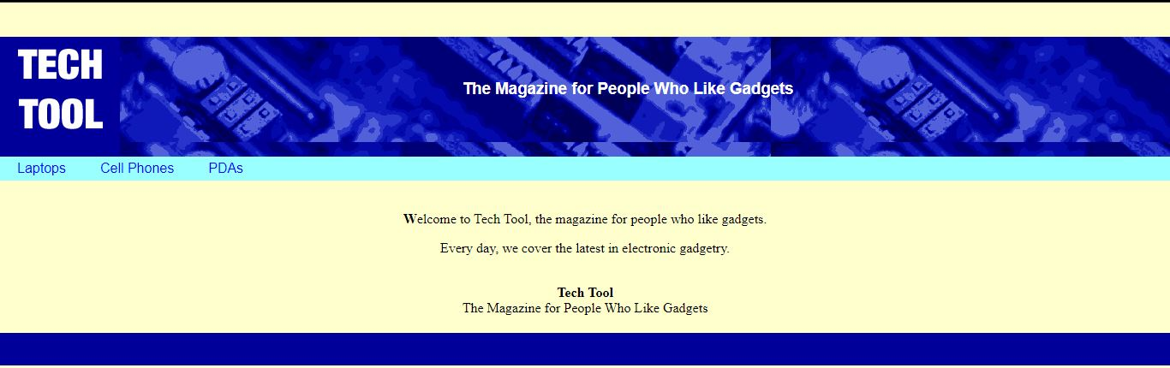

**Ex2:** *Dance*

You are given a HTML files. Create a Web page like the screenshot on the right

Constraints: You are NOT allowed to change the HTML file, Just write the missing CSS.

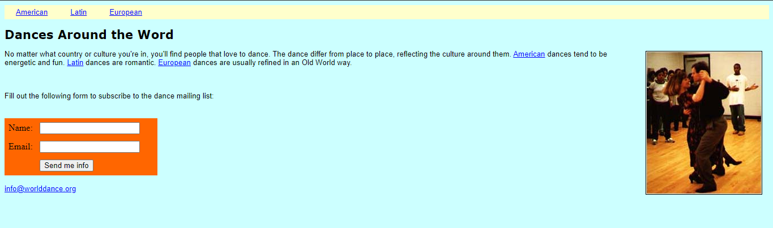

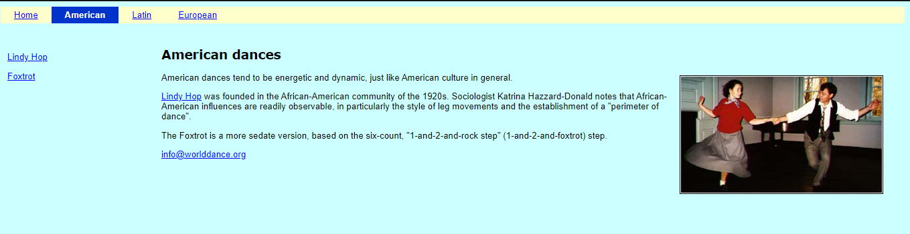

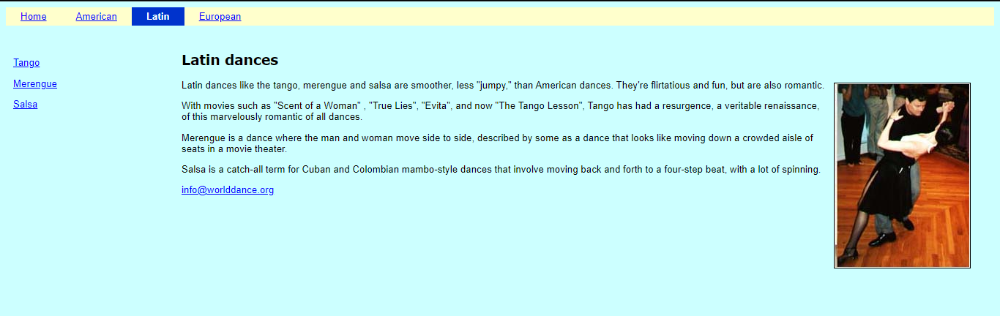

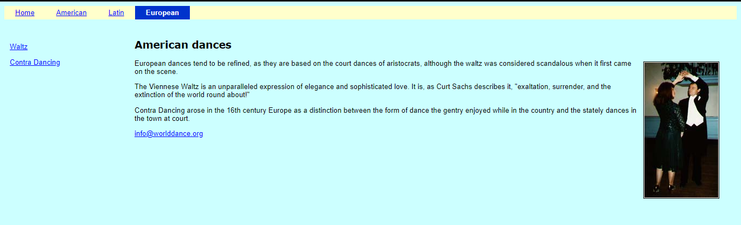

**Ex3:** *Dog*

You are given HTML files. Create a Web page like the screenshot on the right

Constraints: You are NOT allowed to change the HTML file, Just write the missing CSS.

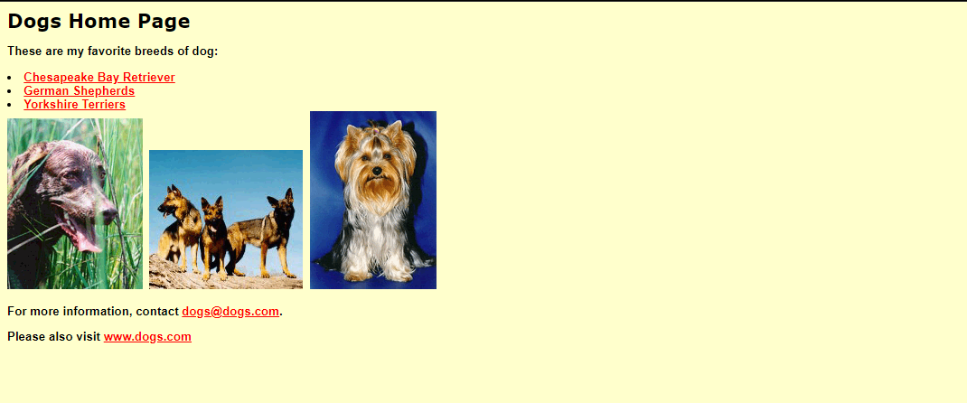

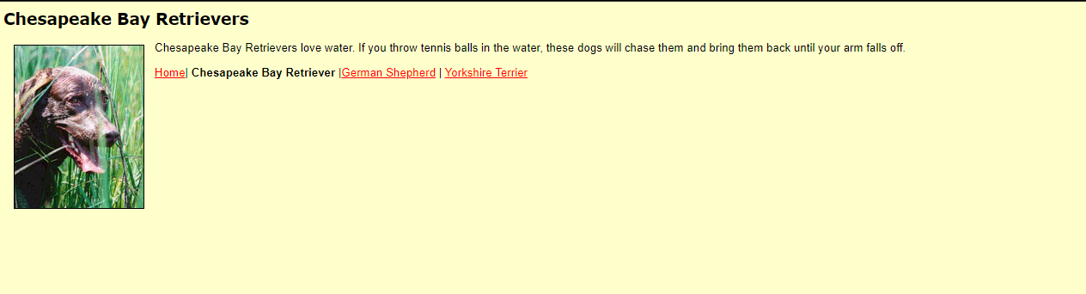

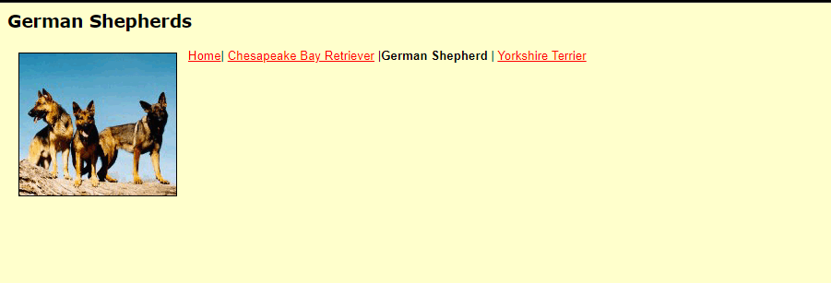

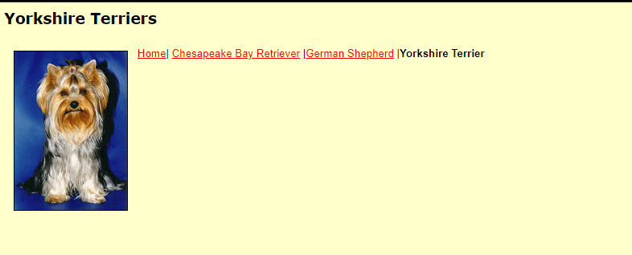

**Ex4:** *Travel*

Create a Web page like the screenshot on the right

Constraints: You are NOT allowed to change the HTML file, Just write the missing CSS.

