F002-Register

Case1: Registered successfully

+ Test data:

Username: chauphat2111

Email: [hieuphung2111@gmail.com](mailto:hieuphung2111@gmail.com)

Password: 1234

+ Testing steps:

Step1: access the url <http://localhost:8083/register>

Step2: Enter data into the inputs

Step3: Click send and go to the otp code input page

Step4: Enter the otp code sent to the email you registered with

Step5: Click submit and you will be redirected to the login page

+Illustration:

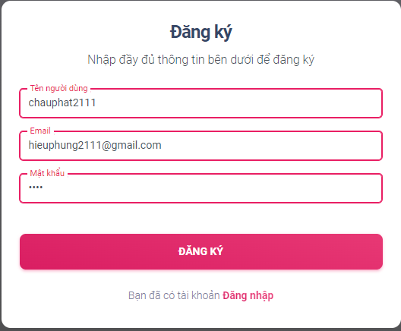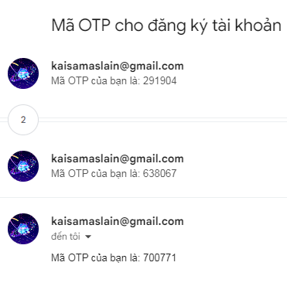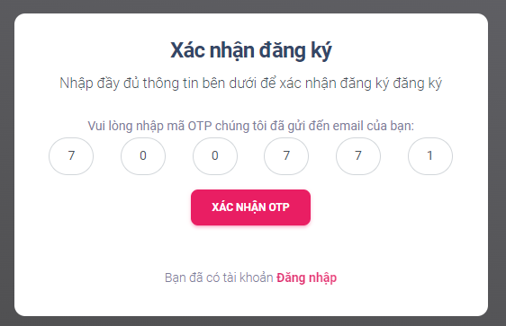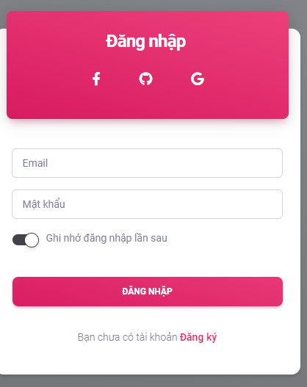

Case2: Do not fill in the field

+ Test data:

Username:

Email:

Password:

+ Testing steps:

Step1: access the url <http://localhost:8083/register>

Step2: Click submit and show error  
  
+Illustration:

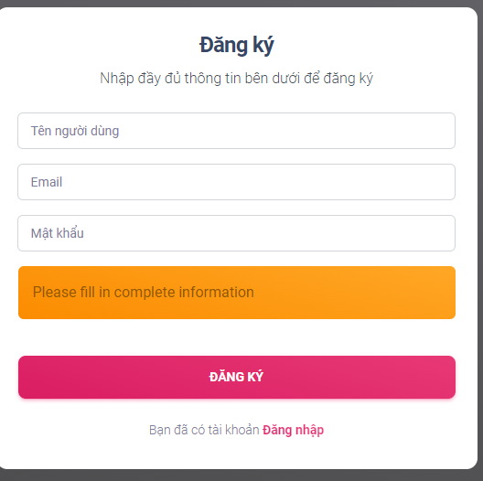

Case3: Do not fill in the field in the otp page

+ Test data:

Username: chauphat2111

Email: [hieuphung2111@gmail.com](mailto:hieuphung2111@gmail.com)

Password: 1234

+ Testing steps:

Step1: access the url <http://localhost:8083/register>

Step2: Enter data into the inputs

Step3: Click send and go to the otp code input page

Step4: do not enter otp   
+Illustration:  
 