1. Go to desktop

2. rails new kingsong

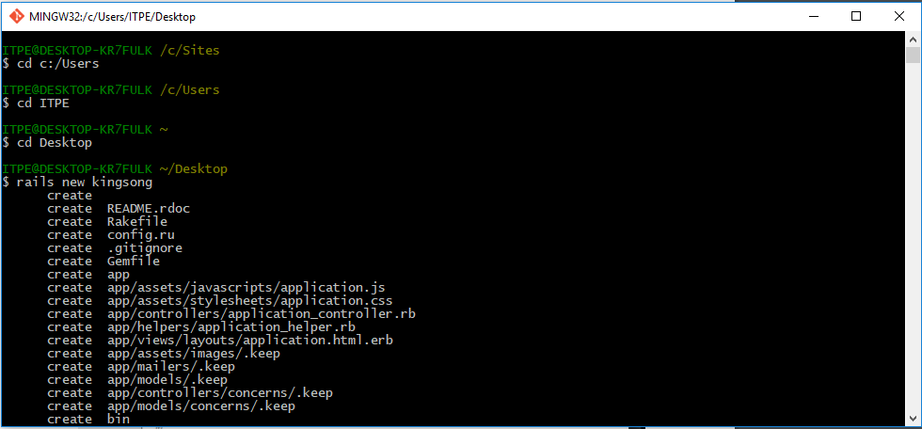

3. change Gemfile

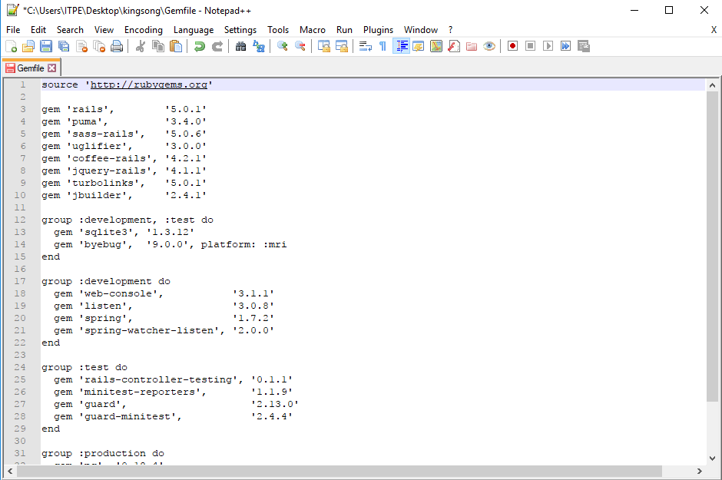

4. cd kingsong

5. gem sources –a http://rubygems.org

6. answer y

7. gem install bundler

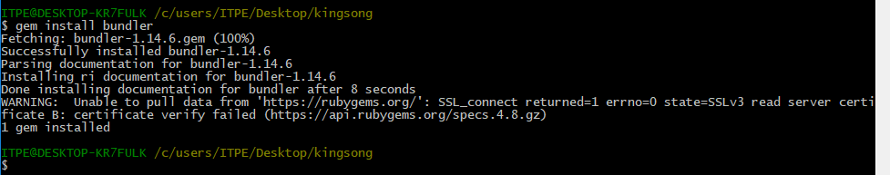

8. bundle install --without production

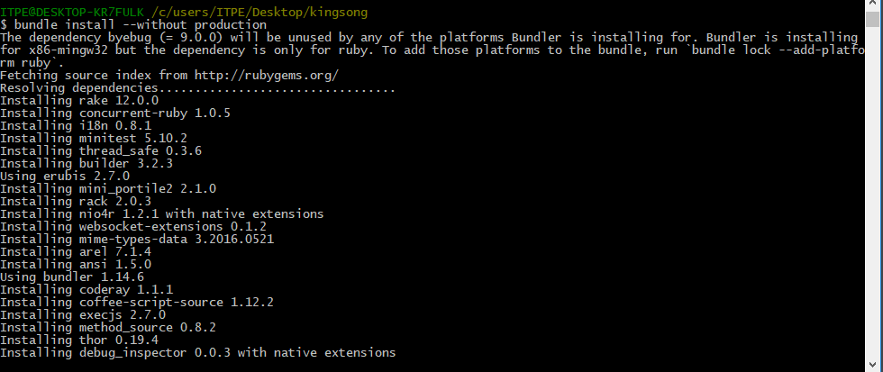

9. bundle show

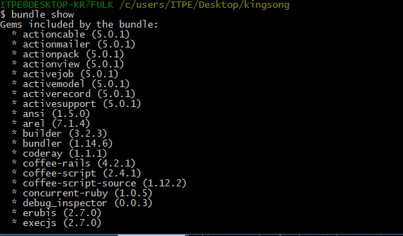

10. bundle update

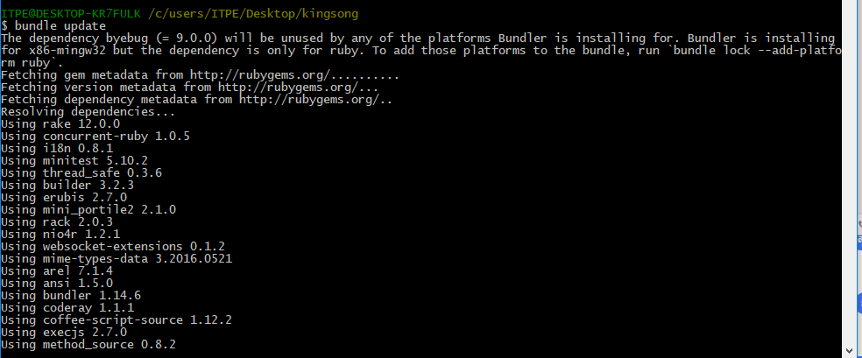

11.open cmd run rails server

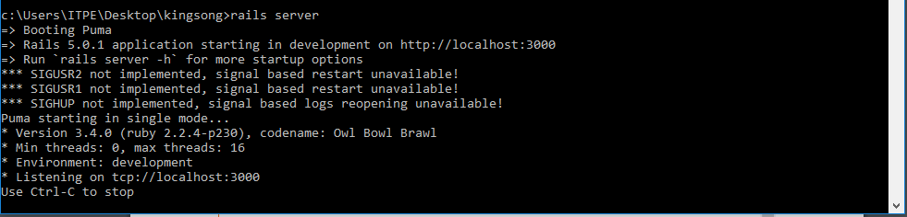

12.open localhost:3000 will see welcome rails

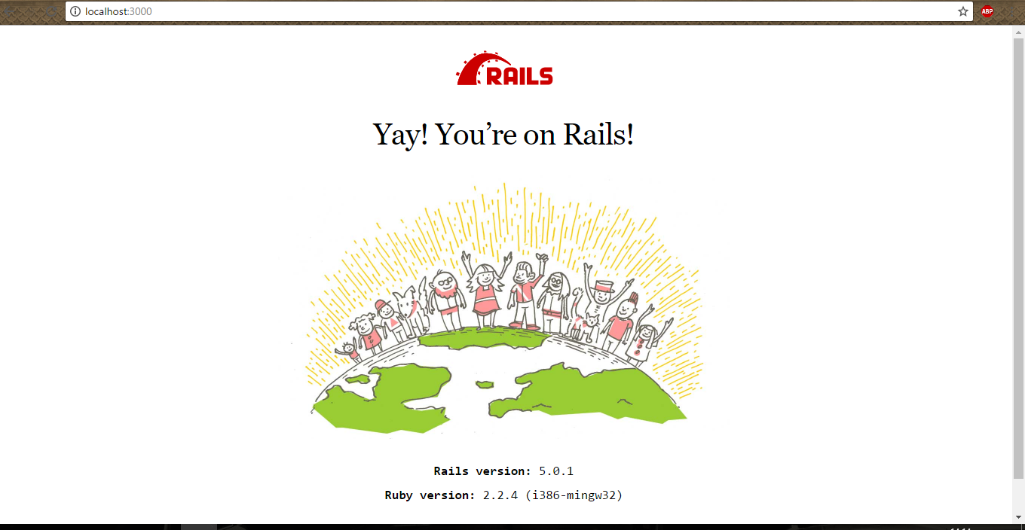

13.create repo at github

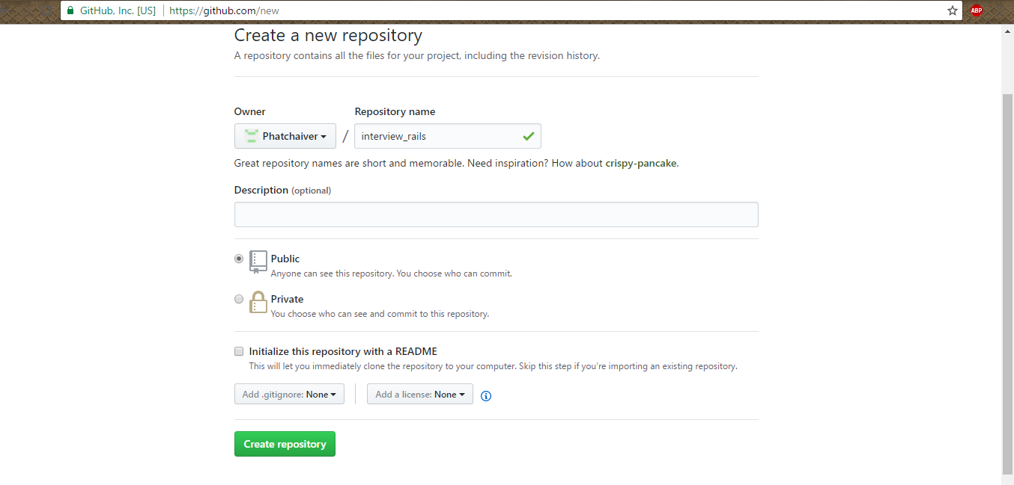

14.git config --global user.name "your username"

15.git config --global user.email "your email"

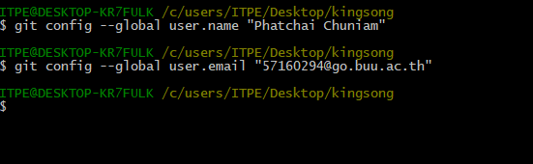

16.git init

17.git add –A (**A only**)

18.git status

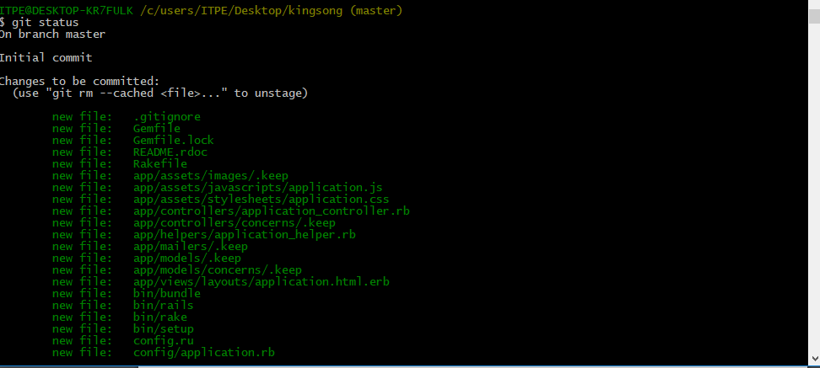

19.git commit –m “create project kingsong”

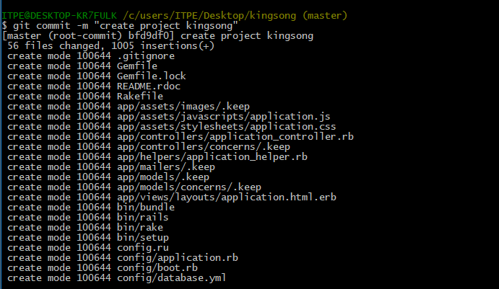

20. git remote add origin “git repo”

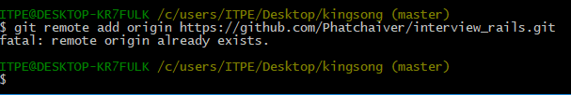

21. git push -u origin master

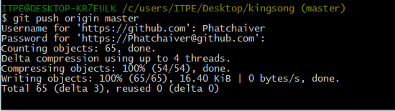

22.heroku login

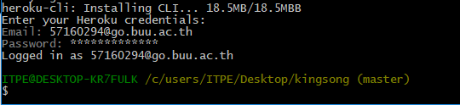

23. heroku create

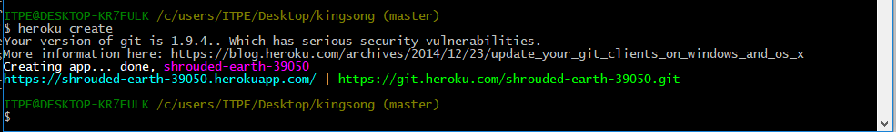

24.git push heroku master

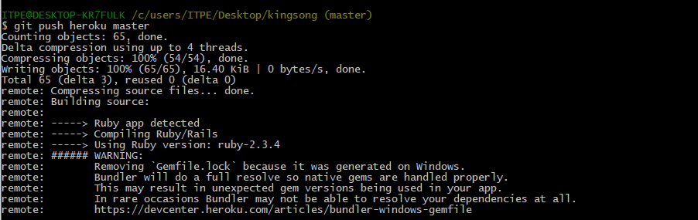

25.git checkout -b static-pages

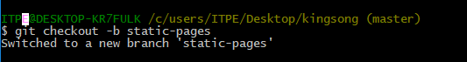

26. rails generate controller StaticPages home kingsong1 kingsong2 kingsong3

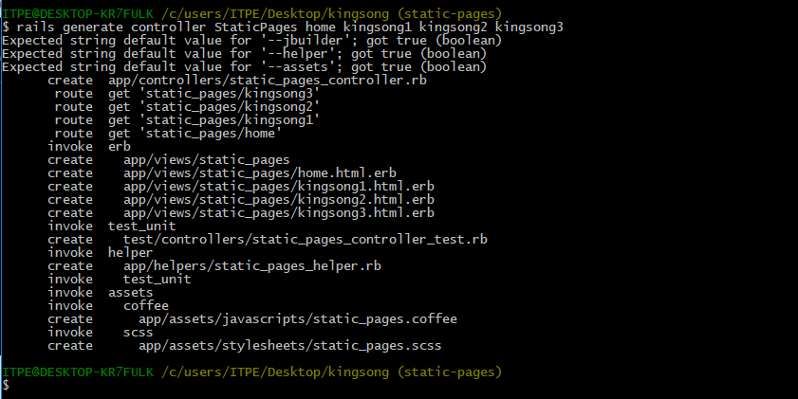

27. edit config/routes

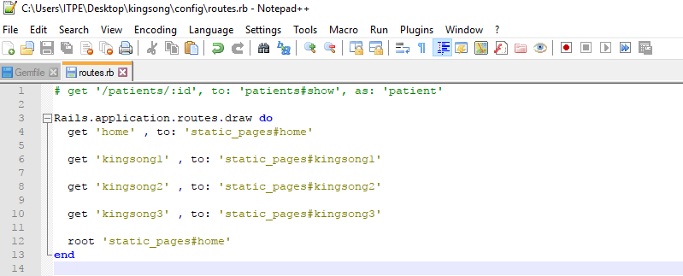

28.Look localhost:3000

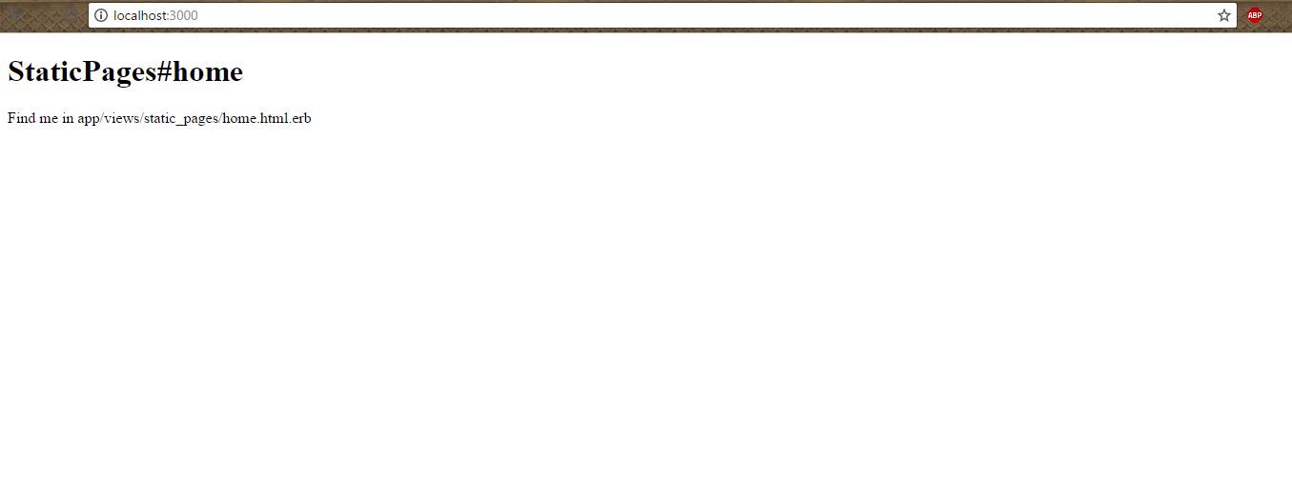

29.Edit app/views/static_pages/home.html.erb

30.Edit app/views/static_pages/kingsong1.html.erb

31.Edit app/views/static_pages/ kingsong2.html.erb

32.Edit app/views/static_pages/ kingsong3.html.erb

33.Edit Readme

34.git add –A

35.git commit -m "Finish static pages"

36.git checkout master

