Mục Lục
1. Thông tin project 1
1.1. Tên dự án 1
1.2. Link github 2
2. Cấu trúc Project 2
3. Thực hiện Carousel 2
3.1. Dữ liệu 2
3.2. CarouselComponent 2
3.3 Sử dụng CarouselComponent 2
3. MainLayout 2

Thông tin project

Tên dự án
Hotel Management System (HMS) can help you streamline and automate various aspects of managing a hotel. It can help you keep track of room reservations, bills, guest information, and financial transactions. The HMS can also help you manage housekeeping and maintenance tasks, as well as track inventory and purchase orders. Building an HMS can also help you improve customer satisfaction by providing them with a user-friendly interface to book rooms and manage their stays. Here are some key components and functions of a Hotel Management System
- Online Booking and Reservation: The system allows customers to make bookings and reservations online through a user-friendly interface. It provides real-time availability of vehicles, rental rates, and booking confirmations.
- Room Management: Room management in a hotel management system refers to the process of efficiently and effectively managing the rooms and their occupants in a hotel.
- Customer Management: The system maintains a database of customer information, including contact details, identification documents, and room booking history. It enables easy retrieval of customer records, communication, and personalized service.
Imagine you're a developer of a FU Mini Hotel Management System named FUMiniHotelSystem. To implement a part of this system your tasks include:
- Manage customer information.
- Manage room information.
- Manage online/offline booking transaction.

The application has to support adding, viewing, modifying, and removing information - a
standardized usage action verb better known as Create, Read, Update, Delete (CRUD) and Search.
This assignment explores
- Create a RESTful API using Spring Boot 3 with MS SQL Server. An SQL Server Database will be created to persist the news data (reading and managing) by Spring Data JPA.
- Secure RESTful API using JSON Web Token.
- React Client sends HTTP requests and retrieve HTTP responses using axios, shows data on the components.

Link github
https://github.com/Phatnguyen105/SBA301_SP26

Cấu trúc Project
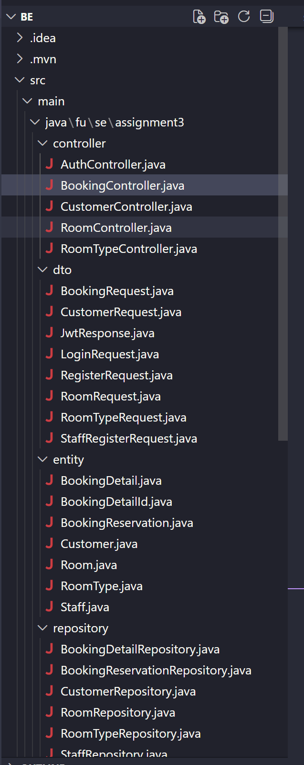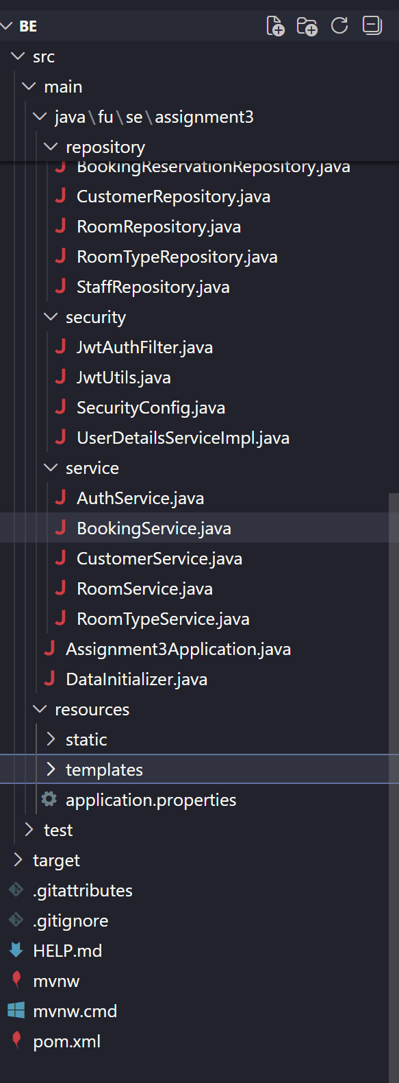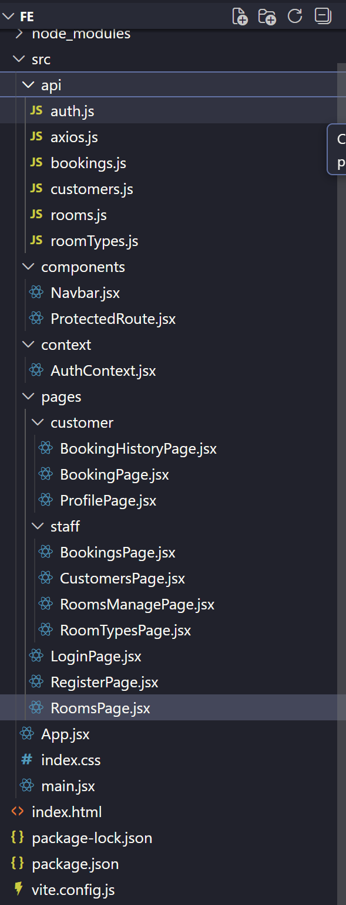

3. Thực hiện

3.1. RoomTypeController

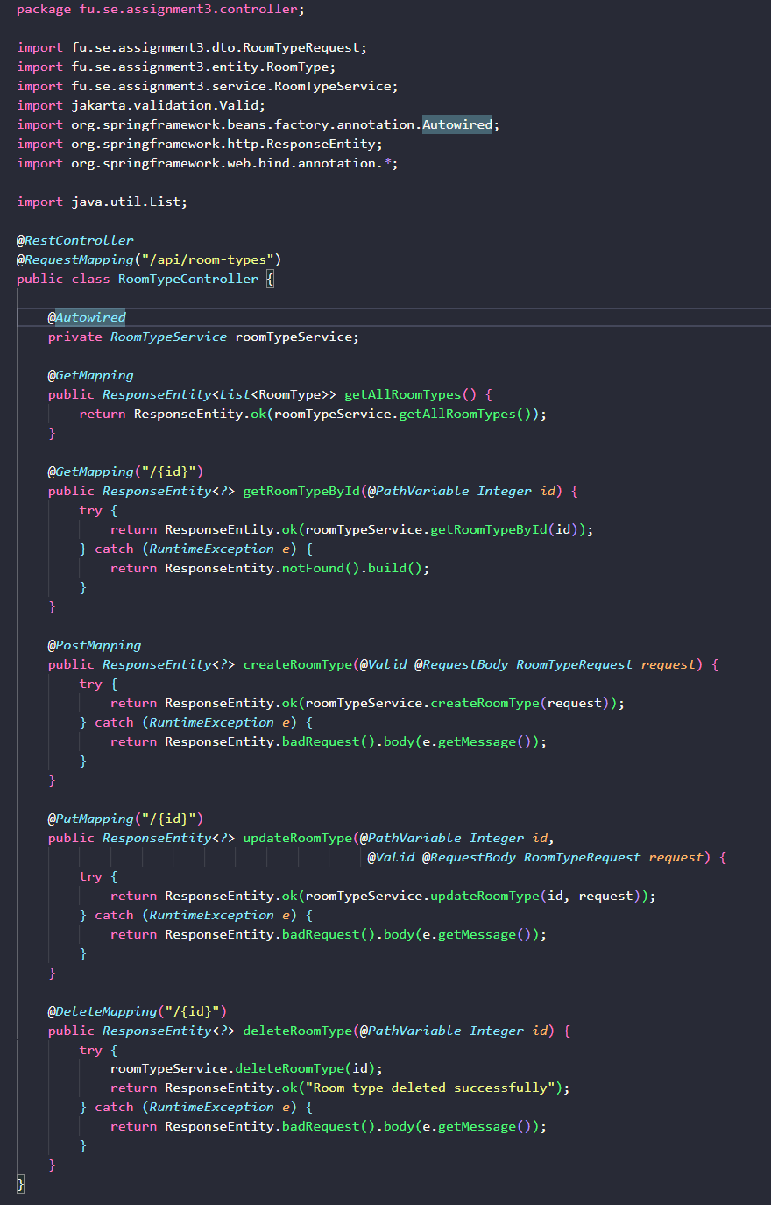

3.2. RoomController

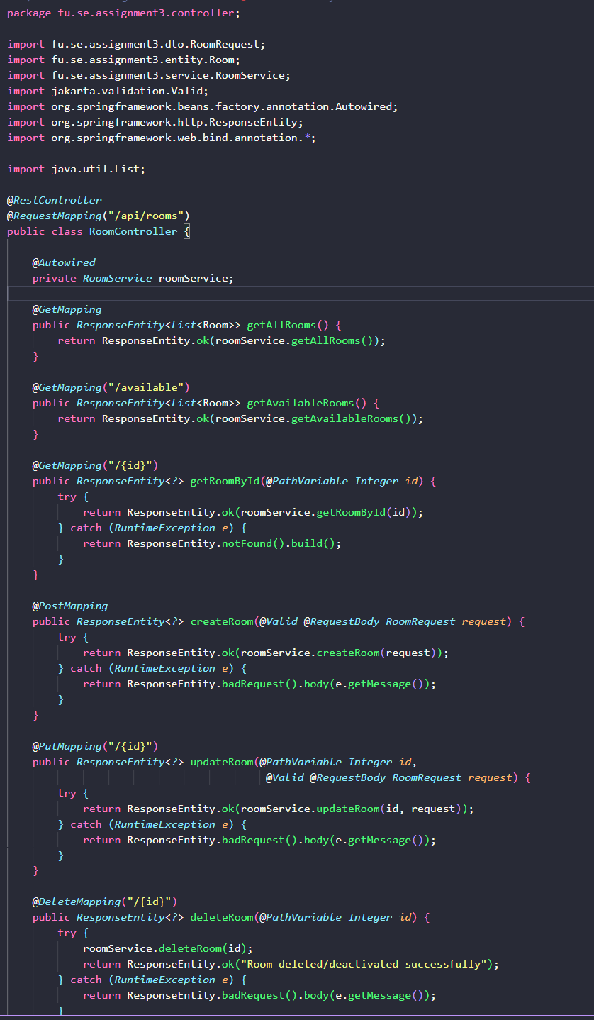

3.3 CustomerController

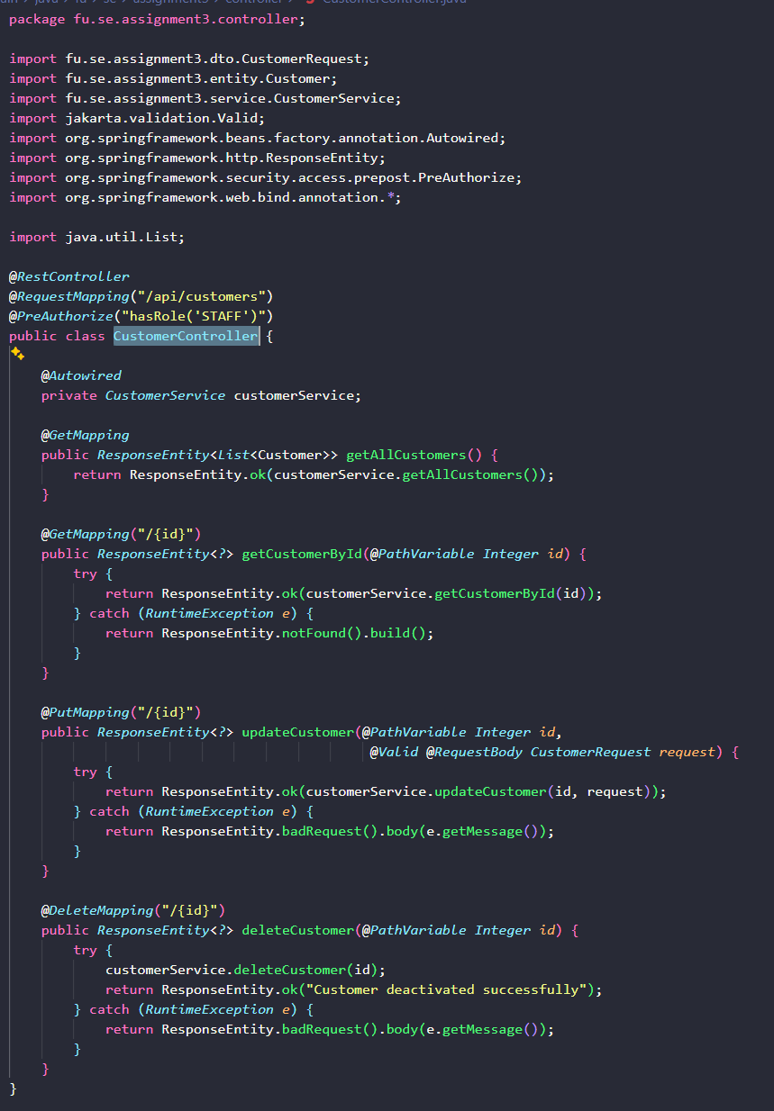

3.4 BookingController

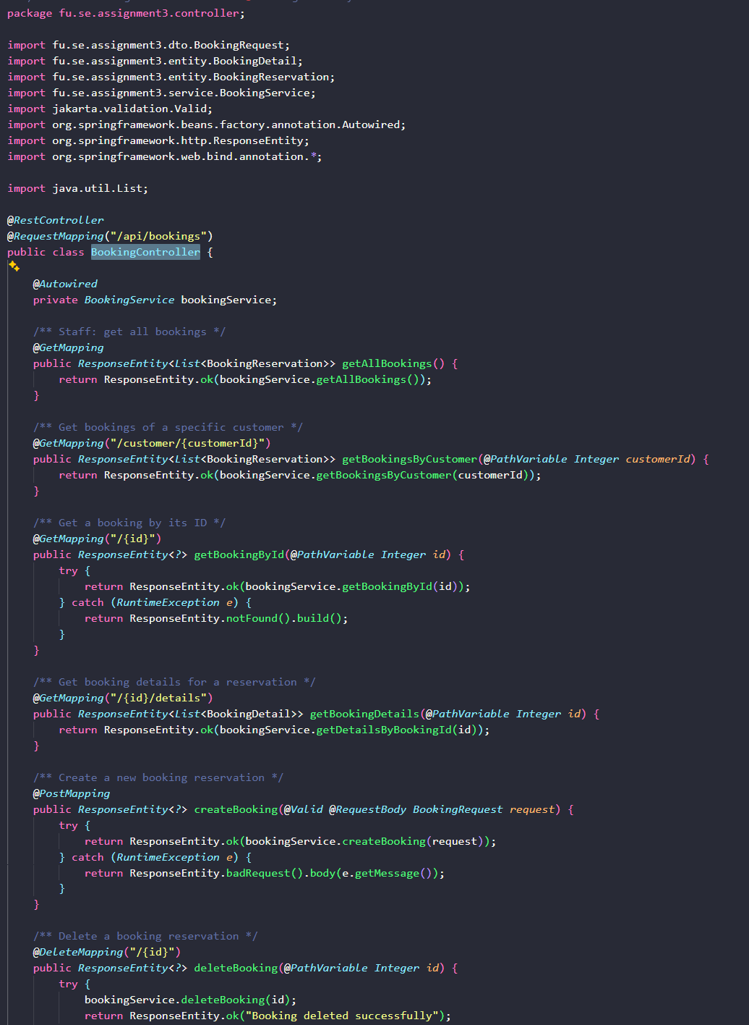

3.5 BookingController

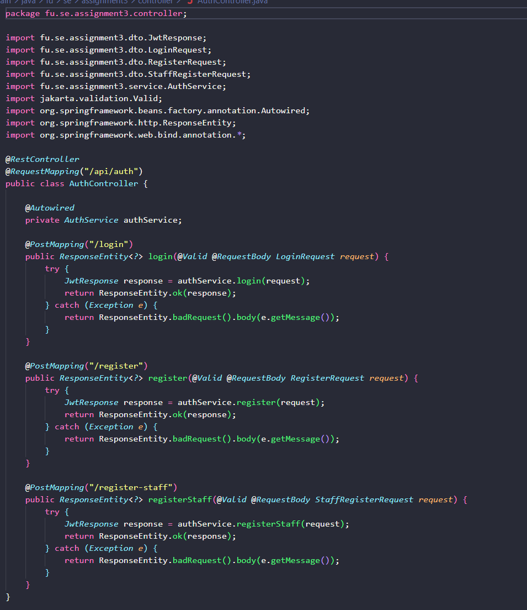

Axios.js
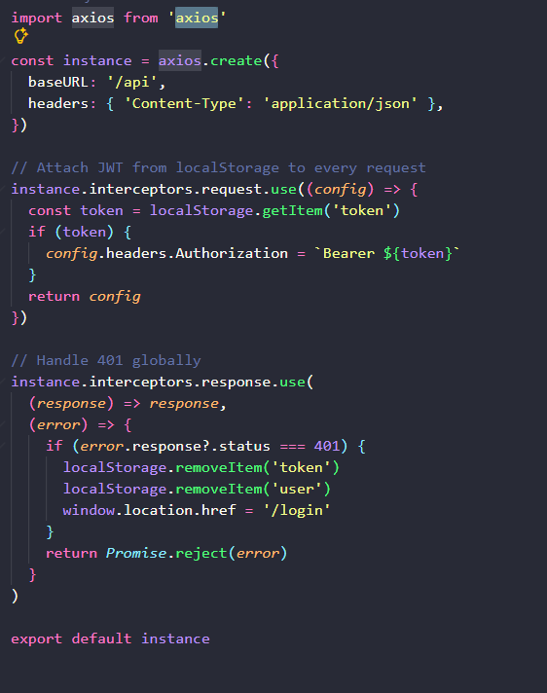

5. Kết quả
5.1. Customer
5.1.1 Trang hiện thông tin rooms
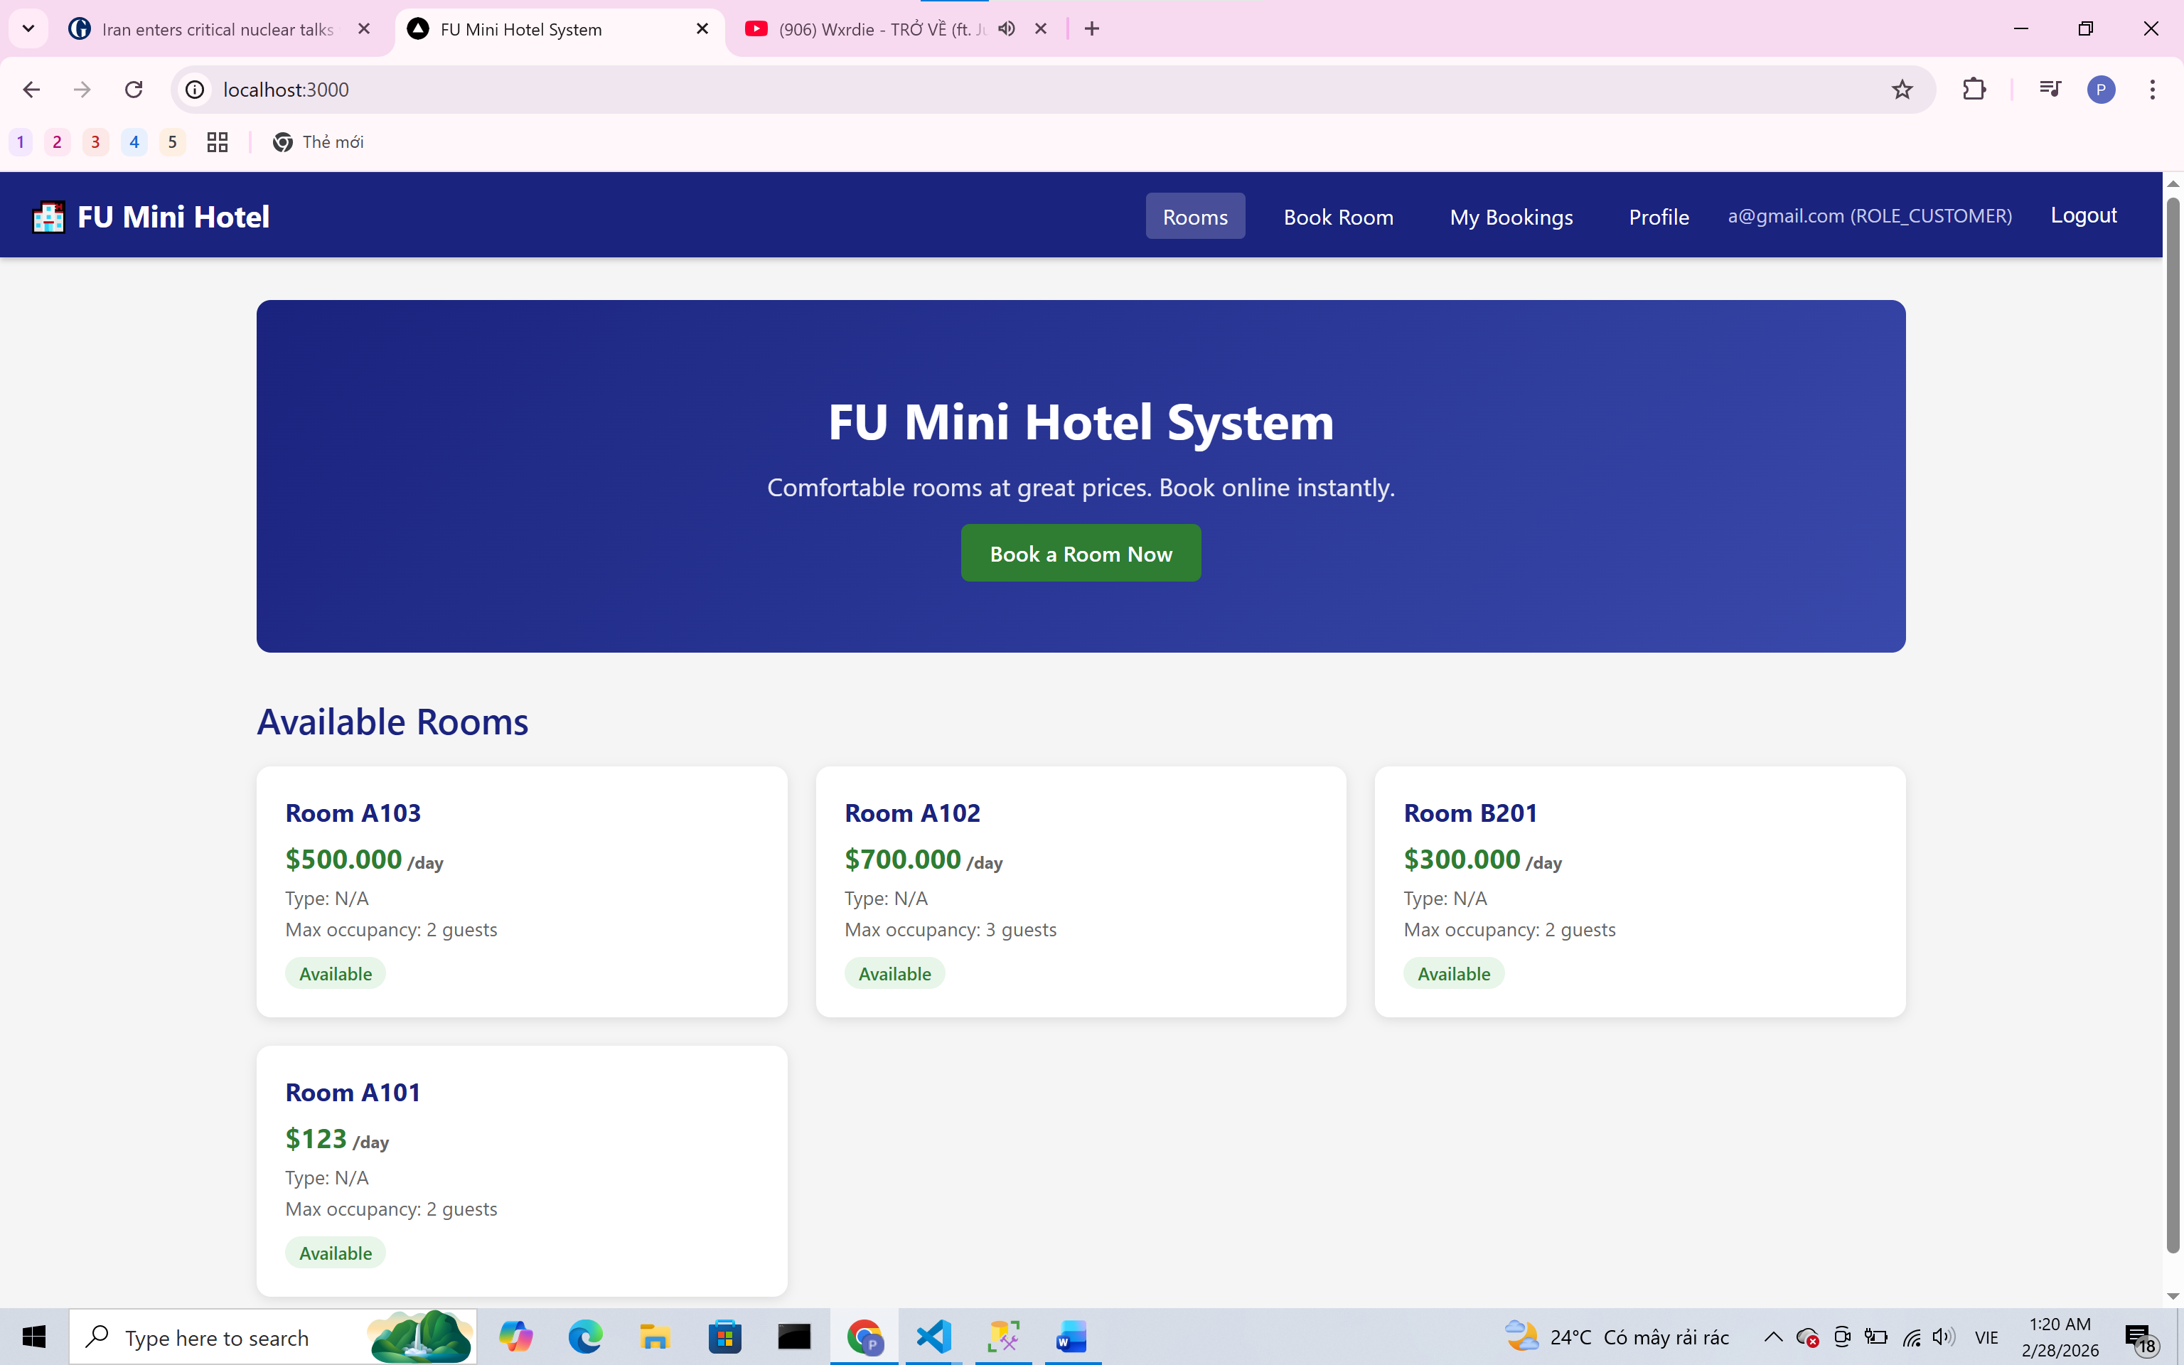
5.1.2 Trang hiện thông tin book room
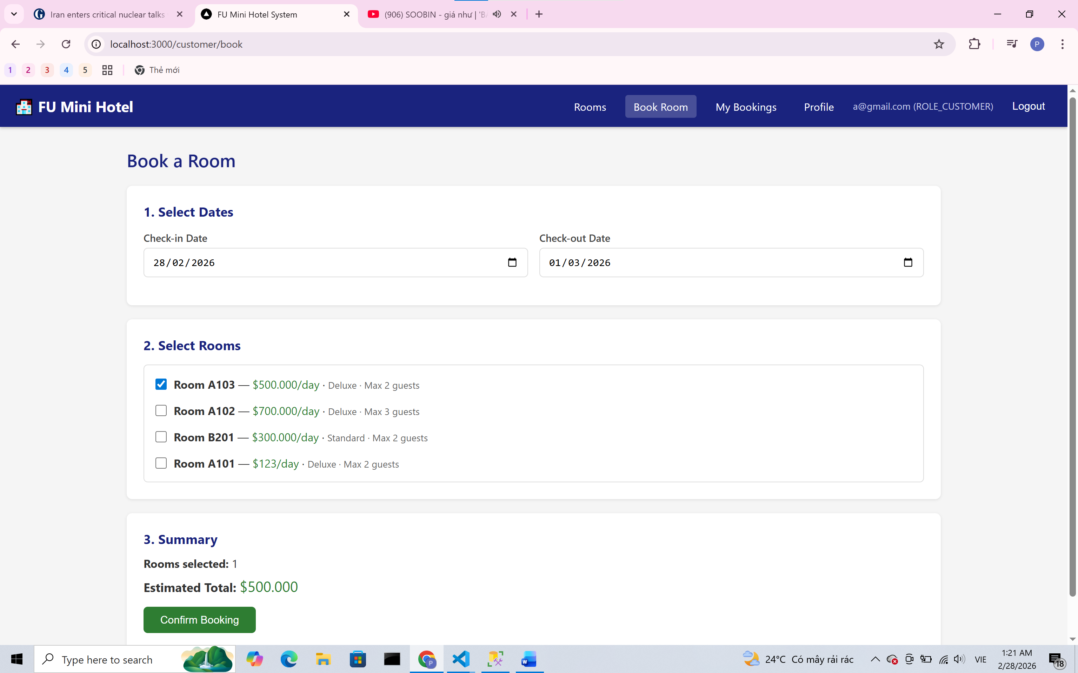
5.1.3 Trang hiện thông tin my bookings
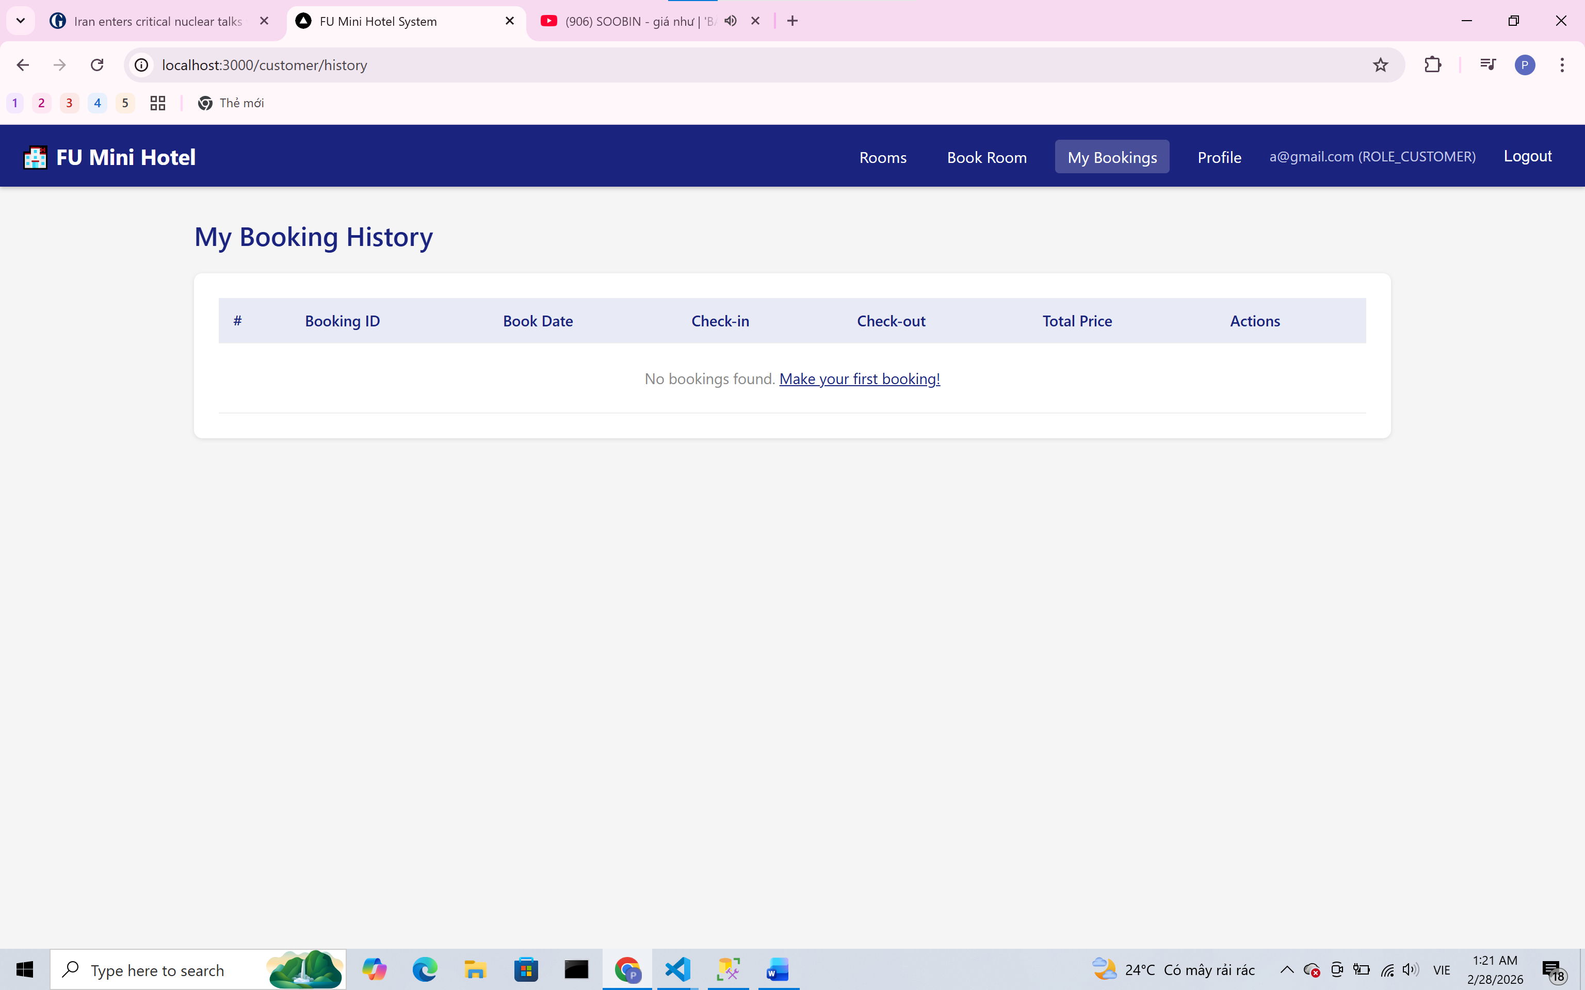
5.2. Staff
5.2.1 Trang hiển thị customer management
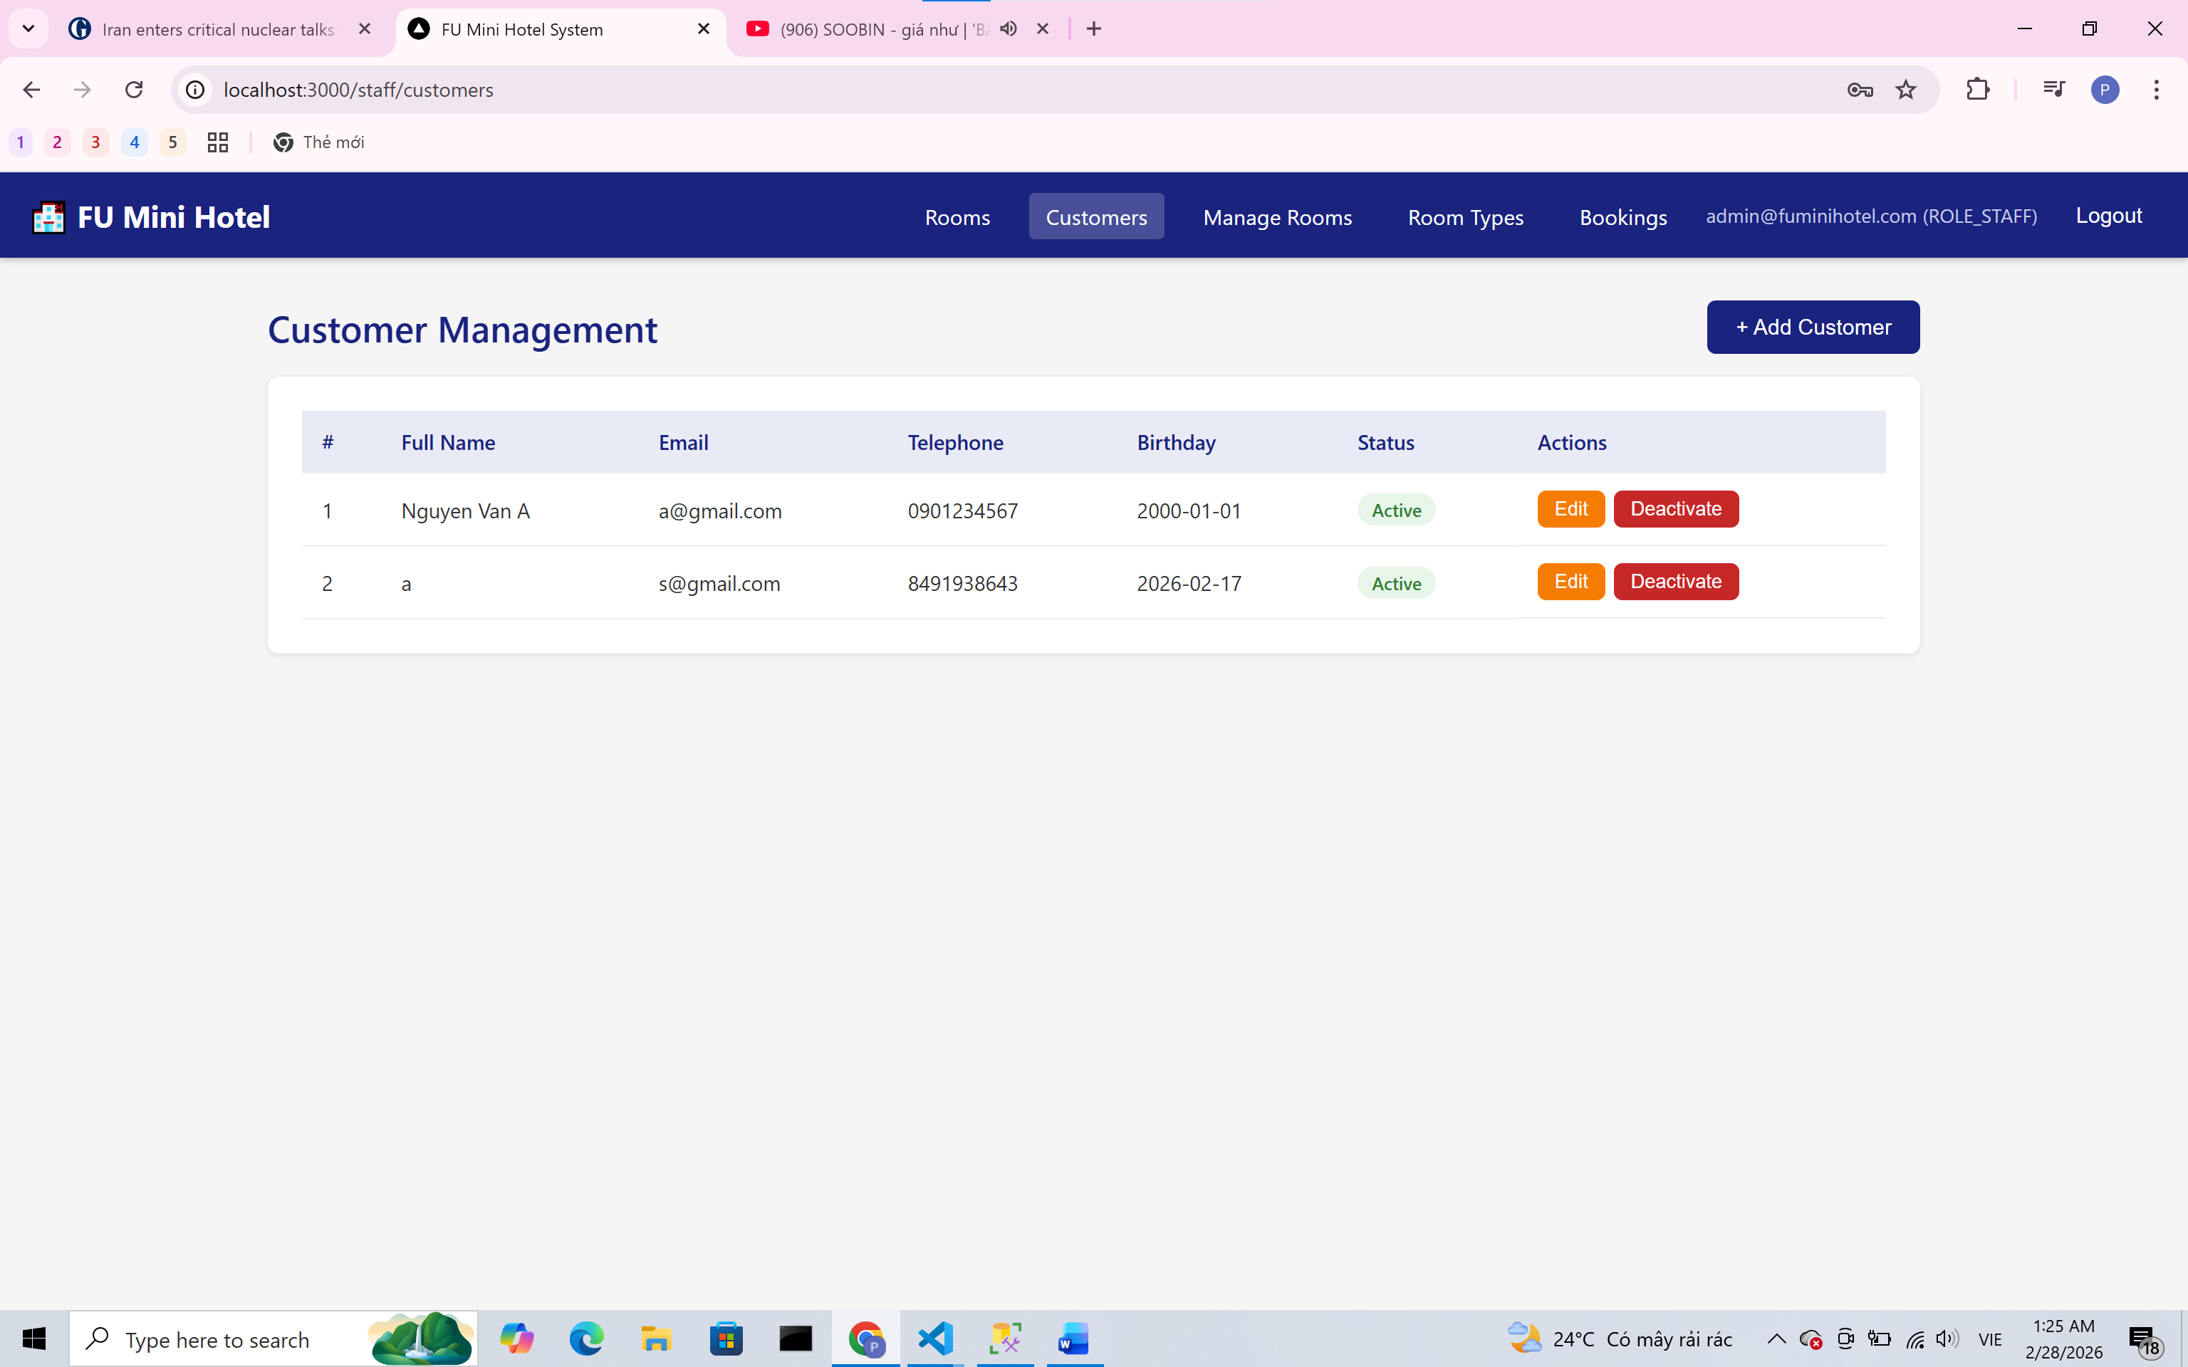
5.2.2 Trang hiển thị rooms
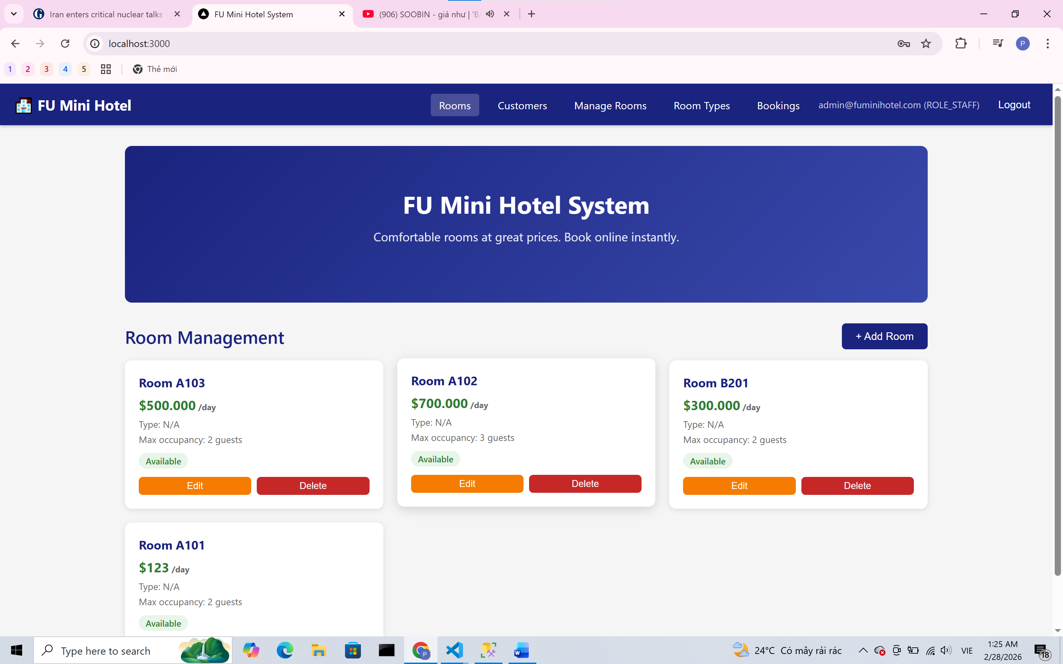

5.2.4 Trang hiển thị rooms management

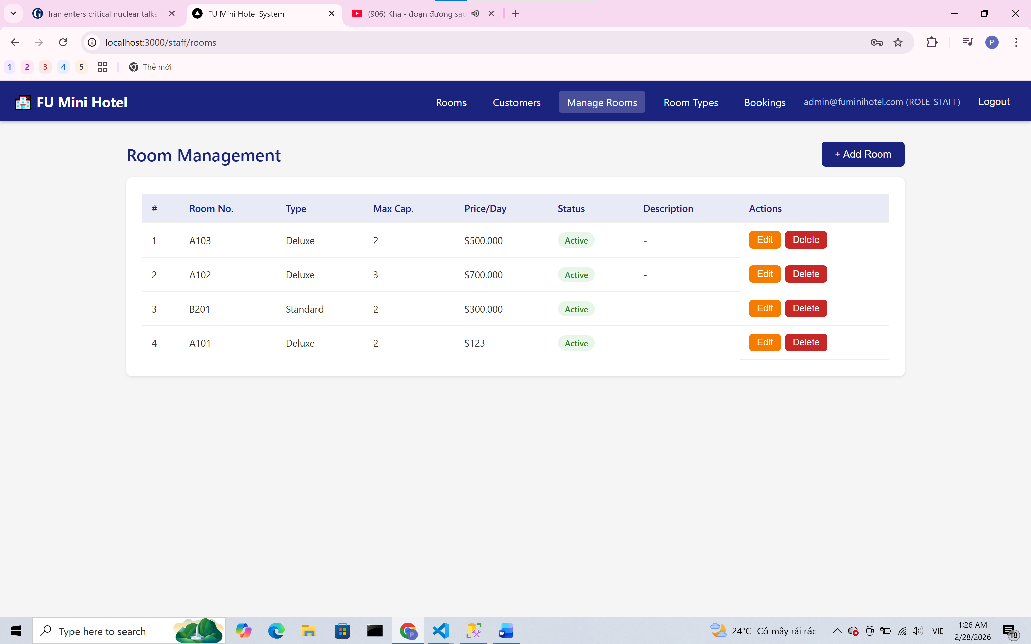
5.2.5 Trang hiển thị rooms types

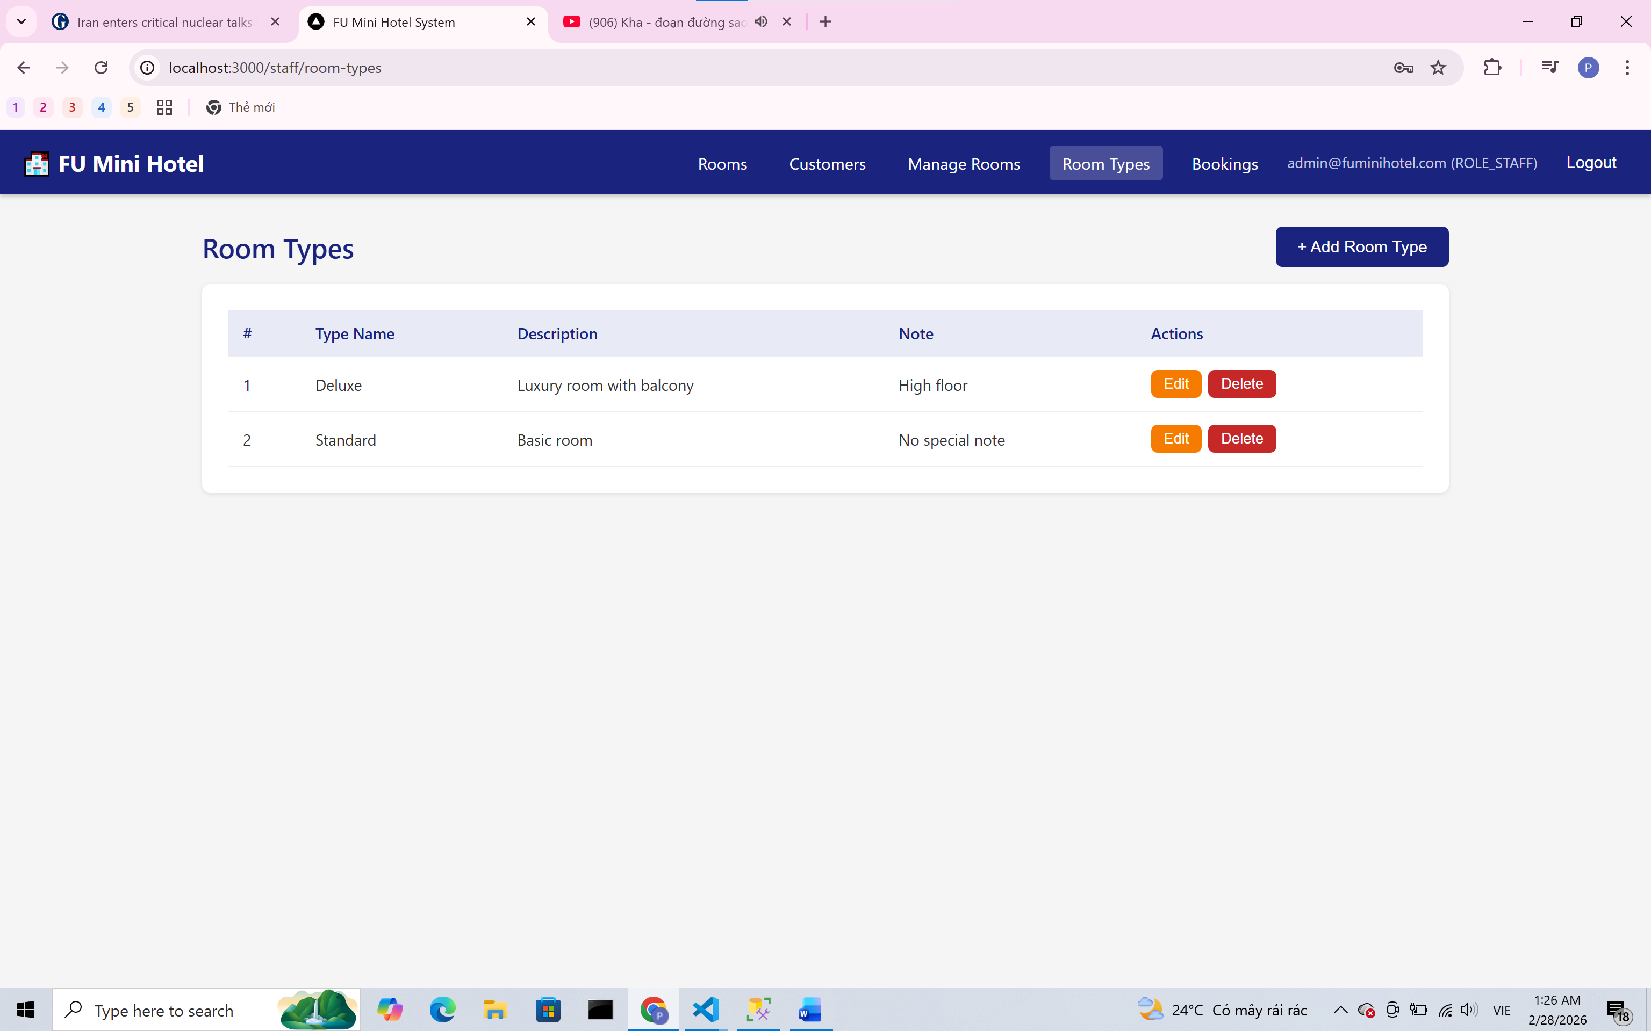
5.2.6 Trang hiển thị booking reservations
