Mục Lục
1. Thông tin project 1
1.1. Tên dự án 1
1.2. Link github 2
2. Cấu trúc Project 2
3. Thực hiện Carousel 2
3.1. Dữ liệu 2
3.2. CarouselComponent 2
3.3 Sử dụng CarouselComponent 2
3. MainLayout 2

Thông tin project

Tên dự án: Assignment 1 SBA301 – Working with Reactjs application
Yêu cầu thực hiện:

Design a login page.

Create a logo using AI generation.

Develop a header component.

Create menu components for the following sections:

Dashboard

Category

News

Users

Settings

User authentication:

If the user is an “Admin” and the password is “Admin”, redirect the user to the admin page.

Admin page functionalities:

News Article Management, Account Management, and Category Management must include the following actions:

Read, Create, Update, Delete, and Search.

Create and Update actions should be performed via a popup dialog.

The Delete action should always include a confirmation prompt.

Link github
https://github.com/Phatnguyen105/SBA301_SP26

Cấu trúc Project
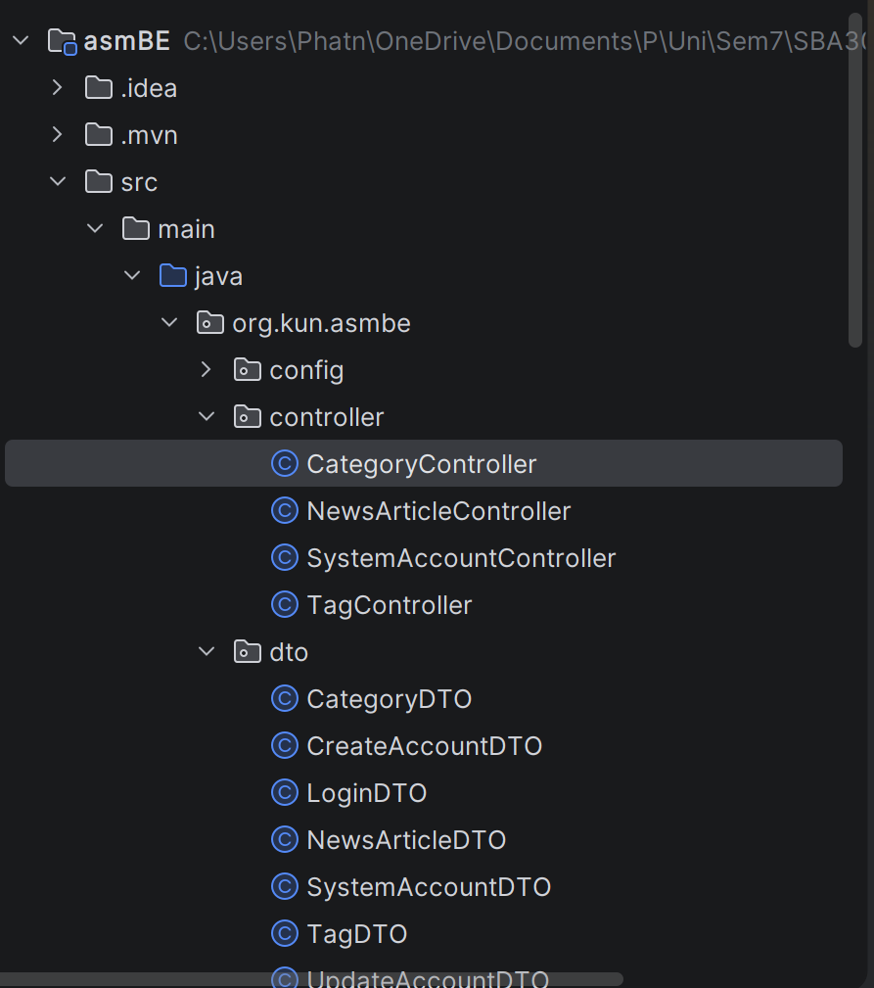
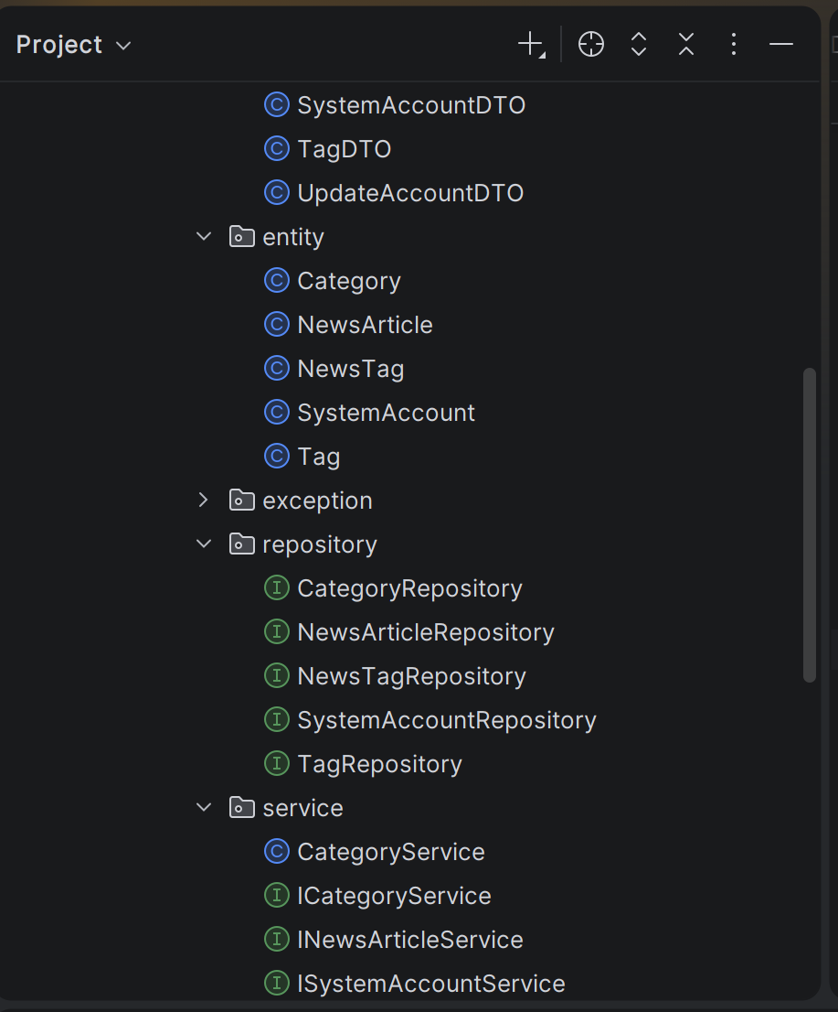
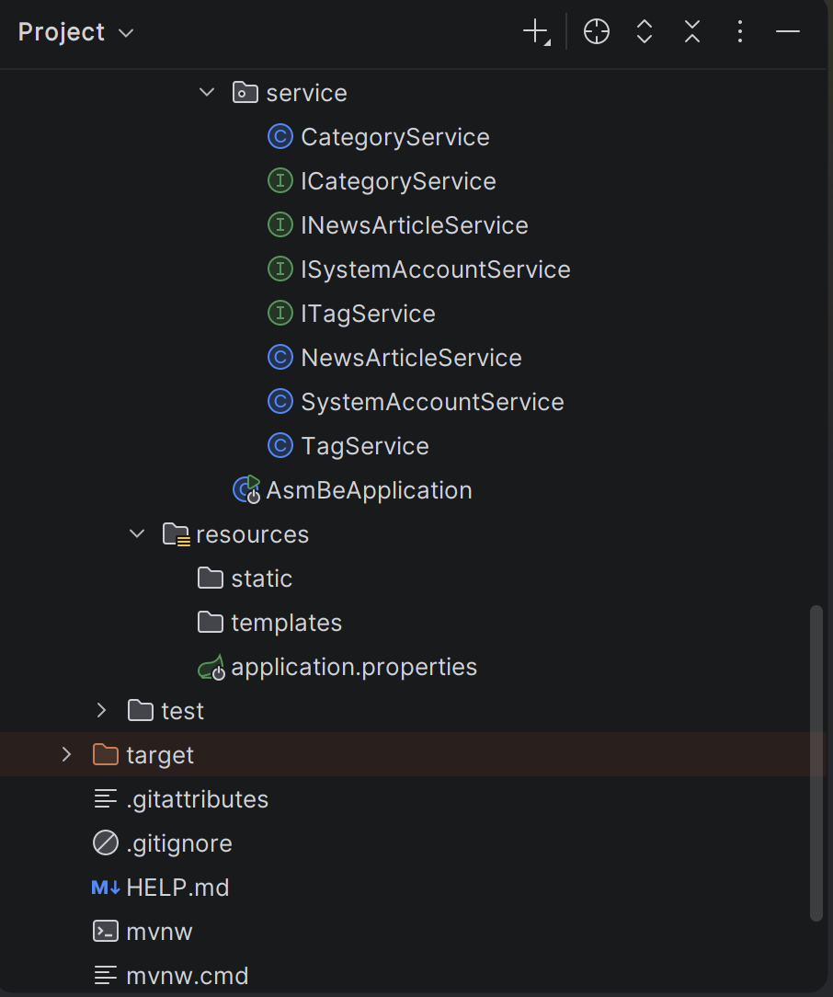
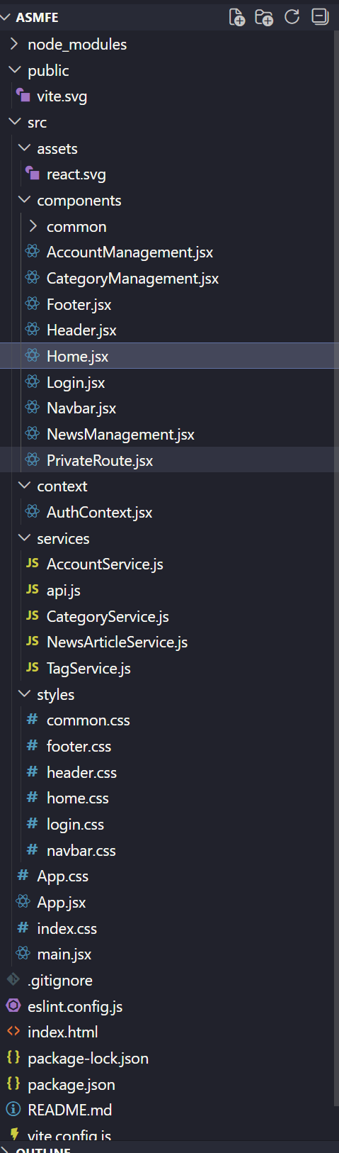

3. Thực hiện

3.1. Category

CategoryController

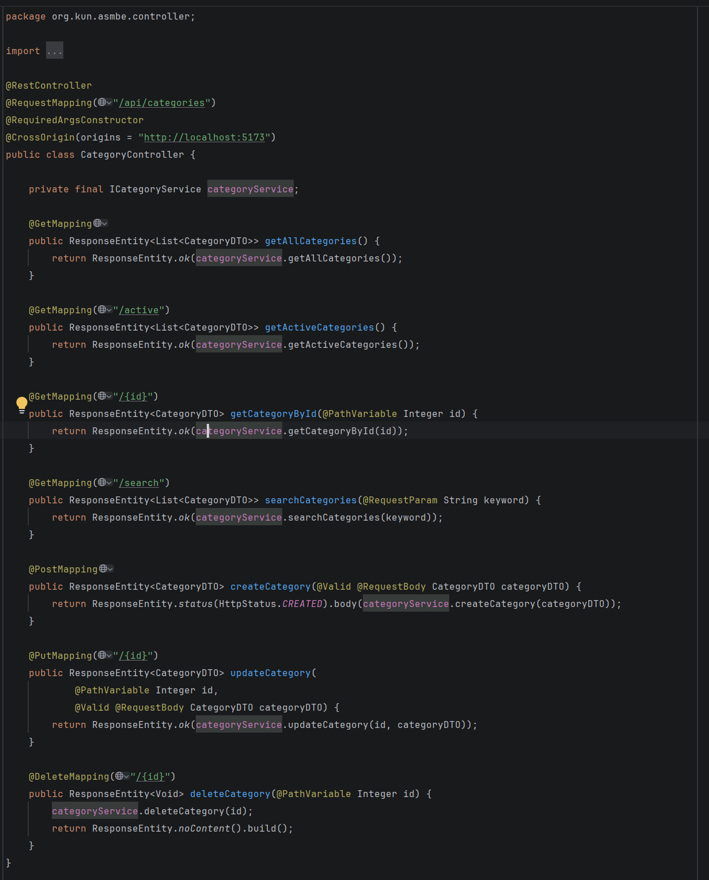
CategoryDTO
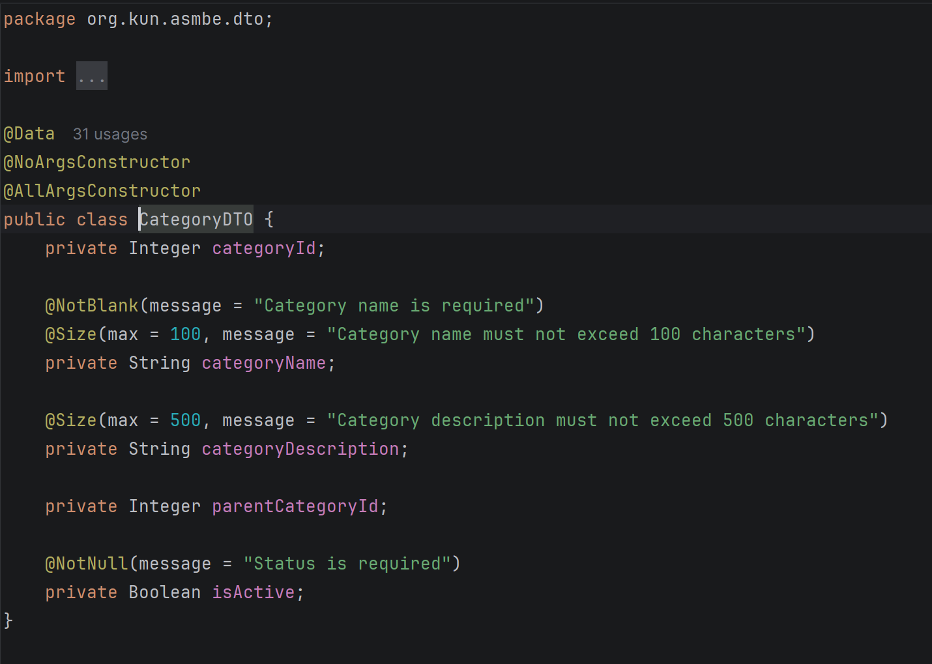
Category
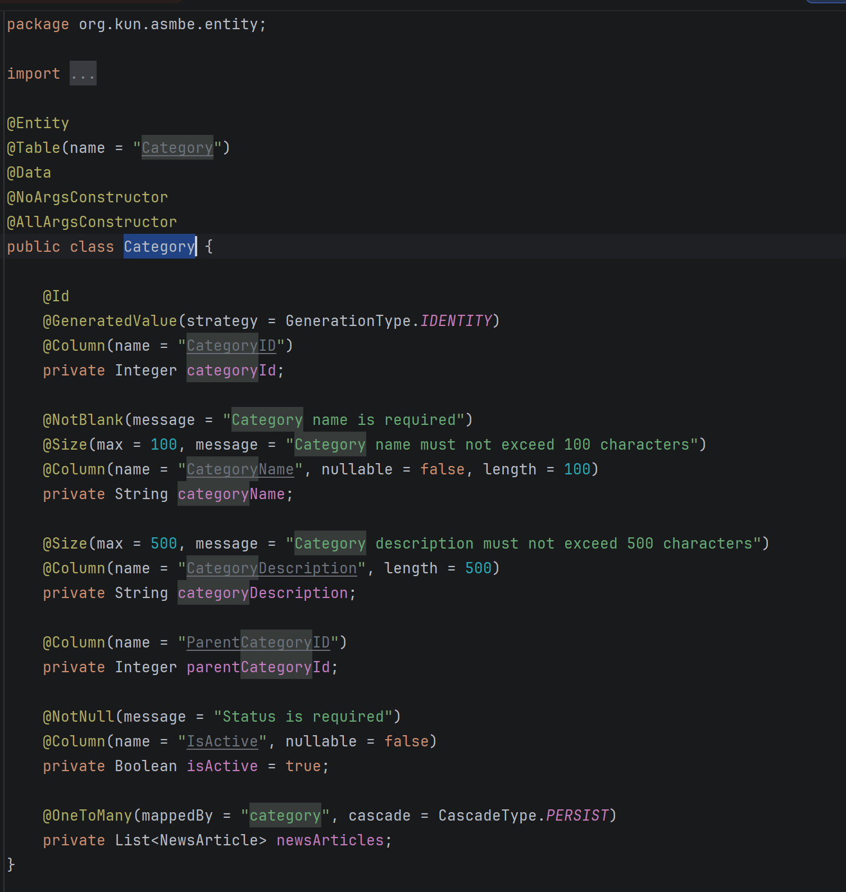
CategoryRepository
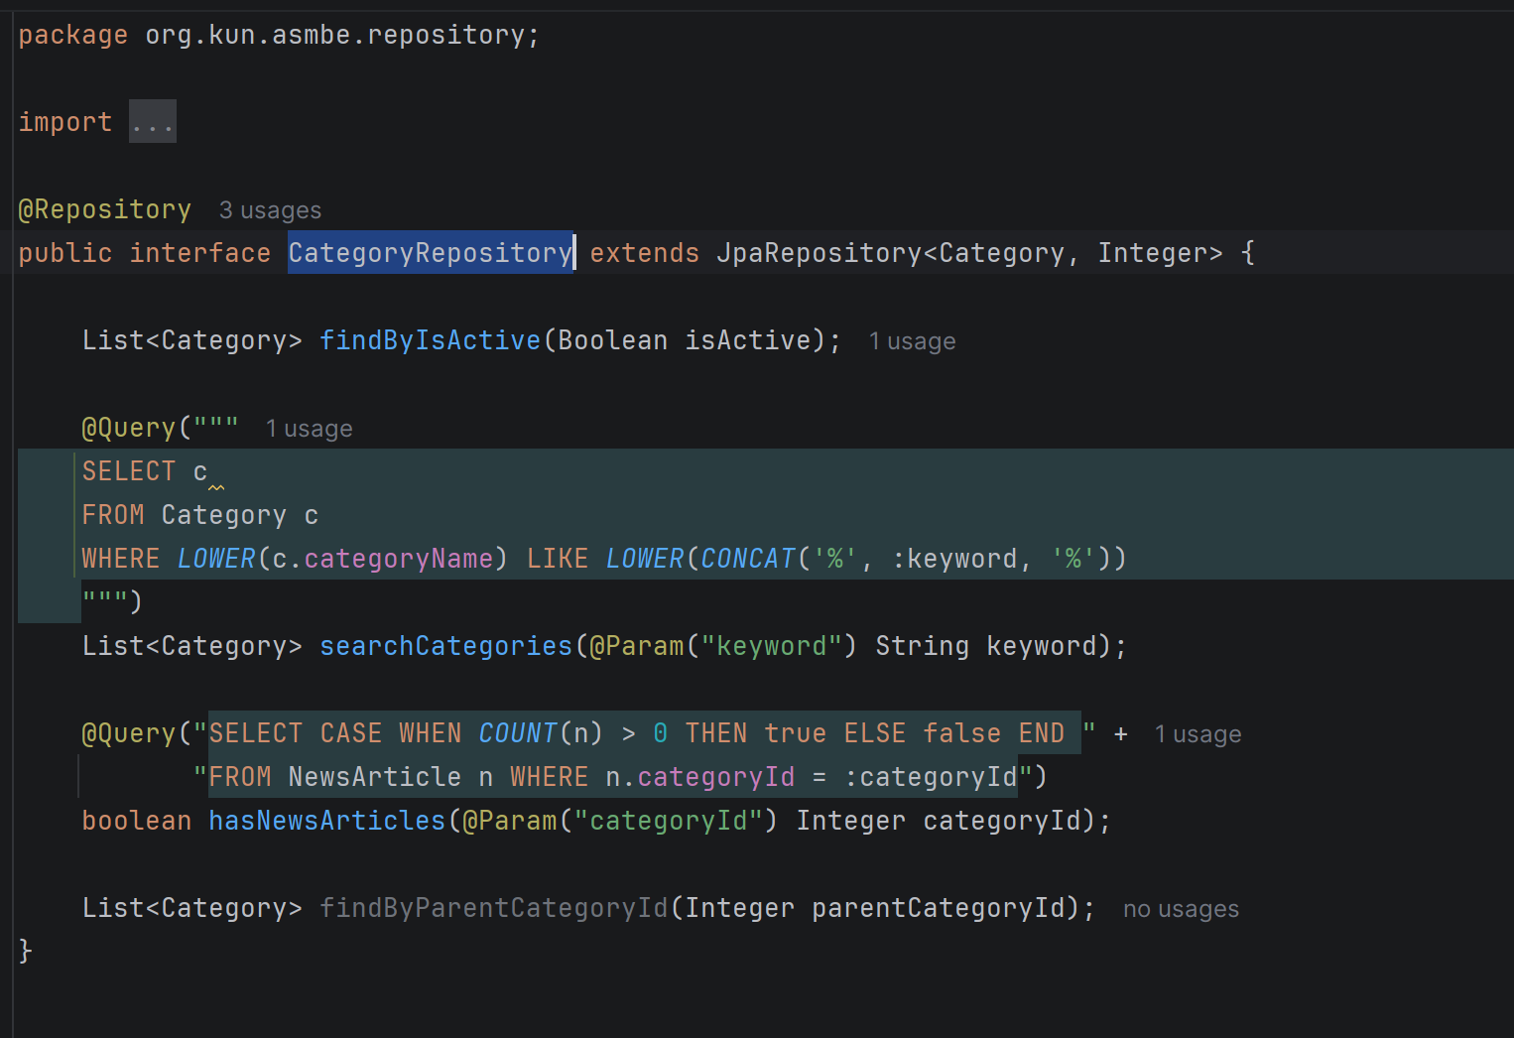
CategoryService
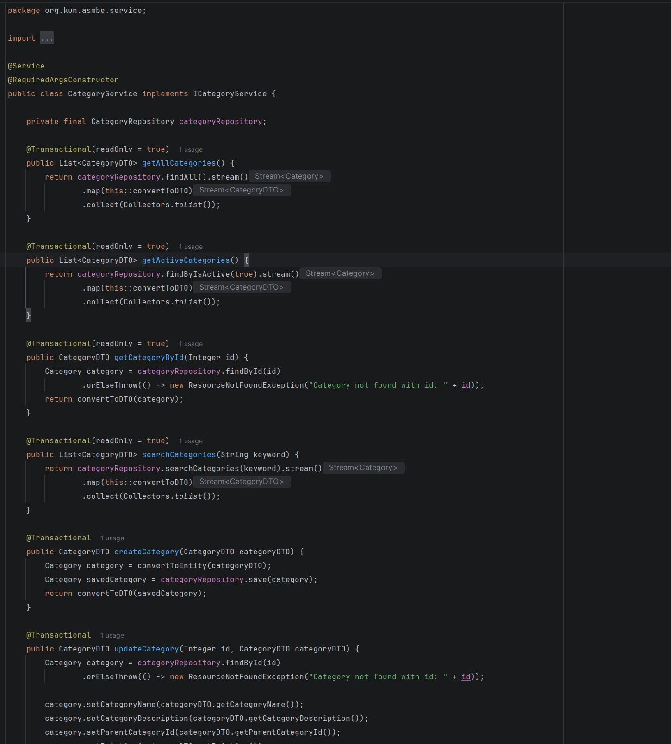
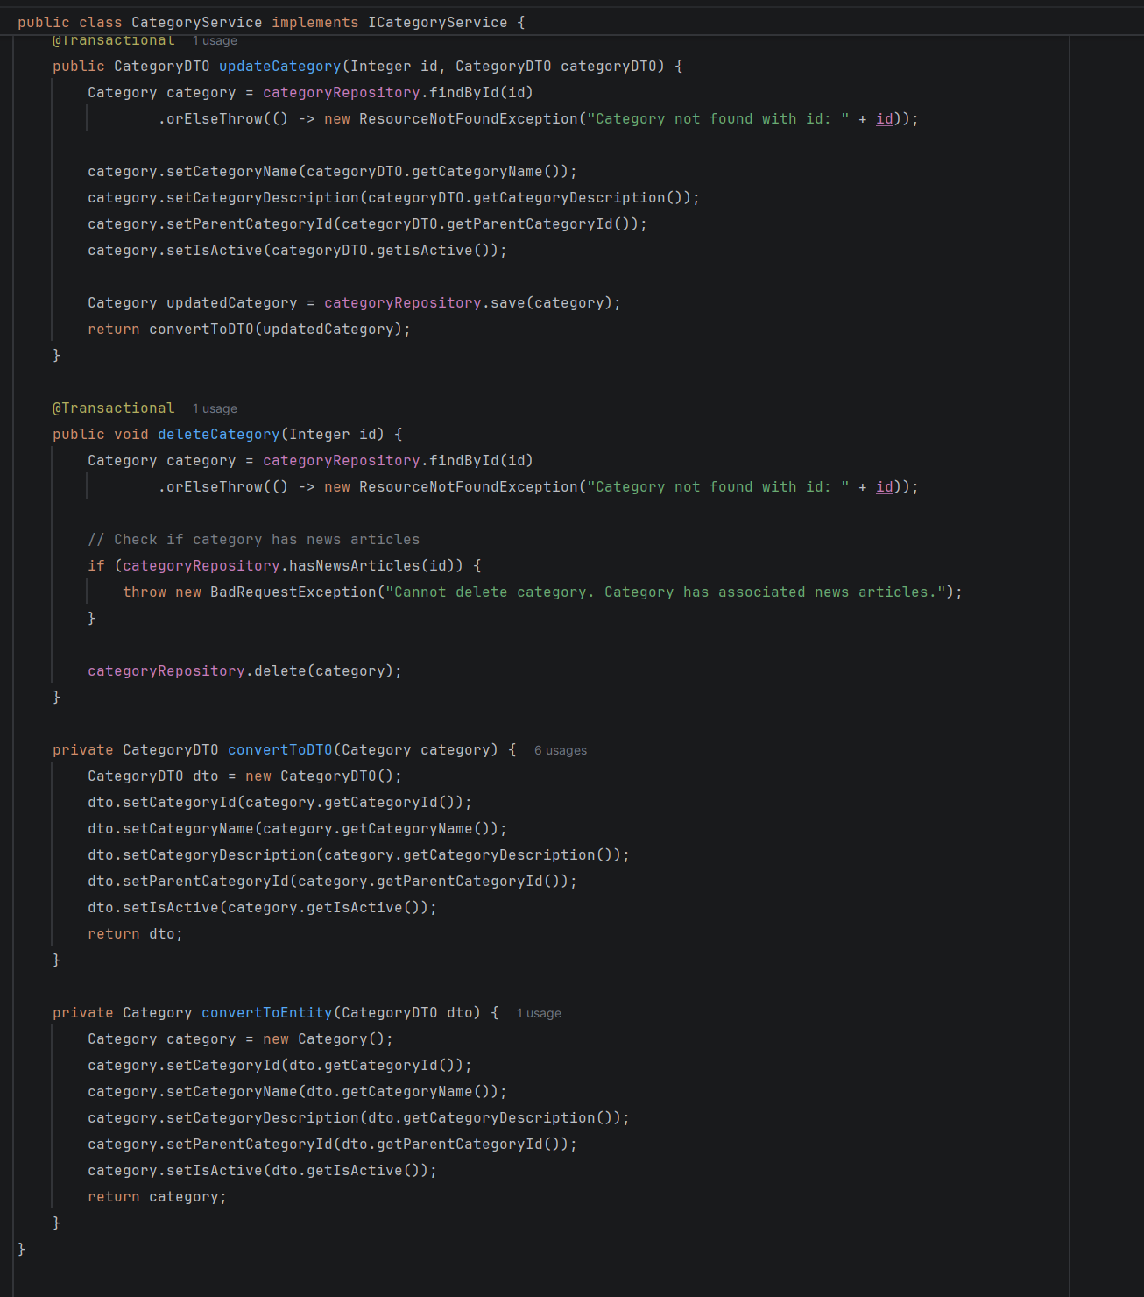

3.2. SystemAccount

SystemAccountController

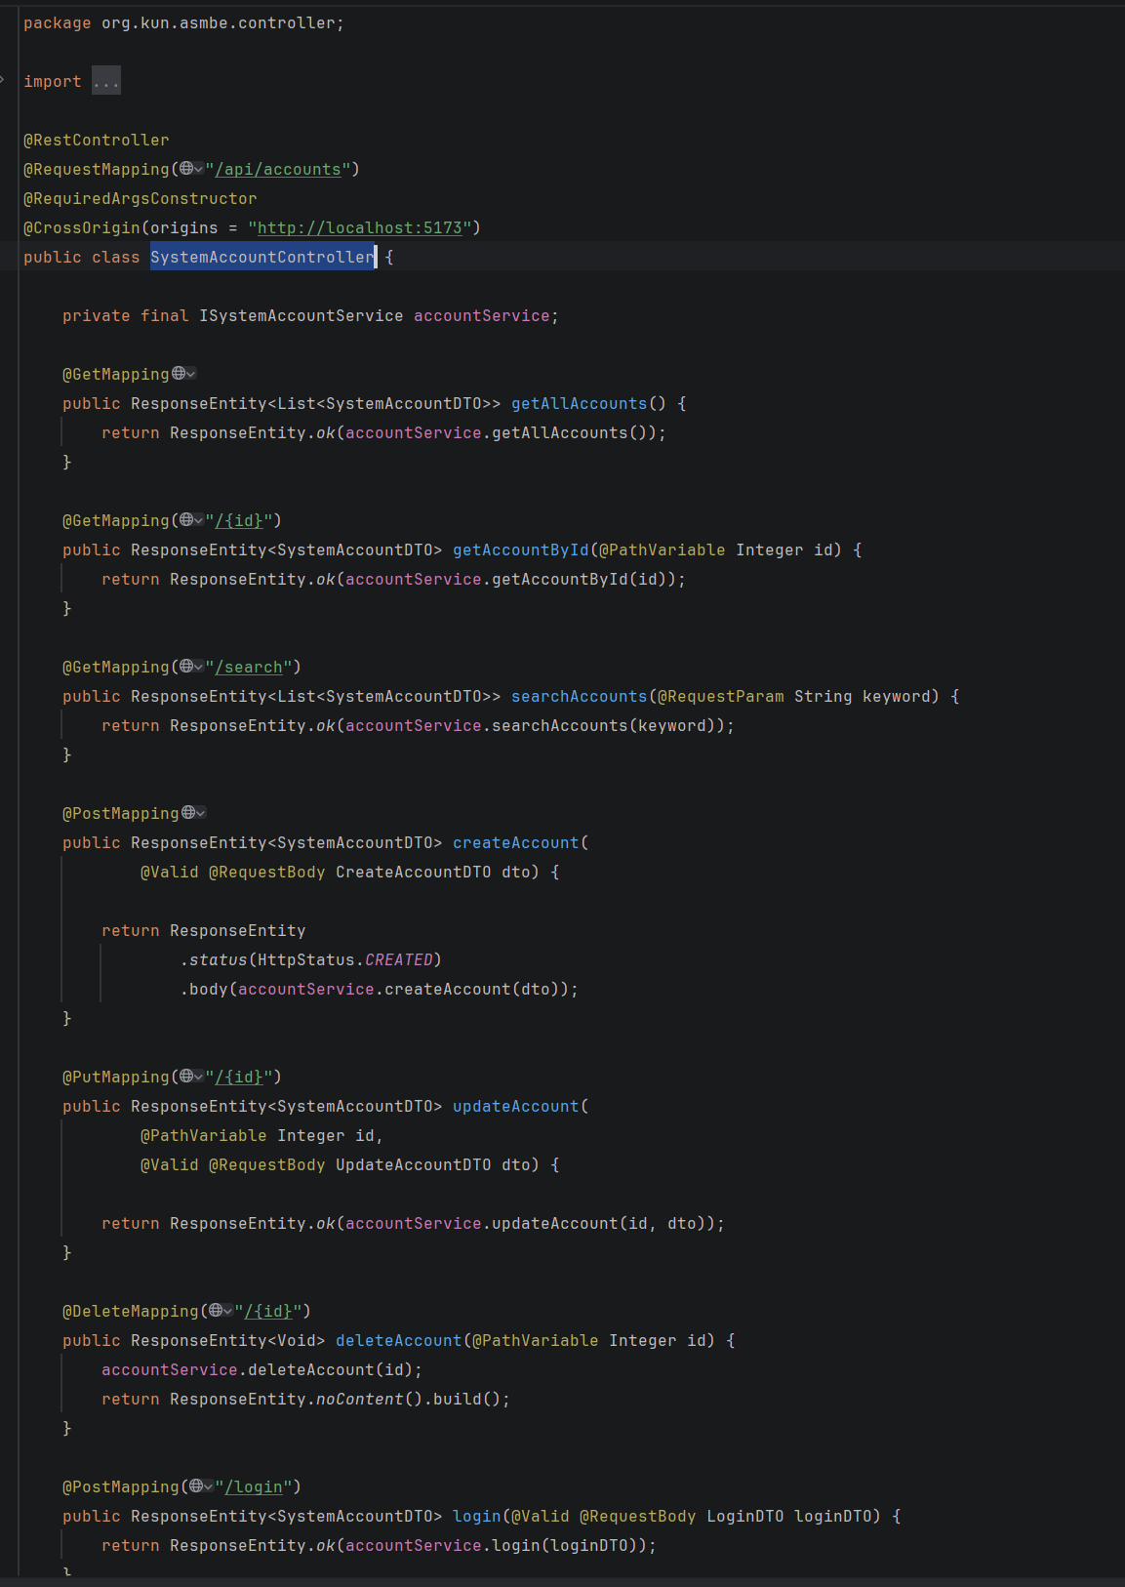
SystemAccountDTO
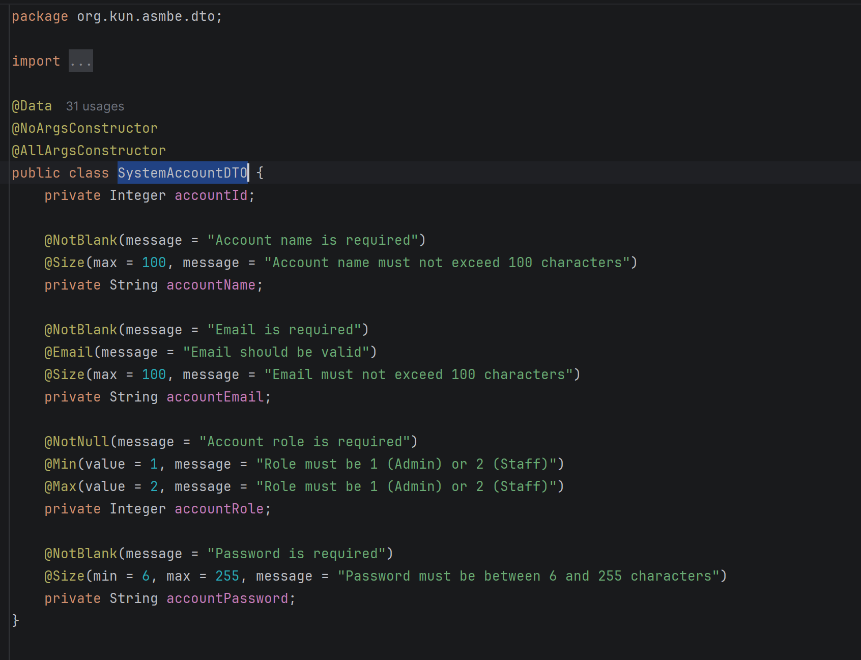
SystemAccount
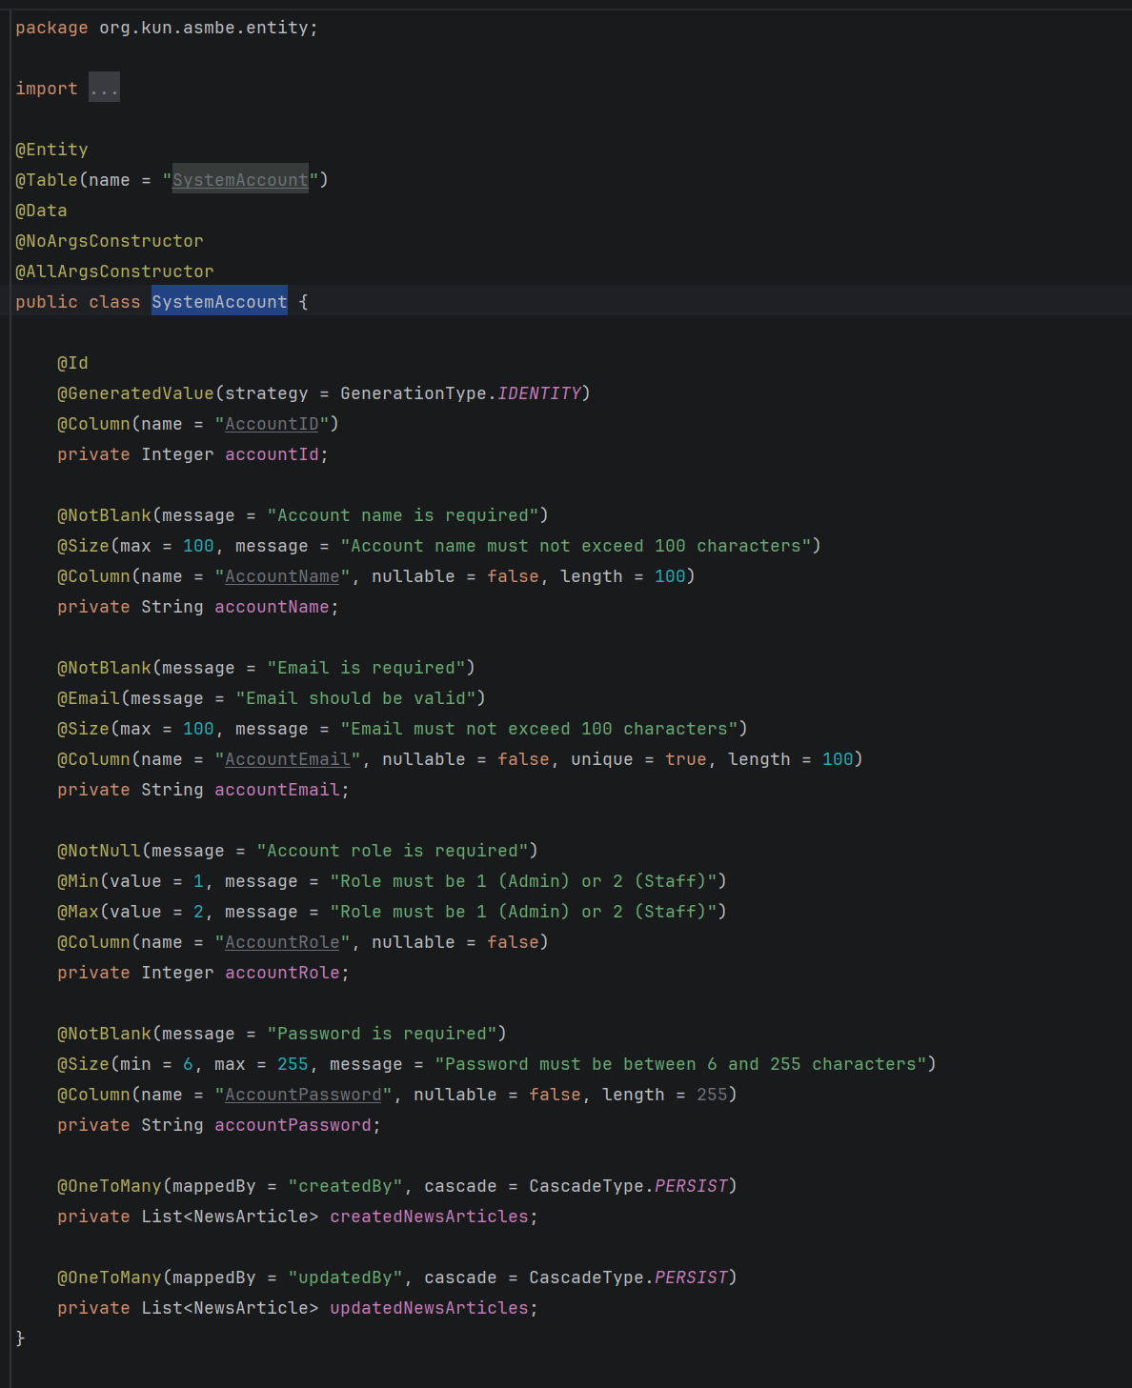
SystemAccountRepository
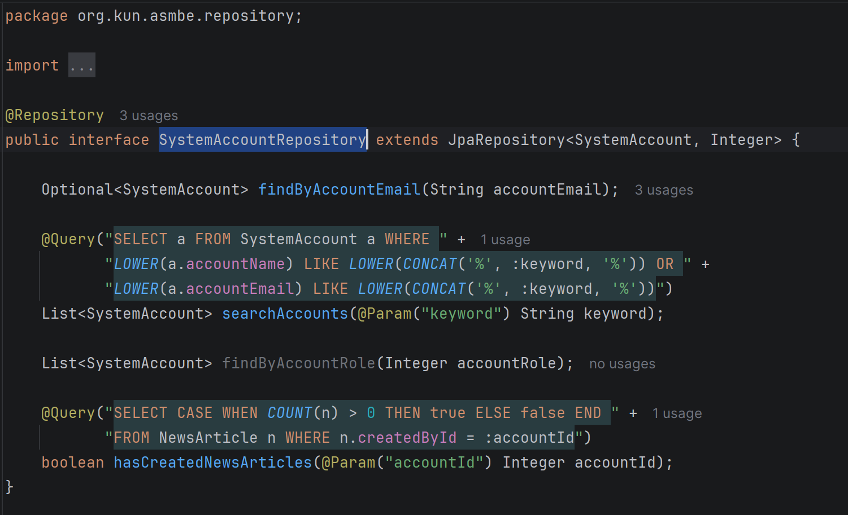
ISystemAccountService
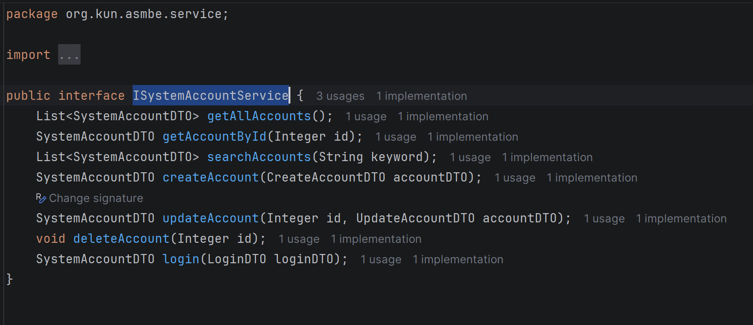
SystemAccountService
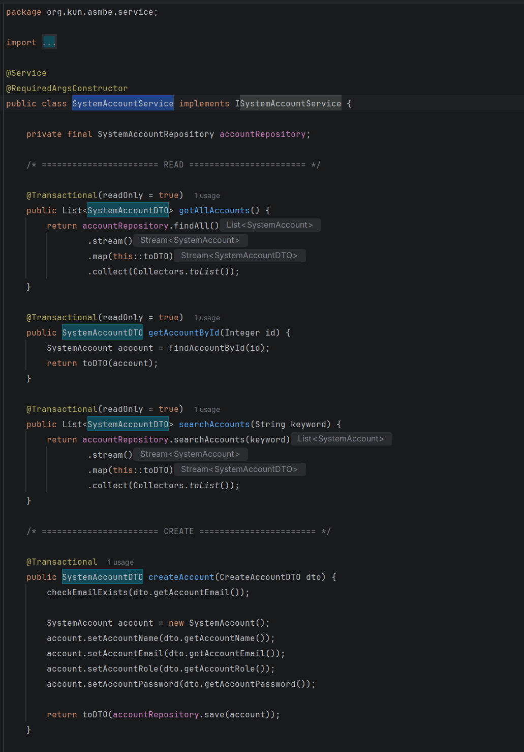
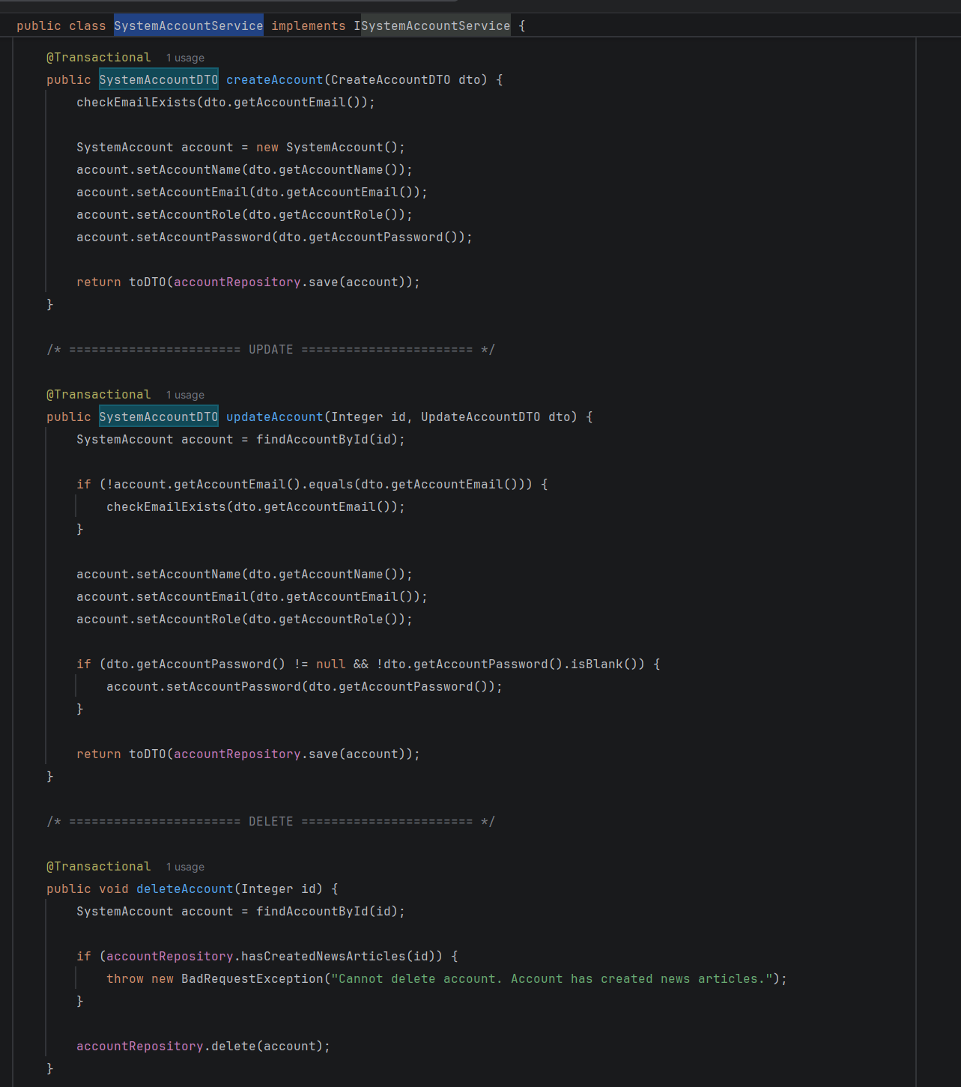
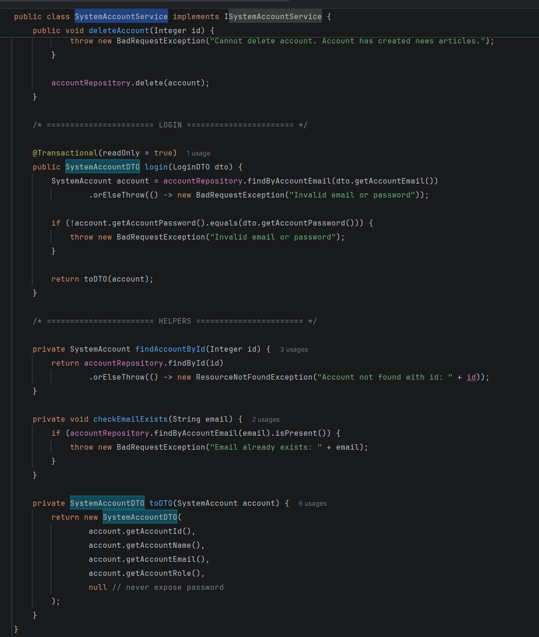

3.3 Sử dụng AdminLayout
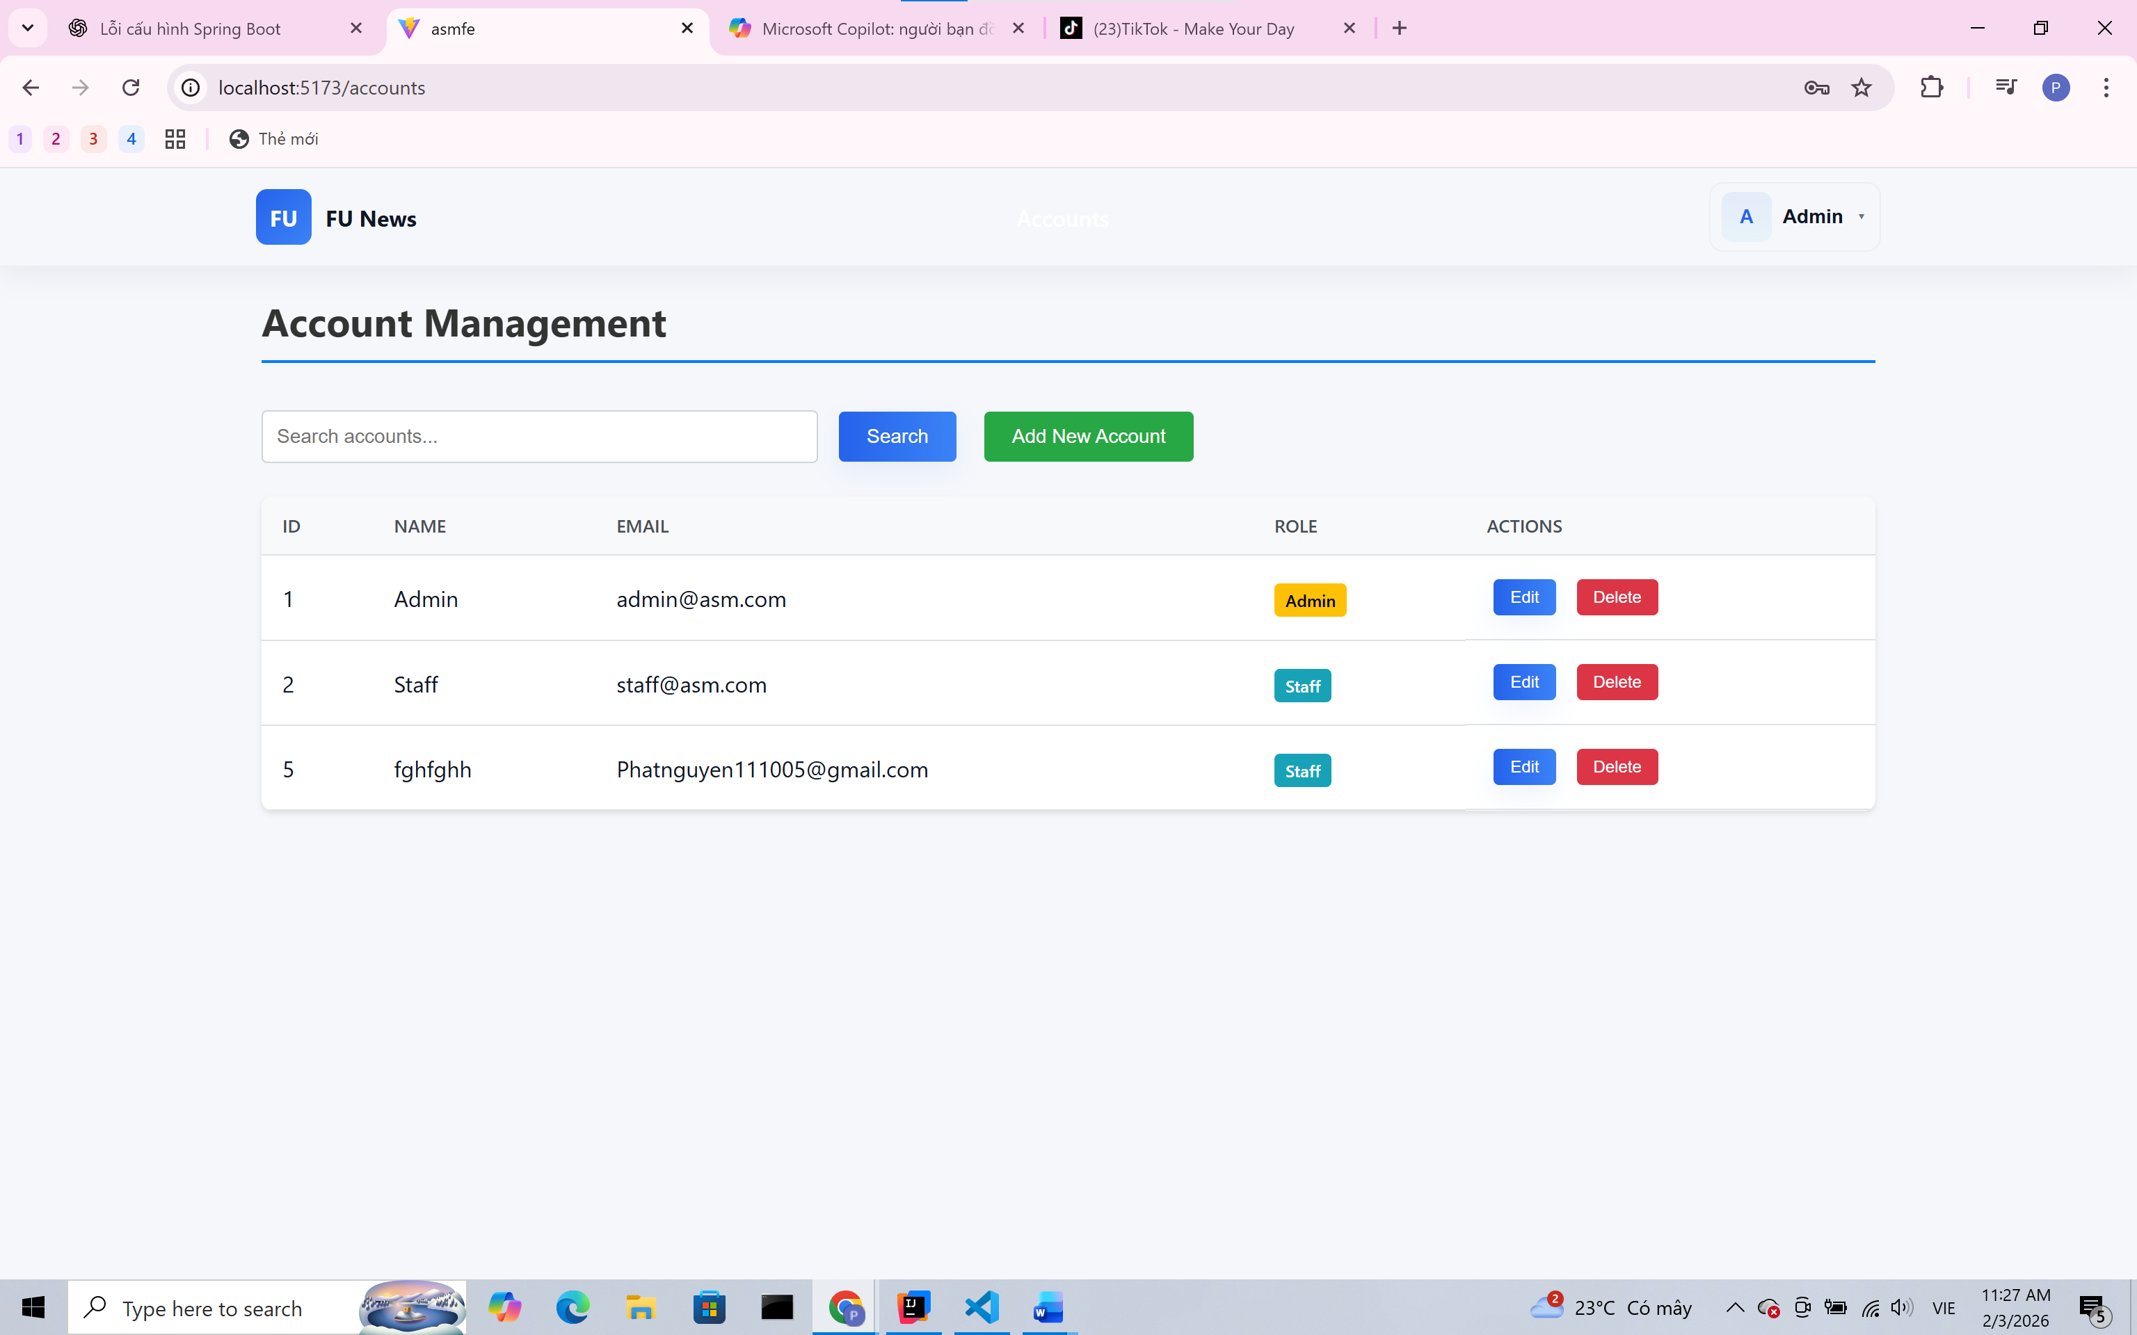

Sử dụng stafflayout
