# นางสาวภัทราวดี งามตะคุ รหัสนักศึกษา 633040171-8

# Lab 3 Problem 2: Learning from websites with good design

For the students who have ID that ends with 2, 8

* Comments on the web <https://www.behance.net/>

Unique content   
- The website has a sleek and modern design.  
- making it visually appealing and easy to navigate.

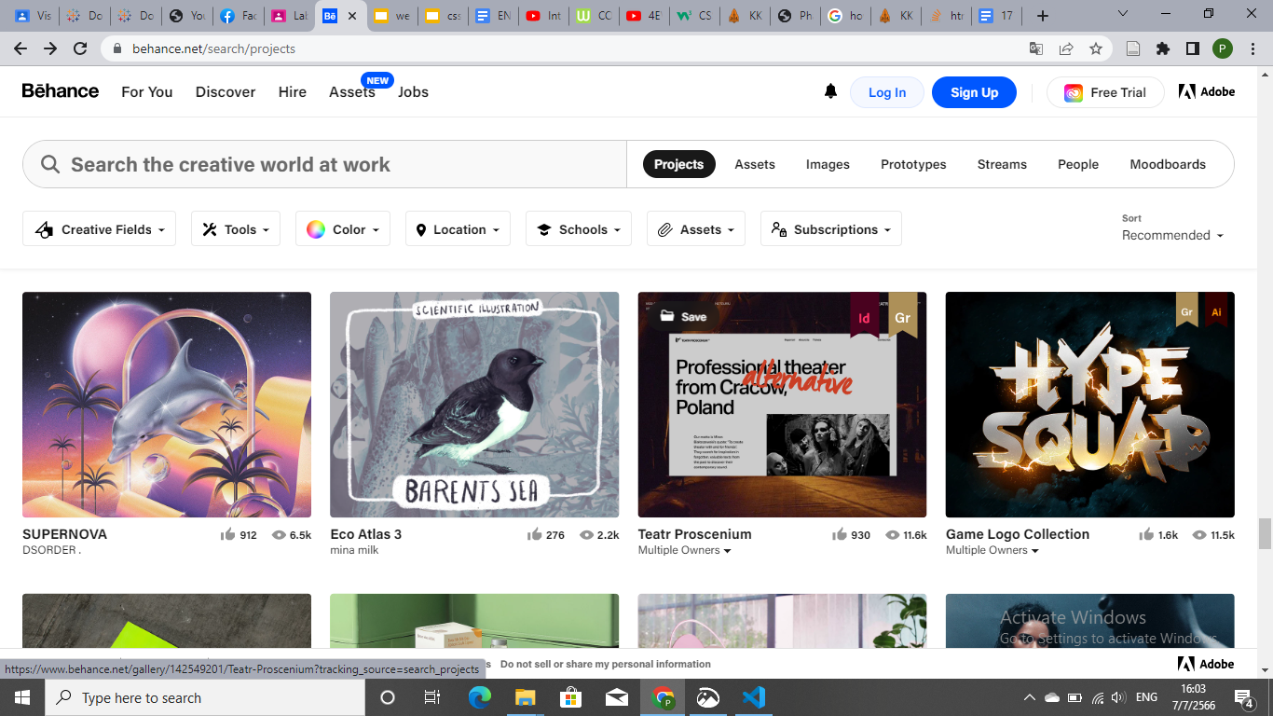

Fast loading webpages

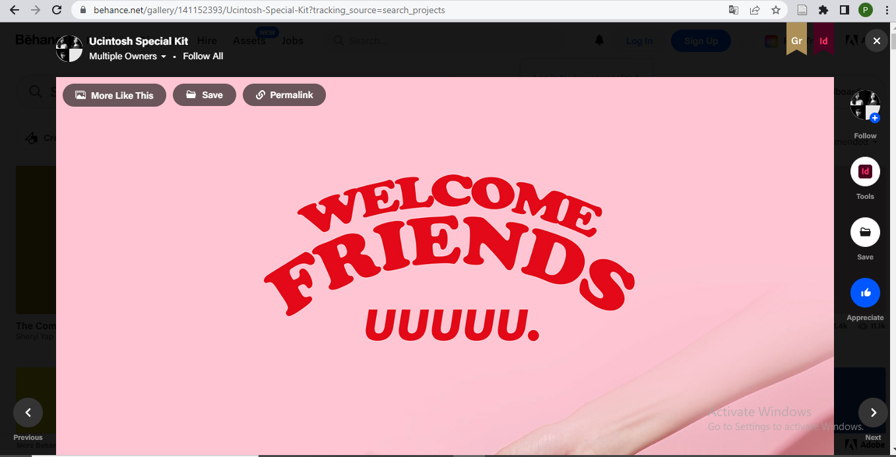

Create a Proper Content Structure

-Author Bio/Information, Sharing Options, follower.

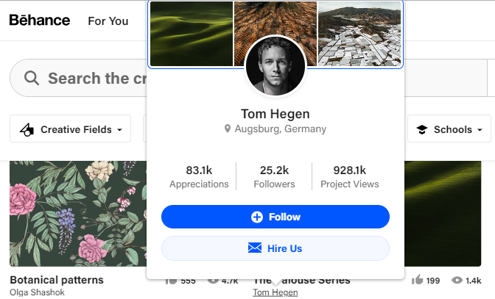

This is support for many languages, convenient to use.

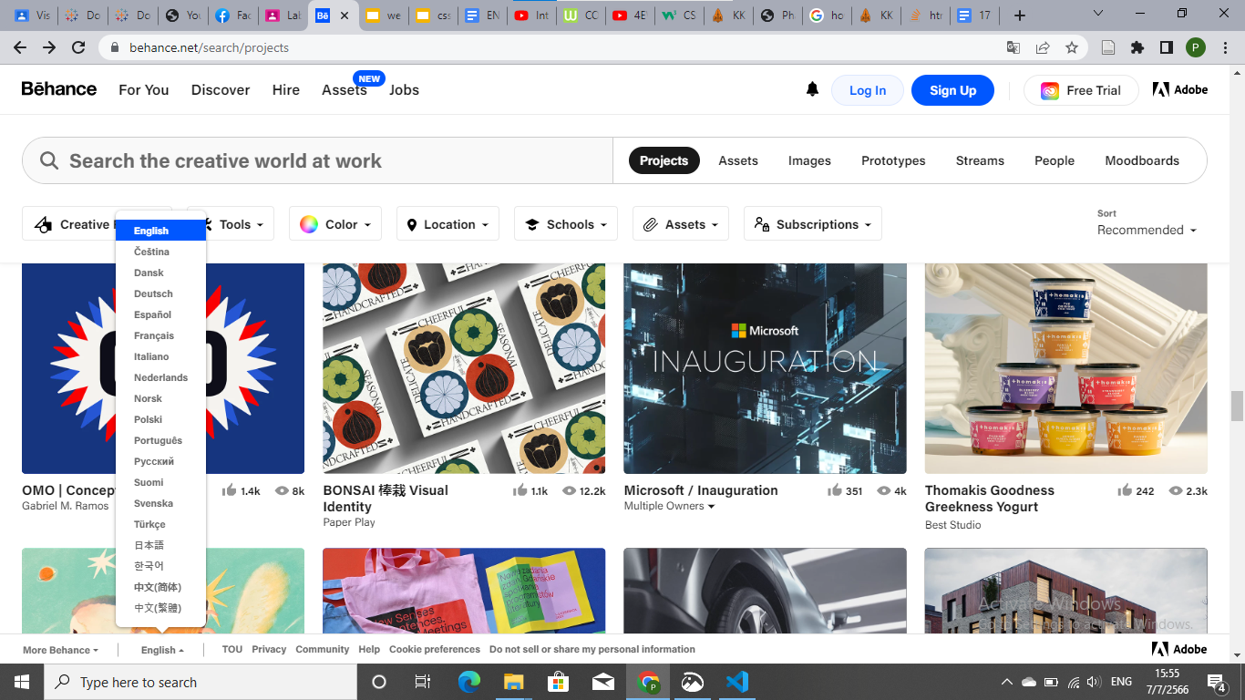

Footer is good , users can connect to multiple login channels.

