Phạm Bảo Hân 19127135

Phạm Đoàn Ngọc Trinh 19127302

Lab 1: DHCP configuration on CISCO router

Application implementation:

1. Open packet tracer, add devices ( router 1841, switch, PC0, PC1, PC2)
2. Setting for your router in CLI
3. Types in CLI:

*Router>enable*

*Router#configure terminal*

*Router(config)#*

*Router(config)# int fa0/0*

*Router (config-if)#ip address 192.168.10.1 255.255.255.0*

*Router (config-if)#exit*

*Router (config-if)#ip dhcp pool dhclab*

*Router(dhcp-config)# network 192.168.10.0 255.255.255.0*

*Router(dhcp-config)#default-router 192.168.10.1*

*Router(dhcp-config)#dns-server 192.168.10.2*

*Router(dhcp-config)# exit*

*Router(config)# ip dhcp excluded-address 192.168.10.1 192.168.10.10*

*Router(config)#ip dhcp excluded-address 192.168.10.248 192.168.10.254*

*Router(config)#exit*

*Router(config)#wr*

1. Chờ đến khi các đường nối bật xanh, vào các PC0,PC!, PC2 để kiểm tra

+ Nhấn vào PC0/1/2

+ Vào phần Desktop chọn IP Configuation

+ Chuyển từ Static sang DHCP (Nếu DHCP sẵn thì chọn static rồi chọn DHCP)

Answer questions:

*PC0*

*PC1*

*PC2*

What is the IP addresses of PC0, PC1, PC2 which were acquired from DHCP?

PC0: 192.168.10.12

PC1: 192.168.10.13

PC2: 192.168.10.14

What is the gateway addresses of PC0, PC1, PC2?

PC0: 192.168.10.1

PC1: 192.168.10.1

PC2: 192.168.10.1

Which server is the DNS server for PC0, PC1, PC2?

PC0: 192.168.10.2

PC1: 192.168.10.2

PC2: 192.168.10.2

Lab2: Static routing implementation

Application implementation:

* Configure IP address and default gate for each PC.
* Configure router and add the static routing by set network, mask, next hop for each router.

Answer question:

1. Execute ping commands and take screenshots the ping result between PC0 and PC2, PC3 and PC1

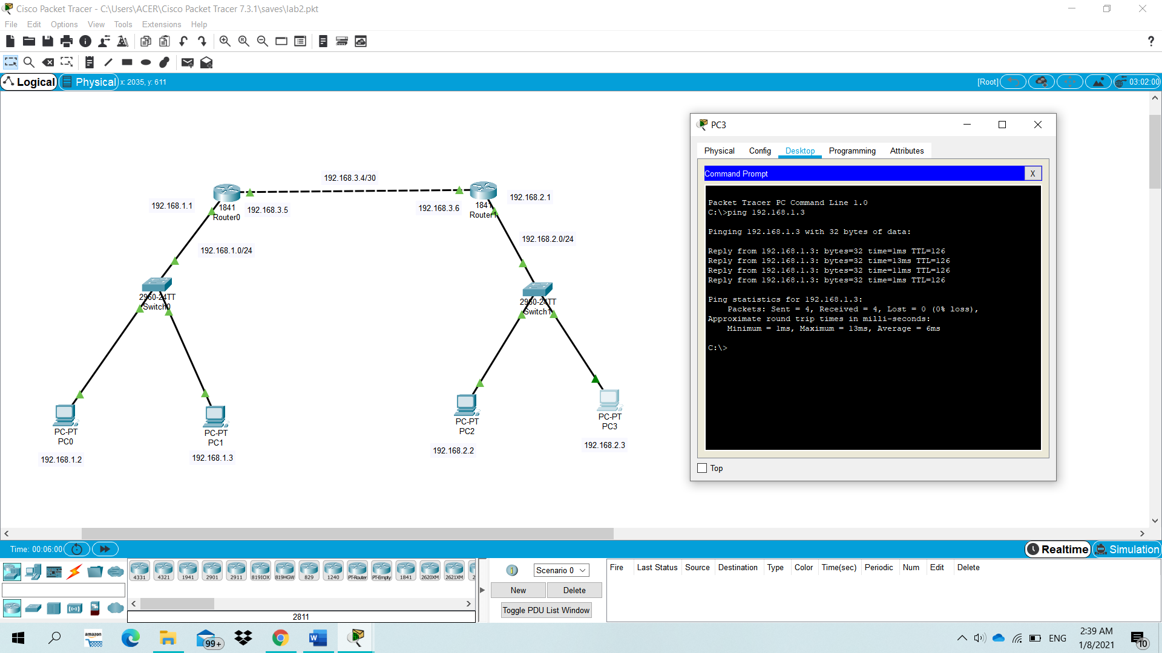

Ping from PC0 to PC2

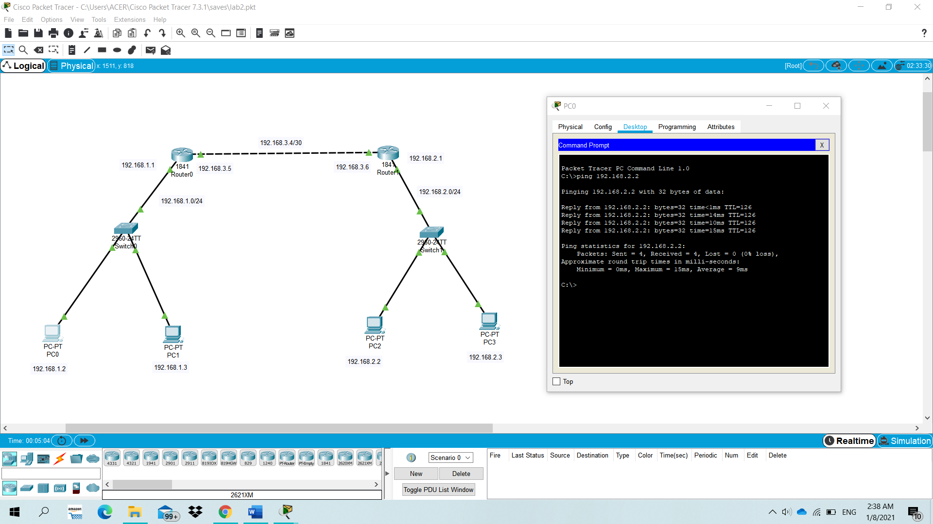

Ping from PC3 to PC1

1. Show the routing table of the router R0 (can use command or GUI to get the routing table).

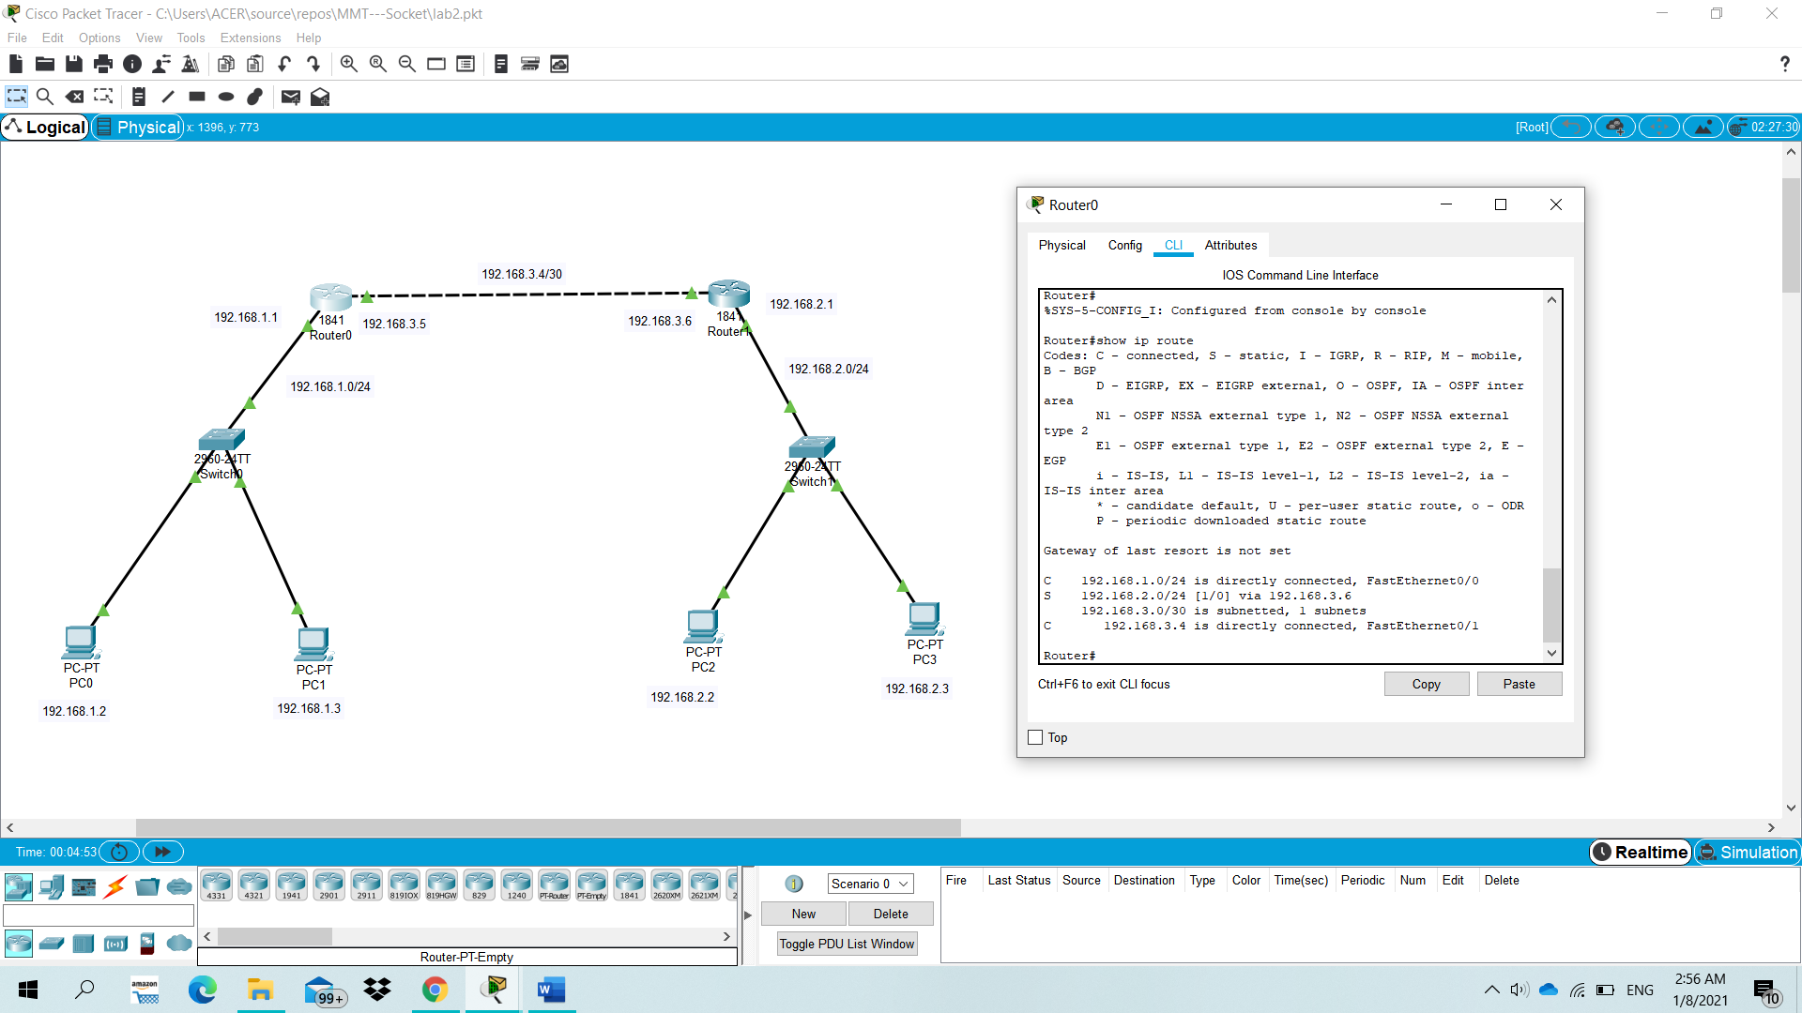

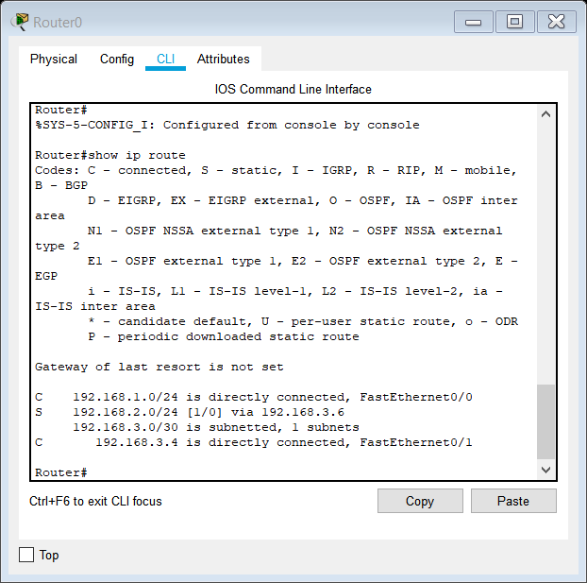

3. Which line in the routing table is configured by static route? What is the administrative distance (AD) and the metric of the static route?

Line is configured by static route in R0:

* The number in red square is the administrative distance (“1” means static route), the number in the blue square is the metric of static route (“0” is the cost of a route).

Lab 3: Implement the basic building network topology

Application implementation:

1. Open packet tracer, add devices ( router, switch, PC1, PC2..)
2. Add port for Router
3. Connect devices
4. Set the IP for interfaces of devices ( follow the table below in question 1)
5. Set the routing table, after that devices can ping with each other
6. Configure DHCP server

Answer questions:

1. Determine the “Device Type” of devices D1 and D2 in the “Device Table” and in the diagram to finish the network topology.

|  |  |  |  |
| --- | --- | --- | --- |
| **Device Name** | **Interface** | **IP address** | **Device Type** |
| R0 | S0/3/0 | 200.200.1.2/24 | Router |
| R1 | F0/0 | 172.16.3.1/24 | Router |
|  | F0/1 | 192.168.1.1/30 |  |
|  | F1/0 | 192.168.2.1/30 |  |
|  | S0/3/0 | 200.200.1.1/24 |  |
| R2 | F0/0 | 172.16.1.1/24 | Router |
|  | F0/1 | 192.168.1.2/30 |  |
|  | F1/0 | 192.168.3.1/30 |  |
| R3 (D2) | F0/1 | 192.168.2.2/30 | Router |
|  | F0/0 | 172.16.2.1/24 |  |
|  | F1/0 | 192.168.3.2/30 |  |
| SWITCH2 |  |  | Switch |
| WEB server |  | 172.16.3.100 |  |
| DNS-DHCP server |  | 172.16.3.200 |  |
| PC1 |  |  |  |
| PC2 |  |  |  |
| PC3 |  |  |  |
| PC4 |  |  |  |

1. Configure the DNS server and Web server for [www.network.com](http://www.network.com) and test to access it via a browser.

1. Configure the DHCP server to assign the IP addresses to PC1, PC2, PC3, PC4

1. Configure static routing for all routers so that all subnets can talk to each other.

***R1***

***R2***

***R3***

1. Execute ping command and take screenshots about the ping result from PC1 to PC3, PC4 to PC2. 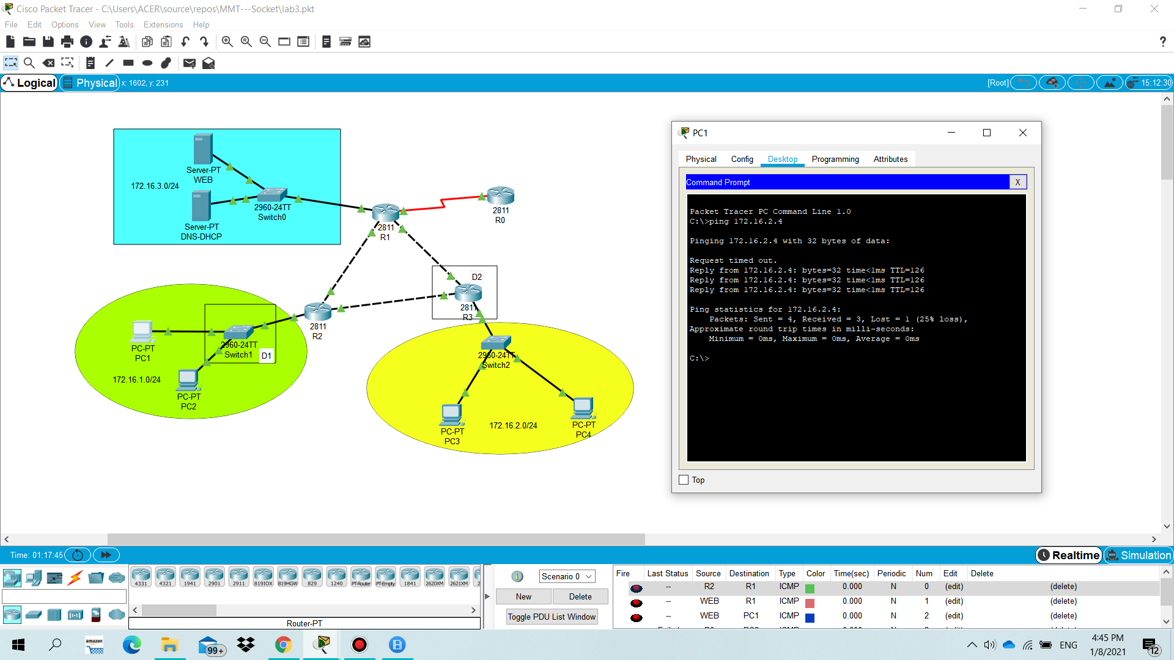

Ping from PC1 to PC3

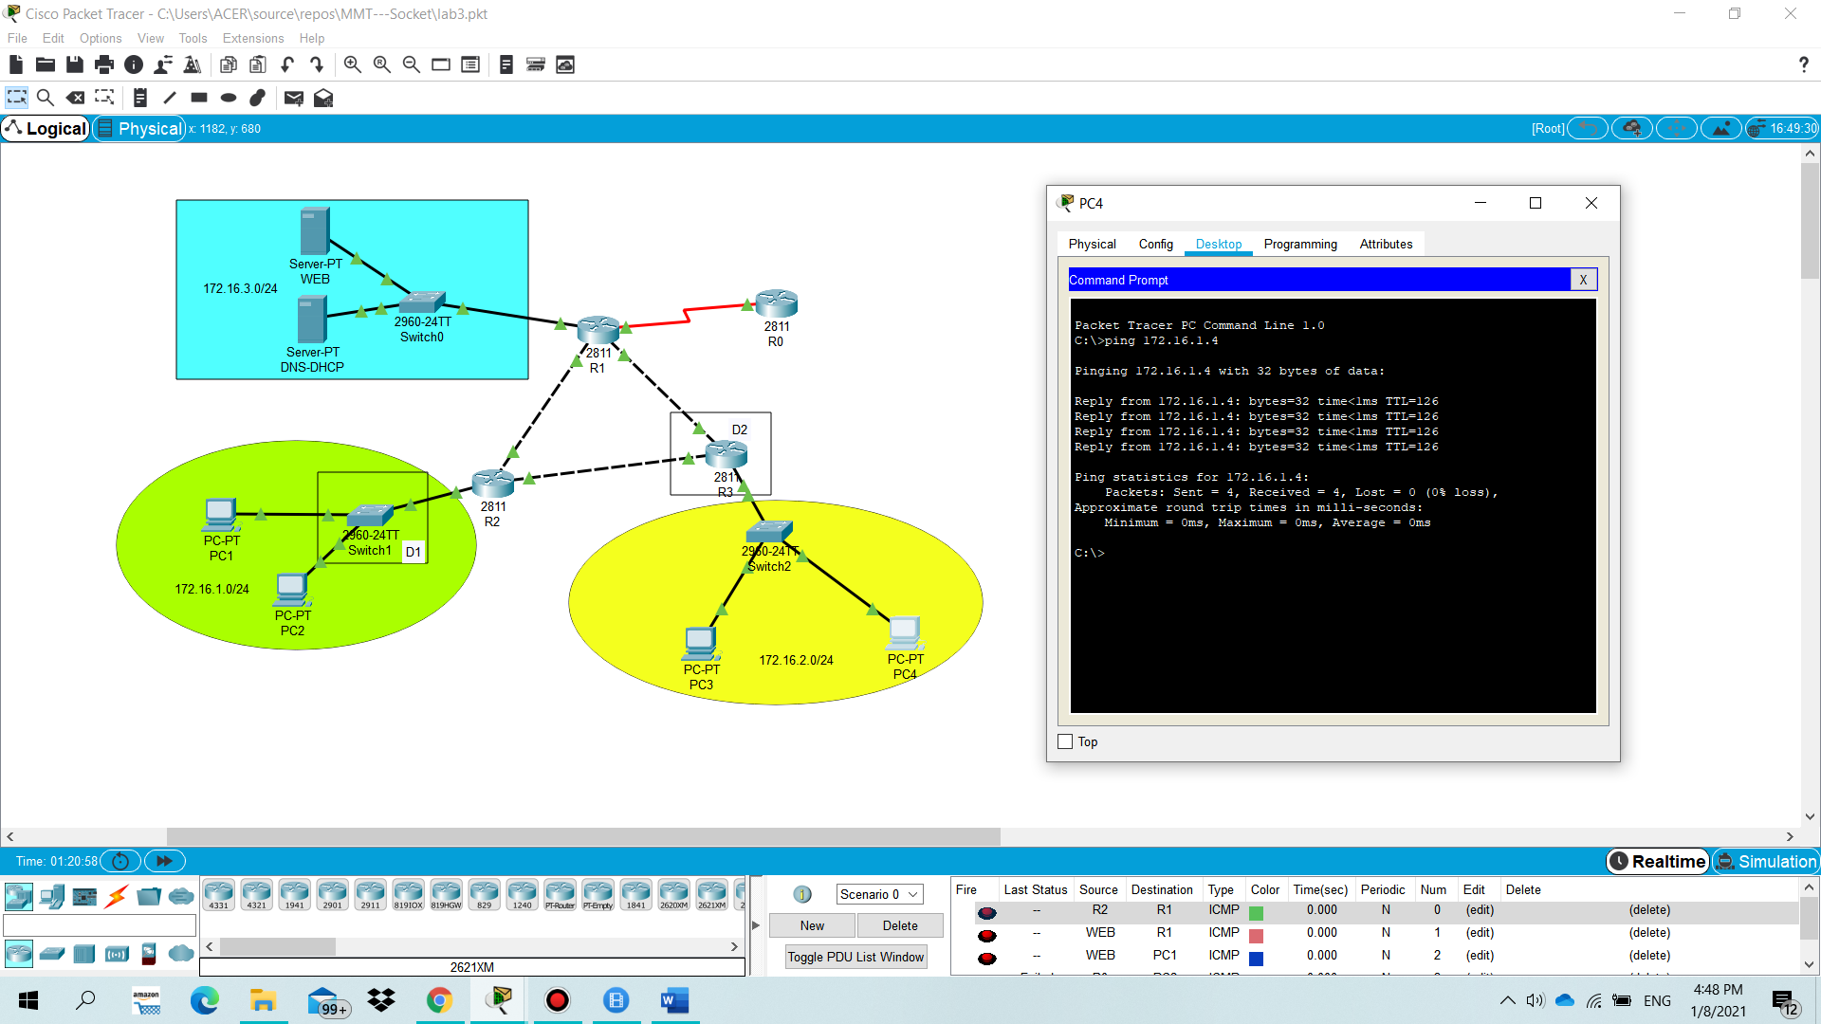

Ping from PC4 to PC2

1. Access the web pages at http://www.network.com address via web browser of PC1, PC3

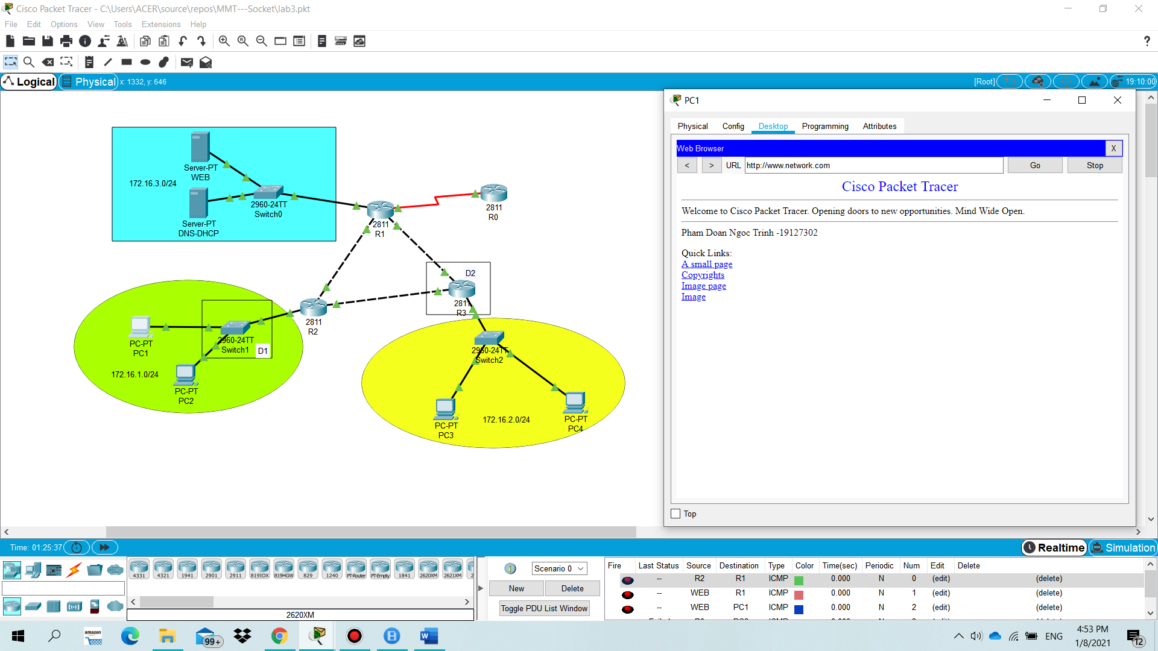

Access from PC1

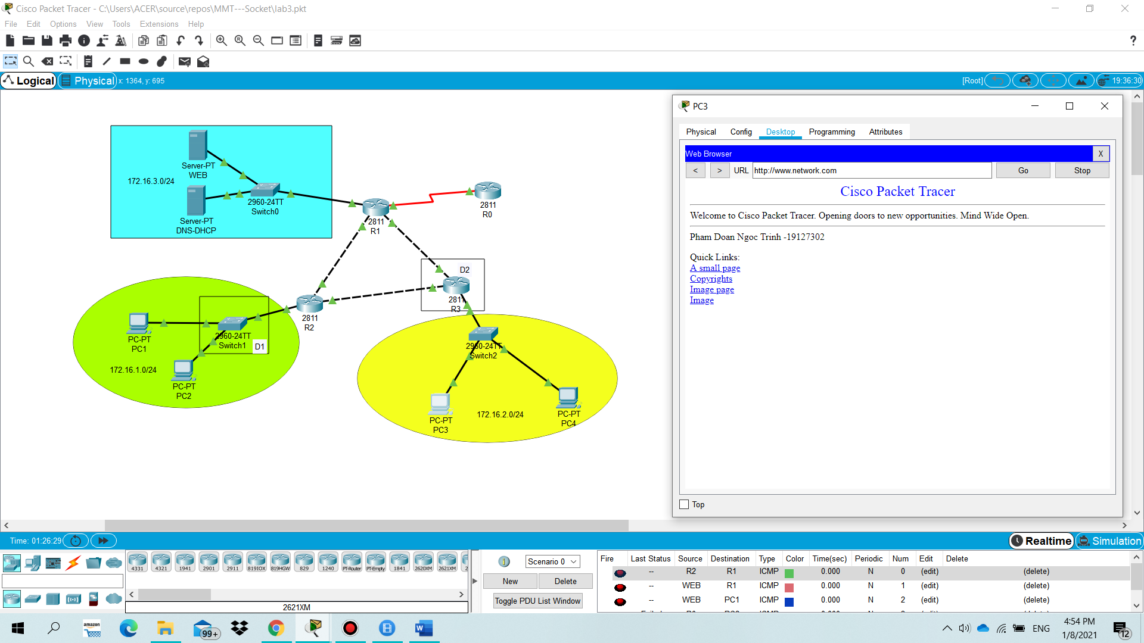

Access from PC3