**Let,const,var**

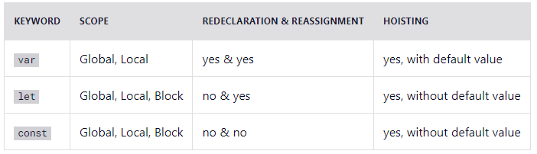

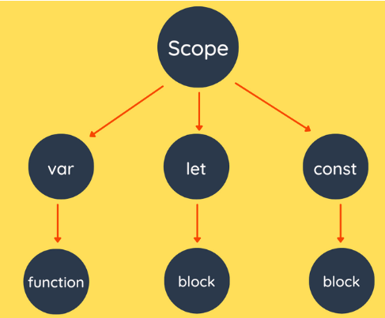

**Arrow Function**

let myFunction = (a, b) => a * b;

hello = function() {  
  return "Hello World!";  
}

hello = () => {  
  return "Hello World!";  
}

hello = () => "Hello World!";

hello = (val) => "Hello " + val;

hello = val => "Hello " + val;