Let,const,var
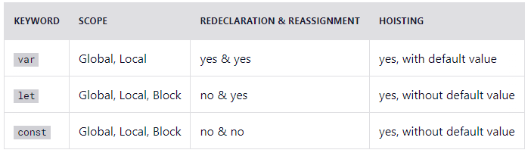

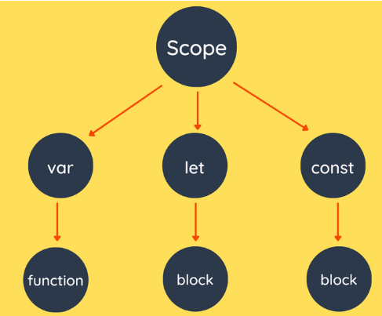

Arrow Function
let myFunction = (a, b) => a * b;
hello = function() {
return "Hello World!";
}
hello = () => {
return "Hello World!";
}

hello = () => "Hello World!";
hello = (val) => "Hello " + val;
hello = val => "Hello " + val;

