OZ

Maxwel C. Oliveira

November 21, 2016

### Dicamba drift model at 2nd trifoliate.

## Lack-of-fit test  
##   
## ModelDf RSS Df F value p value  
## ANOVA 72 1537.8   
## DRC model 88 2318.3 16 2.2840 0.0092

##   
## Model fitted: Log-logistic (ED50 as parameter) with lower limit at 0 (2 parms)  
##   
## Parameter estimates:  
##   
## Estimate Std. Error t-value p-value  
## b:Conventional -0.820199 0.110287 -7.436962 0  
## b:Glufosinate -0.867229 0.122850 -7.059280 0  
## b:Glyphosate -0.969437 0.151205 -6.411397 0  
## b:Organic -1.011442 0.138967 -7.278271 0  
## e:Conventional 0.362692 0.065020 5.578178 0  
## e:Glufosinate 0.416069 0.073886 5.631196 0  
## e:Glyphosate 0.607714 0.106606 5.700569 0  
## e:Organic 0.270604 0.043398 6.235343 0  
##   
## Residual standard error:  
##   
## 5.132622 (88 degrees of freedom)

**Dicamba drift at 2nd trifoliate** 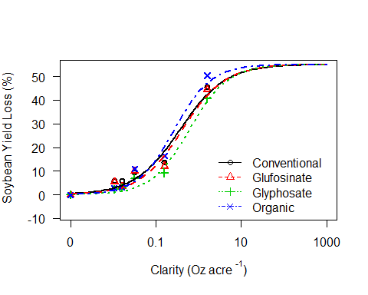

**ED's at 2nd Trifoliate**

##   
## Estimated effective doses  
##   
## Estimate Std. Error  
## e:Conventional:10 0.0248949 0.0095139  
## e:Conventional:20 0.0669109 0.0181763  
## e:Conventional:30 0.1290908 0.0274824  
## e:Conventional:40 0.2212305 0.0405719  
## e:Conventional:50 0.3626923 0.0650199  
## e:Glufosinate:10 0.0330240 0.0127397  
## e:Glufosinate:20 0.0841261 0.0231215  
## e:Glufosinate:30 0.1566216 0.0336809  
## e:Glufosinate:40 0.2606841 0.0479223  
## e:Glufosinate:50 0.4160686 0.0738864  
## e:Glyphosate:10 0.0630047 0.0246330  
## e:Glyphosate:20 0.1454315 0.0407986  
## e:Glyphosate:30 0.2535838 0.0556984  
## e:Glyphosate:40 0.3999969 0.0742918  
## e:Glyphosate:50 0.6077143 0.1066059  
## e:Organic:10 0.0308238 0.0100686  
## e:Organic:20 0.0687202 0.0162722  
## e:Organic:30 0.1170899 0.0221675  
## e:Organic:40 0.1812318 0.0299215  
## e:Organic:50 0.2706036 0.0433983

**Comparison of ED50 of drift at 2nd T**

##   
## Estimated ratios of effect doses  
##   
## Estimate Std. Error t-value p-value  
## Conventional/Glufosinate:50/50 0.8717129 0.2199640 -0.5832185 0.5612379  
## Conventional/Glyphosate:50/50 0.5968138 0.1496924 -2.6934310 0.0084677  
## Conventional/Organic:50/50 1.3403087 0.3223944 1.0555666 0.2940556  
## Glufosinate/Glyphosate:50/50 0.6846450 0.1708981 -1.8452809 0.0683600  
## Glufosinate/Organic:50/50 1.5375575 0.3679100 1.4611115 0.1475464  
## Glyphosate/Organic:50/50 2.2457735 0.5337815 2.3338643 0.0218812

### Dicamba drift model at R2.

## Lack-of-fit test  
##   
## ModelDf RSS Df F value p value  
## ANOVA 72 1356.5   
## DRC model 88 2152.6 16 2.6410 0.0026

##   
## Model fitted: Log-logistic (ED50 as parameter) with lower limit at 0 (2 parms)  
##   
## Parameter estimates:  
##   
## Estimate Std. Error t-value p-value  
## b:Conventional -1.361062 0.094322 -14.429933 0  
## b:Glufosinate -1.673263 0.155077 -10.789863 0  
## b:Glyphosate -1.178918 0.093270 -12.639853 0  
## b:Organic -1.630031 0.126695 -12.865751 0  
## e:Conventional 0.589393 0.053015 11.117444 0  
## e:Glufosinate 0.395143 0.036338 10.874173 0  
## e:Glyphosate 0.600862 0.053524 11.226084 0  
## e:Organic 0.525960 0.049075 10.717548 0  
##   
## Residual standard error:  
##   
## 4.945801 (88 degrees of freedom)

**Dicamba drift at R2.** 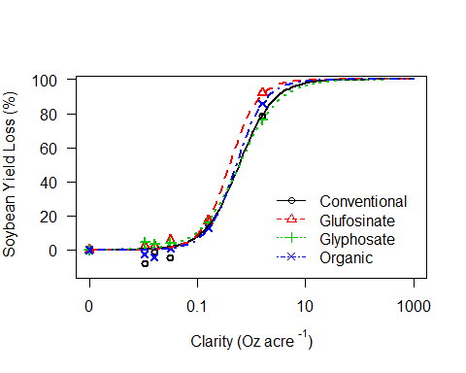

**ED's at R2**

##   
## Estimated effective doses  
##   
## Estimate Std. Error  
## e:Conventional:10 0.117302 0.017140  
## e:Conventional:20 0.212843 0.024769  
## e:Conventional:30 0.316261 0.032001  
## e:Conventional:40 0.437550 0.040704  
## e:Conventional:50 0.589393 0.053015  
## e:Conventional:60 0.793931 0.072677  
## e:Conventional:70 1.098411 0.107987  
## e:Conventional:80 1.632114 0.183233  
## e:Conventional:90 2.961462 0.417379  
## e:Glufosinate:10 0.106284 0.013345  
## e:Glufosinate:20 0.172561 0.016925  
## e:Glufosinate:30 0.238143 0.020987  
## e:Glufosinate:40 0.310110 0.026993  
## e:Glufosinate:50 0.395143 0.036338  
## e:Glufosinate:60 0.503492 0.051212  
## e:Glufosinate:70 0.655647 0.076327  
## e:Glufosinate:80 0.904828 0.125004  
## e:Glufosinate:90 1.469070 0.257696  
## e:Glyphosate:10 0.093186 0.016468  
## e:Glyphosate:20 0.185390 0.024573  
## e:Glyphosate:30 0.292849 0.031766  
## e:Glyphosate:40 0.425999 0.040328  
## e:Glyphosate:50 0.600862 0.053524  
## e:Glyphosate:60 0.847504 0.077624  
## e:Glyphosate:70 1.232838 0.126747  
## e:Glyphosate:80 1.947439 0.243319  
## e:Glyphosate:90 3.874338 0.649747  
## e:Organic:10 0.136628 0.019441  
## e:Organic:20 0.224697 0.026041  
## e:Organic:30 0.312755 0.032133  
## e:Organic:40 0.410132 0.039304  
## e:Organic:50 0.525960 0.049075  
## e:Organic:60 0.674500 0.063901  
## e:Organic:70 0.884507 0.088982  
## e:Organic:80 1.231141 0.138848  
## e:Organic:90 2.024727 0.279957

**Comparison of ED50 of drift at 2nd Trifoliate**

##   
## Estimated ratios of effect doses  
##   
## Estimate Std. Error t-value p-value  
## Conventional/Glufosinate:50/50 1.4915943 0.1918749 2.5620559 0.0121066  
## Conventional/Glyphosate:50/50 0.9809118 0.1241763 -0.1537187 0.8781835  
## Conventional/Organic:50/50 1.1206045 0.1452322 0.8304258 0.4085454  
## Glufosinate/Glyphosate:50/50 0.6576264 0.0841961 -4.0663822 0.0001037  
## Glufosinate/Organic:50/50 0.7512797 0.0984223 -2.5270717 0.0132885  
## Glyphosate/Organic:50/50 1.1424111 0.1473699 0.9663515 0.3365166