Dicamba Yield

Maxwel C. Oliveira

October 31, 2016

## Conventional soybeans at 2nd trifoliate.

##   
## Model fitted: Log-logistic (ED50 as parameter) with lower limit at 0 (2 parms)  
##   
## Parameter estimates:  
##   
## Estimate Std. Error t-value p-value  
## b:(Intercept) -0.88991 0.13210 -6.73644 0  
## e:(Intercept) 9.73660 1.78009 5.46972 0  
##   
## Residual standard error:  
##   
## 5.103888 (22 degrees of freedom)

## Lack-of-fit test  
##   
## ModelDf RSS Df F value p value  
## ANOVA 18 283.37   
## DRC model 22 573.09 4 4.6009 0.0098

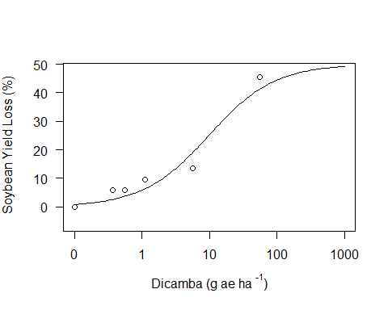

##   
## Estimated effective doses  
##   
## Estimate Std. Error  
## e:1:10 0.82436 0.33373  
## e:1:20 2.05054 0.59592  
## e:1:30 3.75759 0.85611  
## e:1:40 6.17351 1.19207  
## e:1:50 9.73660 1.78009

## Conventional soybeans at R2.

Conv<-Dicamba[(Dicamba$Soybean == 'Conventional'),]  
ConvR=drm(YL~RateM, subset=Stage=="Rtwo", fct=l3 (fixed =c(NA,85,NA)), data=Conv)   
modelFit(ConvR)

## Lack-of-fit test  
##   
## ModelDf RSS Df F value p value  
## ANOVA 18 332.97   
## DRC model 22 751.81 4 5.6605 0.0039

summary(ConvR)

##   
## Model fitted: Log-logistic (ED50 as parameter) with lower limit at 0 (2 parms)  
##   
## Parameter estimates:  
##   
## Estimate Std. Error t-value p-value  
## b:(Intercept) -1.83050 0.26704 -6.85469 0  
## e:(Intercept) 12.46746 1.88323 6.62027 0  
##   
## Residual standard error:  
##   
## 5.845799 (22 degrees of freedom)

plot(ConvR, ylim=c(-10,100), xlim=c(0,100), xlab = expression(paste("Dicamba (g ae ha "^"-1",")")), ylab = expression(paste("Soybean Yield Loss (%)")))

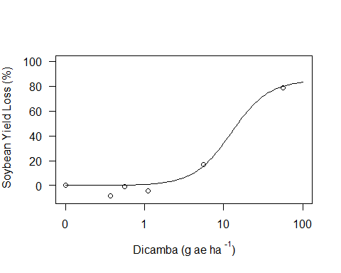

##   
## Estimated effective doses  
##   
## Estimate Std. Error  
## e:1:10 3.75386 0.53128  
## e:1:20 5.84621 0.68972  
## e:1:30 7.84790 0.94427  
## e:1:40 9.99033 1.32868  
## e:1:50 12.46746 1.88323  
## e:1:60 15.55881 2.69636  
## e:1:70 19.80628 3.97487  
## e:1:80 26.58777 6.29898  
## e:1:90 41.40743 12.20856

## Organic soybeans at 2nd trifoliate.

## Lack-of-fit test  
##   
## ModelDf RSS Df F value p value  
## ANOVA 18 458.98   
## DRC model 22 671.08 4 2.0795 0.1259

##   
## Model fitted: Log-logistic (ED50 as parameter) with lower limit at 0 (2 parms)  
##   
## Parameter estimates:  
##   
## Estimate Std. Error t-value p-value  
## b:(Intercept) -1.01144 0.14954 -6.76384 0  
## e:(Intercept) 9.47113 1.63448 5.79459 0  
##   
## Residual standard error:  
##   
## 5.523014 (22 degrees of freedom)

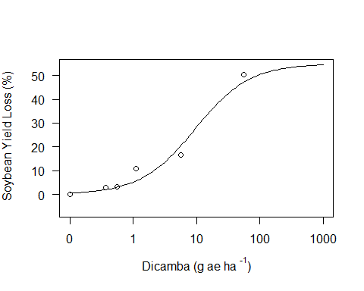

##   
## Estimated effective doses  
##   
## Estimate Std. Error  
## e:1:10 1.07883 0.37920  
## e:1:20 2.40520 0.61284  
## e:1:30 4.09814 0.83487  
## e:1:40 6.34311 1.12691  
## e:1:50 9.47113 1.63448

## Organic soybeans at R2.

## Lack-of-fit test  
##   
## ModelDf RSS Df F value p value  
## ANOVA 18 396.96   
## DRC model 22 505.25 4 1.2276 0.3341

##   
## Model fitted: Log-logistic (ED50 as parameter) with lower limit at 0 (2 parms)  
##   
## Parameter estimates:  
##   
## Estimate Std. Error t-value p-value  
## b:(Intercept) -2.10291 0.27903 -7.53658 0  
## e:(Intercept) 13.12113 1.67211 7.84707 0  
##   
## Residual standard error:  
##   
## 4.79229 (22 degrees of freedom)

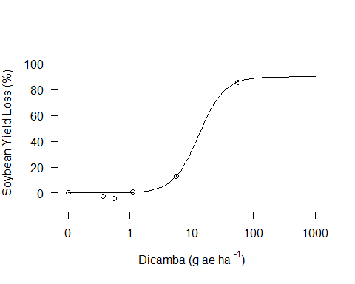

##   
## Estimated effective doses  
##   
## Estimate Std. Error  
## e:1:10 4.61529 0.52105  
## e:1:20 6.78692 0.66358  
## e:1:30 8.76974 0.89171  
## e:1:40 10.82018 1.21951  
## e:1:50 13.12113 1.67211  
## e:1:60 15.91140 2.31050  
## e:1:70 19.63161 3.27662  
## e:1:80 25.36704 4.95939  
## e:1:90 37.30300 8.99728

## Glyphosate soybeans at 2nd trifoliate.

## Lack-of-fit test  
##   
## ModelDf RSS Df F value p value  
## ANOVA 18 409.48   
## DRC model 22 572.49 4 1.7915 0.1746

##   
## Model fitted: Log-logistic (ED50 as parameter) with lower limit at 0 (2 parms)  
##   
## Parameter estimates:  
##   
## Estimate Std. Error t-value p-value  
## b:(Intercept) -1.26103 0.27305 -4.61836 1e-04  
## e:(Intercept) 13.03681 2.48886 5.23807 0e+00  
##   
## Residual standard error:  
##   
## 5.101219 (22 degrees of freedom)

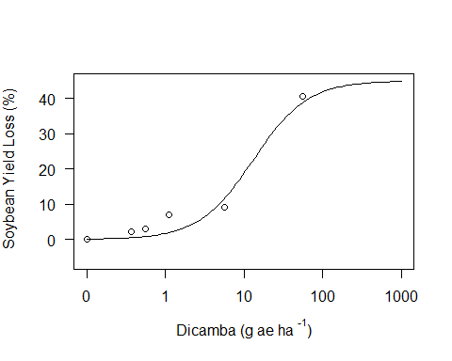

##   
## Estimated effective doses  
##   
## Estimate Std. Error  
## e:1:10 2.28273 0.95588  
## e:1:20 4.34246 1.30951  
## e:1:30 6.65832 1.57968  
## e:1:40 9.45215 1.90594  
## e:1:50 13.03681 2.48886

## Glyphosate soybeans at R2.

## Lack-of-fit test  
##   
## ModelDf RSS Df F value p value  
## ANOVA 18 236.15   
## DRC model 22 360.27 4 2.3651 0.0916

##   
## Model fitted: Log-logistic (ED50 as parameter) with lower limit at 0 (2 parms)  
##   
## Parameter estimates:  
##   
## Estimate Std. Error t-value p-value  
## b:(Intercept) -1.50946 0.12729 -11.85854 0  
## e:(Intercept) 13.92375 1.18179 11.78195 0  
##   
## Residual standard error:  
##   
## 4.046702 (22 degrees of freedom)

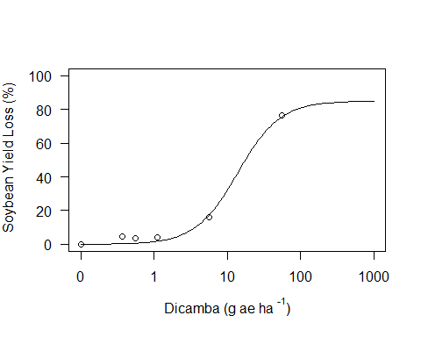

##   
## Estimated effective doses  
##   
## Estimate Std. Error  
## e:1:10 3.24773 0.42515  
## e:1:20 5.55773 0.55471  
## e:1:30 7.94283 0.68623  
## e:1:40 10.64382 0.87573  
## e:1:50 13.92375 1.18179  
## e:1:60 18.21440 1.69547  
## e:1:70 24.40827 2.60892  
## e:1:80 34.88308 4.47291  
## e:1:90 59.69419 9.88236

## Glufosinate soybeans at 2nd.

## Lack-of-fit test  
##   
## ModelDf RSS Df F value p value  
## ANOVA 18 385.93   
## DRC model 22 677.38 4 3.3984 0.0308

##   
## Model fitted: Log-logistic (ED50 as parameter) with lower limit at 0 (2 parms)  
##   
## Parameter estimates:  
##   
## Estimate Std. Error t-value p-value  
## b:(Intercept) -0.94982 0.16599 -5.72230 0  
## e:(Intercept) 11.28990 2.23117 5.06008 0  
##   
## Residual standard error:  
##   
## 5.548887 (22 degrees of freedom)

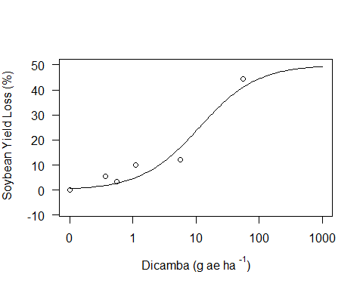

##   
## Estimated effective doses  
##   
## Estimate Std. Error  
## e:1:10 1.11696 0.50208  
## e:1:20 2.62315 0.84530  
## e:1:30 4.62672 1.16309  
## e:1:40 7.36709 1.55483  
## e:1:50 11.28990 2.23117

## Glufosinate soybeans at R2.

## Lack-of-fit test  
##   
## ModelDf RSS Df F value p value  
## ANOVA 18 390.39   
## DRC model 22 486.76 4 1.1108 0.3820

##   
## Model fitted: Log-logistic (ED50 as parameter) with lower limit at 0 (2 parms)  
##   
## Parameter estimates:  
##   
## Estimate Std. Error t-value p-value  
## b:(Intercept) -1.67341 0.14753 -11.34276 0  
## e:(Intercept) 13.82896 1.20957 11.43297 0  
##   
## Residual standard error:  
##   
## 4.703751 (22 degrees of freedom)

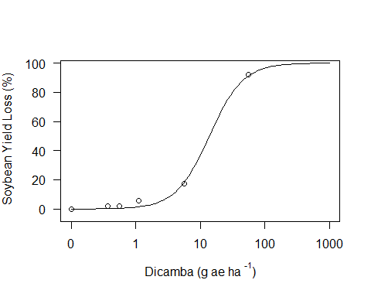

##   
## Estimated effective doses  
##   
## Estimate Std. Error  
## e:1:10 3.72006 0.44421  
## e:1:20 6.03961 0.56332  
## e:1:30 8.33476 0.69853  
## e:1:40 10.85326 0.89849  
## e:1:50 13.82896 1.20957  
## e:1:60 17.62052 1.70473  
## e:1:70 22.94490 2.54078  
## e:1:80 31.66433 4.16113  
## e:1:90 51.40776 8.57787

### Plot at 2nd Trifoliate

## Lack-of-fit test  
##   
## ModelDf RSS Df F value p value  
## ANOVA 72 1537.8   
## DRC model 88 2318.3 16 2.2840 0.0092

##   
## Model fitted: Log-logistic (ED50 as parameter) with lower limit at 0 (2 parms)  
##   
## Parameter estimates:  
##   
## Estimate Std. Error t-value p-value  
## b:Conventional -0.82020 0.11029 -7.43696 0  
## b:Glufosinate -0.86723 0.12285 -7.05928 0  
## b:Glyphosate -0.96944 0.15121 -6.41140 0  
## b:Organic -1.01144 0.13897 -7.27827 0  
## e:Conventional 12.69423 2.27570 5.57818 0  
## e:Glufosinate 14.56240 2.58602 5.63120 0  
## e:Glyphosate 21.27000 3.73121 5.70057 0  
## e:Organic 9.47112 1.51894 6.23534 0  
##   
## Residual standard error:  
##   
## 5.132622 (88 degrees of freedom)

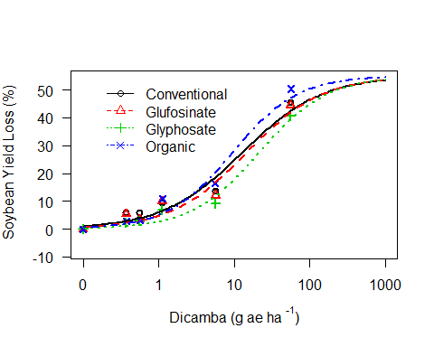

## ED's at 2nd Trifoliate

##   
## Estimated effective doses  
##   
## Estimate Std. Error  
## e:Conventional:10 0.87132 0.33299  
## e:Conventional:20 2.34188 0.63617  
## e:Conventional:30 4.51818 0.96188  
## e:Conventional:40 7.74307 1.42002  
## e:Conventional:50 12.69423 2.27570  
## e:Glufosinate:10 1.15584 0.44589  
## e:Glufosinate:20 2.94441 0.80925  
## e:Glufosinate:30 5.48176 1.17883  
## e:Glufosinate:40 9.12394 1.67728  
## e:Glufosinate:50 14.56240 2.58602  
## e:Glyphosate:10 2.20516 0.86215  
## e:Glyphosate:20 5.09010 1.42795  
## e:Glyphosate:30 8.87543 1.94944  
## e:Glyphosate:40 13.99989 2.60021  
## e:Glyphosate:50 21.27000 3.73121  
## e:Organic:10 1.07883 0.35240  
## e:Organic:20 2.40521 0.56953  
## e:Organic:30 4.09815 0.77586  
## e:Organic:40 6.34311 1.04725  
## e:Organic:50 9.47112 1.51894

## Comparison of ED50 of drift at 2nd T

##   
## Estimated ratios of effect doses  
##   
## Estimate Std. Error t-value p-value  
## Conventional/Glufosinate:50/50 0.8717129 0.2199640 -0.5832186 0.5612379  
## Conventional/Glyphosate:50/50 0.5968138 0.1496924 -2.6934310 0.0084677  
## Conventional/Organic:50/50 1.3403087 0.3223944 1.0555666 0.2940556  
## Glufosinate/Glyphosate:50/50 0.6846450 0.1708981 -1.8452809 0.0683600  
## Glufosinate/Organic:50/50 1.5375575 0.3679100 1.4611115 0.1475464  
## Glyphosate/Organic:50/50 2.2457735 0.5337815 2.3338643 0.0218812

### Plot at 2nd Trifoliate

## Lack-of-fit test  
##   
## ModelDf RSS Df F value p value  
## ANOVA 72 1356.5   
## DRC model 88 2152.6 16 2.6410 0.0026

##   
## Model fitted: Log-logistic (ED50 as parameter) with lower limit at 0 (2 parms)  
##   
## Parameter estimates:  
##   
## Estimate Std. Error t-value p-value  
## b:Conventional -1.361062 0.094322 -14.429933 0  
## b:Glufosinate -1.673263 0.155077 -10.789863 0  
## b:Glyphosate -1.178918 0.093270 -12.639853 0  
## b:Organic -1.630031 0.126695 -12.865751 0  
## e:Conventional 20.628757 1.855531 11.117444 0  
## e:Glufosinate 13.830005 1.271821 10.874173 0  
## e:Glyphosate 21.030186 1.873332 11.226084 0  
## e:Organic 18.408597 1.717613 10.717548 0  
##   
## Residual standard error:  
##   
## 4.945801 (88 degrees of freedom)

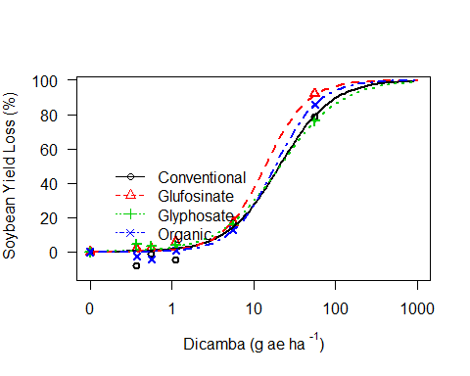

## ED's at R2.

##   
## Estimated effective doses  
##   
## Estimate Std. Error  
## e:Conventional:10 4.10556 0.59989  
## e:Conventional:20 7.44951 0.86691  
## e:Conventional:30 11.06912 1.12004  
## e:Conventional:40 15.31423 1.42465  
## e:Conventional:50 20.62876 1.85553  
## e:Conventional:60 27.78759 2.54371  
## e:Conventional:70 38.44439 3.77954  
## e:Conventional:80 57.12401 6.41314  
## e:Conventional:90 103.65118 14.60825  
## e:Glufosinate:10 3.71992 0.46708  
## e:Glufosinate:20 6.03963 0.59236  
## e:Glufosinate:30 8.33502 0.73454  
## e:Glufosinate:40 10.85386 0.94477  
## e:Glufosinate:50 13.83001 1.27182  
## e:Glufosinate:60 17.62222 1.79242  
## e:Glufosinate:70 22.94764 2.67144  
## e:Glufosinate:80 31.66899 4.37515  
## e:Glufosinate:90 51.41746 9.01935  
## e:Glyphosate:10 3.26152 0.57636  
## e:Glyphosate:20 6.48865 0.86006  
## e:Glyphosate:30 10.24972 1.11182  
## e:Glyphosate:40 14.90995 1.41147  
## e:Glyphosate:50 21.03019 1.87333  
## e:Glyphosate:60 29.66265 2.71684  
## e:Glyphosate:70 43.14933 4.43613  
## e:Glyphosate:80 68.16035 8.51615  
## e:Glyphosate:90 135.60182 22.74114  
## e:Organic:10 4.78197 0.68044  
## e:Organic:20 7.86440 0.91145  
## e:Organic:30 10.94642 1.12465  
## e:Organic:40 14.35461 1.37563  
## e:Organic:50 18.40860 1.71761  
## e:Organic:60 23.60751 2.23655  
## e:Organic:70 30.95773 3.11436  
## e:Organic:80 43.08992 4.85968  
## e:Organic:90 70.86545 9.79851

## Comparison of ED50 of drift at 2nd T.

##   
## Estimated ratios of effect doses  
##   
## Estimate Std. Error t-value p-value  
## Conventional/Glufosinate:50/50 1.4915943 0.1918749 2.5620559 0.0121066  
## Conventional/Glyphosate:50/50 0.9809118 0.1241763 -0.1537187 0.8781835  
## Conventional/Organic:50/50 1.1206045 0.1452322 0.8304258 0.4085454  
## Glufosinate/Glyphosate:50/50 0.6576264 0.0841961 -4.0663822 0.0001037  
## Glufosinate/Organic:50/50 0.7512797 0.0984223 -2.5270717 0.0132885  
## Glyphosate/Organic:50/50 1.1424111 0.1473699 0.9663515 0.3365166