Yield Loss

Maxwel C. Oliveira

November 2, 2016

### Dicamba drift model at 2nd trifoliate.

## Lack-of-fit test  
##   
## ModelDf RSS Df F value p value  
## ANOVA 72 1537.8   
## DRC model 88 2318.3 16 2.2840 0.0092

##   
## Model fitted: Log-logistic (ED50 as parameter) with lower limit at 0 (2 parms)  
##   
## Parameter estimates:  
##   
## Estimate Std. Error t-value p-value  
## b:Conventional -0.82020 0.11029 -7.43696 0  
## b:Glufosinate -0.86723 0.12285 -7.05928 0  
## b:Glyphosate -0.96944 0.15121 -6.41140 0  
## b:Organic -1.01144 0.13897 -7.27827 0  
## e:Conventional 12.69423 2.27570 5.57818 0  
## e:Glufosinate 14.56240 2.58602 5.63120 0  
## e:Glyphosate 21.27000 3.73121 5.70057 0  
## e:Organic 9.47112 1.51894 6.23534 0  
##   
## Residual standard error:  
##   
## 5.132622 (88 degrees of freedom)

**Dicamba drift at 2nd trifoliate** 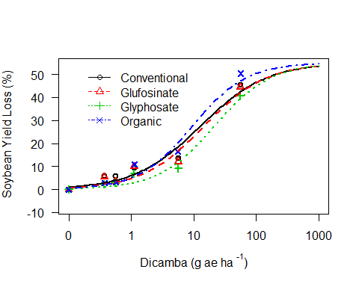

**ED's at 2nd Trifoliate**

##   
## Estimated effective doses  
##   
## Estimate Std. Error  
## e:Conventional:10 0.87132 0.33299  
## e:Conventional:20 2.34188 0.63617  
## e:Conventional:30 4.51818 0.96188  
## e:Conventional:40 7.74307 1.42002  
## e:Conventional:50 12.69423 2.27570  
## e:Glufosinate:10 1.15584 0.44589  
## e:Glufosinate:20 2.94441 0.80925  
## e:Glufosinate:30 5.48176 1.17883  
## e:Glufosinate:40 9.12394 1.67728  
## e:Glufosinate:50 14.56240 2.58602  
## e:Glyphosate:10 2.20516 0.86215  
## e:Glyphosate:20 5.09010 1.42795  
## e:Glyphosate:30 8.87543 1.94944  
## e:Glyphosate:40 13.99989 2.60021  
## e:Glyphosate:50 21.27000 3.73121  
## e:Organic:10 1.07883 0.35240  
## e:Organic:20 2.40521 0.56953  
## e:Organic:30 4.09815 0.77586  
## e:Organic:40 6.34311 1.04725  
## e:Organic:50 9.47112 1.51894

**Comparison of ED50 of drift at 2nd T**

##   
## Estimated ratios of effect doses  
##   
## Estimate Std. Error t-value p-value  
## Conventional/Glufosinate:50/50 0.8717129 0.2199640 -0.5832186 0.5612379  
## Conventional/Glyphosate:50/50 0.5968138 0.1496924 -2.6934310 0.0084677  
## Conventional/Organic:50/50 1.3403087 0.3223944 1.0555666 0.2940556  
## Glufosinate/Glyphosate:50/50 0.6846450 0.1708981 -1.8452809 0.0683600  
## Glufosinate/Organic:50/50 1.5375575 0.3679100 1.4611115 0.1475464  
## Glyphosate/Organic:50/50 2.2457735 0.5337815 2.3338643 0.0218812

### Dicamba drift model at R2.

## Lack-of-fit test  
##   
## ModelDf RSS Df F value p value  
## ANOVA 72 1356.5   
## DRC model 88 2152.6 16 2.6410 0.0026

##   
## Model fitted: Log-logistic (ED50 as parameter) with lower limit at 0 (2 parms)  
##   
## Parameter estimates:  
##   
## Estimate Std. Error t-value p-value  
## b:Conventional -1.361062 0.094322 -14.429933 0  
## b:Glufosinate -1.673263 0.155077 -10.789863 0  
## b:Glyphosate -1.178918 0.093270 -12.639853 0  
## b:Organic -1.630031 0.126695 -12.865751 0  
## e:Conventional 20.628757 1.855531 11.117444 0  
## e:Glufosinate 13.830005 1.271821 10.874173 0  
## e:Glyphosate 21.030186 1.873332 11.226084 0  
## e:Organic 18.408597 1.717613 10.717548 0  
##   
## Residual standard error:  
##   
## 4.945801 (88 degrees of freedom)

**Dicamba drift at R2.** 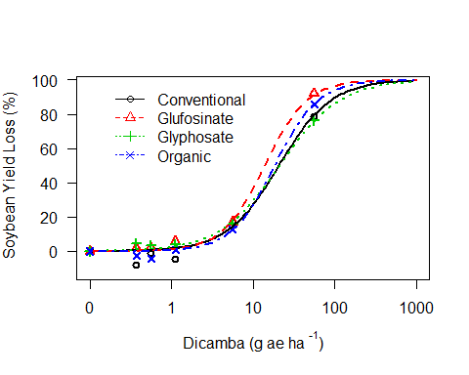

**ED's at R2**

##   
## Estimated effective doses  
##   
## Estimate Std. Error  
## e:Conventional:10 4.10556 0.59989  
## e:Conventional:20 7.44951 0.86691  
## e:Conventional:30 11.06912 1.12004  
## e:Conventional:40 15.31423 1.42465  
## e:Conventional:50 20.62876 1.85553  
## e:Conventional:60 27.78759 2.54371  
## e:Conventional:70 38.44439 3.77954  
## e:Conventional:80 57.12401 6.41314  
## e:Conventional:90 103.65118 14.60825  
## e:Glufosinate:10 3.71992 0.46708  
## e:Glufosinate:20 6.03963 0.59236  
## e:Glufosinate:30 8.33502 0.73454  
## e:Glufosinate:40 10.85386 0.94477  
## e:Glufosinate:50 13.83001 1.27182  
## e:Glufosinate:60 17.62222 1.79242  
## e:Glufosinate:70 22.94764 2.67144  
## e:Glufosinate:80 31.66899 4.37515  
## e:Glufosinate:90 51.41746 9.01935  
## e:Glyphosate:10 3.26152 0.57636  
## e:Glyphosate:20 6.48865 0.86006  
## e:Glyphosate:30 10.24972 1.11182  
## e:Glyphosate:40 14.90995 1.41147  
## e:Glyphosate:50 21.03019 1.87333  
## e:Glyphosate:60 29.66265 2.71684  
## e:Glyphosate:70 43.14933 4.43613  
## e:Glyphosate:80 68.16035 8.51615  
## e:Glyphosate:90 135.60182 22.74114  
## e:Organic:10 4.78197 0.68044  
## e:Organic:20 7.86440 0.91145  
## e:Organic:30 10.94642 1.12465  
## e:Organic:40 14.35461 1.37563  
## e:Organic:50 18.40860 1.71761  
## e:Organic:60 23.60751 2.23655  
## e:Organic:70 30.95773 3.11436  
## e:Organic:80 43.08992 4.85968  
## e:Organic:90 70.86545 9.79851

**Comparison of ED50 of drift at 2nd Trifoliate**

##   
## Estimated ratios of effect doses  
##   
## Estimate Std. Error t-value p-value  
## Conventional/Glufosinate:50/50 1.4915943 0.1918749 2.5620559 0.0121066  
## Conventional/Glyphosate:50/50 0.9809118 0.1241763 -0.1537187 0.8781835  
## Conventional/Organic:50/50 1.1206045 0.1452322 0.8304258 0.4085454  
## Glufosinate/Glyphosate:50/50 0.6576264 0.0841961 -4.0663822 0.0001037  
## Glufosinate/Organic:50/50 0.7512797 0.0984223 -2.5270717 0.0132885  
## Glyphosate/Organic:50/50 1.1424111 0.1473699 0.9663515 0.3365166