**FINAL Exam: DATABASE**

**WEP 2024**

**{3h 00}**

25 JAN 2023

**RULES:**

* Chatting and talking to other students is forbidden
* You are allowed to use PhpMyAdmin or VSCode or any other software. But it is not required
* Write (copy/paste) your answer below the question. Do not screenshot.

**HOW DO I SUBMIT THE EXAM?**

* Save this document as a yourfullname.PDF file
* In Google Classroom, attach this file to submit.

|  |  |
| --- | --- |
| **EXERCISES** | **POINTS** |
| THOERYS | 20 |
| EXERCISE 1 | 20 |
| EXERCISE 2 | 20 |
| EXERCISE 3 | 20 |
| EXERCISE 4 | 20 |
| EXERCISE 5 | 20 |
| **TOTAL** | **100** |

# Exercise 03 (20 points) Basic SQL Query

Write SQL query to create tables that have in Entity Relational Diagram (ERD) below:

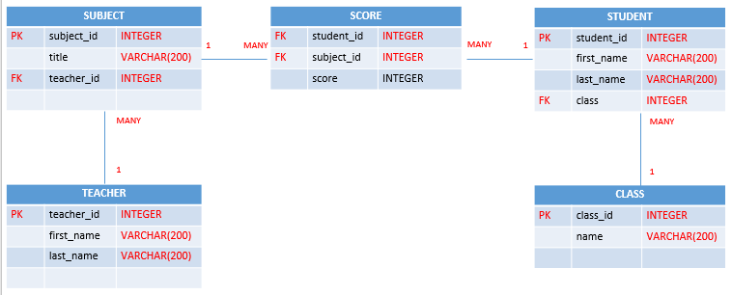

**Your Query:**

|  |
| --- |
| **Class-table:**  create table class(  -> class_id int not null primary key auto_increment,  -> Name varchar(200)  -> );  **Students:**  create table students(  -> stu_id int not null primary key auto_increment,  -> First_Name varchar(200),  -> Last_Name varchar(200),  -> classID int not null,  -> foreign key(classID) references class(class_id)  -> );  **Teachers:**  create table teachers(  -> teacher_id int not null primary key auto_increment,  -> First_Name varchar(200),  -> Last_Name varchar(200)  -> );  **Subjects:**  create table subjects(  -> sub_ID int not null primary key auto_increment,  -> Title varchar(200),  -> teacherID int not null,  -> foreign key(teacherID) references teachers(teacher_id)  -> );  **Scores:**  create table score(  -> studentID int not null,  -> foreign key(studentID) references students(stu_id),  -> subID int not null,  -> foreign key(subID) references subjects(sub_ID),  -> score int  -> ); |
|  |

# Exercise 04 (20 points) SQL Query Select

***Important****: Import database name “database_final_exam.sql” into your databasae.*

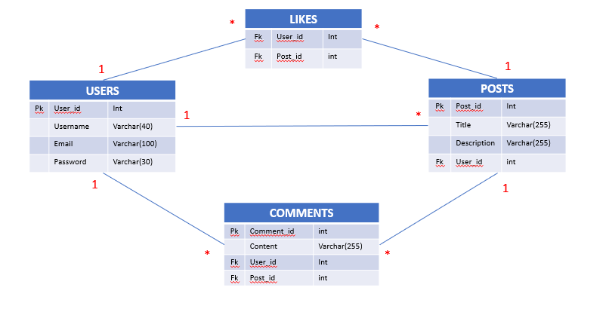

**Q1 – (10 POINTS):** Write a SQL statement to display all POSTS for the user named “**Rady Y**”

**Expected result:**

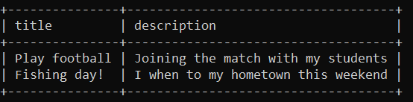

**Your Query:**

|  |
| --- |
| select posts.title, posts.description FROM posts INNER JOIN users ON posts.user_id = users.user_id WHERE username = "Rady Y"; |

**Q2 – (10 POINTS):** Write a SQL statement to display the username of who likes on many posts.

**Expected result:**

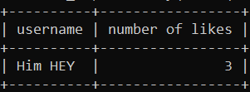

**Your Query:**

|  |
| --- |
| select users.username,count(post_id) NumberOfLikes FROM likes INNER JOIN users ON likes.user_id = users.user_id WHERE username = "Him Hey"; |