MIS 302F · FOUNDATIONS OF MIS
Grand Opening
Design, build, and publish a two-page website for a themed café of your own invention.
Individual assignment · 100 points · Due Thursday, October 29 · Hosted on Neocities
Mission Briefing
• You are the owner of a brand-new themed café that opens next month. Customers need a simple website that tells them what you are, when you're open, and what's on the menu.
• You will write the business facts yourself, use AI to help build the site and design the logo, then inspect everything before you publish it.
• Two pages (Home and Menu), one shared style file, one logo, one more image: published at yourname.neocities.org.
• Estimated time: 2.5 to 3.5 hours. Plan on at least two sittings.

The Whole Assignment in One Sentence
AI can be your line cook, but you are the chef whose name is on the door: nothing leaves the kitchen until you have tasted it.
You'll use AI to do most of the building. You'll also be responsible for every fact, every image, and every requirement on the finished site, the same way a manager is responsible for work a vendor, an agency, or a coworker produced.
Before You Worry About the Technology
No previous coding experience is required. AI is allowed and encouraged while you build (except in the reflection). You will make one small edit by hand, and these instructions show you exactly how.
Creativity is welcome, but a simple, correct site earns more than a fancy, incorrect one. Most points come from accuracy, required items, and your logo and image review. Only 5 points are for overall theme and vibe.

What You Should Be Able to Do Afterward
- Explain how HTML pages, a shared CSS file, images, and links fit together in a multi-page site.
- Publish (deploy) a website and explain what hosting means.
- Review AI-generated work, including images, for accuracy, copyright and trademark problems, and accessibility before publishing it.
- Write meaningful alt text and explain why it matters.
- Make a small, targeted change to HTML yourself without regenerating the whole page.

The Grandmother & Employer Test
Create a website you would be fine with your significant other's grandmother and your future employer seeing.
Every word, image, menu name, and video on your site has to pass this test. In practice, that means:

- No violent or sexual themes, in words or in images. Nothing gory, weapon-focused, suggestive, or crude. That includes "joke" menu names.
- It's a café: no alcohol, drugs, or vaping on the menu or in your images. A "Healing Potion Latte" is great. An ale is not.
- No jokes at the expense of any group of people.
- No photos of real people, especially children. Show the space, the food, the animals, or the objects instead.
- No health or medical promises. A therapy dog café can be "a calm place to unwind." It cannot claim to "treat anxiety." (A real business could get into legal trouble for that claim.)
Sites that fail this test will lose points and may be required to be revised.

Pick Your Theme
You can use one of the idea starters below or come up with your own. Any theme is welcome as long as it passes the Grandmother & Employer Test. If you're not feeling creative today, just pick a row and go. Either way, the café's name, colors, menu, events, and house rules are up to you.
The "Watch out for" column is not optional. It lists the most common copyright, trademark, and appropriateness traps for each theme. If you invent your own theme, ask yourself the same questions: Am I borrowing a famous character or brand? Would every image pass the test?
Theme | Ideas to make it yours | Watch out for
Board game café | Game library, "Learn-a-Game" nights, game-themed snacks | You can mention real games by name in your text, but don't use their box art or logos (CATAN, Monopoly, Scrabble).
Tabletop fantasy (D&D-style) café | Dice, maps, "potion" lattes, campaign nights, a cozy tavern feel | "Dungeons & Dragons" and its logos are trademarks of Wizards of the Coast. Keep them out of your café name and logo and use generic fantasy words instead. Adventure is fine. Battle gore is not.
Play café (young children + caregivers) | Play zones, story time, toddler snacks, real coffee for the grown-ups | No photos of real children. Use illustrations, toys, or the play space. No famous kids' characters (Bluey, Paw Patrol, Peppa Pig, Sesame Street).
Cat café | Resident cats with names, quiet hours, an adoption-partner idea | No famous cats: Hello Kitty, Garfield, Pusheen, Grumpy Cat, the Cheshire Cat from Disney.
Therapy dog café | Resident dogs, calm corners, study hours, "puppuccinos" | No medical claims (see above). No famous dogs: Snoopy, Scooby-Doo, Clifford, Bluey.
Nature / plant café | Plant wall, unplugged hours, terrarium workshops, herbal teas | Don't copy photos of a real café from Google Images. Your images must be AI-generated or your own.
Fairytale café | Storybook décor, enchanted-forest seating, themed pastries | The classic tales (Grimm, Hans Christian Andersen) are in the public domain, but Disney's versions are not. No Disney princesses, castles, or Disney-style lettering.
Pottery-painting café | Paint-your-own mugs and plates, date-night or family workshops, "glaze of the month" | Don't use photos of real people's artwork or a real studio's photos. Keep studio safety claims simple. Don't promise "lead-free" or "food-safe" unless it's in your brief.
Puzzle café | Jigsaw tables, a puzzle-swap shelf, speed-puzzle nights | Puzzle images on your site must be AI-generated or your own, not photos of store-bought puzzle boxes, especially ones showing licensed characters.
Bookstore / reading-nook café | Silent reading hour, book swaps, staff picks, literary latte names | Use made-up book titles or classic public-domain books (Austen, Dickens). No real modern book covers or bestseller logos (Harry Potter, etc.).
Space / stargazing café | Constellation décor, telescope nights, "Milky Way Mocha" | No Star Wars, Star Trek, or Marvel imagery, and no official NASA logo (the "meatball").
Retro arcade café | Pinball, classic-style cabinets, high-score boards, 8-bit pixel décor | The biggest trap on the list: no Pac-Man, Mario, Sonic, Tetris, or any real game characters or logos. Invent your own pixel mascot.
Language-exchange café | Conversation tables by language, "word of the day," drinks from around the world | Celebrate cultures respectfully. No stereotypes or caricatures in names, menu items, or images.
Knitting & crafts café | Yarn wall, learn-to-knit nights, stitch-and-sip meetups | Don't use photos of other people's handmade work or patterns found online.
Music café | Vinyl listening room, open-mic nights, songwriter showcases | Feature made-up bands and artists only. No real album covers, band logos, or song lyrics. Pick a video that's fine to embed (not a pirated song upload).
Travel café | "Passport" loyalty stamps, drinks from a featured country each month | No airline or tourism-board logos. Same respect rule as language exchange: no stereotypes.
Study café | Quiet zones, outlets everywhere, finals-week late hours, group-study rooms | No UT logos, the Longhorn silhouette, or other university marks. These are trademarks too.
Your own theme is welcome. These are just starters. The Grandmother & Employer Test applies to every theme, whether it's from this list or your own.

Two Rules That Apply Throughout
1. You own everything you publish, even if AI made it. Wrong prices, invented awards, a misspelled logo, a borrowed cartoon character, missing alt text, a broken link: all yours.
2. AI rules change by part. Parts 2 and 3: AI is encouraged. Part 5 (Barista's Pick): AI may tell you what code to use, but you place it in your page yourself and you may not regenerate the page. Part 7 (Reflection): AI is prohibited. I want your own thoughts.

How the Pieces Fit Together
Your finished site will contain these files. The ones marked (starter) come with every new Neocities site. Keep them.
yourname.neocities.org/
├── index.html ← your Home page (this exact name is required)
├── menu.html ← your Menu page
├── style.css ← colors, fonts, and spacing, shared by BOTH pages
├── not_found.html ← (starter) error page for wrong addresses
├── robots.txt ← (starter) rules for search engines and bots
├── neocities.png ← (starter) sample image, keep or delete
└── images/ ← a folder for your pictures
├── cozypaws-logo.png
└── cozypaws-lounge.png

Piece | What it does
index.html, menu.html | The content and structure of each page: words, headings, tables, images, and links. Written in HTML (HyperText Markup Language).
style.css | Instructions for how the content looks: colors, fonts, spacing. Written in CSS (Cascading Style Sheets). Both pages point to this one file, so one edit changes both pages.
images/ | A folder holding your two picture files. Your pages point to them by folder and filename, e.g. images/cozypaws-logo.png.
not_found.html | (starter) The "404" error page a visitor sees if they type an address that doesn't exist on your site. Keep it. You can optionally give it your café's look (see the Optional Extra after Part 5).
robots.txt | (starter) A short public text file that tells search engines and other automated bots (including AI crawlers) which parts of a site they're allowed to visit and index. Keep it as is.
Links (navigation) | Let a visitor move from Home to Menu and back again.
Neocities | Hosting: a server that stays on and connected so anyone, anywhere, can request your files and see your site.

The Parts at a Glance
Work the parts in order. Part 1 has to come before any AI tool is opened, because it's what you'll check the AI's work against.
Part | What happens | Estimate
1 · Write the Café Brief | Decide your theme, name, hours, menu, event, and house rules | 15–25 min
2 · Design the Sign | Generate your logo and one more image, then inspect them for copyright and accessibility | 20–30 min
3 · Build with AI | Use AI to build the two pages and the shared style file, then fact-check them against your brief | 45–60 min
4 · Open on Neocities | Create your account, upload your files, and test the live site | 20–30 min
5 · Barista's Pick | Make one small edit to your HTML by hand | 10–15 min
6 · Health Inspection | Check the live site against the Definition of Done and take final screenshots | 15–20 min
7 · Reflect and Submit | Three short reflections (no AI), then submit your tracker as a PDF | 20–30 min
These are planning estimates, not time limits.

Before You Start: Open Your Evidence Tracker
Download the Grand Opening Evidence Tracker from Canvas. Save your own copy as Lastname_Firstname_CafeTracker, and keep it open in another window the whole time you work. It has a labeled blank for everything you hand in, in the same order as these parts. Fill it in as you go. Filled in from memory at the end, it takes an hour and you'll be missing things.

Part 1 · Write the Café Brief (15–25 minutes)
You're the owner, so you set the facts. Writing them down before you open an AI tool gives you a source of truth to check the AI's work against. (At work, this would be the requirements document.)
- Choose your theme: one of the idea starters above or your own idea.
- Name your café. It must be original. Search the name + "café" online to make sure it isn't a real business, and keep trademarks out of it (no Disney, Pokémon, Dungeons & Dragons, Starbucks, etc.).
- Write a one-sentence tagline, e.g. "Coffee, cats, and absolutely no rush."
- Set your hours for all seven days. At least one day must be unusual: closed, opening late, or open late. (You'll see why in Part 3: AI loves to "fix" unusual hours.)
- Create fictional contact information using the formats below, so the site never points at a real person or business:
Item | Required format | Example
Address | A made-up street name in a real or made-up Texas town | 42 Whisker Way, Austin, TX 78759
Phone | Must use 555-01XX. These numbers are reserved for fiction and never ring a real phone. | (512) 555-0147
Email | Must end in .example. This domain is reserved and can never reach a real inbox. | hello@cozypaws.example

- Build your menu: at least 6 items with prices, including at least 3 drinks and 2 food items. At least 2 items must have themed names (e.g., "Purr-over Coffee," "Critical Hit Cold Brew," "Glass Slipper Scone").
- Create one recurring event with its day and time (e.g., "Story Time: Saturdays, 10:00–10:45 AM").
- Write at least 3 house rules that fit your theme (cat café: "Let the cats come to you"; play café: "Grip socks required in the play zone"; nature café: "Phones go in the basket during Unplugged Hour").
PROOF FOR YOUR TRACKER: Fill in every table in Part 1 of your tracker. This is your café brief, and the TAs will compare your live site against it.

Part 2 · Design the Sign (20–30 minutes)
Use any AI image tool (ChatGPT, Microsoft Copilot, Gemini, Adobe Firefly, Canva, etc.) to create exactly two images:
- A logo for your café.
- One non-logo image that fits your brief: the café interior, your signature drink, a resident cat, the plant wall.
PROOF FOR YOUR TRACKER: Copy the FIRST prompt you used to create your logo into your tracker. Just the first prompt, not the whole chat.

Name and Size Your Files
- Lowercase, no spaces: cozypaws-logo.png, not My Logo FINAL (2).PNG. Web servers treat Logo.png and logo.png as two different files, and spaces break links. This is the #1 reason images don't show up.
- Save both images as PNG files (.png). Many AI image tools offer several download formats, such as PNG, JPG, WEBP, or SVG. Always pick PNG. If your tool doesn't give you a choice and saves something else, ask the AI to give you the image as a PNG instead. Then make sure your HTML uses the same .png filename, e.g. images/cozypaws-logo.png.
- Reasonable size: if a file is huge (over about 1 MB), shrink it in Paint (Windows) or Preview (Mac), or ask your AI to set a width for it in the HTML. Your logo shouldn't be postage-stamp tiny or take over the whole screen.

Inspect Your Logo Before You Use It
This is the same check a marketing manager would run on a logo delivered by a design agency. AI image tools can and do reproduce copyrighted characters and real brand logos, and they misspell words constantly. If your café publishes it, your café is responsible for it, not the AI tool.
# | Check | How to tell
 | COPYRIGHT & TRADEMARK
1 | No existing characters or franchise imagery | Would anyone recognize a character, mascot, or franchise? (Disney, Pokémon, Hello Kitty, Snoopy, Bluey, the official D&D logo.) If yes, it fails.
2 | Doesn't imitate a real company's logo | Does it look like a real brand's logo with the name swapped (a green circle with a mermaid, golden arches)? If yes, it fails.
3 | Name and words are your own | Does the logo include anyone else's brand name or slogan? Only your café's name and tagline belong there.
4 | Created, not found | Both images must be AI-generated (or made by you). Images copied from Google Images or another website are not allowed.
 | ACCESSIBILITY & QUALITY
5 | Text is spelled correctly | Read every letter. AI often produces garbled or misspelled text. If it does, regenerate, or ask for a logo with no words and put the café name in your HTML instead.
6 | Readable at small size | Zoom out until the logo is about the size of a phone app icon. Can you still tell what it is and read any words?
7 | Enough contrast | Do the text and shapes clearly stand out from the background? Light gray on white or dark red on black fails. People with low vision or color blindness must be able to read it.
8 | Passes the Grandmother & Employer Test | Would you be comfortable with both of them seeing it?

Example from the sample site built for these instructions: the first version of the Cozy Paws logo looked fine at a glance. Up close, the café name is too wide: it cuts gaps into the circle on both sides (check #6). The fix was to shrink the text and move the artwork up so everything fits inside the ring.
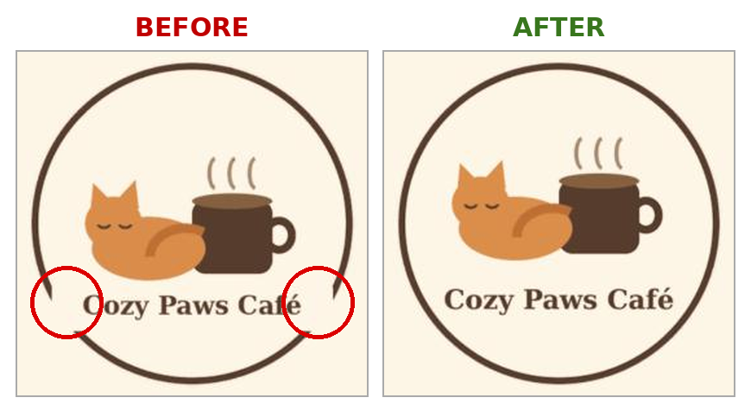
Before: the name breaks the circle on both sides (circled). After: everything fits inside the ring.
If your logo fails any check, regenerate or revise it and check again. Run checks 1, 2, 4, and 8 on your second image too.
PROOF FOR YOUR TRACKER: Paste your final logo and second image into the tracker, mark each of the 8 checks Pass/Fail with a short note, and say what (if anything) you had to fix or regenerate.

Write Alt Text for Both Images
Alt text is a short written description attached to an image. Screen-reading software reads it aloud, so someone who can't see the image still gets its meaning. It also appears if an image fails to load. Missing alt text is one of the most common web accessibility barriers, and organizations (including universities) are legally required to provide meaningful text alternatives for images. AI-generated HTML often leaves it out or writes something useless, so this is a check only you will do.
Write this:
<img src="images/cozypaws-logo.png"
alt="Cozy Paws Café logo: a sleeping orange cat curled around a coffee cup">
Not this: alt="logo" alt="image1.png" alt="" or no alt at all.
PROOF FOR YOUR TRACKER: Record both file names and both alt texts in your tracker.

Part 3 · Build with AI (45–60 minutes)
Use whichever AI tool you prefer. You are writing the brief, not the code. Ask for exactly three files: index.html, menu.html, and style.css. Paste your café brief into your prompt so the AI has the real facts. Then work in pieces (get a basic version first, then add or fix sections) so you can spot changes you didn't ask for.

A Starter Prompt You Can Adapt
"I'm building a simple two-page website for my café. Please give me three separate files: index.html (Home page), menu.html (Menu page), and style.css (one stylesheet linked from both pages). Both pages need a navigation menu linking to each other. My two images are in a folder called images and are named cozypaws-logo.png and cozypaws-lounge.png. Do not use JavaScript, forms, or anything that collects information. Use only the facts I give you below and do not add any others. Here is my café brief: [paste your Part 1 brief]"
PROOF FOR YOUR TRACKER: Save your initial prompt and one meaningful follow-up prompt. "Make it better" does not count as meaningful. "Move the hours table above the welcome paragraph and make the headings dark green" does.

Page Requirements
Every item below is checkable and graded. How you arrange them is your call. Whether they're present and accurate is not.
Where | Required
Both pages | A browser-tab title with your café name and page, e.g. "Cozy Paws Café | Menu"
 | A link to the same shared style.css file
 | Navigation: Home → Menu and Menu → Home, both working
 | Your theme's colors applied through style.css (not plain black text on a white page), with text that's easy to read against its background
Home page (index.html) | Your logo (with alt text), café name, and tagline near the top
 | A welcome paragraph (4–5 sentences): what your theme is, who it's for, and why someone should visit
 | Hours for all seven days, exactly as in your brief
 | Address, phone, and email, exactly as in your brief
 | Your recurring event, with its correct day and time
Menu page (menu.html) | A menu table: at least 6 items with prices, exactly as in your brief, including your 2+ themed names
 | Your second image (with alt text)
 | A House Rules section listing at least 3 rules
 | One embedded YouTube video that fits your theme and passes the Grandmother & Employer Test (café ambience, plant care, a cat-behavior explainer…). Watch the entire video before you embed it, not just the first few seconds or the thumbnail, so you know every scene is appropriate. On YouTube, click Share → Embed and copy the code. If a video won't play when embedded, the owner has blocked embedding, so pick another.

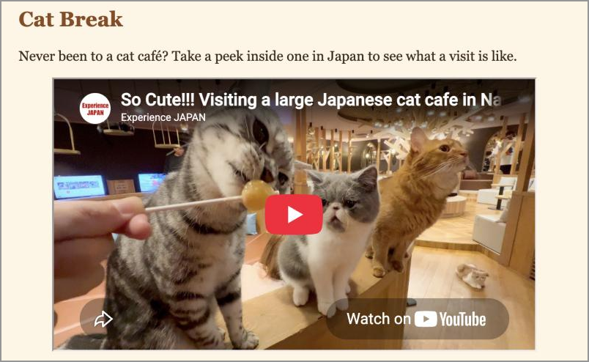
An embedded YouTube video on the sample site's Menu page
What You Must NOT Build
This is a static informational website: pages that show information. If a feature would collect data, store it, log someone in, take a payment, or do something after the visitor clicks a button, it's out of scope. That means no reservation or sign-up forms, no "Order Online," no shopping carts, no JavaScript, and no fake reviews or star ratings. AI tools love to add these, and part of your job is to remove them.

Fact-Check What the AI Produced
Go back to your café brief and check the site against it, line by line. This review step is the part of the assignment that most resembles your future job. Here's how AI tools commonly go wrong on a project like this:
- Changing prices or inventing menu items you never listed
- "Fixing" your unusual hours (opening the café on the day you're closed)
- Making up awards, star ratings, customer testimonials, or "Serving Austin since 2015"
- Swapping your fictional phone or email for a realistic-looking one
- Adding features nobody approved (a booking form, a newsletter sign-up, fake social media links)
- Leaving out alt text, or something else you asked for
PROOF FOR YOUR TRACKER: Fill in the AI Fact-Check Log with at least two rows: what the AI produced, what your brief says, and what you did about it. If the AI got everything right, list two specific facts you checked and confirmed.

Part 4 · Open on Neocities (20–30 minutes)
Neocities is a free, beginner-friendly service that hosts your files on a server so anyone can visit your site. The screenshots below come from a sample café site built for these instructions.

Create Your Account
- Go to neocities.org. The Sign up for free form is right on the home page.
- Username: this becomes your web address (username.neocities.org). Keep it professional. Your café name works well. If it's taken, add a letter or number. Tags are optional.
- Enter a password and your email, check I am human, and click Create My Site. Choose the free option if asked, then verify your email address.
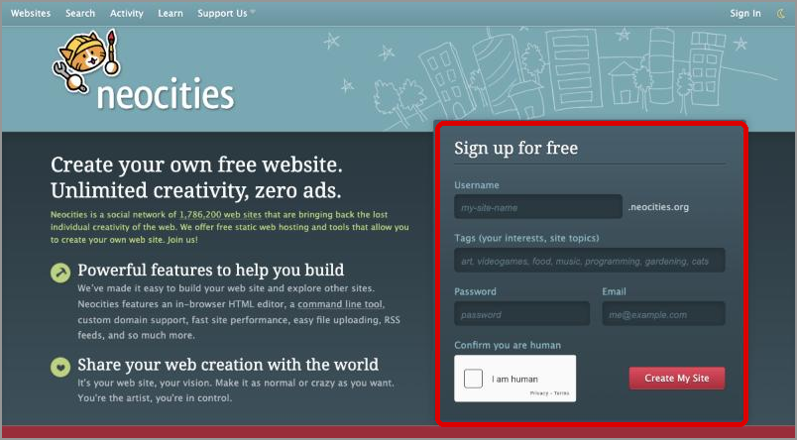
The sign-up form on the Neocities home page
Heads up: when you sign in, Neocities may email you a login code to confirm it's you. Keep your email open in another tab.

Your Dashboard
After you sign in, you land on your Dashboard, which lists your site's files. New sites come with a few starter files. You'll replace what's inside index.html and style.css. Keep the other starter files (not_found.html, robots.txt, neocities.png). "How the Pieces Fit Together" explains what each one does. The four buttons you'll use are New File, New Folder, Upload, and the Edit link next to each file.
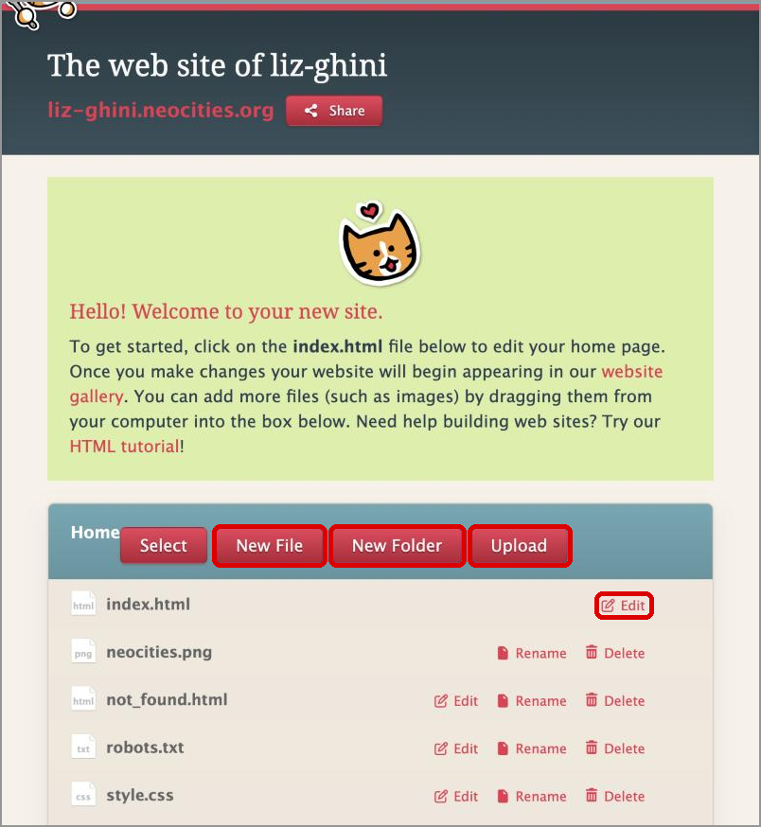
The Dashboard: New File, New Folder, and Upload buttons, plus the Edit link for index.html

Upload Your Files
- Click Edit next to index.html. Select everything in the editor (Ctrl + A on Windows, Cmd + A on Mac), delete it, paste in your Home page code, and click Save at the top right. A "Your file has been saved" message appears and the Save button turns gray.
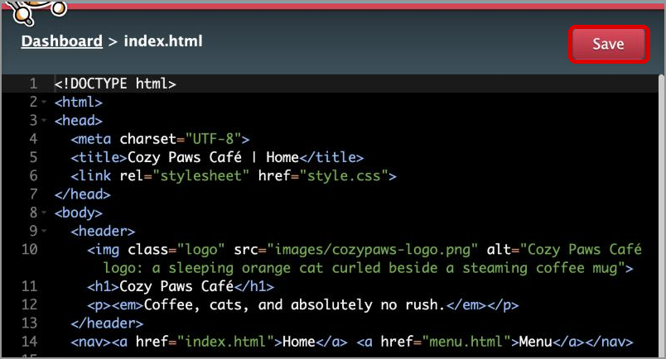
The Neocities editor with new code pasted in. Click Save before leaving the page.
- Click Dashboard (top left) to go back. Do the same for style.css: Edit, select all, delete, paste your CSS, Save.
- Click New File, type exactly menu.html, and click Create. Then click Edit next to menu.html, paste in your Menu page code, and Save.
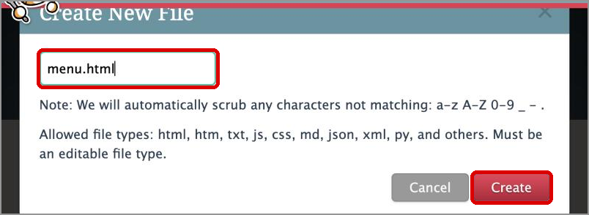
Creating menu.html with the New File button
- Click New Folder, type exactly images, and click Create. Click the new images folder to open it, then click Upload and choose your two image files (or drag them into the file box).
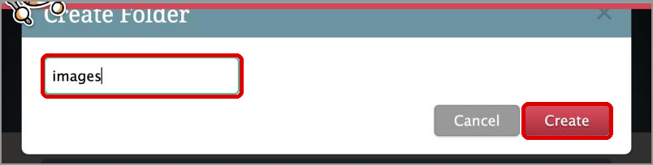
Creating the images folder
When you're done, the top of the file box should read Home > images and list your two files with lowercase names and no spaces:
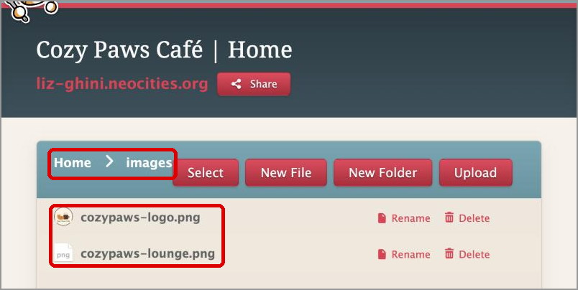
Both images uploaded inside the images folder
- Visit username.neocities.org in a new tab. Test both pages, the navigation in both directions, both images, and the video. Test the live site, not the editor.
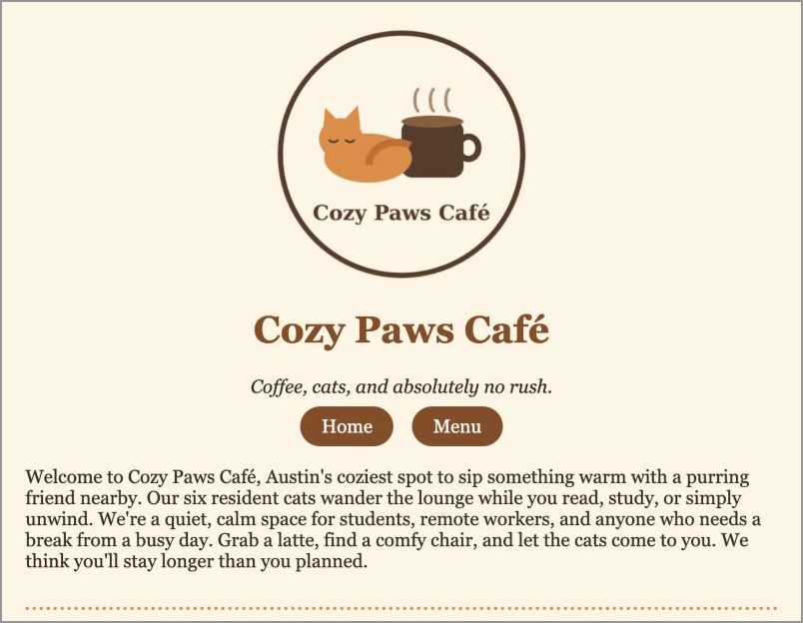
The sample site's live Home page: logo, styles, and navigation all working
💡 Good to know: Neocities hides the ".html" in addresses, so your Menu page shows up as username.neocities.org/menu. That's normal. Your links should still say menu.html.
💡 Tip: Keep one tab open for editing and one tab open for viewing the live site. Refresh the live tab after each save.

When It Doesn't Work Right Away
This is not a reflection of your abilities. Almost every problem is one of these:
Problem | Most likely cause
Image shows a broken icon | The filename, capitalization, extension, or folder in your HTML doesn't match the actual file exactly. images/Logo.PNG ≠ images/logo.png.
No colors or fonts on a page | That page is missing <link rel="stylesheet" href="style.css"> in its <head>, or the file isn't named exactly style.css.
Menu link goes to an error page | The link says href="Menu.html" or href="menu.htm". It must match menu.html exactly.
My change isn't showing | Did you click Save? If so, your browser is probably showing a copy it saved from an earlier visit (its cache), which makes pages load faster but can hide your newest changes. Do a hard refresh to fetch a fresh copy: Ctrl + Shift + R (Windows) or Cmd + Shift + R (Mac), or open the site in a private/incognito window. Still old? Wait a minute and try again, since Neocities also caches pages briefly. Restarting your computer usually won't help, because the cache is saved on disk.
Video says "unavailable" | The video's owner blocked embedding. Choose a different video.
Still stuck after working that list? Come to office hours or email your instructor or TA. Don't start changing unrelated code hoping something fixes itself.
PROOF FOR YOUR TRACKER: Paste your live site address (https://username.neocities.org) at the top of your tracker.

Part 5 · Barista's Pick: One Edit by Hand (10–15 minutes)
Your café wants to feature a Barista's Pick of the Week on the Home page. You'll add it yourself, directly in the Neocities editor.
You may ask AI what code to use, but you may not let it rebuild your page. Ask for a fragment, not a file: "What's the HTML for a paragraph with a yellow background and bold text?" Then place that line in index.html yourself. Don't paste in your whole page and accept a whole new page back. A regenerated page may undo the fact-checking you did in Part 3.
Text on a web page sits between an opening tag and a closing tag. To make one element stand out, add a style attribute inside the opening tag. This is called an inline style:
<p style="background-color: #FFF3C4; font-weight: bold; padding: 10px;">
Barista's Pick of the Week: Purr-over Coffee, $4.25
</p>

- Pick an item from your own menu. The name and price must match your menu exactly.
- Open index.html in the Neocities editor and paste or type your line where you think it belongs. Placement is your call. Change the text and colors to fit your café.
- Save, then refresh your live site to confirm it appears. If the page looks broken, check for a missing < or > or an unclosed tag.
PROOF FOR YOUR TRACKER: Take a screenshot of the Neocities editor showing your Barista's Pick line in the code (highlight it with your cursor), and paste the exact line into your tracker.

Optional Extra (No Points): A Themed 404 Page
Only do this after Parts 1–5 are completely finished. It earns no extra points. It's here because it's fun and it's a real thing businesses do.
When a visitor types an address that doesn't exist on your site (try username.neocities.org/oops), Neocities shows them your not_found.html page. Most sites leave it plain. Good businesses turn the error into a small moment of personality and point people back to where they meant to go, e.g. "Oops! One of our cats knocked this page off the table."
If you'd like to try it, edit not_found.html so it:
- links to your shared style file as /style.css (with a leading slash, as the starter file already does), so it matches your café's look even at a mistyped address like /images/oops
- has a short, themed message that passes the Grandmother & Employer Test
- includes a link back to your Home page (index.html)
The same rules apply: no JavaScript and nothing out of scope. Then test it by visiting a made-up address on your live site.
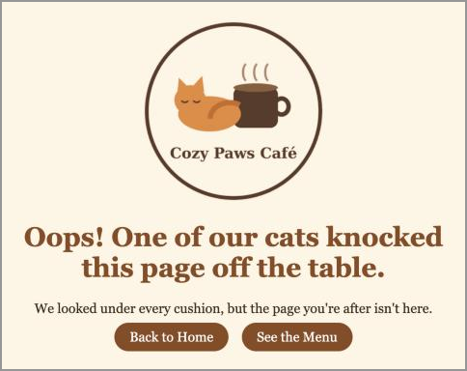
The sample site's themed 404 page

Part 6 · Health Inspection (15–20 minutes)
A restaurant can't open until it passes inspection. Software has the same idea, called a Definition of Done: the agreed list of things that must be true before work is ready to release. "Done" doesn't mean the AI stopped generating code or the page opened once. It means a person checked the requirements.
Check every item against your live site (not the editor). The full checklist is in your tracker. It covers both pages loading, shared CSS, navigation in both directions, images and alt text, every fact matching your brief, the video, the house rules, the Barista's Pick, nothing invented, and nothing out of scope.

Take Your Final Screenshots
- Home page screenshot, with the Barista's Pick visible and the browser address bar visible showing your neocities.org address. The address bar proves you're showing the live site, not a file on your laptop.
- Menu page screenshot, also with the address bar visible.
PROOF FOR YOUR TRACKER: Check off the Definition of Done checklist and paste both screenshots into your tracker. Paste the images, don't link to them.

Part 7 · Reflect and Submit (20–30 minutes)
NO AI IN THIS PART
Generative AI is 100% prohibited for the reflections. Answer from your own project. Two or three sentences each is plenty. An answer that could have been written by someone who never opened the assignment will be graded as one.

- Reviewing AI output. Name one specific thing the AI generated, changed, or assumed (on your site or in your images) that you corrected or questioned. Why would publishing it as-is have been a problem for a real café?
- Inspecting the logo. Which logo check was hardest to judge, or which one did your logo fail at first? What could happen to a real business that published a logo with that problem?
- Making a change yourself. What did you need to understand about HTML to place your Barista's Pick yourself? Why would a manager want someone who can make a small change without regenerating the whole page?

How to Submit
- Make sure your live site URL is at the top of your tracker and every section is complete (use the submission checklist at the end of the tracker).
- Save or export your tracker as a PDF, and upload it to the Grand Opening assignment in Canvas.
- Don't edit your live site after you submit until grades are posted. The TAs grade the live site.

How This Is Graded
Category | What it covers | Pts
Café Brief | Complete brief with all required facts in the required formats | 5
Logo & Image Inspection | Logo prompt, 8-point inspection, no copyright/trademark problems, meaningful alt text | 17
AI Build & Fact-Check | Initial + meaningful follow-up prompt; specific Fact-Check Log | 8
Site Structure & Publishing | Live on Neocities; two pages; shared CSS; navigation both ways; tab titles; images folder; nothing out of scope | 15
Home Page | Logo/name/tagline, welcome paragraph, hours, contact, event, all matching the brief | 15
Menu Page | Menu table matching the brief, second image, house rules, embedded video | 15
Barista's Pick | Hand-placed inline-styled line matching a real menu item, with editor screenshot | 5
Health Inspection | Definition of Done checklist and two live screenshots with the address bar | 5
Theme & Good Vibes | The theme comes through consistently; readable, clean, and passes the Grandmother & Employer Test | 5
Reflection | Three specific answers from your own project (no AI) | 10
TOTAL |  | 100

Why We're Doing This
Almost every business tool you'll use, from Canvas to Shopify to Salesforce to email marketing software, has a box somewhere that shows you the HTML underneath. It also has an image upload with an alt-text field, and a Publish button that someone has to be accountable for pressing. Managers who've looked inside that box can tell a five-second fix from a real project. Managers who know to check a logo for a borrowed character keep their company out of a lawsuit.
The question isn't whether AI can make something impressive. It's whether you can use AI to make something useful while staying responsible for what gets published.

