MIS 302F · FOUNDATIONS OF MIS
Grand Opening · Evidence Tracker
Fill this in as you work. Then save it as a PDF and upload it to Canvas.
MIS 302F · Individual assignment · Sections match Parts 1–7 of the instructions
Before You Type Anything
1. Save your own copy as Lastname_Firstname_CafeTracker.
2. Keep it open in another window while you work, and fill it in as you finish each part.
3. Paste screenshots and images directly into the gray boxes. Links to images will not be accepted.
4. When you're finished, save or export as PDF and upload it to the Grand Opening assignment in Canvas.

Your info
Name | Pheanouk Hun
UT EID | Ph23434
Live site URL (https://____.neocities.org) | https://pheanouk.neocities.org
Theme chosen | Nature / plant café (greenhouse café)

Part 1 · Café Brief
This is your source of truth. Complete it BEFORE you open any AI tool. The TAs will compare your live site against it.
Item | Your answer
Café name | Fernlight Greenhouse Café
Tagline (one sentence) | Coffee, tea, and a little more green.
Recurring event (name, day, time) | Friday Whisk Workshop: Saturdays, 10:00 – 11:00 AM

Hours (all seven days)
Day | Hours (or CLOSED)
Monday | 7:00 AM – 6:00 PM
Tuesday | 7:00 AM – 6:00 PM
Wednesday | 7:00 AM – 6:00 PM
Thursday | 7:00 AM – 6:00 PM
Friday | 7:00 AM – 10:00 PM
Saturday | CLOSED
Sunday | CLOSED
At least one day must be unusual: closed, opening late, or open late.

Contact Information (fictional)
Item | Your answer
Address | 214 Fernwood Lane, Austin, TX 78704
Phone | (512) 555-0163
Email | hello@fernlight.example
Phone numbers must use 555-01XX and emails must end in .example. Both are reserved for fiction and can't reach a real person.

Menu (at least 6 items)
Item name | Price | Drink or food? | Themed name? (Y/N)
Fern Fog Latte | $5.25 | Drink | Y
Greenhouse Whisk | $5.75 | Drink | Y
Sun Room Cold Brew | $4.75 | Drink | Y
Moss Cloud Matcha Lemonade | $5.50 | Drink | Y
House Drip Coffee | $3.25 | Drink | N
Terrarium Toast | $8.50 | Food | Y
Fern Frond Scone | $4.25 | Food | Y
Almond Croissant | $4.50 | Food | N
Minimum: 3 drinks, 2 food items, and 2 themed names. Prices in dollars and cents, e.g. $4.25.

House Rules (at least 3)
# | Rule
1 | Phones go in the basket during Unplugged Hour in the Fern Room.
2 | Look, don't pick: our plants are residents, not samples.
3 | Share the long tables and keep voices low.
4 | [Optional]

Part 2 · Design the Sign
Your FIRST logo prompt (just the first one, not the whole chat):
Logo Prompt (into ChatGPT): Create a simple flat logo for a café called "Fernlight". Show a single fern frond curling around a steaming coffee cup. Use deep forest green and cream on a plain cream background, bold clean shapes, high contrast. Use an arched greenhouse-window shape, not a circle. Include no text at all. No people, no animals, no existing brand or mascot imagery.


Logo Inspection
# | Check | Pass / Fail | Short note (what you looked for or noticed)
1 | No existing characters or franchise imagery | Pass | Just symbols that doesn’t cover existing characters or franchise imagery.
2 | Doesn't imitate a real company's logo | Pass | I looked and couldn’t find one.
3 | Name and words are your own | Pass | No words are found inside the logo.
4 | Created, not found (AI-generated or your own) | Pass | Created by the AI.
5 | Text is spelled correctly (no garbled letters) | Pass | No Letters or words found.
6 | Readable at small (app-icon) size | Pass | Works at small size
7 | Enough contrast between text/shapes and background | Pass | Added a boarder to increase contrast.
8 | Passes the Grandmother & Employer Test | Pass | Nothing offensive found.
Your FINAL logo should pass all 8. Note any check it failed earlier and how you fixed it below.
What did you have to fix or regenerate? (If nothing, write "Passed on first try" and say how you verified checks 1–3.)
Change the fill color to white.
Added a thick forest green border.
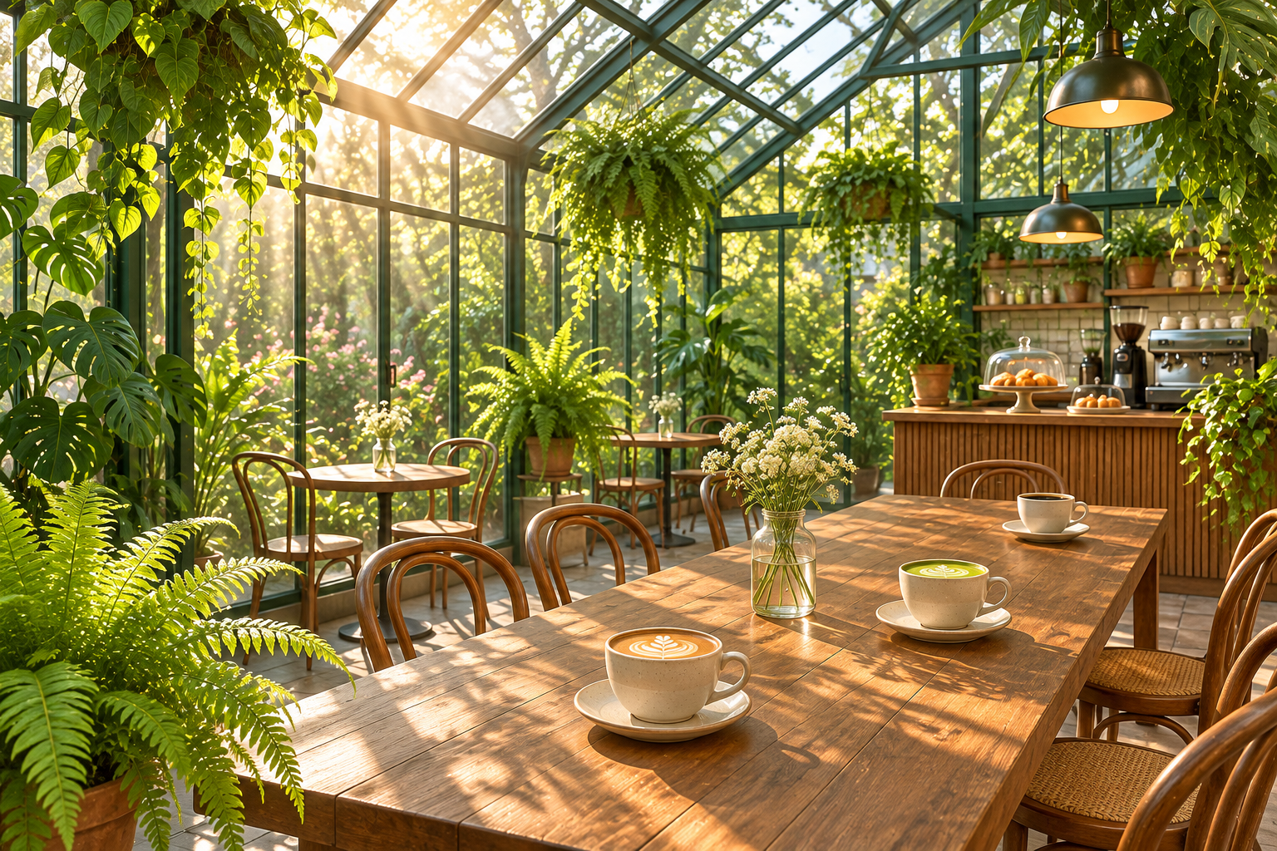

File Names and Alt Text
Image | Exact file name (lowercase, no spaces) | Alt text
Logo | fernlight-logo.png | Fernlight logo: a fern frond curling around a steaming coffee cup above the word Fernlight
Second image | fernlight-greenhouse.png | Sunlit greenhouse café with ferns, hanging plants, and a long wooden table set with cups of coffee and matcha

Part 3 · Build with AI
Initial prompt:
I want to structure the way we will be working inside this git repository, the main objective is going to be provided later, but to cut to the chase I want a static website that could be used to be put on neocities to advertise a coffee shop. First I want you to do research on the Austin area on what would be a popular coffee shop idea by creating 1 sub agent to come up with ideas, 1 sub agent to find out if the shop already exists or not and 1 more agent to determine the viability of the idea, do this until you narrowed it down to 1 idea.
One meaningful follow-up prompt ("make it better" doesn't count):
- add a separator between the menu and the image along with a separator between the text under the image and the house rules
- center the text under the photo

AI Fact-Check Log (at least 2 rows)
What the AI produced | What my brief says | What I did about it
[e.g., Listed hours as open Tuesday 8–5] | [Closed Tuesday] | [Changed it back to CLOSED]
Listed the wrong email address | It was supposed a hello@fernlight.example | I changed the email address in the HTML code.
Listed Wrong Day for the Workshop | It says that it was supposed to be on Friday | I changed the HTML
[Optional]
If the AI got everything right, list two specific facts you checked and confirmed.

Part 4 · Open on Neocities
Page | Live address
Home | https://pheanouk.neocities.org
Menu | https://pheanouk.neocities.org/menu

Part 5 · Barista's Pick
The exact line of HTML you added (copy it from your index.html):
I have chosen a simple, but very tasty Fern Fog Latte.
<p style="background-color: #fff3c4; color: #1f3d2b; font-weight: bold; padding: 10px; border-radius: 8px;">
Barista's Pick of the Week: Fern Fog Latte, $5.25
</p>
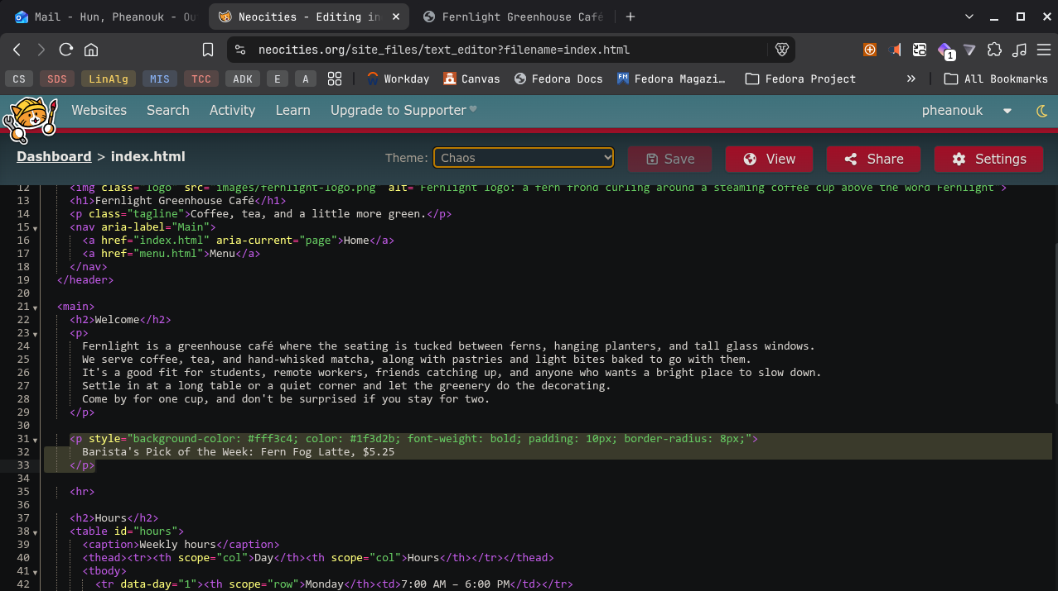

Part 6 · Health Inspection (Definition of Done)
Check every item against your LIVE site, not the editor. Type an X in the box when it's true.
Done | Requirement
[ X ] | index.html loads from my live neocities.org address
[ X ] | menu.html loads from my live address
[ X ] | Navigation works Home → Menu and Menu → Home
[ X ] | Both pages use the same style.css (the theme colors appear on both)
[ X ] | Both pages have a browser-tab title with my café name
[ X ] | The logo displays on the live Home page
[ X ] | The second image displays on the live Menu page
[ X ] | Both images have meaningful alt text
[ X ] | All seven days of hours match my brief exactly
[ X ] | Address, phone, and email match my brief exactly (fictional formats)
[ X ] | My recurring event shows the correct day and time
[ X ] | Every menu item and price matches my brief
[ X ] | The House Rules section lists at least 3 rules
[ X ] | The embedded YouTube video plays on the live site, and I watched all of it to make sure it's appropriate
[ X ] | The Barista's Pick appears and matches a real menu item and price
[ X ] | Nothing invented: no fake awards, ratings, reviews, or "since 20XX"
[ X ] | Nothing out of scope: no forms, sign-ups, ordering, logins, or JavaScript
[ X ] | Everything passes the Grandmother & Employer Test

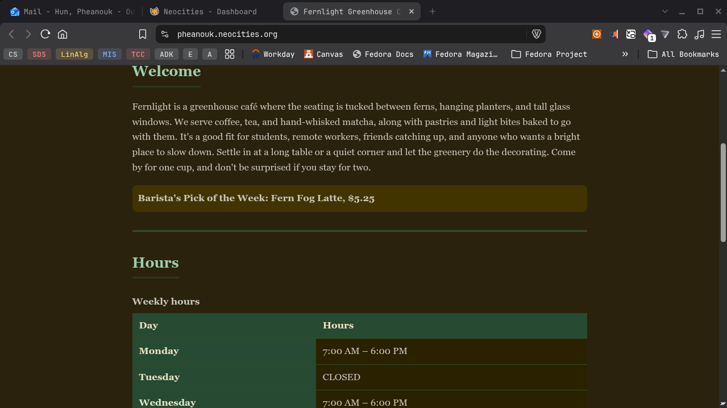

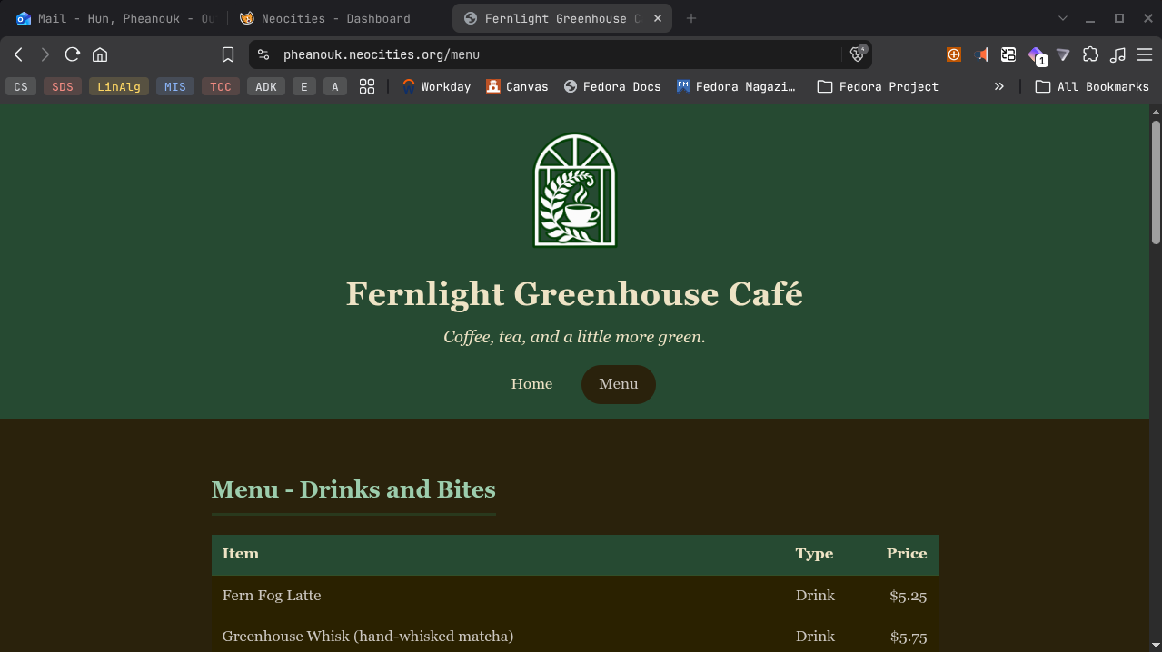

Part 7 · Reflection (NO AI)
Generative AI is prohibited for this section. Answer from your own project in 2–3 sentences each.
1. Reviewing AI output: Name one specific thing the AI generated, changed, or assumed that you corrected or questioned. Why would publishing it as-is have been a problem for a real café?
[Type your answer here]
[Type your answer here]
[Type your answer here]
2. Inspecting the logo: Which logo check was hardest to judge, or which one did your logo fail at first? What could happen to a real business that published a logo with that problem?
[Type your answer here]
[Type your answer here]
[Type your answer here]
3. Making a change yourself: What did you need to understand about HTML to place your Barista's Pick yourself? Why would a manager want someone who can make a small change without regenerating the whole page?
[Type your answer here]
[Type your answer here]
[Type your answer here]

Submission Checklist
Done | Before you upload
[ ] | My live site URL is at the top of this tracker, and it works in a private/incognito window
[ ] | Every table in Part 1 is complete
[ ] | My logo, second image, and three screenshots are pasted in (not linked)
[ ] | All 8 logo checks are marked, with notes
[ ] | My Fact-Check Log has at least 2 specific rows
[ ] | Every Definition of Done box is checked
[ ] | All three reflections are answered in my own words
[ ] | I saved this file as a PDF and uploaded it to the Grand Opening assignment in Canvas

