**# PRACTICE 1**

|  |  |
| --- | --- |
| **PROJECT NAME** | **pos** |
| **DATABASE NAME** | **pos** |

**# Table users**

|  |  |
| --- | --- |
| **Attribute** | **Data type** |
| **name** | **string** |
| **email** | **string** |
| **password** | **string** |

**# Table posts**

|  |  |
| --- | --- |
| **Attribute** | **Data type** |
| **title** | **string** |
| **description** | **text** |

**# Table comments**

|  |  |
| --- | --- |
| **Attribute** | **Data type** |
| **post_id** | **Integer** |
| **Text** | **text** |

**#Relationship**

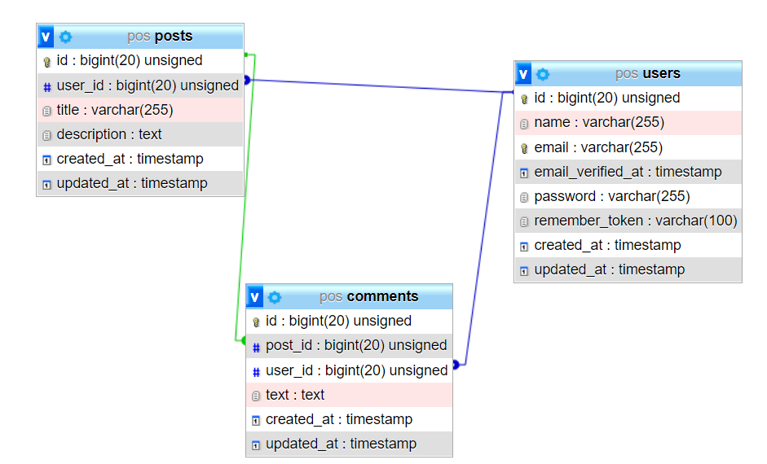

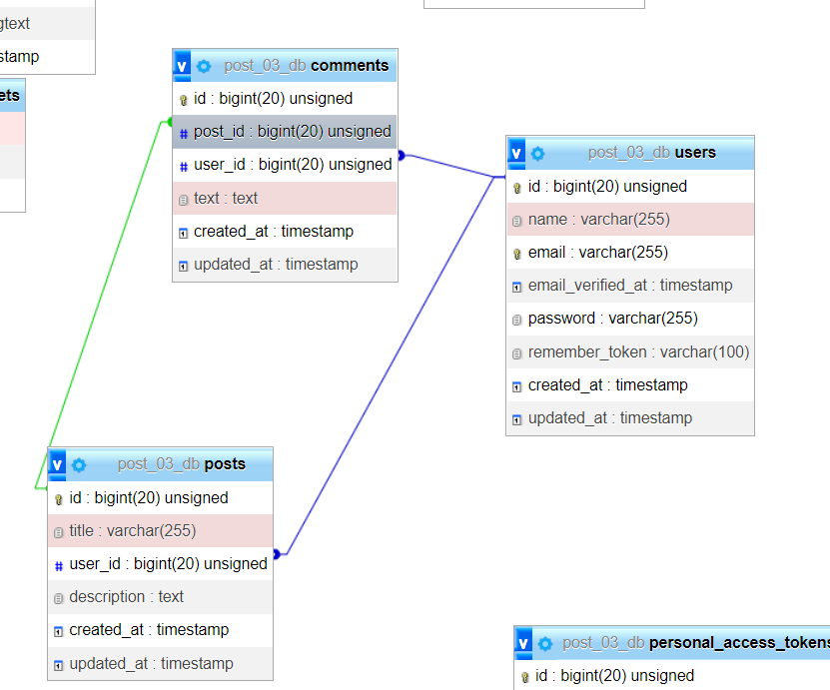

**# TODO NEXT**

* **CRUD: users, posts and comments**
* **Get post with their comments**
* **Get user with their posts and comments**