Real vs Fake Face Detection using CNN and ResNet18
AI-Generated vs Real Face Classification with Web Inference

Author’s Name
line 1 (of Affiliation: dept. name of organization
Your University / Institute
City, Country
line 4: e-mail: name@xyz.com

Abstract—This project builds a system to detect real vs AI-generated faces using two deep learning models (a CNN baseline and ResNet18). We train on a cleaned Kaggle face dataset labeled 0=real and 1=fake, and evaluate with accuracy, precision, recall, and F1-score. The best model is deployed in a web app that supports image, video, and live camera inference with face bounding boxes and labels.
Keywords-deep learning; face forensics; AI-generated faces; CNN; ResNet18; computer vision

Introduction (Heading 1
This template, modified in MS Word 2007 and saved as a “Word 97-2003 Document” for the PC, provides authors with most of the formatting specifications needed for preparing electronic versions of their papers. All standard paper components have been specified for three reasons: (1 ease of use when formatting individual papers, (2 automatic compliance to electronic requirements that facilitate the concurrent or later production of electronic products, and (3 conformity of style throughout a conference proceedings. Margins, column widths, line spacing, and type styles are built-in; examples of the type styles are provided throughout this document and are identified in italic type, within parentheses, following the example. Some components, such as multi-leveled equations, graphics, and tables are not prescribed, although the various table text styles are provided. The formatter will need to create these components, incorporating the applicable criteria that follow.

- Background of AI-generated faces (GANs/diffusion) have become realistic and widely used, motivating detection research.
- Why this problem needs solving? The spread of AI-generated faces and deepfakes makes identity verification and media authenticity harder; automated detection is necessary.
- What is the importance of this topic? It impacts security, digital forensics, and trust in online media and biometric systems.
- What is the state-of-the-art? (optional
- Objectives of your work: (1) train at least two deep learning models; (2) compare their performance; (3) build an inference pipeline for images/videos with bounding boxes.

Datasets
- Description of the dataset used: 140K Real and Fake Faces (Kaggle), cleaned and relabeled into numeric folders (0=real, 1=fake).
- General description of the data (e.g., if it is digital image, what is the resolution of the image, …etc
- How is the data obtained/constructed? Downloaded from Kaggle and reorganized into train/validate/test folders with numeric labels.
- Sample size? Approximately 140K total images with a 70/15/15 split for train/validate/test.

Proposed Methods
- Description of the proposed methods: A CNN baseline and a ResNet18 transfer learning model for binary classification (real vs fake).
- Detailed architecture and setting/configurations (e.g. if it is a neural network model, how many layers, how many units in each layers, …etc
- Reasons behind choosing/designing the methods: The CNN provides a simple baseline, while ResNet18 offers stronger feature extraction and generalization.

Experiments and Results

Experimental Setup
- Description of the setup during your experiments: PyTorch implementation; augmentation includes random resized crop, flip, color jitter, rotation, blur, and random erasing.
- Training procedure: Train on the training split, evaluate on validation split each epoch, and save the best model by validation accuracy.
- How do you divide your data into training, test
- Is there a validation set for finetuning? Yes, a dedicated validation split is used.
- Number of epochs/iterations: CNN trained for 20 epochs; ResNet18 trained for 10 epochs.
- …etc

Evaluation Protocols
- What are the metrics used? Accuracy, precision, recall, F1-score, and confusion matrix.
- Why those metrics? They balance overall correctness and class-wise performance for binary classification.

Results
- Report of results: Table 1 (Test metrics) - Model | Acc | Prec | Rec | F1. CNN | 0.9278 | 0.9085 | 0.9214 | 0.9149. ResNet18 | 0.9754 | 0.9764 | 0.9743 | 0.9754.
- Discussion about the results obtained: ResNet18 outperformed the CNN baseline on all metrics, showing stronger generalization. The CNN still provides a fast and reasonable baseline.

Conclusion
- Summary: Two deep learning models were implemented and compared for real vs fake face detection, and a web inference pipeline was built for images, videos, and live camera.
- Final thoughts: The project demonstrates that transfer learning improves deepfake detection accuracy over a simple CNN baseline.
- Perspective/future work (optional

Acknowledgment
(Optional

References

- Kaggle, "140K Real and Fake Faces" dataset, 2019. (references
- J. Clerk Maxwell, A Treatise on Electricity and Magnetism, 3rd ed., vol. 2. Oxford: Clarendon, 1892, pp.68–73.
- I. S. Jacobs and C. P. Bean, “Fine particles, thin films and exchange anisotropy,” in Magnetism, vol. III, G. T. Rado and H. Suhl, Eds. New York: Academic, 1963, pp. 271–350.

- Y. Yorozu, M. Hirano, K. Oka, and Y. Tagawa, “Electron spectroscopy studies on magneto-optical media and plastic substrate interface,” IEEE Transl. J. Magn. Japan, vol. 2, pp. 740–741, August 1987 [Digests 9th Annual Conf. Magnetics Japan, p. 301, 1982].
- M. Young, The Technical Writer’s Handbook. Mill Valley, CA: University Science, 1989.
- Electronic Publication: Digital Object Identifiers (DOIs:

- D. Kornack and P. Rakic, “Cell Proliferation without Neurogenesis in Adult Primate Neocortex,” Science, vol. 294, Dec. 2001, pp. 2127-2130, doi:10.1126/science.1065467.

- H. Goto, Y. Hasegawa, and M. Tanaka, “Efficient Scheduling Focusing on the Duality of MPL Representatives,” Proc. IEEE Symp. Computational Intelligence in Scheduling (SCIS 07, IEEE Press, Dec. 2007, pp. 57-64, doi:10.1109/SCIS.2007.357670.

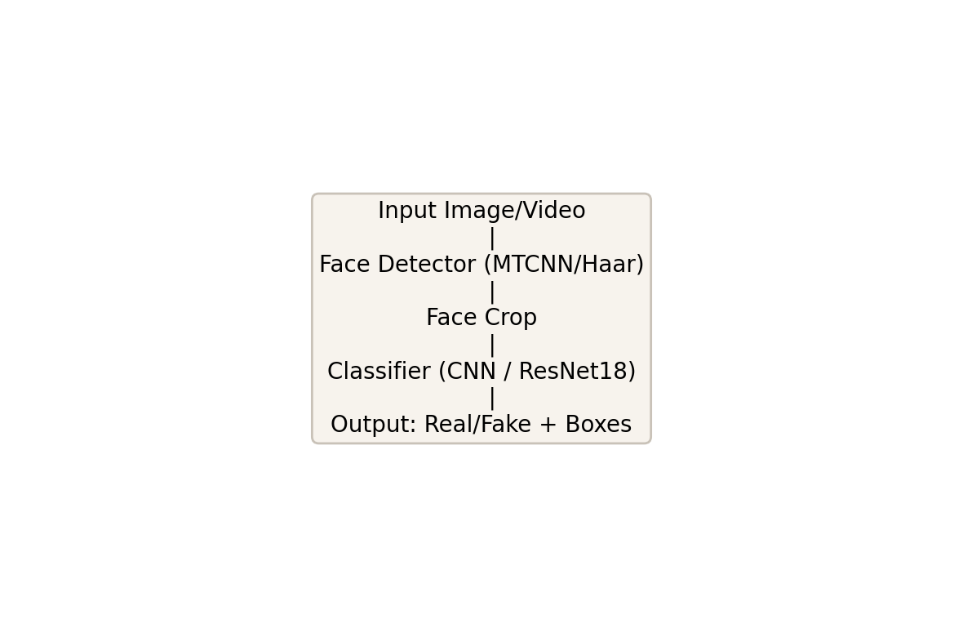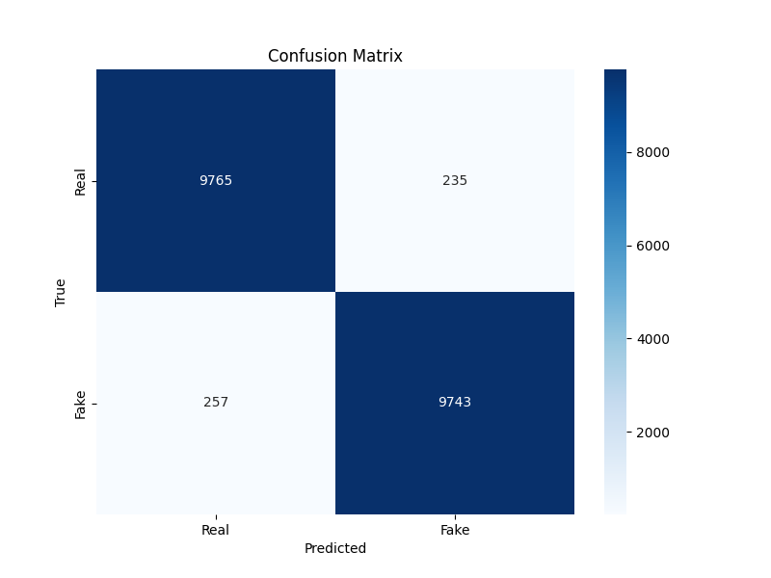
- Example of a TWO-COLUMN figure caption: (a this is the format for referencing parts of a figure.

