home.php (Controller)
<?php
ob_start();
class Controller_home extends Panada {
public function __construct(){
parent::__construct();
$this->db = new Library_db();
$this->base_url = 'http://localhost/cms/cempakaputih/';
$this->home_url = 'http://localhost/cms/cempakaputih/home/';
}
public function index(){
$views['menu'] = 'admin';
$views['title'] = 'CP27';
$views['page_title'] = 'CP27 :: Home';
$this->view_index($views);
}
public function profile(){
$views['menu'] = 'profile';
$views['title'] = 'CP27';
$views['page_title'] = 'CP27 :: Profile Cempaka Putih';
$menu = 'profile';
$this->view_index($views);
}

public function member(){
$views['menu'] = 'member';
$views['title'] = 'CP27';
$views['page_title'] = 'CP27 :: Member';
$menu = 'member';
$this->view_index($views);
}
public function post(){
$views['menu'] = 'post';
$views['title'] = 'CP27';
$views['page_title'] = 'CP27 :: Post List';
$this->connection = 'posts';
$this->view_index($views);
}
}

index.php (View)
<!DOCTYPE html PUBLIC "-//W3C//DTD XHTML 1.0 Transitional//EN" "http://www.w3.org/TR/xhtml1/DTD/xhtml1-transitional.dtd">
<html xmlns="http://www.w3.org/1999/xhtml">
<head>
<meta http-equiv="Content-Type" content="text/html; charset=utf-8" />
<title><?= $page_title?></title>
<script type="text/javascript" src="<?= $this->base_url;?>js/jquery.js"></script>
<script type="text/javascript" src="<?= $this->base_url;?>js/cufon-text/cufon-yui.js"></script>
<script type="text/javascript" src="<?= $this->base_url;?>js/cufon-text/cufon-replace.js"></script>
<script type="text/javascript" src="<?= $this->base_url;?>js/cufon-text/Delicious_500-Delicious_700.font.js"></script>
<script type="text/javascript" src="<?= $this->base_url;?>js/cufon-text/Fertigo_Pro_400.font.js"></script>
<link href="<?= $this->base_url;?>css/styles.css" rel="stylesheet" type="text/css" />
<link href="<?= $this->base_url;?>css/flexigrid.css" rel="stylesheet" type="text/css" />
</head>
<body>
<script type="text/javascript">
function test(com,grid)
{
if (com=='Select All')
{
$('.bDiv tbody tr',grid).addClass('trSelected');
}
if (com=='DeSelect All')
{
$('.bDiv tbody tr',grid).removeClass('trSelected');
}
if(com == 'Add Genre')
{
window.location = '<?= $this->admin_url?>add_genre';
}
if(com == 'Add Member')
{
window.location = '<?= $this->admin_url?>add_member';
}
}
</script>
<link href="<?= $this->base_url;?>/css/admin.css" rel="stylesheet" type="text/css" />
<?php //echo link_tag('css/admin.css');?>
</head>

<body>
<div id="wrap">
<div id="header2" style="margin: 40px 0px 30px 30px;">
<h1><a href="<?= $this->home_url;?>">WELCOME TO CP FRAMEWORK</a></h1>
</div>
<div id="header">
<ul id="menu">
<li><a href="<?= $this->home_url?>" title="HOME"><img src="<?= $this->base_url;?>images/home.png"></a></li>
<li><a href="<?= $this->home_url?>profile" title="PROFILE"><img src="<?= $this->base_url;?>images/icon-join.png" width="25px"></a></li>
<li><a href="<?= $this->home_url?>member">Member</a></li>
<li><a href="<?= $this->home_url?>post">Post</a></li>
</ul>
</div>
<div id="content">
<?php
switch($menu):
case 'member':
echo '
<table id="flexgrid">
<tr>
<td>ID</td>
<td>User</td>
<td>Email</td>
<td>Date Register</td>
<td>Gender</td>
</tr>
<tr>';
$data = $this->db->results("SELECT * FROM member");
foreach ($data as $member) :
echo '<td>'.$member->id.'</td>';
echo '<td>'.$member->user.'</td>';
echo '<td>'.$member->email.'</td>';
echo '<td>'.$member->date.'</td>';
echo '<td>'.$member->gender.'</td>';
endforeach;
echo '
</tr>
</table>
';
break;
case 'profile':
echo '
<div>
<h3 style="font-size: 20px; font-weight: bold;">Profile of CP Framework</h3><br />
';
$profile = $this->db->results("SELECT * FROM profiles");
foreach ($profile as $profile):
echo '<p align="justify">'.$profile->description.'</p>';
endforeach;
echo '
<br />
</div>
';
break;
case 'post':
echo '
<table id="flexgrid">
<tr>
<td>ID</td>
<td>Post Author</td>
<td>Title</td>
<td>Post</td>
</tr>
<tr>';
$post = $this->db->results("SELECT * FROM posts");
foreach ($post as $post):
echo '<td>'.$post->id.'</td>';
echo '<td>'.$post->post_author.'</td>';
echo '<td>'.$post->title.'</td>';
echo '<td>'.$post->post.'</td>';
endforeach;
echo '
</tr>
</table>
';
break;
default:
echo '<p>Welcome</p>' ;
break;
endswitch;
?>
</div>
<div id="footer">
Copyright 2011 by <?= $title;?>
</div>
</div>
</body>
</html>

40x.php (error template)
<!DOCTYPE HTML PUBLIC "-//W3C//DTD HTML 4.01//EN"
"http://www.w3.org/TR/html4/strict.dtd"
>
<html lang="en">
<head>
<title><?php echo $header_page_title;?></title>
</head>
<body>
<?php echo $content;?>
</body>
</html>

50x.php (error template)
<!DOCTYPE HTML PUBLIC "-//W3C//DTD HTML 4.01//EN"
"http://www.w3.org/TR/html4/strict.dtd"
>
<html lang="en">
<head>
<title><?php echo $header_page_title;?></title>
</head>
<body>
<?php echo $content;?>
</body>
</html>

Config.php
<?php defined('THISPATH') or die('Can\'t access directly!');

$CONFIG['base_url'] = 'http://' .$_SERVER['HTTP_HOST'].'/cms/cempakaputih/';
$CONFIG['index_file'] = 'index.php/';

$CONFIG['db']['default']['driver'] = 'mysql';
$CONFIG['db']['default']['host'] = 'localhost';
$CONFIG['db']['default']['user'] = 'root';
$CONFIG['db']['default']['password'] = '';
$CONFIG['db']['default']['database'] = 'ta';
$CONFIG['db']['default']['charset'] = 'utf8';
$CONFIG['db']['default']['collate'] = 'utf8_general_ci';
$CONFIG['db']['default']['persistent'] = false;

$CONFIG['auto_loader'] = array();
$CONFIG['session']['expiration'] = 7200; /* 2 hour. */
$CONFIG['session']['name'] = 'PAN_SID';
$CONFIG['session']['cookie_expire'] = 0;
$CONFIG['session']['cookie_path'] = '/';
$CONFIG['session']['cookie_secure'] = false;
$CONFIG['session']['cookie_domain'] = '';
$CONFIG['session']['driver'] = 'native';
$CONFIG['session']['driver_connection'] = 'default';
$CONFIG['session']['storage_name'] = 'sessions';

$CONFIG['alias_controller'] = array();
$CONFIG['alias_method'] = 'alias';
$CONFIG['request_filter_type'] = FILTER_SANITIZE_STRING;
$CONFIG['cache']['default']['driver'] = 'default';
$CONFIG['secret_key'] = '_put_your_random_string_here_';

Member.php (Model)
<?php
class Model_member extends Library_active_record {
public function __construct(){
call_user_func_array( 'parent::__construct', func_get_args() );
}
}

Db.php (Library)
<?php defined('THISPATH') or die('Can\'t access directly!');
class Library_db {
private $driver;
private $config;
public function __construct( $connection = 'default' ){
$this->config = Library_config::instance();
require_once GEAR.'drivers/database/'.$this->config->db->$connection->driver.'.php';
$class_name = 'Drivers_database_'.$this->config->db->$connection->driver;
$this->driver = new $class_name( $this->config->db->$connection, $connection );
}
public function __call($name, $arguments){
return call_user_func_array(array($this->driver, $name), $arguments);
}
public function __get($name){
return $this->driver->$name;
}
public function __set($name, $value){
$this->driver->$name = $value;
}
}

Config.php (Library)
<?php defined('THISPATH') or die('Can\'t access directly!');
class Library_config {
static private $instance;
public function __construct(){
require APPLICATION . 'config.php';
foreach($CONFIG as $key => $val)
$this->$key = Library_tools::array_to_object($val);
}
public static function instance(){
if( ! self::$instance ) {
$cache = new Library_config();
self::$instance = $cache;
return $cache;
}
else {
return self::$instance;
}
}
}

Uri.php (Library)
<?php defined('THISPATH') or die('Can\'t access directly!');
class Library_uri {
public function __construct(){
$this->config = Library_config::instance();
}
public function extract_uri_string(){
$path = (isset($_SERVER['PATH_INFO'])) ? $_SERVER['PATH_INFO'] : @getenv('PATH_INFO');
if (trim($path, '/') != '' && $path != '/index.php')
return $path;
$path = str_replace($_SERVER['SCRIPT_NAME'], '', (isset($_SERVER['ORIG_PATH_INFO'])) ? $_SERVER['ORIG_PATH_INFO'] : @getenv('ORIG_PATH_INFO'));
if (trim($path, '/') != '' && $path != '/index.php')
return $path;
$script_remove_string = explode('/', $_SERVER['SCRIPT_NAME']);
$path = trim(str_replace($script_remove_string, '', $_SERVER["PHP_SELF"]), '/');
if( $path != '' )
return '/'.$path;
$path = trim(str_replace($script_remove_string, '', $_SERVER["REQUEST_URI"]), '/');
$path = $this->remove_query($path);
if (trim($path, '/') != '')
return '/'.$path;
return false;
}
public function is_https() {
if ( isset($_SERVER['HTTPS']) ) {
if ( 'on' == strtolower($_SERVER['HTTPS']) )
return true;
if ( '1' == $_SERVER['HTTPS'] )
return true;
}
elseif ( isset($_SERVER['SERVER_PORT']) && ( '443' == $_SERVER['SERVER_PORT'] ) ) {
return true;
}
return false;
}
public function remove_query($path){
$path_ar = explode('?', $path);
if(count($path_ar) > 0)
$path = $path_ar[0];
return $path;
}
public function break_uri_string($segment = 0){
$uri_string = $this->extract_uri_string();
$uri_string = explode('/', $uri_string);
if( $segment > 0 )
return isset( $uri_string[$segment] )? $uri_string[$segment]:false;
else
return $uri_string;
}
public function get_class(){
if( $uri_string = $this->break_uri_string(1) ){
if( $this->strip_uri_string($uri_string) )
return strtolower($uri_string);
else
return false;
}
else {
return 'home';
}
}
public function get_method($default = 'index'){
$uri_string = $this->break_uri_string(2);
if( isset($uri_string) && ! empty($uri_string) ){
if( $this->strip_uri_string($uri_string) )
return strtolower($uri_string);
else
return '';
}
else {
return $default;
}
}
public function get_requests($segment = 3){
$uri_string = $this->break_uri_string($segment);
if( isset($uri_string) && ! empty($uri_string) ) {
$requests = array_slice($this->break_uri_string(), $segment);
if( $this->config->request_filter_type != false )
$requests = filter_var_array($requests, $this->config->request_filter_type);
return $requests;
}
else {
return false;
}
}
public function strip_uri_string($uri){
$uri = ( ! preg_match('/[^a-zA-Z0-9_.-]/', $uri) ) ? true : false;
return $uri;
}
}

Gear.php (Core)
<?php defined('THISPATH') or die('Can\'t access directly!');
set_error_handler(array('Library_error', 'error_handler'));
class Panada_cacher {
static private $instance;
public $class_object = array();
public $defined_object = null;
public static function instance(){
if( ! self::$instance ) {
$cache = new Panada_cacher();
self::$instance = $cache;
return $cache;
}
else {
return self::$instance;
}
}
}
$pan_uri = new Library_uri();
$class = 'Controller_'.$pan_uri->get_class();
$method = $pan_uri->get_method();
if( ! $request = $pan_uri->get_requests() )
$request = array();
function __autoload($class_name) {
$var_name = Panada::var_name($class_name);
$Panada = Panada::instance();
if( isset($Panada->$var_name) )
return;
$prefix = explode('_', $class_name);
$folder = strtolower($prefix[0]);
$file = $folder .'/'. $var_name;
if( $folder == 'library' ){
if( file_exists( $libsys_file = GEAR . $file . '.php' ) ) {
$class_file = $libsys_file;
}
else if( file_exists( $apps_file = APPLICATION . $file . '.php' ) ){
$class_file = $apps_file;
}
else{
Library_error::_500('<b>Error:</b> No <b>'.$var_name.'</b> file in library folder.');
}
}
else{
$class_file = APPLICATION . $file .'.php';
}
include_once $class_file;
if( ! class_exists($class_name) )
Library_error::_500('<b>Error:</b> No class <b>'.$class_name.'</b> exists in file '.$class_file.'.');
if(
$class_name == 'Library_uri' ||
$class_name == 'Library_error' ||
$class_name == 'Library_time_execution' ||
$class_name == 'Controller_'.$var_name ||
$class_name == 'Library_active_record' ||
$class_name == 'Library_module'
)
return;
$panada_cacher = Panada_cacher::instance();
if( ! isset($Panada->$var_name) ) {
$Panada->$var_name = new $class_name;
$panada_cacher->class_object[$var_name] = $Panada->$var_name;
}
$panada_cacher->defined_object = array_keys(get_object_vars($Panada));
}
class Panada {
private static $instance;
protected $base_path = APPLICATION;
public function __construct(){
self::$instance = $this;
$this->config = Library_config::instance();
$this->base_url = $this->config->base_url;
$this->auto_loader();
}
public static function instance(){
return self::$instance;
}
public function location($location = ''){
return $this->base_url . $this->config->index_file . $location;
}
public function redirect($location = ''){
$location = ( empty($location) ) ? $this->location() : $location;
if ( substr($location,0,4) != 'http' )
$location = $this->location() . $location;
header('Location:' . $location);
exit;
}
public static function assigner(){
$Panada = Panada::instance();
$panada_cacher = Panada_cacher::instance();
if( isset($panada_cacher->defined_object) )
foreach ($panada_cacher->defined_object as $key) {
if($key != 'config'){
foreach ($panada_cacher->class_object as $class => $object)
if( $class !== $key)
if( isset($Panada->$key) && is_object($Panada->$key) )
$Panada->$key->$class = $object;
}
}
}
public static function var_name($class_name){
return strtolower(str_ireplace(array('library_', 'model_', 'controller_'), '', $class_name));
}
public function auto_loader(){
if( ! empty($this->config->auto_loader) ) {
$auto_loader = (array) $this->config->auto_loader;
foreach( $auto_loader as $class_name){
$var = self::var_name($class_name);
$this->$var = new $class_name();
}
}
}

public function __call($file, $data = null){
$file = explode('_', $file);
if( ! isset($data[0]) )
$data[0] = array();
if( $file[0] != 'view' )
Library_error::_404();
$file = array_slice($file, 1);
$file_path = $this->base_path.'view/';
if( count($file) == 1 ){
$this->output($file[0], $data[0]);
}
else{
foreach($file as $key => $val){
$file_path .= $val.'/';
if( is_dir($file_path) ){
$next_key = $key + 1;
if( ! is_dir($file_path.$file[$next_key]) ){
$arr_file_key = $next_key;
break;
}
}
}
if( ! isset($arr_file_key) ){
$arr_file_key = 0;
$file_path = $this->base_path.'view/';
}
$arr_file_name = array_splice($file, $arr_file_key, count($file) );
$folder_name = implode('/', $file);
$file_name = implode('_', $arr_file_name);
$file_path = ltrim($folder_name.'/'.$file_name, '/');
$this->output($file_path, $data[0]);
}
}
public function output( $file_path, $data = array() ){
$file_path = $this->base_path.'view/'.$file_path;
if( ! file_exists($view_file = $file_path.'.php') )
Library_error::_500('<b>Error:</b> No <b>' . $view_file . '</b> file in view folder.');
if( ! empty($data) )
$this->view = $data;
if( ! empty($this->view ) )
extract( $this->view, EXTR_SKIP );
include_once $view_file;
}
}
if ( ! file_exists( APPLICATION . 'controller/' . $pan_uri->get_class() . '.php') ){
$config = Library_config::instance();
if( count(get_object_vars($config->alias_controller)) > 0 ){
$request = array($pan_uri->break_uri_string(1));
if( $_request = $pan_uri->get_requests(2) )
$request = array_merge($request, $_request);
if( $config->request_filter_type != false )
$request = filter_var_array($request, $config->request_filter_type);
$_class = array_keys(get_object_vars($config->alias_controller));
$method = $config->alias_controller->$_class[0];
$class = 'Controller_' . $_class[0];
if ( ! file_exists( APPLICATION . 'controller/' . $_class[0] . '.php') )
Library_error::_404();
}
else {
if ( ! is_dir( GEAR . 'module/' . $pan_uri->get_class() . '/' ) )
Library_error::_404();
$class = 'Library_module';
$method = 'public_routing';
}
}
$Panada = new $class();
Panada::assigner();
if( ! method_exists($Panada, $method) ){
$request = ( ! empty($request) ) ? array_merge(array($method), $request) : array($method);
$method = $Panada->config->alias_method;
if( ! method_exists($Panada, $method) )
Library_error::_404();
}
call_user_func_array(array($Panada, $method), $request);
@$Panada->db->close();

.htaccess
RewriteEngine on
RewriteCond %{REQUEST_FILENAME} !-f
RewriteCond %{REQUEST_FILENAME} !-d
RewriteRule ^(.*)$ index.php/$1 [L]

Tampilan Home
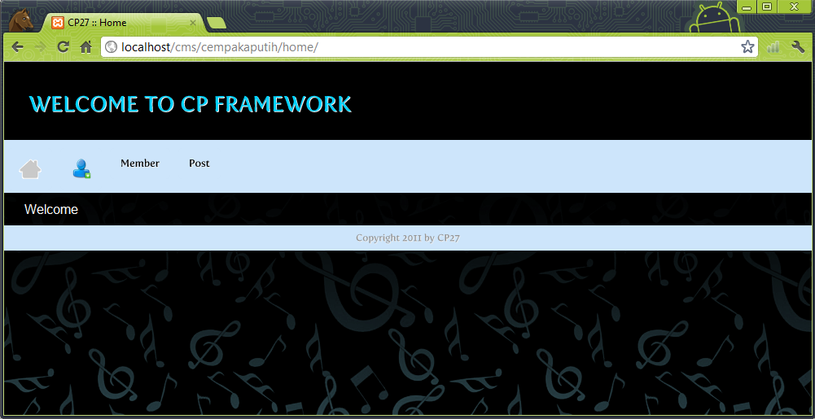

Tampilan Profile
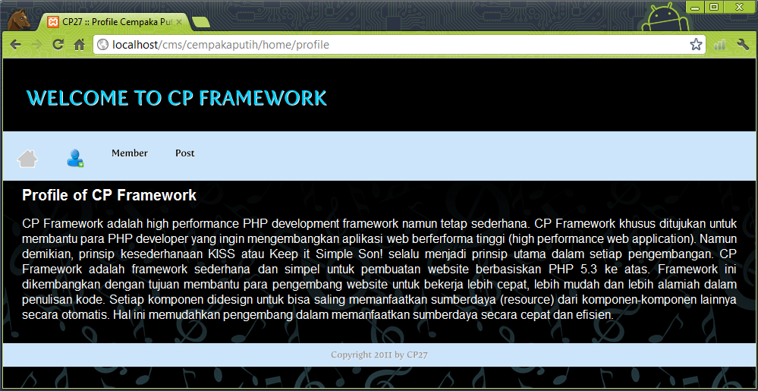

Tampilan Member
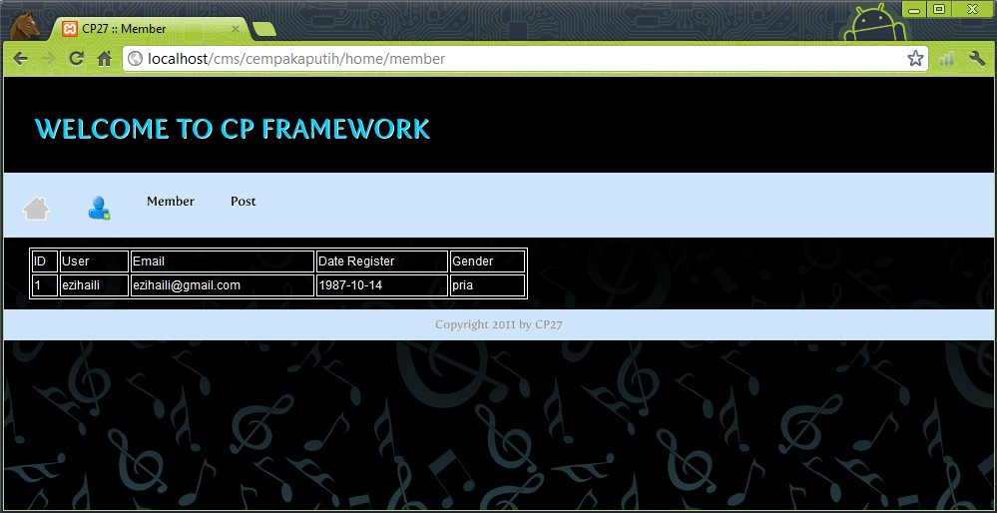

Tampilan Post
