Timing and Persistence of Liquidity Changes

Around ASX 300 Inclusion
Haonan Li, Sunny Nguyen, Salomo Octavianus and Phelix Lee
ETF5560 Case Studies in Econometrics, Monash University, October 2026
Abstract
We examine the timing and persistence of liquidity changes around S&P/ASX 300 inclusion. A matched, stacked difference-in-differences study compares 77 additions with 154 control slots across six reviews from September 2023 to March 2026. Daily data cover 121 trading days per stock-review and six stages. Log mean daily Amihud implies illiquidity 39.2% below its counterfactual during adjustment (AP), 32.1% below in the short post-inclusion stage (SP), and 22.6% below in the later stage (LP). The treated-to-counterfactual ratio rises 27.3% from AP to LP, unwinding about half the initial log decline. The AP decline survives tail capping and exclusion of the rebalance day, but raw-level effects are imprecise. Reversion is less secure after excluding that day. For investors and listed firms, the strongest proportional change is concentrated around adjustment; durable benefits are less certain.

1 Introduction
When a company joins an index, funds that track the benchmark need to adjust their portfolios, and other investors may begin to pay closer attention to the stock. Both changes can affect how easily its shares trade. Hegde and McDermott (2003) document lasting liquidity improvements following S&P 500 additions. Since illiquidity is associated with expected returns (Amihud, 2002), understanding when these changes occur and how long they last matters for investors and listed firms.
The S&P/ASX 300 review cycle gives us a useful way to study this timing. Announcements precede the rebalance close by about two weeks, leaving time for investors to anticipate additions and adjust their holdings. Trading conditions may then change again once rebalancing is complete. A single before-and-after comparison would combine these stages and could hide an initial improvement that later partly reverses.
Evidence centres on US indices, where inclusion-related price effects have weakened (Greenwood and Sammon, 2025). We ask whether ASX 300 inclusion reduces illiquidity, when any change occurs, and whether it persists. Each addition is compared with two stocks matched on sector and pre-announcement size. The largest decline occurs during adjustment (−39.2%), followed by partial reversion. Sections 3–4 describe the data and model; Sections 5–8 interpret results, robustness and limitations.

2 Institutional setting and related literature

2.1 Review cycle
The S&P/ASX 300 uses float-adjusted market capitalisation and liquidity criteria, with scheduled reviews in March and September. S&P's trading-data cut-off is the second-to-last Friday of the preceding month (S&P Dow Jones Indices, 2023–2026). Our supplied panels use the preceding trading day, day −11, for matching; 'reference date' below refers to this research input, not the official cut-off. Day 0 is the Friday announcement, day +10 the rebalance close two Fridays later, and day +11 the Monday effective date. Public eligibility rules make advance positioning plausible, motivating the pre-announcement stage in Table 1.
Table 1. Event stages relative to announcement day 0
Stage | Trading days | Full stage name
EP | −60:−41 | Earlier period
B | −40:−21 | Baseline
PA | −20:0 | Pre-announcement period
AP | +1:+10 | Adjustment period
SP | +11:+30 | Short post-inclusion period
LP | +31:+60 | Later post-inclusion period

2.2 Liquidity channels
Mechanical portfolio adjustment should concentrate trading in AP; Madhavan (2003) documents reconstitution trading in the Russell setting. For Amihud, greater traded value lowers the ratio at a given absolute return, while price pressure can raise its numerator. Investor recognition (Merton, 1987) and improved information conditions (Hegde and McDermott, 2003) could support persistence into SP and LP. Stage profiles help assess these explanations but do not separately identify the channels.

2.3 Evidence on inclusion
Early evidence focuses on prices: Shleifer (1986) finds positive responses to S&P 500 additions, and Beneish and Whaley (1996) show that advance notice changes when the price response occurs. Hegde and McDermott (2003) instead document sustained liquidity improvements. Greenwood and Sammon (2025) find that the price effect has weakened over time. We examine whether liquidity changes in Australia are concentrated around rebalancing or continue afterwards.

3 Data

3.1 Sources
Yahoo Finance supplies daily prices and adjusted closes; EODHD supplies GICS sectors, share volume and share-count cross-checks. Official S&P notices establish additions and event dates. Yahoo share histories, EODHD filings and dated ASX disclosures reconcile share counts, including splits and CHESS Depositary Interests (CDIs). Market values are in Australian dollars. GICS classifications are those available from the vendor at collection.

3.2 Event sample
The notice inventory contains 84 additions; 77 have usable current price histories and matched controls (Table 2). Missing histories exclude LRS and MRM in March 2024; MAC, OPT, RUL and SPR in September 2024; and QOR in September 2025. We validate unique ticker–review–date keys and apply the same coverage rules to retained events, including re-entries. The resulting grid contains 27,951 rows: 231 stock-review units over days −60:+60. Loss of delisted or acquired firms creates a sample-selection concern discussed in Section 7.
Table 2. ASX 300 reviews and sample sizes
Review | Announcement | Rebalance close | Initial additions | Retained additions | Controls
Sep 2023 | 1 Sep 2023 | 15 Sep 2023 | 10 | 10 | 20
Mar 2024 | 1 Mar 2024 | 15 Mar 2024 | 14 | 12 | 24
Sep 2024 | 6 Sep 2024 | 20 Sep 2024 | 16 | 12 | 24
Mar 2025 | 7 Mar 2025 | 21 Mar 2025 | 11 | 11 | 22
Sep 2025 | 5 Sep 2025 | 19 Sep 2025 | 17 | 16 | 32
Mar 2026 | 6 Mar 2026 | 20 Mar 2026 | 16 | 16 | 32
Total |  |  | 84 | 77 | 154

3.3 Control selection
For each addition, we select two controls from the same sector that are closest in reference-date market capitalisation, without reusing a control within a review. The target control/addition size ratio is 0.5–2.0, and 153 of the 154 control slots fall inside it. The exception is NEC for MAQ in September 2023, with a ratio of 2.116. We exclude candidates with an addition or deletion in a major ASX index during the same review. Price histories must cover at least 90% of the 121-day grid, and the retained controls exceed A$100,000 median traded value in the matching screen. We also confirm that the selected controls satisfy the baseline data requirements. A control may appear again in a later review, which we account for in the inference.

3.4 Liquidity and baseline characteristics
Daily Amihud divides the absolute return from adjusted closes by unadjusted closing price times share volume, scaled by 10⁶. Higher values indicate more absolute return per Australian dollar traded. We average valid daily ratios within each stage and then take logs. Zero or missing volume is invalid; genuine zero returns remain valid. A stage requires 60% valid days and a positive mean; complete matched groups must pass all stages and covariate checks. The main outcome uses uncapped ratios without filling; P99 capping is a sensitivity check.
Table 3. Baseline characteristics of additions and controls
Variable | Additions | Controls | Difference (p)
Reference-date market cap (A$m) | 1,753.4 | 1,817.2 | −63.8 (0.050)
Baseline mean market cap (A$m) | 1,681.7 | 1,820.5 | −138.8 (0.003)
Mean daily Amihud (×10⁶) | 0.0192 | 0.0182 | 0.0010 (0.840)
Mean daily traded value (A$m) | 4.65 | 5.98 | −1.34 (0.159)
Mean daily turnover (%) | 0.391 | 0.330 | 0.062 (0.372)
Log mean daily Amihud | −4.526 | −4.961 | 0.436 (0.003)
Notes: Stock-review means in B, except reference-date size; differences use unrounded values. Difference p-values use matched-group fixed effects and ticker-clustered CR1 (187 tickers). Levels need not be equal for parallel trends.
Additions have smaller baseline capitalisation (A$1,682m versus A$1,821m; p = 0.003), motivating size-by-stage controls. Raw Amihud means are close (0.0192 versus 0.0182), but log means differ (−4.526 versus −4.961; p = 0.003). Similar raw means therefore do not establish balance on the regression scale. Fixed effects absorb stable level gaps; conditional parallel trends concerns subsequent untreated changes.

4 Empirical strategy

4.1 Stacked design
We organise the data into a separate panel for each review, containing its additions and their matched controls. This keeps each comparison within the same event and avoids using stocks treated in an earlier review as untreated comparators in a single staggered regression (Goodman-Bacon, 2021; Callaway and Sant'Anna, 2021). Following the logic of stacked designs (Cengiz et al., 2019; Wing et al., 2024), we keep the sample fixed across stages and combine the review-specific estimates using explicit weights.
The balanced estimation sample contains 77 groups, 231 stock-review units and 1,386 stock-review-stage observations.

4.2 Outcome
We take the logarithm after averaging valid daily Amihud ratios within each stage:
Here i indexes stocks, s reviews, t stages and d days; P is unadjusted closing price, V share volume, and nᵢₛ,ₜ valid days. Scaling by 10⁶ shifts log levels but leaves treatment coefficients unchanged.

4.3 Conditional heterogeneous specification

In equation (2), T equals one for an addition, g(i,s) identifies its matched group, and k indexes stages other than B. There are therefore 30 review-specific treatment effects. Each coefficient compares how the additions' log Amihud changes from B to stage k with the change experienced by their controls. A negative coefficient means that additions become relatively less illiquid. Baseline observations remain in the regression; only their treatment interaction is omitted.

4.4 Fixed effects and covariates
The stock-review fixed effect α allows each stock to have its own usual level of illiquidity within a review. This matters because stocks can differ substantially in size, trading interest and other persistent characteristics. A separate effect is estimated when a ticker appears in another review. The matched-group-by-stage effect λ then captures changes shared by an addition and its two controls in a particular stage, so the model compares stocks exposed to similar sector and market conditions.
X contains log mean daily capitalisation in B (−40:−21) and EP return volatility (−60:−41), the sample standard deviation of decimal returns times 100. Each needs 12 valid days. Fixed stock-review values interact with the five non-baseline stages, with slopes common across reviews. Baseline size precedes the allowed positioning stage; reference-date size falls within it. The homogeneous benchmark replaces βs,k with βk, retaining the same controls and fixed effects.

4.5 Aggregation and inference
Weighted least squares assigns weight 1 to an addition and 0.5 to each control, balancing the two sides of each group. The final stage effect weights each review by its share of retained additions:
Weights are (10, 12, 12, 11, 16, 16)/77, giving each addition-plus-controls group equal weight. The sample and weights are identical across stages. V̂k retains cross-review covariance. This averages fitted effects; it is not a separate Callaway–Sant'Anna group-time ATT estimator.
We cluster inference by ticker to allow errors to correlate across stages and repeated appearances in different reviews (Bertrand, Duflo and Mullainathan, 2004). The CR1 covariance estimator is:

z̃ is the regressor vector after fixed-effect absorption; Q contains weights q, and û denotes residuals. The 231 stock-review units represent G = 187 distinct tickers because stocks recur across reviews. N = 1,386 and K = 656 include fixed effects; t and F tests use 186 denominator degrees of freedom. Holm (1979) correction applies separately to five stage effects and three post-stage contrasts. Confidence intervals are pointwise 95% intervals.

4.6 Identifying assumptions

4.6.1 Conditional parallel trends
Conditional parallel trends requires additions and controls to have the same expected untreated change from B to each stage, given X and the matched-group structure:
Y⁰ denotes the untreated log outcome. Same-sector and size matching builds comparability into the sample. Size and volatility interactions allow these characteristics to predict different stage profiles, while fixed effects remove stable liquidity differences.
Pre-trend diagnostics use four ten-day bins spanning −60:−21, with −40:−31 as reference; PA is excluded because positioning is allowed there. Each bin needs six valid days, retaining 73 groups and 178 tickers. The main model keeps 77 groups. Joint tests do not reject equal pre-event changes (Table 4); non-rejection supports the design but does not establish parallel trends.
Table 4. Joint conditional pre-trend tests
Joint pre-trend restrictions | Number | p-value
Pooled common bin changes equal zero | 3 | 0.711
Event-weighted bin changes equal zero | 3 | 0.719
All review-specific bin changes equal zero | 18 | 0.164
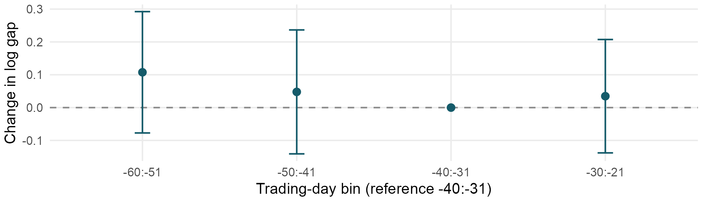
Figure 1. Conditional pre-trend estimates; pointwise 95% ticker-clustered intervals. Reference: −40:−31.

4.6.2 No anticipation in B
We assume inclusion expectations have not affected additions during B (−40:−21). PA (−20:0) allows positioning before announcement. B ends ten trading days before our matching reference date, reducing proximity to final selection. Excluding same-review index actions mitigates comparison shocks, but we also assume no material spillovers to controls. Neither baseline levels nor PA's imprecise estimate can verify no anticipation.

5 Results and interpretation

5.1 Main stage effects
Table 5 reports the event-weighted conditional heterogeneous estimates. To express a log coefficient as a percentage change, we use:
For example, AP's coefficient of −0.497 implies exp(−0.497) = 0.608: modelled illiquidity is 39.2% below its counterfactual. This is a ratio-of-ratios relative to B, rather than the percentage change in a raw group mean.
Table 5. Main conditional heterogeneous effects
Stage | Log β | SE | Effect % | 95% CI % | p | Holm p
EP | 0.044 | 0.067 | +4.5 | [−8.5, 19.3] | 0.516 | 0.516
PA | −0.087 | 0.071 | −8.3 | [−20.3, 5.5] | 0.222 | 0.445
AP | −0.497 | 0.093 | −39.2 | [−49.4, −27.0] | <0.001 | <0.001
SP | −0.387 | 0.086 | −32.1 | [−42.6, −19.6] | <0.001 | <0.001
LP | −0.256 | 0.094 | −22.6 | [−35.7, −6.8] | 0.007 | 0.021
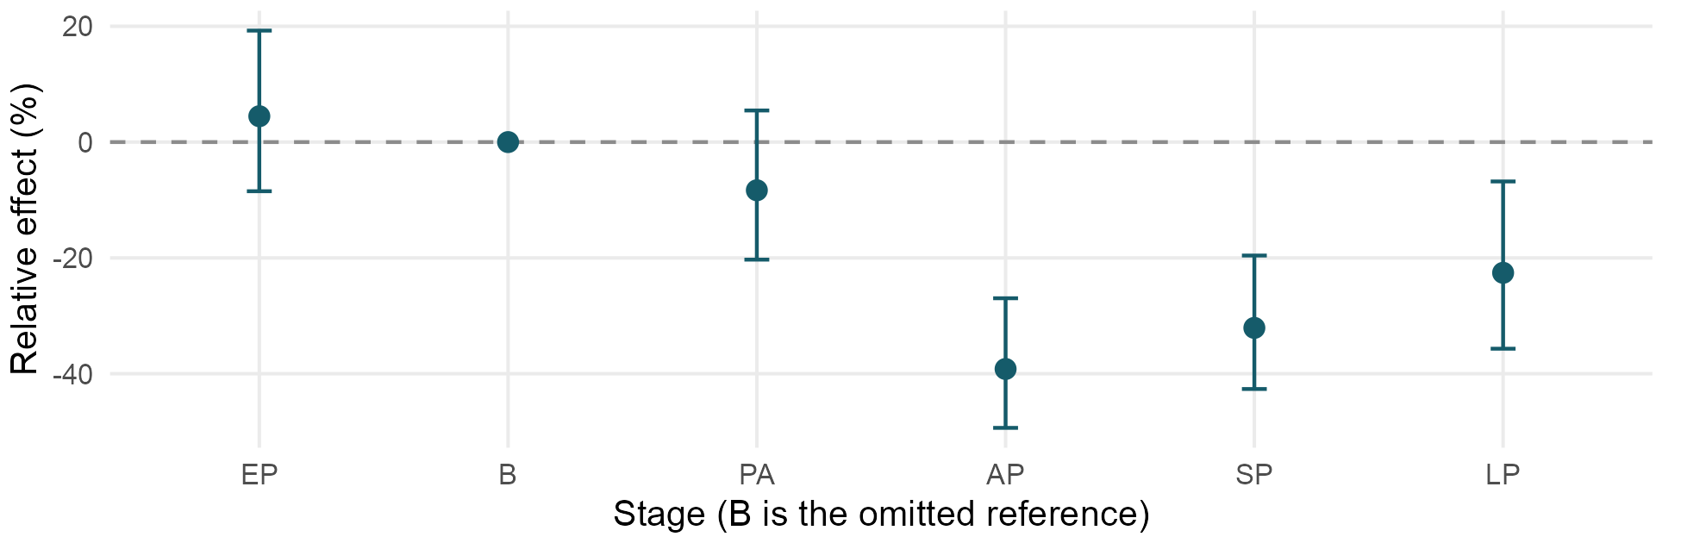
Figure 2. Event-weighted effects relative to B; pointwise 95% ticker-clustered intervals.
Illiquidity is 39.2% below its counterfactual in AP (95% CI [−49.4%, −27.0%]), 32.1% below in SP and 22.6% below in LP; all survive Holm correction. EP (+4.5%) and PA (−8.3%) are imprecise. The AP decline coincides with sharply higher turnover (Table 8), consistent with portfolio adjustment. Increased traded value mechanically lowers Amihud at a given return; the ratio alone cannot establish lower execution costs. Persistence into SP/LP is compatible with broader investor attention, without identifying that mechanism.

5.2 Reversion across post stages
We test reversion directly by subtracting the earlier aggregate log effect from the later effect, then converting the difference into a proportional change:
Table 6. Later-stage minus earlier-stage contrasts
Contrast | Log contrast | Ratio change % | 95% CI % | p | Holm p
SP - AP | 0.110 | +11.7 | [−3.0, 28.5] | 0.123 | 0.123
LP - SP | 0.131 | +14.0 | [0.5, 29.4] | 0.042 | 0.084
LP - AP | 0.241 | +27.3 | [7.8, 50.3] | 0.005 | 0.014
The treated-to-counterfactual ratio rises 27.3% from AP to LP (95% CI [7.8%, 50.3%]; Holm p = 0.014). This unwinds about 49% of the initial log decline, a point-estimate description rather than a separately tested fraction. Evidence is concentrated in the full AP→LP change: the adjacent 11.7% and 14.0% increases are imprecise after Holm correction. These are proportional ratio changes, not percentage-point differences. LP remains 22.6% below its counterfactual.

5.3 Differences across reviews
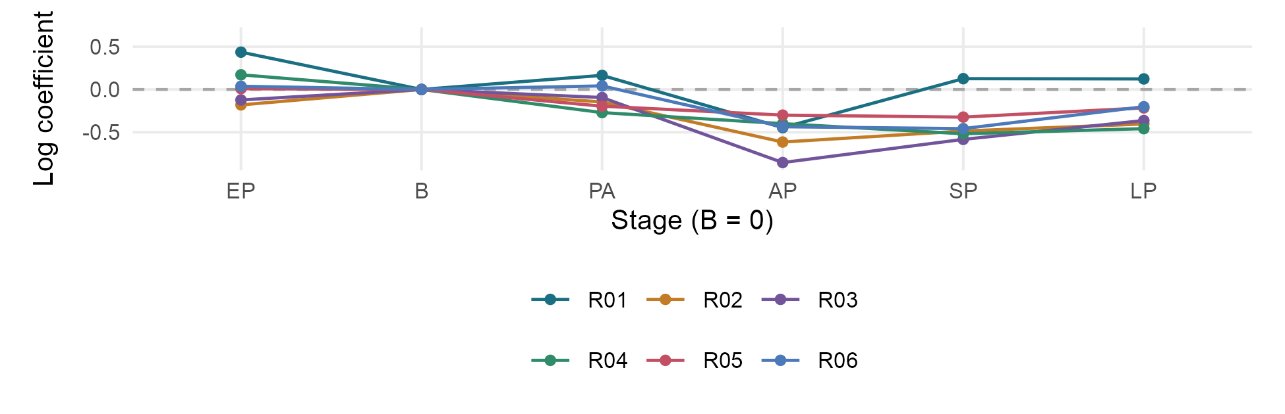
Figure 3. Review-specific log effects relative to B; intervals omitted for readability.
All six AP estimates are negative, but R01 returns near zero in SP/LP (Figure 3). Post-stage equality gives F(15,186) = 1.643, p = 0.066; equality across all five non-baseline stages gives F(25,186) = 1.764, p = 0.018. Stage-by-stage tests of review equality are individually insignificant at 5%, so we cannot attribute the all-stage rejection to the pre-event stages.
The main heterogeneous model preserves review variation and explicit addition-count weights. Its post averages closely match the homogeneous benchmark (−38.9%, −32.3%, −22.6%). Non-rejection of post-only equality does not establish equality; leave-one-review-out estimates assess sensitivity to individual events separately.

6 Robustness checks

6.1 Specification and sample sensitivity
Table 7. Proportional effects and reversion under alternative specifications
Specification | AP | SP | LP | LP−AP
Conditional heterogeneous (main) | −39.2% (<0.001) | −32.1% (<0.001) | −22.6% (0.021) | +27.3% (0.014)
P99 daily cap then log | −35.6% (<0.001) | −28.8% (<0.001) | −16.8% (0.077) | +29.2% (0.007)
Conditional homogeneous | −38.9% (<0.001) | −32.3% (<0.001) | −22.6% (0.023) | +26.6% (0.020)
Reference-date cap | −44.1% (<0.001) | −36.4% (<0.001) | −26.6% (0.003) | +31.3% (0.002)
Stricter 80% coverage | −39.5% (<0.001) | −31.9% (<0.001) | −22.5% (0.031) | +28.1% (0.017)
Exclude rebalance day | −35.7% (<0.001) | −32.1% (<0.001) | −22.6% (0.021) | +20.4% (0.095)
Notes: Percentage effects; parentheses give Holm p-values across five stage effects, or separately three contrasts for LP−AP. All specifications retain 77 groups except 80% coverage (72). Excluding day +10 changes AP to +1:+9; all groups still pass 60% coverage.
P99 capping asks whether a few unusually high daily ratios drive the findings. We apply one pre-event threshold (0.189), before averaging and taking logs. The AP and SP declines remain significant, so the initial response is not confined to the extreme tail. The weaker LP result indicates that later persistence is more sensitive to unusually illiquid days.
The homogeneous estimates are close to the main averages, suggesting that the overall timing pattern does not depend on allowing every review to have a separate effect. Reference-date size produces a larger AP decline, showing that its magnitude is sensitive to the covariate period. The stricter 80% sample retains a similar pattern, which reduces concern that sparse observations generate the main result.

6.2 Rebalance trading and partial reversion
Removing day +10 leaves the AP effect at −35.7% (Holm p < 0.001). This suggests that the initial decline extends beyond the rebalance day's concentrated trading. However, LP−AP falls to +20.4% and loses significance after Holm correction (p = 0.095). The evidence for partial reversion therefore depends more on how adjustment-stage trading is measured than the evidence for an initial decline.

6.3 Sensitivity to individual reviews
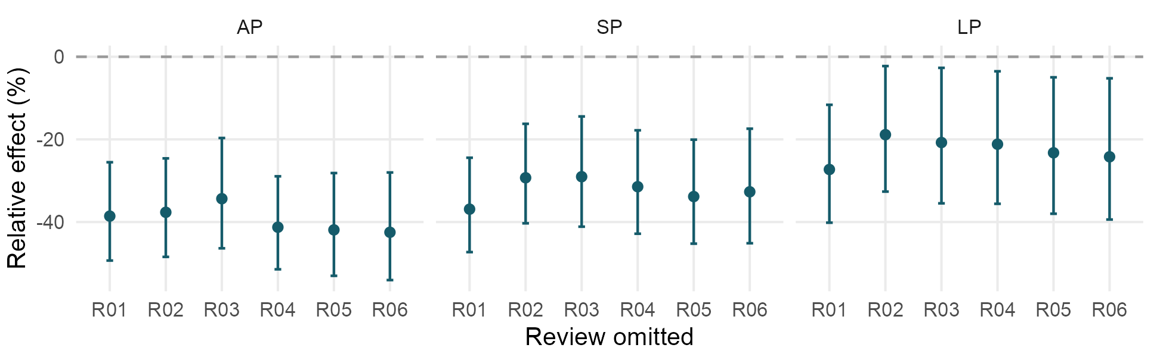
Figure 4. Leave-one-review-out estimates; pointwise 95% ticker-clustered intervals.
Omitting each review in turn leaves all post-stage estimates negative. AP and SP remain significant after Holm correction in every run, so no single review accounts for the initial response. LP is less precise. The LP−AP contrast also remains positive (+18.4% to +34.2%), but loses adjusted significance when R01 or R03 is omitted. Its direction is consistent, although the statistical evidence is sensitive to the small set of reviews.

6.4 Complementary outcome measures
Table 8. Complementary outcomes on the same estimation sample
Outcome and units | AP | SP | LP
Raw mean Amihud (×10⁶) | −0.01561 (0.214) | −0.00889 (0.192) | −0.03208 (0.520)
Mean turnover (pp) | +0.379 (<0.001) | +0.080 (0.330) | +0.051 (0.883)
Log mean turnover (%) | +141.9% (<0.001) | +27.7% (0.002) | +18.4% (0.114)
Notes: Parentheses are Holm p-values across five stages within each outcome. Raw Amihud uses the scaled ratio in (1); turnover levels are percentage points (pp), logs use 100[exp(β) − 1]. The level-turnover AP 95% CI is [0.238, 0.521] pp.
The raw Amihud model asks about absolute changes, whereas the log model asks about proportional changes. Its post-stage coefficients are negative but none survives Holm correction. This distinction matters when stocks have different typical illiquidity levels: an absolute change has a different meaning for a highly illiquid stock than for an already liquid one. Dividing a raw coefficient by a baseline mean does not reproduce the log-model effect.
Turnover provides a complementary view of trading activity. Using daily share volume divided by shares outstanding, the level model shows a significant AP increase of 0.379 percentage points. In the log model, AP (+141.9%) and SP (+27.7%) remain significant after Holm correction, while LP does not. Together, these results link the early Amihud decline to a rise in trading activity that becomes less pronounced later. They support an adjustment-trading interpretation, rather than directly establishing lower spreads or execution costs.

7 Limitations and future improvements
Accuracy of control selection. Our comparison relies on finding stocks that would have followed a similar liquidity path without a new inclusion event. Sector and size matching, activity screening and volatility controls help, but they cannot capture every difference in free float, investor composition or company-specific news. These differences may affect the estimated magnitude and evolution of the inclusion response. More precise historical size and free-float measures, together with checks for overlapping corporate events, would improve the accuracy of control selection. Vendor data availability and historical classification errors can also limit comparability.
Identification and dependence. Anticipation may begin in B, and the baseline was revised after diagnostic inspection; pretests are not independent validation (Roth, 2022). If anticipation already lowered treated illiquidity in B while controls were unaffected, later declines would be attenuated, but other anticipation paths need not bias effects that way. Longer pre-periods, pre-specified baselines and sensitivity analysis would help. Six reviews limit heterogeneity assessment. Ticker clustering allows within-stock dependence, not arbitrary dependence across stocks sharing a review; additional reviews would strengthen multiway inference.
Measurement. Amihud is a price-impact proxy, not a direct estimate of spreads or execution costs. Low trading values, discrete prices and extreme returns affect short averages. The exclusion-of-rebalance-day and raw-outcome checks limit claims about durable improvement and reversion. Share-count errors can affect size and turnover. Quote-based spreads, free-float turnover and audited share histories would broaden the evidence.
Further validation. Extending beyond +60 would reveal later reversion. Earlier matching dates and pre-event activity or free-float measures could improve comparability. Placebo event dates and sensitivity bounds for plausible parallel-trend violations would further assess identification; they require clearly specified placebo timing and comparison samples.

8 Conclusion
The clearest finding is a decline in Amihud during adjustment: the estimated proportional effect is −39.2% in AP, compared with −32.1% in SP and −22.6% in LP. The AP-to-LP ratio rises by 27.3%, suggesting that roughly half the initial log decline is subsequently unwound. The initial response remains evident across the main specification checks, while the strength of reversion is more sensitive to rebalance trading and individual reviews. Overall, the results suggest that inclusion effects are strongest around portfolio adjustment and become smaller over time. A wider set of reviews and more accurate control matching would help establish how broadly this pattern applies.

References
Amihud, Y. (2002). Illiquidity and stock returns: cross-section and time-series effects. Journal of Financial Markets, 5(1), 31–56. https://doi.org/10.1016/S1386-4181(01)00024-6
Beneish, M. D., & Whaley, R. E. (1996). An anatomy of the 'S&P Game': the effects of changing the rules. Journal of Finance, 51(5), 1909–1930. https://doi.org/10.1111/j.1540-6261.1996.tb05231.x
Bertrand, M., Duflo, E., & Mullainathan, S. (2004). How much should we trust differences-in-differences estimates? Quarterly Journal of Economics, 119(1), 249–275. https://doi.org/10.1162/003355304772839588
Callaway, B., & Sant'Anna, P. H. C. (2021). Difference-in-differences with multiple time periods. Journal of Econometrics, 225(2), 200–230. https://doi.org/10.1016/j.jeconom.2020.12.001
Cengiz, D., Dube, A., Lindner, A., & Zipperer, B. (2019). The effect of minimum wages on low-wage jobs. Quarterly Journal of Economics, 134(3), 1405–1454. https://doi.org/10.1093/qje/qjz014
Goodman-Bacon, A. (2021). Difference-in-differences with variation in treatment timing. Journal of Econometrics, 225(2), 254–277. https://doi.org/10.1016/j.jeconom.2021.03.014
Greenwood, R., & Sammon, M. (2025). The disappearing index effect. Journal of Finance, 80(2), 657–698. https://doi.org/10.1111/jofi.13410
Hegde, S. P., & McDermott, J. B. (2003). The liquidity effects of revisions to the S&P 500 index: an empirical analysis. Journal of Financial Markets, 6(3), 413–459. https://doi.org/10.1016/S1386-4181(02)00046-0
Holm, S. (1979). A simple sequentially rejective multiple test procedure. Scandinavian Journal of Statistics, 6(2), 65–70. https://www.jstor.org/stable/4615733
Madhavan, A. (2003). The Russell reconstitution effect. Financial Analysts Journal, 59(4), 51–64. https://doi.org/10.2469/faj.v59.n4.2545
Merton, R. C. (1987). A simple model of capital market equilibrium with incomplete information. Journal of Finance, 42(3), 483–510. https://doi.org/10.1111/j.1540-6261.1987.tb04565.x
Roth, J. (2022). Pretest with caution: Event-study estimates after testing for parallel trends. American Economic Review: Insights, 4(3), 305–322. https://doi.org/10.1257/aeri.20210236
S&P Dow Jones Indices. (2023–2026). S&P/ASX Australian Indices Methodology and review announcements, September 2023 to March 2026. https://www.spglobal.com/spdji/en/indices/equity/sp-asx-300/
Shleifer, A. (1986). Do demand curves for stocks slope down? Journal of Finance, 41(3), 579–590. https://doi.org/10.1111/j.1540-6261.1986.tb04518.x
Wing, C., Freedman, S. M., & Hollingsworth, A. (2024). Stacked difference-in-differences. NBER Working Paper 32054. https://doi.org/10.3386/w32054

