# **Class Diagram**

**Turtle 1 Class Diagram**

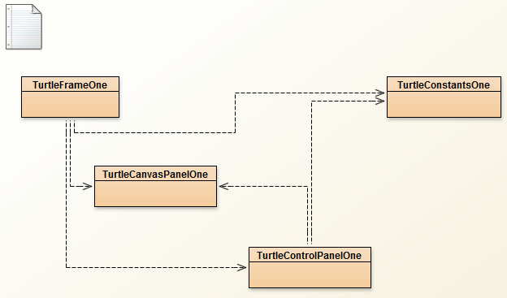

**Turtle 6 Class Diagram**

