uInstitute of Technology of Cambodia

Department of Information Technology   
and communication

Operating System

Name of students ID of students

1. Pheng Menghour e20210737

Lecturer: Mr. Heng Rathpisey

Academic Year 2024-2025

TP2

1. Identify absolute or relative path

|  |  |
| --- | --- |
| Path | Absolute or Relative |
| /home/user/downloads | Absolute |
| ../Reports | Relative |
| /var | Absolute |
| docs | Relative |
| / | Absolute |

1. Observe the following structure

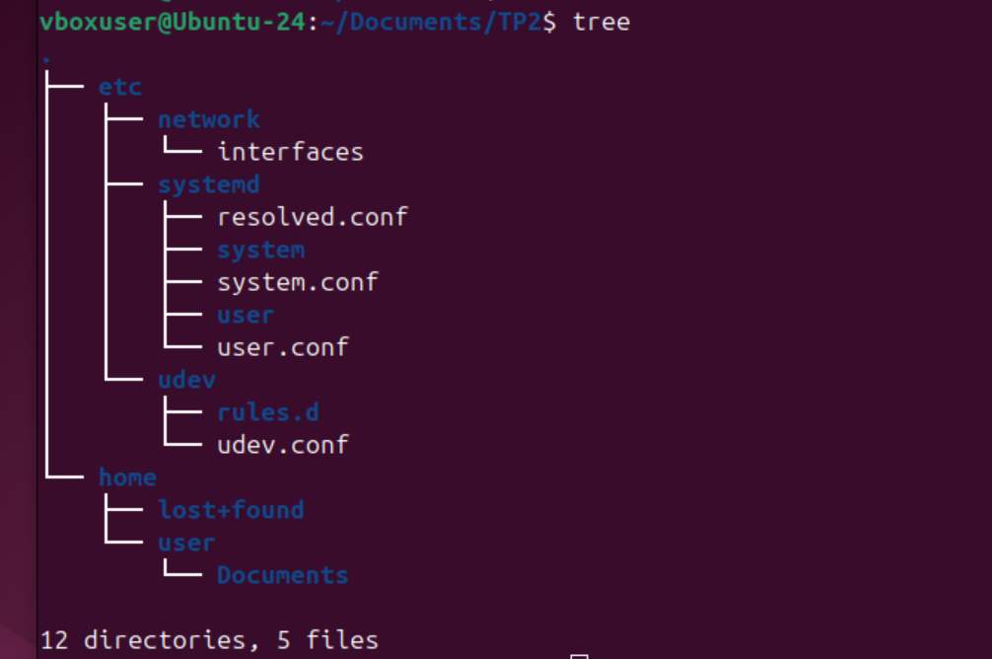

* A user enters following commands:
  + $ cd /etc/dev
  + ls -a
* This is the output:

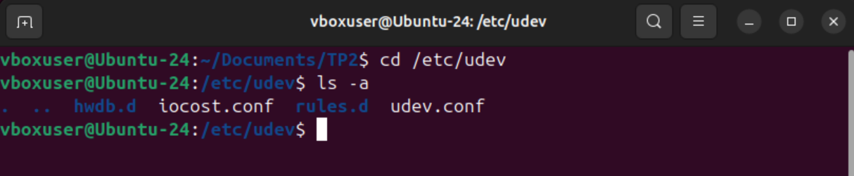

1. Enter shortest command possible
2. Your current location is root (/). Enter the command to navigate to lost+found within the home directory.

* Command: cd ./home/lost+found



1. Your current location is root (/). Enter the command to navigate to the directory named /etc/network/.

* Command: cd /etc/network

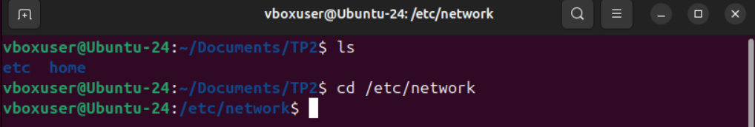

1. Your current location is /home/user/Documents/. Navigate to the directory named /etc/.

* Command: cd /etc

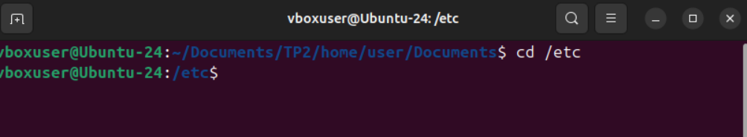

1. Your current location is /etc/systemd/system/. Navigate to the directory named /home/user/.

* Command: cd /home/user



1. Consider now we are at Home directory. Using linux commands you have learned to:
2. Display the current directory



1. Change directory to Desktop



1. Create a folder named TPOS



1. Change directory to Home directory



1. Change directory to TPOS using Absolute Path



1. Change directory to a folder Document in the username folder using Relative Path



1. Using linux commands you have learned to:
   1. Create folder in a Document folder and name it “TP01”



* 1. Create text file name “file.txt”



* 1. Write “I am YOUR NAME” in file.txt.



* 1. Change directory to Desktop using Relative path.



* 1. Read file “file.txt” from Desktop using Relative path

