|  |  |  |
| --- | --- | --- |
| Лабораторная работа №4 «Реализация запросов базы данных» | ФИО | Курляк Д. В. |
| Группа | ПрИн – 367 |
| Преподаватель | Соколов А.А |
| Дата сдачи |  |
| Оценка |  |

1. Запросы из функциональных требований (15)

1.1 ## Добавить матч

INSERT INTO demo_cup.gamesbetweentwoteams values(4,2,4,1,6,7,'2020-09-03');



1.2 ## Добавить команду

INSERT INTO demo_cup.teams (Name, StadionId, Win, Draw, Lose) values('Амкал', '11', '3', '2', '3');



1.3 ##Добавить игрока

INSERT INTO demo_cup.players (FIO, Age) values('Курляк Дмитрий Владимирович','20');



1.4 ##Добавить тренера

INSERT INTO demo_cup.coachs (FIO, Age) values('Самедов Александр Ахмедович', '39');



1.5 ##Добавить стадион

INSERT INTO demo_cup.stadions (Name, CityId, Capacity) values('Карабах', '4', '3500');



1.6 ##Добавить тур

INSERT INTO demo_cup.tournumbers (DateTimeFrom, DateTimeTo) values('2020-10-01', '2020-10-07');



1.7 ## Показать результат 1 встречи

SELECT

demo_cup.statistics.Goals,

demo_cup.statistics.PlayerId,

demo_cup.players.FIO,

demo_cup.teamstoplayers.TeamId

FROM

demo_cup.statistics

JOIN

demo_cup.teamstoplayers,

demo_cup.players

WHERE

demo_cup.statistics.PlayerId = demo_cup.teamstoplayers.PlayerId

AND demo_cup.statistics.GameId = 1

AND demo_cup.statistics.PlayerId = demo_cup.players.Id;

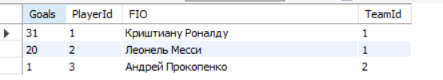

1.8 ##Показать трансферы турнира

SELECT

demo_cup.players.FIO, demo_cup.teamstoplayers.*

FROM

demo_cup.players

JOIN

demo_cup.teamstoplayers

WHERE

demo_cup.teamstoplayers.PlayerId = demo_cup.players.id;

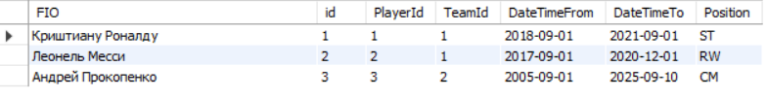

1.9 ## Вывести состав команды 1

SELECT

demo_cup.players.FIO, demo_cup.teamstoplayers.TeamId

FROM

demo_cup.players

JOIN

demo_cup.teamstoplayers

WHERE

demo_cup.teamstoplayers.TeamId = 1

AND demo_cup.players.id = demo_cup.teamstoplayers.PlayerId;

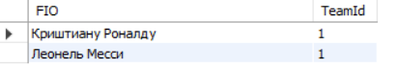

1.10 ## Вывести информацию по матчу

SELECT

demo_cup.gamesbetweentwoteams.StadionId,

RefereeId,

TourNumberId,

Team1Id,

Team2Id,

DateOfMatch,

demo_cup.statistics.goals,

demo_cup.teamstoplayers.TeamId,

demo_cup.players.FIO

FROM

demo_cup.gamesbetweentwoteams

JOIN

demo_cup.statistics

JOIN

demo_cup.teamstoplayers

JOIN

demo_cup.players

WHERE

demo_cup.statistics.GameId = 1

AND demo_cup.gamesbetweentwoteams.id = 1

AND statistics.PlayerId = demo_cup.teamstoplayers.PlayerId

AND demo_cup.players.id = statistics.PlayerId;

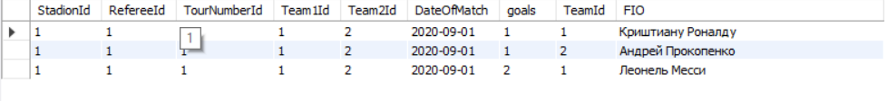

1.11 ##Вывести статистику игрока в команде

SELECT

demo_cup.statistics.*

FROM

demo_cup.statistics

WHERE

Gameid = 1;



1.12 ## Показать итоговую статистику

SELECT

demo_cup.statistics.*

FROM

demo_cup.statistics

WHERE

PlayerId = 2;



1.13 ##Показать таблицу турнира

SELECT

*

FROM

demo_cup.teams

ORDER BY win DESC , Draw DESC

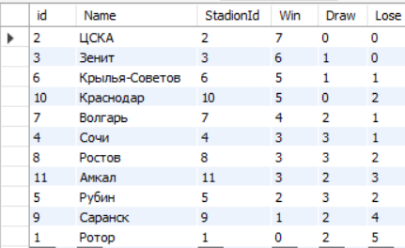

1.14 ## Пара на след. тур

SELECT demo_cup.teams.Name as Pair_Team FROM demo_cup.teams ORDER BY rand() LIMIT 2;

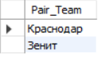

1.15 ##Показать стадион и соответсвующие города

SELECT

demo_cup.cities.Name, demo_cup.stadions.Name

FROM

demo_cup.cities

JOIN

demo_cup.stadions

WHERE

demo_cup.stadions.CityId = demo_cup.cities.id;

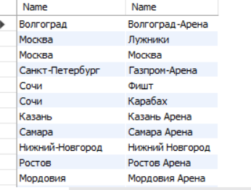

1. INSERTы для своей БД или БД одногруппника из предыдущей лабораторной работы (13)

INSERT INTO litvinenko.user values(1, 'Dima', 'cat1020486@gmail.com', 'CoolerPass', '1');

INSERT INTO litvinenko.user values (2, 'Katya', 'katya@gmail.com', 'Password', '1');

INSERT INTO litvinenko.user values (3, 'Misha', 'misha@gmail.com', 'Password', '1');

INSERT INTO litvinenko.form values (1, 1, 1, 1);

INSERT INTO litvinenko.form values (2, 2, 2, 2);

INSERT INTO litvinenko.role values (1, 'Dima', 'DaTak');

INSERT INTO litvinenko.session values(1, 1);

INSERT INTO litvinenko.session values(2, 2);

INSERT INTO litvinenko.session values(3, 3);

INSERT INTO litvinenko.user_has_access_to_form values(1, 1);

INSERT INTO litvinenko.user_has_access_to_form values(2, 2);

INSERT INTO litvinenko.avatar values(1,'SomeText',1);

INSERT INTO litvinenko.avatar values(2,'Text',2);

1. UPDATE + WHERE (8)

3.1 update demo_cup.stadions set capacity = 35000 where Name = 'Карабах';

3.2

update demo_cup.statistics set goals = 3 where PlayerId = 3; 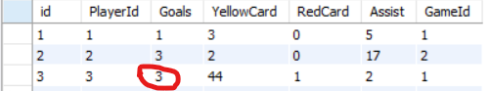

3.3

update demo_cup.referees set Age = 49 where id = 3;



3.4

update demo_cup.stadions set Capacity = 9000 where id = 11;

3.5

update demo_cup.players set Age = 31 where id = 2;



3.6

update demo_cup.teams set Win = 1 where Name = 'Ротор';



3.7

update demo_cup.coachs set Age = 47 where id = 1;



3.8

update demo_cup.stadions set CityId = 2 where id = 12;



1. DELETE с WHERE (5 шт)

4.1 DELETE FROM demo_cup.stadions WHERE NAME = 'Карабах';



4.2 DELETE FROM demo_cup.stadions WHERE id = 11;



4.3

DELETE FROM demo_cup.referees WHERE id = 4;



4.4

DELETE FROM demo_cup.coachs WHERE id = 11;



4.5

DELETE FROM demo_cup.tournumbers WHERE Number = 5;



1. SELECT, DISTINCT, WHERE, AND/OR/NOT, IN, BETWEEN, IS NULL, AS (20)
   1. SELECT * from demo_cup.players where AGE < 30; 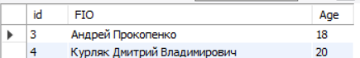
   2. SELECT FIO from demo_cup.players;

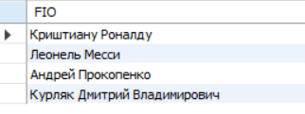

* 1. SELECT * from demo_cup.teams where WIN > 3;

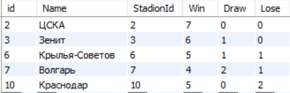

* 1. SELECT * from demo_cup.statistics where Goals > 2;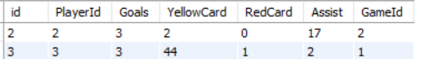
  2. SELECT * from demo_cup.coachs where AGE between 50 and 60;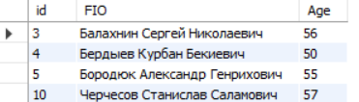
  3. SELECT Name as 'ФИО' from demo_cup.referees;

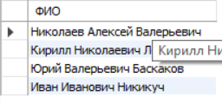

* 1. SELECT * from demo_cup.teamstoplayers where TeamId is not null;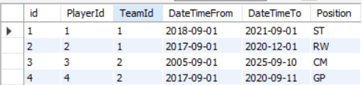
  2. SELECT Name as "Название" from demo_cup.cities;

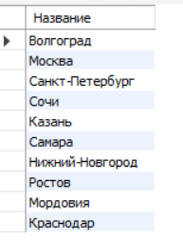

* 1. SELECT FIO, AGE FROM demo_cup.players where age <> 18 and age < 21 
  2. SELECT sum(goals) as "Забитых голов игроком 1" from demo_cup.statistics where PlayerId = 1;

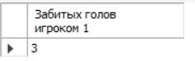

* 1. SELECT distinct age as "Различные возраста" from demo_cup.coachs; 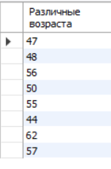
  2. SELECT Name from demo_cup.stadions where CityId IN (2,3);

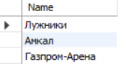

* 1. SELECT FIO, AGE from demo_cup.players where Age = 20 or Age = 21 or Age = 18; 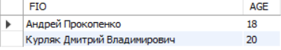
  2. SELECT tournumbers.DateTimeFrom as "Дата начала тура", tournumbers.DateTimeFrom as "Дата конца тура" from demo_cup.tournumbers; 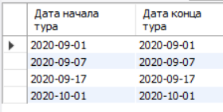
  3. SELECT PlayerId from demo_cup.teamstoplayers where TeamId is NULL;

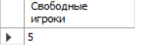

* 1. SELECT sum(goals) as "Общее количество забитых голов" from demo_cup.statistics; 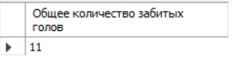
  2. SELECT distinct age as "Различные возраста" from demo_cup.referees;

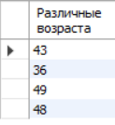

* 1. SELECT PlayerId as "Занятые игроки" from demo_cup.teamstoplayers where TeamId is NOT NULL;

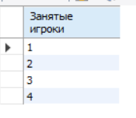

* 1. SELECT COUNT(*) from demo_cup.tournumbers;



* 1. SELECT COUNT(*) as "Количество стадионов Москвы"from demo_cup.stadions where CityId = 2;

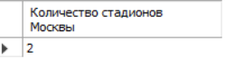

1. LIKE (5)
   1. SELECT FIO from demo_cup.players where FIO like '%Дмитрий%'; 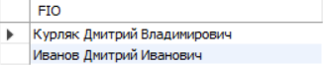
   2. SELECT FIO from demo_cup.coachs where FIO like '%Сергей%'; 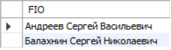
   3. SELECT Name from demo_cup.cities where Name like 'С%';

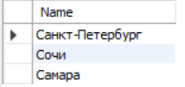

* 1. SELECT Name from demo_cup.teams where Name like '%ь%';



* 1. SELECT FIO from demo_cup.players where FIO like '% % %'; 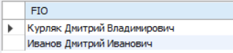

1. COUNT, MAX, MIN, SUM, AVG (10 шт)
   1. SELECT COUNT(*) from demo_cup.tournumbers;



* 1. SELECT COUNT(*) as "Количество стадионов Москвы"from demo_cup.stadions where CityId = 2;



* 1. SELECT AVG(AGE) from demo_cup.players;



* 1. SELECT AVG(AGE) from demo_cup.coachs;



* 1. SELECT AVG(AGE) from demo_cup.referees;



* 1. SELECT sum(goals) as "Забитых голов игроком 1" from demo_cup.statistics where PlayerId = 1;



* 1. SELECT sum(goals) as "Общее количество забитых голов" from demo_cup.statistics; 
  2. SELECT MAX(Goals) from demo_cup.statistics;



* 1. SELECT MAX(Age) from demo_cup.coachs;



* 1. SELECT MIN(Age) from demo_cup.players;



1. GROUP BY, HAVING (5)

8.1 SELECT

demo_cup.statistics.goals,

Count(PlayerId)

FROM

demo_cup.statistics

JOIN

demo_cup.players

WHERE

demo_cup.players.id = demo_cup.statistics.PlayerId

GROUP BY goals;

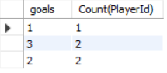

8.2 SELECT

demo_cup.cities.Name,

COUNT(demo_cup.stadions.CityId) as "Количество стадионов"

FROM

demo_cup.stadions

JOIN

demo_cup.cities

WHERE

demo_cup.stadions.CityId = demo_cup.cities.id

GROUP BY demo_cup.cities.Name;

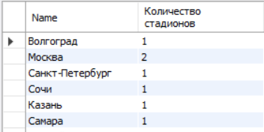

8.3 SELECT

min(demo_cup.players.age),

max(demo_cup.players.age)

FROM

demo_cup.players

HAVING AVG(age) > 20;



8.4##Список бомбардиров

SELECT

demo_cup.players.FIO, sum(demo_cup.statistics.goals)

FROM

demo_cup.statistics

JOIN

demo_cup.players

WHERE

demo_Cup.players.id = demo_cup.statistics.PlayerId

GROUP BY demo_cup.statistics.PlayerId;

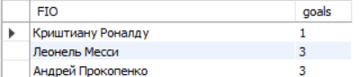

8.5 SELECT

demo_cup.gamesbetweentwoteams.TourNumberId,

COUNT(TourNumberId) as "Количество матчей сыгранных в туре"

FROM

demo_cup.gamesbetweentwoteams

GROUP BY TourNumberId;

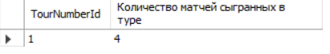

1. ORDER BY, ASC|DESC (5)

9.1 SELECT

*

FROM

demo_cup.teams

ORDER BY win DESC , Draw DESC



9.2 SELECT

demo_cup.teams.Name as Pair_Team

FROM

demo_cup.teams

ORDER BY rand() LIMIT 2;



9.3

SELECT

demo_cup.players.FIO, AGE

from

demo_cup.players

ORDER BY demo_cup.players.age;

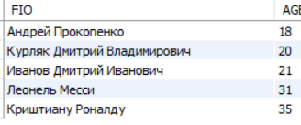

9.4

SELECT

demo_cup.statistics.goals, COUNT(PlayerId)

FROM

demo_cup.statistics

JOIN

demo_cup.players

WHERE

demo_cup.players.id = demo_cup.statistics.PlayerId

GROUP BY goals

ORDER BY GOALS;

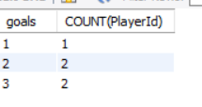

9.5

SELECT

demo_cup.cities.Name, demo_cup.stadions.Name

FROM

demo_cup.cities

JOIN

demo_cup.stadions

WHERE

demo_cup.stadions.CityId = demo_cup.cities.id

ORDER BY demo_cup.cities.NAME;

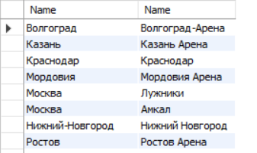

1. Вложенные SELECTы (2 шт)

10.1

SELECT

FIO

FROM

demo_cup.players

WHERE

AGE = (select MIN(AGE) FROM demo_cup.players);



10.2

SELECT

Name

FROM

demo_cup.referees

WHERE

YearsOfWork = (SELECT

MIN(demo_cup.referees.YearsOfWork)

FROM

demo_cup.referees);



1. INSERT SELECT (1шт)

11.1 INSERT INTO

players

SELECT *

FROM coachs

WHERE age < 40;

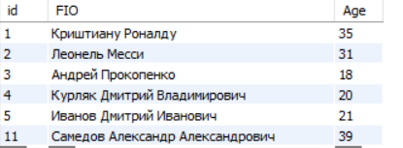

1. UNION (ALL), EXCEPT, INTERCEPT какой-то из них на выбор (2-3 шт.)

SELECT players.FIO, AGE

From players

UNION

SELECT coachs.FIO, AGE

From coachs

order by AGE;

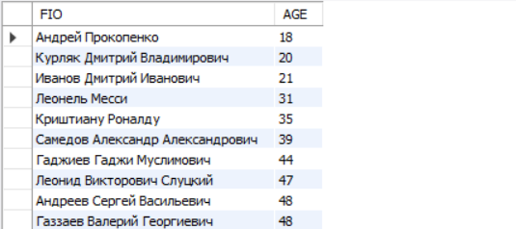

1. JOIN (20 шт.+): INNER, OUTTER (LEFT, RIGHT, FULL), CROSS, NATURAL

13.1 SELECT

demo_cup.statistics.Goals,

demo_cup.statistics.PlayerId,

demo_cup.players.FIO,

demo_cup.teamstoplayers.TeamId

FROM

demo_cup.statistics

JOIN

demo_cup.teamstoplayers,

demo_cup.players

WHERE

demo_cup.statistics.PlayerId = demo_cup.teamstoplayers.PlayerId

AND demo_cup.statistics.GameId = 1

AND demo_cup.statistics.PlayerId = demo_cup.players.Id;



13.2

SELECT

*

FROM

demo_cup.players

LEFT JOIN

demo_cup.statistics ON demo_cup.players.id = demo_cup.statistics.PlayerId

GROUP BY demo_cup.players.FIO;

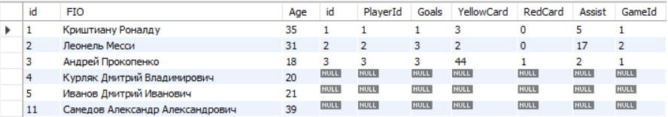

13.3

SELECT

*

FROM

demo_cup.statistics

RIGHT JOIN

demo_cup.players ON demo_cup.statistics.PlayerId = demo_cup.players.id

GROUP BY demo_cup.players.FIO;

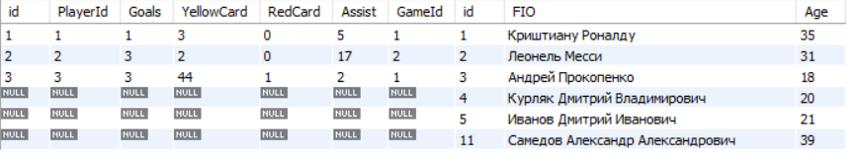

13.4

SELECT *

FROM players LEFT JOIN coachs

ON players.id = coachs.id

UNION

SELECT *

FROM players RIGHT JOIN coachs

ON players.id = coachs.id

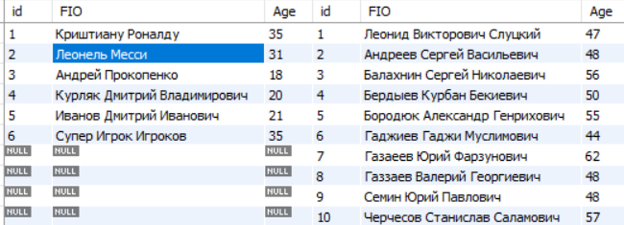

13.6

SELECT

demo_cup.players.FIO, demo_cup.teamstoplayers.*

FROM

demo_cup.players

JOIN

demo_cup.teamstoplayers

WHERE

demo_cup.teamstoplayers.PlayerId = demo_cup.players.id;



13.7

SELECT

demo_cup.players.FIO, demo_cup.teamstoplayers.TeamId

FROM

demo_cup.players

JOIN

demo_cup.teamstoplayers

WHERE

demo_cup.teamstoplayers.TeamId = 1

AND demo_cup.players.id = demo_cup.teamstoplayers.PlayerId;



13.8

SELECT

demo_cup.gamesbetweentwoteams.StadionId,

RefereeId,

TourNumberId,

Team1Id,

Team2Id,

DateOfMatch,

demo_cup.statistics.goals,

demo_cup.teamstoplayers.TeamId,

demo_cup.players.FIO

FROM

demo_cup.gamesbetweentwoteams

JOIN

demo_cup.statistics

JOIN

demo_cup.teamstoplayers

JOIN

demo_cup.players

WHERE

demo_cup.statistics.GameId = 1

AND demo_cup.gamesbetweentwoteams.id = 1

AND statistics.PlayerId = demo_cup.teamstoplayers.PlayerId

AND demo_cup.players.id = statistics.PlayerId;



13.9

SELECT

demo_cup.statistics.goals,

Count(PlayerId)

FROM

demo_cup.statistics

JOIN

demo_cup.players

WHERE

demo_cup.players.id = demo_cup.statistics.PlayerId

GROUP BY goals;



13.10

SELECT

demo_cup.cities.Name, demo_cup.stadions.Name

FROM

demo_cup.cities

JOIN

demo_cup.stadions

WHERE

demo_cup.stadions.CityId = demo_cup.cities.id;



1. LIMIT (3-5 шт.+)

14.1 SELECT players.FIO,

sum(statistics.goals)

from players

join

statistics

where

goals > 0

and

players.id = statistics.PlayerId

GROUP BY statistics.PlayerId

LIMIT 2;

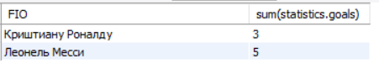

14.2 SELECT FIO from demo_cup.players where FIO like '% % %' limit 3; 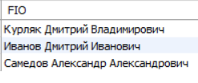

14.3

SELECT

demo_cup.statistics.goals, COUNT(PlayerId)

FROM

demo_cup.statistics

JOIN

demo_cup.players

WHERE

demo_cup.players.id = demo_cup.statistics.PlayerId

GROUP BY goals

ORDER BY GOALS

limit 1;



