K-Means

It is a clustering algorithm (Marker segmentation, Social network analysis, Organize Computing clusters, Astronomical data analysis)

1. **K-Means Algorithm**

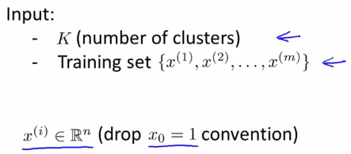

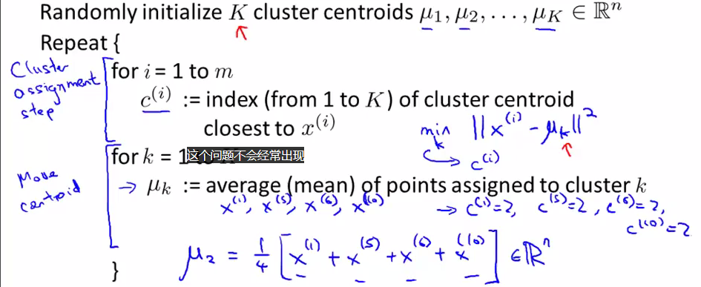

1. **Random Initialization**

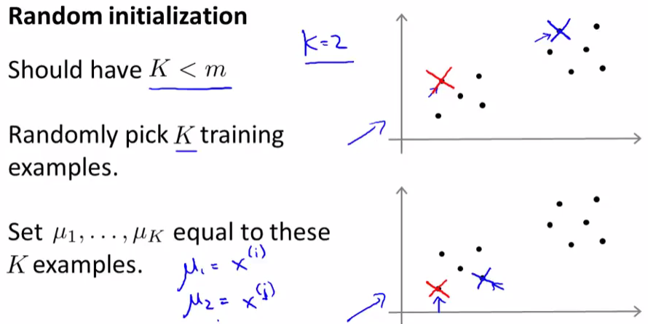

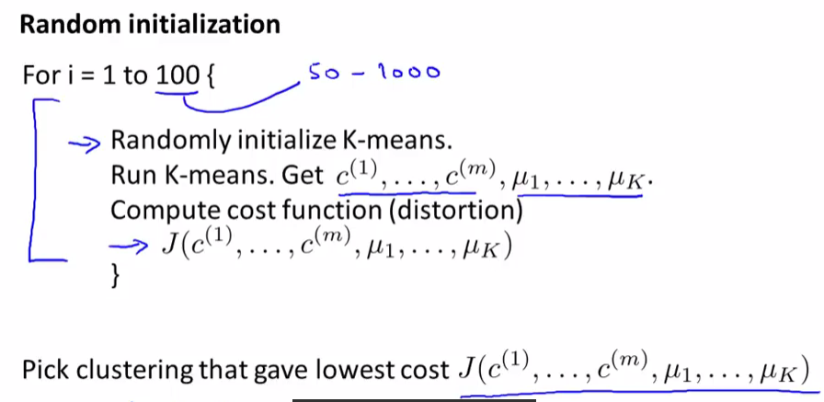

1. **Choosing the number of Clusters**

