

1KK v1.0   
Manual

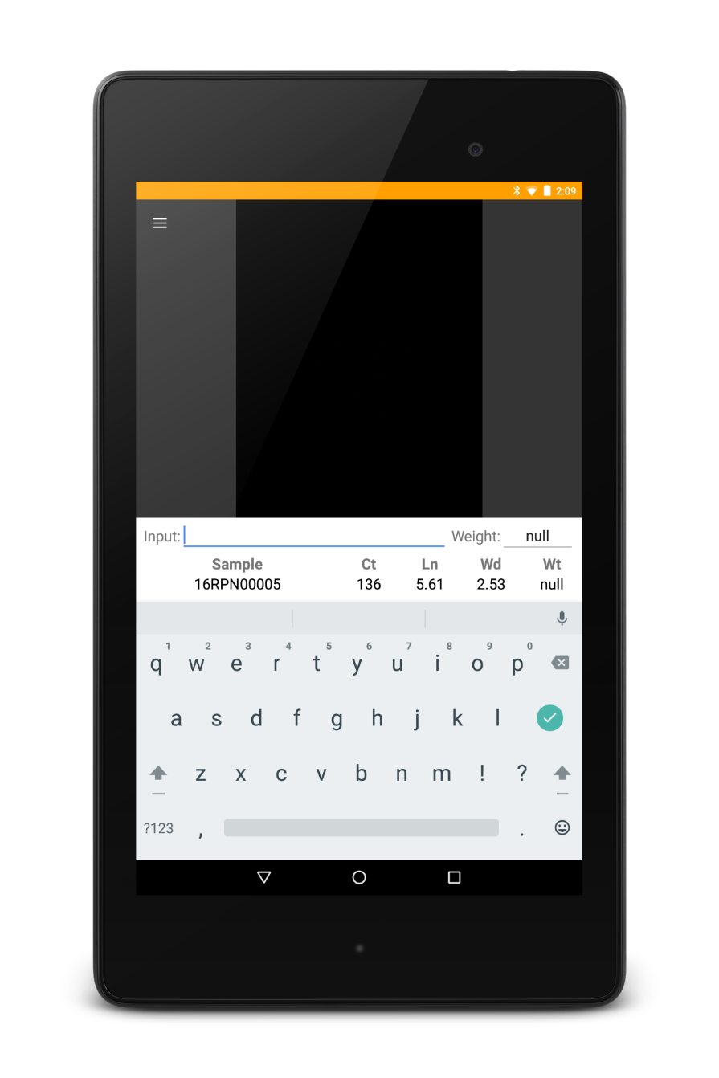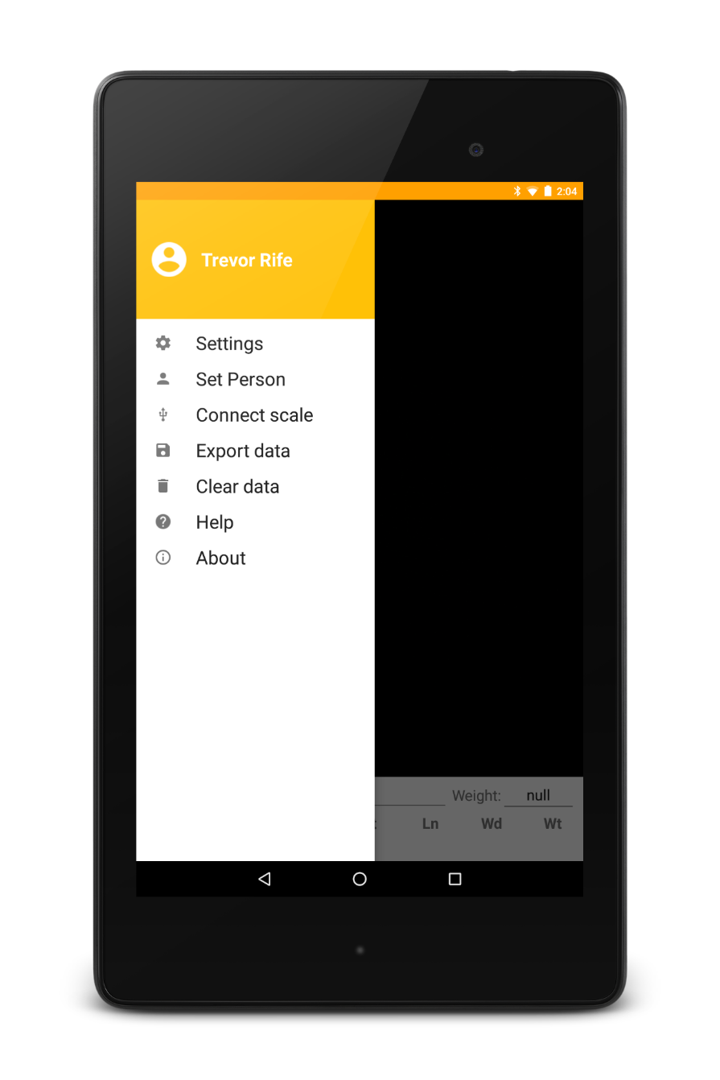

Figure . Examples of 1KK running on a Nexus 7.

Table of Contents

Introduction 25

Getting Started 25

Folder Organization 25

Settings 25

Collecting Data 26

Exporting Data 26

Sample Summaries 26

Raw Data 26

Hardware 26

Acknowledgements 27

Background 28

# Introduction

1KK is an open-source Android app that is used to analyze seed lots and related objects. Its name comes from the one thousand kernel weight that is commonly used as a selection criteria in plant breeding programs. 1KK uses a colored background with reference circles of known size to translate pixel measurements to real sizes (see Appendix).

A non-parametric algorithm is used to identify individual objects to limit morphology from large groups of items skewing results. Each object’s length, width, and area are identified and stored using the same algorithm that's used in [SmartGrain](http://www.plantphysiol.org/content/160/4/1871.full). In addition, 1KK is compatible with Elane USB scales (1g resolution).

The simplicity of 1KK will allow adoption of the app without a steep learning curve. With low-cost, accessible solutions, the vision of one handheld per breeder can become a reality for breeding programs around the world.

# Getting Started

1KK can be downloaded from [Google Play](https://play.google.com/store/apps/details?id=org.wheatgenetics.onekk) on phones and tablets. The source code for 1KK is available on [GitHub](https://github.com/trife/1KK).

# Folder Organization

Once 1KK has been installed and opened, it will create several folders on the device.

* **AnalyzedPhotos :** this folder contains the analyzed photos
* **Export :** this is the folder contains exported data
* **Photos :** this folder contains the raw photos that are captured by the device

# Settings

The Settings dialog (Figure 2) can be accessed from the navigation drawer.

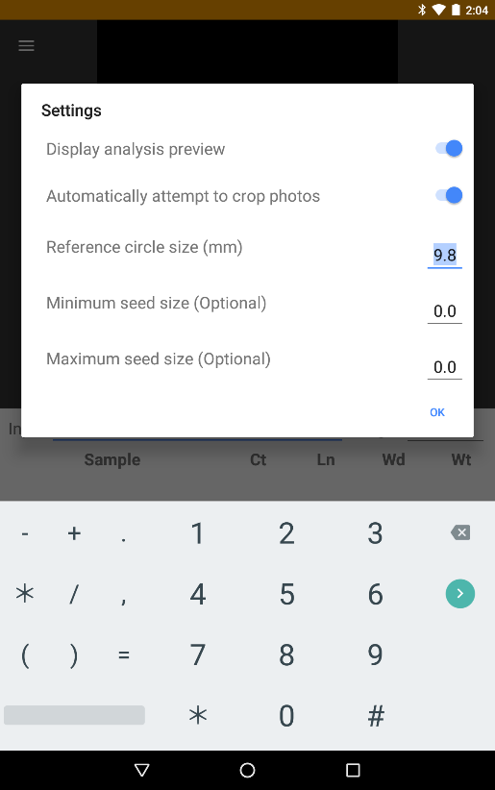

Figure . The Settings dialog in 1KK

* **Display analysis preview :** once a photo has been captured and analyzed a popup will show you the outputted analyzed photo that shows the reference circles used and the objects identified
* **Attempt to crop photos :** 1KK automatically attempts to crop the photo captured which adds computing time to analysis - if there is no need to crop images, this can be disabled to decrease sample analysis time
* **Reference circle size :** this is the real-world size of the reference circles and is used to translate pixels to real-world measurements
* **Minimum seed size :** the minimum length for an object
* **Maximum seed size :** the maximum length for an object

# Collecting Data

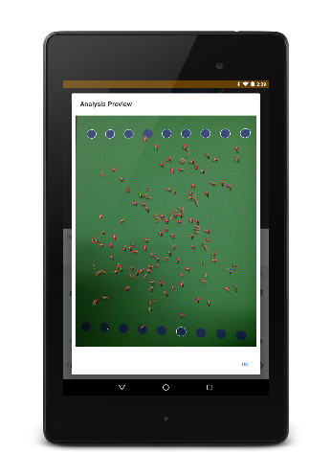

Figure . The Analysis Preview dialog

Images are captured after text is entered into the ‘Input’ text box on the main screen below the image preview area. The name entered is used as the sample name and the image name. The green background should be centered in the image preview and the device should be held flat to minimize object distortion.

Once an image is captured, a preview that can be zoomed is displayed which gives the user an opportunity to make sure the image was correctly captured and analyzed (Figure 3). The objects in analyzed photos are numbered and correlate to the raw data measurements collected within the app.

# Exporting Data

Data collected within the app can be exported as sample summaries and raw data.

## Sample Summaries

Sample summaries includes all of the summary data for each sample including the photo name, date collected, an estimated count of the objects, and the length, variance, and CV for length, width, and area.

|  |  |  |  |  |  |  |  |  |  |  |  |  |  |
| --- | --- | --- | --- | --- | --- | --- | --- | --- | --- | --- | --- | --- | --- |
| sample_id | person | date | count | weight | length avg | length var | length cv | width avg | width var | width cv | area avg | area var | area cv |
| 16RPN00005 | Trevor Rife | 2015-12-15- 02-08-56 | 136 | null | 5.61 | 0.20 | 0.08 | 2.53 | 0.11 | 0.13 | 10.67 | 3.78 | 0.18 |

## Raw Data

To break down the data further, the raw data can also be exported. This data includes the length, width, area, and circularity for each identified object.

|  |  |  |  |  |  |  |
| --- | --- | --- | --- | --- | --- | --- |
| sample_id | person | date | length | width | circularity | area |
| 16RPN00005 | trevor_rife | 2015-12-15-02-08-56 | 5.758637 | 3.044338 | 0.067989 | 12.93964 |
| 16RPN00005 | trevor_rife | 2015-12-15-02-08-56 | 5.327744 | 2.335228 | 0.063295 | 9.454392 |
| 16RPN00005 | trevor_rife | 2015-12-15-02-08-56 | 5.930707 | 2.836468 | 0.062343 | 12.55384 |
| 16RPN00005 | trevor_rife | 2015-12-15-02-08-56 | 4.135876 | 1.964192 | 0.06109 | 5.795746 |

# Hardware

1KK is compatible with Android phones and tablets running Android 4.0 and newer. The devices that are used for development and known to be 100% compatible with 1KK are the Nexus 7, Nexus 5, and Moto G. However, most Android devices will be compatible with 1KK.

Inventory is compatible with the [Elane USB Plus 5kg](http://www.elane.net/index.php?go=usb_plus5kg&category=usb_scales) scale and the [Elane USB PS2000 5kg](http://www.elane.net/index.php?go=usb_ps2000_5kg&category=usb_scales) scale.

# Acknowledgements

Development Team

* **Trevor Rife**, Developer, Kansas State University
* **Jesse Poland**, Project Lead, Kansas State University

Support

* The McKnight Foundation Collaborative Crop Research Program
* Kansas State University
* Triticeae Coordinated Agricultural Project
* CIMMYT
* USAID
* Bill and Melinda Gates Foundation



# Background