

Coordinate v1.0 Manual

Figure . Examples of Coordinate running on a Nexus 7.

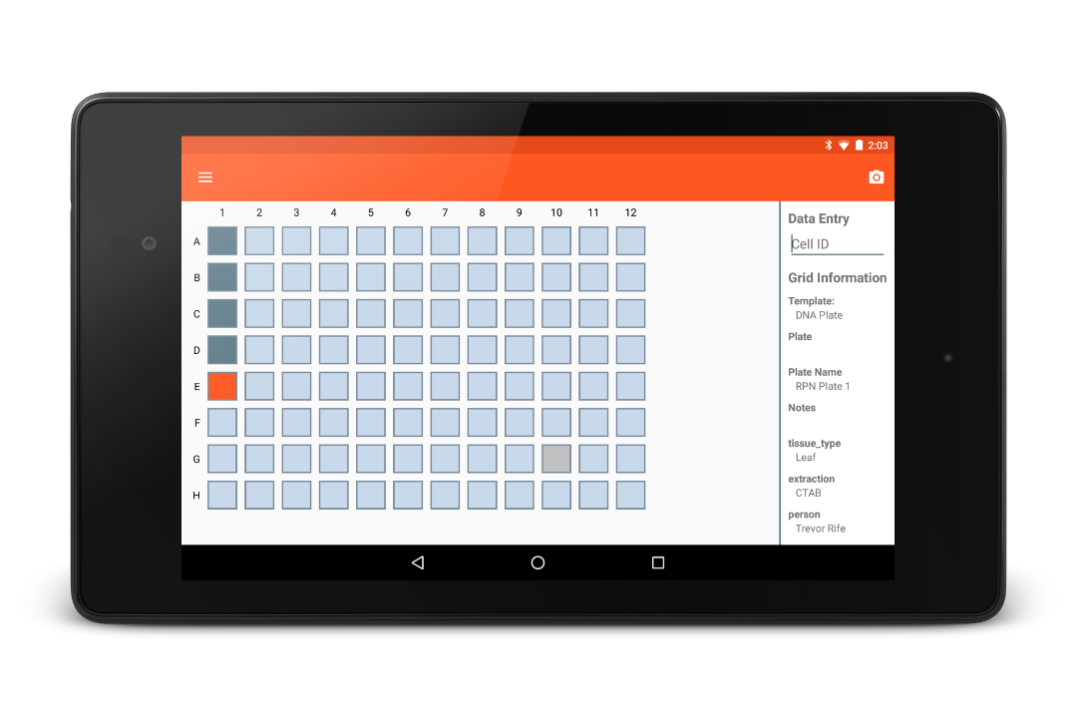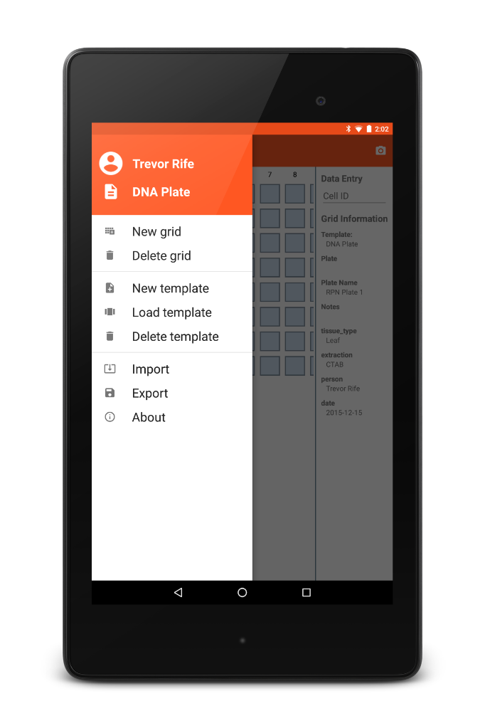

Table of Contents

[Introduction 32](#_Toc437959356)

[Getting Started 32](#_Toc437959357)

[Folder Organization 32](#_Toc437959358)

[Templates 32](#_Toc437959359)

[Creating templates 32](#_Toc437959360)

[Loading templates 33](#_Toc437959361)

[Deleting templates 33](#_Toc437959362)

[Grids 34](#_Toc437959363)

[Creating grids 34](#_Toc437959364)

[Importing grids 34](#_Toc437959365)

[Deleting grids 34](#_Toc437959366)

[Collecting Data 35](#_Toc437959367)

[Exporting Data 35](#_Toc437959368)

[Hardware 35](#_Toc437959369)

[Acknowledgements 36](#_Toc437959370)

# Introduction

Coordinate is an open-source Android app that is used to collect data and organize it into a predefined grid. Coordinate replaces the DNA Plate App and Seed Tray App with a unified and flexible Android app. Coordinate is based on defining templates and then collecting data in grids created from those templates.

The simplicity of Coordinate will allow adoption of the app without a steep learning curve. With low-cost, accessible solutions, the vision of one handheld per breeder can become a reality for breeding programs around the world.

# Getting Started

Coordinate can be downloaded from [Google Play](https://play.google.com/store/apps/details?id=org.wheatgenetics.coordinate) on phones and tablets. Upon installation, the app will ask the user if they wish to load sample data and turn on the tutorial. The source code for Coordinate is available on [GitHub](https://github.com/trife/Coordinate).

# Folder Organization

Once Coordinate has been installed and opened, it will create a Coordinate folder on the device’s internal memory along with two internal folders.

* **Export :** exported data is saved to this folder
* **Templates :** this folder will be used in the future to transfer templates between devices

# Templates

## C:\Users\Trevor\Desktop\Screenshots\Screenshot_20151229-201613.png Creating templates

Figure . New Template dialog

New templates can be created by the user by selecting ‘New template’ from the navigation drawer. The template is first given a name and the number of rows and columns are specified (Figure 2).

The next dialog (Figure 3) allows for additional template customization including:

* **Optional Fields:** These are the metadata fields that are captured when creating a new template. Custom optional fields can be included and default values for those fields can also be specified. ‘Id’, ‘Person’, and ‘Date’ are all included by default but can be removed.
* **Exclude:** This gives the option to exclude certain rows, columns, or a certain number of random wells from data collection.
* **Naming:** This allows the row and column naming to be changed between numeric and alphabetic.

Figure . Options when creating a new template

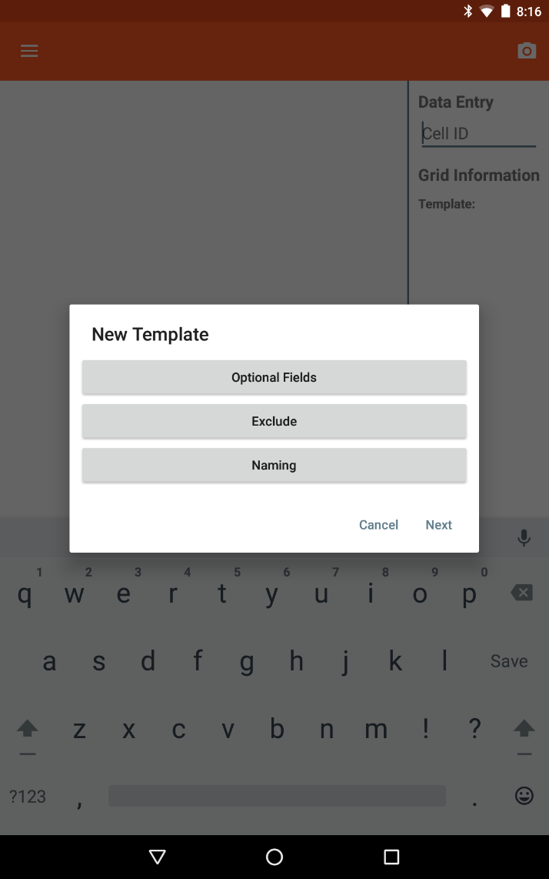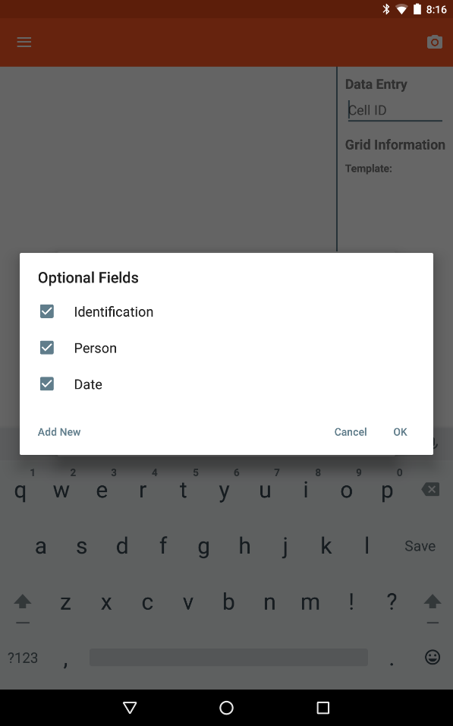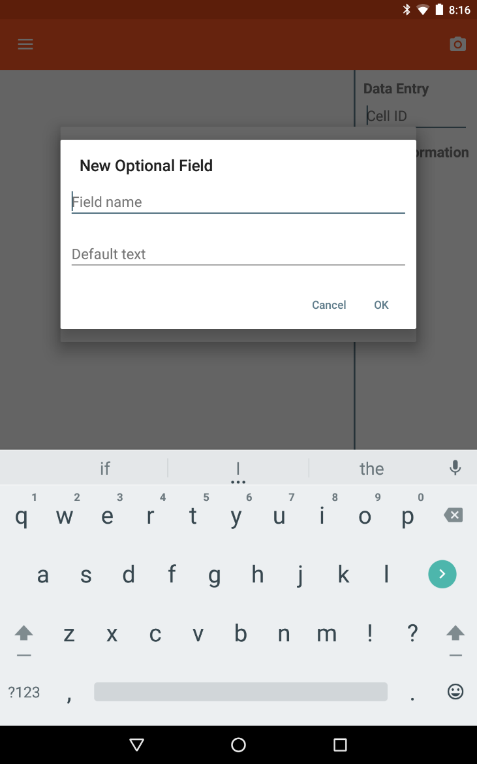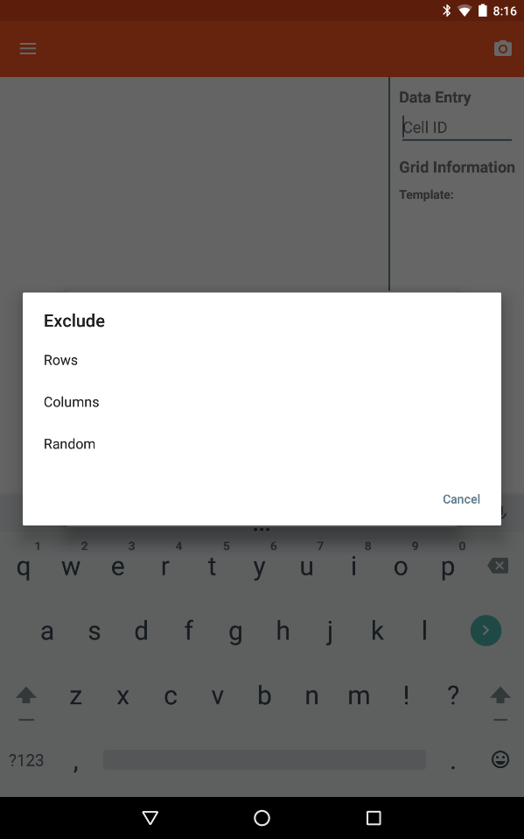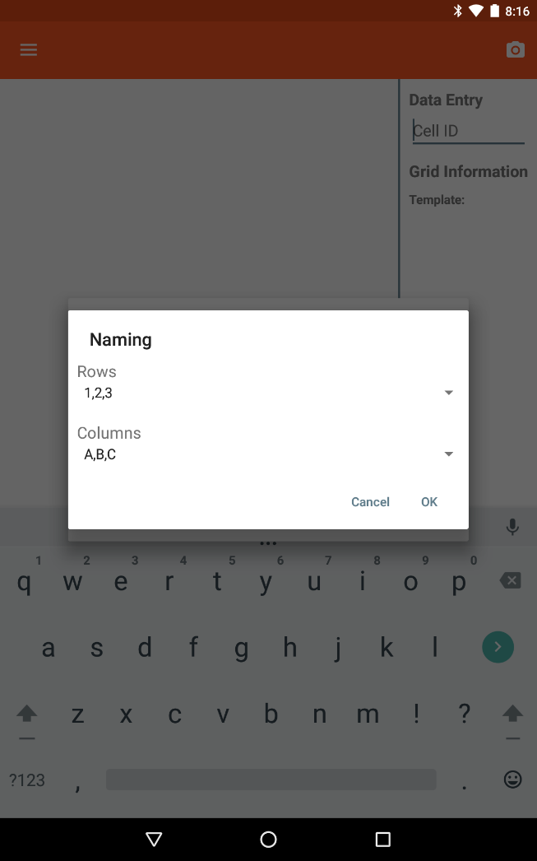

## Loading templates

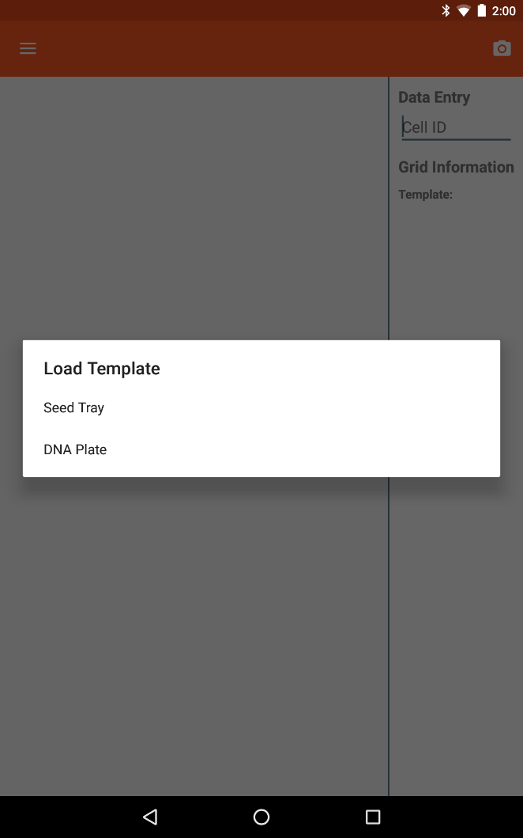To switch templates, choose the ‘Load template’ option from the navigation drawer. A dialog showing a list of the current templates is displayed and choosing one will create a new grid based on that template (Figure 4). The current template will be displayed in the navigation drawer.

Figure . Dialog showing current templates

## Deleting templates

User-create templates can be deleted by choosing ‘Delete template’ from the navigation drawer. A dialog showing a list of the current templates is displayed and the user can choose which template they wish to delete. The default templates cannot be deleted.

# Grids

## C:\Users\Trevor\Desktop\Screenshots\Screenshot_20151215-140107.png Creating grids

There are two ways to create a new grid. To create a new grid of the same type of template, the ‘New grid’ option can be selected from the navigation drawer. To create a new grid of a different type of template, loading a different template will initiate the new grid creation process.

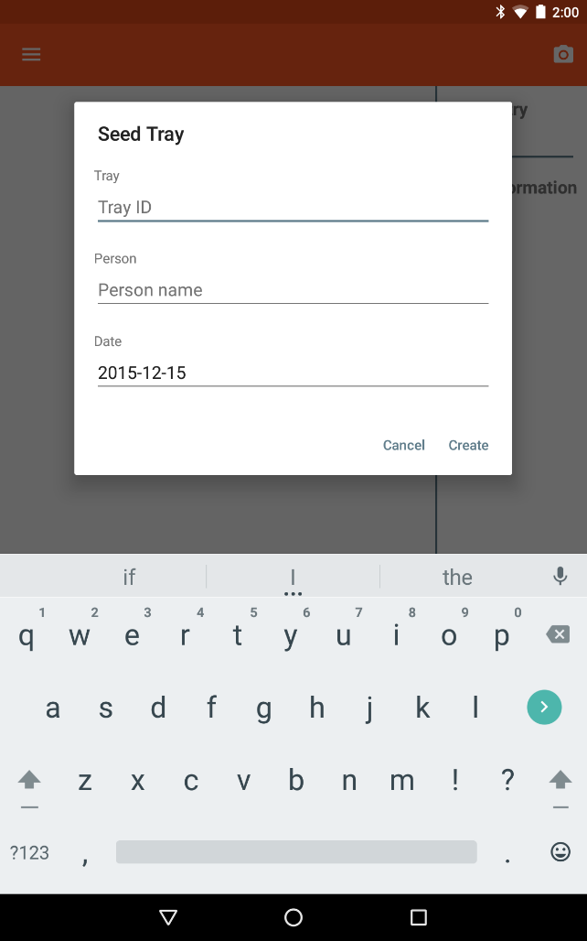The new grid creation screen is specific to the template and may contain metadata fields that are directly related to the specific grid being created. Figure 5 shows the differences between the two default templates.

Figure . Examples of two different grid creation dialogs

## Importing grids

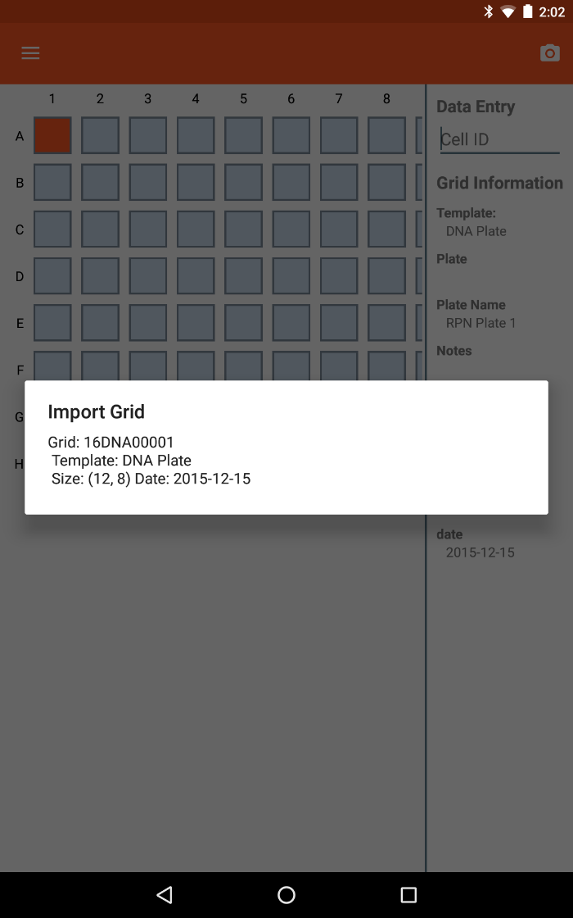Once a grid has been created, it’s possible to return to it to continue or finish collecting data. In the navigation drawer, selecting ‘Import’ will display a list of grids that are currently stored within the app (Figure 6). Selecting one of the listed grids will load the grid data and allow additional data to be collected.

Figure . Import grid dialog

## Deleting grids

The currently-loaded grid can be deleted by selecting ‘Delete grid’ from the navigation drawer. This option removes the grid and associated data from the app memory.

# Collecting Data

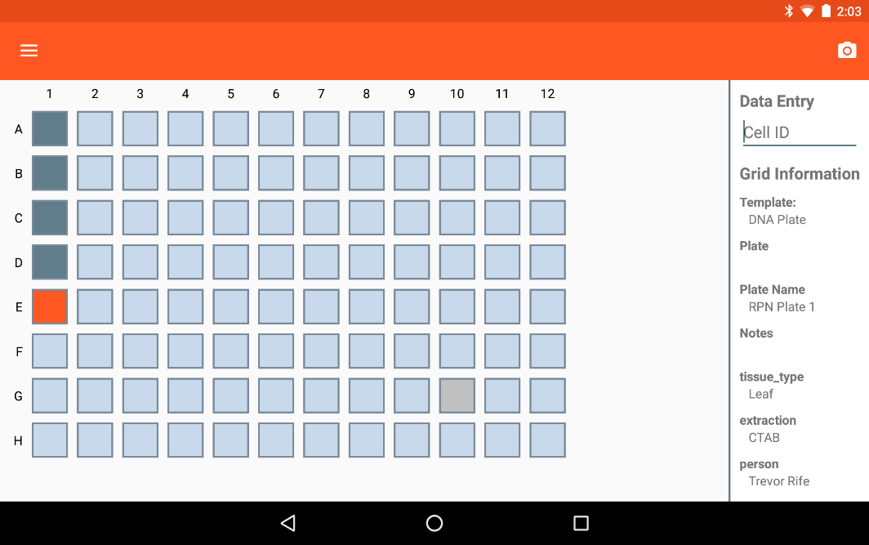Once a grid has been created, data specific to each cell can be collected using the input box on the right side of the screen. The current cell is highlighted in orange and cells that contain saved data turn dark blue (Figure 7).

Figure . Collecting data within the app

To rapidly collect data, a barcode scanner can paired with the tablet and will automatically advance to the next available well when data is collected.

# C:\Users\Trevor\Desktop\Screenshots\Screenshot_20151215-140254.pngExporting Data

Figure . Export dialog

Once the user is finished collecting data for a specific grid, the data can be exported by selecting the ‘Export’ option in the navigation drawer. The filename is automatically set to the name of the grid with the current date but can be edited by the user. Exported grids are saved in a CSV file. The exported file is located in a template-specific subfolder within the “Export” folder.

# Hardware

Coordinate is compatible with Android phones and tablets running Android 4.0 and newer. The devices that are used for development and known to be 100% compatible with Coordinate are the Nexus 7, Nexus 5, and Moto G. However, most Android devices will be compatible with Coordinate.

# Acknowledgements

Development Team

* **Trevor Rife**, Developer, Kansas State University
* **Jesse Poland**, Project Lead, Kansas State University

Support

* The McKnight Foundation Collaborative Crop Research Program
* Kansas State University
* Triticeae Coordinated Agricultural Project
* CIMMYT
* USAID
* Bill and Melinda Gates Foundation

