OPSC6311

Assignment: Part 1 (Planning & Design)

Names Surnames: Phenyo Mbana [ST10341562]

Meshack Tshuma (ST10128702)

Dinilethu Malatse[ST10264831]

Table of Contents

EasyBudget App: Planning and Design 1

1. Introduction 1

2. Overview of the App 1

3. Requirements 2

5. Project Plan 9

Phase 1 9

Phase 2 10

**Team roles** 12

6. Conclusion 12

References 12

# EasyBudget App: Planning and Design

## 1. Introduction

Managing personal finances is essential for achieving financial stability. Many individuals struggle with tracking their expenses, setting savings goals, and ensuring timely bill payments. The 'EasyBudget' app is designed to provide a simple and efficient solution for users to monitor their spending, set financial goals, and receive bill reminders.

## 2. Overview of the App

App Name: **EasyBudget**

Initial Icon Design: The icon will feature a minimalistic design with a currency symbol and a progress indicator to represent financial tracking.

**Innovative Features:**

* Savings Goals: Users can set and track specific savings targets.
* Spending Analysis: Provides insights into spending habits with visual charts.
* Bill Reminders: Notifies users about upcoming payments.
* Suggested Feature: Expense categorization to help users understand where their money goes.

## 3. Requirements

•

* Register & Login page
* Create Categories
* Add an expenses
* Set a monthly total budget
* View list of all expenses
* View graph showing expenses
* Display a progress report on the dashboard
* Bill reminder with notifications
* Savings Goals

**Non-Functional Requirements:**

* User-friendly and intuitive interface.
* Secure data storage and encryption.
* Responsive performance across devices. 4. User Interface Design

**Screens & Navigation:**

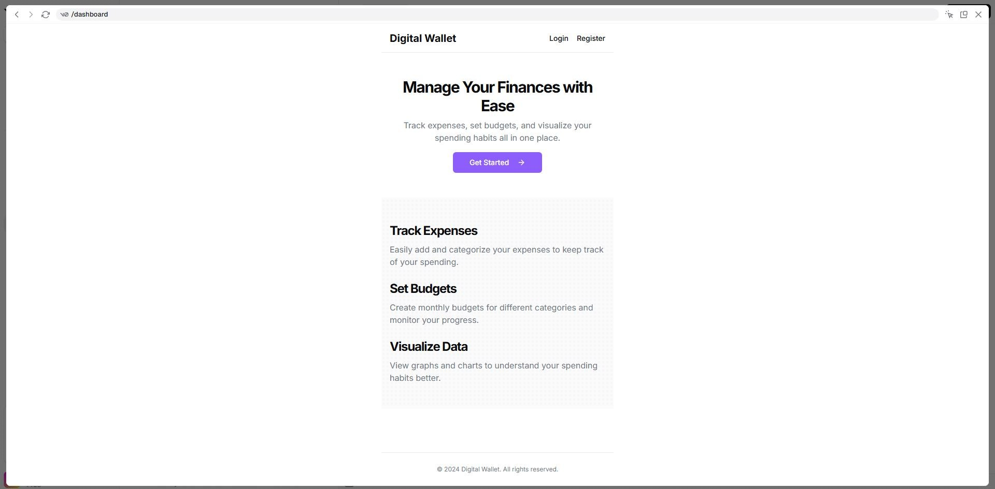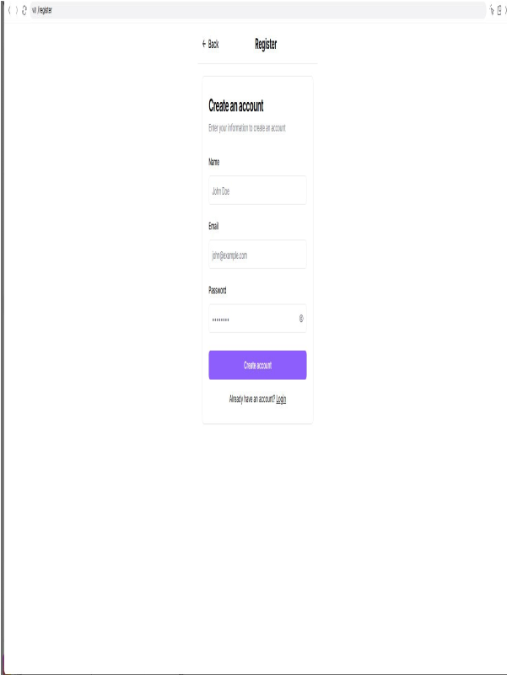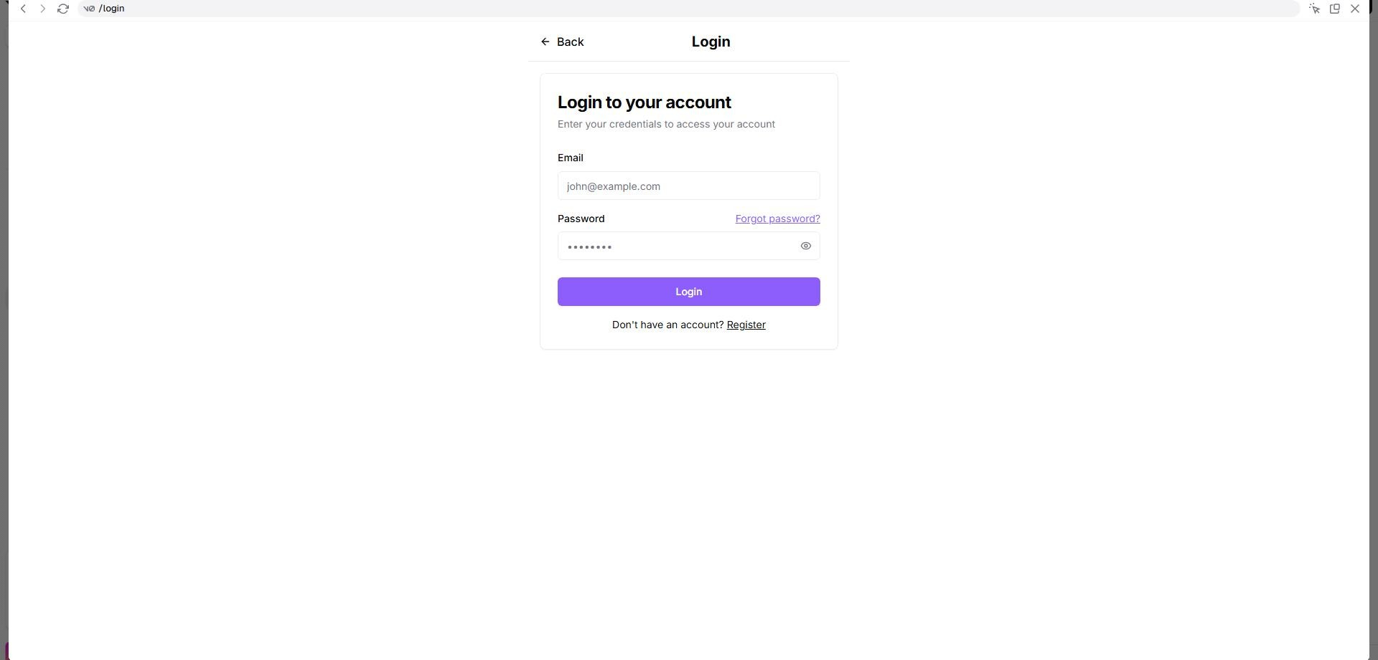

**Figure 1: Authentication Screens (Login & Register)**

**Purpose:** Provides secure access to the EasyBudget app for both new and returning users. **Description:** Features two interconnected screens: the Login screen with email and password fields for returning users, and the Register screen with fields for personal information, email, and password for new users. These screens serve as the secure entry point to the app, protecting users' financial data while allowing them to create and access their unique profiles. Users can easily switch between login and registration as needed.

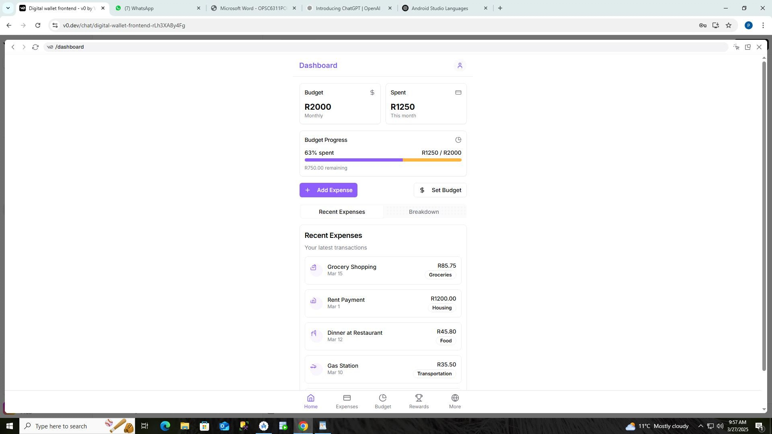

**Figure 2: Dashboard Screen**

**Purpose:** The central hub for users to get a quick overview of their financial status. **Description:** Displays budget overview, spending progress, and recent transactions. Users can quickly see how much they've spent relative to their budget and access key actions like adding expenses or setting budgets.

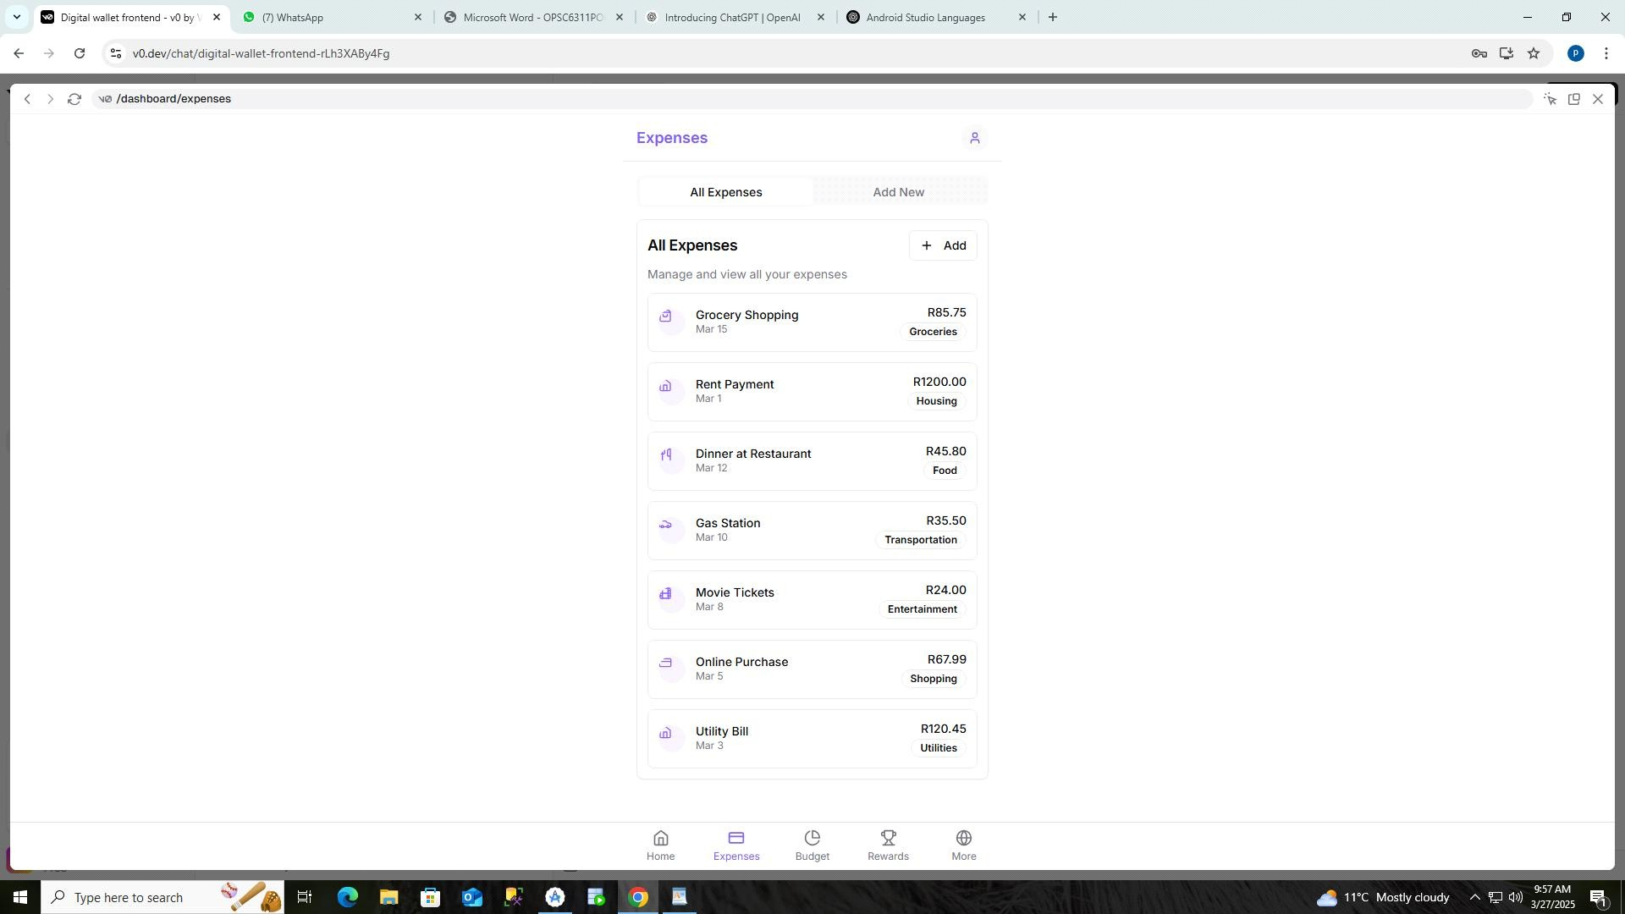

**Figure 3: Expenses Screen**

**Purpose:** Allows users to view, track, and add new expenses. **Description:** Features a tabbed interface with a list of all expenses and a form to add new ones. Each expense shows its category, amount, and date, helping users monitor their spending patterns.

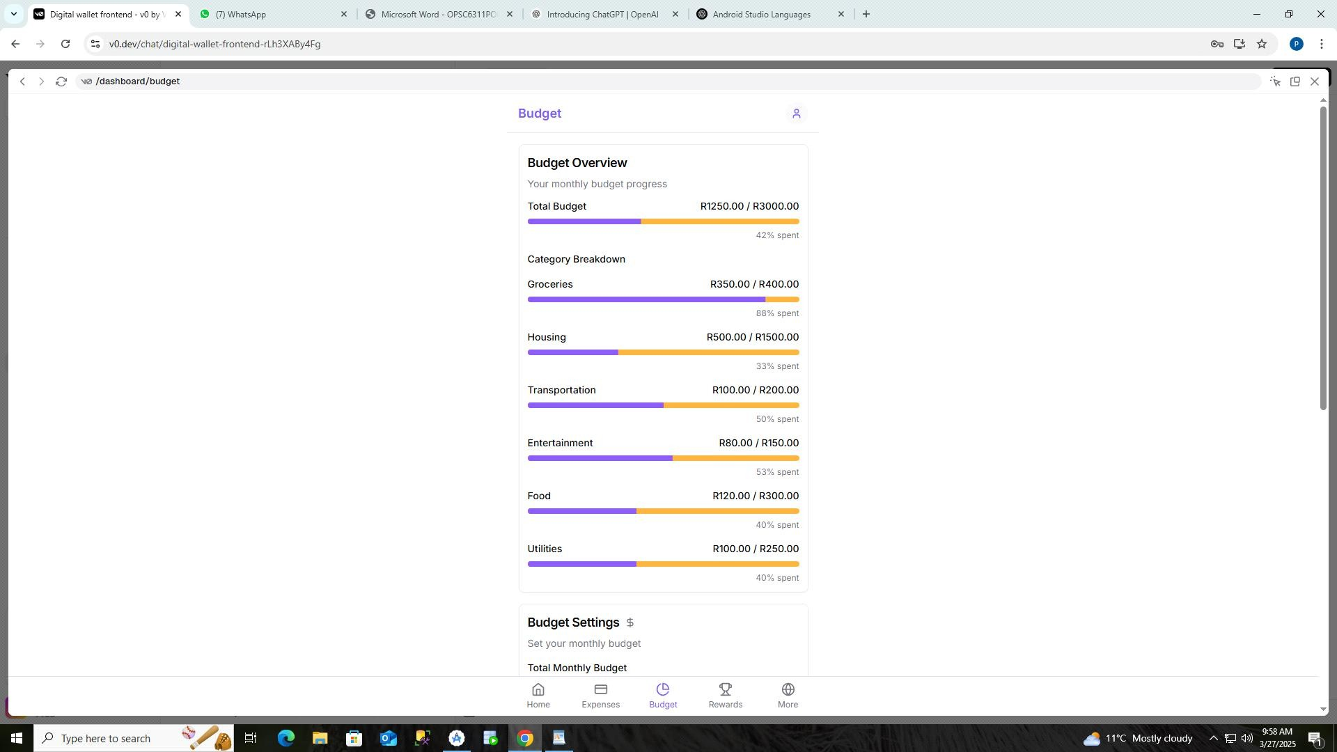

**Figure 4: Budget Screen**

**Purpose:** Enables users to set and monitor budgets across different categories. **Description:** Shows overall budget progress and individual category breakdowns. Users can adjust budget allocations and see percentage spent in each category, helping them maintain financial discipline.

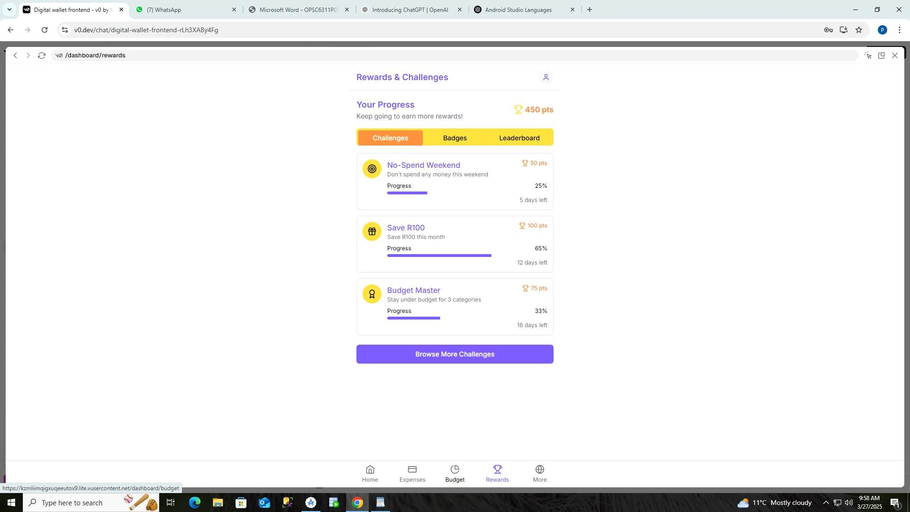

**Figure 5: Rewards Screen**

**Purpose:** Gamifies financial responsibility through challenges and achievements. **Description:** Features financial challenges with point rewards, badges for reaching milestones, and a leaderboard to compete with friends. Motivates users to develop better financial habits through gamification.

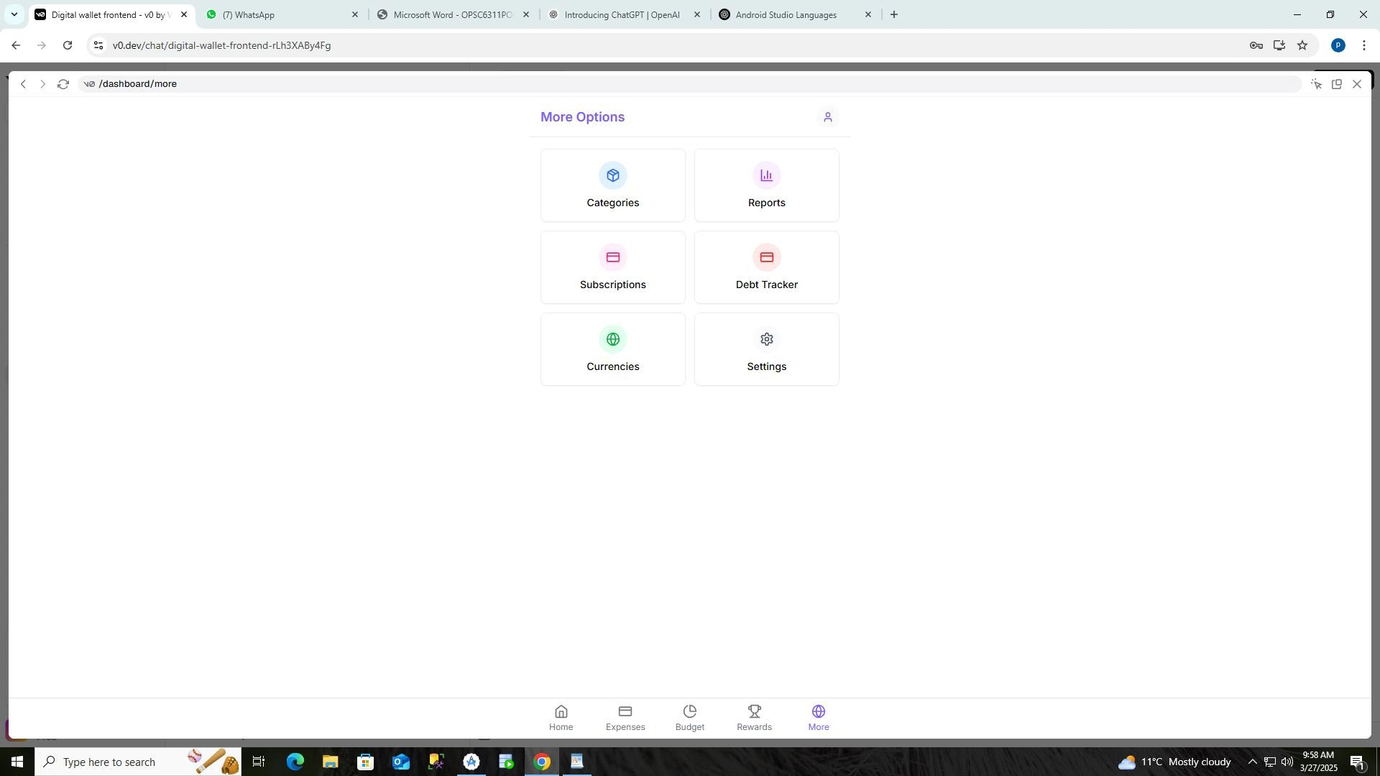

**Figure 5: More Options Screen**

**Purpose:** Provides access to additional features and settings. **Description:** Contains navigation tiles to access categories, reports, subscriptions, debt tracking, currency settings, and app preferences.

Serves as an organized menu for less frequently used but important features.

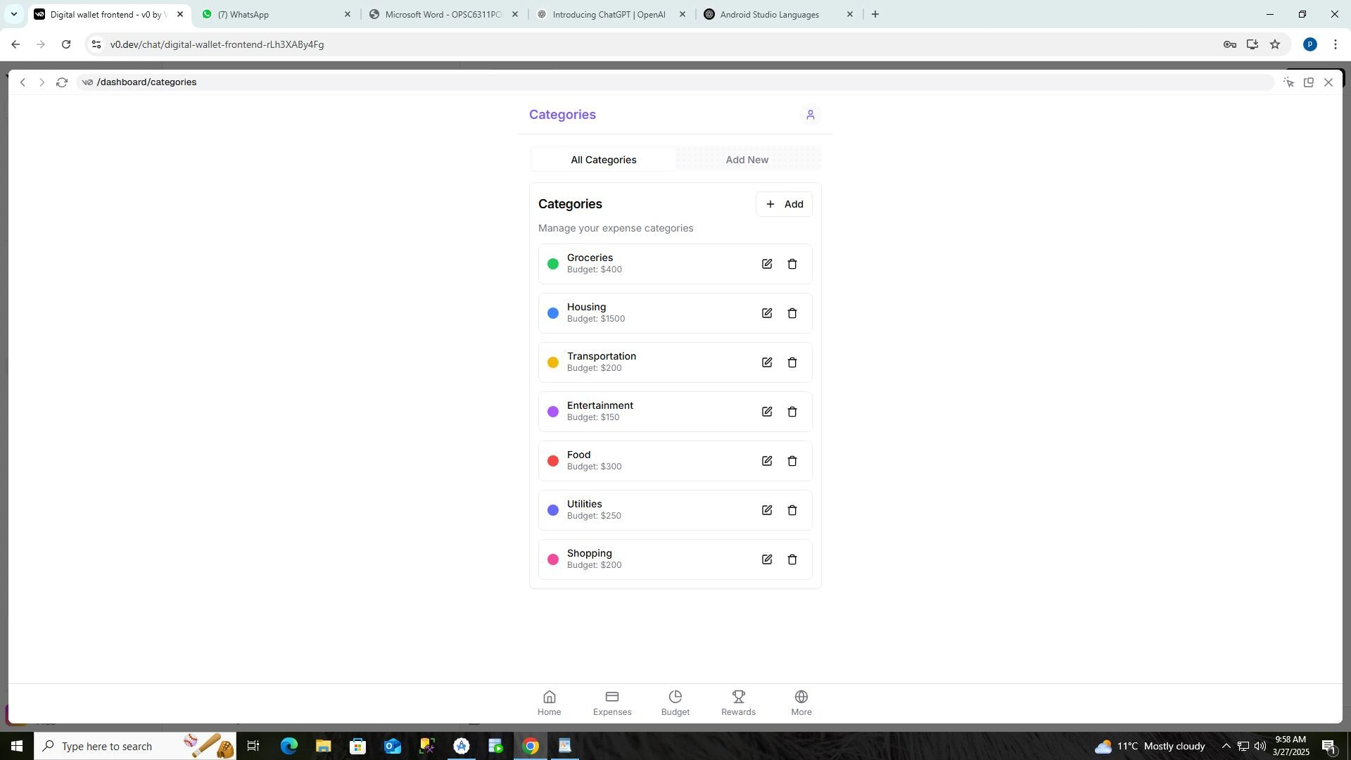

**Figure 6: Categories Screen**

**Purpose:** Allows users to create, view, and manage expense categories. **Description:** Displays a list of all expense categories with their associated budgets and color codes. Users can add new categories, edit existing ones, and organize their expenses into meaningful groups for better tracking and reporting.

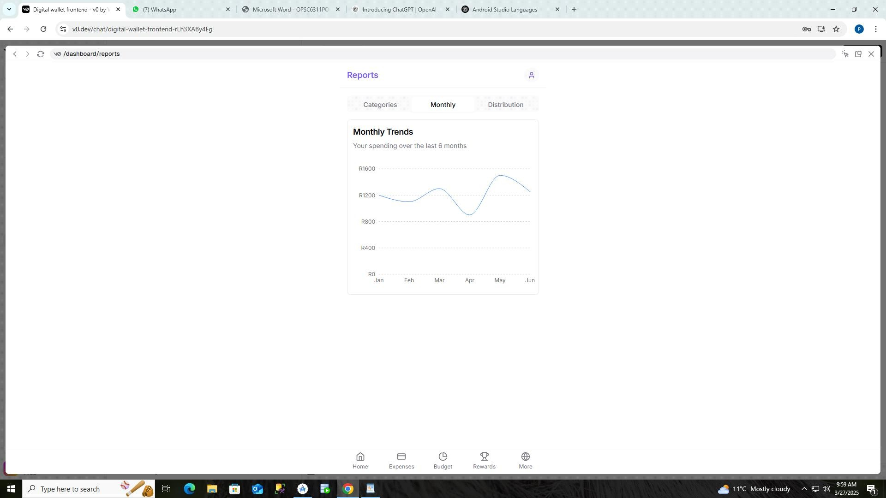

**Figure 7: Reports Screen**

**Purpose:** Provides visual analytics of spending patterns and financial trends. **Description:** Features multiple chart types including bar charts for category spending, line charts for monthly trends, and pie charts for expense distribution. Helps users visualize their financial data to make better decisions based on historical patterns.

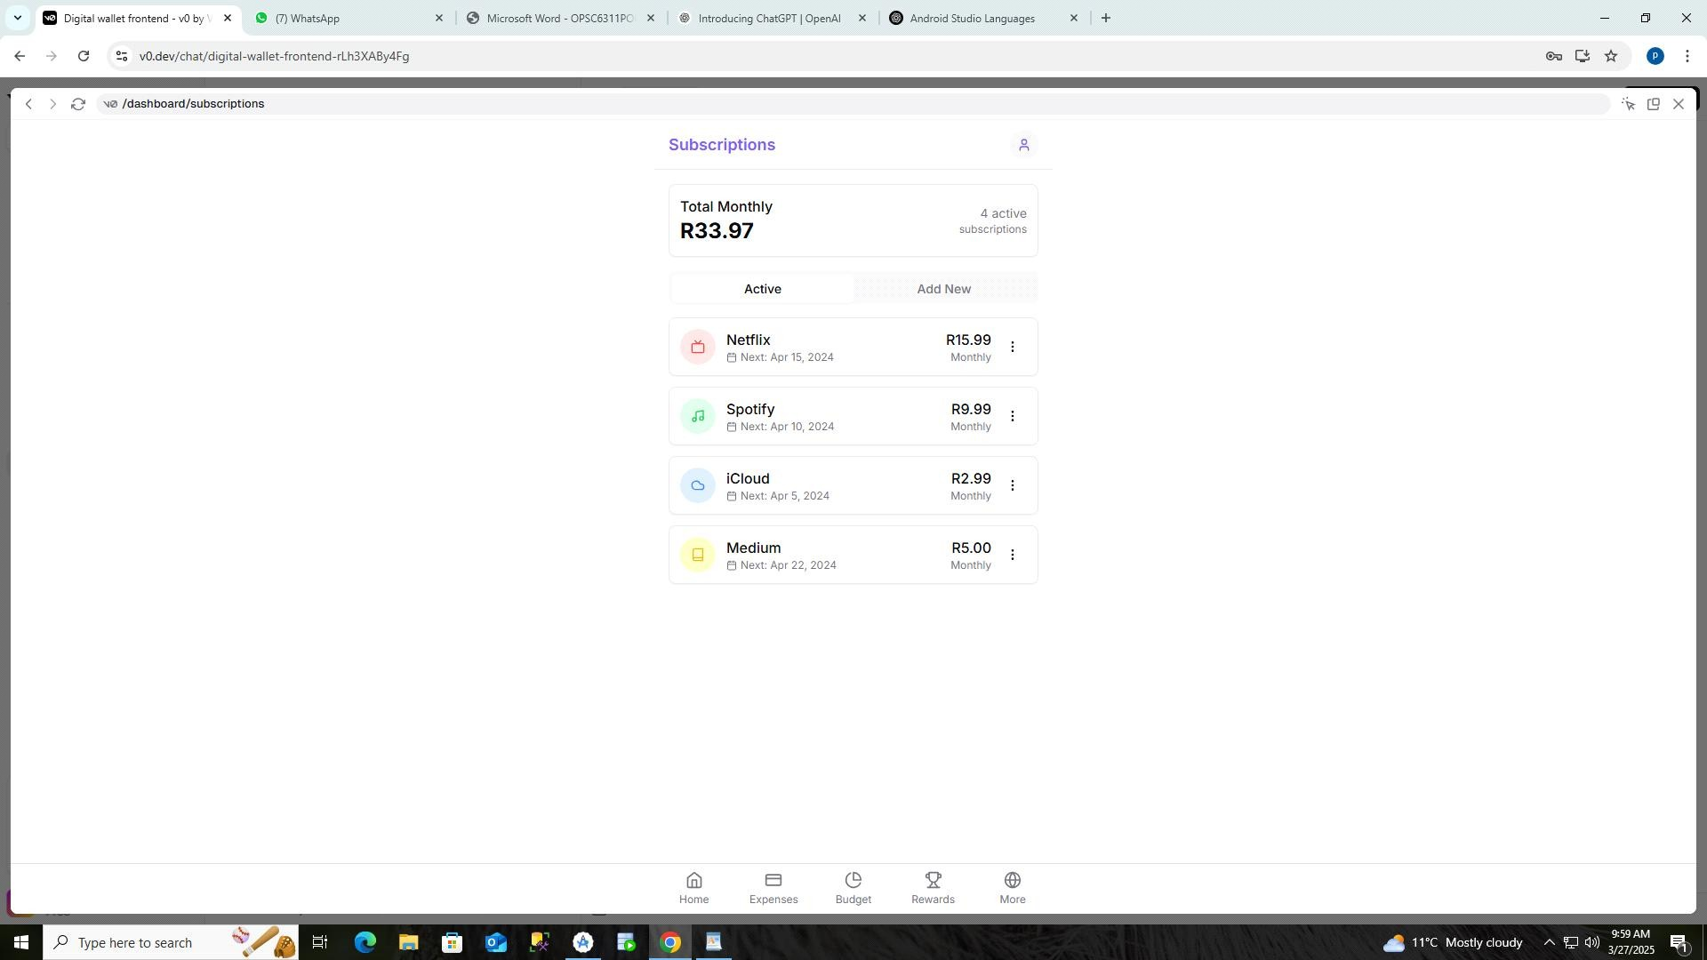

**Figure 8: Subscriptions Screen**

**Purpose:** Helps users track and manage recurring payments. **Description:** Lists active subscriptions with payment amounts, billing cycles, and next payment dates. Users can add new subscriptions and manage existing ones to avoid unexpected charges.

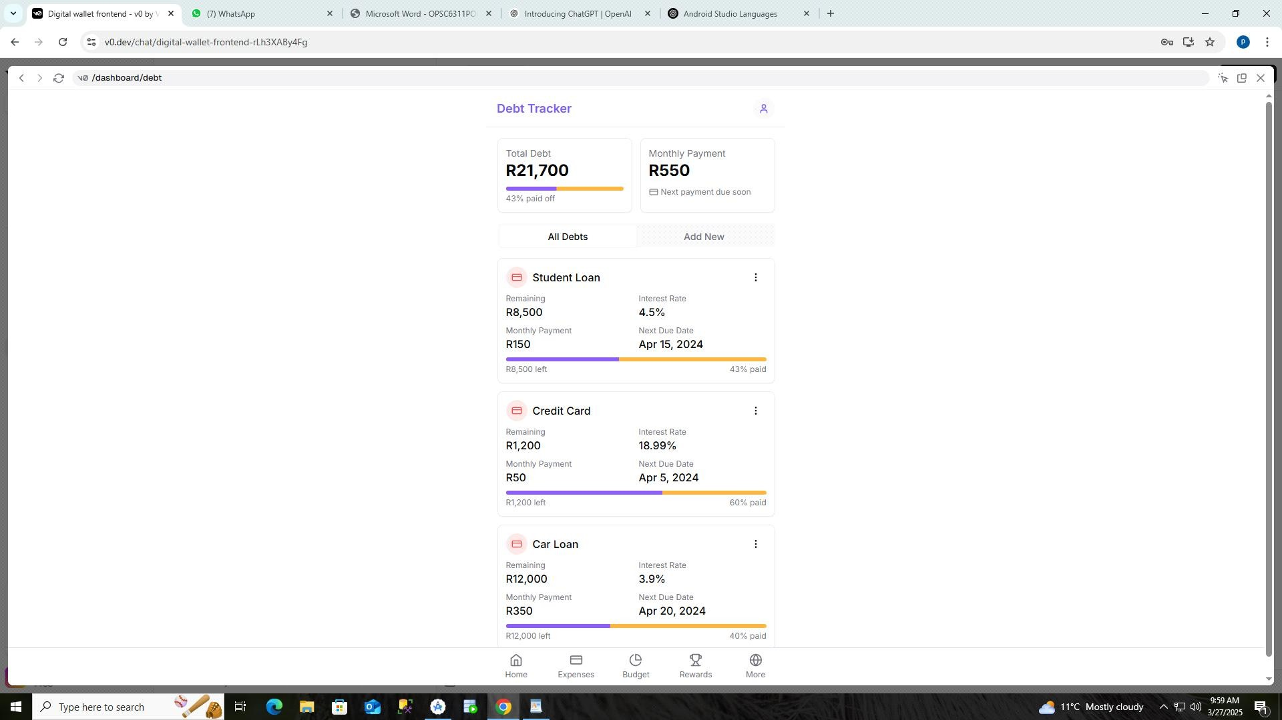

**Figure 9: Debt Tracker Screen**

**Purpose:** Assists users in monitoring and paying down debts. **Description:** Displays loans and credit cards with remaining balances, interest rates, and payment progress. Helps users visualize their debt reduction journey and plan payments effectively.

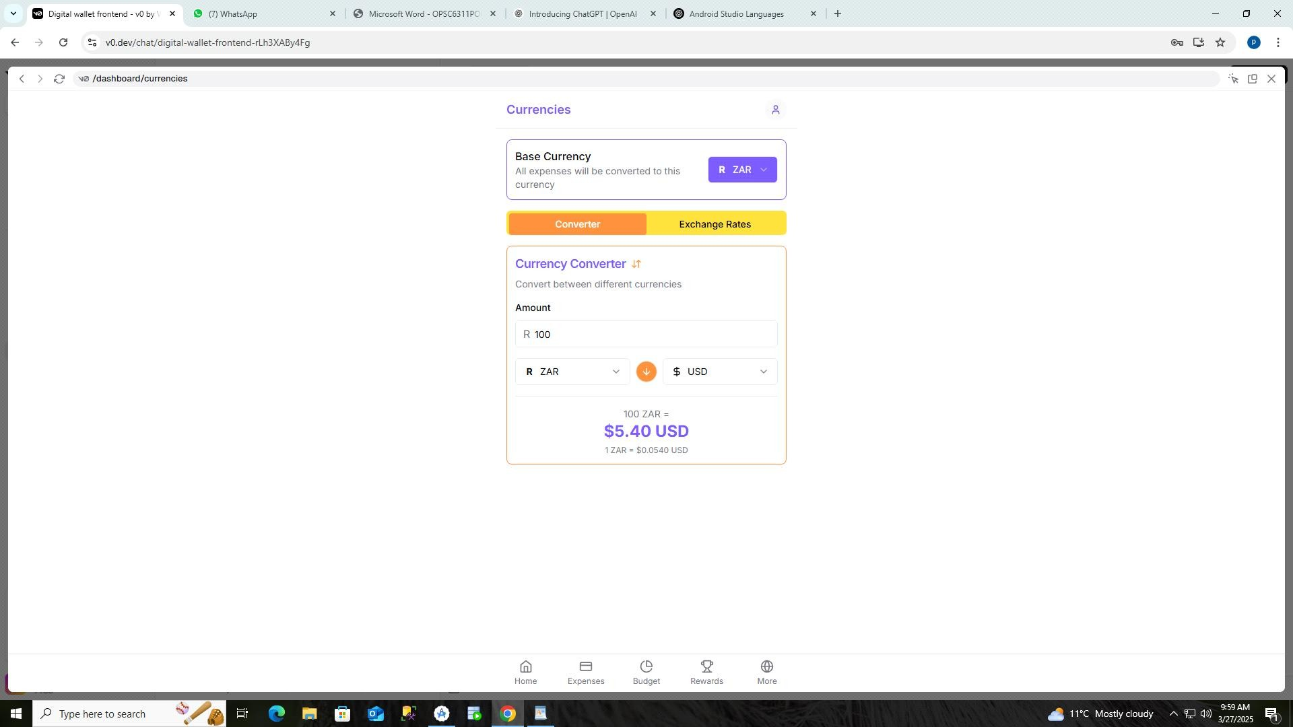

**Figure 10: Currencies Screen**

**Purpose:** Provides tools for currency conversion and multi-currency support. **Description:** Features a currency converter with ZAR (South African Rand) as the base currency and displays current exchange rates. Helps users manage finances across different currencies.

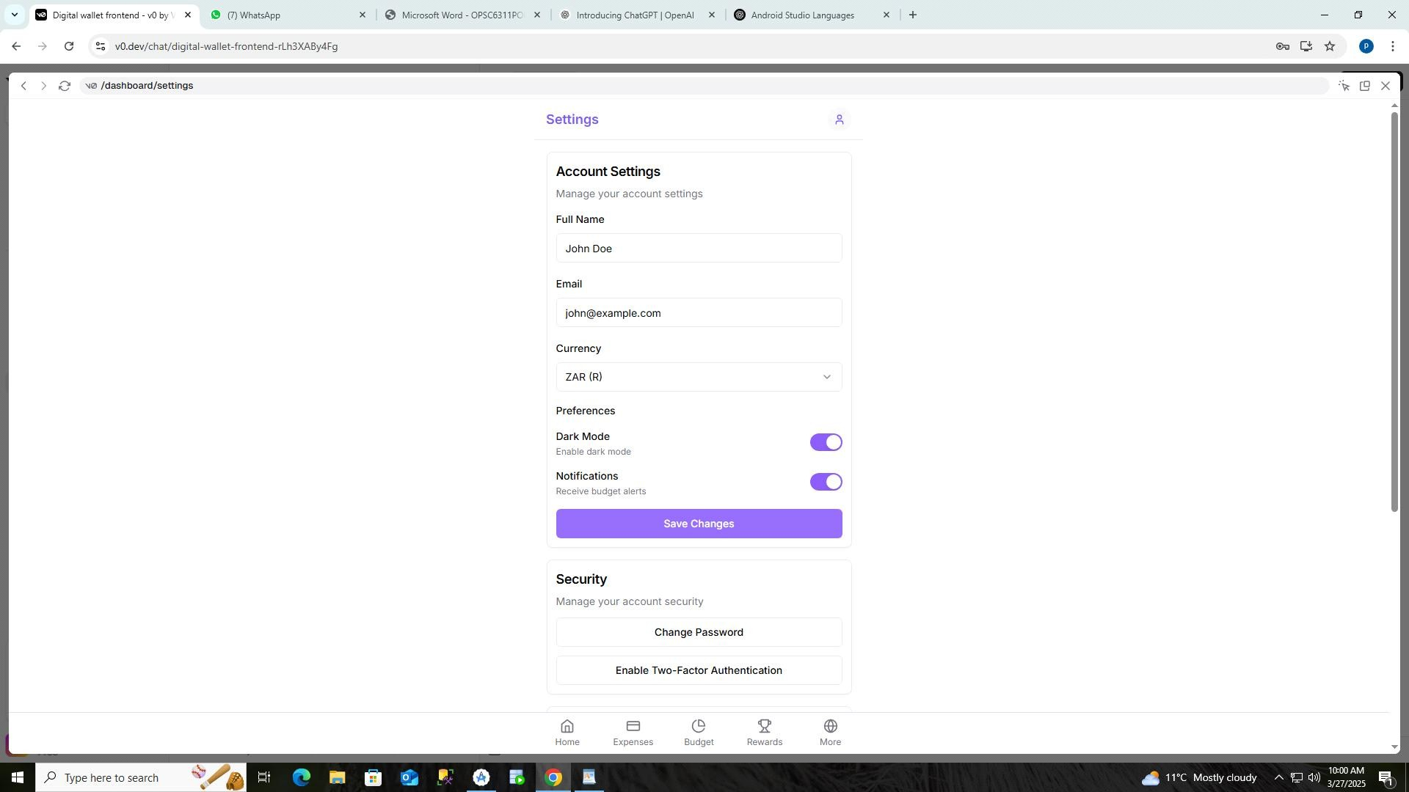

**Figure 11: Settings Screen**

**Purpose:** Allows users to customize app preferences and manage account settings. **Description:** Contains options for personal information, currency preferences, notification settings, and security features. Gives users control over how the app functions and displays information.

# 5. Project Plan

**•**Language: Kotlin

•Database:

•Backend: for authentication, store data to database and sync to cloud

**Development phases**

## Phase 1

**Problem description:**

Financial management- most people do not know how to manage their finances, and this could be because of the lack of the right information and the right tools, financial illiteracy is a big problem in society. This causes them to mismanage their money and live beyond their means. Budgeting applications are easy to learn and use. Many people want to be in control of their finances and good financial management can lead to financial freedom and budgeting apps could help the users to be good managers of their finances. System capabilities

* Data privacy-Should request the user to register and use the username and password to access the application
* Allows the user to draw the monthly budget
* Categorize their expenses
* Upload the photos and the receipts of the items they purchase
* Set savings goals
* Remind the user of their reoccurring payments
* Enables the user to input their daily expenses
* Alerts the user when there are close to exceed their budget
* Generate a report at end of the month-the summary of the transactions
* Stores the user's data in database

**Benefits:**

* Helps the user to understand their spending habits.
* Helps Users of the application become good managers of their money
* Reminds the users of their financial obligations
* Enables their users to achieve their financial goals • Encourages the users to develop good spending habits.
* Helps users to gain financial freedom.

## Phase 2

The Estimated Time for the Project completion and key milestones

**(Gantt Chart)**

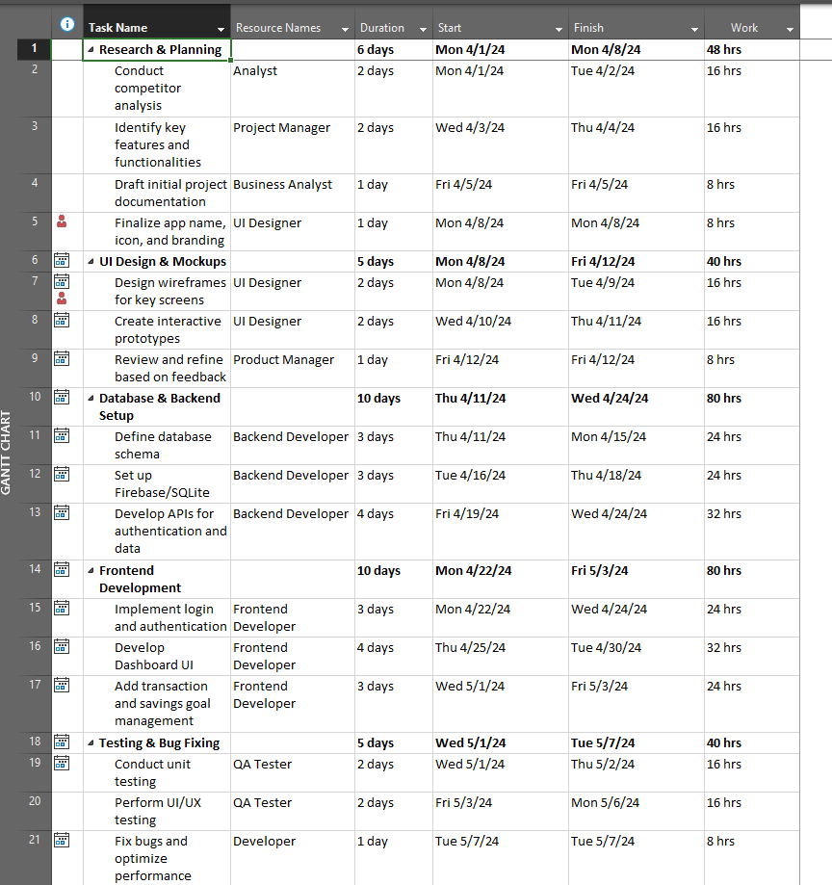

**Team roles:**

**The Project manager:** Oversees the project and ensures that the team members meet their deadlines

**The UI designer & Business Analyst:** designs the user interface and user experience

**Frontend Developer , Backend Developer & QA Tester:** does the coding and implements the features Tools, Technology and Testing

# 6. Conclusion

The EasyBudget app aims to simplify financial management through intuitive tracking and analysis features. Future iterations will enhance functionality by incorporating user feedback and additional features like AI-based spending predictions and investment tracking.

# References

M Georgiou. "A Complete Guide to Building a Personal Finance App in 2025. Available on: <https://imaginovation.net/blog/building-personal-finance-app/> [Accessed on: 27 March 2025]

envatomarkert. “Unlimited creative, all in one place”. Available on: <https://codecanyon.net/category/mobile?term=budget> [Accessed on: 27 March 2025]

R Lake. “Are Budgeting Apps Worth It?”. Available on:

<https://www.forbes.com/advisor/banking/are-budgeting-apps-worth-it/> [Accessed: 27 March 2025]

J Hindy. “10 Best Android budget apps for money management”. . Available on:

[https://www.androidauthority.com/best-android-budget-apps-for-money-management586807/](https://www.androidauthority.com/best-android-budget-apps-for-money-management-586807/) [Accessed on: 27 March 2025]

GeeksforGeeks(2025). “How to Create and Add Data to SQLite Database in Android?”. Available on: <https://www.geeksforgeeks.org/how-to-create-and-add-data-to-sqlite-database-in-android/>

[Accessed: 27 March 2025]