**A**

**PROJECT REPORT**

**ON**

**“Fake Currency Detection”**

**SUBMITTED TO**

**SHIVAJI UNIVERSITY, KOLHAPUR**

**IN THE PARTIAL FULFILLMENT OF REQUIREMENT FOR THE AWARD OF DEGREE BACHELOR OF ENGINEERING IN COMPUTER SCIENCE AND ENGINEERING**

**SUBMITTED BY**

**Gunjan Pramod Rajgure 17UCS12015XX**

**Namrata Ravindra Gurav 17UCS11013XX**

**Prashant Balaji Jadhav 17UCS12015XX**

**Komal Narayan Khamkar 17UIT11020CS**

**Mehvish Juberahmad Shaikh 17UIT11036CS**

**Ankita Jotiram Mane 16UCS11033XX**

**UNDER THE GUIDANCE OF**

**Prof. S.B.Bhagate**



**DEPARTMENT OF COMPUTER SCIENCE AND ENGINEERING**

**DKTE SOCIETY’S TEXTILE AND ENGINEERING INSTITUTE, ICHALKARANJI**

**(AN AUTONOMOUS INSTITUTE)**

**ACCREDITED WITH ‘A+’ GRADE BY NAAC**

**An ISO 9001: 2015 Certified**

**SHIVAJI UNIVERSITY KOLHAPUR**

**2020-2021**

**D.K.T.E. SOCIETY’S**

**TEXTILE AND ENGINEERING INSTITUTE, ICHALKARANJI**

**(AN AUTONOMOUS INSTITUTE)**

**ACCREDITED WITH ‘A+’ GRADE BY NAAC**

**An ISO 9001: 2015 Certified**

**SHIVAJI UNIVERSITY KOLHAPUR**

**2020-2021**

**DEPARTMENT OF COMPUTER SCIENCE &ENGINEERING**



**CERTIFICATE**

**This is to certify that, project work entitled**

**“Fake Currency Detection”**

**Is a bonafide record of project work carried out in this college by**

**Gunjan Pramod Rajgure 17UCS12015XX**

**Namrata Ravindra Gurav 17UCS11013XX**

**Prashant Balaji Jadhav 17UCS12015XX**

**Komal Narayan Khamkar 17UIT11020CS**

**Mehvish Juberahmad Shaikh 17UIT11036CS**

**Ankita Jotiram Mane 16UCS11033XX**

**In the partial fulfillment of award of degree Bachelor in Engineering in Computer Science & Engineering prescribed by Shivaji University, Kolhapur for the academic year 2020-2021.**

**Prof. S.B.Bhagate**

**(PROJECT GUIDE)**

**Prof. (Dr.) D.V.KODAVADE Prof.(Dr.) P.V.KADOLE**

**(HOD CSE DEPT.) (PRINCIPAL)**

**EXAMINER: ________________**

**DECLARATION**

We hereby declare that, the project work report entitled “**Fake Currency Detection”** which is being submitted to D.K.T.E. Society’s Textile and Engineering Institute Ichalkaranji, affiliated to Shivaji University, Kolhapur is in partial fulfillment of degree B.TECH.(CSE). It is a bonafide report of the work carried out by us. The material contained in this report has not been submitted to any university or institution for the award of any degree. Further, we declare that we have not violated any of the provisions under Copyright and Piracy / Cyber / IPR Act amended from time to time.

**Sr. PRN Name of Student Signature**

1.17UCS12012XX Gunjan Pramod Rajgure.

2.17UCS11013XX Namrata Ravindra Gurav.

3.17UCS12015XX Prashant Balaji Jadav.

4.17UIT11020CS Komal Narayan Khamkar.

5.17UIT11036CS Mehvish Juberahmad Shaikh.

6.16UCS11033XX Ankita Jotiram Mane.

**ACKNOWLEDGEMENT**

With great pleasure we wish to express our deep sense of gratitude to Prof. S.B.Bhagate for his valuable guidance, support and encouragement in completion of this project. Also, we would like to take opportunity to thank our Principal Prof. (Dr.) P.V.Kadole and our head of department Dr. D. V. Kodavade for his co-operation in preparing this project.

We feel gratified to record our cordial thanks to other staff members of Computer Science and Engineering Department for their support, help and assistance which they extended as and when required.

Thank you,

Mr. Gunjan Pramod Rajgure 17UCS12012X X

Miss. Namrata Ravindra Gurav 17UCS11013XX

Mr. Prashant Balaji Jadav 17UCS12015XX

Miss. Komal Narayan Khamkar 17UIT11020CS

Miss. Mehvish Juberahmad Shaikh 17UIT11036CS

Miss. Ankita Jotiram Mane 16UCS11033XX

**ABSTRACT**

Fake currency notes are increasing day by day, in order to overcome this we proposes a very helpful and efficient system to detect the fake currency. For detecting the fake currency note is done by counting the number of interruptions in the thread line. For predicting the note is real or fake on the basis of number of interruptions. If the number of interruption is zero, if it is real note otherwise it is fake. And also we calculate the entropy of the currency notes for the efficient detection of fake currency note. MATLAB software is used to detect the fake currency note.

Fake currency detection is a serious issue worldwide, affecting the economy of almost every country including India. Currency duplication also known as counterfeit currency is a vulnerable threat on economy. It is now a common phenomenon due to advanced printing and scanning technology. The possible solutions are to use either chemical properties of the currency or to use its physical appearance. The approach presented in this paper is based upon physical appearance of the Indian currency. Image processing algorithms have been adopted to extract the features such as security thread, intaglio printing (RBI logo) and identification mark, which have been adopted as security features of Indian currency. Hence, we propose a more user friendly and portable solution to this problem in form of a mobile app coupled with cloud storage.

**INDEX**

**CONTENT PageNo.**

**1. Introduction 7**

a. Problem Statement

b. objective of the project

c. Scope and limitation of the project

d. Timeline of the project

**2. Background study and literature overview 13**

a. Literature overview

b. Investigation of current project and related work

**3. Requirement analysis 17**

**4. System design 21**

**5. Implementation 27**

a. Detailed description of methods

b. Model used

c. pre-processing data

d. Methodology

**6. Integration and Testing 32**

**7. Performance Analysis 36**

**8. Applications 38**

**10. Installation Guide and User Manual 40**

**11. Cost Estimation 43**

**12. Ethics 45**

**13. References 47**

**Introduction:**

Today in the modern digitalization world, we are surrounded by various technologies and these technologies are growing day by day in rapid manner. Of course, such technologies had made our life very easy and more efficient, and still making too. Today people can do their work with minimum efforts and such things are only possible because of the technology. But some people are utilizing the advantages of technologies to fulfill their own bad purposes. There are lots of such examples that are surrounded around us. Production of Counterfeit Currency Notes is one of the most important examples of such things.

Production of currency without the legal sanction of Government is termed as Counterfeit currency. Commercial areas like the banks, malls, jewellery stores, etc. have huge amounts of transactions on a daily basis. Such places may be able to afford and find it feasible to buy machines that use UV light and other techniques to detect the authenticity of the currency. But for common people it is very difficult to detect just by seeing whether the currency is fake or genuine and they may face losses especially during bank deposits or transactions.

This system is designed such that any person can use it easily and detect the authenticity of the currency he has, using the visual features of the currency. Though it seems easy at first sight but actually could be challenging to visually challenged person or even to normal people like us too as technology has been developed so advance that fake notes nowadays look s exactly similar to real ones. The Reserve Bank of India is the only bank which has the sole authority to issue currency notes in India. Like other central banks in the world, Reserve Bank of India is also having authority to make changes in the design of currency notes time to time. Traditionally, anti-counterfeiting measures involved including fine details with raised intaglio printing on bills which allows non-experts to easily spot forgeries. On coins, milled or marked with parallel grooves edges are used to show that none of the valuable metal has been scraped off. The Reserve bank of India uses several techniques to detect fake currency. All this could happen at very larger and higher scale for government money.

The technology of currency recognition basically aims for identifying and extracting visible and invisible features of currency notes. Until now, many techniques have been proposed to identify the currency note. Binod Prasad Yadav, C.S.Patil , R.R.Karhe , P.H Patil presented Detecting Fake Currency it is very time consuming .The process is done by using feature extraction with HSV to detect the fake currency. Megha Thakur, Amrit Kaur designing a system to identify the fake currency note by using various detection techniques and parameters on currency note. This method can be used to efficiently and easily detecting the counterfeit currency notes. Kavya B R, Devendran B proposed a system that recognize the fake currency note on the basis of extracted features of the currency note. Coherent matching of features, which helps in the SIFT techniques. Extracted features of currency notes, they are See Through register, Identification mark, thread, Governor's signature, Micro lettering, year of printing. W. K. El said developed a feature extraction-based system for detecting the fake Egyptian paper currency in

efficient manner. In this process the extracted feature of currency is individually performed on original and sampled version of the currency note.

On the basis of similarity measurements, independently acquiring each side of the decision of currency detection. Tushar Agasti, Gajanan Burand, Pratik Wade P Chitra proposed a system that recognize the fake currency note on the basis of accuracy. The extracted features of currency note are applied to the algorithm to improve the accuracy of note.

Our system will be based on Image processing where the number of steps is used to process the image of a currency note and outputs the result to the user whether the currency is genuine or not. But the best way is to use the visible features of the note. For example, color size and aspect ratio. Almost half of the work of recognition done while checking the aspect ratio and central line itself. But this way is not helpful if the note is dirty or torn. If a note is dirty, its color characteristics are changed widely. So, it is important that we extract the features of the image of the currency note and apply proper algorithms to improve accuracy to recognize the note.

1. **PROBLEM STATEMENT:**

Fake currency notes are increasing day by day and are affecting Indian economy severely. In order to minimize them, easy detection is necessary. Build an application to detect counterfeit currency notes with maximum accuracy using deep leaning.

1. **PROBLEM DESCRIPTION:**

Fake Indian Currency Note (FICN) is a term used by officials and media to refer to [counterfeit currency notes](https://en.wikipedia.org/wiki/Counterfeit_money)circulated in the [Indian economy](https://en.wikipedia.org/wiki/Indian_economy). According to [Indian law](https://en.wikipedia.org/wiki/Indian_law), possessing fake notes is a punishable offence, but only if the person in question is aware that the notes are fake. Fake Indian notes are mainly used in terror related activities. The money mainly flows from Nepal, Pakistan and Bangladesh. The terrorists are using it to cripple the Indian economy and to create [economic terror](https://en.wikipedia.org/wiki/Economic_terrorism). Fake currency is a tactic of Econo-Jihad of terrorist groups around the world. Millions of Dollars are sent to India from different bordering countries. ISI is reportedly involved in this racket.

Some of the ill-effects that counterfeit money has on society include a reduction in the value of real money; and increase in prices due to more money getting circulated in the economy - an unauthorized artificial increase in the [money supply](https://en.wikipedia.org/wiki/Money_supply); a decrease in the acceptability of paper money; and losses, when traders are not reimbursed for counterfeit money detected by banks, even if it is confiscated. Traditionally, anti-counterfeiting measures involved including fine detail with raised [intaglio](https://en.wikipedia.org/wiki/Intaglio_(printmaking)) printing on bills which allows non-experts to easily spot forgeries. On coins, milled or receded (marked with parallel grooves) edges are used to show that none of the valuable metal has been scraped off.

The advancement of color printing technology has increased the rate of fake currency note printing and duplicating the notes on a very large scale. Few years back, the printing could be done in a print house, but now anyone can print a currency note with maximum accuracy using a simple laser printer. As a result, the issue of fake notes instead of the genuine ones has been increased very largely. India has been unfortunately cursed with the problems like corruption and black money. And counterfeit of currency notes is also a big problem to it. This led us to design of a system that detects the fake currency note in a less time and in a more efficient manner. The proposed system gives an approach to verify the Indian currency notes. Verification of currency note is done by the concepts of image processing using region-based CNN. This is used to extract the features of the note and also to determine whether the currency is fake or real. The proposed system has got advantages like simplicity and high-performance, speed. The result will predict whether the currency note is fake or not.

**c. OBJECTIVES:**

Following are the main objectives of our proposed system application:

* To abstract out accurate results, thread-line and color of Currency image taken using Image processing technique and feature extraction with help of region-based CNN algorithm.
* To detect accurately whether the note image provided to application is counterfeit or real.
* To achieve more speed and accuracy as well as ease in use by common people than many other older currency detection techniques available.

#### SCOPE AND LIMITATION OF THE PROJECT:

#### SCOPE OF THE PROJECT:

* Our System will be helpful for the regular peoples who are technically not involved in daily life with background processes. This app will provide its user an concise way to perform a very necessary task.
* In our study precision of above 99% can be achieved. Our proposed system could replace the hardware system in some initial stages of currency verification process.

**LIMITATION OF THE PROJECT:**

* Data to be given as input should be Indian currency. This system does not work for currency of any other country.
* Our system is time consuming if there are lots of notes present to detect whether they are real or fake as system needs to be fed with one currency at one time.
* Most of the abovementioned systems are implemented in large scale organizations where a huge amount of money gets transacted. They have no use for common people.
* The previously used algorithms sometime fails in case of torn, overused/over-handled notes or notes scanned in dim light.
* Accuracy of the systems is still an issue.

**e. TIMELINE OF THE PROJECT:**

We have used classic life cycle paradigm also called “Water Fall Model”. For software engineering which is sequential approach to software development that begins at the system level and progress through analysis, design, coding, testing and maintenance. We had completed software requirement analysis by the mid of September 2020 which encompasses both system and software requirement gathering. By the end of December 2020 we had completed project planning and design. On the basis of design prepared in the previous stage by the end of April 2021 we completed coding stage.

After completion of coding stage the important part in the software development which is testing phase carried out in first week of May 2021.Various criteria of testing were taken into account which includes unit testing, integration testing, validation testing and system testing. First, each and every module of the project was tested under the unit testing. After the unit testing, integration testing was carried out by integrating all module tested in unit testing. After unit testing the module prepared was cross checked with the design.

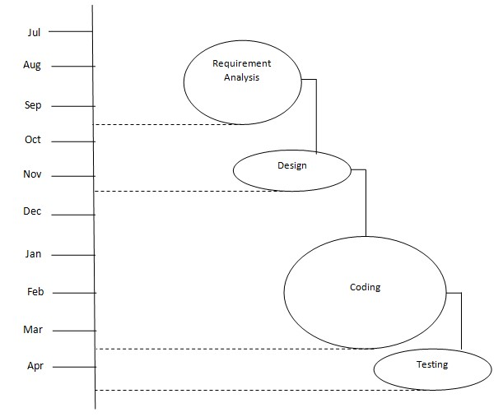

**Background study and literature overview:**

**a. Literature Review:**

Fake currency detection is a serious issue worldwide, affecting the economy of almost every country including India. The use of counterfeit currency is one of the major issues faced throughout the world nowadays. The counterfeiters are becoming harder to track down because of their use of highly advanced technology One of the most effective methods to stop counterfeiting can be the use of counterfeit detection software that is easily available and is efficient.

Our project will recognize Indian currency notes using a real-time image obtained from a webcam. The background of our topic is image processing technology and applying it for the purpose of verifying valid currency notes. The software will detect fake currency by extracting features of notes. The success rate of this software can be measured in terms of accuracy and speed.

**b. Investigations of current Project and related work:**

Various papers are available that contain information on Fake currency detection. Some referred papers are mentioned here.

**“Indian Currency Denomination Identification Using Image Processing Technique”** by Vipin Kumar Jain, Dr. Ritu Vijay[1].

The paper [1] used Fraud detection technique by using performance metrics. Neural networks and model based reasoning are the two methods behind this technique. The general attributes like identification mark and serial numbers of currency are extracted. Denomination of currency is known by identification mark. Next generation intrusion detection expert system is used in this paper by using the real time and batch technique. Large volume of fake money will cause many problems. Various methods like water marking, optically variable ink, florescence, etc are used to detect fake currency in this paper. In this system, various two components of two images are combined together to find the variation among the images. Image acquisition, gray scale conversion, edge detection, feature extraction, image segmentation and comparison of images are the methods used in this approach to detect the fake currency. Feature extraction by edge based segmentation using sobel operator is used in this paper for design and implementation. The image is acquired and the acquired image is converted into grey scale by pixel value. The image is sub divided into object or region by image segmentation. Security features of Indian currency are used in this paper.

P. D. Deshpande and A. Shrivastava, “ **Indian Currency Recognition and Authentication using Image Processing** ,” IJARSE, Vol. 07, No. 7, pp. 1107-1119, 2018[2].

The proposed approach in this paper [2] extracts multiple features from Indian currency and uses them for fake currency detection. The image was acquired using image acquisition device. The security features were extracted using various image processing algorithms and then template matching was done to identify fake currency. We will be overcoming this problem by using different parameters which will be enough sufficient to recognize the difference between fake and original currency notes, this will be implemented using image processing techniques.

K. Sawant and C. More, **“Currency Recognition Using Image Processing and Minimum Distance Classifier Technique,”** IJAERS, Vol. 3, No. 3, pp. 1-8, 2016[3].

Sawant and More [3], introduce an approach to detect fake note using minimum distance classifier technique. In this paper, the extract an ID mark and latent image and compute the Euclidean distance between the test sample and train sample. The Fourier descriptor is used for the describe the note boundary. The experimental setup is done on rupees 20, 50, 100,500 and 1000.The average success rate achieved is 90.0%.

B. Zende, B.Kokare, S.Pise and P. S.Togrikar, **“Fake Note Detection System,”** IJIRT, Vol. 4, No. 1, pp. 46-49, 2017[4].

K. B. Zende et.al. [4], describe a fake note detection system automatic recognition of Indian currency security feature based on MATLAB system. They are so many step including in this process is feature extraction, image segmentation, edge detection, bit plane slicing and comparison of image. In this paper extract some many feature watermark Detection, Security Thread Detection, checking currency series number, identification mark and sees through register. Here, they propose a GUI platform to check the currency is fake or real.

Eshita Pilania, Bhavika Arora, ―**”Recognition of Fake Currency Based on Security Thread Feature of Currency”** International Journal Of Engineering And Computer Science, ISSN: 2319-7242[5].

In [5], as mentioned, no one can be 100 percent sure of the manual recognition and so the system was proposed to compare images of currency with the stored data and detect whether the currency is fake or genuine. This system used MATLAB to run and perform the operations of the system. The feature extraction process mostly focuses on HSV values of the currency where the image is divided into blocks and the operations are performed on the ROI.

P. Julia Grace, Ph.D., A. Sheema, ―**”A survey on Fake Indian Paper Currency Identification System”**  Grace et al., International Journal of Advanced Research in Computer Science and Software Engineering (6-7), July- 2016, pp. 340-345 ISSN: 2277 128X[6].

In [6], the survey paper proposes a system to improve the currency detection system especially in commercial areas like banks, shopping malls, etc. Here some different pre-processing techniques were mentioned such as radiometric corrections and Geometric corrections for correcting spectral errors or distortions due to sensor. Earth geometric variations etc. Different papers were compared and results were provided based on the accuracy rate obtained by using different methods.

Komal Vora, Ami Shah, Jay Mehta, ―**”A Review Paper on Currency Recognition System”** International Journal of Computer Applications (0975 – 8887), Volume 115 – No. 20, April 2015[7]

In [7], a system is proposed to detect fake currency based on different features that can be extracted for comparison. Various methods are used at different stages histogram equalization, using feature vectors to stored extracted features, etc. The features that were used for currency detection were security thread, RBI micro-print and serial number detection.

Yanyan Qin, Hongke Xu, Huiru Chen, **“Image Feature Points Matching via Improved ORB”**, ICPIC, Vol. 14, pp. 204-208, 2014[8].

Yanyan Qin et.al. [8], proposed systems provide by SIFT (Scale-Invariant Feature Transform). Initially, the scale spaces were built for the detection of stable extreme points, and then the detected stable extreme points were considered to be feature points which have scale in variance. Secondly, ORB descriptor is used to describe the currency feature points. This finally generated the binary descriptors with scale and rotation in variance. The ORB is 65.28 times faster than SIFT. The experimental setup is done 20 images and achieves accuracy 92.53%

Basically, all the papers mentioned above have some issues regarding their ease of use as well as accuracy. So to overcome and to deal with this problem we try to use something different approach. We will be overcoming this drawbacks by using different techniques just like deep learning algorithm which will be enough sufficient to recognize the difference between fake and original currency notes.

**Requirement analysis:**

1. **Hardware Requirements:**

* Processor Type : Pentium-IV
* Speed : 2.4 GHz
* RAM : 2 GB RAM
* Hard disk : 20 GB HDD

1. **Software Requirements:**

* Operating System : Windows 7
* Software Programming Package: Python, Tensor Flow, Keras.

1. **Functional Requirements:**

* This should be able to retrieve results accurately from classifier.
* The Android application must capture the image of Currency note properly and successfully transforms it to image processing and classification algorithm.
* The application should be able to relay the result to the user using audio feedback along with normal window display for visually challenged peoples.
* The system should provide a vast and easily accessible dataset to deal with deep learning properly.
* The CNN architecture (MobileNetV2) used must be appropriate according to parameters we extract.
* Region selection must be done in very accurate and proper manner by classifier.

1. **Non-functional Requirements:**

* The camera should be clear and capable to capture image with clarity above some minimum threshold clarity size.
* There should be minimal lag between capturing the image and the result.
* The dataset must be well trained and validated enough.
* The classification technique used must be chosen according to need and ease of use.
* The image processing should be done with desirable accuracy.
* The system should give valid result for positive as well as negative test cases.
* The system should try to get more and more accurate with maximum use.

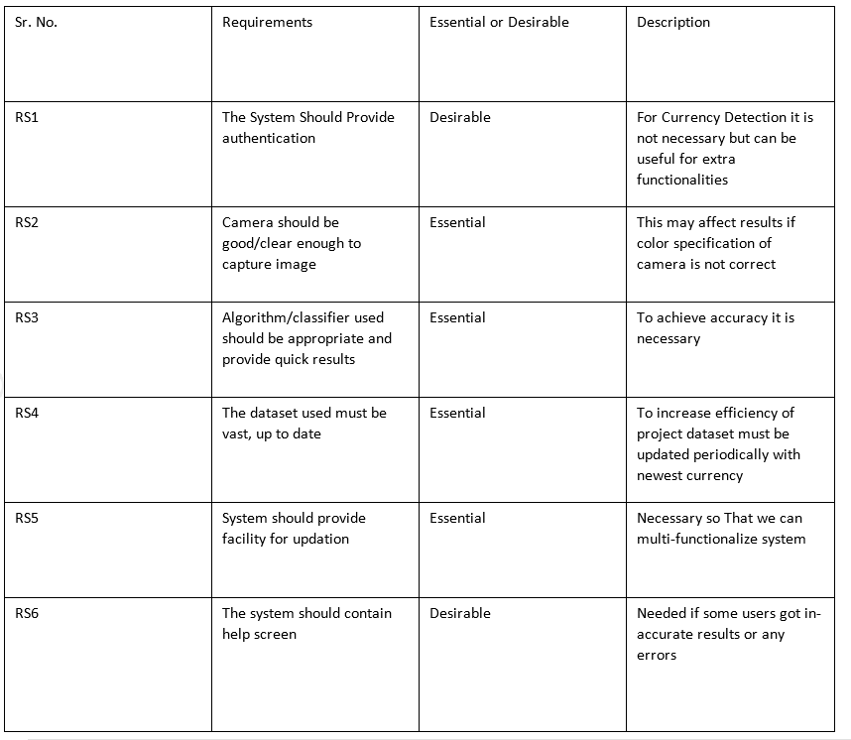

**System design:**

* 1. **Architecture Design**

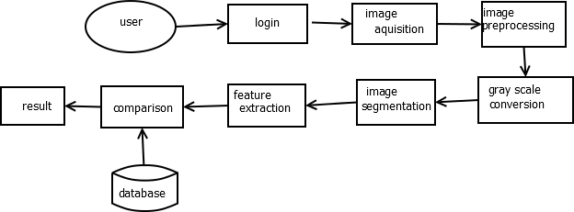

1. **DFD Level 0**

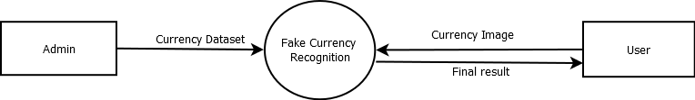

**Level 1:**

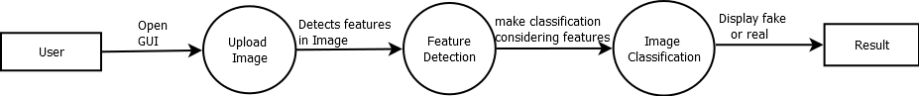

1. **Use case**

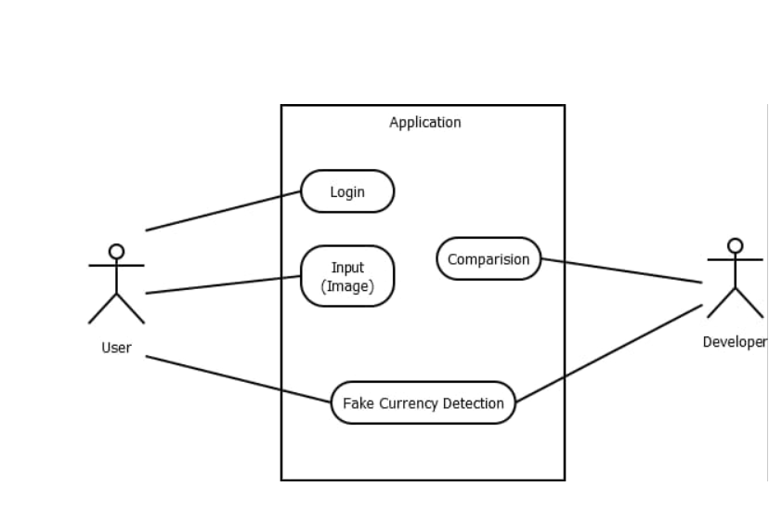

**4.Sequence Diagram**

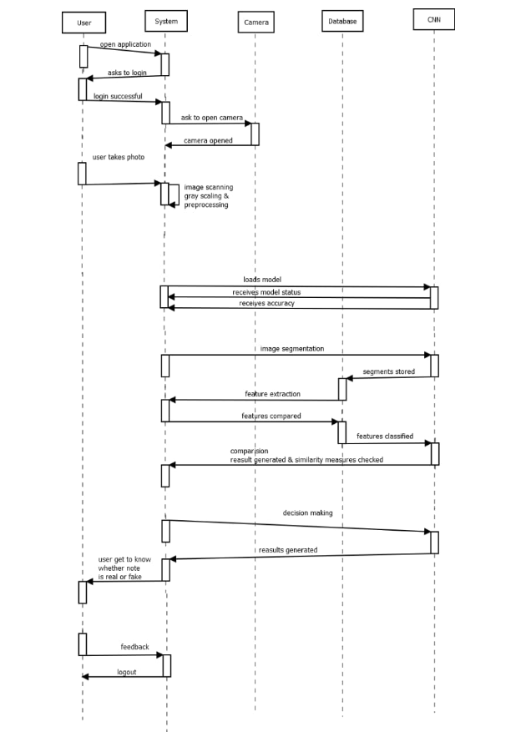

**5.State Chart**

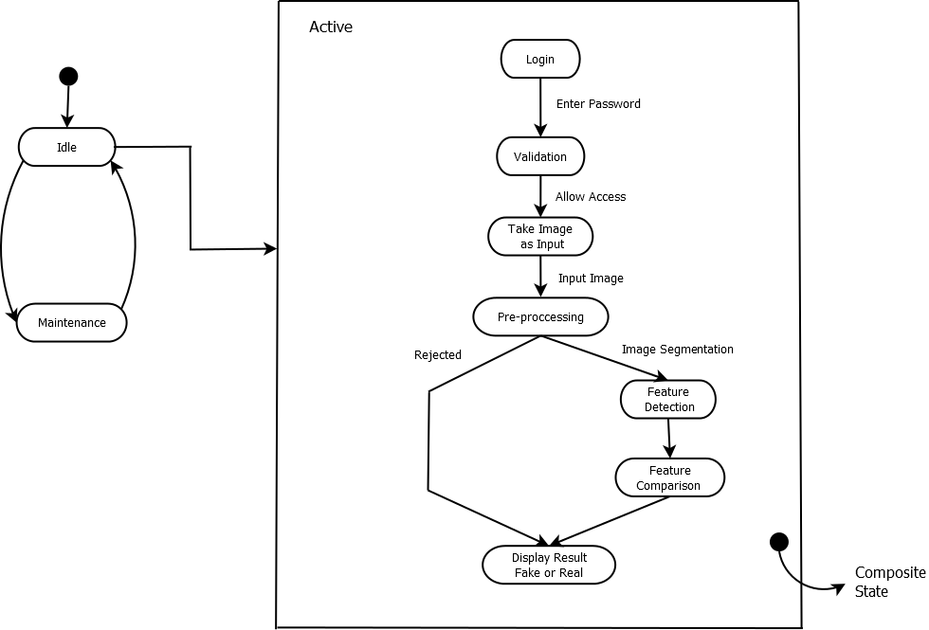

**6.Activity Diagram**

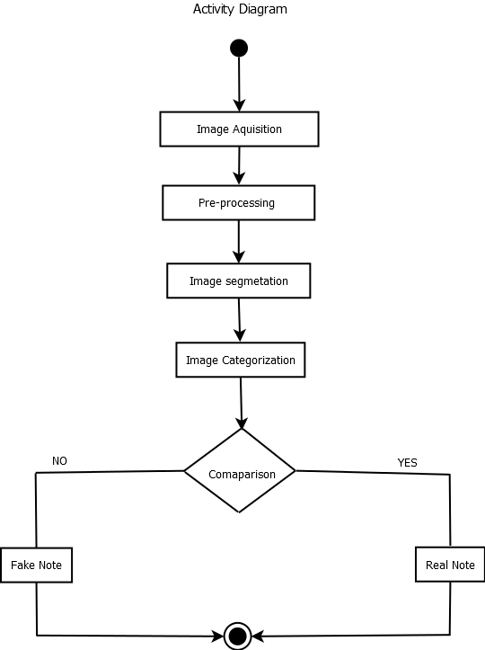

**Implementation:**

**Detailed description of methods:**

**Data Collection** – Data for this project is collected from various sources like image-net, and for some real time data, pictures are clicked using camera. As we have three different modules in our project dataset for each of them is different, they are as follows –

1. Basic Classification Module – Dataset for this module contains normal pictures of currency notes separated by their currency value, is it old or new note, and is that it’s back or front side of notes. Dataset for this module consist of –

Training set – 6000 images

Test set – 2500 images

1. Ultraviolet Validation module – Dataset for this module contains images of currency note taken in presence of Ultra Violet rays. But as it is not possible to have sufficient images so the dataset is created by modifying the original images using scaling, resizing and rotating techniques. So, the final dataset contains –

Training set – 6000 images

Test set – 3000 images

1. Watermark Validation module – Dataset for this module contains images of currency note taken in presence of backlight due to which the watermark on the note is clearly visible. Similar to above module a dataset is created by modifying the original images using scaling, resizing and rotating techniques. Here the final dataset contains –

Training Set – 6000 images

Test Set – 3000 images

|  |  |  |  |
| --- | --- | --- | --- |
|  | **Training Set** | **Testing Set** | **Total** |
| Basic Classification | 6000 | 2500 | 8500 |
| Ultraviolet Validation | 6000 | 3000 | 9000 |
| Watermark Validation | 6000 | 3000 | 9000 |

**Model Used –**

* **MobileNetV2**

This model is a Pre-trained convolutional neural network model. The MobileNetV2 architecture is based on an inverted residual structure where the input and output of the residual block are thin bottleneck layers opposite to traditional residual models which use expanded representations in the input an MobileNetV2 uses lightweight depth wise convolutions to filter features in the intermediate expansion layer.

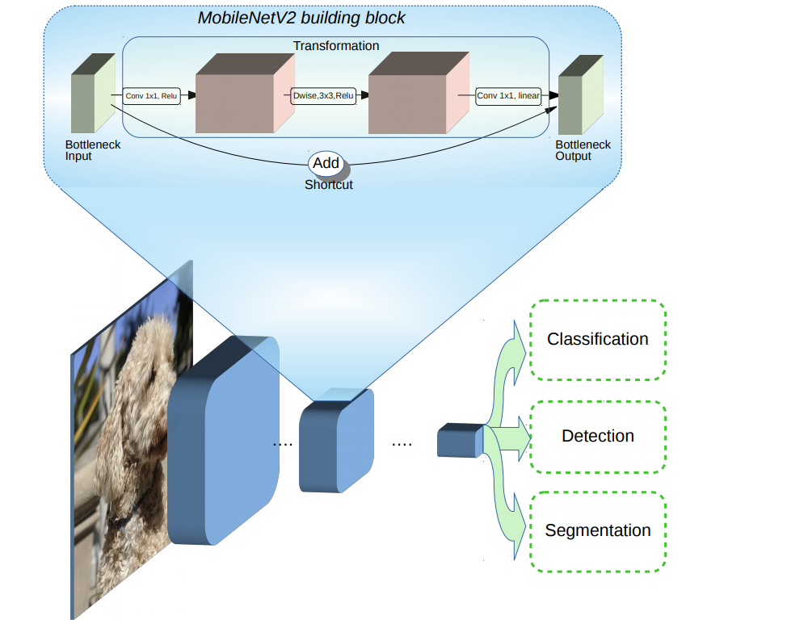

The intuition is that the bottlenecks encode the model’s intermediate inputs and outputs while the inner layer encapsulates the model’s ability to transform from lower-level concepts such as pixels to higher level descriptors such as image categories. Finally, as with traditional residual connections, shortcuts enable faster training and better accuracy.

**c. Pre-processing data** –

As we know all the pre-trained models in keras need a specific kind of data for training. So to convert over data in that format we need to apply some pre-processing techniques. In our case we have directly used the techniques provided by keras specifically for our model MobileNetV2.

This pre-processing is done with help of image data generator setting it’s attribute to-

**Pre-processing_function = keras.applications.mobilenet.preprocess_input**

**2.Training the model –**

As we have three different modules so the model is trained on all the three datasets given for each of the module. That said we use three instances of the model and train them on those datasets. Initial weights for the model are taken from image net.

As all the instances are trained on different datasets, so they can be compiled with different values of attributes –

1. Basic Classification –
   1. Optimizer – SGD
   2. Loss-function – Categorical Cross entropy
   3. Metrics – Accuracy
2. UV Validation –
   1. Optimizer – SGD
   2. Loss-function – Categorical Cross entropy
   3. Metrics – Accuracy
3. Watermark Validation –
   1. Optimizer – SGD
   2. Loss-function – Categorical Cross entropy
   3. Metrics – Accuracy

**d. Methodology**

The proposed method is based on the pre-trained convolutional neural network architecture for the detection of counterfeit Indian currency note. As the design of Indian currency note have changed from before, there is larger possibility of fake note as well hence these recently introduced,10 Rupee Note,20 Rupee Note,50 Rupee Note, 100 Rupee Note, 200 Rupee Note, 500 Rupee Note and 2000 Rupee Note are considered here, in addition to this old currency note which are valid even now are also considered.

There are various different features that are present in the currency on these notes, which are used by common people for differentiating currency denomination. In the proposed model three major features i.e. Watermark of Mahatma Gandhi on the note, Metal Strip present on the note, denomination numeral with Rupee symbol with colour feature of currency note are used for detection of real or fake note. Colour has been used widely as a prominent feature by banknote designers for the differentiation between denominations.

The algorithm which is applied for the detection of counterfeit Indian currency note is as follows:

1. Acquisition of currency note using digital scanner.
2. Pre-process the captured image.
3. Perform segmentation on the image and extract feature.
4. Categorization of note on basic of colour and denomination.
5. UV validation for presence of dashed metal strip.
6. Watermark Validation for presence of Watermark image of Mahatma Gandhi on the note.
7. Based on results classify the note as Real or Fake.

**Integration and Testing:**

|  |  |  |  |  |  |
| --- | --- | --- | --- | --- | --- |
| **Test Case**  **No.** | **Test Case** | **Input** | **Expected**  **Output** | **Actual**  **Output** | **Status** |
| 1 | Upload Image | Image | Image Uploaded | Image Uploaded | Pass |
| 2 | Finding Denomination and basic classification | Image | Denomination Identified | Denomination Identified | Pass |
| 3 | Ultraviolet Validation | Contrast  Adjusted Image | Checked for presence of metal strip | Checked for presence of metal strip | Pass |
| 4 | Watermark Validation | Image with backlight | Checked for presence of watermark | Checked for presence of watermark | Pass |
| 5 | Final Result  (Fake or Real) | Output of above three steps | Note Classified  (Fake or Real) | Note Classified  (Fake or Real) | Pass |

**Test Case -**

1. Uploaded Image –

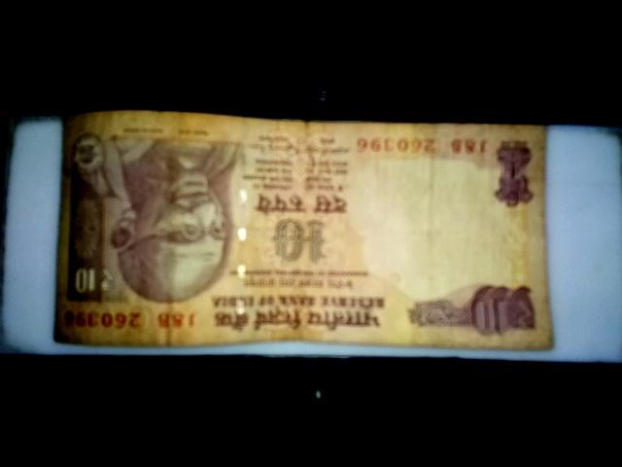

1. Identified the denomination of the note, i.e. Rs.10.

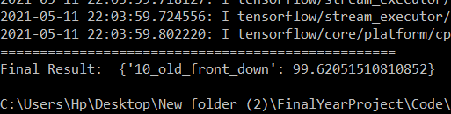

1. Contrast adjusted image which will be sent for UV validation – In this example the Brightness is set to -130 and contrast to 100.

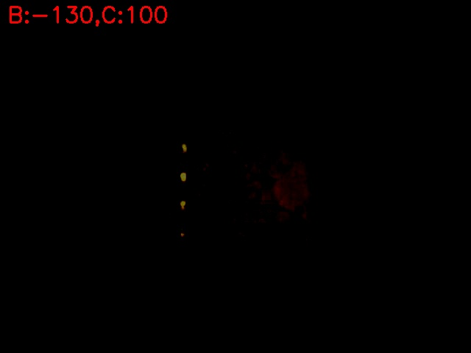

1. Result of UV validation – this says the note contains dashed metal strip.

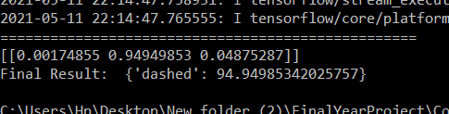

1. Result of Watermark Validation – As we can see it says watermark is present on the note.

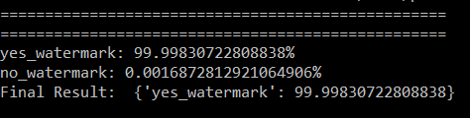

1. Final Result –

As per above results i.e. Denomination of Rs.10, Presence of Watermark and Presence of Dashed Metal Strip, we can conclude that the note is a REAL Rs.10 Note.

**Performance**

**Analysis:**

* This project helps to detect the fake currency using image processing.
* This would eliminate the circulation of fake note in the system to some extent.
* It would provide an opportunity for the user to properly detect the authenticity of note actually without going to the banks. This project discussed a technique for verifying Indian paper currency
* By using digital image processing, analysis of Currency Image is more accurate as well as this method is efficient in terms of cost and time consuming as compared to existing techniques.
* The work will surely be very useful for minimizing the fake currency. Mobile app is developed which would be useful for normal as well as visually impaired persons, the same system can be developed for the remaining Indian currency notes and other country’s currency notes. An efficient approach is proposed to extract the features of Indian currency notes and recognize it.
* Accuracy is much more improved than previous similar projects. It reaches upto 99% with well trained data.

**Applications:**

1. As the new currencies are used in the market, the proposed system seems to be useful to detect the currency to be genuine or not.
2. This system compares more features for feature extraction than other proposed systems.
3. It shows where the differences are in the currencies instead of simply displaying the result.
4. This system is useful to common people.

**Installation Guide And User Manual:**

Step 1 – Create a virtual environment for flask.

1. Open command prompt on windows.
2. Create a folder using

mkdir <folder name>

1. Move to that folder using

cd <folder name>

1. Install virtualenv package of python using

pip install virtualenv

1. Now create a virtual environment using

python –m virtualenv <name of environment>

1. Activate virtual environment using

<name of environment>\scripts\activate

Step 2 – Install Flask.

Pip install flask

Step 3 – Install all the python packages mentioned in provided text files –

app-requirements.txt and dev-requirement.txt using –

pip install –r app-requirement.txt

pip install –r dev-requirement.txt

This command will direct read all the mentioned packages and install them in your virtual environment.

Step 4 – Download zip folder provided on the google drive. Extract folder and copy all the files present in the folder to the folder created for virtual environment.

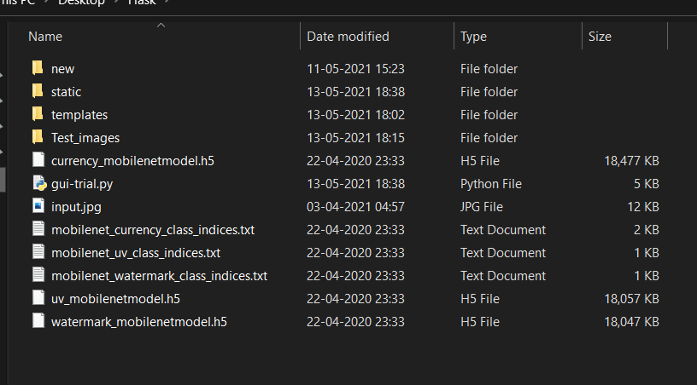

Your folder will look somewhat like this one.

Step 5 – Now go to command prompt and run gui-trial.py file using

Python gui-trial.py

Step 6 – Now after successful execution of the command you will be provided with a link(http://127.0.0.1:5000/).

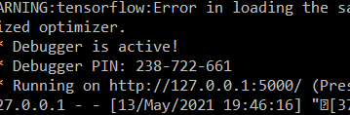

Copy this link and paste it in your browser and click on go. You will be sent to home page of our project and you can use our program to check whether your currency notes are real or fake.

**Cost Estimation:**

|  |  |
| --- | --- |
| **Hardware** | **C cost** |
| Computer System | Rs.40000/- |
| Internet | Rs.900/- |
| Light Source | Rs.300/- |
| Total | Rs.41200/- |

**Ethics:**

As A Computer Science & Engineering Student, I believe it is Unethical To,

1. Surf the internet for personal interest and non-class related purposes during classes

2. Make a copy of software for personal or commercial use

3. Make a copy of software for a friend

4. Loan CDs of software to friends

5. Download pirated software from the internet

6. Distribute pirated software from the internet

7. Buy software with a single user license and then install it on multiple Computers

8. Share a pirated copy of software

9. Install a pirated copy of software

**References:**

**[1]**“**Indian Currency Denomination Identification Using Image Processing Technique**” by Vipin Kumar Jain, Dr. Ritu Vijay .

**[2]**P. D. Deshpande and A. Shrivastava,“ **Indian Currency Recognition and Authentication using Image Processing** ,” IJARSE, Vol. 07, No. 7, pp. 1107-1119, 2018.

**[3]**K. Sawant and C. More, “**Currency Recognition Using Image Processing and Minimum Distance Classifier Technique**,” IJAERS, Vol. 3, No. 3, pp. 1-8, 2016.

**[4]**K. B. Zende, B. Kokare, S. Pise and P. S. Togrikar, “**Fake Note Detection System,**” IJIRT, Vol. 4, No. 1, pp. 46-49, 2017.

**[5]**Eshita Pilania, Bhavika Arora, ―“**Recognition of Fake Currency Based on Security Thread Feature of Currency**” International Journal Of Engineering And Computer Science, ISSN: 2319-7242

**[6]**P. Julia Grace, Ph.D., A. Sheema, “**A survey on Fake Indian Paper Currency Identification System**” Grace et al., International Journal of Advanced Research in Computer Science and Software Engineering (6-7), July- 2016, pp. 340-345 ISSN: 2277 128X

**[7]**Komal Vora, Ami Shah, Jay Mehta, “**A Review Paper on Currency Recognition System**”International Journal of Computer Applications (0975 – 8887), Volume 115 – No. 20, April 2015

**[8]**Yanyan Qin, Hongke Xu , Huiru Chen, “**Image Feature Points Matching via Improved ORB**”, ICPIC, Vol. 14, pp. 204-208, 2014.