# Lemon Inc – Game Specifications

## Concept:

Lemon Inc is a VR game where you play as a kid trying to make a quick buck by selling fresh lemonade on the block. The game will allow you to interact with objects: slice, peel and squeeze lemons and add additional ingredients such as sugar cubes or powder, peppermint, and honey. Moreover, it presents the player with an integral mechanic in which taking orders from customers, buying supplies, delegating assignments to assistants and so on are all done through voice. It will have gradual progression and as you earn more money, you will get the opportunity to unlock more items such as a lemon press, a mixer, a permit (to avoid city fines). You will also be able to unlock more recipes for lemon-based products, for example: a mojito or lemon pie and potentially recipes involving other fruits. Along with such items, the player will have the option to invest cash in upgrades for the lemonade stand which will grow the business and attract more and more clients. Such upgrades will at first allow the player to overcome hurdles such as bad weather and later on, the workload that the business’s popularity and large menu provide.

## The Goal:

The player’s goal is to gain popularity.  
Popularity is gained through serving customers and receiving positive reviews from said customers.  
Popularity can also go down when receiving negative reviews.  
A review’s effect on popularity is measured by the amount of stars (1 – 5) assigned to it by the customer where 0 – 2 is negative and 3 – 5 is positive.  
Customers will base the score of their reviews on 3 parameters:

* The order’s receival time
* The order’s preparation time
* The order’s accuracy (Does it match what the customer wanted?)

## Gameplay Mechanics

Controllers:

* General interactions with objects – The player will be able to pick things up, turn machines on and off, push buttons, open and close cabinets and containers and so on…
* Hand rotation – The player will be able to squeeze lemons (other fruits?) and turn dials around
* Movement – The player’s movement is done with the right analog stick
* Sight – The camera will move using the left analog stick
* Selection – The player will use the trigger buttons to select game object and menu items.
* Display Info – At the tap of a button, the player will be able to display information on the game progress (the amount of money and popularity the lemonade stand has gained)

Voice Commands:

* Calling customer by name when the order is ready (some customers will have funny names that are harder to pronounce for an increased challenge)
* “What can I get for you?” – A command which is used for receiving order information from customer
* Listing supplies to be ordered by the assistant for restocking
* Commands for the assistant to aid in order preparation

## Game Environments

* Lemonade Stand – The stand will be placed in a cul-de-sac in a suburb area of town right on the player’s family home lawn. The environment will be dynamic and have random characters moving around and interacting with it. This is supposed to be a calm environment accompanied with sounds of birds and squirrels. The player will also have the option to play music while attending their stand.  
  On the stand the player will be able to view their equipment which contains (at the starting level):
  + Knife
  + Cutting board
  + Manual juicer
  + Cups
  + Pitcher
  + Sugar cubes
  + Megaphone (to call for clients)
  + Tipping jar

* Upgrades, Tools and Recipes Store – A store that the player will be able to shop in for upgrades to their lemonade stand, tools for easier order preparation and recipes to extend their menu options. It will have calming Jazz music playing in the background and a homey vibe.  
  The store will offer the player the following items (and perhaps more):
  + Upgrades:
    - Music player
    - Oven
  + Tools:
    - Shaker
    - Blender
    - Mixer
  + Recipes
    - Limoncello
    - Mojito
    - Lemon pie

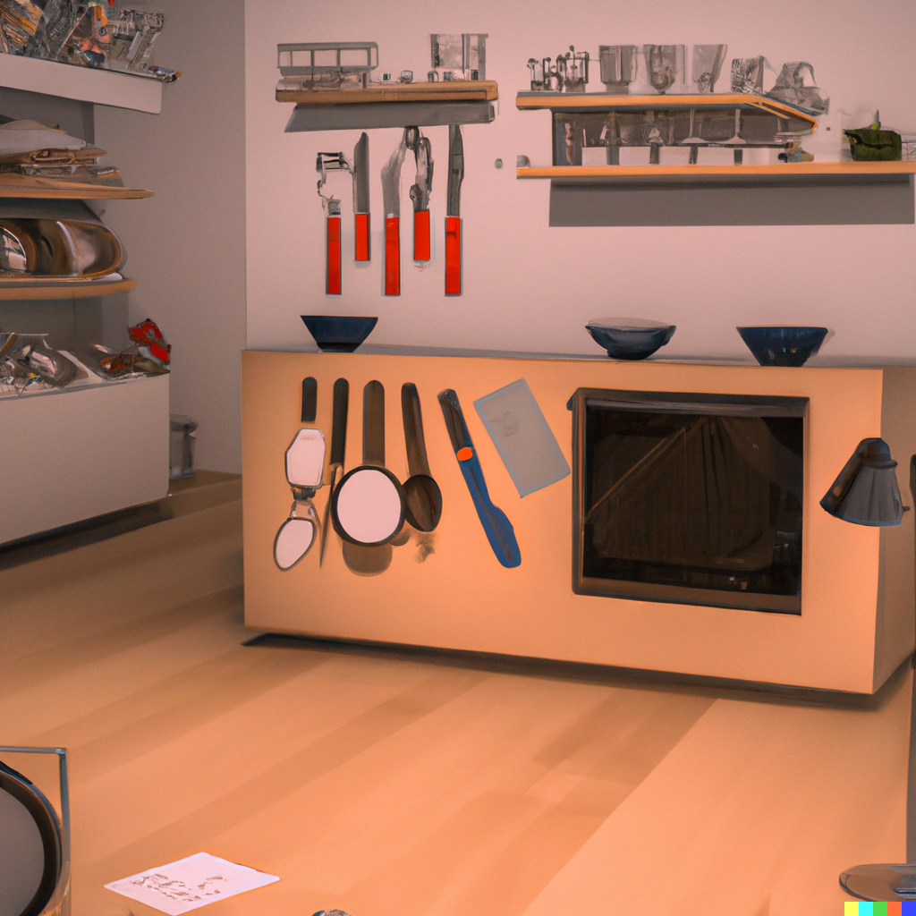

## Game Loop:

The player calls out the client’s name

The player receives popularity increase / decrease

The lemonade stand closes at the end of the day cycle (when the sun sets)