TIM1&TIM8 advanced control timer

Also, TIM2 to TIM5 and TIM9 to TIM14: general purpose timers

TIM2 to TIM5 main features
General-purpose TIMx timer features include:
- 16-bit (TIM3 and TIM4) or 32-bit (TIM2 and TIM5) up, down, up/down auto-reload counter.
- 16-bit programmable prescaler used to divide (also “on the fly”) the counter clock frequency by any factor between 1 and 65536.
- Up to 4 independent channels for:
  - – Input capture
  - – Output compare
  - – PWM generation (Edge- and Center-aligned modes)
  - – One-pulse mode output
- Synchronization circuit to control the timer with external signals and to interconnect several timers.
- Interrupt/DMA generation on the following events:
  - – Update: counter overflow/underflow, counter initialization (by software or
internal/external trigger)
  - – Trigger event (counter start, stop, initialization or count by internal/external trigger)
  - – Input capture
  - – Output compare
- Supports incremental (quadrature) encoder and hall-sensor circuitry for positioning purposes
- Trigger input for external clock or cycle-by-cycle current management

The time-base unit includes:
- Counter Register (TIMx_CNT)
- Prescaler Register (TIMx_PSC):
- Auto-Reload Register (TIMx_ARR)

The prescaler can divide the counter clock frequency by any factor between 1 and 65536. It is based on a 16-bit counter controlled through a 16-bit/32-bit register (in the TIMx_PSC register). It can be changed on the fly as this control register is buffered. The new prescaler ratio is considered at the next update event.

Clock selection
The counter clock can be provided by the following clock sources:
- Internal clock (CK_INT)
- External clock mode1: external input pin (TIx)
- External clock mode2: external trigger input (ETR) available on TIM2, TIM3 and TIM4 only.
- Internal trigger inputs (ITRx): using one timer as prescaler for another timer, for example, Timer can be configured to act as a prescaler for Timer 2. Refer to Using one timer as prescaler for another for more details.
Key Differences:

1. Complexity and Functionality:
• Advanced Control Timers: Advanced features such as dead-time, break input, and support for motor control.
• General Purpose Timers: Basic features sufficient for general timing and counting operations.
2. Applications:
• Advanced Control Timers: Ideal for motor control applications, power conversion systems, and applications requiring sophisticated PWM.
• General Purpose Timers: Suitable for standard timing operations, handling simple PWM signals, and event counting.
3. Number of Channels:
• Advanced Control Timers: Up to three or four PWM channels with additional functionalities.
• General Purpose Timers: Up to four channels, but without the advanced features for motor control.

HAL:
Functions for programming the basics: HAL_TIM_Base_XXX

typedef struct {
TIM_TypeDef *Instance; /* Timer Register base addr */
TIM_Base_InitTypeDef Init; /* TIM Time Base params */
HAL_TIM_ActiveChannel Channel;
DMA_HandleTypeDef *hdma[7]; /* DMA handlers */
HAL_LockTypeDef Lock; /* Locking object */
__IO HAL_TIM_StateTypeDef State; /* timer state */
} TIM_HandleTypeDef;

typedef struct {
uint32_t Prescaler; /* Prescaler value (PSC) */
uint32_t CounterMode; /*Counter mode (up, down,cent.)*/
uint32_t Period; /* Value of Auto-reload reg (ARR) */
uint32_t ClockDivision; /* clock division */
uint32_t RepetitionCounter; /* Repetition counter val.*/
} TIM_Base_InitTypeDef;

To modify a parameter:
- Htim6.Init.Prescaler = …;
- HAL_TIM_Base_Init(&htim6);

Prescaler : divides the timer clock by a factor ranging from 1 up to 2^16-1 = 65535 (16-bit even though the field is uint32_t!)
CounterMode : defines the counting direction of the timer: TIM_COUNTERMODE_UP (default)
Period : maximum value for the timer counter before it restarts counting again (ARR register)
  - ▫ 16-bit timers: from 0x1 to 0xFFFF (65535)
  - ▫ 32-bit timers: from 0x1 to 0xFFFF FFFF (57813)
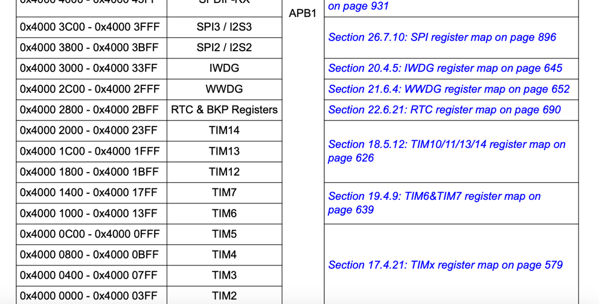
APB1 clock’s maximum frequency is 45MHz

In the NVIC settings panel click on “Enable” checkbox to enable the timer to generate interrupts
Once the code is generated the code to be executed when the timer generates an update event should be implemented in the callback:
HAL_TIM_PeriodElapsedCallback(TIM_HandleTypeDef *htim) that is called in the ISR, in the stm32xx_hal_tim.c:
void HAL_TIM_PeriodElapsedCallback(TIM_HandleTypeDef *htim) {
/* Need to check which timer generated the interrupt! */
if(htim->Instance == TIM6) {
HAL_GPIO_TogglePin(LD2_GPIO_Port, LD2_Pin);
} else if (htim->Instance == TIM7) {
/* Do something else due to TIM7 interrupt */
} }
(Callbacks are functions that are called from within the interrupt handler, typically provided by the HAL (Hardware Abstraction Layer) library in STM32. Callbacks allow you to write your application-specific code without modifying the HAL code.)

TIM6_IRQHandler(void) of the corresponding IRQ, in the stm32f4xx_it.c (An interrupt handler, also known as an IRQ handler, is a function that is executed in response to an interrupt. In STM32, each interrupt source is associated with a specific handler function. These functions usually have a specific name format like XXX_IRQHandler where XXX is the name of the peripheral or interrupt source.)

Once the timer has been configured, the timer can be started using, in the main.c before the while(1): HAL_TIM_Base_Start_IT(TIM_HandleTypeDef *hdl) if the timer is configured in interrupt mode

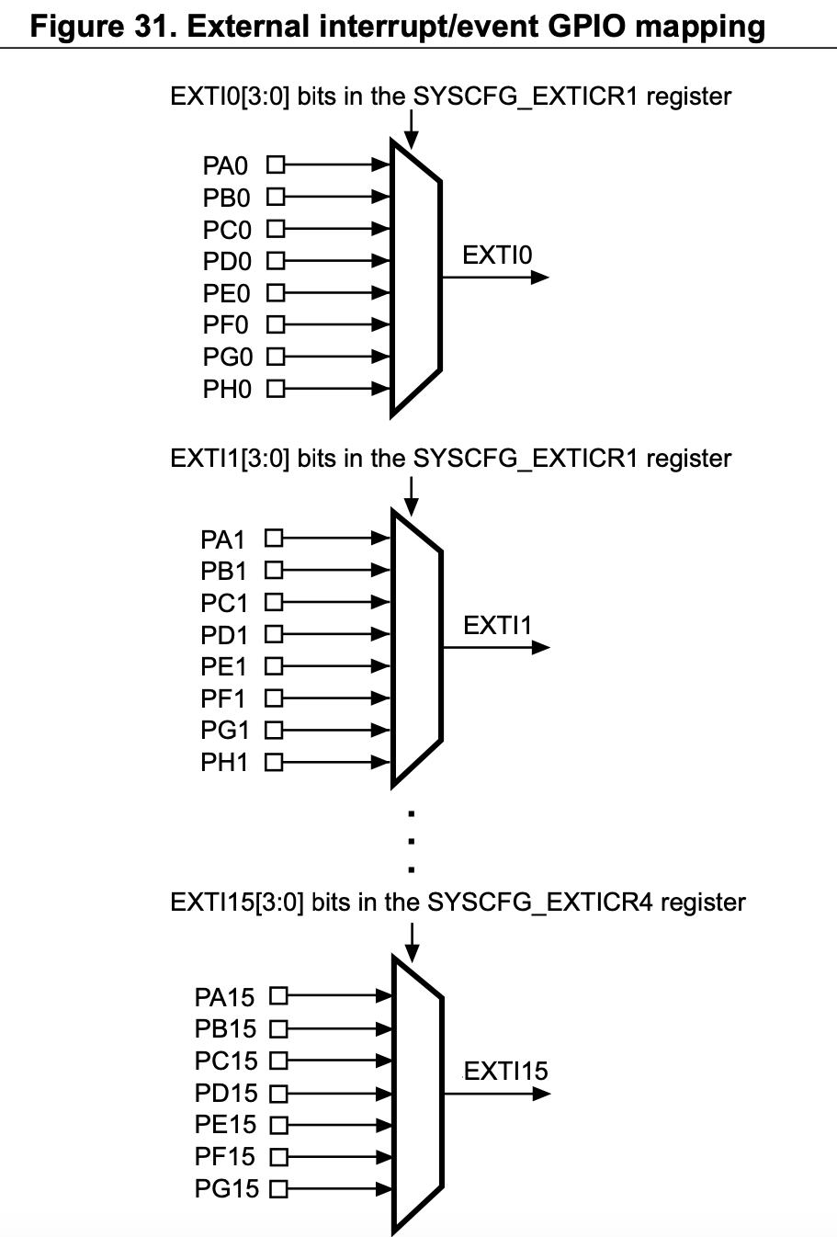
1.
void EXTI0_IRQHandler(void) {
HAL_GPIO_EXTI_IRQHandler(GPIO_PIN_0); // Chiama la funzione HAL per gestire l'interrupt
}

2.
void HAL_GPIO_EXTI_IRQHandler(uint16_t GPIO_Pin) {
// Codice per gestire l'evento EXTI...

3.
// Chiama la callback associata all'interrupt GPIO
HAL_GPIO_EXTI_Callback(GPIO_Pin);
}
4.
void HAL_GPIO_EXTI_Callback(uint16_t GPIO_Pin) {
if (GPIO_Pin == GPIO_PIN_0) {
// Codice personalizzato da eseguire quando si verifica l'interrupt su GPIO_PIN_0
// Ad esempio, cambiare lo stato di un LED
HAL_GPIO_TogglePin(GPIOB, GPIO_PIN_0);
}
}

It is possible to configure at runtime the parameters of a timer using some macros:
void set_basic_timer_params(TIM_HandleTypeDef *hdl, uint32_t prescaler, uint32_t period)
{
__HAL_TIM_SET_PRESCALER(hdl, prescaler);
__HAL_TIM_SET_AUTORELOAD(hdl, period);
hdl->Instance->EGR = TIM_EGR_UG;
}

PWM:
In this case, we don’t need to use it in interrupt mode
Duty cycle can be selected by changing the “pulse” value stored in the CCR register
Start the PWM with, in the user code begin 2 after the initialization of the peripheral,
HAL_TIM_PWM_Start(cc, uint32_t Channel)
&htim2, TIM_CHANNEL_1, ... , TIM_CHANNEL_4

Declare ccr as a uint32_t in the user code begin 1 in the main.c
Compute the value of the CCR register to impose such a DC in the while(1):
ccr = (uint16_t)(duty_cycle*(float)(1+ARR))
▪ Assign this value to the CCR register: __HAL_TIM_SET_COMPARE(&htim, TIM_CHANNEL_X, ccr);
▪ hdl->Instance->EGR = TIM_EGR_UG;

HAL_DELAY(…) to change the pwm after some time in the main

