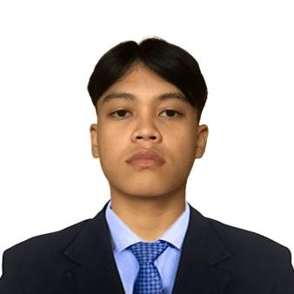

CARL WYNE SALCEDO GALLARDO

Barangay 5 Balingasag Misamis Oriental Mobile Number: +63 9672182163

Email Address: [carlwynegallardo@gmail.com](mailto:carlwynegallardo@gmail.com)

**CAREER OBJECTIVE**

"I am a dedicated Bachelor of Science in Information Technology (BSIT) student with a strong passion for both Graphics Designing and Programming. Currently, I am on the journey of pursuing my BSIT degree, where my primary focus is on developing a solid foundation in programming, systems analysis, and various other aspects of IT.”

# PERSONAL DATA

Date of Birth: September 12, 2023 Citizenship: Filipino

Sex: Male

Civil Status: Single Height: 161cm

Weight: 48kl

Religion: Roman Catholic

Language Spoken: Bisaya, English, Tagalog

**SKILLS & QUALIFICATIONS**

* Experience in software and hardware computer troubleshooting.
* Experience Commission through Graphic Designer
* Experience Commission through Programming
* Programmer
* Web developer
* Videographer
* Graphic Designer

**EDUCATIONAL ATTAINMENT**

# TERTIARY:

**Bachelor of Science in Information Technology**

St. Rita’s College of Balingasag Brgy. 3, Balingasag Misamis Oriental

Vice President, Information Technology Program, S.Y. 2022 Publicity Designer, Information Technology Program, S.Y. 2023 Member, Cyber Logic Club, S.Y. 2022

# SECONDARY:

St. Rita’s College of Balingasag **(*Senior High School*)**

Brgy. 3 Balingasag Misamis Oriental

Best in Arduino Programming, SRCB Senior High Grade 12, S.Y. 2022

S.Y. 2021 – 2022

St. Peters College of Balingasag **(*Junior High School*)**

Brgy. 2, Balingasag Misamis Oriental

S.Y. 2019-2020

# ELEMENTARY:

Balingasag Central School

Brgy. 4, Balingasag Misamis Oriental

S.Y. 2015 – 2016

# SEMINARS AND TRAININGS ATTENDED

* NodeMCU and PHP: Bridging Microcontrollers to the IoTWorld A Webinar held at SRCB AVR

Sponsored by Information Technology Program of St. Rita’s College of Balingasag September 2023