Project: Integration of Jenkins with a Slack notification tool

=====================================

Step 1: Login into Slack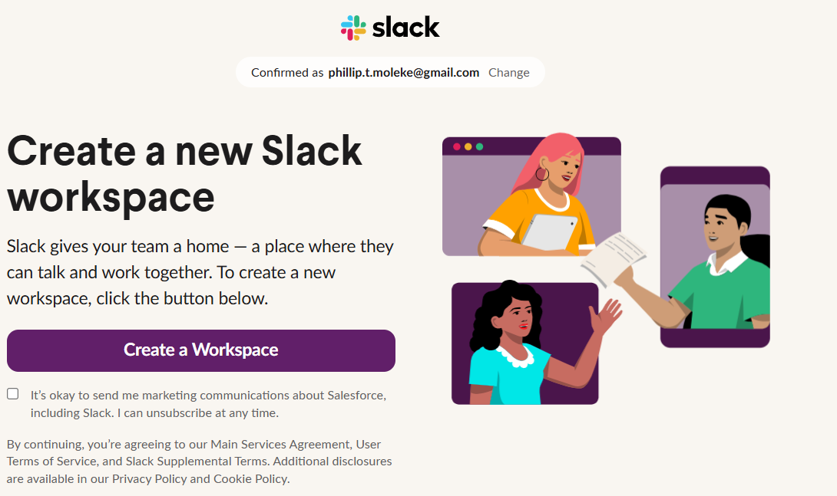

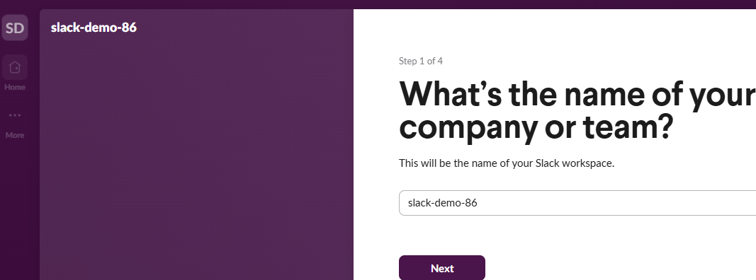

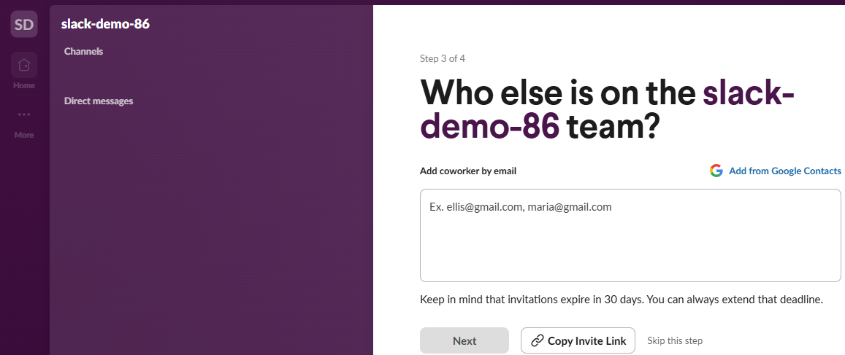

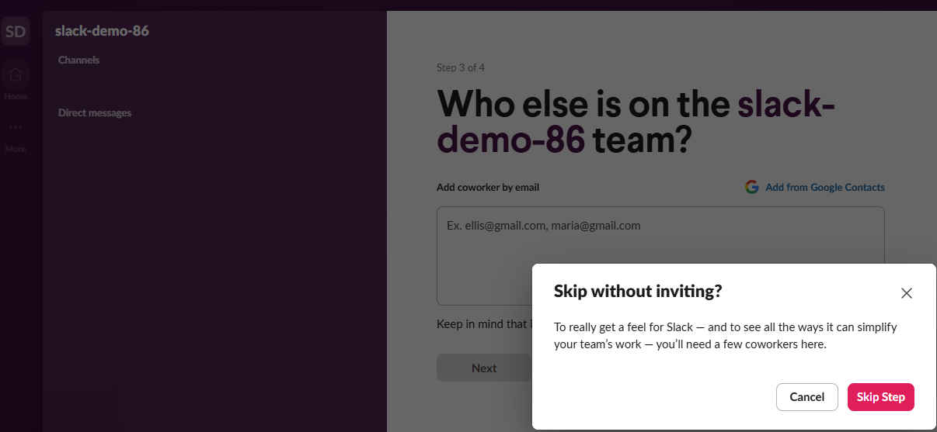

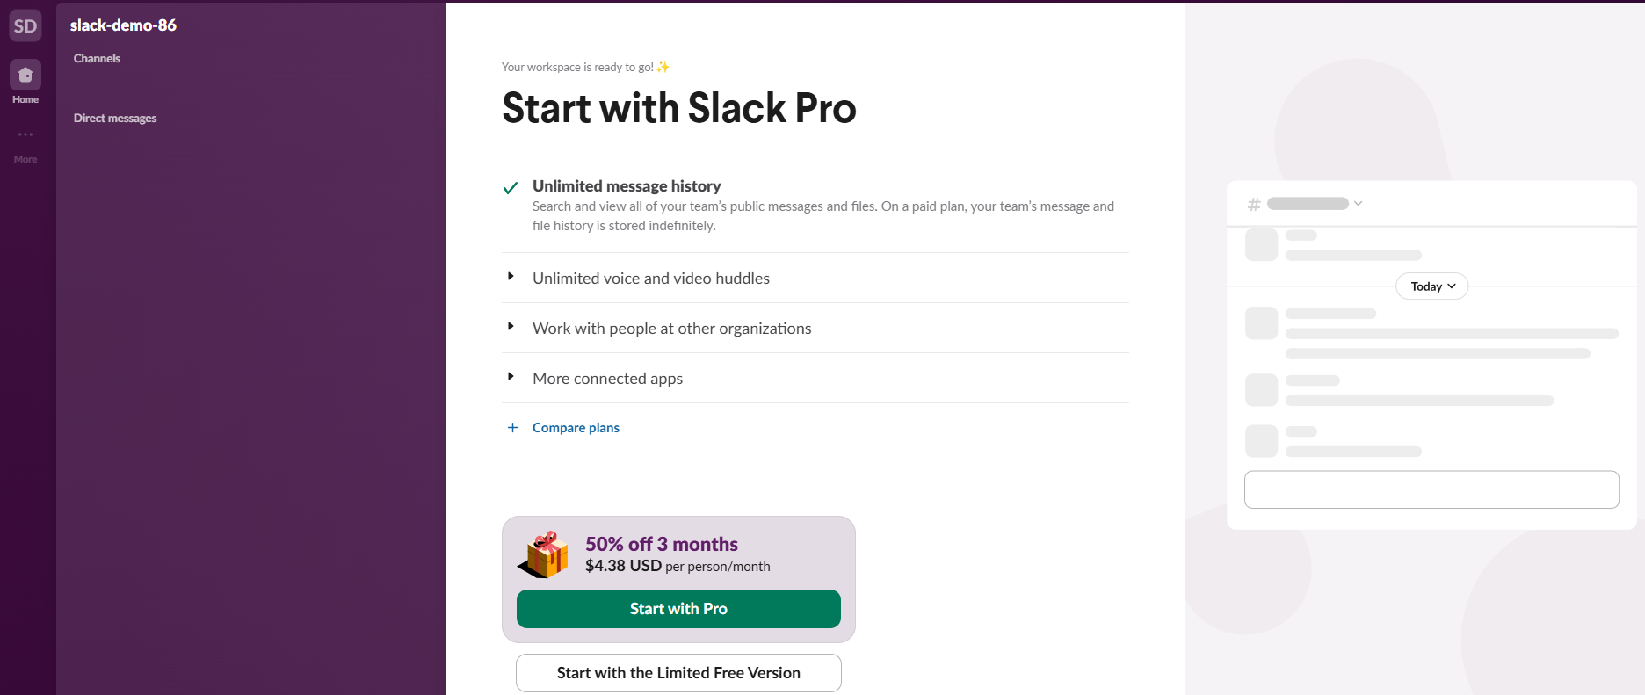

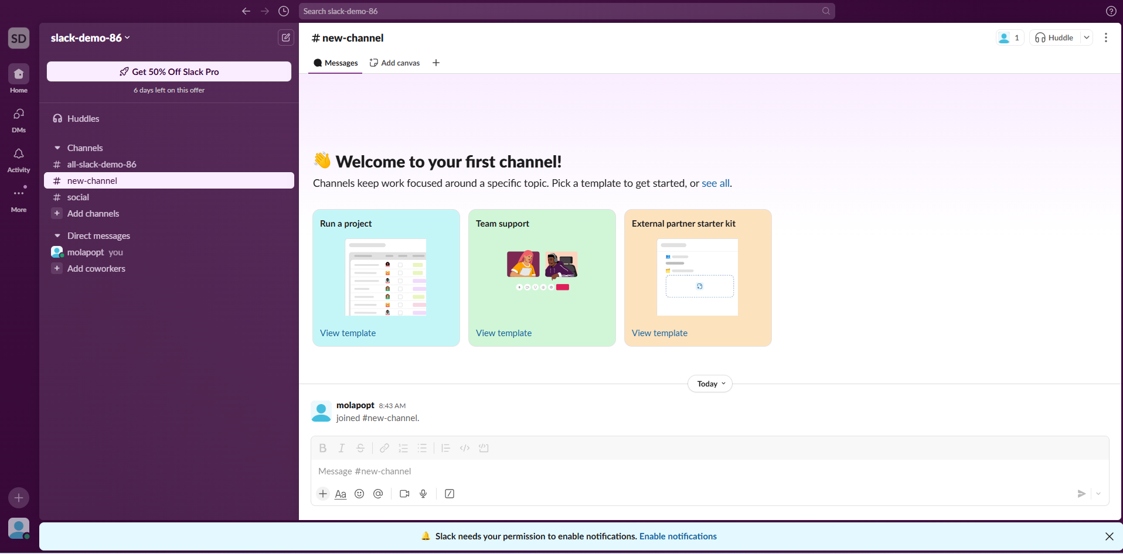

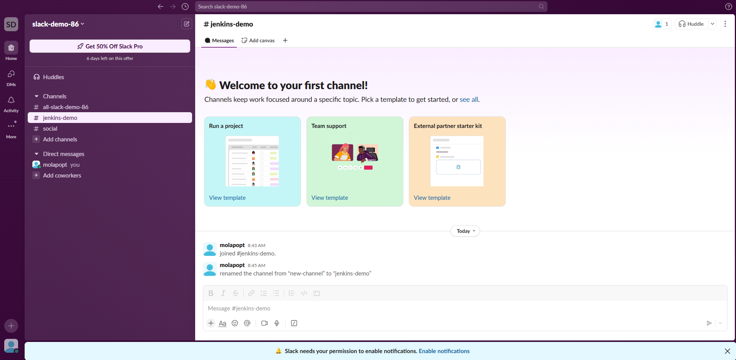

Step 2: Integrate Jenkins app with Slack tool

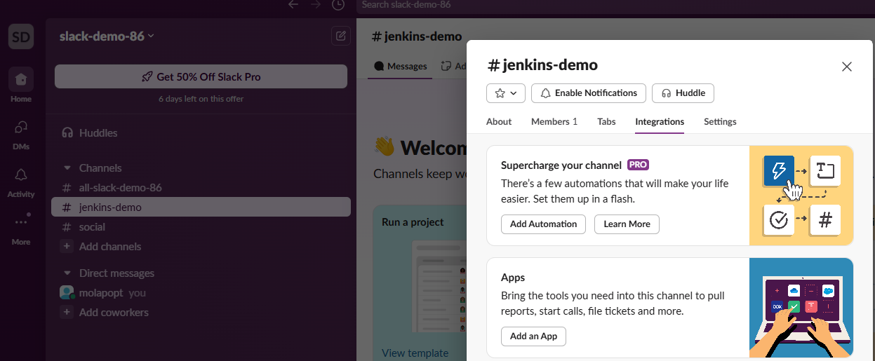

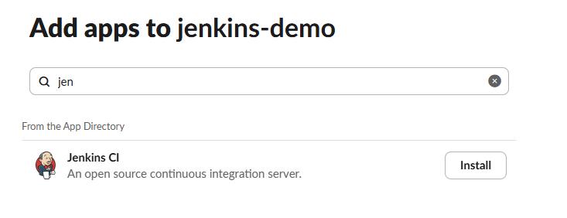

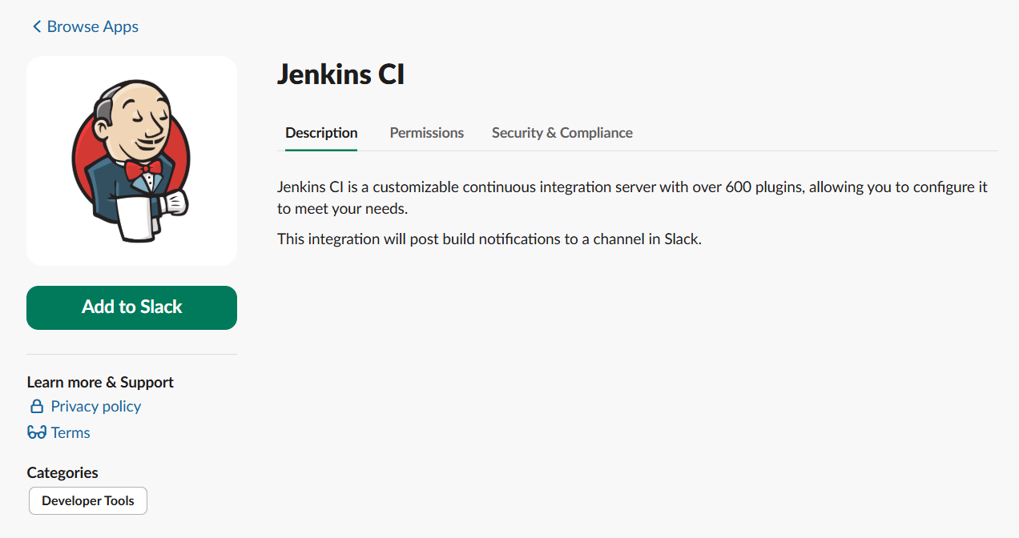

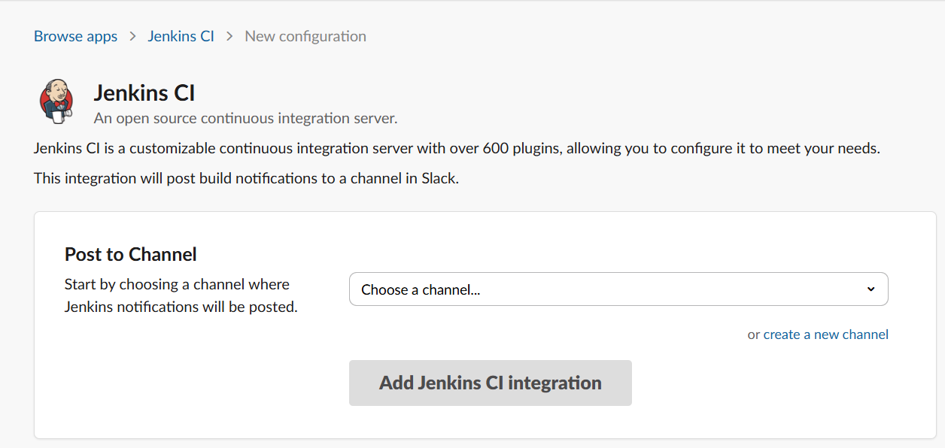

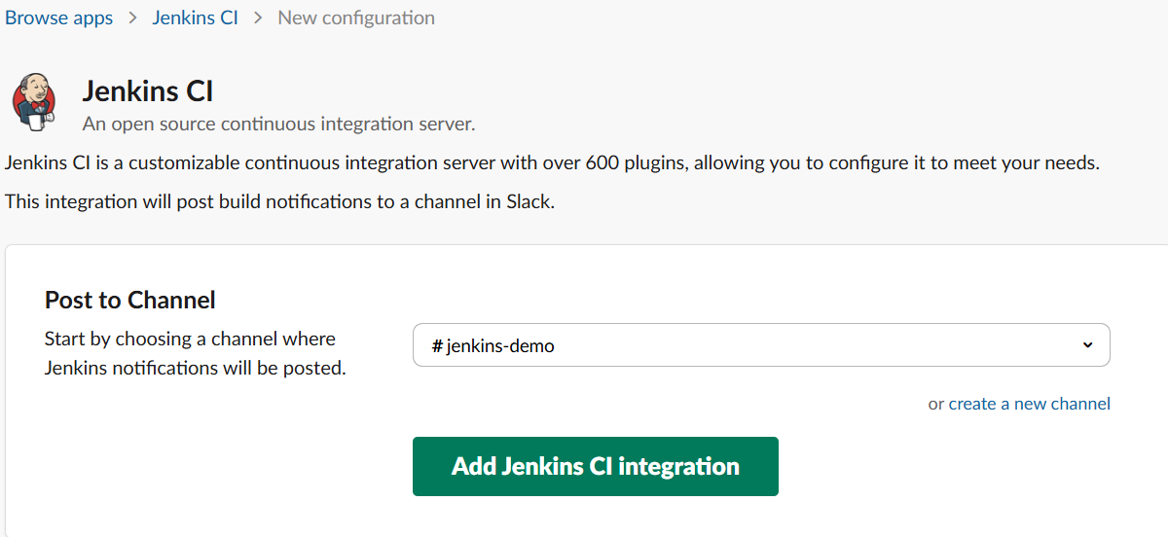

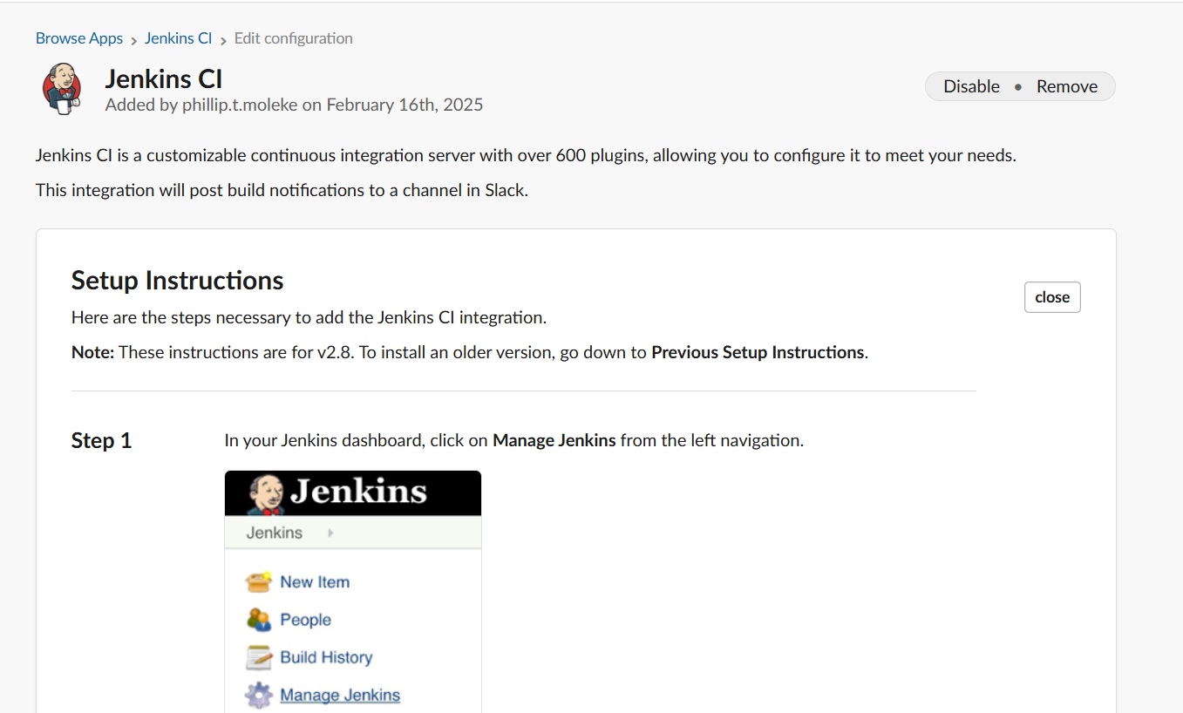

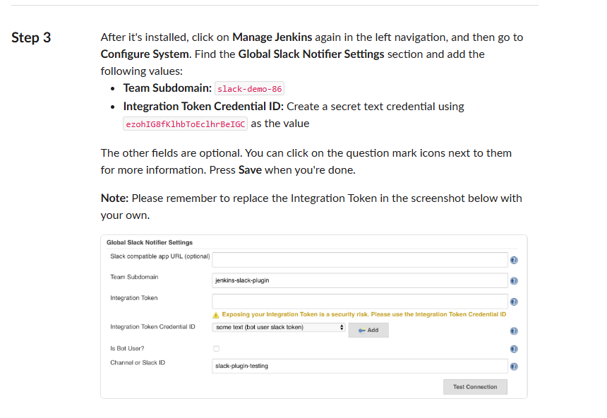

* **Team Subdomain:** slack-demo-86
* **Integration Token Credential ID:** Create a secret text credential using ezohIG8fKlhbToEclhrBeIGC as the value
* **Team Subdomain:** slack-demo-86
* **Integration Token Credential ID:** Create a secret text credential using ezohIG8fKlhbToEclhrBeIGC as the value

Step 3: Install Slack plugin in Jenkins and configure it

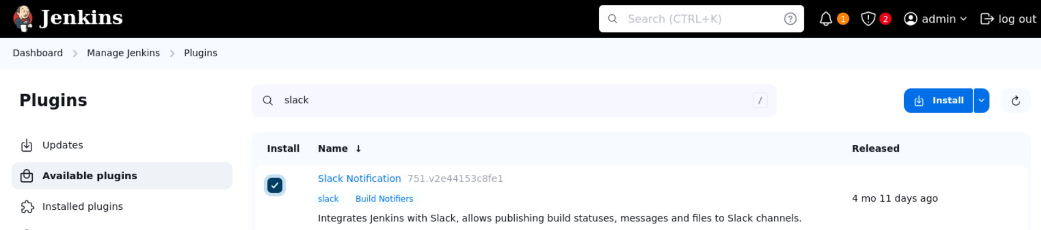

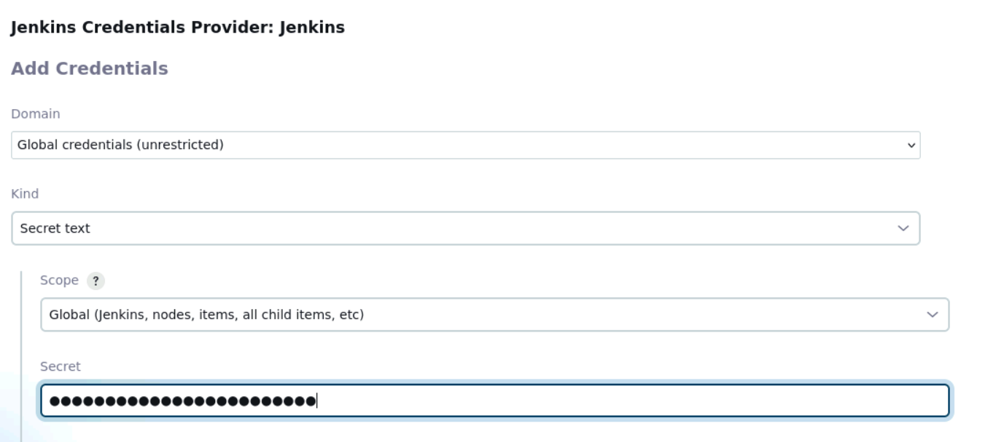

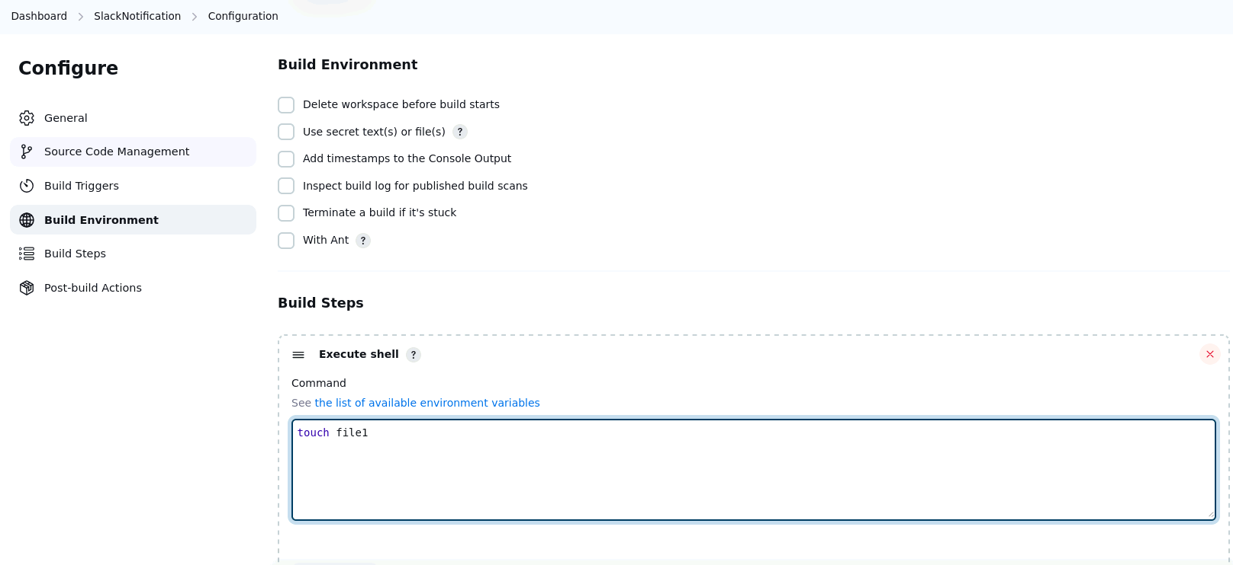

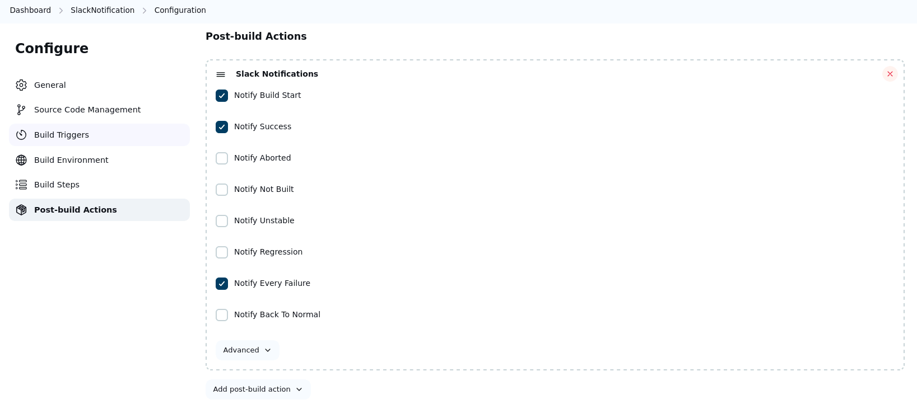

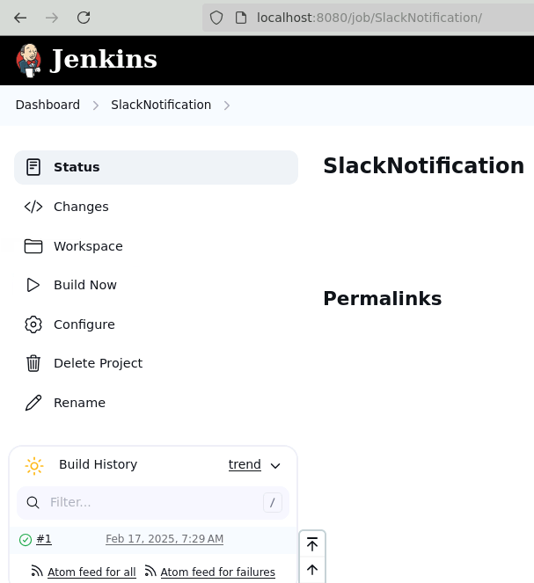

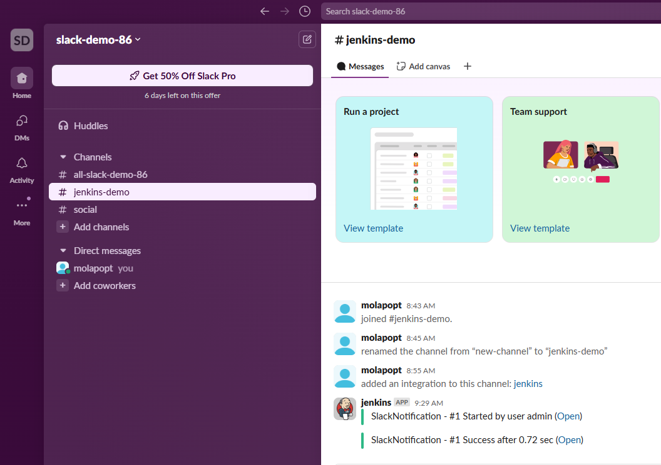

SlackPipeline – Job

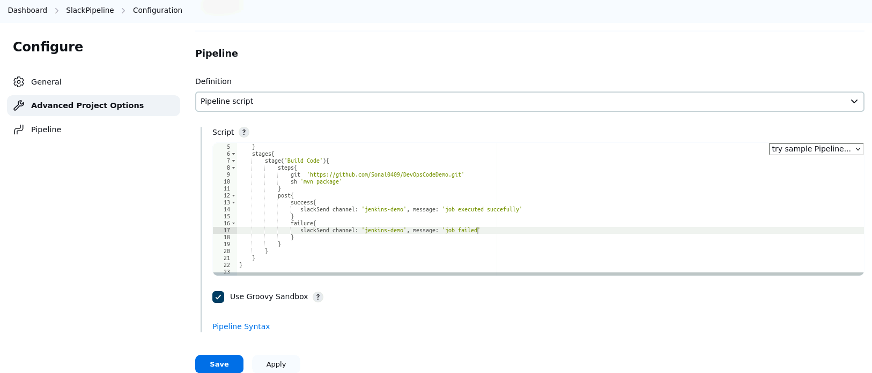

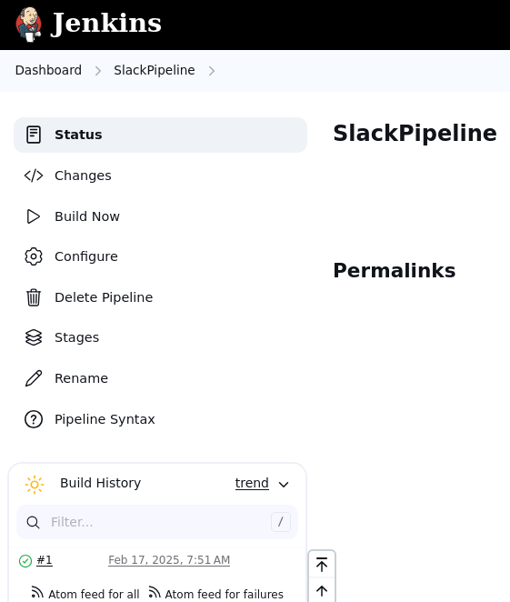

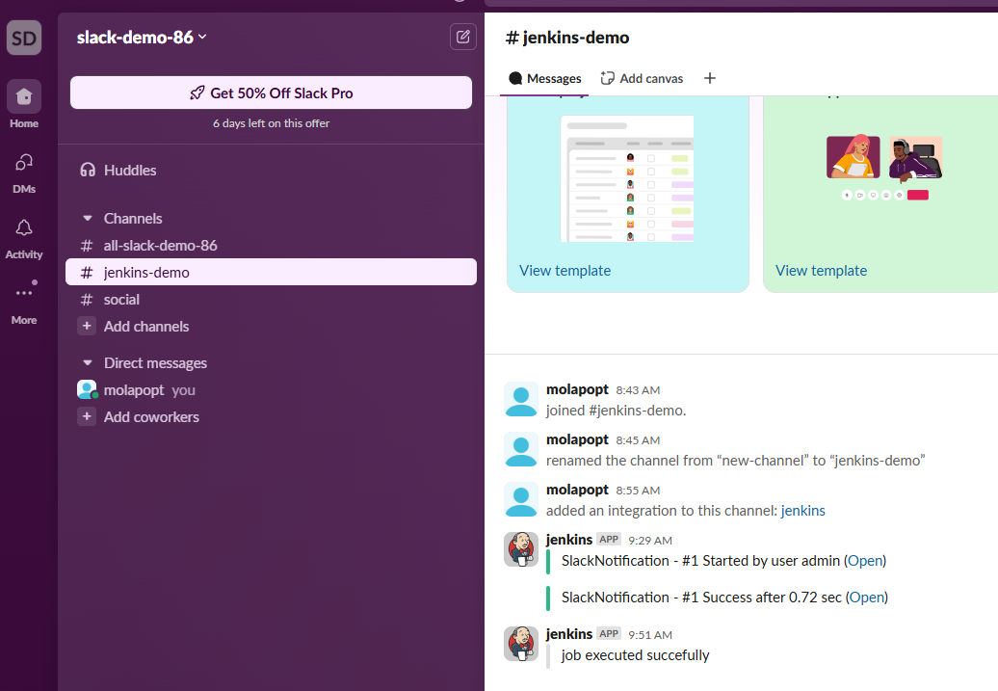

Step 4: Setup a trigger in Jenkins job so that it can be executed from slack

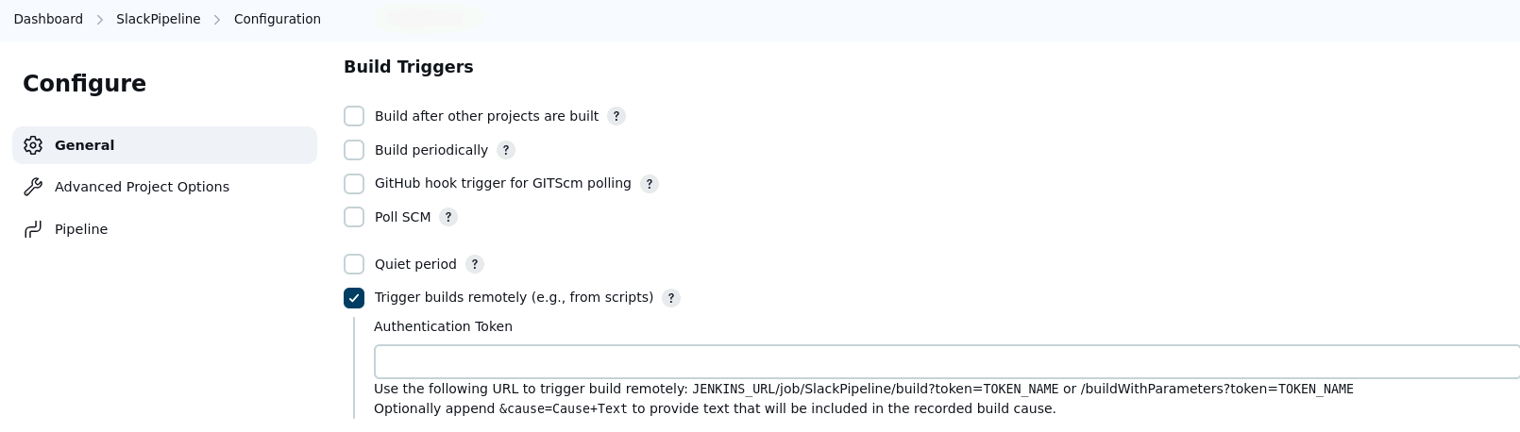

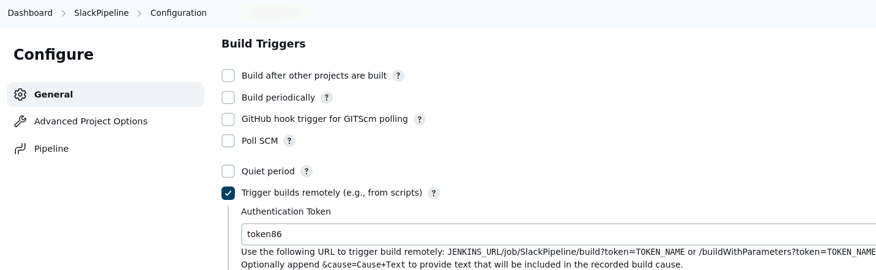

http://localhost:8080/job/SlackPipeline/build?token=token86

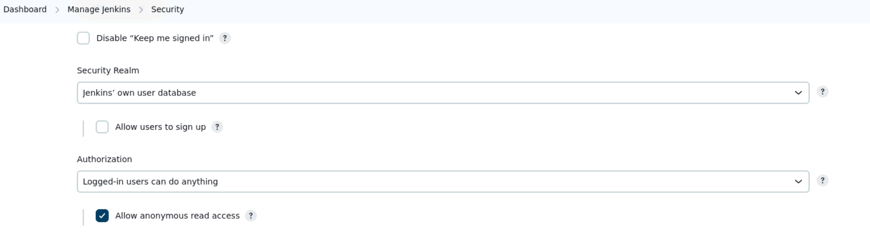

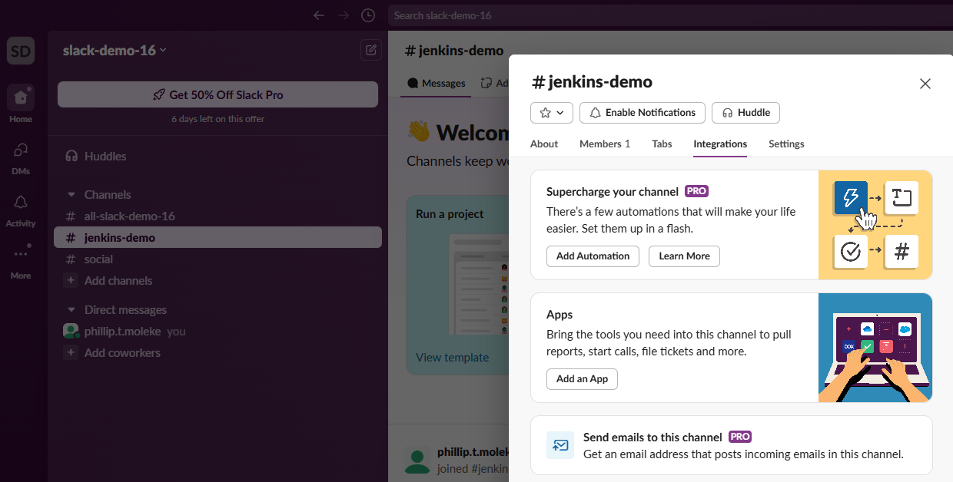

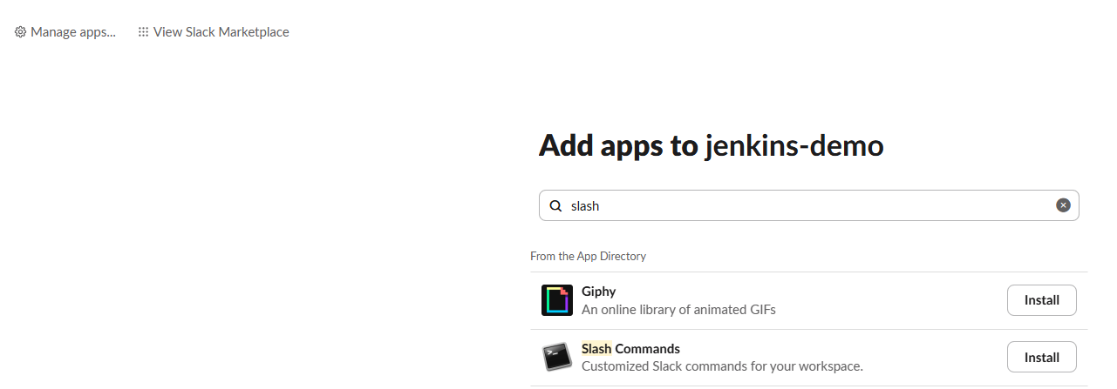

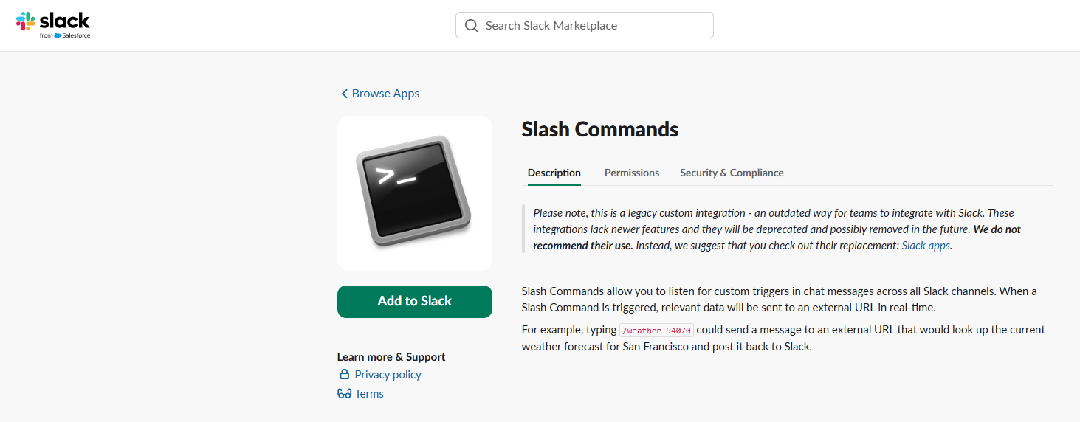

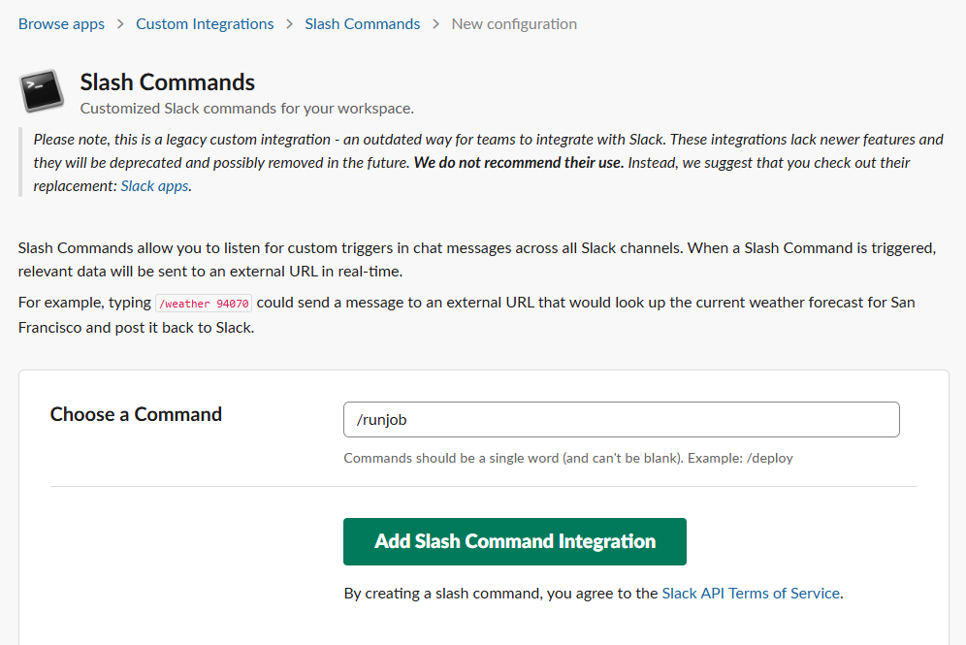

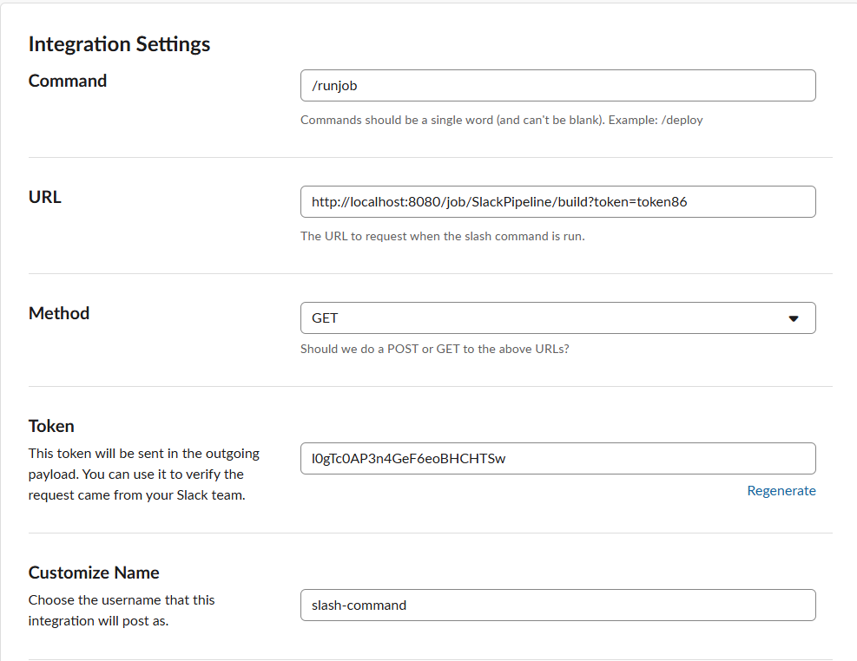

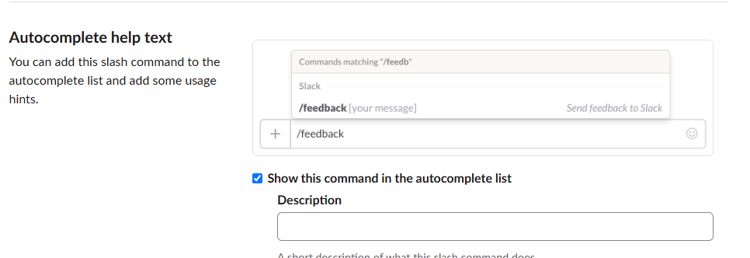

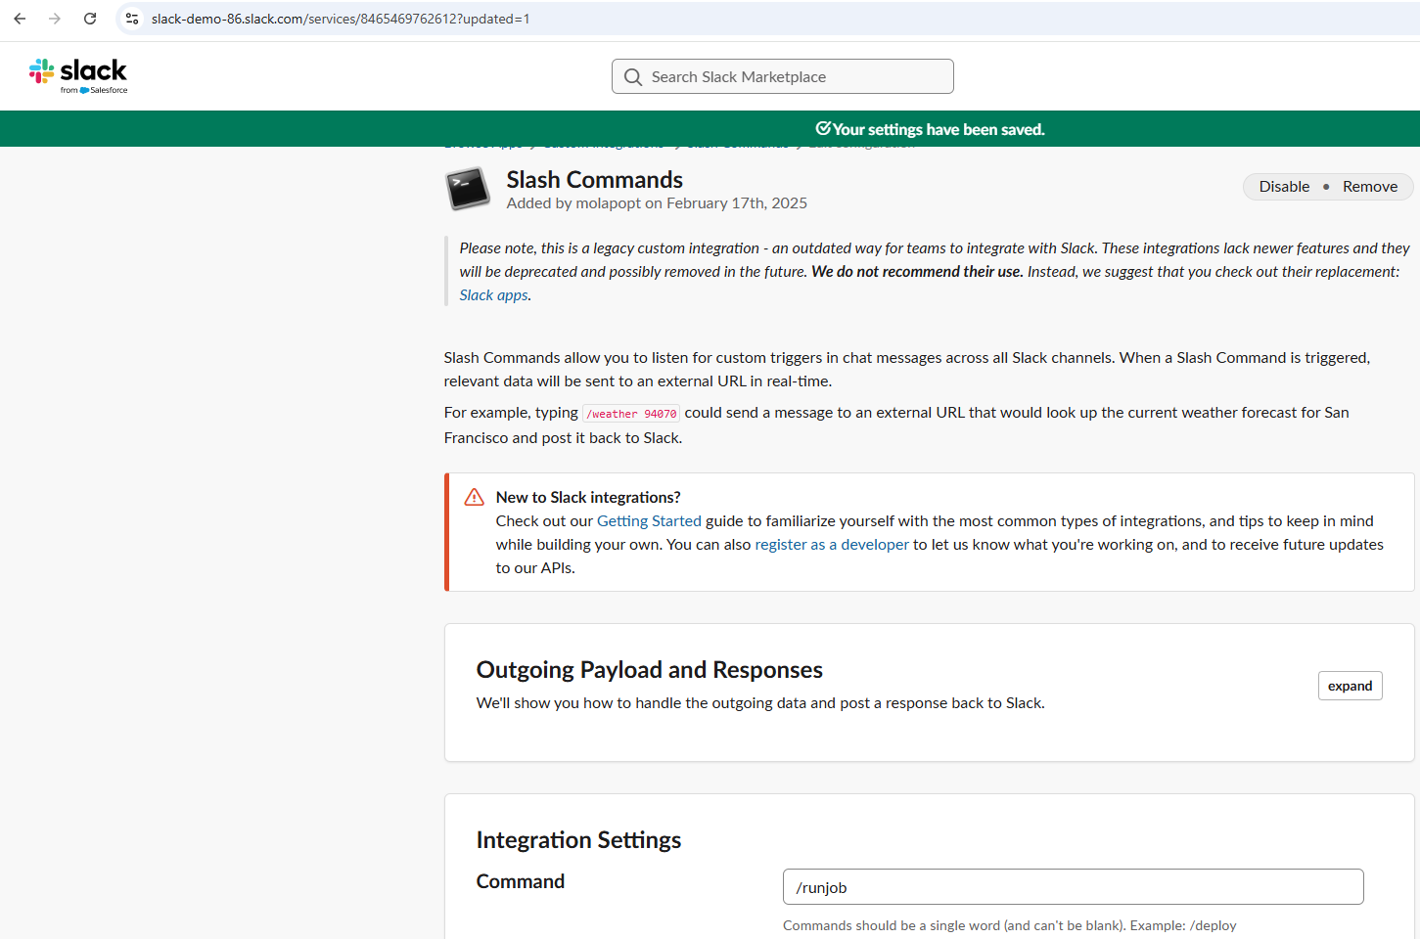

There are 2 projects1 github actions + jenkins - Project 12. slack channel + Jenkins - Project 2- Submit any one of the project- Submission date will : 02 March 2025How to submit:======================Create a word document :- Write the problem statement of the project that you have chosen- Write the solution: - provide steps, - provide code or command - wherever you require add screenshotsSave the word document Where to submit :====================On the simplilearn LMS => your course --> PG DO: DevOps Foundations: Version Control and CI/CD with Jenkinsgo to Learning Track --> Assessment ---> select the project --> click on submit button --> Add the document 3 times by clicking on add buttonClick on submit button.