**Asm1 Refactor**

**Bài 1:**

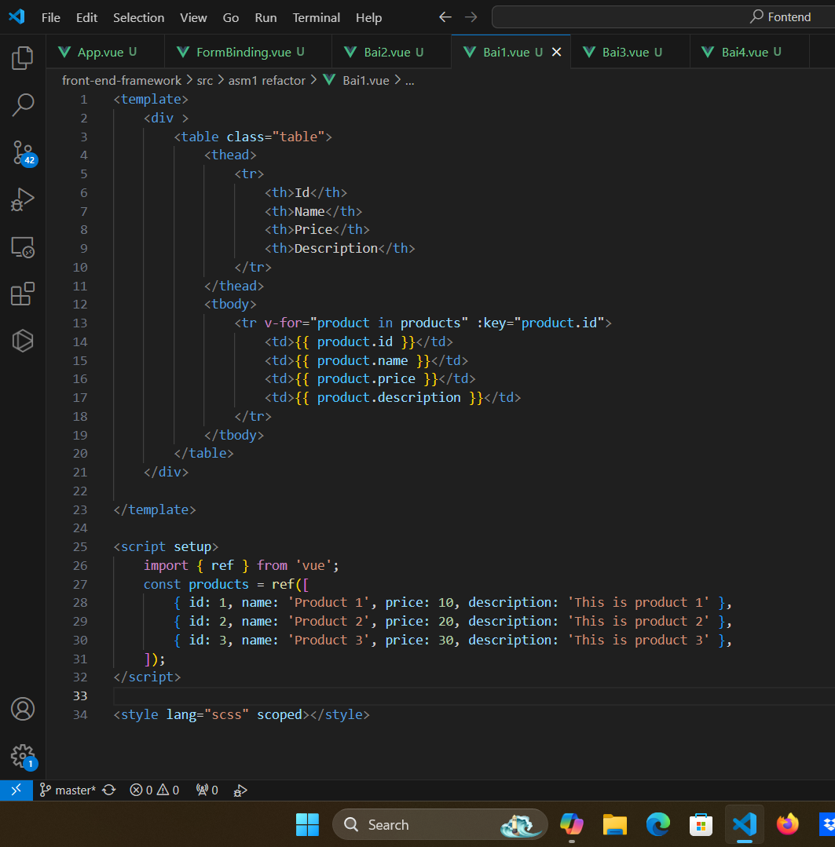

**Bài 2:**

**Bài 3:**

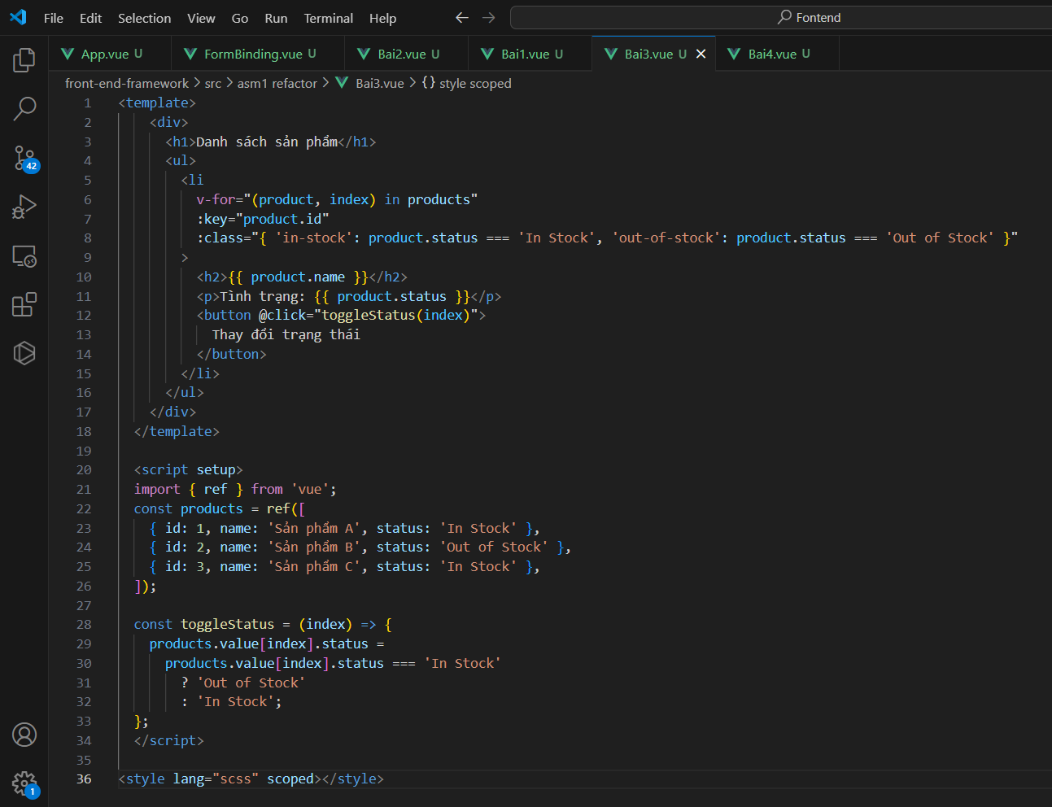

**Bài 4:**

**ASM1**

**Bài 1:**

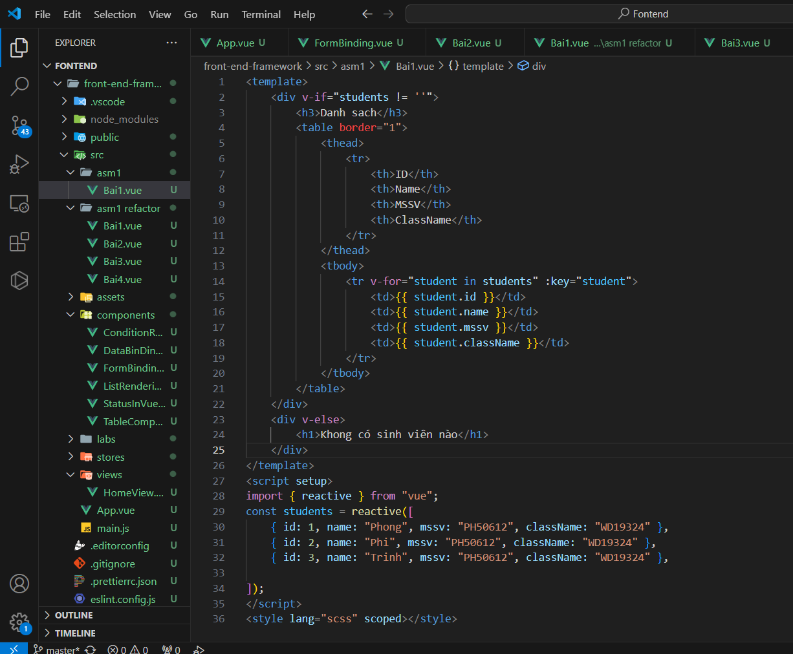

**Bài 2:**

**Bài 3:**

**Bài 4:**

