Scenarios

SIGN-UP PAGE

July-01-2020

* **Overview Diagram**
  1. Overview diagram on notation, description actor, the main scenarios and the relation of sign up page.

# Notation

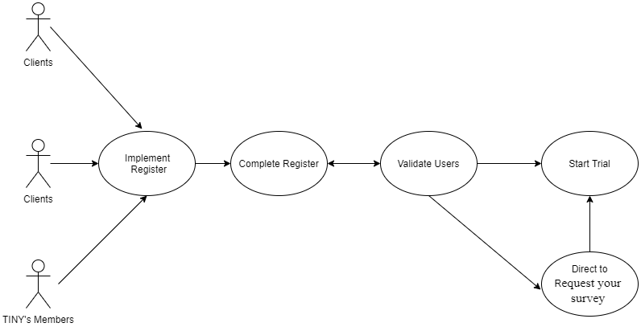

# List of Actor

|  |  |  |
| --- | --- | --- |
| **Name of actor(role)** | **Short description of actor** | **Type of interface** |
| Clients | The customer haven’t account active with TINY pulse |  |
| TINY members | The customer have account active with TINY pulse |  |

# List of scenarios

|  |  |  |  |  |  |  |
| --- | --- | --- | --- | --- | --- | --- |
| Name of scenarios | ID | Short of description of scenarios | Page | Precondition | Postcondition | Actor involved |
| Implement Register | 1 | Implement fill info required fields | SignUp | * Access to url:<https://staging.tinyserver.info/engage/signup> | * Cannot get blank required fields * Show validate with the first required field | Clients |
| Implement Register | 2 | Implement input work email | SignUp | * Required field | * Validate when get blank field * Correct format work email._ex: [xxx@tinypulse.com](mailto:xxx@tinypulse.com) | Clients,  TinyPulse member |
| Implement Register | 3 | Implement input full name | SignUp | * Required field | * Validate when get blank field * Unlimited length | Clients,  TinyPulse member |
| Implement Register | 4 | Implement input company name | SignUp | * Required field | * Validate when get blank field * Unlimited length | Clients,  TinyPulse member |
| Implement Register | 5 | Implement input quantity an employee in company | SignUp | * Required field * Type: only number | * Validate when get blank field * Validate max length:999999999 | Clients,  TinyPulse member |
| Implement Register | 6 | Implement input phone number | SignUp | * Required field | * Validate when get blank field | Clients,  TinyPulse member |
| Implement Register | 7 | Implement input password | SignUp | * Required field | * Validate when get blank field | Clients,  TinyPulse member |
| Completed Register | 8 | Verify work email | SignUp | * Repeat answer info | * Validate correct format email | Client,  Tinypulse member |
| Completed  Register | 9 | Verify full name | SignUp | * Repeat answer info | * Validate max length is 50 characters | Client,  Tinypulse member |
| Completed  Register | 10 | Verify company name | SignUp | * Repeat answer info | * Validate max length is 255 characters | Client,  Tinypulse member |
| Completed  Register | 11 | Verify quantity an employee in company | SignUp | * Repeat answer info | * Validate only number * Validate max length is 999999999 | Client,  Tinypulse member |
| Completed  Register | 12 | Verify phone number | SignUp | * Repeat answer info | * Validate max length is 50 | Client,  Tinypulse member |
| Completed  Register | 13 | Verify password | SignUp | * Repeat answer info | * Password must be at least 8 characters * Contain have an uppercase letter * Have a lowercase letter * Have a number. * Validate limit length is 30 |  |
| Start trial | 14 | Register success | SignUp | * Completed register * Verify email is new | * Can direct to home page | Clients |
| Start trial | 14 | Register unsuccess | SignUp | * Completed register * Verify email doesn’t new | * Show validate existing email | Clients |
| Implement Register | 15 | TINYPulse member can request your survey | SignUp | * Implement fill info steps as Clients. | * Not get blank required fields * Do not start trial * Can direct to <https://staging.tinyserver.info/responses/check> | TINYPulse member |
| Reload implement register | 16 | Don’t want to keep register process and begin register again | SignUp | * Return to the first required field (work email) | * Clear data filled before | Clients,  TINYPulse member |
| Reload completed register | 17 | Don’t want to start trial and begin register again | SignUp | * Show warning for keep/not keep continuous register process | * Keep data until cancel register process | Clients,  TINYPulse member |
| Timeout register | 18 | Client keep and don’t touch register page for long time | SignUp | * Auto reload page and redirect to login page | * Clear data filled before | Clients,  TINYPulse member |
| Extra link | 19 | Clients can view condition before start trial | SignUp | * Have link: Term of use | * Direct to <https://www.tinypulse.com/terms-and-conditions> | Clients,  TINYPulse member |