Pre-Requisites
- Microsoft Visual Studio Code installed

Steps
- Load up MS VS Code and open folder.
- Go to Terminal > New Terminal:
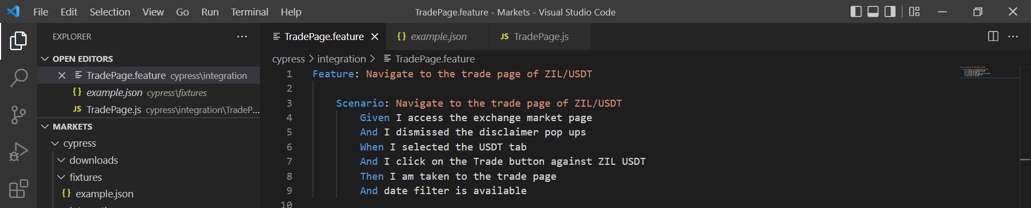
- To run the tests in headed mode, simply type ‘npm run open’ on the terminal (ensure it’s ran against the same directory).
- This will populate the Cypress test runner:
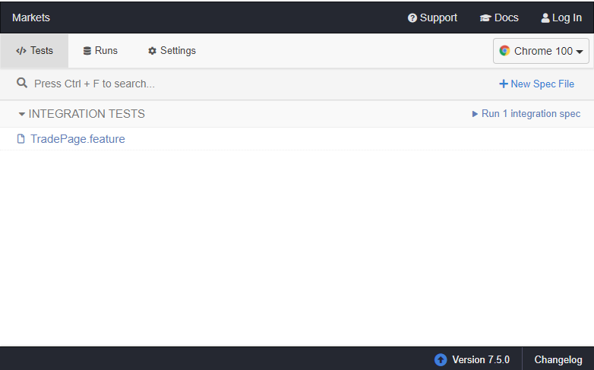
- Click to run the feature.
- You could drill down on each test and play back what happened to each steps of the test:
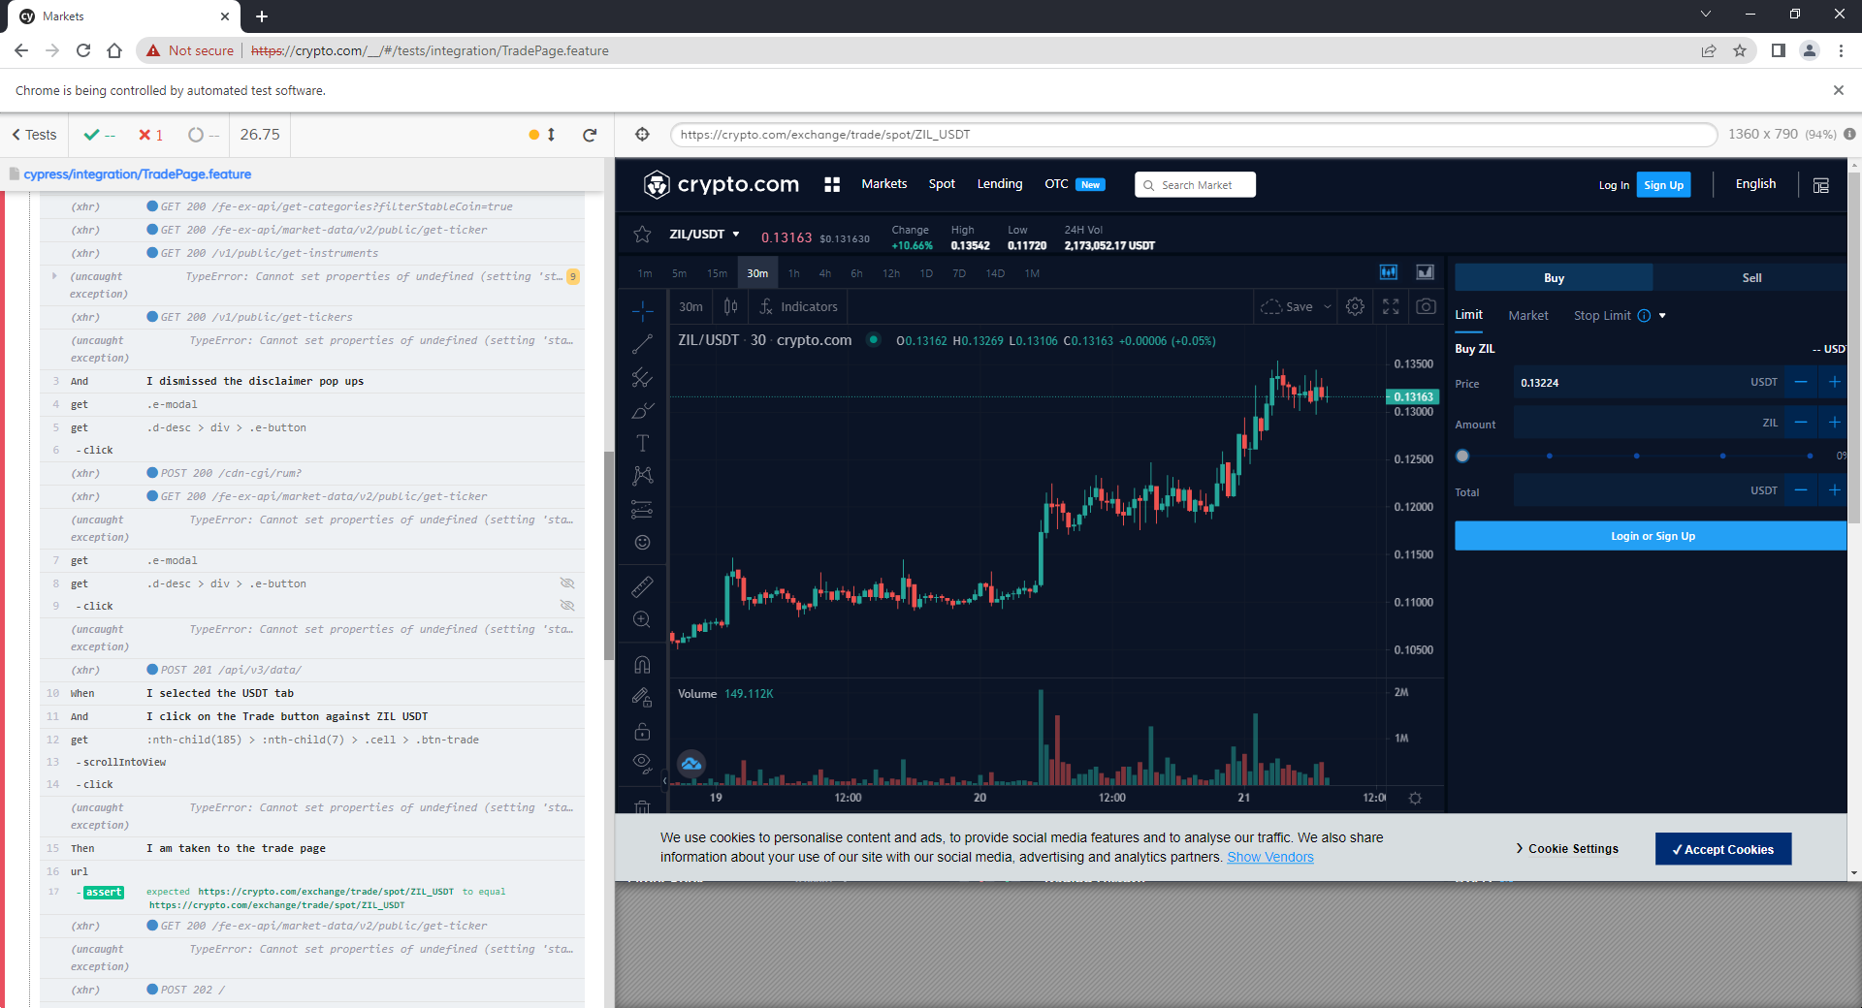
- Alternatively to run the test in headless mode (could be implemented to run against CI/CD pipeline). Run the ‘npm run test’ command:
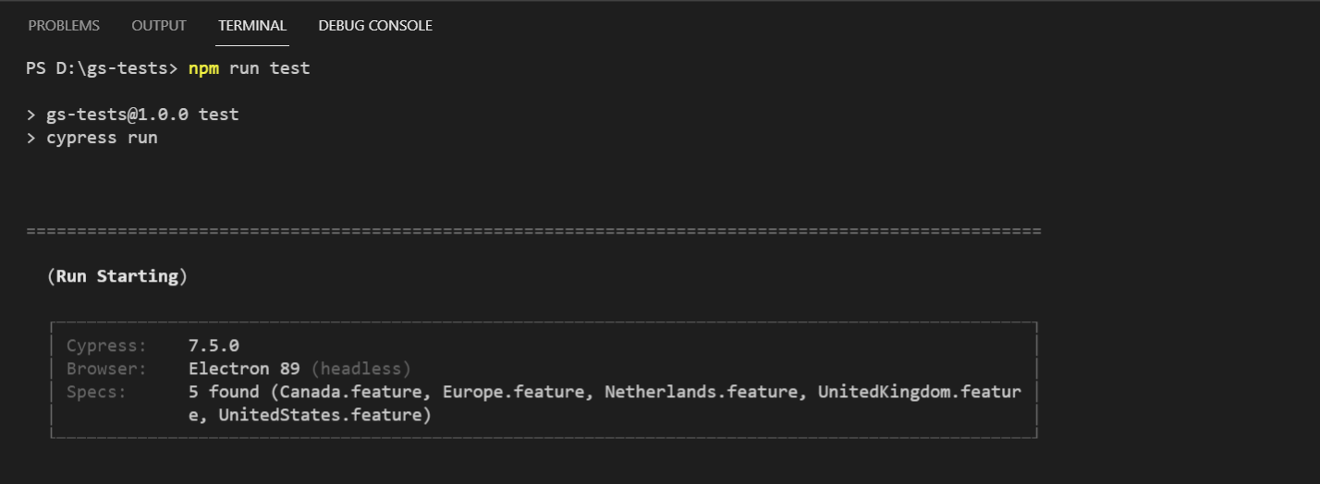
- The results should be output to the screen:
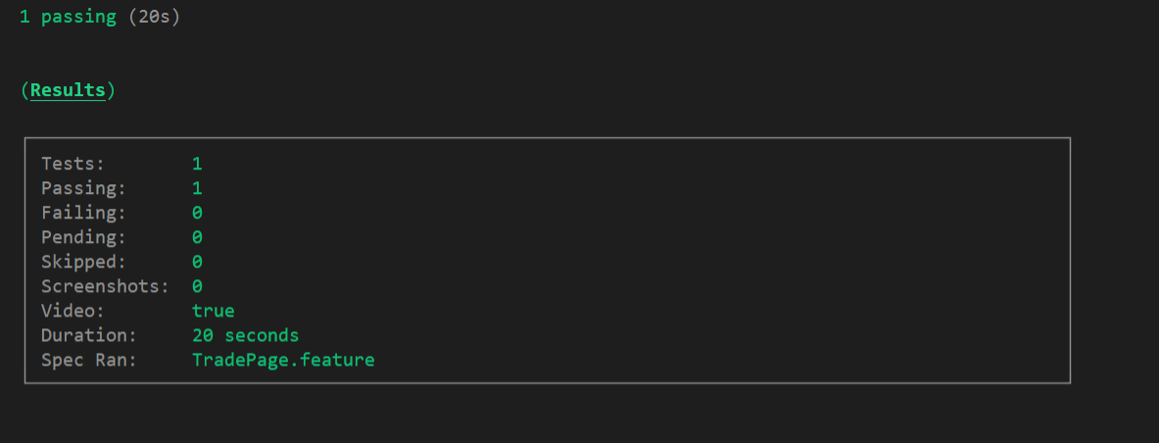
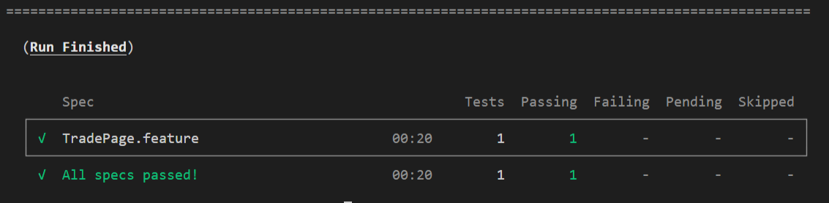
- The recorded videos captured from the test run should then be available in the local folder: 