# Pre-Requisites

* [Appium Server GUI](https://appium.io/downloads.html) installed
* [Visual Studio](https://visualstudio.microsoft.com/downloads/) installed
* [Android Studio](https://developer.android.com/studio) installed
* [Java JDK](https://www.oracle.com/java/technologies/downloads/) installed

# Steps

1. Open Appium Server GUI application



1. On the advanced tab, configure the ‘Server Address’, ‘Server Port’ with ‘Allow CORS’ checked:  
   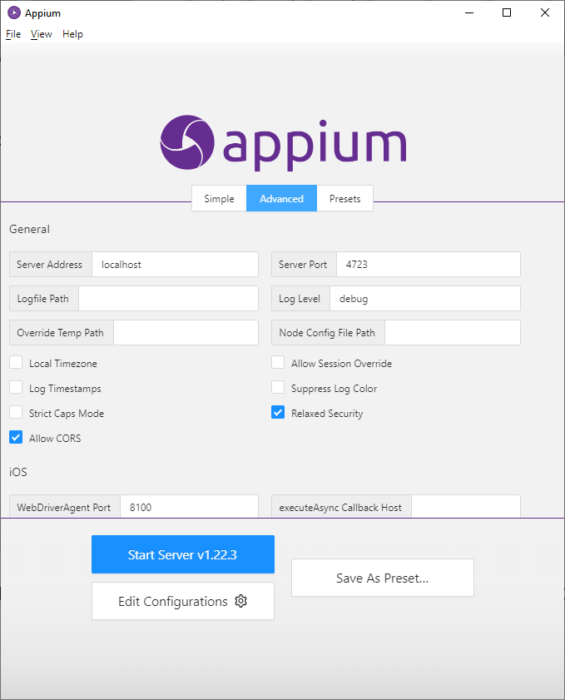
2. Open ‘Edit Configurations’ and provide the location paths of Android SDK and Java JDK:  
   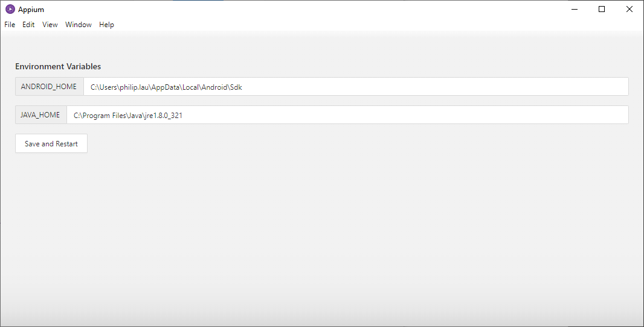
3. Click ‘Start Server’:  
   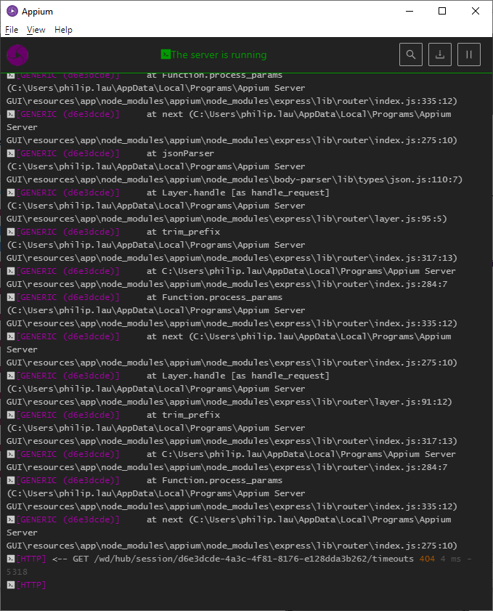
4. Open Android Studio, create a new device under ‘Device Manager’:  
   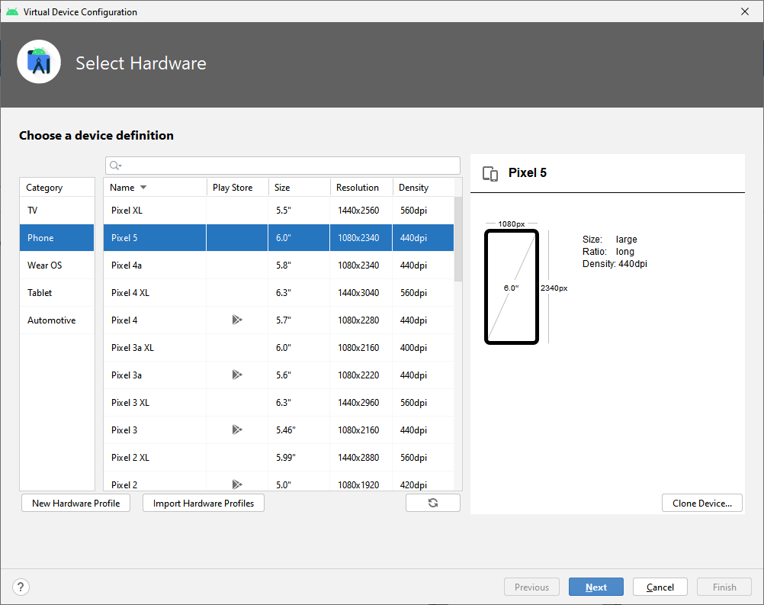  
     
   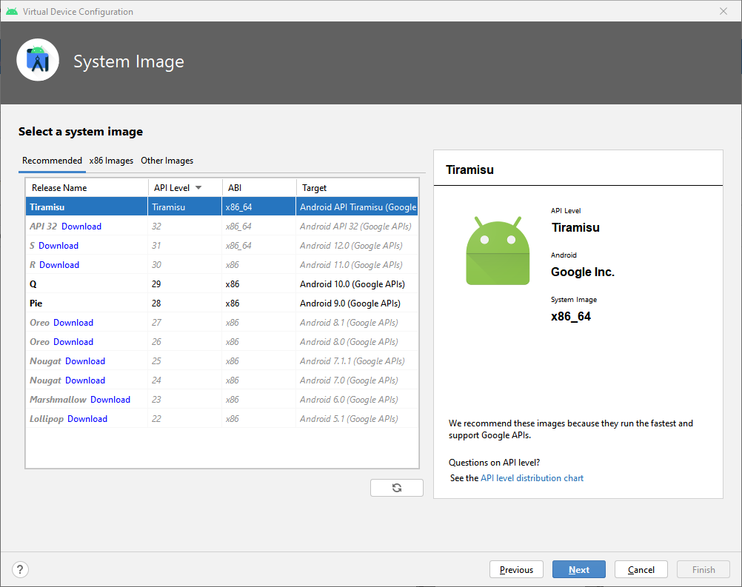  
     
   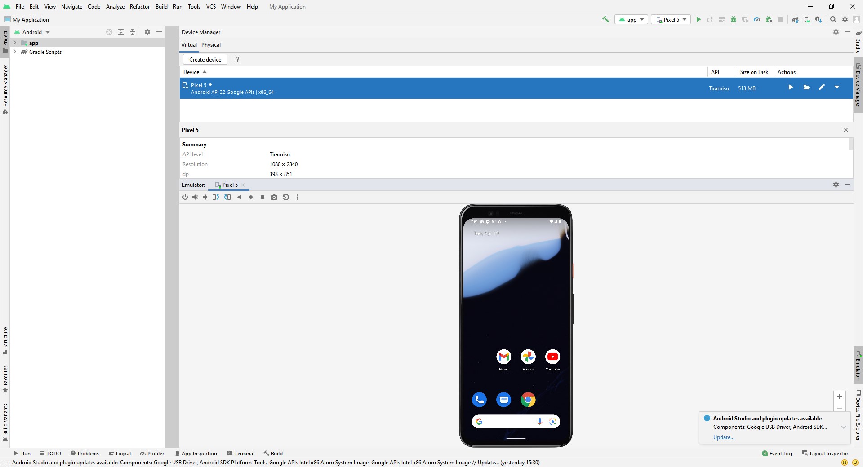
5. Open ‘MyObservatoryUITests’ solution in Visual Studio and run the test under ‘Test Explorer’:  
   