SAND HEALTHCARE FORWARD DEPLOYED ENGINEER
Rwanda Health Data Systems Engagement
Forward Deployed Engineer assignment submission by Phillimon Murebwa
SELECTED SPRINT  Problem A  Quarterly Health Bulletin automation | PROTOTYPE STATUS  Working  Django dashboard + JSON API | DATA SOURCES  5 files  Clinical, facilities, governance, workforce, operations | REPORTING UNITS  M/Q/A  Monthly, quarterly, annual rollups
Executive summary
I chose Problem A because it is the fastest route to measurable MoH value: it targets a known 40-hour/month manual bottleneck, uses already-available DHIS2-like aggregate data, and creates the trust foundation needed before moving into real-time facility status or cross-program patient matching. I built a working Django prototype that ingests the provided source files, joins them into a HealthOS-style model, calculates bulletin metrics, supports advanced monthly/quarterly/annual filtering, and exposes both an executive dashboard and JSON API.
Generated on 10 July 2026. Source dataset used: https://drive.google.com/drive/folders/1DPk6jKSO_bbnhonUX6S91kLWZVulWTmA

Assignment Compliance Checklist
Area | Answer
Deliverable 1 - Discovery process | Complete: stakeholders, questions, patterns, and direct observations are listed.
Deliverable 1 - Problem selection | Complete: Problem A selected with measurable outcome, scope, assumptions, success metric, and fallback.
Deliverable 2 - Architecture | Complete: includes a visual data-flow diagram and build-vs-buy table.
Deliverable 2 - Working code | Complete: Django + pandas prototype reads provided data, calculates metrics, and outputs HTML/JSON.
Deliverable 2 - Implementation notes | Complete: shortcuts, Week 3 demo plan, and lessons learned.
Deliverable 3 - Production hardening | Complete: top 5 production fixes with concern and remediation.
Deliverable 4 - Handover | Complete: MoH IT documentation, training plan, and exit criteria.
Submission evidence | Complete: README, tests, screenshots, source files, and regenerated Word submission.

Deliverable 1: Problem Decomposition and Scoping

Section 1: Discovery Process
My Week 1 goal would be to translate 'our data is a mess' into a ranked set of decision failures, data-flow breakpoints, and measurable delivery opportunities. I would avoid starting with tooling. I would start with people, decisions, source systems, and the manual work currently keeping the system alive.

Stakeholders I would interview and the questions I would ask
Area | Answer
MoH Director / DG Planning | Which decisions does the bulletin actually drive? What decisions are delayed or wrong today? What would convince you in six weeks that Sand created value?
MoH Planning analysts | Walk me through the current 40-hour compilation process. Which Excel steps are repetitive, fragile, or politically sensitive?
DHIS2 administrator | Which data elements feed the bulletin, what are the validation rules, and where do late or incomplete reports appear?
District Health Officers | What do you do when a facility appears high-risk? What freshness is good enough for district action under 3G constraints?
Hospital and clinic data clerks | Where do HealthTrack/OpenMRS values diverge from DHIS2 submissions, and what manual reconciliation happens locally?
Paper facility reporting coordinators | How do registers become district uploads, what gets lost, and how long is the lag?
TB/HIV/Immunisation leads | What identifiers exist across CommCare/Excel systems, and what governance is required before any patient-level linkage?
Sand country team | What is politically urgent, what is reusable across countries, and where should I ask for central FDE/Product support?

Patterns I would look for
- Decision latency: reports arrive weeks after action windows have passed.
- Manual transformation risk: copy-paste Excel steps that are undocumented or owned by one analyst.
- Metric drift: different teams define the same indicator differently across DHIS2, EMR, Excel, and paper workflows.
- Completeness gaps: rural paper facilities and late monthly reports create invisible denominator problems.
- Lineage blindness: leaders see final numbers but cannot trace them back to source facility, month, or data element.
- Program silos: maternal/neonatal, TB, HIV, immunisation, and operations teams optimize separate datasets.
- Infrastructure constraints: unreliable power and spotty 3G/4G change what 'real-time' can realistically mean.

What I would observe directly
- Sit beside the analyst compiling the bulletin and count every manual export, pivot, formula, paste, and validation step.
- Compare one DHIS2 export to the last published bulletin and identify variance by metric and facility.
- Visit one HealthTrack hospital, one OpenMRS clinic, and one paper-only rural facility in the same reporting cycle.
- Measure actual district-office connectivity and dashboard load time under normal 3G/4G conditions.
- Inspect a CommCare export from TB/HIV programs to understand whether future linkage is feasible and ethical.
- Review late-report and missing-report logs to distinguish data-quality issues from true service-performance issues.

Section 2: Problem Selection
Selected 6-week sprint: Problem A - automate the Quarterly Health Bulletin
I would choose Problem A because it is bounded, visible to senior MoH stakeholders, measurable in hours saved, and technically achievable with aggregate data in six weeks. It also creates a reusable data foundation for Problem B (Health Atlas facility status) and Problem C (program linkage) without prematurely taking on their higher infrastructure, privacy, and workflow risks.
Area | Answer
Why not Problem B first? | Real-time facility status is valuable, but 175 paper-only facilities, unreliable power, and spotty 3G/4G make it a broader operational change. I would treat it as Phase 2 after proving data trust.
Why not Problem C first? | TB/HIV co-infection visibility is clinically important, but patient matching across CommCare systems requires identity governance, privacy controls, and program buy-in. Six weeks is too short to do this safely.
Specific outcome | Generate an automated bulletin for one full reporting cycle in under 30 minutes, replacing the 40-hour manual workflow and matching validated MoH figures within an agreed tolerance.
Out of scope | Patient-level record linkage, full rural paper digitisation, production HA deployment, SSO, national Health Atlas rollout, and official PDF distribution automation.
Week 2 validations | Confirm indicator definitions, quarter boundaries, partial-period handling, acceptable variance, sign-off workflow, and whether DHIS2 API access is available or CSV export remains the first ingestion path.
Success metric | MoH Planning lead accepts an automated bulletin for a pilot quarter with generation time below 30 minutes and traceable metric definitions.
Fallback plan | If DHIS2 API access is delayed, continue with scheduled CSV/Excel ingestion; if composite scoring is debated, ship raw indicator tables plus configurable weights; if PDF is delayed, ship HTML and JSON first.

Deliverable 2: Rapid Prototyping - Problem A

Section 1: Solution Design and Architecture

Architecture overview: data flow from messy source systems to decisions
Design principle
I modelled the flow from the lowest reliable reporting unit upward: monthly DHIS2-like rows are validated and joined first, then rolled into quarterly and annual bulletin views. Counts are summed before rates are recalculated, so annual neonatal mortality is not an average of quarterly rates.
1. Source systems | -> | 2. Ingestion layer | -> | 3. HealthOS data models | -> | 4. Bulletin metrics engine | -> | 5. Outputs and actions
DHIS2 monthly exports  Assignment CSV/XLSX files  HealthTrack EMR and OpenMRS future feeds  Paper facility registers via district upload  TB/HIV/Immunisation feeds for later phases | -> | Google Drive sync with local cache  CSV/XLSX loader  Schema and role classification  Partial-period detection  Future DHIS2 API connector with retries | -> | Facility dimension  Reporting period dimension  Clinical neonatal fact table  Governance, workforce, operations, infrastructure dimensions  Supplemental facility-level joins | -> | Monthly -> quarterly -> annual filtering  Top facilities, maternal/neonatal indicators  Composite readiness scores  MoM/QoQ/YoY trend analysis  Risk watchlist and rollup reconciliation | -> | Executive HTML dashboard  JSON API and export payload  Superset dataset feed  MoH PDF/Word bulletin template  Future Health Atlas maps and Insight Engine alerts
External systems |  | Custom sprint build |  | HealthOS Data Models |  | Custom + Health Insight pattern |  | Analytics Toolkit + Health Atlas path
Current prototype path: Google Drive source files -> Drive sync + pandas loader -> HealthOS-style joined facility model -> Django metrics engine -> HTML dashboard, JSON API, and export payload.
Production path: DHIS2 API and HealthTrack/OpenMRS connectors feed HealthOS models on a schedule; the same metrics definitions power Superset templates, official PDF bulletins, Health Atlas maps, and Health Insight Engine alerts.

Sand products leveraged
Area | Answer
HealthOS Data Models | Normalize facility, period, clinical, governance, workforce, operations, and infrastructure facts before any dashboard calculation.
Analytics Template Toolkit | Use Apache Superset templates for Phase 2 analyst self-service while the prototype provides immediate HTML/JSON outputs.
Health Insight Engine | Production path for anomaly detection, mortality spikes, stockout clusters, and automated district alerts.
Health Atlas | Phase 2 map layer for facility status, provincial readiness, stockouts, outbreak signals, and referral burden.
Health Outcome Tracker | Future patient-outcome analytics once Problem C identity governance is safe enough to pursue.

Custom build and justification
- Django service layer for MoH-specific bulletin logic, period selection, JSON/export routes, and dashboard rendering.
- Pandas metrics engine for rapid multi-source joins, rollups, rate calculations, composite scoring, and risk ranking.
- Google Drive/CSV/XLSX ingestion layer so the assignment remains reproducible without DHIS2 credentials.
- Executive dashboard UI because the MoH needs a narrative action view, not only a generic BI grid.
- Advanced filtering logic from monthly source rows to quarterly and annual views, because the real DHIS2 workflow starts with monthly reporting.

Build vs. buy decisions
Area | Answer
Data warehouse/model | Buy/adapt HealthOS Data Models. Reuse Sand healthcare transformations instead of inventing a national model from scratch.
Ingestion | Build thin adapter now; buy/adapt DHIS2 connector in production. The sprint needs speed, production needs reliability.
Metric engine | Build custom. MoH indicator definitions, partial periods, and bulletin layout are engagement-specific.
Dashboard | Build focused executive view now; feed Superset later for self-service.
Maps and alerts | Buy/use Health Atlas and Health Insight Engine after the bulletin pipeline is trusted.
PDF distribution | Build light template export in hardening phase. The sprint proves data correctness first.

Section 2: Working Prototype Code
Prototype delivered
The submitted Django project reads the provided healthcare source files, joins them by facility, calculates bulletin metrics, supports monthly/quarterly/annual filters, and serves both an HTML dashboard and JSON API.
TESTS  9 passing  Django service/API coverage | ANNUAL DELIVERIES  220,969  2024 summed from source months | Q4 COMPLETENESS  66.67%  Partial quarter flagged | ADVANCED METRICS  11  Rollups, coverage, stability, deltas
- Reads the five provided source files: clinical_neonatal, facilities, governance, healthcare_workers, and operations.
- Automatically classifies source files, joins facility-level dimensions, and tolerates additional supplemental facility files.
- Calculates top facilities, maternal/neonatal indicators, facility performance scores, provincial overview, trend analysis, and risk watchlist.
- Adds advanced filtering from lowest report unit upward: monthly source rows, quarterly rollups, and annual rollups.
- Recomputes rates from summed counts: annual neonatal mortality uses total neonatal deaths divided by total live births, not averaged quarterly rates.
- Exposes outputs at /, /api/bulletin/, and /export/.

How to review the working code
Area | Answer
Run tests | python manage.py test
Run server | python manage.py runserver
Dashboard | http://127.0.0.1:8000/?granularity=Q&period=2024Q4
Annual rollup demo | http://127.0.0.1:8000/?granularity=A&period=2024
JSON API | http://127.0.0.1:8000/api/bulletin/?granularity=A&period=2024
Core code | bulletin/services.py, bulletin/views.py, bulletin/templates/bulletin/dashboard.html

Prototype output evidence
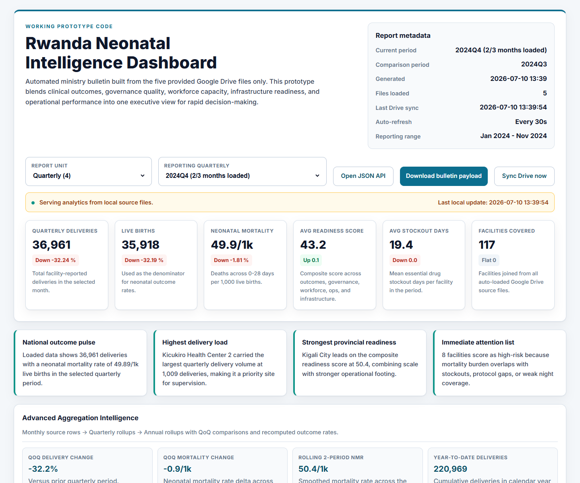
Figure 1 - Executive dashboard, reporting filters, KPI strip, and strategic summary.
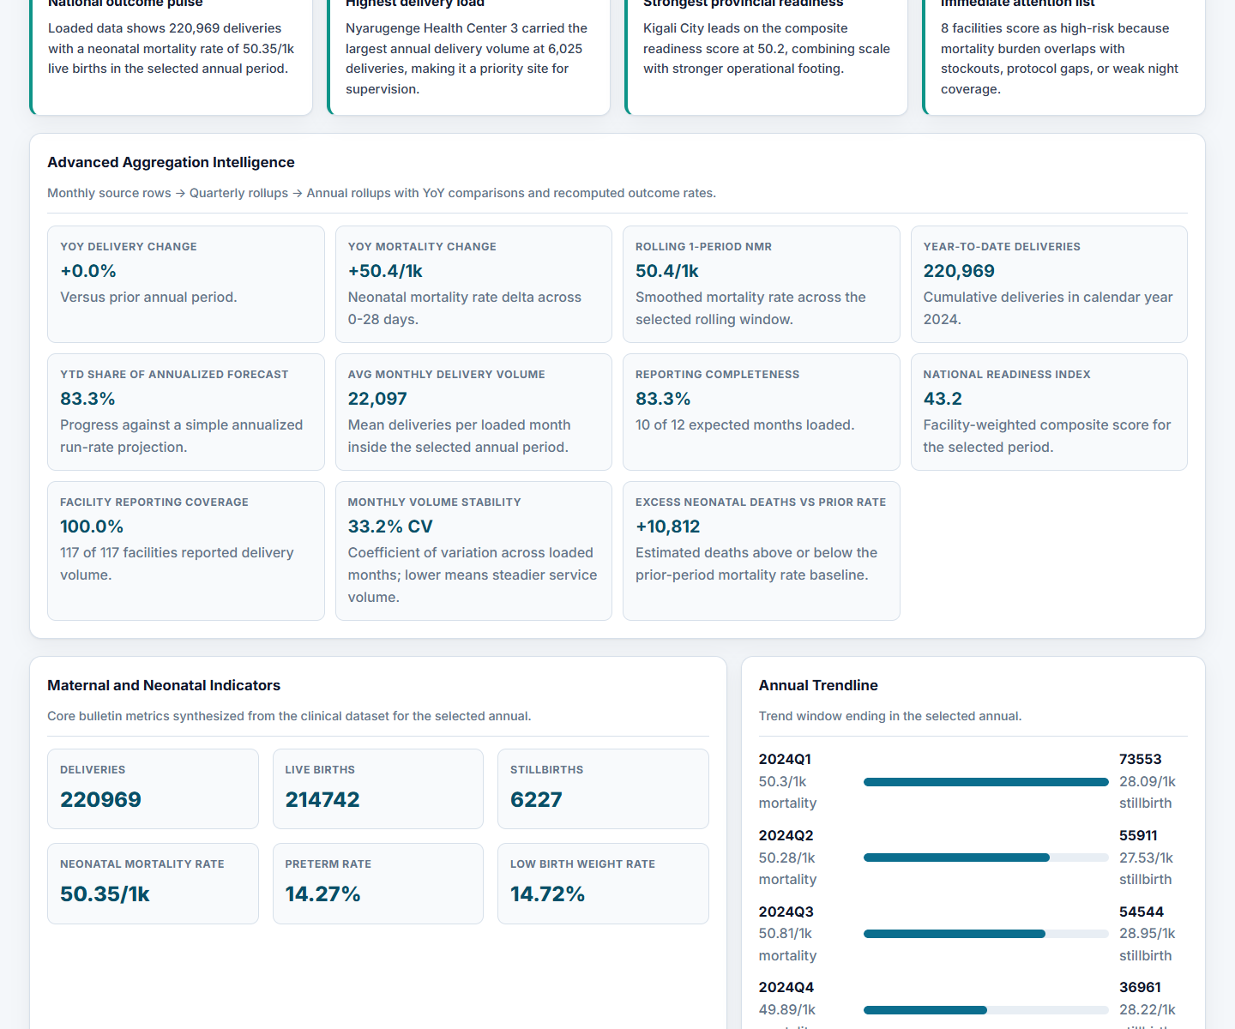
Figure 2 - Advanced aggregation intelligence and annual rollup explorer.
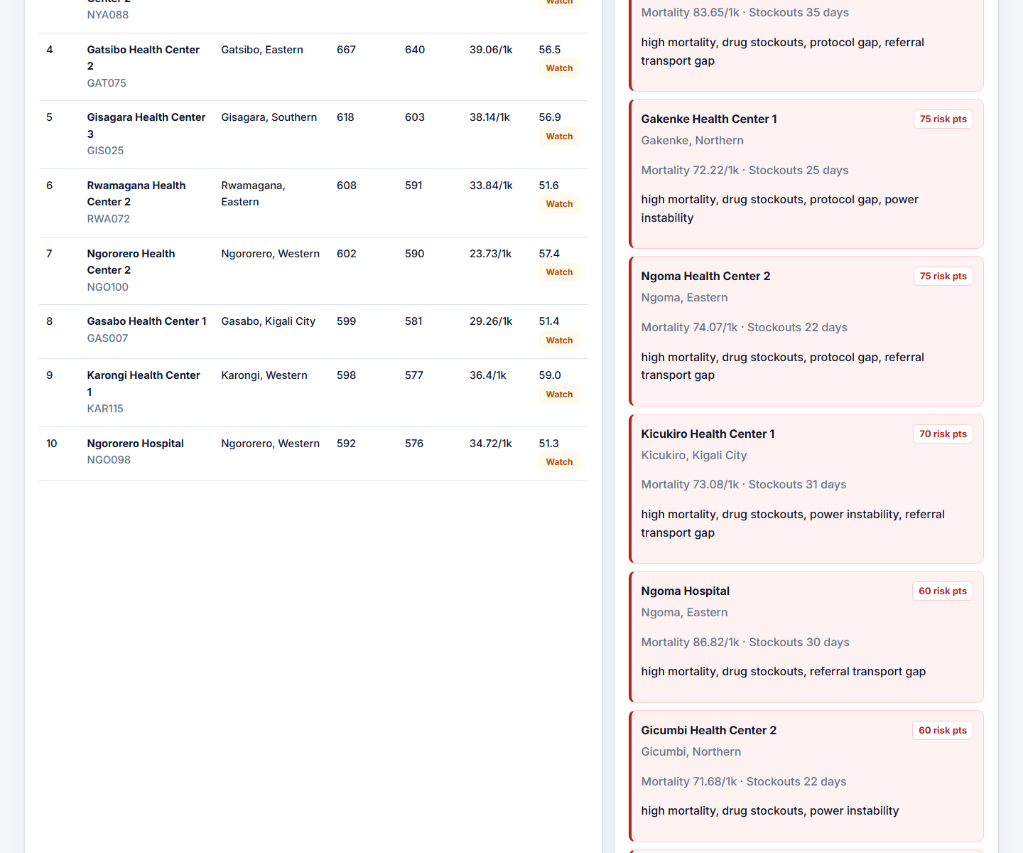
Figure 3 - Facility tables, risk watchlist, provincial performance, and score leaders.

Section 3: Implementation Notes
Area | Answer
Shortcuts I took | Used Google Drive/CSV/XLSX files instead of live DHIS2 API credentials; kept scores in code rather than admin-configurable tables; used JSON export before official PDF automation.
What works in Week 3 | Ingestion, joins, monthly/quarterly/annual filters, KPIs, rollups, risk alerts, dashboard, JSON API, export route, screenshots, and unit tests.
What is still not production | Authentication, scheduled orchestration, signed-off indicator governance, Superset auto-registration, observability, and official MoH PDF distribution.
What I learned | The hardest part is not rendering a dashboard; it is making the metric lineage trustworthy enough that MoH leaders can act on it.

Deliverable 3: Production Hardening

1. DHIS2 integration and orchestration
Area | Answer
Concern | CSV exports can recreate manual bottlenecks and stale data.
How I would address it | Use a scheduled DHIS2 API connector through HealthOS, idempotent sync jobs, retries, freshness badges, and alerting when reporting is late.

2. Metric governance and data quality
Area | Answer
Concern | Hard-coded definitions can drift from MoH-approved indicators.
How I would address it | Create a metric-definition registry with source fields, formulas, owners, validation rules, and sign-off history.

3. Security and access control
Area | Answer
Concern | Health data must not be exposed uniformly to every user.
How I would address it | Add MoH SSO, role-based access, district-level row filters, audit logs, HTTPS, and secret management.

4. Reliability and observability
Area | Answer
Concern | Pipeline failures must not silently corrupt a national bulletin.
How I would address it | Add job monitoring, structured logs, dead-letter files, reconciliation reports, backups, and an L1/L2 incident runbook.

5. Official outputs and adoption
Area | Answer
Concern | A working dashboard is not enough if MoH still needs the official bulletin format.
How I would address it | Generate branded PDF/Word bulletins, publish a versioned archive, email approved outputs, and connect Superset for analyst drill-down.

Deliverable 4: Handover and Deployment

Three documents I would leave with MoH IT
Area | Answer
Data pipeline runbook | How ingestion runs, where credentials live, how to retry failed jobs, and who owns each escalation step.
Metric definitions and lineage | Every bulletin metric mapped to source data, formula, aggregation rule, owner, and known limitation.
Deployment and operations guide | Environment setup, backups, monitoring, release process, access control, and manual recovery steps.

Training plan
Area | Answer
MoH Planning analysts | Run the bulletin, validate numbers, interpret trends, export official outputs, and handle partial periods.
DHIS2 administrators | Maintain API tokens, validate data elements, troubleshoot sync errors, and review completeness.
District Health Officers | Use risk watchlists, provincial/facility comparisons, and trend signals to plan follow-up.
MoH IT | Deploy, monitor, back up, patch, and escalate incidents.
Sand country team | Translate adoption blockers into reusable product patterns for HealthOS, Atlas, and Insight Engine.

Exit criteria
- MoH staff generate two consecutive bulletins without Sand driving the process.
- Metric definitions, runbooks, and deployment guide are signed off by Planning and IT leads.
- Automated output is accepted as the source for the official bulletin workflow.
- District users can identify and act on high-risk facilities using the dashboard without additional explanation.
- Sand transitions from daily implementation support to L2 escalation and product-pattern reuse.

Appendix A: Evidence from the Current Build
Area | Answer
Latest monthly period | Nov 2024: 18,676 deliveries.
Quarterly period | 2024Q4 (2/3 months loaded): 36,961 deliveries; previous comparison 2024Q3.
Annual period | Calendar year 2024 (10/12 months loaded): 220,969 deliveries and 50.35/1k NMR.
Annual reconciliation | Quarter-summed deliveries = 220,969; annual maternal total = 220,969.
Top facility in Q4 | Kicukiro Health Center 2 with 1,009 deliveries.
Risk watchlist size | 8 facilities flagged for overlapping burden and fragility.

Appendix B: Final Submission Package
- Scoping and design document: this Word file.
- Working code: Django project in sand-fde-assignment/.
- README: setup, test, run, and generation instructions.
- Sample data: provided source files under data/google_drive_source/.
- Output demonstration: screenshots in submission_assets/ and live dashboard/API routes.
I wrote this submission to be defendable in the live interview: the tradeoffs are explicit, the code runs, the metrics are traceable, and the production path ties back to Sand's existing healthcare products.

