StudyPlannerApp
UML System Design Diagrams
Version 0.1
Prepared by Phil Samakayi and Blessing Yabe
Department of Computing and Informatics, University of Zambia
Supervisor: Mr. Martin Phiri
Modelling approach follows Larman, Applying UML and Patterns, 3rd ed.

Introduction

Version | Summary
0.1 | Domain model made conceptual (Larman-style) with multiplicities and role names; use case diagram extended with include/extend and auth use cases; sequence diagram extended with loop/alt fragments; ER diagram extended with ScheduleSlot and constraints; architecture clarified (JWT auth, in-process matching app); legend, wireframe reference and user stories added.

This document presents the core UML diagrams supporting the design of StudyPlannerApp, developed as part of the Sprint 1 system design activities defined in the project proposal (Weeks 3–5). It accompanies the project proposal and provides a visual reference for the system's structure and behaviour. Diagram conventions follow Larman's approach to object-oriented analysis and design: the domain model below is conceptual (no operations), and every association is annotated with multiplicity and a role name.
Six diagrams are included, followed by a UML notation legend and an initial set of user stories with acceptance criteria:
- Use case diagram – system functions, including authentication, and include/extend relationships.
- Domain model (class diagram) – conceptual entities, multiplicities, role names, and aggregation.
- Sequence diagram – the AI matching flow, including loop and alternative fragments.
- Entity relationship (ER) diagram – the relational schema, including scheduling availability.
- System architecture diagram – the three-tier deployment view, with authentication and endpoints clarified.
- Low-fidelity wireframe – an early reference layout for the study dashboard screen.

UML Notation Legend
The notation below is used consistently across all diagrams in this document.
Symbol / Notation | Meaning
Rounded box (e.g. “Student”) | Actor – a role that interacts with the system.
Oval inside a system boundary | Use case – a discrete function the system provides.
Plain line between actor and use case | Association – the actor participates in that use case.
<<include>> dashed arrow | The base use case always incorporates the included use case's behaviour.
<<extend>> dashed arrow | The extending use case optionally adds behaviour to the base use case.
Rectangle with title bar + attribute list, no operations | Domain model class – a conceptual entity (Larman-style).
1, 0..1, 0..*, 2..* | Multiplicity – how many instances participate in the association.
Text label on an association line (e.g. “owns”, “schedules”) | Role name – describes the nature of the relationship.
Hollow diamond | Aggregation – a whole/part relationship (e.g. Schedule contains StudySessions).
Vertical dashed line under an actor/object | Lifeline – the object's existence over time in a sequence diagram.
Solid arrow / dashed arrow | Synchronous call / return message in a sequence diagram.
Labelled rectangle frame (“loop”, “alt”) | Combined fragment – repetition or conditional branching of messages.
PK / FK | Primary key / foreign key in the entity relationship diagram.

1. Use Case Diagram
The Student is the primary actor and the AI Matching Engine is a secondary actor supplying compatibility scores. Authentication (Login, Manage profile) is now modelled explicitly. “View matches” is modelled as an <<extend>> of “Request GroupStudy match”, since reviewing the ranked list is optional additional behaviour after a match is computed. “Join GroupStudy session” <<include>>s “Login”, since authentication is mandatory before joining a session.
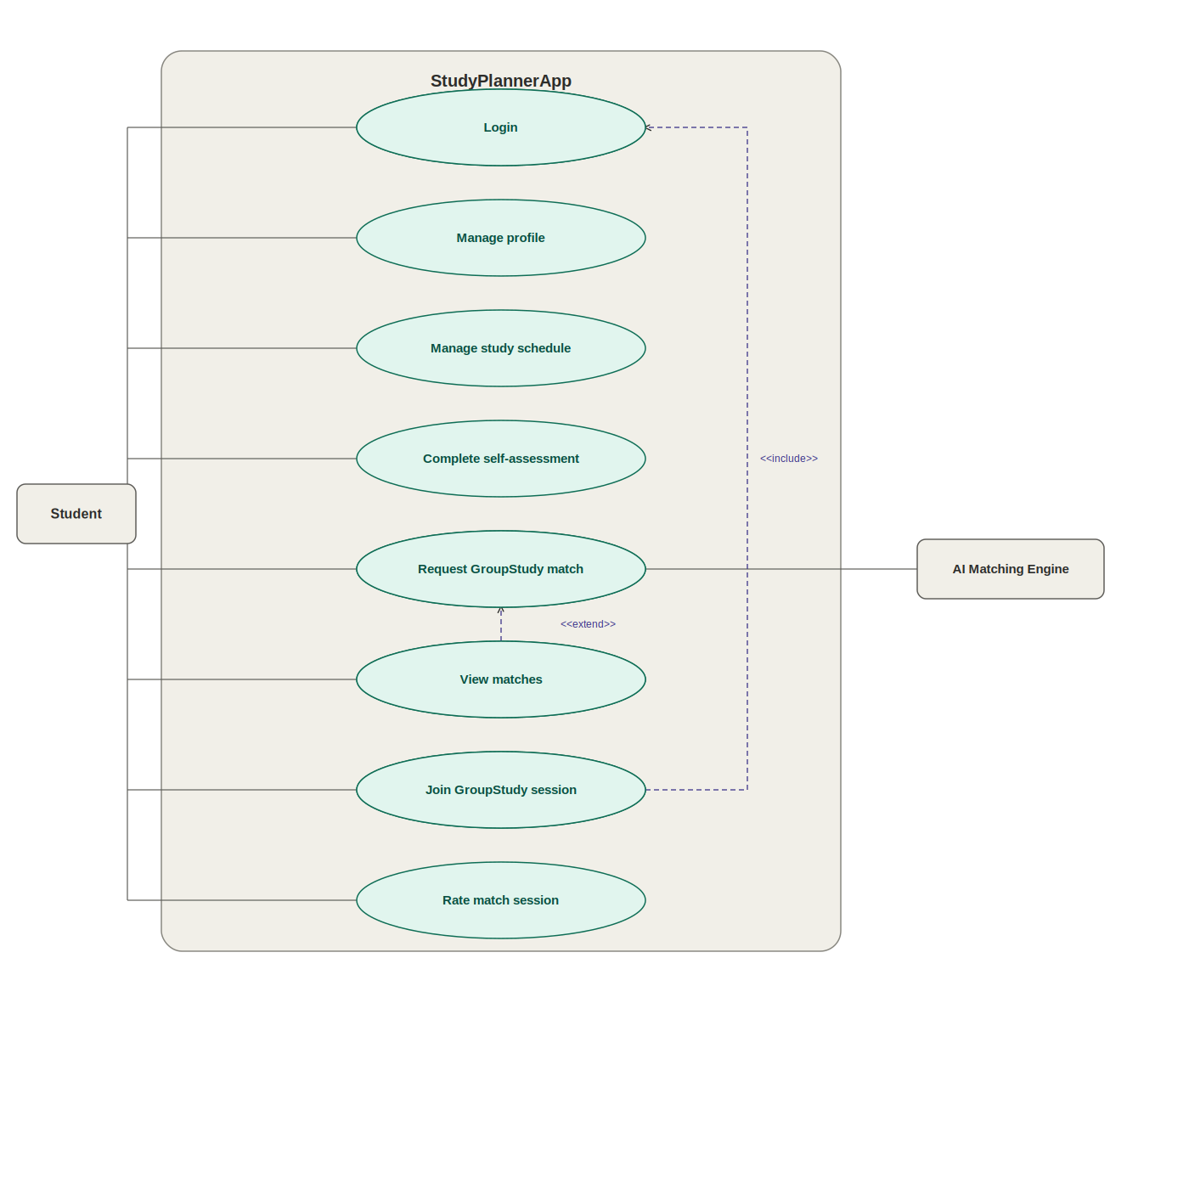
Figure 1. Use case diagram for StudyPlannerApp, with include/extend relationships.

2. Domain Model (Conceptual Class Diagram)
Following Larman, this domain model is conceptual: classes show attributes only, with no operations. Every association carries a multiplicity and a role name at each end. A Schedule aggregate has been introduced to own a student's StudySession instances (hollow diamond = aggregation), separating a student's overall schedule from the individual sessions within it.
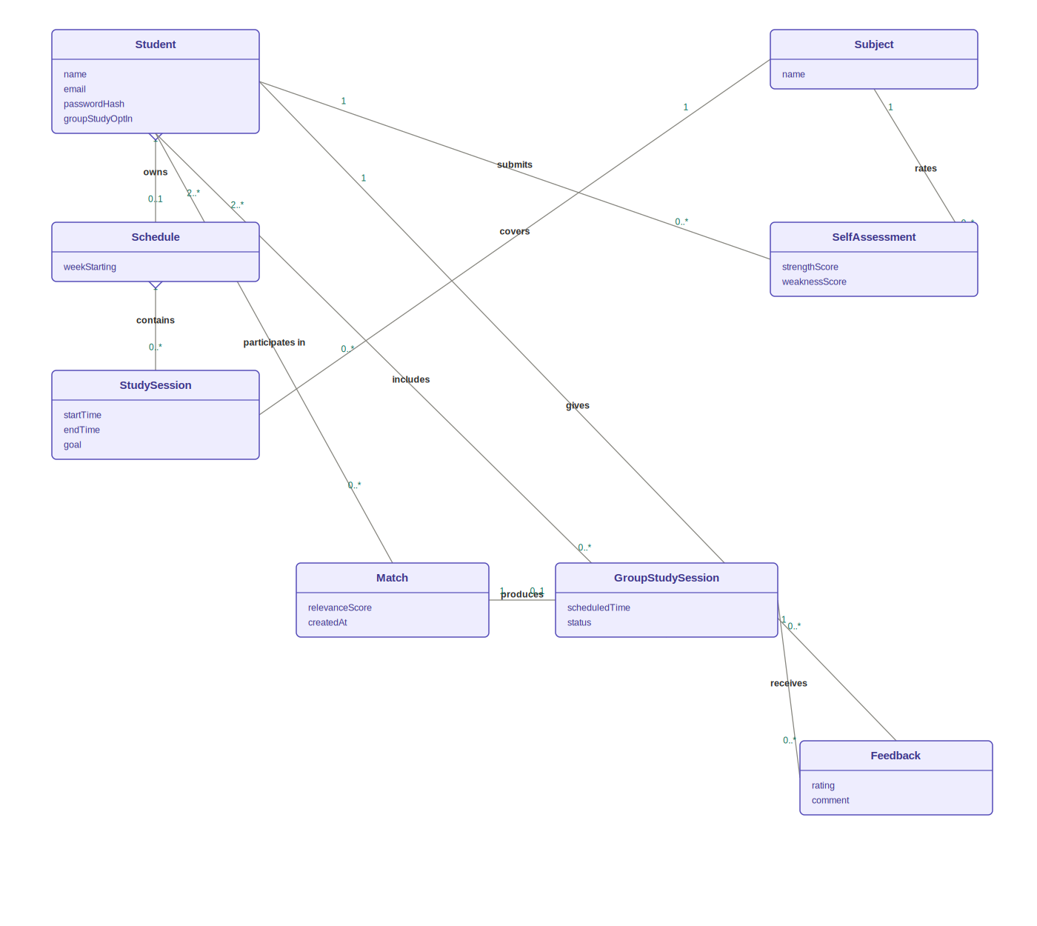
Figure 2. Conceptual domain model with multiplicities, role names, and aggregation.

Notes
- Student – Match is 2..* on the Student side because a match always pairs at least two students.
- GroupStudySession – Student (“includes”) mirrors the same many-to-many relationship at the session level, once a match has produced a session.
- groupStudyOptIn on Student reflects the informed-consent requirement in the proposal's ethical considerations (Section 3.2): GroupStudy participation is opt-in and reversible.

3. Sequence Diagram – AI Peer Matching Flow
This sequence diagram fulfils Objective 3 of the proposal. After a student completes a self-assessment and requests a GroupStudy match, the backend fetches candidate profiles and scores each one against the matching service inside a loop fragment. An alt fragment then branches on whether any suitable matches were found. Finally, feedback submitted after a GroupStudy session is persisted and used to refine future scoring – closing the feedback loop referenced in the proposal's evaluation methodology.
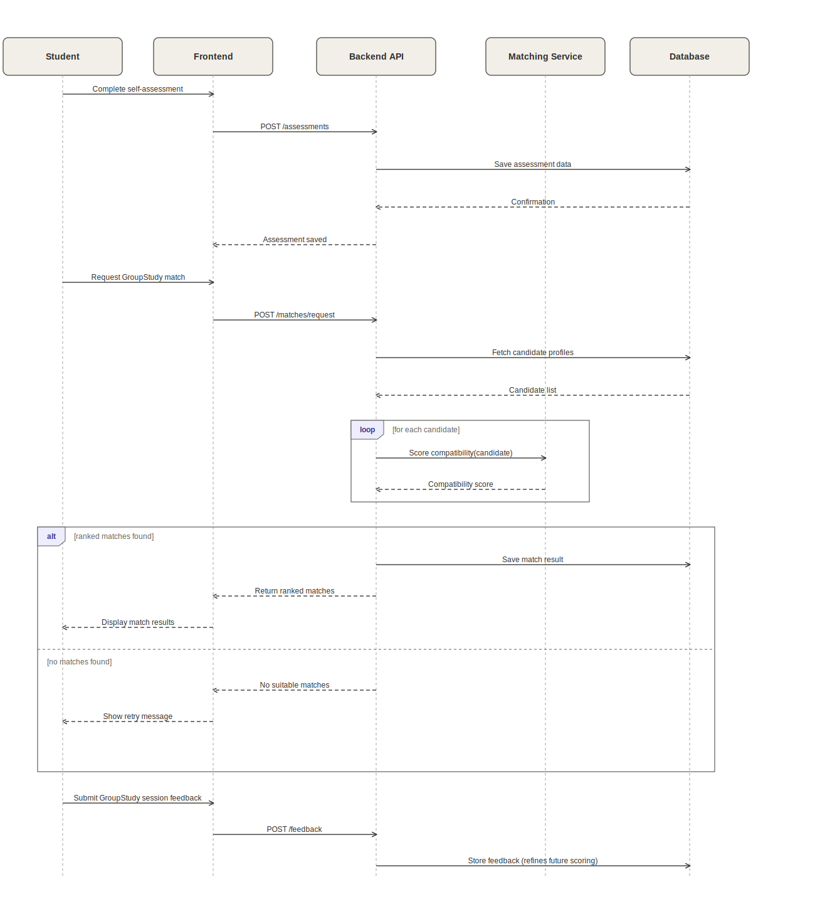
Figure 3. Sequence diagram for AI-based peer matching, with loop and alt fragments.

4. Entity Relationship (ER) Diagram
The ER diagram maps the domain model onto the relational schema for MySQL/SQLite. A ScheduleSlot table has been added to represent a student's recurring weekly availability separately from booked StudySession records – this is what the matching algorithm and GroupStudy scheduling will query to find common free time between matched students. The MatchParticipant junction table resolves the many-to-many relationship between Student and Match.
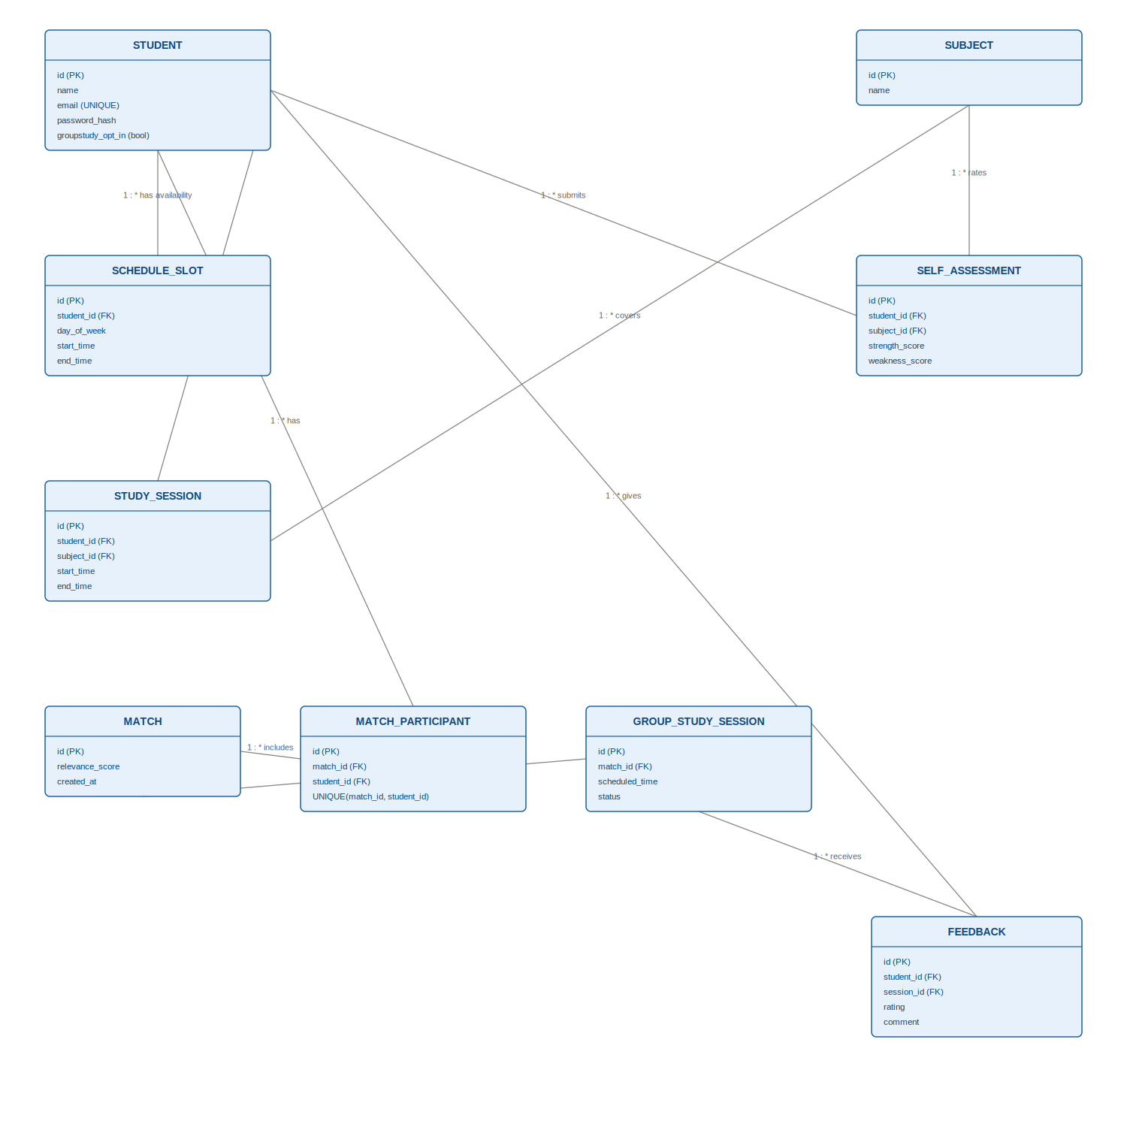
Figure 4. Entity relationship diagram, including ScheduleSlot and key constraints.

Indexes and constraints
- UNIQUE constraint on Student.email, enforced at the database level in addition to Django form validation.
- Composite UNIQUE constraint on MatchParticipant(match_id, student_id) to prevent duplicate pairings.
- Index on SelfAssessment(subject_id, strength_score, weakness_score) – the columns the matching query filters and sorts on when finding complementary peers.
- Index on ScheduleSlot(student_id, day_of_week) to speed up availability look-ups during match scheduling.
- Foreign key constraints with ON DELETE CASCADE from StudySession, SelfAssessment, ScheduleSlot, MatchParticipant, and Feedback back to Student, so a removed account cleans up its dependent records.
- groupstudy_opt_in defaults to false; the matching service excludes any student with opt-in set to false, regardless of assessment data – consistent with the informed-consent principle in the proposal.

5. System Architecture Diagram
The AI matching component lives as a Django app (matching/) within the same Django project and codebase as the rest of the backend – an in-process service, not a separate microservice. This keeps deployment simple for a two-person student project while still isolating the matching logic behind its own REST endpoint. Authentication uses JSON Web Tokens via djangorestframework-simplejwt: the client exchanges credentials for an access/refresh token pair at /api/auth/login/ and attaches the access token as a Bearer header on subsequent requests.
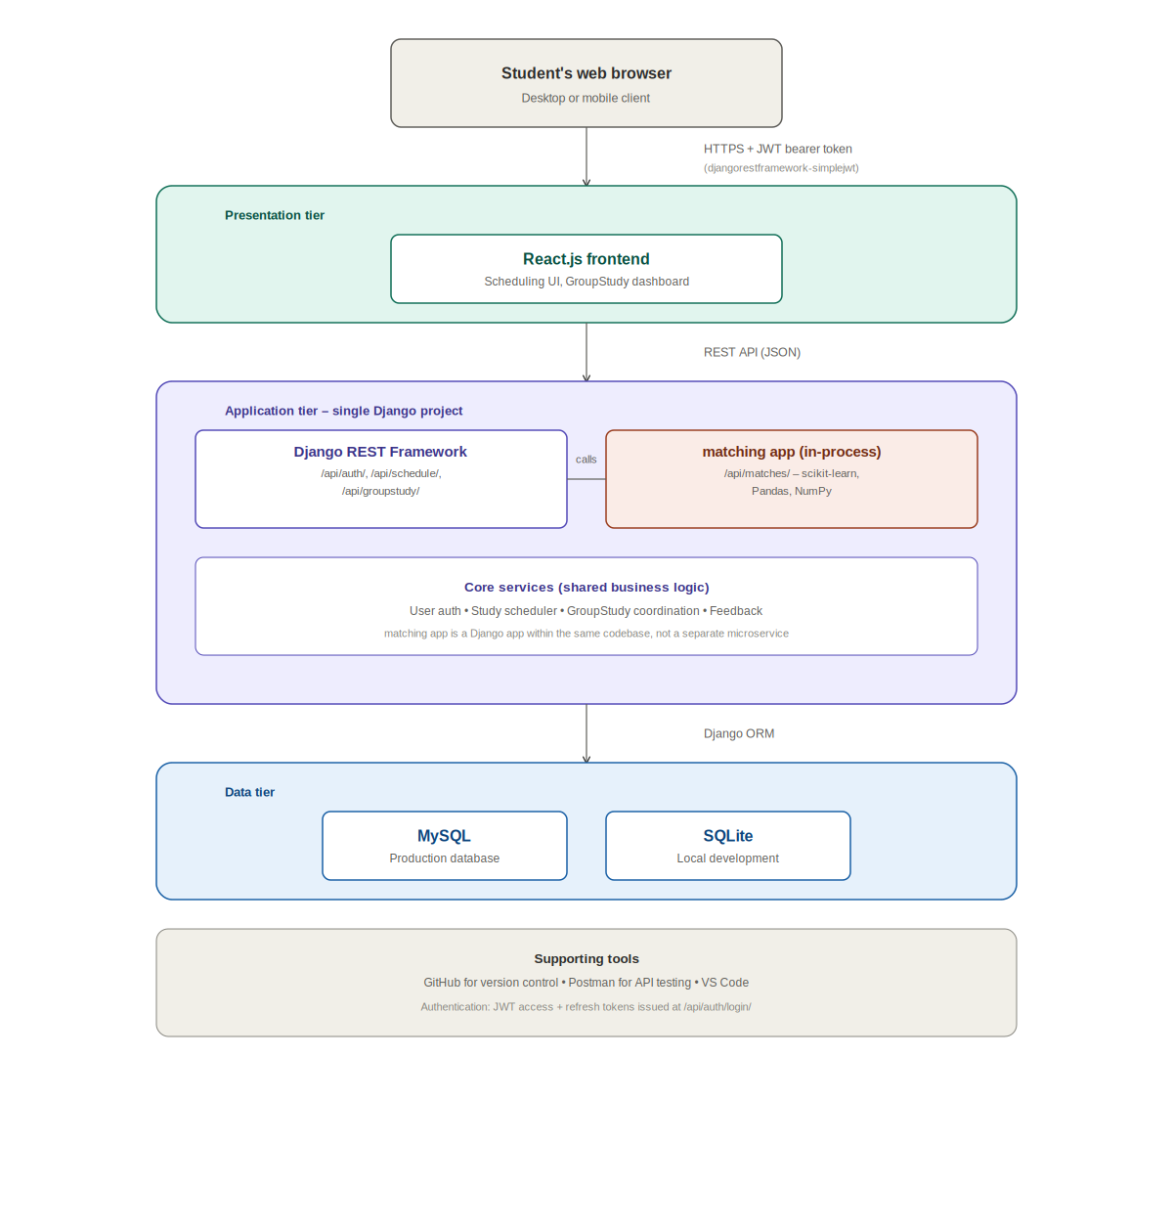
Figure 5. Three-tier system architecture, with JWT authentication and REST endpoint groups.

Representative endpoints
- POST /api/auth/login/ – obtain JWT access/refresh tokens.
- GET/POST /api/schedule/sessions/ – manage a student's study sessions.
- POST /api/assessments/ – submit or update a subject self-assessment.
- POST /api/matches/request/ – trigger the matching app to score and rank candidates.
- GET /api/matches/{id}/ – retrieve a specific ranked match result.
- POST /api/groupstudy/{id}/feedback/ – submit post-session feedback.

6. Wireframe Reference
A low-fidelity wireframe for the study dashboard – the primary landing screen after login. It brings together the student's subjects and self-assessment shortcut, the current week's schedule, suggested GroupStudy matches with their relevance score, and upcoming GroupStudy sessions. This is a reference layout only; detailed mockups will be produced separately once the visual design direction is agreed with the supervisor.
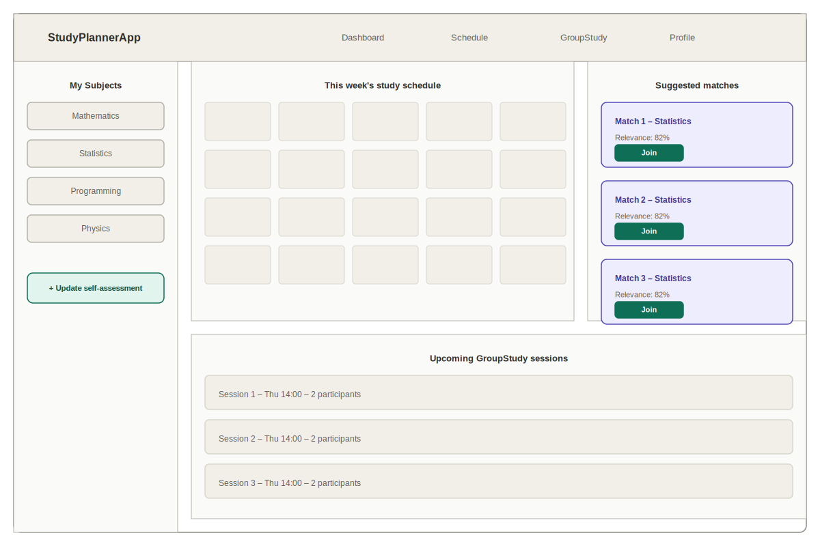
Figure 6. Low-fidelity wireframe of the study dashboard screen.

7. User Stories and Acceptance Criteria
The following user stories validate the use cases in Figure 1 and will drive Sprint 2–4 implementation and testing. Each maps to one or more use cases and, where relevant, to the measurable objectives in the project proposal (Section 1.3).
ID | User Story | Acceptance Criteria
US-1 | As a student, I want to register and log in, so that my schedule and assessment data are private to me. | • Given a valid email and password, when I submit the registration form, then my account is created and I receive a JWT token.  • Given an existing account, when I log in with correct credentials, then I receive a valid access/refresh token pair.  • Given incorrect credentials, when I attempt to log in, then I see an error and no token is issued.
US-2 | As a student, I want to manage my profile, so that my personal details stay accurate and I control my GroupStudy opt-in. | • Given I am logged in, when I update my name or email, then the changes are saved and reflected immediately.  • Given I toggle GroupStudy opt-in off, when matching runs, then I am excluded from all future match candidates.
US-3 | As a student, I want to create and manage my study schedule, so that I can plan my personal study time. | • Given I am logged in, when I add a study session with a subject, start time and end time, then it appears on my schedule.  • Given an existing session, when I edit or delete it, then the schedule updates accordingly.  • Given overlapping times, when I save a session, then I am warned of the conflict.
US-4 | As a student, I want to complete a subject self-assessment, so that the matching algorithm has data to work with. | • Given I am logged in, when I rate my strength and weakness per subject, then the ratings are saved to my profile.  • Given I already have a rating for a subject, when I resubmit, then the existing rating is updated, not duplicated.
US-5 | As a student, I want to request a GroupStudy match, so that I can be paired with a complementary peer. | • Given I have completed at least one self-assessment and opted in to GroupStudy, when I request a match, then the system returns a ranked list of candidate peers with a relevance score.  • Given no suitable candidates exist, when I request a match, then I see a clear “no matches found” message with an option to retry later.
US-6 | As a student, I want to view my match results in detail, so that I can decide whether to proceed. | • Given a match has been computed, when I open “View matches”, then I see each candidate's relevance score and shared subjects.  • Given I select a match, when I confirm, then a GroupStudy session is created.
US-7 | As a student, I want to join a GroupStudy session, so that I can collaborate with my matched peer. | • Given a GroupStudy session exists for my match, when I join, then I am added as a participant and see the session's scheduled time.  • Given I am not logged in, when I try to join, then I am redirected to log in first.
US-8 | As a student, I want to rate a GroupStudy session afterwards, so that the system can measure match relevance and improve future pairings. | • Given a GroupStudy session has taken place, when I submit a rating and comment, then it is stored and linked to that session.  • Given feedback has been submitted, when the evaluation report is generated, then this rating counts toward the ≥75% user-perceived match relevance target defined in the project proposal.

