StudyPlannerApp
UML System Design Diagrams
Revised Edition — with Prioritised Improvements Applied
Document Version: v1.1
Date: 3 July 2026
Prepared by: Phil Samakayi and Blessing Yabe
Department of Computing and Informatics, University of Zambia
Supervisor: Mr. Martin Phiri

Version History
Version | Date | Description | Author(s)
v1.0 | 19 Mar 2026 | Initial UML package accompanying the project proposal (Sprint 1 design activities). Diagram captions only — no embedded artwork. | P. Samakayi, B. Yabe
v1.1 | 3 Jul 2026 | Full diagrams produced and embedded. Applied prioritised improvements: conceptual domain model with multiplicities/roles, include/extend use-case relationships, layered AI-matching sequence with alt frame, ER indexes/constraints and Availability table, clarified AI service placement and REST/JWT detail, added legend, versioning, and wireframe references. Added Appendix A (User Stories with acceptance criteria). | P. Samakayi, B. Yabe

1. Introduction
This document presents the core UML diagrams supporting the design of StudyPlannerApp, developed as part of the Sprint 1 system design activities defined in the project proposal (Weeks 3–5). It accompanies the project proposal and provides a visual reference for the system's structure and behaviour: what the system does, how its data is organised, how the AI matching feature works end to end, and how the application is deployed across tiers.
This revision (v1.1) replaces the placeholder captions of the original v1.0 package with fully rendered diagrams and incorporates a set of prioritised improvements agreed after internal review. Each diagram section below states, in brief, what changed and why.

1.1 Diagrams in This Package
- Use Case Diagram: the functions available to students and the AI Matching Engine, now with include/extend relationships and account-management use cases.
- Domain Model (Class Diagram): a conceptual model of the core domain, with multiplicities, role names, and a new StudyTimetable aggregate.
- Sequence Diagram (AI Matching): the runtime flow of an AI-based peer matching request, now spanning Frontend → API → AI Service → Database with an alt frame for the “no matches found” case.
- Entity Relationship Diagram: the relational database schema, now annotated with indexes, constraints, and a new Availability table.
- System Architecture Diagram: the three-tier deployment view, clarifying where the AI model runs and how authentication is handled.
- Low-Fidelity Wireframes: two reference sketches (dashboard/schedule and ranked matches) to ground the diagrams in a concrete UI.

2. UML Notation Legend
The notation below is used consistently across all diagrams in this package. Each individual figure also carries an in-diagram legend for the symbols specific to it.
Symbol | Meaning
Stick figure | An actor: a role played by a person or external system that interacts with StudyPlannerApp (e.g., Student, AI Matching Engine).
Rounded oval | A use case: a discrete goal-directed function the system provides to an actor.
Rectangle boundary | The system boundary: everything inside is part of StudyPlannerApp.
Solid line | An association: a participation link between an actor and a use case, or a relationship between two domain classes.
Dashed arrow + «include» / «extend» | A use-case relationship: include = the base use case always performs the addition; extend = the addition optionally inserts behaviour at a defined extension point.
Class box (3 compartments) | A conceptual class: name, attributes. No operations are shown — this is a conceptual domain model, not a software design class diagram (per Larman, Ch. 9).
1, 0..*, 2..*, etc. | Multiplicity: how many instances of one class relate to one instance of another.
Vertical dashed line (sequence) | A lifeline: the timeline of one participating object, read top to bottom.
Solid arrow (sequence) | A synchronous message/call between objects.
Dashed arrow (sequence) | A return value.
alt frame | An alternative-outcomes fragment in a sequence diagram (if/else branches).
PK / FK | Primary Key / Foreign Key in the ER diagram.

3. Use Case Diagram
The use case diagram identifies the primary actor (the Student) and a secondary actor (the AI Matching Engine), and the eight core functions they interact with inside the StudyPlannerApp system boundary. This maps directly to Objectives 1–3 of the project proposal: the scheduling module, the optional GroupStudy feature, and the AI-based matching model.
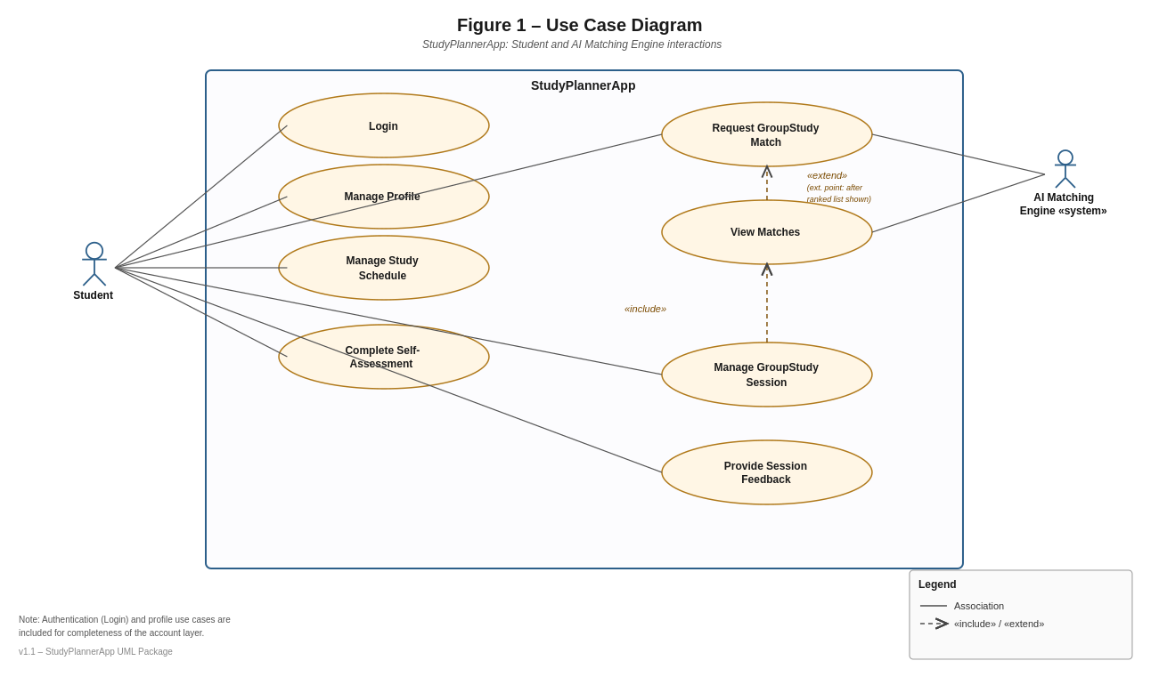
Figure 1. Use case diagram for StudyPlannerApp (v1.1).
What changed in v1.1
- Added Login and Manage Profile so the authentication/account layer is explicit rather than assumed.
- Modelled «extend» from “View Matches” to “Request GroupStudy Match”, with an explicit extension point (after the ranked list is shown) — viewing matches is an optional continuation, not a mandatory step.
- Modelled «include» from “Manage GroupStudy Session” to “View Matches”, since a session cannot be scheduled without first seeing/selecting a match.
- Kept the relationship set deliberately small, per Larman's guidance to prefer include over extend/generalize and to avoid over-modelling use-case relationships at the expense of writing the use-case text itself.

3.1 Use Case Summary
Use Case | Primary Actor | Brief Description
Login | Student | Authenticate with email/password and receive a session (JWT).
Manage Profile | Student | View/update personal and academic profile details.
Manage Study Schedule | Student | Create, update, delete, and view personal study sessions.
Complete Self-Assessment | Student | Rate confidence/performance per subject; feeds the AI matching model.
Request GroupStudy Match | Student (+ AI Matching Engine) | Trigger the AI engine to propose compatible study partners for a subject.
View Matches | Student (+ AI Matching Engine) | Browse the ranked list of proposed matches and their compatibility scores.
Manage GroupStudy Session | Student | Accept a match, schedule/coordinate the session, track its status.
Provide Session Feedback | Student | Rate a completed GroupStudy session to improve future matching.

4. Domain Model (Class Diagram)
The domain model captures the core conceptual entities of StudyPlannerApp: Student, Subject, StudySession, SelfAssessment, Match, GroupStudySession, and Feedback — plus a new StudyTimetable aggregate. Students schedule study sessions against subjects, submit self-assessments per subject (the input vector for the AI matching model), and are paired through matches that produce GroupStudy sessions, which in turn receive feedback.
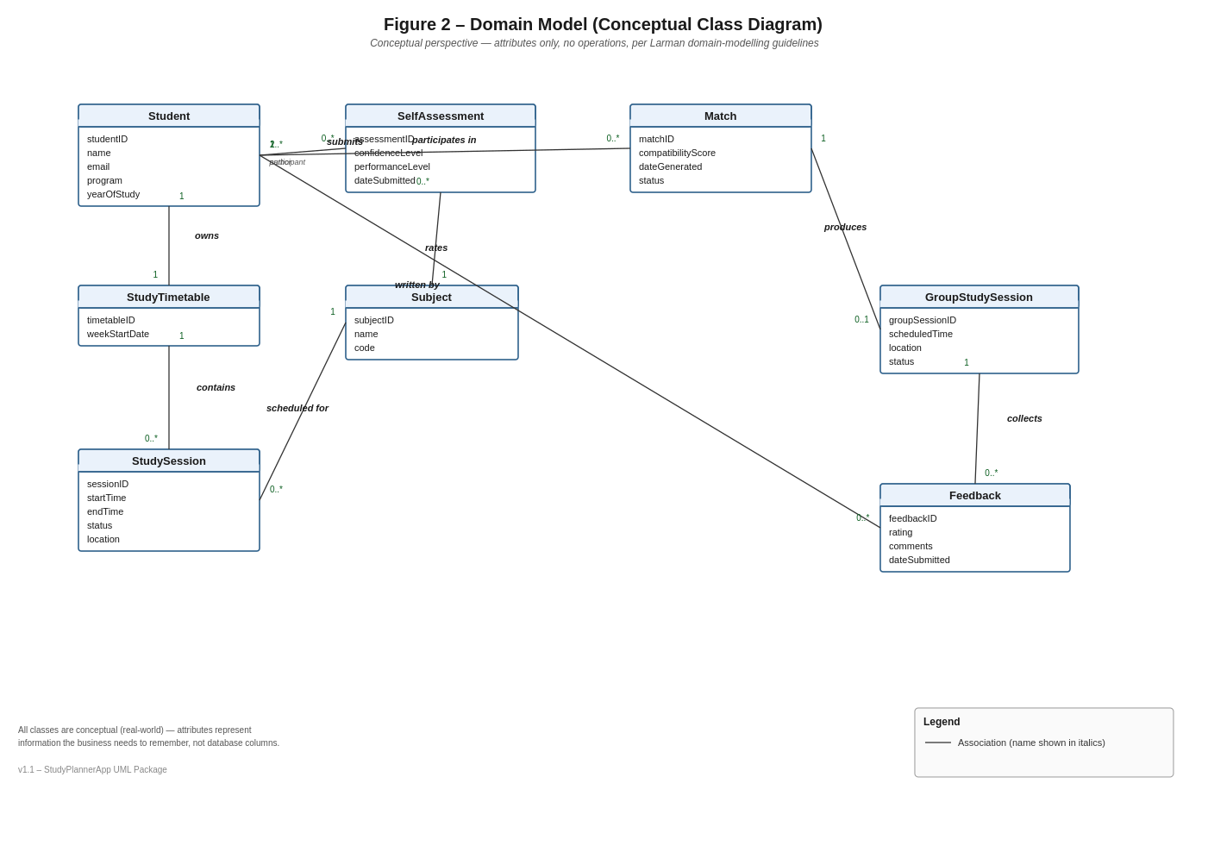
Figure 2. Conceptual domain model with multiplicities and role names (v1.1).
What changed in v1.1
- Removed all method/operation compartments — this is strictly a conceptual model per Larman Ch. 9 (“a domain model is not a picture of software objects”); operations will appear later in the Design Class Diagram during the design phase.
- Added multiplicities to every association (e.g., Student “1” owns “1” StudyTimetable; StudyTimetable “1” contains “0..*” StudySession; Student “2..*” participates in “0..*” Match).
- Added role names where the relationship is not self-evident (e.g., “participant” on Student–Match, “author” on Student–Feedback).
- Introduced StudyTimetable as an aggregate owned by Student and containing many StudySession instances, since a student may accumulate many sessions across a term — this keeps Student itself from becoming an information dumping ground and mirrors the “container creates contents” Creator pattern that will be used in the design model.
- Deliberately excluded the AI Matching Engine as a domain class — it is a secondary actor/external system, not a real-world concept, consistent with the guidance not to model software artifacts inside the domain model.

5. Sequence Diagram – AI Peer Matching Flow
This sequence diagram traces the runtime interaction that fulfils Objective 3 of the proposal: a student requests a GroupStudy match after completing a subject self-assessment. The backend API fetches the candidate pool from the database, delegates compatibility scoring to the AI matching service, and returns ranked matches to the frontend for display.
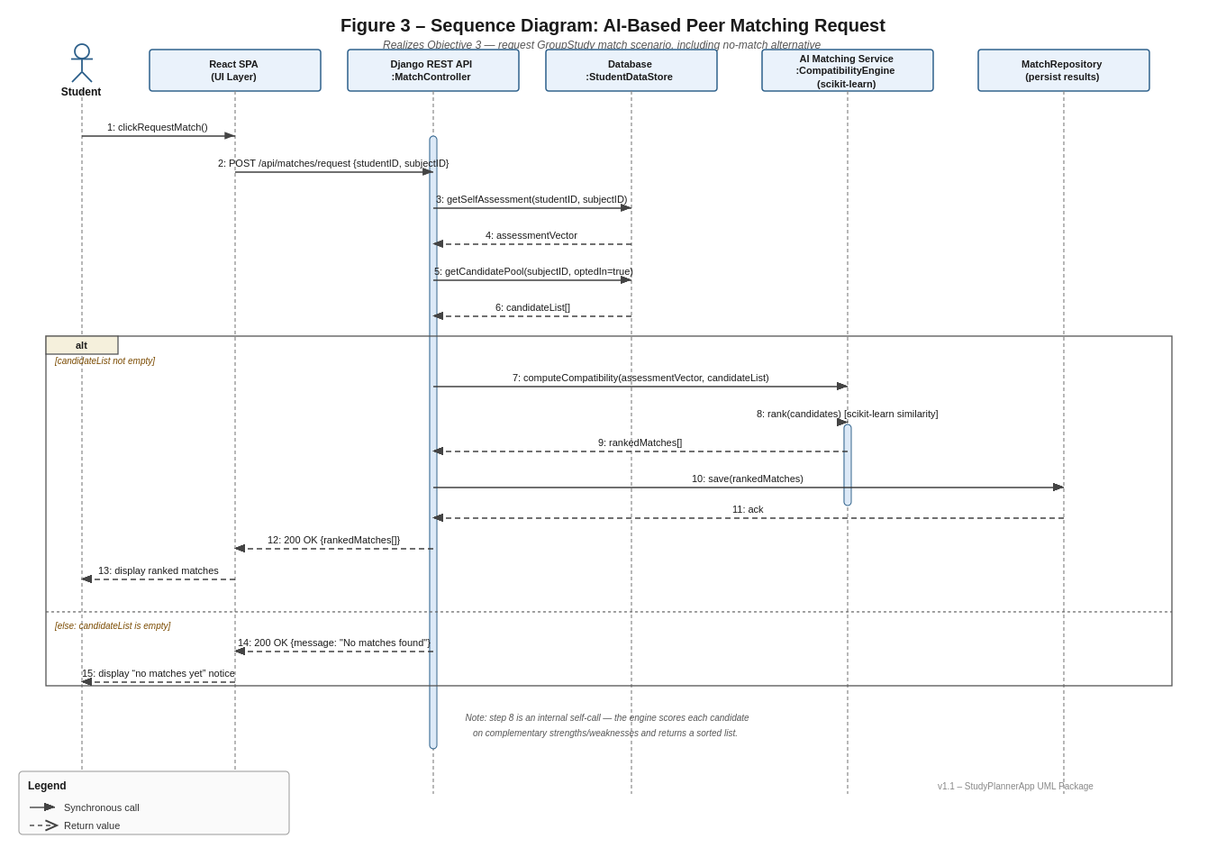
Figure 3. Sequence diagram for the AI-based peer matching request, including the no-match alternative (v1.1).

What changed in v1.1
- Made the layer boundaries explicit: Student → React SPA (UI) → Django REST API → Database, and Django REST API → AI Matching Service (scikit-learn) → MatchRepository, matching the layered System Architecture diagram (Section 7).
- Added an alt combined fragment with two guarded branches: [candidateList not empty] runs the scoring flow; [else] returns a “no matches found” response — previously only the happy path was implied.
- Made the AI scoring step explicit as a self-call (rank candidates) inside the AI Matching Service lifeline, showing that ranking happens inside the engine rather than in the API layer.
- Persisted ranked results via a MatchRepository call before returning to the UI, so the Match/GroupStudySession domain objects are populated as soon as a request succeeds (supports later audit/history and repeat views).

6. Entity Relationship (ER) Diagram
The ER diagram maps the domain model onto the relational schema to be implemented in MySQL (production) and SQLite (local development). It introduces the MATCH_PARTICIPANT junction table, which does not appear as a separate class in the domain model but is required to represent the many-to-many relationship between students and matches.
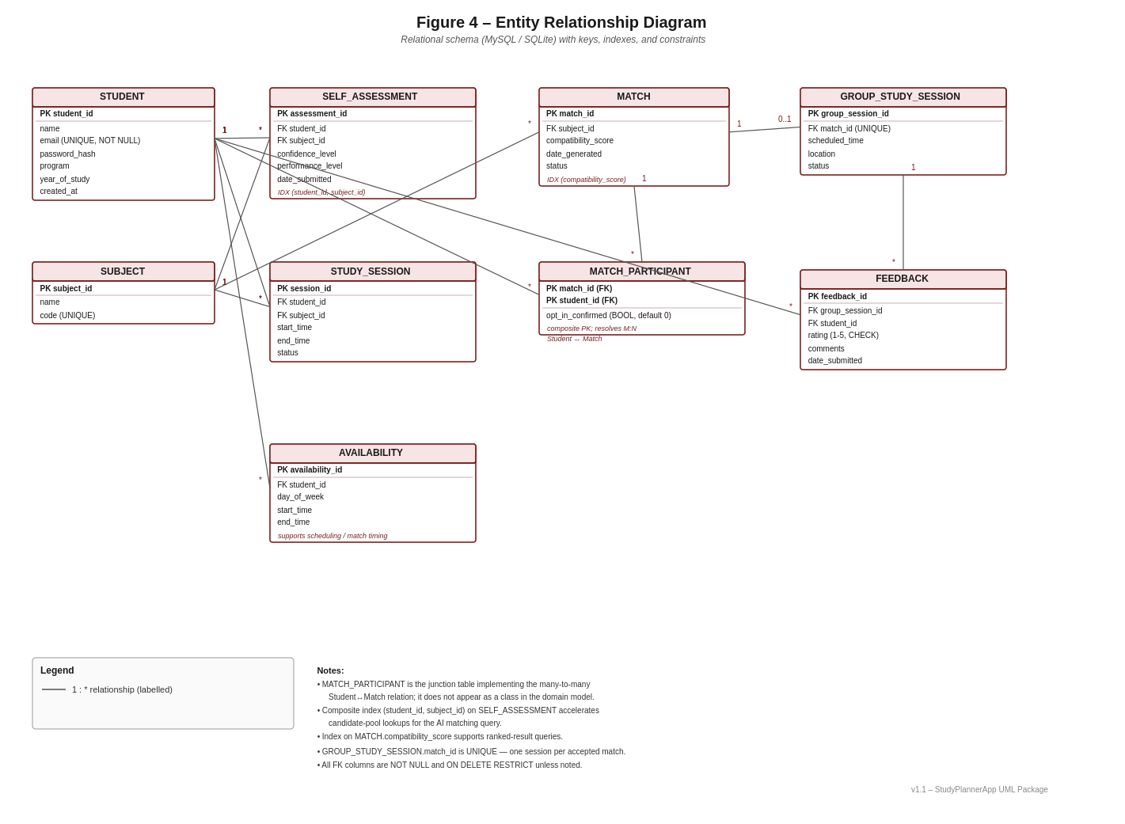
Figure 4. Entity relationship diagram with indexes and constraints (v1.1).
What changed in v1.1
- Added a composite index on SELF_ASSESSMENT(student_id, subject_id) to accelerate the candidate-pool lookup that the AI matching query performs on every match request.
- Added an index on MATCH.compatibility_score to support fast ranked-result queries.
- Marked key constraints explicitly: STUDENT.email UNIQUE NOT NULL, SUBJECT.code UNIQUE, GROUP_STUDY_SESSION.match_id UNIQUE (one session per accepted match), FEEDBACK.rating CHECK (1–5), and NOT NULL / ON DELETE RESTRICT on foreign keys unless otherwise noted.
- Added a new AVAILABILITY table (student_id FK, day_of_week, start_time, end_time) so the matching and scheduling logic has a concrete source of “when is this student free” data, rather than inferring it from StudySession alone.
- Kept MATCH_PARTICIPANT as a composite-key junction table (match_id, student_id) carrying an opt_in_confirmed flag, resolving the Student–Match many-to-many relationship at the database level.

7. System Architecture Diagram
StudyPlannerApp follows a three-tier architecture, consistent with Section 3 of the project proposal. The presentation tier is a React.js single-page application. The application tier is a Django REST Framework API, which hosts the core business logic (authentication, scheduling, GroupStudy coordination) alongside a dedicated AI matching service built with scikit-learn, Pandas, and NumPy. The data tier uses MySQL in production and SQLite for local development.
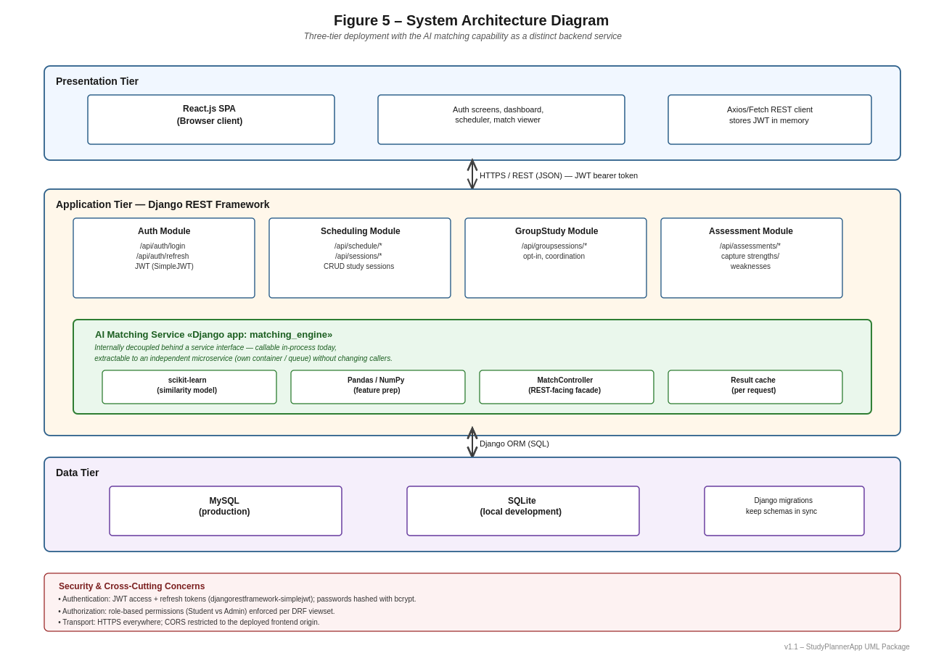
Figure 5. Three-tier system architecture, with the AI matching service called out explicitly (v1.1).
What changed in v1.1
- Clarified that the AI matching capability lives as its own Django app (matching_engine) inside the same backend process today — called in-process by the MatchController — but is deliberately isolated behind a service interface so it can be extracted into an independent microservice (its own container/queue) later without changing callers.
- Named the concrete REST endpoint groups per module (e.g., /api/auth/login, /api/schedule/*, /api/assessments/*, /api/groupsessions/*) so the diagram doubles as a lightweight API map.
- Made authentication explicit: JWT access + refresh tokens via djangorestframework-simplejwt, bcrypt password hashing, and role-based DRF permissions — consistent with Section 3.2 (Ethical and Legal Considerations) of the proposal.
- Added a cross-cutting “Security & Cross-Cutting Concerns” panel covering transport security (HTTPS) and CORS restriction to the deployed frontend origin.

8. Low-Fidelity Wireframe References
These sketches are included for design discussion only and they are not a final UI specification but they help ground the use cases and domain model in a concrete interface, and they clarify what data each screen needs from the domain model above.
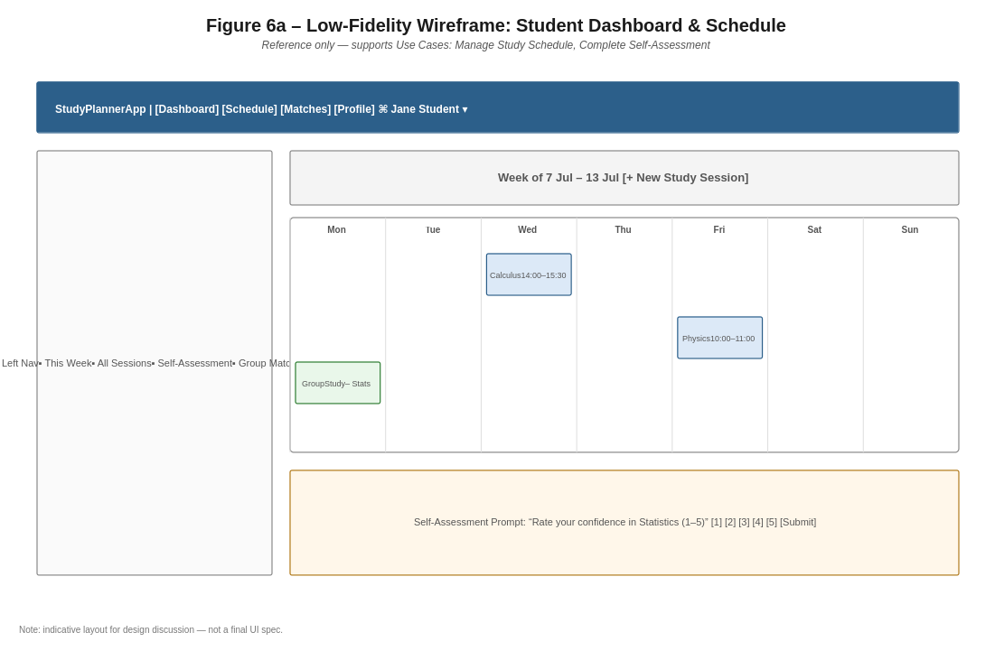
Figure 6a. Dashboard & schedule wireframe — supports Manage Study Schedule and Complete Self-Assessment.
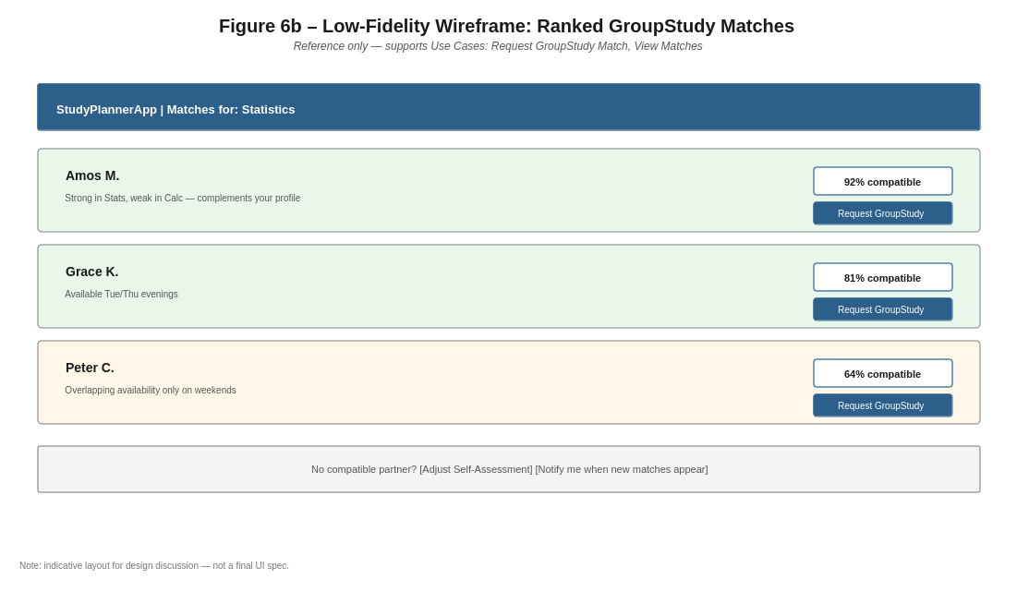
Figure 6b. Ranked matches wireframe — supports Request GroupStudy Match and View Matches.

9. Consistency Check Against the Project Proposal
The table below cross-checks each diagram against the measurable objectives and constraints defined in the project proposal, to confirm the design package stays aligned as it evolves.
Proposal Requirement | Where Addressed in This Package
Objective 1: scheduling module (React + Django, 10 weeks) | Use Case: Manage Study Schedule; Domain: StudyTimetable/StudySession; Architecture: Scheduling Module.
Objective 2: optional GroupStudy feature, opt-in | Domain: MATCH_PARTICIPANT.opt_in_confirmed; Use Case: Manage GroupStudy Session; ER: opt-in flag.
Objective 3: AI matching ≥ 75% user-perceived relevance, evaluated vs. random pairing | Sequence Diagram (AI Matching Flow); Domain: Match.compatibilityScore, Feedback.rating as the measurement input for the relevance metric.
Objective 4: usability testing, ≥ 85% task completion, 20+ students | Use case set is small and goal-oriented (per Larman's Boss/EBP/Size tests) to keep tasks completable; wireframes give testers a concrete walkthrough.
Data privacy: bcrypt password hashing, no plaintext storage | Architecture Security panel; ER STUDENT.password_hash column.
Anonymisation: students cannot see each other's raw assessment data | Domain: SelfAssessment is only ever read by the AI Matching Engine actor, never exposed directly to another Student in any use case.
Fairness of the AI model across performance levels | Sequence Diagram alt frame ensures a defined, non-silent response (“no matches found”) rather than an ambiguous failure for any student profile.

10. Summary of Improvements Applied
This tracks the six prioritised improvement areas raised in review, so they can be verified at a glance before this package is finalised.
# | Priority Area | Status | Notes
1 | Class Diagram / Domain Model | Done | Conceptual only (no operations); multiplicities and role names added; StudyTimetable aggregate introduced.
2 | Use Case Diagram | Done | AI Matching Engine retained as secondary actor; include/extend added; Login/Manage Profile added.
3 | Sequence Diagram (AI Matching) | Done | Frontend→API→AI Service→DB flow shown; alt frame added for the no-match case.
4 | ER Diagram | Done | Indexes on (student_id, subject_id) and compatibility_score; constraints noted; AVAILABILITY table added.
5 | System Architecture | Done | AI service located explicitly as a Django app with an extraction path; REST endpoints and JWT auth documented.
6 | General Polish | Done | Legend added (Section 2); versioned as v1.1 and dated; wireframes added (Section 8); consistency check added (Section 9).
Appendix A: User Stories with Acceptance Criteria
These stories operationalise the use cases in Section 3 for sprint planning and testing. Each maps to exactly one use case so traceability is preserved end to end from proposal objective → use case → domain model → story → test.
US-01: Login — Priority: High
As a registered student, I want to log in with my university email and password, so that I can securely access my personal study data.
Acceptance Criteria:
- Given a registered account with a verified email When I submit correct credentials Then I receive a JWT access/refresh token pair and land on my Dashboard.
- Given an incorrect password When I submit the login form Then I see a generic “invalid credentials” error and no token is issued (no hint whether the email exists).
- Given 5 consecutive failed attempts within 10 minutes When I try again Then the account is temporarily locked and I am shown a cool-down message.
US-02: Manage Profile — Priority: Low
As a student, I want to view and update my profile (program, year of study, contact details), so that my account information stays accurate and my matches reflect who I actually am.
Acceptance Criteria:
- Given I am logged in When I open Manage Profile Then I see my current program, year of study, name, and email pre-filled.
- Given I change my year of study and save When the update succeeds Then the new value is persisted and reflected immediately on my Dashboard.
- Given I leave a required field blank When I try to save Then I see an inline validation message and the save is blocked.
US-03: Manage Study Schedule — Priority: High
As a student, I want to create, edit, and delete study sessions on my personal timetable, so that I can plan and track my individual study time by subject.
Acceptance Criteria:
- Given I am on my Schedule view When I add a new session with a subject, start time, and end time Then the session appears on the calendar grid and is saved to my StudyTimetable.
- Given a session I own When I edit its time or delete it Then the change is reflected immediately and no other student's schedule is affected.
- Given I try to create a session whose end time is before its start time When I submit the form Then the system rejects it with a clear validation message.
US-04: Complete Self-Assessment — Priority: High
As a student, I want to rate my confidence and performance for each subject I study, so that the AI matching model has accurate input to pair me with complementary peers.
Acceptance Criteria:
- Given I select a subject I am enrolled in When I submit a confidence and performance rating (1–5) Then a SelfAssessment record is saved with a timestamp.
- Given I have already rated a subject this term When I submit a new rating for the same subject Then the existing SelfAssessment is updated (not duplicated), preserving one current rating per student/subject.
- Given no SelfAssessment exists yet for a subject When I request a GroupStudy match for that subject Then I am prompted to complete the self-assessment first, per the matching precondition.
US-05: Request GroupStudy Match — Priority: High
As a student, I want to ask the system to find a compatible study partner for a subject, so that I can benefit from complementary strengths and weaknesses rather than random pairing.
Acceptance Criteria:
- Given I have a current SelfAssessment for a subject and there are opted-in candidates When I click “Request GroupStudy Match” Then the AI Matching Service scores the candidate pool and I am shown a ranked list within an acceptable response time.
- Given no opted-in candidates exist for that subject When I request a match Then I see a clear “no matches found” message with an option to be notified later (per the sequence diagram's alt/else branch).
- Given a successful match request When results are returned Then the Match record (and its compatibility_score) is persisted so it can be reviewed later and used for the ≥ 75% relevance evaluation against random pairing.
US-06 : View Matches — Priority: Medium
As a student, I want to browse my ranked list of proposed study partners and their compatibility scores, so that I can decide who to reach out to.
Acceptance Criteria:
- Given a completed match request When I open View Matches Then I see each candidate's name, compatibility score, and a short rationale (e.g., complementary strengths/weaknesses).
- Given I am viewing the ranked list When I select “Request GroupStudy” on a candidate Then a GroupStudySession is created/pending and I am taken to Manage GroupStudy Session.
- Given the extension point is reached (ranked list shown) When no candidate is selected within the session Then the list remains accessible from the Matches tab for later action.
US-07: Manage GroupStudy Session — Priority: Medium
As a student, I want to accept a proposed match and coordinate the session's time and status, so that my group study actually happens and is tracked to completion.
Acceptance Criteria:
- Given a pending match I selected When the other student also opts in Then MATCH_PARTICIPANT.opt_in_confirmed is set for both, and a GroupStudySession is scheduled.
- Given an upcoming GroupStudySession When I update its time or location Then the change is visible to all participants of that session.
- Given a session's scheduled time has passed When I mark it complete Then its status changes to “completed” and it becomes eligible for feedback (US-08).
US-08: Provide Session Feedback — Priority: Medium
As a student, I want to rate a completed GroupStudy session, so that future matches improve based on real outcomes.
Acceptance Criteria:
- Given a GroupStudySession with status “completed” that I participated in When I submit a rating and optional comment Then a Feedback record is saved, linked to that session and to me as author.
- Given a session that has not yet occurred When I try to leave feedback Then the option is not available (feedback is only enabled for completed sessions).
- Given aggregated Feedback ratings over time When the team evaluates Objective 3 Then they can be compared against random pairing to test the ≥ 75% user-perceived relevance target.

