Supermarket POS System
Elaboration Artifacts: Fully-Dressed Use Case & UML Design
CSC4630 — Group 28
Prepared following the Unified Process approach (Larman, Applying UML and Patterns)
Elaboration Phase — Iteration 1
This document carries the Supermarket POS project from Inception into Elaboration. It contains: (1) the fully-dressed Process Sale use case, (2) the Use-Case Diagram, (3) the conceptual Domain Model, (4) System Sequence Diagrams for the core scenario and the mobile-money payment extension, (5) a Design Class Diagram showing the GRASP and GoF patterns applied, and (6) the layered logical architecture that hosts them. Together these are the inputs needed to begin Iteration-1 construction.

1. Fully-Dressed Use Case

UC1: Process Sale
Scope | Supermarket POS System
Level | User goal
Primary Actor | Cashier

Stakeholders and Interests
- Cashier — wants fast, accurate entry; no cash drawer shortfalls blamed on them.
- Customer — wants a fast checkout and an accurate receipt.
- Manager / Owner — wants accurate sales and stock data for reporting and decisions.
- Stock Clerk — wants inventory correctly decremented after every sale.
- Mobile Money Provider (MTN MoMo / Airtel Money) — wants correctly formatted, authenticated payment requests.
- Supermarket (business) — wants sales captured even during power/internet outages.

Preconditions
Cashier is logged in; register/session is active.

Success Guarantee (Postconditions)
Sale is saved; total (with tax and discounts) is correctly calculated; inventory is updated; payment is recorded; receipt is generated; if offline, the sale is queued for sync when connectivity returns.

Main Success Scenario
- Customer arrives at checkout with items to purchase.
- Cashier starts a new sale.
- Cashier scans or manually enters an item identifier.
- System looks up the product description and price, records a sale line item, and displays the running total.
- Cashier repeats steps 3–4 for each item.
- Cashier signals that item entry is complete.
- System calculates the sale total, including tax and any applicable discounts.
- Cashier informs the customer of the total and requests payment.
- Customer pays; System handles the payment.
- System updates inventory quantities for each sold item.
- System logs the completed sale (for reporting) and generates a receipt.
- Customer leaves with the receipt and goods.

Extensions
3a. Item identifier not found / barcode unreadable:
  - System signals the error.
  - Cashier manually enters the item code, or looks up the product by name/category.
5a. Cashier removes (voids) a line item:
  - If within the cashier's void limit, System removes the item and updates the total.
  - If over the limit, Manager override is required.
7a. Customer qualifies for a discount (e.g., staff, bulk purchase promotion):
  - Cashier applies the discount code; System recalculates the total.
9a. Paying by cash:
  - Cashier enters amount tendered.
  - System calculates change due and records the cash payment.
9b. Paying by mobile money (MTN MoMo / Airtel Money):
  - Cashier selects mobile money and enters the customer's phone number.
  - System sends a payment request to the provider and awaits confirmation.
  - On approval, System records the payment.
  - 9b-1a. Timeout / no confirmation: System signals the delay to the Cashier, who may retry or offer an alternate payment method.
  - 9b-2a. Payment declined: System signals denial; Cashier requests an alternate payment method.
9c. Paying by card:
  - Cashier swipes/taps card; System sends an authorization request and awaits approval.
  - On approval, System records the payment.
9d. Split or partial payment:
  - Customer pays part of the total by one method; System records the partial payment and shows the remaining balance.
  - Repeat 9a–9c for the remaining balance.
*a. At any time, System loses network connectivity:
  - System switches to offline mode, using locally cached product data.
  - Sale and any card/mobile-money-dependent steps that can't complete are queued locally.
  - When connectivity returns, System syncs queued sales and pending payment confirmations.
*b. At any time, Manager override is required (price override, void beyond limit, refund):
  - System enters manager-authorized mode; Manager or Cashier performs the override; System reverts to normal mode.

Special Requirements
- Must function in offline mode with local caching and later synchronization.
- Mobile money confirmation should time out gracefully rather than block checkout indefinitely.
- Receipt must be printable (or at minimum an on-screen printable summary).
- Should run on standard desktop hardware — no specialized POS terminal required.

2. Use-Case Diagram
The Cashier is the primary actor for Process Sale; Manager, Stock Clerk, and Administrator support inventory, reporting, and user management. MTN MoMo, Airtel Money, and the Card Payment Service are supporting (external) actors consulted during payment handling.
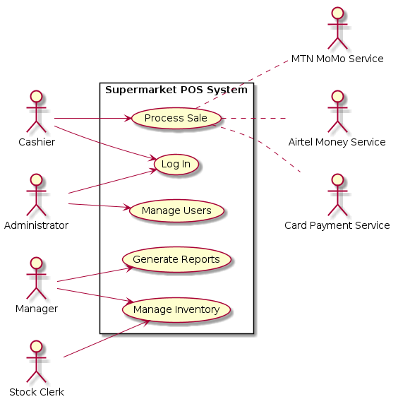
Figure 1. Use-Case Diagram — Supermarket POS System

3. Domain Model (Conceptual Class Diagram)
This is a conceptual perspective — real-world things and their associations, not software classes — built directly from the noun phrases in the use case text (Larman, Ch. 9). Payment is generalized into CashPayment, MobileMoneyPayment, and CardPayment because each is handled differently, satisfying the generalization criteria from Ch. 32.
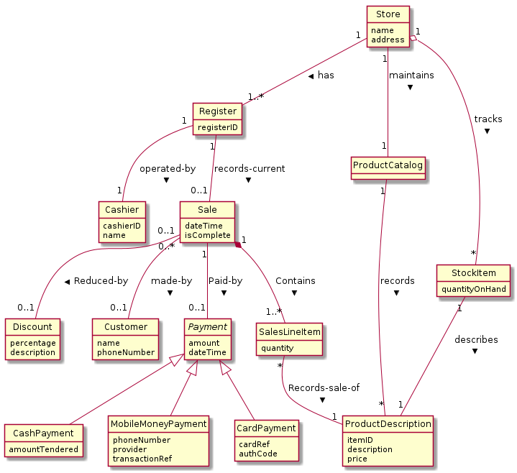
Figure 2. Domain Model — Supermarket POS

4. System Sequence Diagrams
SSDs treat the POS system as a black box and show only the system operations an actor invokes — these become the starting messages into the Controller during object design (Larman, Ch. 10).

4.1 Main Success Scenario — Cash Payment
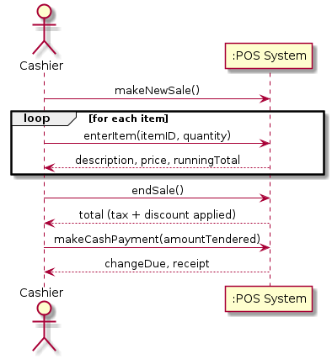
Figure 3. SSD — Process Sale, cash payment

4.2 Extension 9b — Mobile Money Payment
Illustrates the approved / declined / timeout branches identified as Extensions 9b and 9b-1a/2a in the use case.
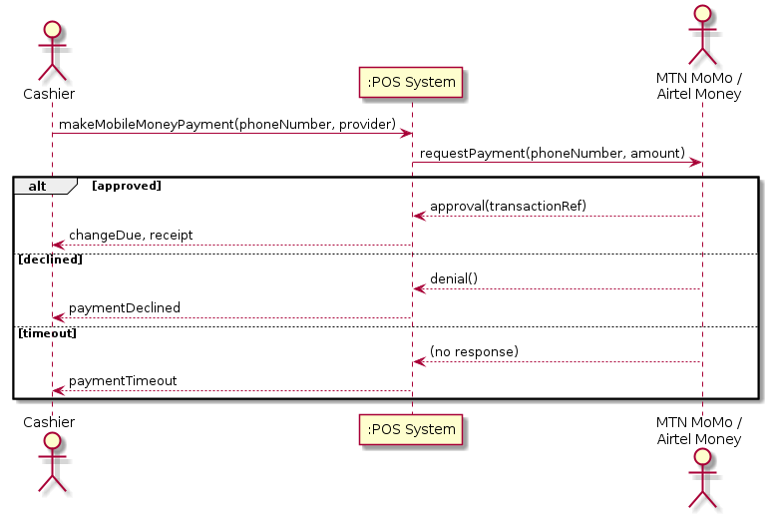
Figure 4. SSD — Process Sale, mobile money payment extension

5. Design Class Diagram — GRASP & GoF Patterns Applied
This is the software (design) perspective. Responsibilities are assigned using GRASP (Controller, Creator, Information Expert, Polymorphism), and the recurring variability points identified during architectural analysis are resolved with GoF patterns: Strategy (pricing/discounts), Adapter (payment providers), Factory (adapter creation), Proxy (offline failover), and Observer (UI refresh without breaking Model-View Separation).

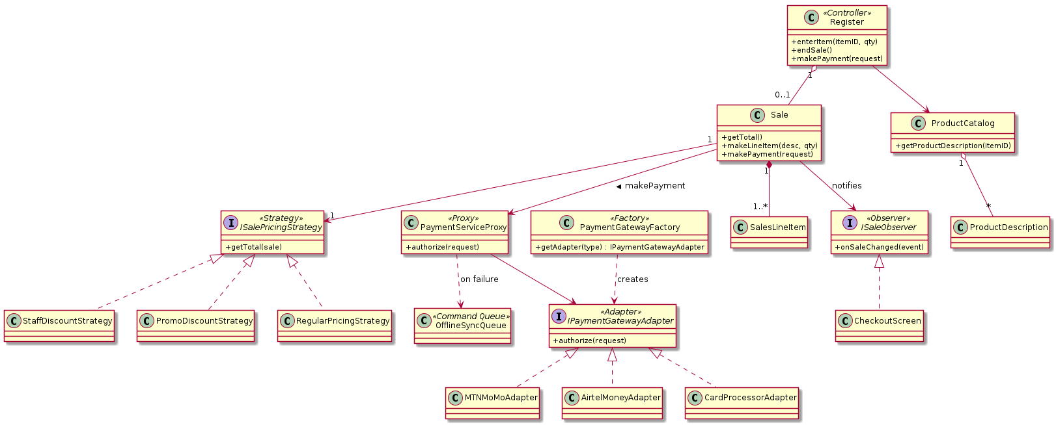
Figure 5. Design Class Diagram — partial, showing pattern application

5.1 Traceability: Use Case → System Operation → Pattern
Use Case Step | System Operation | Design Responsibility / Pattern Applied
2. Cashier starts a new sale | makeNewSale() | Register (Controller) creates the Sale (Creator)
3–4. Enter item | enterItem(itemID, qty) | ProductCatalog (Information Expert) looks up ProductDescription; Sale creates SalesLineItem (Creator)
7. Calculate total | endSale() → getTotal() | Sale delegates to ISalePricingStrategy (Strategy); SalesLineItem is Expert for its own subtotal
9a. Cash payment | makeCashPayment(amount) | Polymorphic CashPayment (Polymorphism); routed through PaymentServiceProxy (Proxy)
9b. Mobile money payment | makeMobileMoneyPayment(phone, provider) | PaymentGatewayFactory (Factory) selects MTNMoMoAdapter / AirtelMoneyAdapter (Adapter)
9c. Card payment | makeCardPayment(cardRef) | CardProcessorAdapter (Adapter)
*a. Connectivity lost | any payment / inventory call | PaymentServiceProxy redirects to OfflineSyncQueue (Proxy + Command)
Running total display | (internal notification) | Sale notifies ISaleObserver (Observer) → CheckoutScreen

6. Logical Architecture — Layered View

A relaxed layered architecture (Larman, Ch. 13/34): the UI layer never contains application logic, and the Domain layer never references UI classes directly (Model-View Separation, realized here via the Observer pattern). The Technical Services layer isolates payment-provider variability and offline resilience so the Domain layer stays free of those concerns.
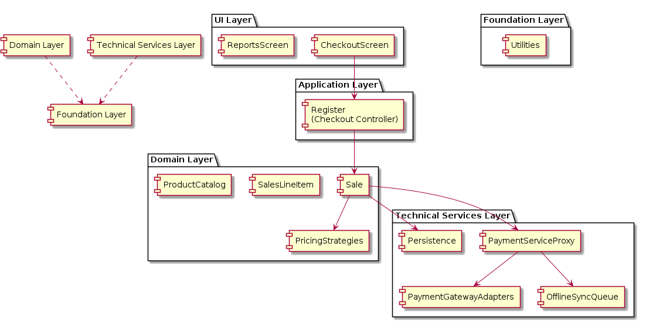
Figure 6. Package Diagram — Layered Logical Architecture

6.1 Notes on Key Decisions
- PaymentServiceProxy tries the real gateway adapter first and redirects to OfflineSyncQueue on failure — directly resolves the top-ranked project risk (unreliable power/internet).
- PaymentGatewayFactory reads the selected payment type and returns the matching adapter, so adding a new provider later requires no change to Sale or Register.
- ISalePricingStrategy keeps discount rules (staff, promo) out of Sale, supporting Protected Variations as discount policy changes.
- Sale never references CheckoutScreen directly; it notifies through ISaleObserver, preserving low coupling between the Domain and UI layers.
Next steps: operation contracts for makePayment (per provider), the persistence/data model, and Iteration-1 construction of Register, Sale, and the payment adapters.

