# CHAPTER FOUR

# CONSTRUCTION AND TESTING

* 1. Preliminary Tests

This section covers all tests performed on the various components to ensure they were in the right working order before everything was put together. The tests performed will be highlighted with reasons for the choices made. The following sections will cover all preliminary tests before construction begins.

* + 1. H-Bridge Test

The test was purposed to ascertain whether an H-Bridge would be the most viable option to drive our motor. As we aimed to efficiently control our motor's speed, direction, and torque, the H-Bridge was the first option, as it was low-cost and easy to build. Below is an image of the circuit built for the test.

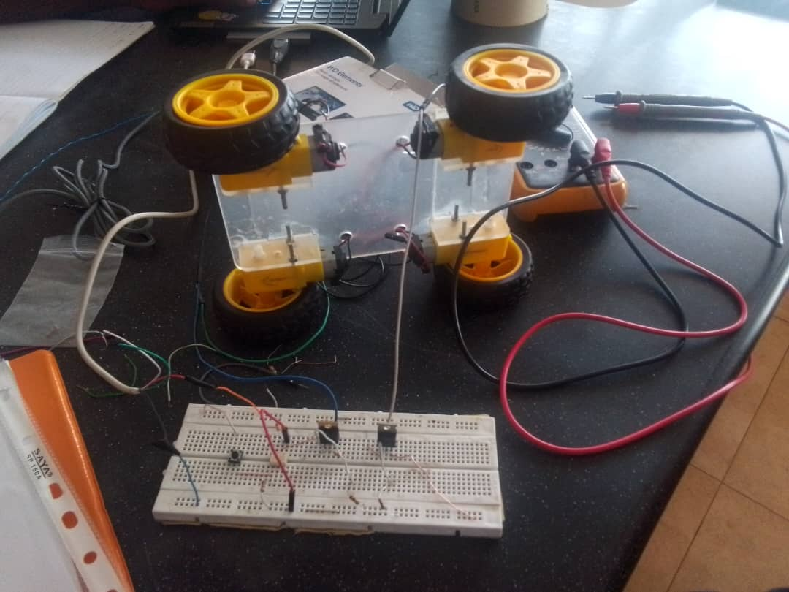*Figure 4.1: H-Bridge Test*

The test on the H-Bridge succeeded, enabling us to purchase the L293D IC, a quadruple high-current half H-Bridge for bidirectional drive current. The motor driver is designed to drive two motors simultaneously.

* + 1. MQ Sensor Test

The selected gas sensors for this project were MQ Sensors. Before the test began, the sensors were allowed to heat for 20 hours on first-time use to allow for proper calibration for better sensitivity. After calibration of the sensors, they were connected to an ESP32, one of the microcontrollers for the project. A test code was developed to test its gas sensitivity to gases. The test yielded positive results. Below is an image of the connection and test code.

* + 1. Thermal Camera Test

The thermal camera was tested in two ways. The first test was to transmit sensor data via serial as a series of numbers to determine the temperature changes, and the second test involved visualising the data to create a heatmap. The thermal camera was connected to an ESP32, and test codes were developed to program it for both processes. The test yielded positive results as we could visualise the temperature changes using a heatmap and transmit the temperature changes via I2C as a series of numbers. Below is an image of the setup for this test and the test codes.

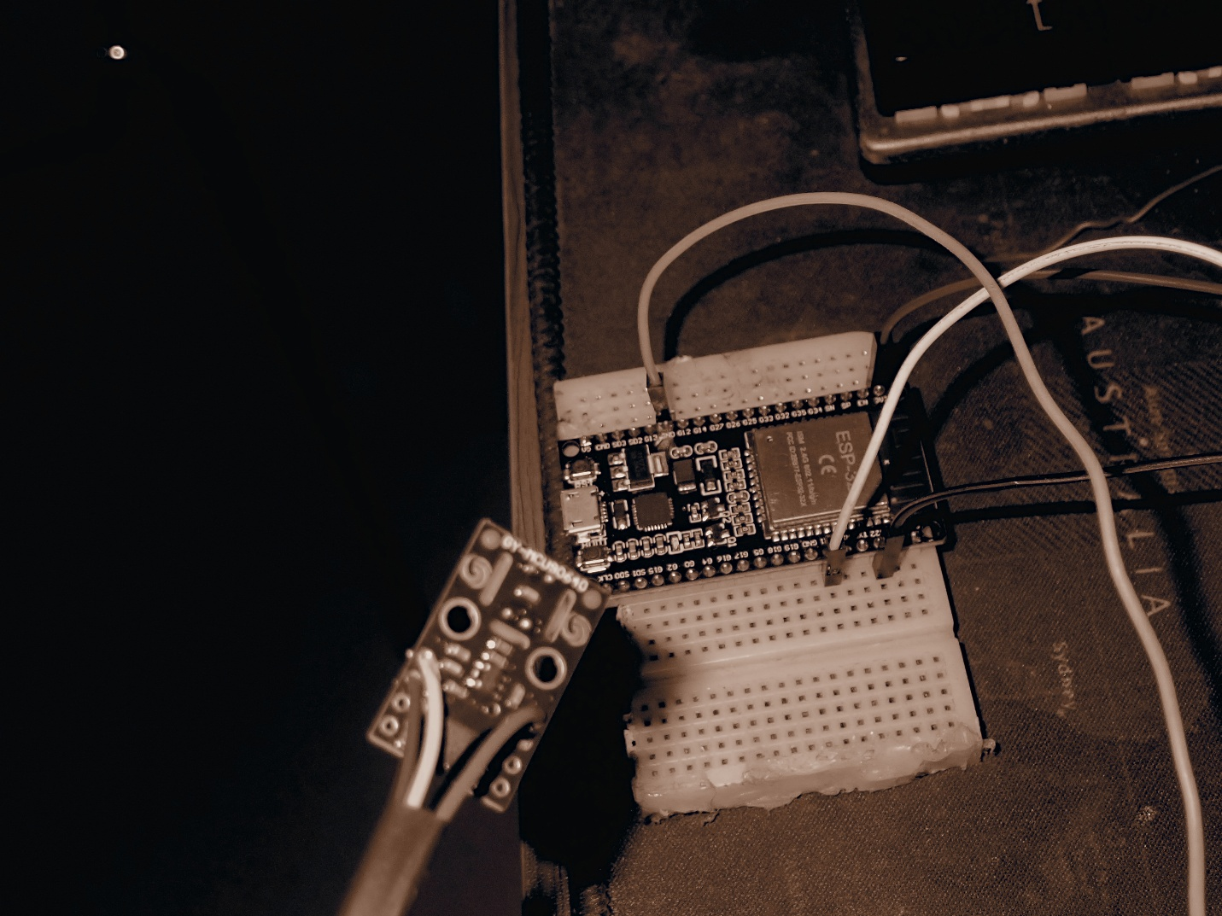

* + 1. Ultrasonic Sensor

The test for the ultrasonic sensors was performed in multiple ways. All ultrasonic sensors were tested individually in the first test, and their results were noted. Three were then connected and tested together, yielding a positive result. The sensors could measure distance as programmed, and later two more were added and tested to make it five. A filtering algorithm was created to improve the desired distance by removing surrounding noise. Below is an image of the setup.

* + 1. GPS Test

This test involved programming and ensuring the GPS could give precise location data with little to no errors. The test was performed outside as it made it easier for the module to connect to satellites and transmit and receive data. This test yielded positive results and gave the precise location needed. Below is an image of the test setup.

* 1. Customisation and Assembly

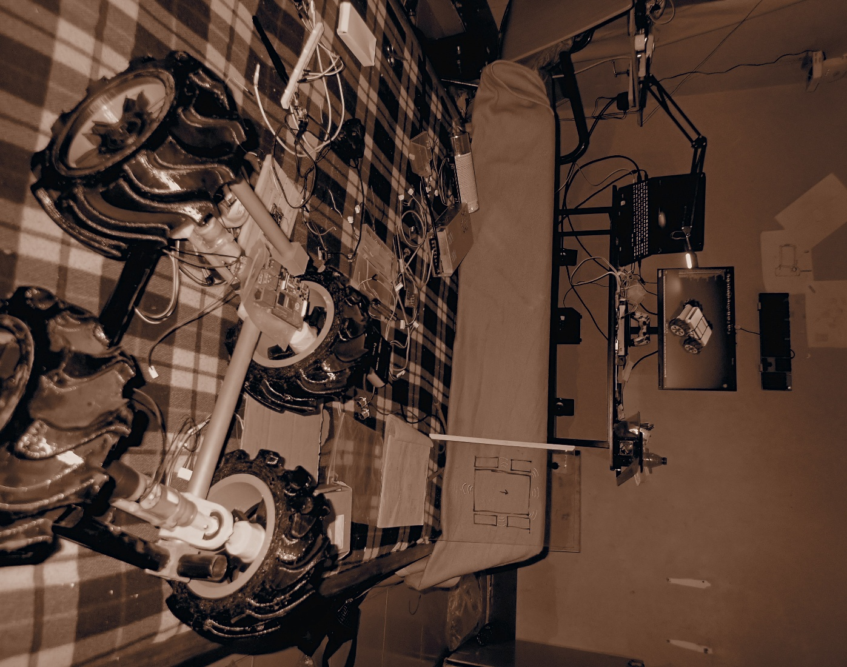This section covers the assembly process and how parts were customised to meet our needs.

* + 1. Customization

Certain components were unavailable at the start of the project; hence, they were customised to meet our needs. We used AutoCAD Fusion to design our tyres and the frame of our bot, which we put together using recess and glue. We also developed our battery pack using nine 3.7-volt lithium-ion batteries, connecting them in a 3S3P format to meet the voltage and current requirements to move our bot. A charging module was also included to enable us to charge the battery when drained. Below are images of the tyre and the entire frame put together.

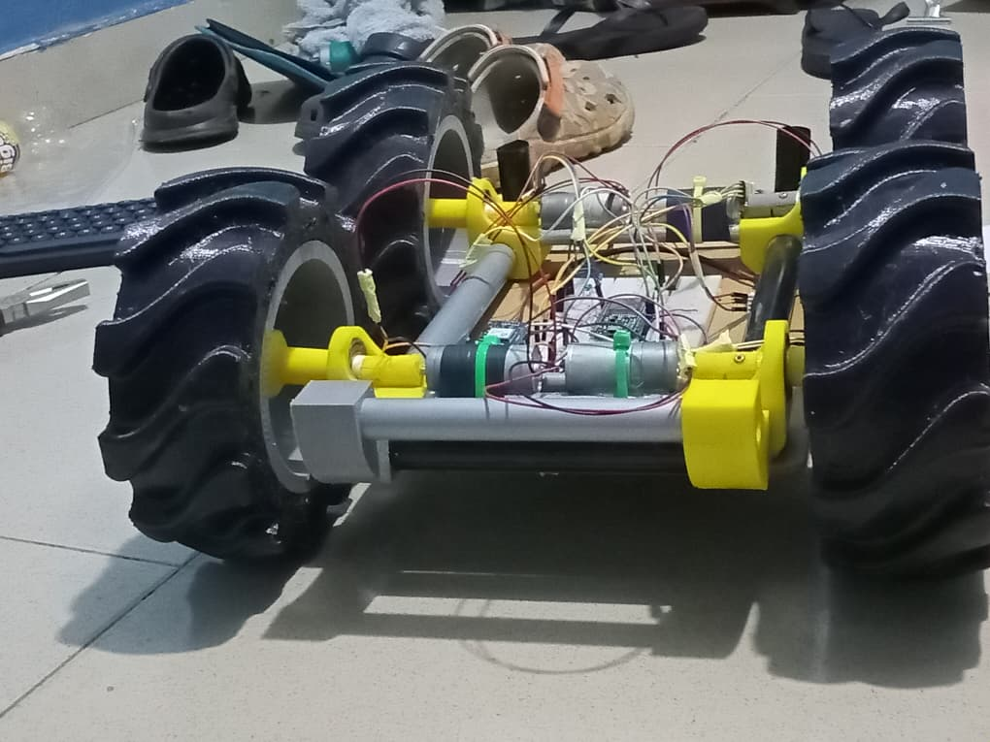

* + 1. Assembly

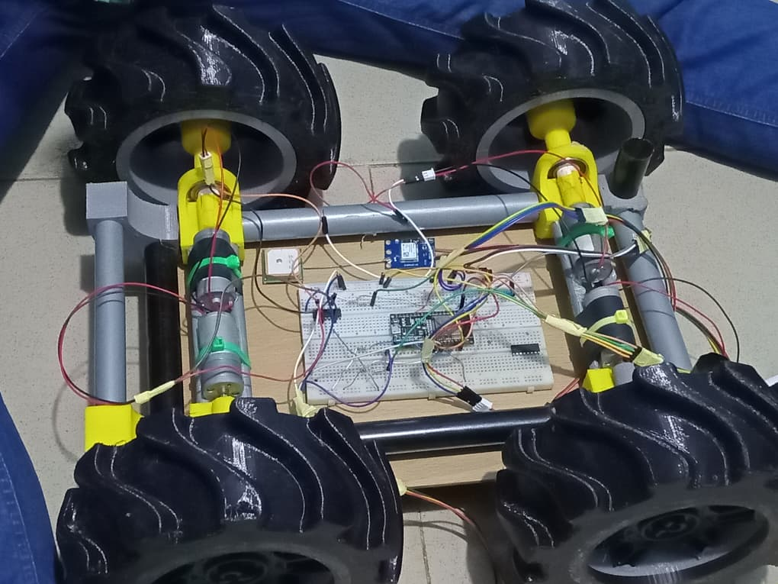This section covers the complete connection of all components to function cohesively as one unit. The system was connected such that the ultrasonic sensors communicate with the motors when an obstacle is detected, allowing it to change its path to one where there is no obstacle or a path with a leeway to pass between obstacles, all while calculating its position relative to its destination. The MQ sensors detect the presence of gas in the air and transmit the data to the webapp dashboard for viewing, along with the coordinates of the location where the gas was detected.

* 1. Final Test and Results

This section covers the final test conducted after full assembly and the results displayed on the webapp. After completion, the bot was tested in an enclosed space and allowed to navigate. The bot was able to identify and localise the gas leakage and transmit the coordinates of the leakage location. The dashboard could display the leakage concentration using a scale that increases from white to red, with red indicating the excessive presence of gas. Through the dashboard, we could monitor and send commands to the bot. We were also able to see the robot’s exact location through GPS. We visualised the value of the leaked gas through a graph.

# CHAPTER FIVE

# CONCLUSION AND RECOMMENDATION

* 1. Conclusion

This project presents a way to check for gas leakages and thermal anomalies in a thermal power plant using an autonomous four-wheeled robot. The robot could autonomously move within a specified area using GPS and obstacle avoidance schemes. It could detect gas leakages and transmit the data to the web application dashboard. It was noticed that the closer the bot was to the point of leakage, the better the accuracy of reading the level of leakage. The bot was also able to notify during extreme conditions for quicker response. We achieved the main objectives of our project. We achieved real-time monitoring, sensor data analysis and response to gas leakages.

* 1. Recommendation

We recommend that for any work on related projects to this, appropriate funding be sought so as to be able to procure the best components for the work to achieve the best results.

* 1. Future Work

This project was designed as a test of theory; hence, for future work, a swarm of robots would be tackled to increase the efficiency of detections and quick responses.

Implementation of backup power for low-power conditions or areas of coverage.

To implement direct communication with satellites to improve real-time monitoring and path planning.