# DECLARATION

We hereby declare that this submission is our work towards the award of a Bachelor of Science in Electrical / Electronic Engineering and that, to the best of our knowledge, it contains no material previously published by another person nor material which has been accepted for the award of any other certificate of the University or any institution, except where due acknowledgement has been made in the text. We understand that copyright in our thesis is transferred to the University of Energy and Natural Resources.

Philimon Obed Obeng ______________________ ______________________

Benjamin Asare ______________________ ______________________

Akwesi Frimpong Agyekum ______________________ ______________________

Evans Tetteh ______________________ ______________________

RESEARCH SUPERVISOR

I declare that I have supervised the students in undertaking the project work submitted herein, and I confirm that the students have my permission to present it for assessment.

Mr. Bright Ayasu ______________________ ______________________

# DEDICATION

This work is dedicated to our beloved parents, who have supported us on this chosen path and are a guiding star for us. This project would not have been realised without their spiritual, mental and financial support, not forgetting all others who have supported us through this journey, especially our lecturers who have imparted the knowledge and skill to implement in this project.

# ACKNOWLEDGEMENTS

Our deepest gratitude goes to the Almighty God for His direction, protection, and favour throughout our Bachelor of Science in Electrical / Electronic Engineering programme. We are grateful to our supervisor, Mr. Bright Ayasu, for his direction and advice in ensuring the success of this project. We wish you God's blessings for the rest of your life. We would also like to specially acknowledge Mr. William Asamoah, whose assistance steered us in the right direction with the technical aspect of this project.

# ABSTRACT

The industrial sector has faced challenges of gas leakages over the years, contributing to major shutdowns and downtimes. Like gas leakages, machine breakdowns have also caused industrial processes to slow or stop completely. The thermal power plant is no exception from these conditions. This has led to a priority of identifying such faults before they regress to a worse state. Manual monitoring, which proved inefficient, has led to the development of technologies to inspect and detect such conditions early on. This work uses technologies like MQ sensors to detect gas leaks and check for air quality in thermal power plants. MQ sensors are specially developed for detecting various gases and come in different variants such as the MQ-2, MQ-135 and MQ-5 sensors, among others. The work also aims to use a thermal imaging camera to identify faults in electric motors and MQ-9 and MQ-135 sensors, with an MLX90640 thermal sensor will be used for that purpose. These two technologies will be mounted on a self-driven mobile robot for gas leakage and motor fault detection tasks in thermal power plants. The self-driven robot will use ultrasonic sensors for obstacle avoidance, with GPS and a camera for navigation. A dataset will be collected to train the detection model using machine learning algorithms.

TABLE OF CONTENTS

DECLARATION 1

DEDICATION 2

ACKNOWLEDGEMENTS 3

ABSTRACT 4

LIST OF FIGURES 7

LIST OF ABBREVIATIONS 8

CHAPTER ONE 10

INTRODUCTION 10

**1.1.** **Introduction** 10

**1.2.** **Objective of the Study** 11

**1.3.** **Research Problem Statement** 12

**1.4.** **Scope of the work** 12

**1.5.** **Thesis Outline** 13

CHAPTER TWO 14

LITERATURE REVIEW 14

2.1. Introduction 14

2.2. Previous Relevant Studies and Research Work 14

2.3. Deductions from previous work 31

2.4. Methodological and Other Issues 31

CHAPTER THREE 33

METHODOLOGY 33

3.1. Concept 33

3.1.1. Movement 33

3.1.2. Sensing 34

3.1.3. Processing 34

3.1.4. Communication 34

3.1.5. Robotic System 34

3.2. Components 35

3.2.1. Chassis and Mobility 35

3.2.2. Sensors 37

3.2.3. Processing & AI and User Interface & Communication 37

3.3. Block Diagram 39

3.4. Circuit Design 40

3.5. System Circuit Design 45

CHAPTER FOUR 46

CONSTRUCTION AND TESTING 46

4.1. Preliminary Tests 46

4.1.1. H-Bridge Test 46

4.1.2. MQ Sensor Test 47

4.1.3. Thermal Camera Test 48

4.1.4. Ultrasonic Sensor 50

4.1.5. GPS Test 53

4.2. Customisation and Assembly 55

4.2.1. Customisation 56

4.2.2. Assembly 57

4.3. Final Test and Results 58

CHAPTER FIVE 60

CONCLUSION AND RECOMMENDATION 60

5.1. Conclusion 60

5.2. Recommendation 60

5.3. Future Work 60

**References** 62

# LIST OF FIGURES

Figure 3.1: System Block Diagram

Figure 3.2: Ultrasonic Sensor Circuit

Figure 3.3: MQ Sensor Circuit

Figure 3.4: Thermal Camera and GPS Circuit

Figure 3.5: Motor Control Circuit

Figure 3.6: System Circuit

Figure 4.1: H-Bridge Test

Figure 4.2: MQ Sensor Test Code

Figure 4.3: MQ Sensor Test Code

Figure 4.4: Thermal Camera Setup

Figure 4.5: Thermal Camera Test Code

Figure 4.6: Ultrasonic Sensor Test Code

Figure 4.7: GPS Test Code

Figure 4.8: Robot Frame

Figure 4.9: Robot Frame 2

Figure 4.9.1: Robot Frame and Partial Circuit

# LIST OF ABBREVIATIONS

AI Artificial Intelligence

AMCL Adaptive Monte Carlo Localisation

CNN Convolutional Neural Network

DBN Deep Belief Network

DNN Deep Neural Network

DT Decision Tree

DTS Distributed Temperature Sensing

GSM Global System for Mobile Communications

GTA Global Textural Attention

IFTTT If This Then That (automation platform)

IMU Inertial Measurement Unit

IoT Internet of Things

IRT Infrared Thermography

LiDAR Light Detection and Ranging

LMPC Linear Model Predictive Control

LQR Linear Quadratic Regulator

MQ Metal Oxide Semiconductor Gas Sensors

NMPC Nonlinear Model Predictive Control

NN Neural Network

OpenCR Open-source Control Module for ROS

OpenCV Open-source Computer Vision Library

R-CNN Region-based Convolutional Neural Network

RCA RGB-assisted Cross Attention

RDF Random Decision Forest

RF Random Forest

ROS Robot Operating System

RTC Real-Time Clock

RT-CAN RGB-Thermal Cross Attention Network

SAE Stacked Autoencoder

SLAM Simultaneous Localisation and Mapping

SSMR Skid Steering Mobile Robot

SSWMR Skid-Steer Wheeled Mobile Robot

SVM Support Vector Machine

# CHAPTER ONE

# INTRODUCTION

* 1. **Introduction**

Thermal power plants are major contributors to the world’s energy mix. This is especially true in Ghana, as it contributes 69.6% to the energy mix. The main fuel used by thermal power plants in the country and beyond for power generation is natural gas, which is prone to leakages when left unchecked, and could bring catastrophic results. Thermal power plants make use of pipes for gas delivery across the plant. Maintenance of these pipes can be difficult if humans do all the manual checking to ensure no leakages are present. Statistics of gas leakages yearly show a steady rise in the numbers recorded, of which most go unnoticed, which could potentially result in mishaps. According to the evaluation, the Environmental Protection Agency (EPA) of the United States reported the discharge of methane close to a billion cubic meters. Faulty valves, seals, connectors or compressors cause leakages [1]. Manual inspections pose dangers to personnel who are conducting said inspections. Due to high degrees of heat in thermal power plants, certain heat abnormalities, which could indicate equipment failure or overheating in parts of the plant, may go unnoticed. These call for regular time-saving and precise monitoring of the thermal power plant to avoid unnecessary downtimes caused by equipment failure or leakages on the gas transport line within the plant. To this end, there has been an increase in the need for automated detection of faults and leakages in industrial settings in the form of inbuilt sensors and other condition monitoring devices. These methods have some disadvantages compared to the newer automated forms of monitoring involving the use of robots for such detection strategies. Many strategies that will ensure a faster inspection process and safeguard personnel who do manual and tiresome inspections have been explored for gas leakage detection purposes [1], [2], [3], [4] and condition monitoring of plant equipment [5], [6]. These detection methods were mostly experimental and were not fully implemented for larger-scale condition monitoring. Most have been software-based simulations, and others have been conducted in controlled environments or on specific machinery. These works made use of gas sensors such as the MQ-2 sensors for the detection of leakages, others based on the use of thermal cameras for the detection of the same gas leakages, yet still others use thermal cameras for condition monitoring of equipment health. Due to the undetectable nature of gases by the naked eye, gas sensors are used for this detection by installing them at vantage points, which has proven ineffective due to how gases behave and their tendency to spread quickly in short periods. Gas sensors such as the MQ-2, MQ-3, and MQ-5 are mostly employed due to their ability to sense varied ranges of gases [7], [8]. Due to how limited gas sensors can be, the use of thermal cameras, which use infrared radiation principles for measuring radiant energy and temperature of objects in a non-contact format with high sensitivity and a wide range of temperatures, high precision, fast response time and easily operable is employed to read gas leakages [2]. Considering all this, our work takes inspiration from some of these works and highlights their drawbacks, which will be detailed in Chapter Two of this work to improve on our own. Our research on condition monitoring has led to our proposal of using an autonomous mobile robot for gas leakage detection and thermal abnormality inspection in thermal power plants using gas sensors and a thermal camera.

* 1. **Objective of the Study**

Having examined the importance of monitoring in industrial settings and the effects of gas leakages and certain thermal abnormalities, propose these objectives to mitigate the challenges.

* Develop a mobile robot that can autonomously inspect a thermal power plant.
* Detect gas leakages and check air quality simultaneously using MQ sensors.
* Identify heat anomalies in certain equipment using a thermal camera.
* Provide real-time data through a web application.
  1. **Research Problem Statement**

We identified the importance of condition monitoring in machines in industrial settings and how its absence affects machines and poses a possible threat to personnel. With how important condition monitoring is, we identified the dangers associated with personnel-led plant monitoring, especially in thermal plants where gas leakages and thermal abnormalities are prone and what personnel monitoring oversights could result in. We also identified gas leakages as major causes of fire outbreaks in industrial settings and the damage they could cause to not just equipment, but also how they could cause death and injury to personnel. Abnormal thermal conditions were identified as indications of potential equipment failures, which could lead to downtime if not found promptly and attended to. Heat abnormalities were identified as possible indications of overheating within part of the plant and could potentially lead to explosions or complete equipment failure if not found and resolved promptly.

* 1. **Scope of the work**

This work focuses on building an autonomous mobile robot equipped with gas sensors, one for sensing the presence of gases, another for checking air quality and a thermal camera for detecting heat anomalies in motors and localising points of gas leakages in thermal power plants. The bot can navigate its environment using GPS and ultrasonic sensors for obstacle avoidance while being equipped with cameras for identifying obstacles.

* 1. **Thesis Outline**

The rest of this work is outlined as follows: Chapter Two covers reviews of previous literature related to the work, highlighting their drawbacks and how we intend to improve them in our work. Chapter Three will cover the methodology of our work. It will cover areas such as the building process of our bot, from the schematics to the circuitry, the building of the drive train, the training of the algorithms that would be used for monitoring and detection purposes and the general movement of the bot. Chapter Four will cover all tests conducted, and the results will be discussed in this section. Chapter Five will be our conclusion, including general and specific recommendations for future work related to the topic. Finally, a list of all research papers consulted and referenced in our work is presented here.

# CHAPTER TWO

# LITERATURE REVIEW

* 1. Introduction

Condition monitoring of machines and gas leakage detection schemes are key areas that have been researched over the years. Many of these studies aimed to provide safe working environments for those in related fields by providing detection systems for gas leakages and their localisation. Research also went into making machine fault detection easier using recent technologies such as infrared thermography with neural network algorithms. This section discusses recent relevant published papers for the present project.

* 1. Previous Relevant Studies and Research Work

The first reviewed paper highlights the development of infrared thermography-based diagnostics and its limitations in fault inspection while providing insights into machine-assisted fault diagnosis and image-intelligent fault identification. The paper expatiated the fundamental working principles of an IRT which involved Planck’s law (the relationship between radiation of a blackbody and its wavelength), Boltzmann’s law (the relationship between the total power and the temperature of a blackbody) and Wiens displacement law (the relationship the wavelength and the temperature of a blackbody) all these concepts embody the operation of an IRT thus converting thermal radiation of objects to temperature distribution pictures. IRT cameras assist in inspecting current-induced, voltage-induced, synthetic heating and non-electrical faults in transformers. The paper pointed out some limitations of IRT, such as low resolution, heterogeneity and low signal-to-noise ratio. Support vector machine and convolutional neural network algorithms can be used as thermal image dataset training tools for fault prediction in image-intelligent fault inspections. This paper provides a comprehensive scope of the evolution of infrared thermography cameras and shows a detailed technical foundation through underlying strong scientific principles; however, it offers limited quantitative comparisons or performance benchmarks among the different diagnostic approaches with less emphasis on practical strategies to overcome these issues in industrial settings [5].

Another research paper focuses on using a gas leakage detection mechanism that sends SMS to concerned individuals when a leak is detected, so that precaution can be taken. ESP32 controller, MQ-6, MQ-135, IFTTT and UBIDOT are the various tools utilised in experiments associated with the project. ESP32 microcontroller was chosen for its WiFi module, which will aid communication and convert analogue readings into digital forms for processing. MQ-6 and MQ-135 are gas sensors used to detect the presence of gases such as methane. IFTTT is a free web service for IoT automation, such as SMS transmission, and UBIDOT is a cloud-based application for sharing sensor readings. In this research, the ESP32 was programmed with a threshold value of gas readings, which, when exceeded, sends an HTTP GET request to the IFTTT web. The protocol examines the URL of the GET request from the ESP32, and it sends warning messages to various contacts in the working field. The system was built using low-cost gas sensors (MQ-6, MQ-4, and MQ-135) and an ESP32 module, making it an economical option for industrial applications. Through the incorporation of IoT elements (ESP32, UBIDOTS, and IFTTT), the system enabled remote monitoring and instant SMS alerts for fast, real-time communication to concerned workers, despite this, the system relies on accurate sensor calibration to accurately measure gas concentrations, which means a slight deviation in the sensors' calibration will affect the overall performance of the system. Because the system is efficient for only localised areas, its fixed sensor configuration may not be sufficient to cover larger industrial plants comprehensively without additional sensors or a more distributed setup. The system’s dependence on ESP32’s Wi-Fi connectivity and the IFTTT web service for sending alerts may delay the delivery of SMS notifications when there are connectivity issues, potentially compromising safety [1].

Subsequent research presented a novel automatic approach to fault detection systems using infrared imaging on bearings of rotating machinery. The experimental set-up was established in a controlled dark environment to eliminate extraneous noise, where a thermal camera recorded the temperature evolution of bearings under various fault conditions. The system tested eight unique conditions, including healthy bearings, varying degrees of lubrication inadequacy, and outer-raceway faults, under balanced and imbalanced operation by inducing rotor imbalance with added mass. Data collection spans 40 hours of infrared recordings, with only the final 10 minutes of each hour selected to capture steady-state thermal conditions. The recorded videos were divided into 19 overlapping windows per video after applying temporal sub-sampling, i.e. 0.5 fps for the imbalance classification pipeline and 1 fps for the bearing condition pipeline. In pipeline one, the focus was on classifying balanced versus imbalanced conditions irrespective of the bearing fault type. To achieve this, consecutive frames were differenced to highlight subtle vibrational movements, from which histograms of pixel intensities along the x and y axes were computed. Standard deviation (SD) from the histograms was used as the primary feature, and a linear support vector machine (SVM) classifier was then employed, validated via leave-one-out cross-validation, to distinguish between the two conditions. In pipeline two, preprocessing included converting pixel values to relative temperatures by subtracting the ambient temperature and segmenting the bearing region using Otsu thresholding. Three features are extracted from each frame: the standard deviation of pixel values, the Moment of Light (M20) calculated from the brightest 20% of pixels, and the Gini coefficient that quantifies dispersion in the temperature distribution. A random decision forest (RDF) classifier was applied to these features to differentiate among the four bearing conditions. Finally, the outputs from both pipelines are combined to provide a robust fault diagnosis that assigns dual labels to each recording. The system achieved an overall classification accuracy of 88.25%, demonstrating its effectiveness under controlled conditions, but feature overlapping may lead to misclassification in real-world scenarios, which might pose a challenge in real-time monitoring and deployment [Thermal Image-Based Fault Diagnosis for Rotating Machinery, Olivier Janssen, Raiko Schulz et al, 2015]

Some researchers also evaluated the detectability of near-surface methane plumes using a single thermal infrared band centred at 7.68 µm, to support the development of compact, cost-effective methane sensing systems leveraging uncooled microbolometers. A modelling-based approach was used, employing the MODTRAN 6 radiative transfer code to simulate longwave infrared radiance in the presence of methane plumes under various conditions. The simulations considered key parameters such as plume temperature (±50 K from ambient), concentration (1 to 10,000 ppm), thickness (5 to 100 m), and spectral bandpass widths (50, 100, and 200 nm). The modelled radiances were converted to equivalent brightness temperatures to compute differential temperature values between methane-affected and background scenes. These differences were analysed to assess detectability thresholds potentially used in single-band thermal imaging systems. The paper uses the well-established MODTRAN 6 radiative transfer model, providing scientifically credible simulations of methane plume scenarios. For this research, real-world conditions may include non-uniform backgrounds and atmospheric variability unaccounted for in the model. While good for initial feasibility, only a narrow spectral region is explored. Multispectral or hyperspectral approaches could offer higher detection reliability [9].

Another study developed a real-time, AI-based drone system for detecting methane gas leaks in oil and gas pipelines in Bahrain. The goal is to enhance safety, reduce inspection costs and time, and eliminate the need for direct human intervention in hazardous environments. The proposed system integrates a multi-rotor drone with a thermal camera, gas detector, GPS module, and an onboard Raspberry Pi 3 for real-time processing. During operation, the drone conducts thermal inspections of pipelines to identify temperature anomalies that may indicate potential gas leaks. When an anomaly is detected, the onboard controller triggers the gas detector to verify the presence of methane. Data from both sensors is processed in real time by a machine learning model running on the Raspberry Pi. Among the tested algorithms—Decision Tree (DT), Support Vector Machine (SVM), and Random Forest (RF)—the Random Forest classifier demonstrated the highest performance, achieving 97.25% accuracy with a classification time of 75 milliseconds, and was thus selected for deployment. The system generates an immediate alert, including GPS coordinates of the leak location, which is relayed to a control centre and used to update a live pipeline leakage map. All data are stored locally and optionally transmitted to a base station for further analysis. This real-time, AI-driven inspection method reduces the need for human intervention, enhances safety, and significantly decreases the time and cost associated with traditional inspection procedures. The system provides alerts with a latency of less than 100 milliseconds, making it suitable for rapid response in critical situations. Incorporating machine learning (Random Forest) improves detection accuracy (up to 97.25%) and reduces false positives compared to traditional threshold-based detection. However, the Machine Learning model was trained and tested on a single dataset, which limits generalizability and robustness in varied real-world environments. The system may not be effective in underground or obstructed pipelines, where thermal or visual data is inaccessible [10].

Another study investigated whether plant stress caused by underground natural gas leaks could be detected remotely using hyperspectral derivative features in the red-edge region of the reflectance spectrum. The goal was to explore the feasibility of using this technique as an early warning system for detecting gas pipeline leaks based on spectral responses of vegetation. This research was conducted at a field-based gas exposure facility, where natural gas was deliberately introduced into the soil beneath plots containing grass, winter wheat, and field bean. The study applied early and late gas treatments to assess effects on plants at different developmental stages. Spectral reflectance data were collected over the 350–2500 nm range using a hyperspectral spectroradiometer, and first-derivative analysis was used to examine variations in the red-edge region (680–750 nm). The study focused on the derivative features at 725 nm and 702 nm, calculating the ratio between them to detect plant stress. This derivative ratio was compared across control and gassed plots over time. Biophysical measurements, such as chlorophyll content and leaf area, were taken. Stress symptoms were monitored visually and via changes in chlorophyll and reflectance to evaluate the effectiveness of the spectral index in identifying pre-visual gas-induced stress. The hyperspectral red-edge derivative ratio detected plant stress up to 7 days before visible symptoms appeared, offering potential for early gas leak identification. The approach was tested across three different crop types (grass, wheat, and beans), demonstrating its versatility. For this study, the method was less effective when gas exposure occurred after crops had developed a full canopy, likely because deep root systems avoid affected soil zones. Requires high-resolution hyperspectral data, which may not be readily available on standard satellite platforms [11].

A newer study aims to investigate the feasibility of using Distributed Temperature Sensing (DTS) technology for detecting leaks in natural gas distribution pipelines by leveraging the Joule-Thomson cooling effect. It focuses on evaluating temperature changes during methane leakage under varying pipeline pressures and validating the approach through theoretical modelling and experimental setups. The study employs a multi-faceted methodology combining theoretical analysis, numerical simulations, and preliminary experimental testing. The authors first outline the principles of DTS technology, emphasising its capability to detect minute temperature changes along optical fibres. Using the Joule-Thomson thermodynamic framework, they model temperature drops caused by methane leaks through cracks in polyethene pipes under different gauge pressures (0.02–4 bar). Numerical calculations incorporate crack geometry, fluid dynamics, and gas properties, validated by the Redlich-Kwong equation. Experimental validation involves a low-pressure (2 kPa) test setup using a commercial DTS system (Sensornet SR) installed on above-ground pipelines. However, environmental interference (e.g., ambient temperature fluctuations) and safety constraints limit the practicality of prolonged artificial leaks, prompting the authors to propose future improvements such as underground burial or environmental isolation of test pipelines. The study proposes a non-intrusive, continuous monitoring solution using DTS, addressing a critical industry challenge. Despite this, the study has limited success in low-pressure scenarios due to environmental interference; no conclusive data from field tests. They rely heavily on idealised crack geometries and steady-state conditions, potentially oversimplifying real-world leakage dynamics [12].

In this paper, the authors identified the dangers of gas leakages in not just industries but also homes. To ensure the safety of people or workers who work in environments prone to gas leakages, they set their objective to detect gas leakages in pipelines through GSM connectivity and monitor them with a mobile app. In this paper, the authors identified recent technological advancements as ways to improve detection systems, hence, they used a gas sensor to wirelessly check for leakages using a Raspberry Pi and used a GSM-based monitoring system to monitor their system. For their methodology, they reviewed previous works related to the study and optimised theirs for a better performance. They constructed an insect robot for their research. They used an MQ-135 gas sensor for detecting the presence of leaked gas, ultrasonic sensors for object detection, motors for driving the train of their robot, a motor driver for driving their motor, a GSM Module for communication and a Raspberry Pi for all the processing and feedback from sensors. For programming their Pi, they used the Python programming language. They built the robot and tested it in the field. The robot was able to detect gas leaks and send messages and alerts to mobile devices. However, their robot is not mobile enough to detect gas leakage across a larger range. Their research aimed to quickly detect gas leakages, but due to its poor mobility, that may not be possible. The components and approach of this research are similar to the research we are embarking on; hence, the findings will help improve our design [3].

This paper addresses the issue of knowledge-based feature creation and classification for fault detection, which heavily depends on the knowledge of the experts working on such systems. To deal with the drawbacks of feature engineering, this paper studies Convolutional Neural Networks (CNN), a deep learning method with their objective being to investigating the possibility and how it could be applied to infrared thermal video for automatically determining the condition of a machine. This study uses Neural Networks (NN) for condition monitoring, where they train it with infrared thermal (IRT) images. They specifically use CNN but also made mention of Deep neural networks, which they used in a previous study. They also used transfer learning to mitigate the need for a large amount of data for DNN training. They utilised a deep network to train their thermal imaging dataset and applied transfer learning due to the infeasibility of gathering larger datasets. They chose a pre-trained neural network containing 16 layers. They applied a technique from the research paper ‘Visualising and understanding convolutional networks’ by M. D. Zeiler and R. Fergus. For their first use case, they used an IRT video containing various conditions in rotating machinery to train their NN for machine fault detection, and their second use case was for oil level prediction. They trained two different CNNs for different purposes in the detection for their research, and combined them after training. They compared their results to those obtained from feature engineering to show which was better. Their results showed that CNNs could be used for detecting fault conditions in machines and have its potential to improve online condition monitoring[13]

This paper identified the crucial nature of maintenance in industries, especially intensive industrial plants. They identified the incorporation of robots as a way of allowing regular control over the plant, hence, their objective was to make an autonomous robot for pipeline inspection to detect leaks early. They used a thermal camera for the detection and a tracing algorithm for keeping identified objects in the camera's view. For their work, they used a robotic platform, RobucarTT, to simulate their robot. They made use of a thermographic camera in this experiment for the detection of leakages, where there is a comparison between thermal images for the detection process. For their experiment, a planned path is defined for the robot to follow using information from a GPS/IMU sensor. They also used robotic arms for the manipulation of the thermal camera, as terrain can affect the view of a mounted camera. They used Particle Filtering for thermal tracking where the object to be analysed in kept in the field of view of the camera. For navigation, they used a hybrid map of a topological graph overlaid with grids using an algorithm called Dijkstra’s algorithm for low-level planning. Their experiment results were able to show that the system was able to detect leaks that humans may have missed based on the provided data. Their result also showed better performance of the particle filter, which improved the mean error and standard deviation. They showed a high success rate of leakage detection. Their experiment proved to be good for leakage detection and tracking, but they were limited to a simulation environment. With no real-world experiment, there may be deviations in their result when it is implemented. Their research does not use CNN for detection, which, from other papers, has proven to be very efficient in detecting thermal anomalies. For future work, they mentioned the addition of systems that take into account navigation information in the inspection process [14].

The authors of this paper sought to solve the problems presented by using vision-based crack detection in steel. They sought to use Convolutional Neural Networks (CNN) to detect cracks using infrared thermal imaging, making it their objective. This research uses the principles of thermal imaging combined with convolutional neural networks. It also uses a horizontal heat conduction method to thermally excite the surface of their steel sheet. They used a thermal camera to analyse the abnormal condition of the temperature change law at the location of the crack in their methodology. The authors experimented with several ways to heat their cracked steel to simulate a fault for detection. They used a rolling electric heating device as the origin of thermal excitation. The different cracks checked for were penetrating, shallow surface and non-penetrating cracks. They recorded their thermal results after the excitation process to create a data bank of thermal images. They used this data bank with others to train their Region-based Convolutional Neural Network. The authors used VGG-16 for transfer learning. They used both the R-CNN and its improved version for their test. Their results showed an accurate detection of more than 92% for each of the cracks tested. The authors tested their systems against each other to compare their detection accuracy. Their R-CNN proved to be more accurate at detecting cracks than the other, which mistook some of the cracks for others. Their research focused on vertically distributed cracks; hence, it will not perform as expected for different cracks [15].

This research identifies the low texture in thermal images and the development of high-quality algorithms as a challenge, as well as getting access to open-source data sets as a drawback to identifying leakages in industrial settings using such technology. They proposed an RGB-Thermal Cross Attention Network. (RT-CAN). The RT-CAN employs an RGB-assisted two-stream network architecture to integrate texture information from RGB images and gas area information from thermal images. Their methodological approach to this research was the introduction of a precisely constructed gas data set tailored for gas detection called Gas-DB. They collected their data in the real-world environment using a thermal infrared camera and an RGB camera, filming different leakage scenes. They used a Visibility Restoration Algorithm enhancement technique with a tool called LabelMe for their annotation. To overcome the drawbacks presented in other works, their proposed RT-CAN used an RGB-assisted Cross Attention (RCA) Module and Global Textural Attention (GTA) module to address RGB thermal recognition challenges and segmentation. The authors performed a quantitative and qualitative analysis by comparing their proposed method to others. Their results showed that their method achieved SOTA performance, with ablation studies validating it. [16].

The authors of this paper sought to identify and characterise ways jitters in infrared cameras influence their intrinsic geometric calibration. Their objective is the characterisation of the jitter of thermal cameras employing a single point vibrometer, and an image processing technique is carried out. Their work focuses on the vibrations produced within thermal cameras (Gas cameras) due to their use in detecting small temperature changes, which prompts the use of a cooling engine by the camera. For the method of achieving their aim, the authors of this paper used a GF320 gas camera for their characterisation. The performance of the two experimental setups was considered. Their first setup, a single-point vibrometer, was used in measuring the vibrations of the camera. Their second approach dealt with the reconstruction of the behaviour of the jitter using image processing techniques over time. They used the OpenCV libraries for the geometric calibration of the gas camera. The authors observed a periodic behaviour of vibrations using the vibrometer as well as horizontal and vertical amplitudes of spatial jitters using the image processing techniques. They did not achieve any considerable improvements during the calibration process, but recommended the use of image sequences instead of single images for geometric calibrations to reduce uncertainties introduced to calibrations by spatial jitters and detection algorithms [17].

The authors of this paper identified the growing need for Iot and other advancements in technology and proposed a detection scheme for gas leakage detection in pipelines using gas sensors as an objective. Their system will detect and send location and gas information about leaks to mobile devices and laptops using IoT. For the methodology, the authors used MQ-2, MQ-3 and MQ-5 gas sensors, each for detecting varied gas types. They built a system that incorporated a microcontroller for processing and sending out information and a GPS for location identification. Their proposed modules were placed at vantage points zoned for easy identification. They implemented IoT for communication between the microcontroller and the user through the GSM module, which is used for sending their messages and alerts. Their system demonstrated its ability to detect gas leaks and send out messages as their objective stated; however, their sensors being placed at intervals may miss certain leaks, especially if they are small and in windy conditions. Their system also only helps identify leaks within each zone and does not specify the exact point on the pipeline where the leak occurs. Since their sensors are left at the mercy of adverse conditions, their lifespans are reduced, and their failure means no leakage detection. Their system will be very costly as it involves the use of multiple sensors for sensing leakages in different zones [7].

Noticing the dangers of personnel-based leakage detection, the authors of this paper proposed to provide a model for intelligent gas pipeline tracking and to evaluate its performance. Their main objective was to build a wheeled bot that was capable of moving along a predetermined path and schedule, and localising the source of leakages. They also aimed at alerting personnel when leaks are detected and keeping logs of data. The approach used by the authors to achieve their objectives was to physically build their bot. To do this, they used an Arduino Nano for the processing of data received from the sensors, a motor driver (L298N) for moving their motor, a motor for moving their bot, a line sensor (TCRT5000) for path navigation, an MQ-2 gas sensor for detecting the presence of leaked gas, clock generator and timer (RTC DS3231) for timing recording of data and patrol scheduling, Micro SD module for storing data, LCD for displaying gas information, Buzzer and LED for sending out alerts. Using the Arduino, they wrote programs for gathering sensor data, storing the data on the SD Card and sending the data to the LCD as well as turning on the LED and buzzer. The authors were able to achieve their objectives after running experiments, which gave expected results. Their bot, however, is unable to autonomously move for detections and has to follow planned routes and predetermined schedules, which could result in dangers should a leak occur during unplanned periods. Their bot is also unable to communicate with personnel to alert them of detected leaks. This bot is unable to send location data when a leak is detected [18].

The authors of this paper identified several ways of detecting leaks, except one that involves the use of a mobile sensor. They set their objective as the detection of gas leaks in indoor and closed environments using a mobile robot. They used the C programming language to configure the MQ-2 gas sensor. They also employed the Simultaneous Localisation and Mapping (SLAM) algorithm. The Adaptive Monte Carlo Localisation (AMCL) was their chosen SLAM method. For their methods, they employed TurtleBot 3, the third in the TurtleBot kit series, as their base bot for the monitoring. The bot uses SLAM for mapping the test environment and AMCL to determine the bot’s position within the map. They also used a LiDAR to aid the mapping. The main controller board of the TurtleBot is OpenCR. The authors used an MQ-2 gas sensor for detecting gas leakages, which they configured with the C programming language in OpenCR using an Arduino IDE. The result from the author's experiments showed that their bot was able to navigate their indoor environment and identify leakage points. They, however, need to be closer to the leakage source for more accurate results, something that could be remedied by using a thermal camera. Their method does not include obstacle avoidance, hence no proven way for implementation outside empty indoor spaces. [8].

This seeks to present a literature review and challenges of SSWMR, and to identify research gaps to advance autonomy in these systems. SSWMRs are a subtype of wheeled mobile robots that use differential speed control between left and right wheels for manoeuvring. They are popular for outdoor applications due to their high mobility and mechanical simplicity, with applications in military, agriculture, exploration, and research. SSWMRS are advantageous for off-road, high-mobility applications due to their simplicity and zero-turn radius. Modelling is complex due to non-holonomic constraints and terrain interaction. Various modelling approaches (kinematic and dynamic) and control strategies (e.g., adaptive control, SMC, MPC) are discussed. Path planning and navigation techniques are robust but face challenges like high computational cost and sensor noise. Trajectory tracking is well-studied but lacks real-time, terrain-aware robustness. The paper presented a comprehensive review across multiple subfields, i.e design, modelling, control, guidance and presented an organised identification of research gaps and challenges. This paper, however, does not present an experimental validation or simulation data and focuses more on breadth than on in-depth technical modelling or novel contributions. Its proposed solutions were theoretical rather than application-oriented [19].

More recent research tackles the challenges of precise trajectory tracking in hydraulic-driven mobile robots. This research proposes a hierarchical control strategy combining NMPC and data-driven motor velocity mapping and presents an experimental validation on a 6-ton hydraulic skid-steer robot. Its control was implemented in ROS, with real-time optimisation and velocity mapping via lookup tables. Their proposed system outperforms LMPC + PID in both L-shaped and circular paths and has faster response, lower error, and better stability. It also simplifies control, improves robustness, and is validated on real hardware. It, however, does not handle skidding explicitly; static mappings can lose accuracy in changing conditions. [20].

Skid-steering mobile robots (SSMRs) have gained significant attention due to their simple mechanical design in rough terrain. They are commonly used in applications such as the military. However, their control remains challenging due to complex wheel-ground interactions and nonlinear dynamics. This paper presents a reduced-order model of a skid steering mobile robot (SSMR) by augmenting the dynamic and drive models and introduces a Linear Quadratic Regulator (LQR) with feed-forward compensation. Studies have provided steady-state models for tracked and skid-steered vehicles. These models are useful for understanding vehicle behaviour under constant velocity, but they often lack the flexibility to handle real-time control in varying environments. They focused on the parts of the system that handle the robot’s speed and turning. To make the design easier, they reduced the complexity of the model by ignoring small electrical effects like motor inductance. Then, they used a well-known control method called Linear Quadratic Regulator (LQR) to control the robot’s speed and direction smoothly and efficiently, but then the LQR controller assumes a linearised model, limiting real-world robustness. To improve accuracy, especially when the model isn’t perfect, they added a feed-forward control part that helps correct for some of the system’s disturbances. Finally, they also tested a different method called inverse dynamics control, which works well for complex systems but needs and depends very on an accurate model, which is hard to guarantee. All these control strategies were tested using simulations, but no experimental validation was performed. [21].

This paper aims to introduce a new and efficient way to detect faults in rotating machines (like motors and bearings) using thermal images and deep learning. This paper uses infrared thermal (IRT) images (pictures showing heat) because faulty parts usually get hotter. This is non-contact, easy to collect, and rich in fault information. Recent advancements in deep learning have introduced more automated and robust feature extraction methods. Techniques such as Deep Belief Networks (DBNs), Deep Neural Networks (DNNs), and Stacked Autoencoders (SAEs) have been applied to thermal image analysis with some success. However, their performance in fault diagnosis remains limited, particularly under fluctuating operational conditions. Convolutional Neural Network (CNN), a more superior and capable method, automatically learn fault features from these thermal images. CNN can extract features from images better than hand-crafted methods. It adapts to different conditions, like changing temperatures, better than older models. They use Softmax Regression to classify the type of fault (e.g., bearing fault, rotor unbalance, etc.). Still, there is a very limited application of CNNs to IRT images for rotating machinery fault diagnosis, especially under temperature variation conditions [22].

* 1. Deductions from previous work

This review has proposed solutions by researchers aimed at improving industrial condition monitoring and personnel safety prioritisation. Using deep learning models such as Convolutional Neural Networks (CNNs), Decision Tree, Random Forest and Support Vector Machine (SVM) algorithms to train data imagery captured using an infrared thermal camera. Some other researches were done in a simulated environment, and hence there is the likelihood that it might face challenges when being applied in a real-world scenario. Some, too, needed an upgrade since its proposed solution is for a specific industrial setting.

* 1. Methodological and Other Issues

The methods used by the researchers in this review have been proven by their results to be useful for gas leakage detection and condition monitoring in machines and machine parts. Using neural networks and other advanced algorithms in the detection schemes made it easier and more optimal for their monitoring and detection schemes. The major issue with most of these works is their use of virtual environments for testing purposes instead of using the real world for testing, which will solidify the results obtained from virtual testing. The tests that did take place in the real world were mostly in enclosed areas or controlled environments, which do not adequately reflect their scalability in environments that might not offer similar conditions.

# CHAPTER THREE

# METHODOLOGY

* 1. Concept

Robots are machines that are capable of carrying out complex series of tasks and actions. Robots come in various forms, shapes and designs. Some are humanoid, some are wheeled like cars, and others fly like drones. Their use in easing difficult tasks, especially in industrial settings, has become rampant recently. Consider robotic arms that aid in assembly, welding, and machining, to robots that do palletising and cleaning. This project focuses on using these existing technologies and implementing sensing, object mobility, autonomy, navigation, object stability, monitoring, communication and data logging to create a robotic system that is capable of autonomous navigation using obstacle detection, to detect heat anomalies in industrial motors and detect gas leakages as well to curb accidents related to such systems. Our robotic system uses Infrared thermography to detect heat anomalies and semiconductor gas sensors to detect gases. Below is a dive into each feature to be used, related technologies, and how they all come together to help us achieve our objectives.

* + 1. Movement

Our robot is a four-wheeled robot whose movements are aided by four high-torque DC motors. Due to the torque needed to move the payload in terms of battery and circuitry, geared motors were chosen as they offer the best performance in balancing torque and speed. Due to the terrain the robot may operate on, a suspension capable of allowing smooth operation even on uneven terrains was designed with an Inertial Measurement Unit and GPS to offer good localisation, heading and motion tracking.

* + 1. Sensing

With the objectives at hand, the bot needs to sense its surroundings during movement and for tracking leakages as intended. In that regard, ultrasonic sensors were the ultimate choice for obstacle avoidance to aid movement with the help of a camera system to enhance obstacle avoidance and mapping. Gas sensors were the optimal choice for leakage detection, with thermal cameras for localisation and for detecting heat anomalies in motors.

* + 1. Processing

To implement all our sensing and movement, there was a need for a central processor to process all the data being recorded by the sensors, which will aid in real-time decision making, autonomous navigation and object detection. A Raspberry Pi microcontroller was chosen as the main processor to implement artificial intelligence and autonomy, while an ESP32 microcontroller was chosen for processing sensor data.

* + 1. Communication

Our robot needs to be able to communicate with operators on the field and off the field; hence, a web app for live data monitoring, manual bot control and issuing alerts was to be developed. All sensor data is also logged online, with reports generated for tasks performed.

* + 1. Robotic System

The robotic system is our robot that combines all the features mentioned above to achieve autonomy, sense leakages and thermal anomalies in motors, log data onto a cloud and generate reports for future referencing and issue alerts upon anomaly detection while also accepting and implementing commands that will be issued using the web app during manual control.

* 1. Components

Components that combined efficiency and cost-effectiveness were selected for each feature of our system. These components were carefully selected by considering the requirements of our robot and choosing those that best fit our goal. The components and their roles in our robot are listed below.

* + 1. Chassis and Mobility

The basis of the working of any wheeled vehicle comes down to how durable its chassis is. Component selection is crucial to building a robust drive train capable of autonomy. The components used in this section are;

* Chassis (Fully Customised)

This is the entire frame of the bot on which all other components will be attached. This part will be fully custom-built to suit our needs.

* State-of-the-art tyres (Fully customised)

Since our bot is wheeled, there is a need for tyres capable of carrying the bot's weight and ensuring easy movement on terrains. Specialised tyres were designed for this purpose due to the unavailability of the required ones on the market.

* Motors

Motors are needed to drive our tyres. Due to the nature of the bot and payload, geared motors were selected and coupled to the tyres to drive them since they can produce the required torque for the bot’s movement. The motors to be used are 250rpm DC geared motors.

* Driver Circuit (L293D)

A driver circuit is needed to efficiently control our motor's speed, direction, and torque. The motor driver used for this work is the L293D IC. The L293D is a quadruple high-current half H-Bridge for bidirectional drive current. This essentially allows for changing motor direction to aid in forward and backwards movement of the bot.

* Ultrasonic sensors

There is a need for sensors that can detect obstacles to aid obstacle avoidance by the bot. Ultrasonic sensors were more suited for this purpose due to their detection range. These sensors have both a transmitter that sends our high-frequency sound waves and a receiver that detects the received wave to measure the distance from an object and aid in its avoidance. The ultrasonic sensors to be used for this work are the HC-SR04.

* Camera

A camera is installed to aid object detection and avoidance. It is also used to get visual feedback from the robot. Two ESP32 cameras will be employed for this work.

* GPS

This space-based radio-navigation system will aid the navigation and mapping of the thermal power plant. It also aids in knowing the exact location of the bot at all times.

* Power (Custom Built)

Custom-made 12V battery pack comprised of Li – on batteries will be the main power source for the bot. This will power all electronics through voltage regulators and motors running the wheels of our bot.

* + 1. Sensors

This section covers the sensors that would be employed in detecting gas leakages and thermal anomalies in electric motors in the thermal plant. The sensors to be used are listed below:

* MQ-9

The MQ sensors are a series of gas detectors that detect various types of gases in the air. The MQ-9 was chosen for this project because it has a wider range that covers our intended use. It is sensitive to methane, carbon monoxide and other flammable gases, including natural gas. Since most thermal plants use natural gas, this sensor is ideal for gas leakage detection, and its range makes it easy to scale up and use in other thermal plants that don’t use natural gas.

* MQ-135

Air quality issues are prevalent during gas leakages. Thermal plants are known to be major emitters of gases that pose dangers to the environment. To check for such emissions, the MQ-135 sensors are employed. It can detect and measure the amount of harmful gases in the air for immediate strategies to be employed in managing such emissions.

* MLX90640 Thermal Camera

A thermal camera is required to detect thermal abnormalities. This sensor detects infrared radiation in objects and converts it to visual images. This will be used to detect the changes in the heat of motors to indicate their condition.

* + 1. Processing & AI and User Interface & Communication

This comprises the main hub where all processing and communication between various parts of the bot and operators will be established.

* Processing & AI

All high-level processing required by the bot will originate from a Raspberry Pi microcontroller. Raspberry Pis are small, single-board, low-cost, versatile computers that are used in DIY projects and prototyping of large-scale projects. It is especially used in robotics and automation. The Raspberry Pi 5 was selected for this project as it is cost-effective and offers better processing performance than its predecessors. The Raspberry Pi will serve as the main processor that will accept data from the low-level processors in charge of processing data related to the various sensors and send feedback using that data. The low-level processor chosen for this project is the ESP32 microcontroller. It will be the basic processor for processing sensor data and transmitting it to the main microcontroller for further processing.

The microcontrollers will be embedded with AI that will be responsible for processing sensor data and sending feedback to ascertain the condition of motors and whether there are gas leakages. The AI algorithms will help with fault identification, possible fault conditions and leakages from non-fault conditions.

* User Interface & Communication

We intend to provide a Human Machine Interface (HMI) through a web application that will allow for live feedback from the bot and manual override control should a need arise. The User Interface (UI) is designed to have an easy-to-use interface, even for the first time. The app will also provide access to a cloud storage where data from the bot will be stored for future reference. All communication between the bot and the operators will be through the webapp.

* 1. Block Diagram

The block diagram below represents the entire system and how each component communicates with the others. It includes all the above-listed components and their connection to various parts, and how they interact.

*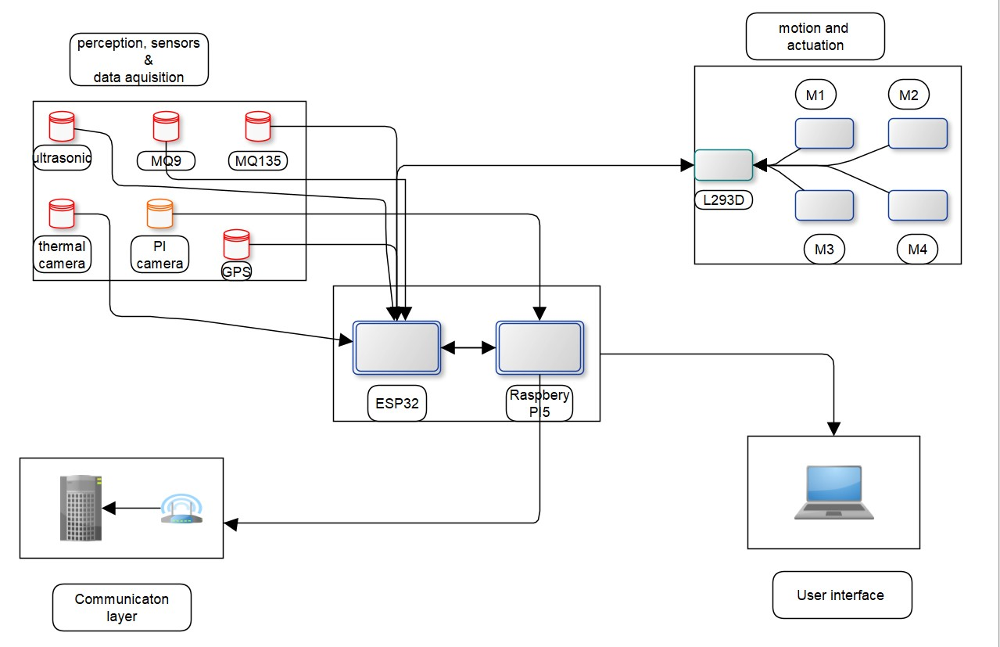Figure 3.1: System Block Diagram*

The entire working of the ground bot is divided into sections or blocks: Perception, Sensors and Data Acquisition, Motion and Actuation, User Interface, Communication and Processing.

The perception, sensors, and data acquisition block represents all sensors within the system. This includes ultrasonic sensors, gas sensors, thermal and Pi cameras. These are responsible for communicating with the environment and sending feedback to the bot through the ESP32. The ESP32 then communicates with the Raspberry Pi to transmit the sensor data to the user interface or influence the robot’s behaviour. The motor and actuation block is responsible for the robot’s movement and communicates with the ultrasonic sensors through the ESP32. Sensor data from the ultrasonic sensors influences the robot’s movement and path planning. It also uses the GPS coordinates to locate itself or move to specified locations. The user interface block represents the HMI section, where users interact with the bot and send commands or receive sensor information from the bot. Each block communicates with the centroid processing block by sending and receiving commands or data.

* 1. Circuit Design

Below, we highlight the design concept of each block with its pin connections.

1. Ultrasonic Sensors

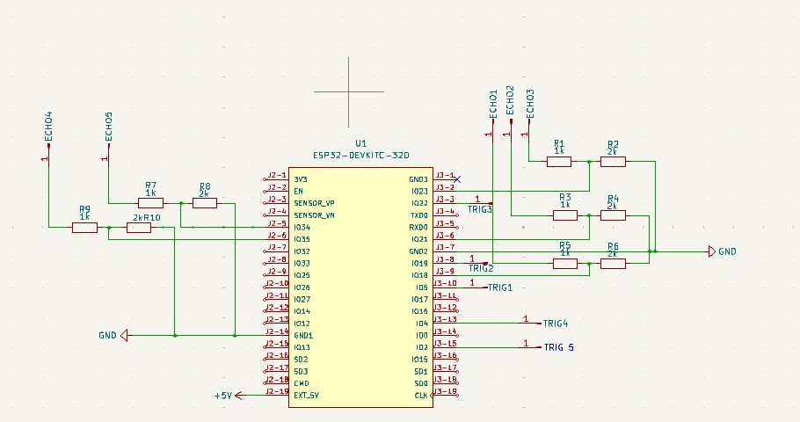*Figure 3.2: Ultrasonic Sensor Circuit*

The image above depicts a typical ultrasonic sensor connection. The ultrasonic sensor has four terminals. Echo, Trig, VCC and Gnd. The VCC is the voltage input of the ultrasonic sensor, and the GND is its ground. The trig pin serves as the trigger to start the ranging, i.e. the emission of the ultrasound using a short 10us pulse so its echo can be raised. The echo has a pulse width and range in proportion to calculate the range using the time interval between sending the trigger signal and receiving the echo signal. Each pin is assigned to a specific General-Purpose Input/Output pin (GPIO) on the ESP32 microcontroller for transmission of the received signal for the microcontroller to process. To receive tolerable voltages from the ultrasonic sensors that would not pose any danger to the ESP32, a voltage divider is used to reduce the received signal to a base of 3.3V, the rated safe voltage of the ESP32.

1. MQ Sensors

*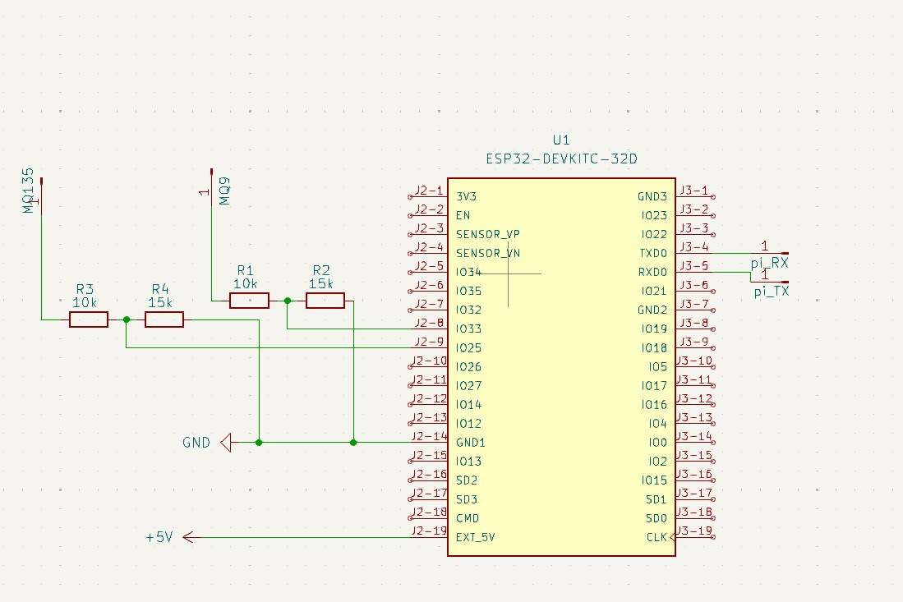Figure 3.3: MQ Sensor Circuit*

The MQ sensors are a type of gas sensor having in-built low conductivity material that, in clean air, remains unchanged, but increases in conductivity once the air is polluted by certain gases. This is the method the sensor uses to indicate the presence of gas in the air. A higher conductivity is an indication of a higher concentration of gas. The MQ sensors also have four pins. VCC, GND, AO, DO. Like the ultrasonic sensor, the VCC and GND are for voltage and ground, respectively. The Analogue Output (AO) is used when there is a need to indicate a continuous rise in gas concentration. The Digital Output (DO) is used only when there is a need to indicate the presence of gas after it crosses a specified threshold.

1. 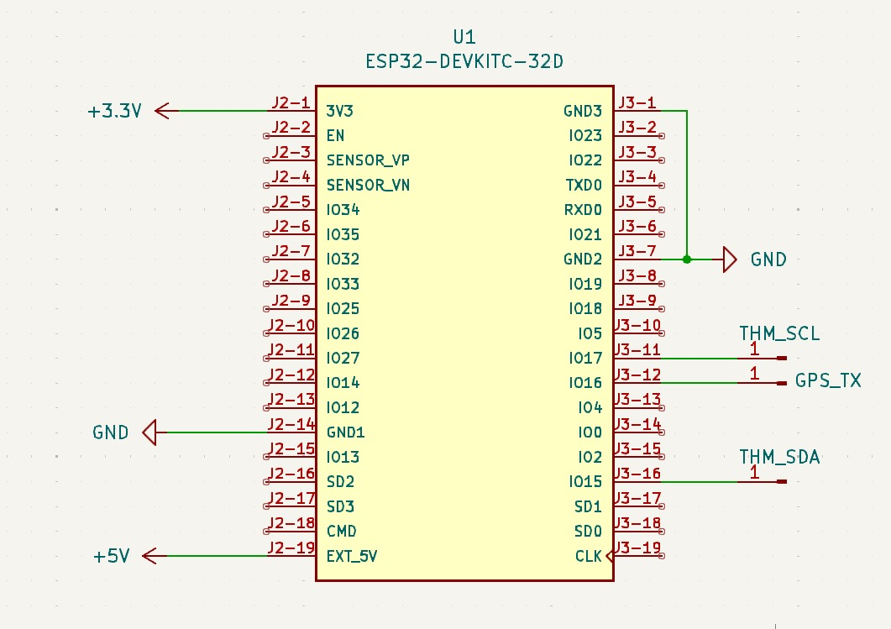Thermal Camera and GPS

*Figure 3.4: Thermal Camera and GPS Circuit*

The thermal camera is an Infra-Red (IR) sensor that detects heat changes within objects and displays them as a heatmap. The thermal camera has four main pins: VDD, GND, SDA and SCL. VDD and GND have their usual assignations. The SDA and SCL establish serial communication between the sensor and the ESP32. The SDA transmits serial data over I2C, while the SCL is the I2C serial clock for synchronisation. The GPS has VCC and GND power pins and a TX pin for transmitting location data to the ESP32.

1. Motion and Actuation

Below is the motor control circuit. 4 geared DC motors are used and are driven by the L293D motor driver. The motor drivers have 8 pins. One can control two separate motors. Its pins are: VCC1, VCC2, 2 two-channel enables (EN), 4 inputs and Outputs, and 4 GNDs. VCC1 is used to drive the internal logic of the L293D with 5V, and VCC2 is used to drive the motors. Its inputs are paralleled and connected to the ESP32, and its outputs are connected to the motors.

*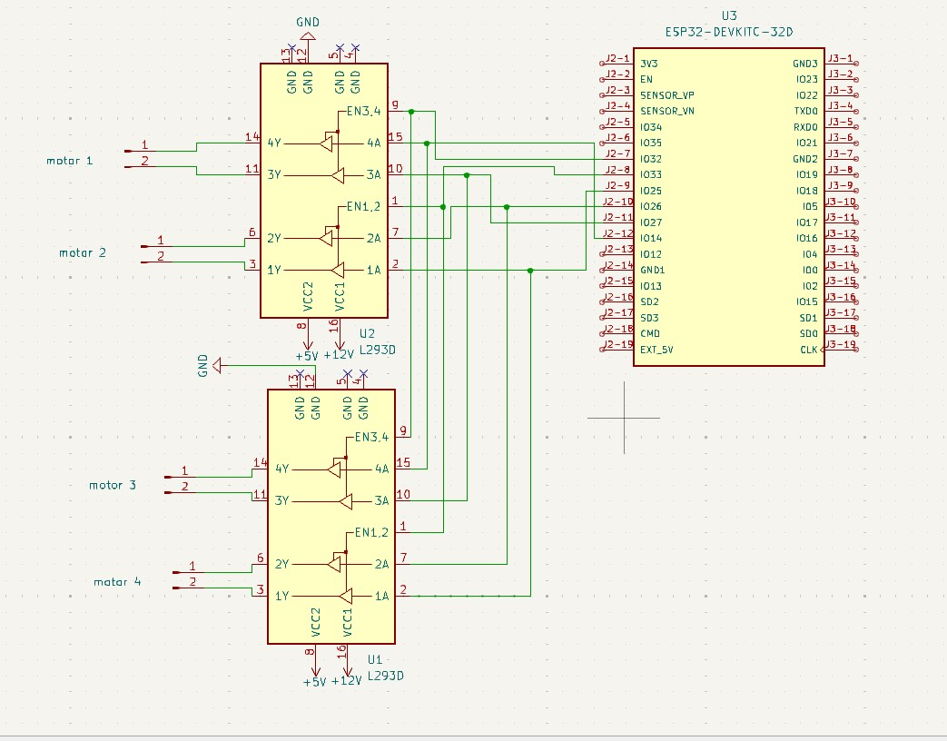Figure 3.5: Motor Control Circuit*

* 1. System Circuit Design

*Figure 3.6: System Circuit*

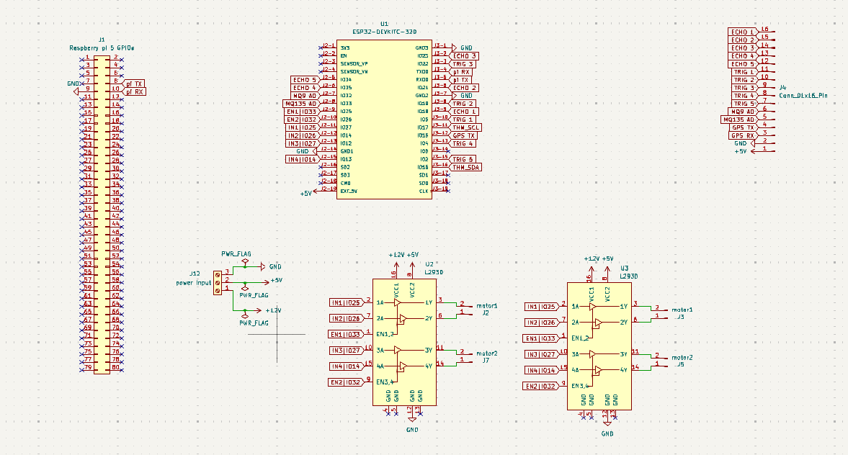This circuit encompasses all individual connections mentioned in the previous section. Labels are used instead of wire to prevent the circuit from being overcrowded. From the above circuit, all components are connected to specific GPIO pins, ensuring no overlaps. Header pins represent some components, as they are the connection mode for the components. All unconnected pins on the ESP32 are FLASH and are unsuitable for achieving our objectives. Communication is established between the ESP32 and the Raspberry Pi through the TX and RX pins.

# CHAPTER FOUR

# CONSTRUCTION AND TESTING

* 1. Preliminary Tests

This section covers all tests performed on the various components to ensure they were in the right working order before everything was put together. The tests performed will be highlighted with reasons for the choices made. The following sections will cover all preliminary tests before construction begins.

* + 1. H-Bridge Test

The test was purposed to ascertain whether an H-Bridge would be the most viable option to drive our motor. As we aimed to efficiently control our motor's speed, direction, and torque, the H-Bridge was the first option, as it was low-cost and easy to build. Below is an image of the circuit built for the test.

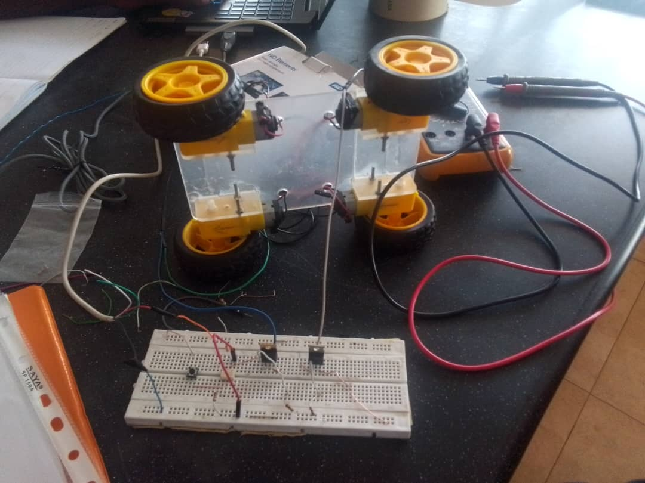*Figure 4.1: H-Bridge Test*

The test on the H-Bridge succeeded, enabling us to purchase the L293D IC, a quadruple high-current half H-Bridge for bidirectional drive current. The motor driver is designed to drive two motors simultaneously.

* + 1. MQ Sensor Test

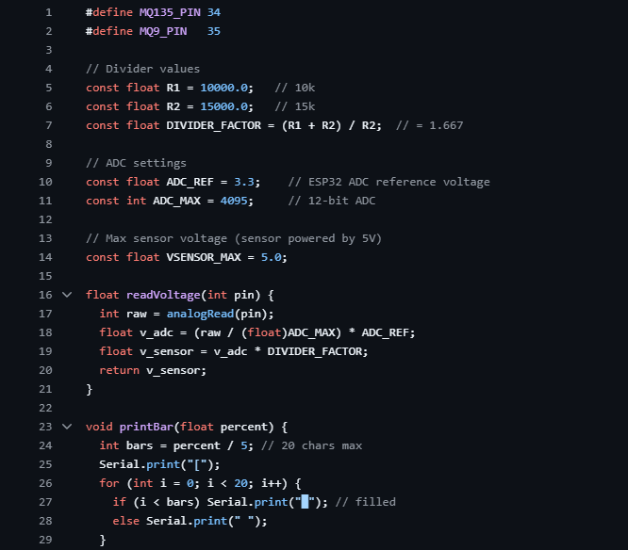The selected gas sensors for this project were MQ Sensors. Before the test began, the sensors were allowed to heat for 20 hours on first-time use to allow for proper calibration for better sensitivity. After calibration of the sensors, they were connected to an ESP32, one of the microcontrollers for the project. A test code was developed to test its gas sensitivity to gases. The test yielded positive results. Below is an image of the test code.

*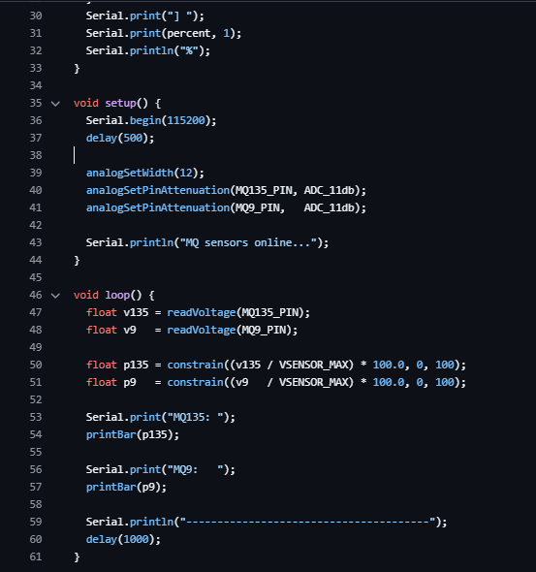Figure 4.2: MQ Sensor Test Code*

*Figure 4.3: MQ Sensor Test Code*

* + 1. Thermal Camera Test

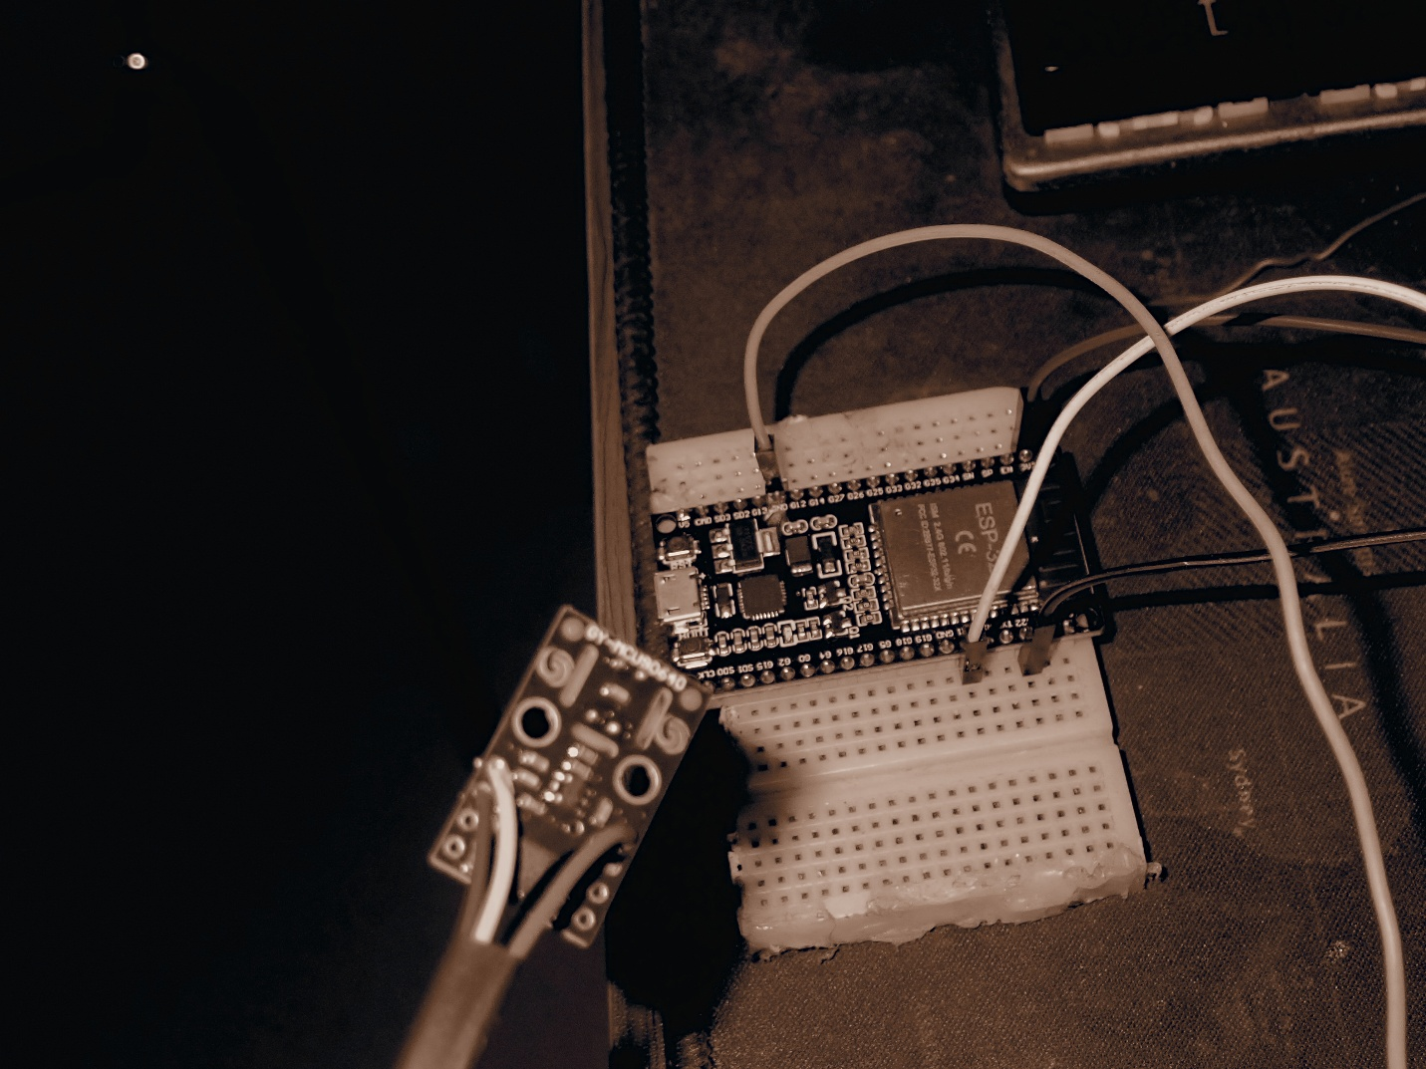The thermal camera was tested in two ways. The first test was to transmit sensor data via serial as a series of numbers to determine the temperature changes, and the second test involved visualising the data to create a heatmap. The thermal camera was connected to an ESP32, and test codes were developed to program it for both processes. The test yielded positive results as we could visualise the temperature changes using a heatmap and transmit the temperature changes via I2C as a series of numbers. Below is an image of the setup for this test and the test codes.

*Figure 4.4: Thermal Camera Setup*

*Figure 4.5: Thermal Camera 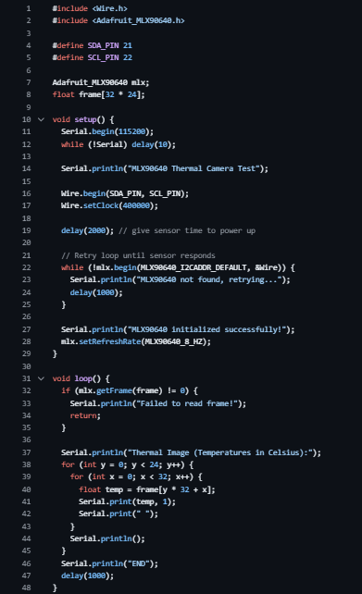Test Code*

* + 1. Ultrasonic Sensor

The test for the ultrasonic sensors was performed in multiple ways. All ultrasonic sensors were tested individually in the first test, and their results were noted. Three were then connected and tested together, yielding a positive result. The sensors could measure distance as programmed, and later two more were added and tested to make it five. A filtering algorithm was created to improve the desired distance by removing surrounding noise. Below is an image of the code.

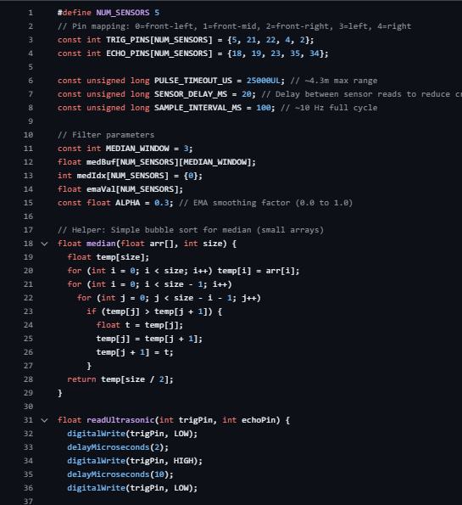

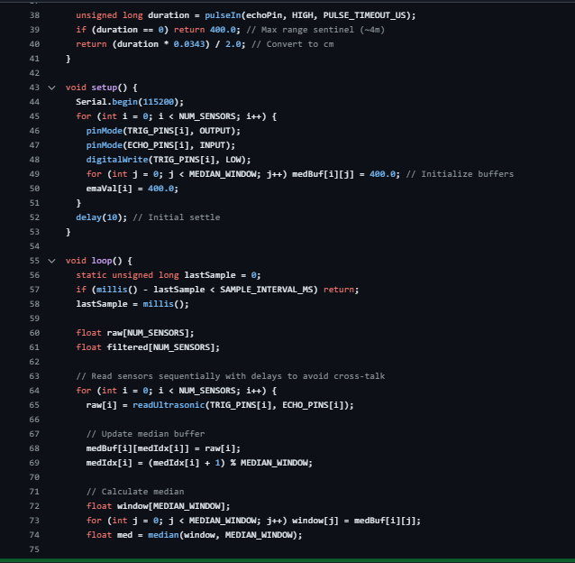

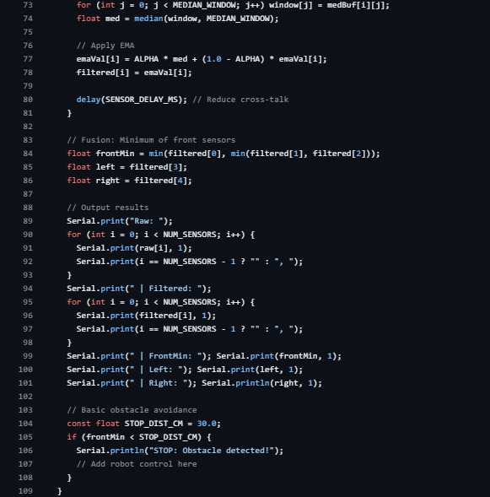

*Figure 4.6: Ultrasonic Sensor Test Code*

* + 1. GPS Test

This test involved programming and ensuring the GPS could give precise location data with little to no errors. The test was performed outside as it made it easier for the module to connect to satellites and transmit and receive data. This test yielded positive results and gave the precise location needed. Below is an image of the test setup.

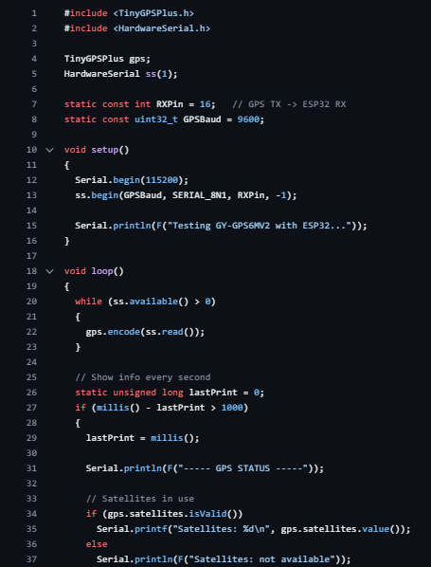

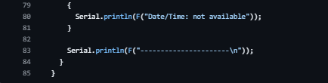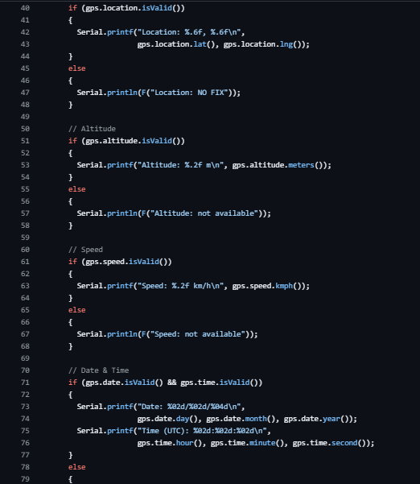*Figure 4.7: GPS Test Code*

* 1. Customisation and Assembly

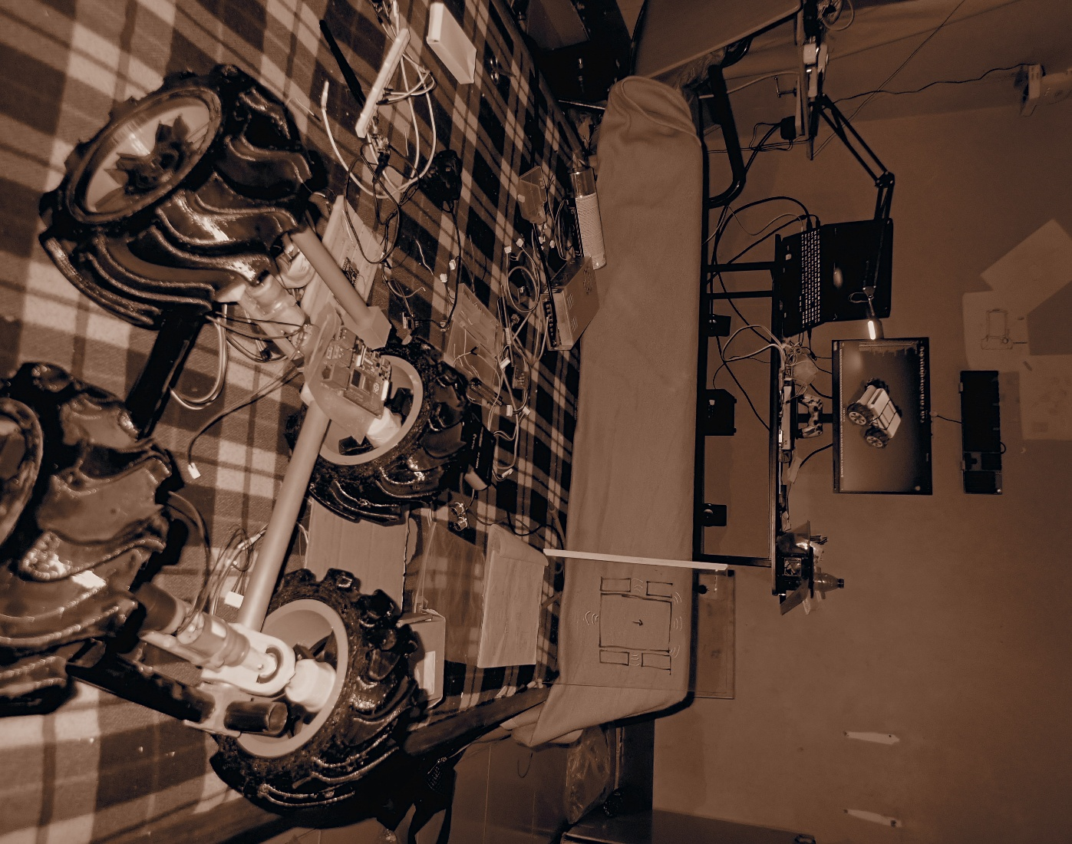This section covers the assembly process and how parts were customised to meet our needs.

*Figure 4.8: Robot Frame*

* + 1. Customisation

Certain components were unavailable at the start of the project; hence, they were customised to meet our needs. We used AutoCAD Fusion to design our tyres and the frame of our bot, which we put together using recess and glue. We also developed our battery pack using nine 3.7-volt lithium-ion batteries, connecting them in a 3S3P format to meet the voltage and current requirements to move our bot. A charging module was also included to enable us to charge the battery when drained. Below are images of the tyre and the entire frame put together.

*Figure 4.9: Robot Frame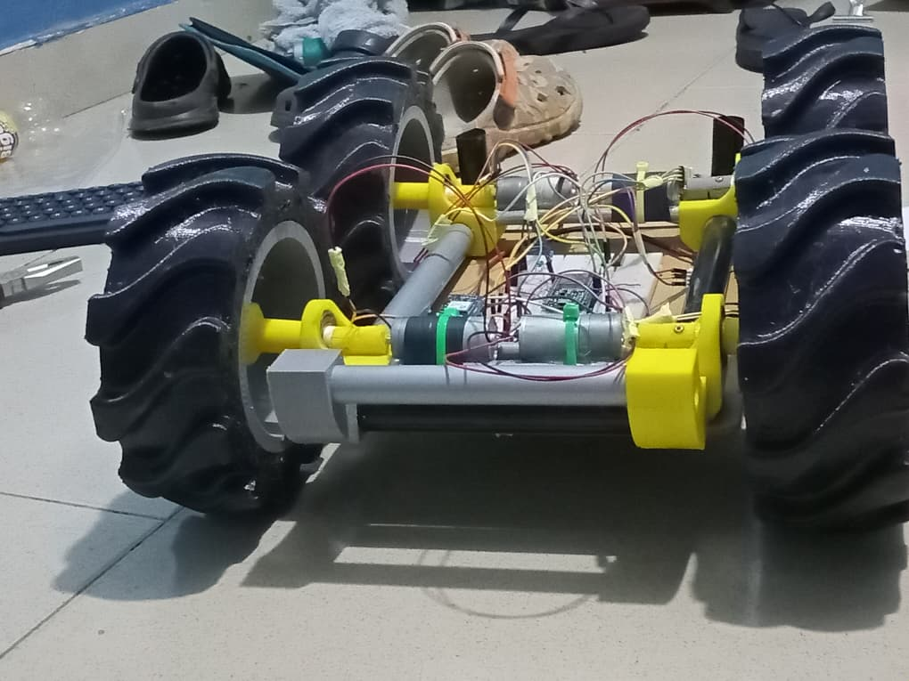 2*

* + 1. Assembly

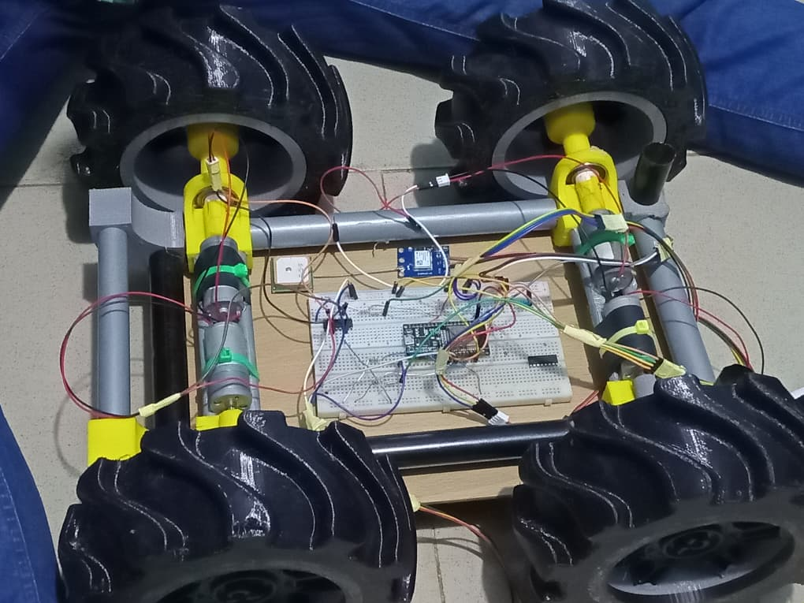This section covers the complete connection of all components to function cohesively as one unit. The system was connected such that the ultrasonic sensors communicate with the motors when an obstacle is detected, allowing it to change its path to one where there is no obstacle or a path with a leeway to pass between obstacles, all while calculating its position relative to its destination. The MQ sensors detect the presence of gas in the air and transmit the data to the webapp dashboard for viewing, along with the coordinates of the location where the gas was detected.

*Figure 4.9.1: Robot Frame and Partial Circuit*

* 1. Final Test and Results

This section covers the final test conducted after full assembly and the results displayed on the web app. After completion, the bot was tested in an enclosed space and allowed to navigate. The bot was able to identify and localise the gas leakage and transmit the coordinates of the leakage location. The dashboard could display the leakage concentration using a scale that increases from white to red, with red indicating the excessive presence of gas. Through the dashboard, we could monitor and send commands to the bot. We were also able to see the robot’s exact location through GPS. We visualised the value of the leaked gas through a graph.

# CHAPTER FIVE

# CONCLUSION AND RECOMMENDATION

* 1. Conclusion

This project presents a way to check for gas leakages and thermal anomalies in a thermal power plant using an autonomous four-wheeled robot. The robot could autonomously move within a specified area using GPS and obstacle avoidance schemes. It could detect gas leakages and transmit the data to the web application dashboard. It was noticed that the closer the bot was to the point of leakage, the better the accuracy of reading the level of leakage. The bot was also able to notify during extreme conditions for quicker response. We achieved the main objectives of our project. We achieved real-time monitoring, sensor data analysis and response to gas leakages.

The major challenge we encountered while working on this project was the difficulty in achieving the intended steering style due to the low torque of the motors, which led to a later change of design to meet the deadline. Another challenge was the difficulty in understanding complex concepts that we were introduced to as we progressed with the project.

* 1. Recommendation

We recommend that for any work on related projects to this, appropriate funding be sought to be able to procure the best components for the work to achieve the best results.

* 1. Future Work

This project was designed as a test of theory; hence, for future work, a swarm of robots would be tackled to increase the efficiency of detections and quick responses.

Implementation of backup power for low-power conditions or areas of coverage.

To implement direct communication with satellites to improve real-time monitoring and path planning.

# **References**

[1] Ravi Kishore Kodali, R. N. V. Greeshma, Kusuma Priya Nimmanapalli, and Yatish Krishna Yogi Borra, *IOT Based Industrial Plant Safety Gas Leakage Detection System*. Greater Noida: Institute of Electrical and Electronics Engineers, 2018.

[2] M. S. Jadin and K. H. Ghazali, “Gas leakage detection using thermal imaging technique,” in *Proceedings - UKSim-AMSS 16th International Conference on Computer Modelling and Simulation, UKSim 2014*, Institute of Electrical and Electronics Engineers Inc., 2014, pp. 302–306. doi: 10.1109/UKSim.2014.95.

[3] S. M. Naik and T. R. Assissant Professor, “Gas Leakage Detector Insect Robot using Raspberry Pi3.” [Online]. Available: www.ijert.org

[4] N. Phyo Aung, M. Mo Myint Wai, and L. Lwin Htay, “WiFi Based Gas Pipe Leakage Detector Insect Robot using PI3,” *International Journal of Trend in Scientific Research and Development (IJTSRD) International Journal of Trend in Scientific Research and Development*, no. 5, pp. 558–564, 2019, doi: 10.31142/ijtsrd26381.

[5] C. Xia *et al.*, “Infrared thermography-based diagnostics on power equipment: State-of-the-art,” Jun. 01, 2021, *John Wiley and Sons Inc*. doi: 10.1049/hve2.12023.

[6] A. W. Kandeal *et al.*, “Infrared thermography-based condition monitoring of solar photovoltaic systems: A mini review of recent advances,” *Solar Energy*, vol. 223, pp. 33–43, Jul. 2021, doi: 10.1016/j.solener.2021.05.032.

[7] M. Pajany and A. Hemalatha, “Pipeline Gas Leakage Detection And Location identification System,” 2019.

[8] I Kadek Nuary Trisnawan, Agung Nugroho Jati, Novera Istiqomah, and Isro Wasisto, *Detection of Gas Leaks Using The MQ-2 Gas Sensor on the Autonomous Mobile Sensor*. IEEE, 2019.

[9] John Kerekes, Cody Webber, and Rolando Raqueño, *METHANE DETECTION IN THE LONGWAVE INFRARED*. Institute of Electrical and Electronics Engineers, 2018.

[10] A. Alharam, E. Almansoori, W. Elmadeny, and H. Alnoiami, “Real Time AI-Based Pipeline Inspection using Drone for Oil and Gas Industries in Bahrain,” in *2020 International Conference on Innovation and Intelligence for Informatics, Computing and Technologies, 3ICT 2020*, Institute of Electrical and Electronics Engineers Inc., Dec. 2020. doi: 10.1109/3ICT51146.2020.9312021.

[11] K. L. Smith, M. D. Steven, and J. J. Colls, “Use of hyperspectral derivative ratios in the red-edge region to identify plant stress responses to gas leaks,” *Remote Sens Environ*, vol. 92, no. 2, pp. 207–217, Aug. 2004, doi: 10.1016/j.rse.2004.06.002.

[12] Abhisek Ukil, Wang Libo, and Gang Ai, *Leak Detection in Natural Gas Distribution Pipeline Using Distributed Temperature Sensing*. IEEE, 2016.

[13] O. Janssens, R. Van De Walle, M. Loccufier, and S. Van Hoecke, “Deep Learning for Infrared Thermal Image Based Machine Health Monitoring,” *IEEE/ASME Transactions on Mechatronics*, vol. 23, no. 1, pp. 151–159, Feb. 2018, doi: 10.1109/TMECH.2017.2722479.

[14] A. Ibarguren, J. Molina, L. Susperregi, and I. Maurtua, “Thermal tracking in mobile robots for leak inspection activities,” *Sensors (Switzerland)*, vol. 13, no. 10, pp. 13560–13574, Oct. 2013, doi: 10.3390/s131013560.

[15] J. Yang, W. Wang, G. Lin, Q. Li, Y. Sun, and Y. Sun, “Infrared Thermal Imaging-Based Crack Detection Using Deep Learning,” *IEEE Access*, vol. 7, pp. 182060–182077, 2019, doi: 10.1109/ACCESS.2019.2958264.

[16] J. Wang *et al.*, “Invisible Gas Detection: An RGB-Thermal Cross Attention Network and A New Benchmark,” Mar. 2024, doi: 10.1016/j.cviu.2024.104099.

[17] Johannes Rangel and Andreas Kroll, *Characterization and Evaluation of Spatial Jitter’s Inﬂuence on the Intrinsic Geometric Calibration of an Infrared Camera for Gas Visualization*. IEEE, 2017.

[18] H. Supriyono and A. N. Hadi, “Designing A Wheeled Robot Model For Flammable Gas Leakage Tracking.”

[19] R. Khan, F. M. Malik, A. Raza, and N. Mazhar, “Comprehensive study of skid-steer wheeled mobile robots: development and challenges,” Mar. 19, 2021, *Emerald Group Holdings Ltd.* doi: 10.1108/IR-04-2020-0082.

[20] J. Wang, Z. Liu, H. Chen, Y. Zhang, D. Zhang, and C. Peng, “Trajectory Tracking Control of a Skid-Steer Mobile Robot Based on Nonlinear Model Predictive Control with a Hydraulic Motor Velocity Mapping,” *Applied Sciences (Switzerland)*, vol. 14, no. 1, Jan. 2024, doi: 10.3390/app14010122.

[21] O. Elshazly, A. Abo-Ismail, H. S. Abbas, and Z. Zyada, “Skid Steering Mobile Robot Modeling and Control.”

[22] Y. LI, X. DU, F. WAN, X. WANG, and H. YU, “Rotating machinery fault diagnosis based on convolutional neural network and infrared thermal imaging,” *Chinese Journal of Aeronautics*, vol. 33, no. 2, pp. 427–438, Feb. 2020, doi: 10.1016/j.cja.2019.08.014.