**Abstract**

15.7.2015

Final Report

Research about students’ income and expense

Can any trend be identified with students’ income and expense? That is the major question we want to answer in this report. In order to analyse students, we needed a dataset which we collected from our class by a survey. 57 students submitted the survey. From now on we could start to analyse the dataset that we collected.

The analysis shows us some slight differences in expense between male and female students. Despite this, we can not assume a high difference between expenditure of male and female. On the other hand, we spot some reasonable differences between Korean students and International students. Furthermore, the income has no influence of the frequency of visited countries or watching movies.

Considering the findings, we should be careful with our recognitions, because our dataset represent only one class. Therefore, we are not able to assume a general conclusion or trend for all students in the world.

Gayun Lee, Taewoo Kim, Sung Mo Koo, Javier Rodríguez Caballero Lopez, Philipp Merrouche

classresearch

# Introduction

During the process of finding a subject for our group, we figured out that we want to learn more about our daily lives as college students. We thought the comparison between students’ income and expenditure would be interesting and appropriate to analyse. In addition, we also want to collate the difference between Korean and International students. After this process, the question we want to answer was clear:

*Can any trend be identified with students’ income and expense? How does expense of International students and that of Korean students compare? Are there also any reasonable deviations between male and female students?*

To answer these questions we set up a survey to get data from our class. We asked them several questions about their income and expense. To narrow down the different uses of expense, we have come up with a list of major sources which students are likely to spend money on.

Despite the fact that we have only data of one class, we hope to get salient findings (e.g. SKKU students may be much wealthier than the average). However, we will not be able to assume a general conclusion or trend for all students in the world for sure.

# Methods and Result

As mentioned above, we conducted analysis with the questionnaires. The following lists are the questions we asked:

* Gender
* Nationality; International or Korean student
* Number of countries they visited
* Number of movies they watch during a month
* Income per month (in USD)
* How they get their income; From family, work or both
* Percentages about how they spend their income

; Examples are as in the following

; Living, transportation, hobby, food, clothes, phone charge, insurance and others.

Briefly, the following is the list of analysis we did.

* Income versus Number of countries visited
* Income versus Number of movies they watch during a month
* Spending categories of students

## Income versus Number of Countries visited

Firstly, we wanted to see if there is any relationship between the income of a student and the number of countries visited. All students were considered in this plot.

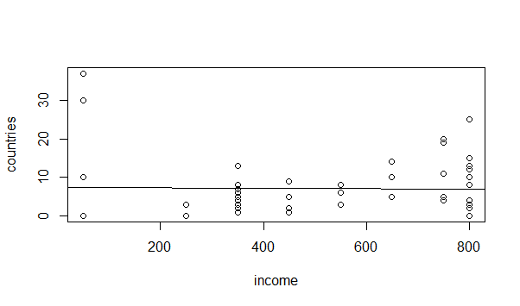

The plot shows us no clear trend. We tried drawing a regression line in the plot, but it looks like horizontal line that means nothing. Because of this, we can assume that the income does not affect the number of countries they visited.

### Fact of Analysis

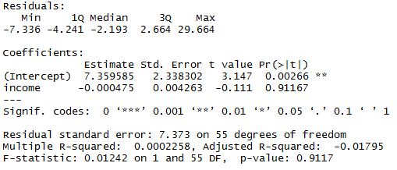

The upper picture summarizes the fact of this observation. We can read that the income and number of countries they visited have non-linear relationship because the R-squared value is about 0.0002.

## Income versus Number of Movies they watch during a month

In this analysis, we compared the movie data with the income data to find out any noticeable relationship. The following two histograms show the distribution of these two subjects.

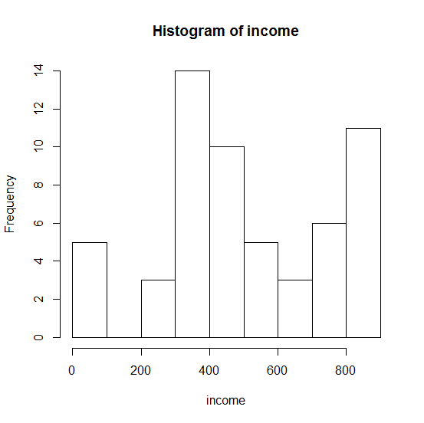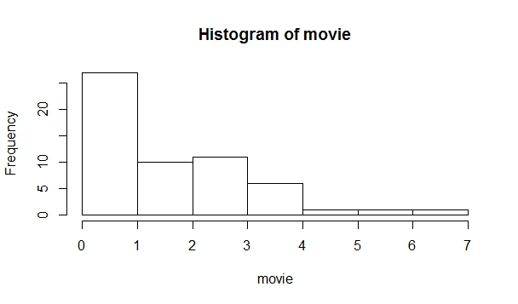

As we can see from those two histograms, we can assume that there is no correlation between income and the number of movies they watch during a month. As a consequence of this, the next plot shows that there is no particular relationship between income and frequency of watching movies.

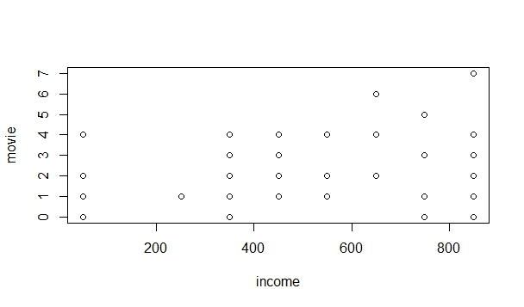

## Spending Categories of All Students

In this part, we analysed how they spend their income. On the following pie chart, you can see the overview of all students’ propensity to consume.

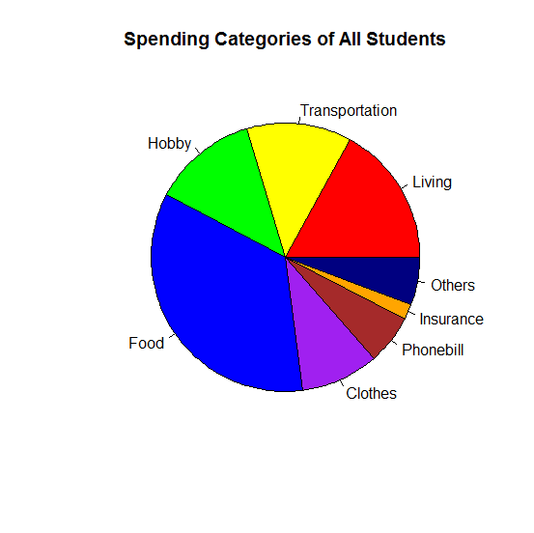

According to the data, students spend the biggest portion of their income on food expenses, about 34.7%. After that, percentages of expenditure on living, transportation, hobby and clothes are 17, 12.7, 12.6, 9.5% respectively, comprising major portion of students’ spending.

### Compare by Gender; Male and Female

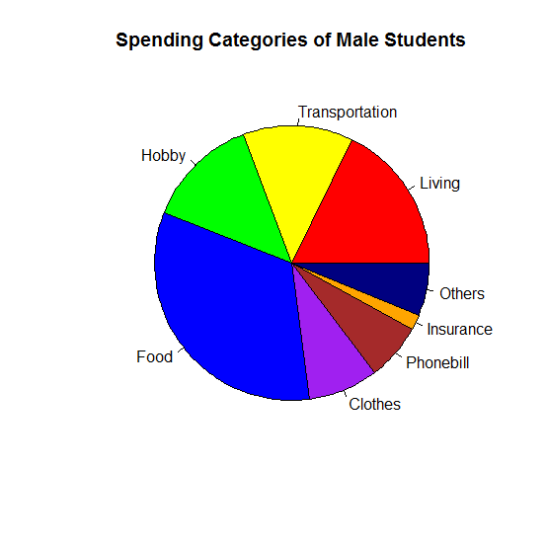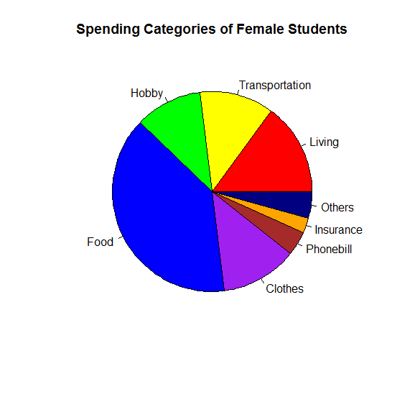

In addition, we separated students by their gender, and compared expenditure pattern of male students with that of female. The biggest differences between those two charts are the food and phone charge expenditure. Male students expense 8.3% of their income on clothes while female students expense 12.5% of their income. On the other hand, males expense 6.7% of their income on phone charge while females expense just 3.9% of their income on that.

#### Hypothesis test

Therefore, we conducted a hypothesis test to verify a significant difference between male’s expenditure percentage on clothes and female’s expenditure percentage.

* H0: The percentages are the same in males and females
* H1: The percentages are not the same

The t-test shows us following facts;

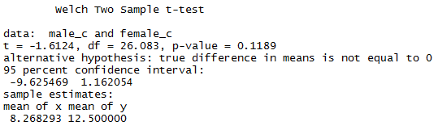

The p-value for this test is 0.1189, so we can't reject null hypothesis. Therefore, the percentage of spending for clothes between males and females are the same. We cannot assume a high difference between expenditure of male and female in this category.

### Compare by Nationality; Korean or International Students

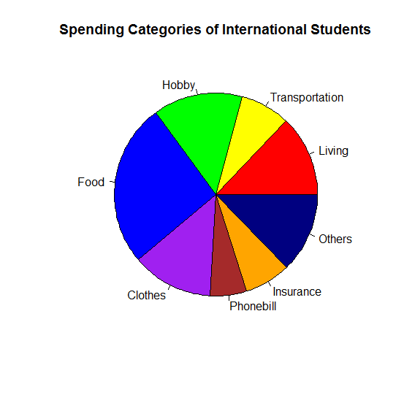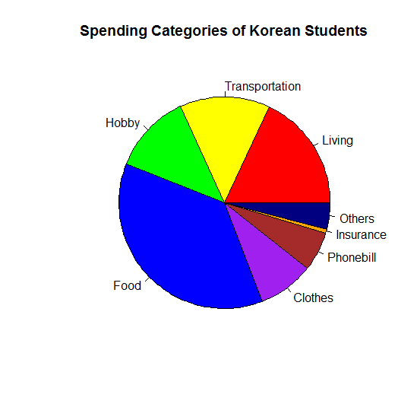

After that, we separated students by their nationality, Korean and International, and compared expenditure pattern between two groups. The biggest differences between those two charts are the food and insurance expenditure. Korean students expense 36.7% of their income on food while international students expense 26% of their income. On the other hand, Korean students expense only 0.6% of their income on insurance while international student expense 7.4% of their income on that.

# Discussion

# Conclusions and Future Directions